Geco ReactJS Training
ReactJS Assignment
Name: | Ho Choo Geok
Date of Issue: | 13th October 2022
Date of Submission: | 15th October 2022
Cohort No.: | 27
Week No.: | 1
Daily Task No.: | 4
- Create multiply, division, subtraction function with arrow function/fat arrow
<input type="text" id="num1" name="num1" value="" placeholder="First number" />
<input type="text" id="num2" name="num2" value="" placeholder="Second number" />
<h4> The result of the operation is: </h4>
<p id="display"> </p>
<button onclick="add()"> Add </button>
<button onclick="subtract()"> Subtract </button>
<button onclick="divide()"> Divide </button>
<button onclick="multiple()"> Multiple </button>
<script>
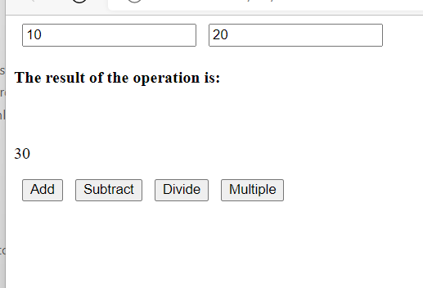
let reuslt = 0;
let num1 = document.getElementById("num1");
let num2 = document.getElementById("num2");
add = () => {
result = (Math.round(num1.value) + Math.round(num2.value));
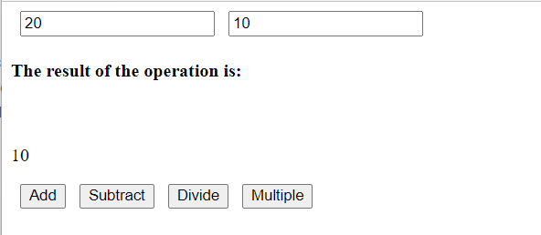
document.getElementById("display").innerHTML = result;
}
subtract = () => {
result = (Math.round(num1.value) - Math.round(num2.value));
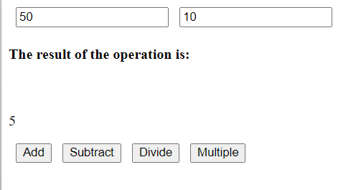
document.getElementById("display").innerHTML = result;
}
divide = () => {
result = (Math.round(num1.value) / Math.round(num2.value));
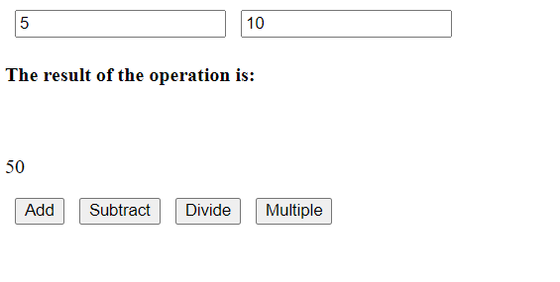
document.getElementById("display").innerHTML = result;
}
multiple = () => {
result = (Math.round(num1.value) * Math.round(num2.value));
document.getElementById("display").innerHTML = result;
}
</script>

- Create a employee object and display its data in console (for...in).
<script>
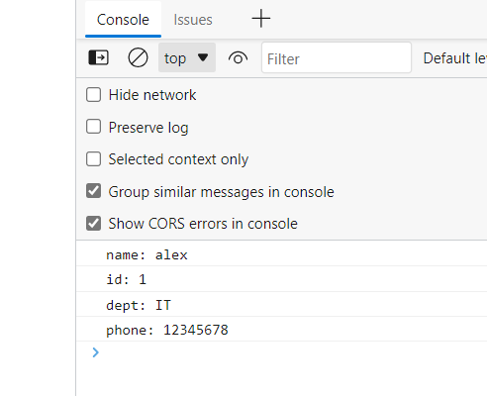
let text="";
const employee = {
name: "alex",
id: "1",
dept: "IT",
phone: "12345678"
};
for(let x in employee){
text = employee[x];
console.log(x + ": " + text);
}
</script>

- Use Array helper functions
  - Check if all the property values(firstName) in an array of object is same or not
array of object
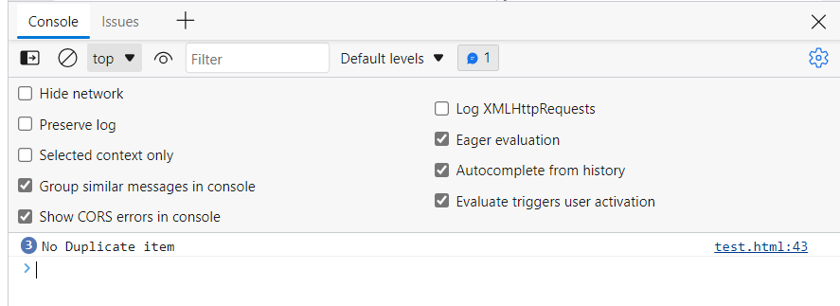
<script>
let array = [{
firstName: 'alina',
id: 1,
age: 14
}, {
firstName: 'harry',
id: 2,
age: 15
}, {
firstName: 'alex',
id: 3,
age: 16
}];
const value = array.map((ele) => ele.firstName);
const result = value.some((item) => {
if(value.indexOf(item) !== value.lastIndexOf(item))
{
console.log("Duplicate item " + value.firstName)
} console.log("No Duplicate item")
});
</script>
  - Get the value of the first element in an array that has value greater than 20
<script>
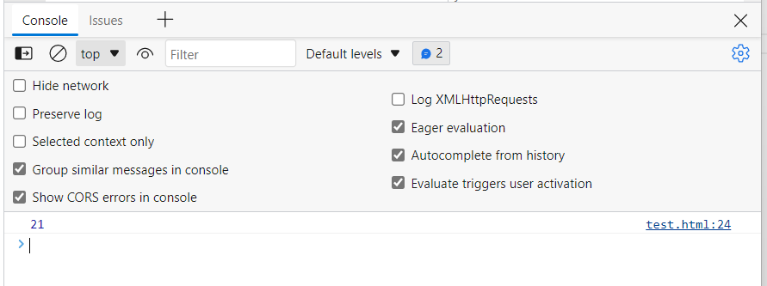
const array = [1,2,3,4,5,20,21,30,50] ;
const value = array.find(ele => {
return ele>20;
}); console.log(value);
</script>

  - Get the value of the first element in an array that has value less than 20
<script>
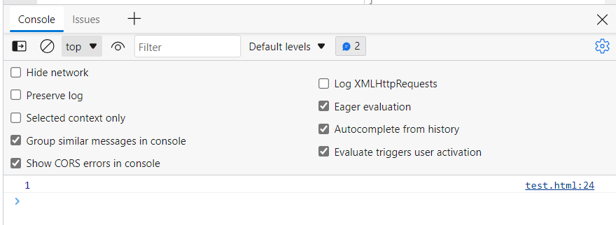
const array = [1,2,3,4,5,20,21,30,50] ;
const value = array.find(ele => {
return ele<20;
}); console.log(value);
</script>
  - Filter data based on a id(property) in an array of objects: pick any random id value
<script>
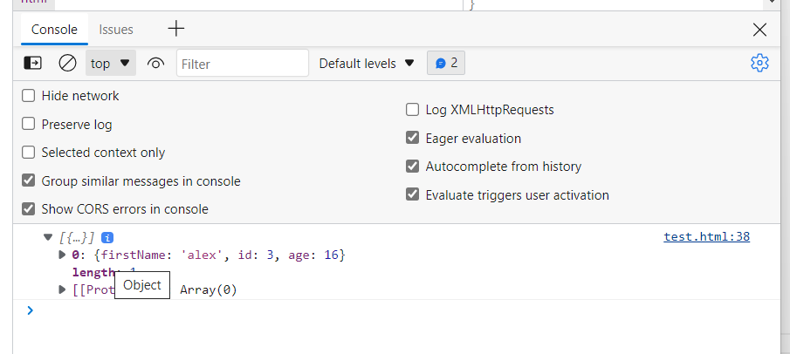
const array =
[{
firstName: 'alina',
id: 1,
age: 14
}, {
firstName: 'harry',
id: 2,
age: 15
}, {
firstName: 'alex',
id: 3,
age: 16
}]
const filterArray = array.filter( ele => {
return (ele.id == 3)
})
console.log (filterArray);
</script>
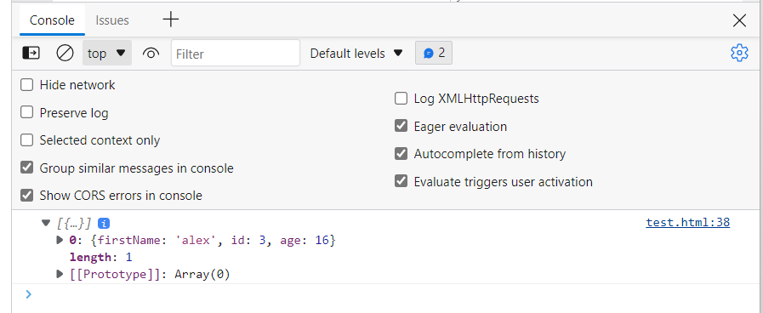
  - Round off all the decimal numbers in an array and sum all the values [9.8, 9.7, 4.5, 3.4]
<script>
let result = [];
let sum = 0;
let array = [9.8, 9.7, 4.5, 3.4]
result = array.map((ele) => {
ele = Math.round(ele);
sum += ele;
return sum;
});
console.log("Sum of the array is:" + sum);
</script>

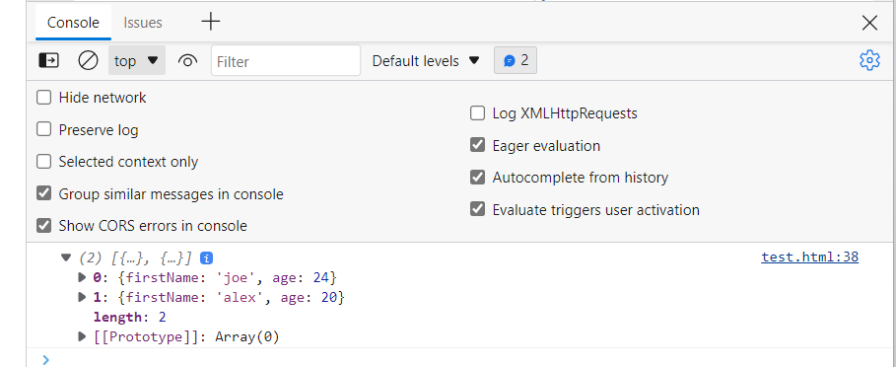
  - Get all the person name based on age greater than and equal to 18, eligible to vote
<script>
let array = [{
firstName: 'joe',
age: 24
}, {
firstName: 'alina',
age: 12
},
{
firstName: 'alex',
age: 20
}]

let result = array.filter((ele) => {
return ele.age >= 18});
console.log(result);
</script>

  - Sum all the elements of an array [90, 89, 56, 45]
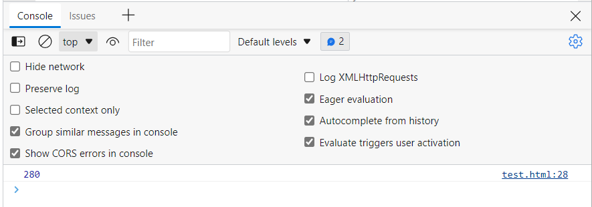
<script>
let array = [90, 89, 56, 45]
let result = array.reduce( (t,n) => {
return t+n;
}) ;
console.log(result);
</script>

  - Check element is odd or even in an array [90, 89, 56, 45]
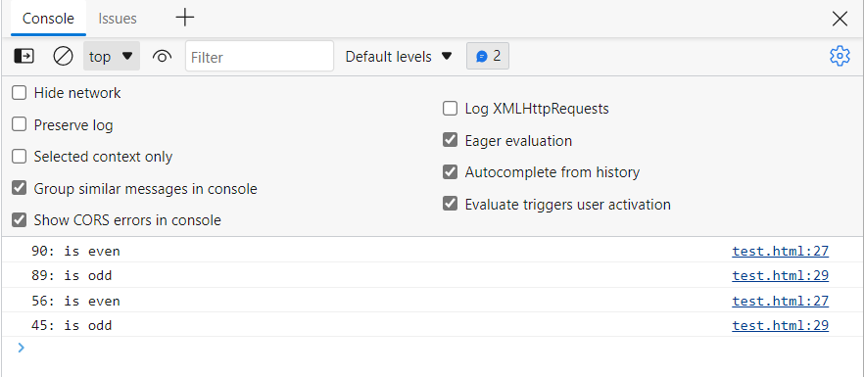
<script>
let array = [90, 89, 56, 45]
let result = array.map( (ele) => {
if (ele % 2 === 0){
console.log(ele + ": is even")
}else {
console.log(ele + ": is odd")
}
})
</script>

  - Sum of all the salaries and display final sum value

<script>
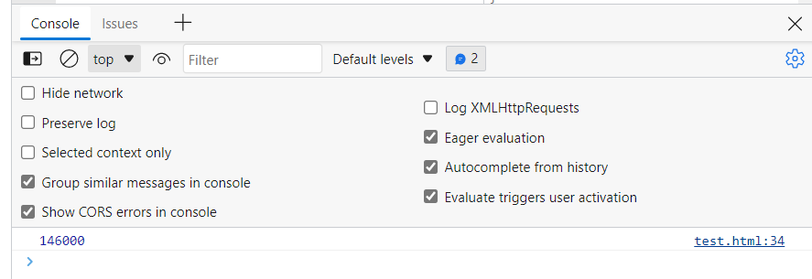
let array = [{
salary: 56000,
},
{
salary: 90000,
}
] ;

let result = array.reduce( (total,item) => {
return (total + item.salary)},0);
console.log(result);
</script>

  - Concat all array elements ['red', 'pink', 'orange', 'red']: 'redpinkorangered'
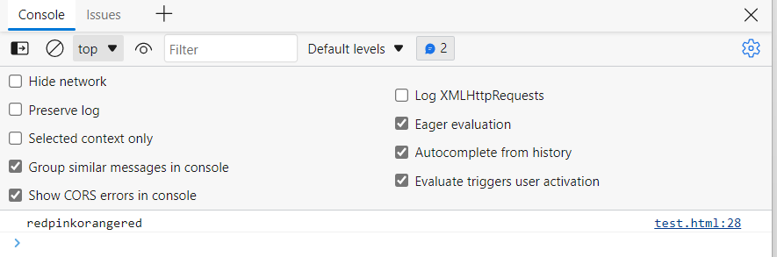
<script>
let array = ['red', 'pink', 'orange', 'red']
let result = array.reduce( (t,n) => {
return t+n;
}) ;
console.log(result);
</script>

