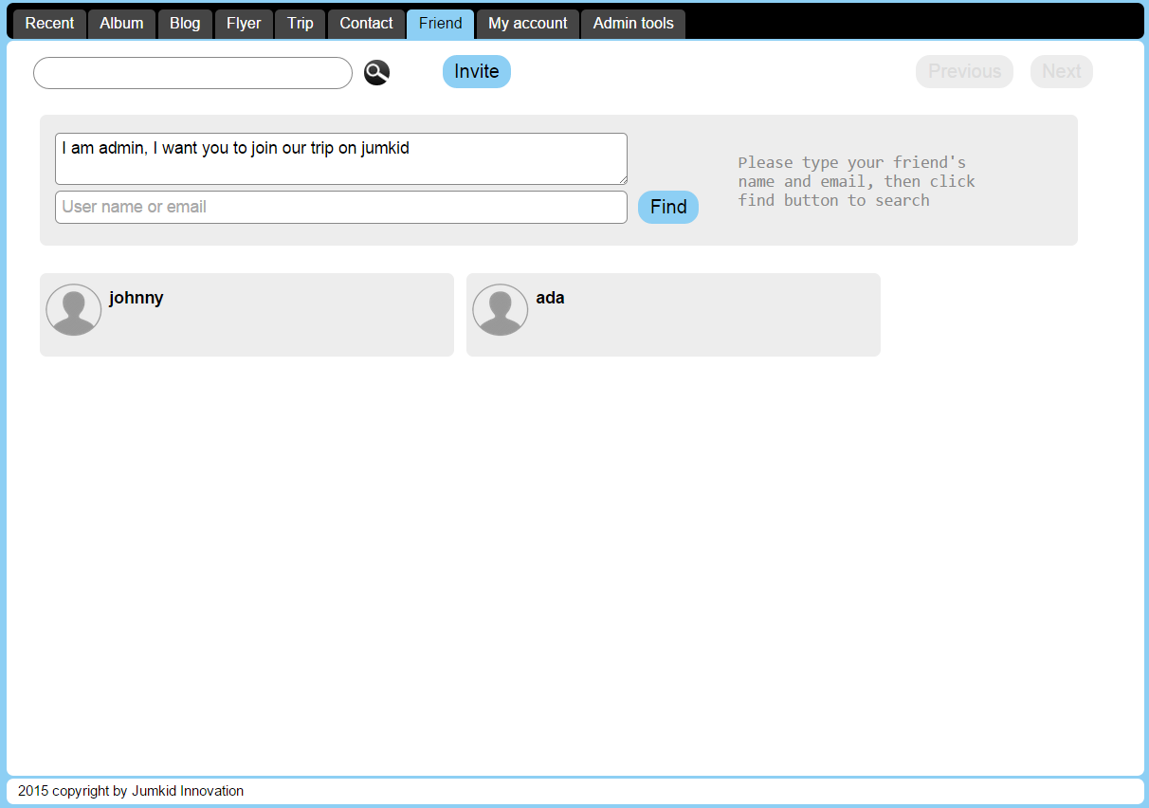





Jackson.ma@gmail.com



Friend Inviter Function

1. Type user name to search members within the website  
   - if found an existing user show account avatar and can add as a friend  
   - if not found then show no found message
2. Type email to search members within the website  
   - if found an existing user show account avatar and can add as a friend  
   - if not found then show invitation by email
3. Type in invite message
4. Show invitation on my friends screen  
   - accept as friend  
   - reject to ignore the invitation