ECIS Excel Upload - ClaudeExcelImport End-to-End Test Evidence
Interface: CLAUDE_WELL_TEST Schedule: ClaudeExcelImport Target: PWEL_DAY_STATUS.AVG_BH_PRESS
Wells AS1_Well_001/002/003 @ 2003-01-10. Local EC sandbox (sysadmin). Live run, DB-verified.

DB ground-truth evidence
Well | BEFORE avg_bh_press | AFTER avg_bh_press
AS1_Well_001 | NULL | 210.5
AS1_Well_002 | NULL | 215
AS1_Well_003 | NULL | 220.3
Schedule run status: OK (2026-06-21 14:20:00). File No 16 status: WRITTEN_TO_EC (parsed + written to EC 14:20).

Step 1: ECIS Excel-upload configuration (Mapping Configuration)
The CLAUDE_WELL_TEST interface with its source mappings (Well/Date/Pressure, sheet 'Data') and target mapping to PWEL_DAY_STATUS.AVG_BH_PRESS.
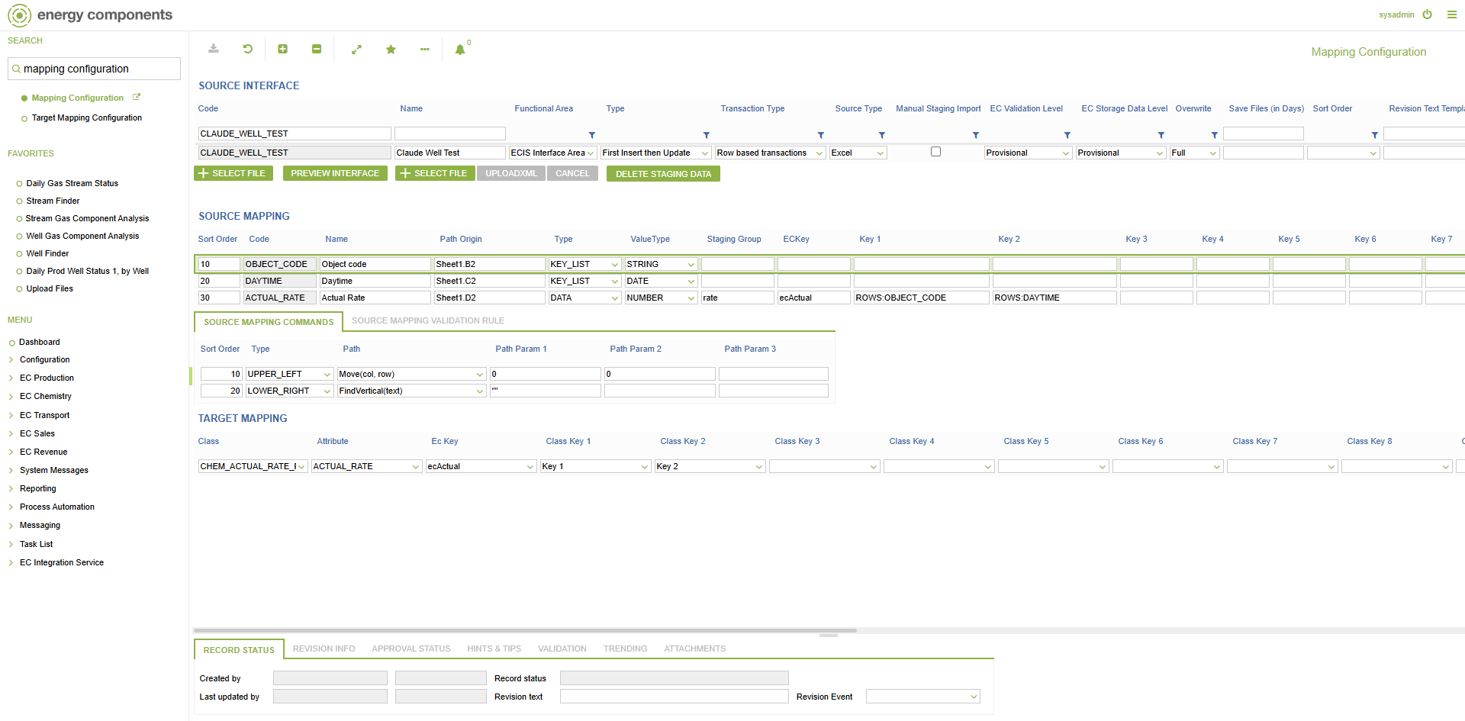

Step 2: Schedule task configuration (Schedules - ClaudeExcelImport)
The ClaudeExcelImport schedule and its two ECISAction steps (10: file->staging, 20: staging->target), INTERFACE_CODE=CLAUDE_WELL_TEST.
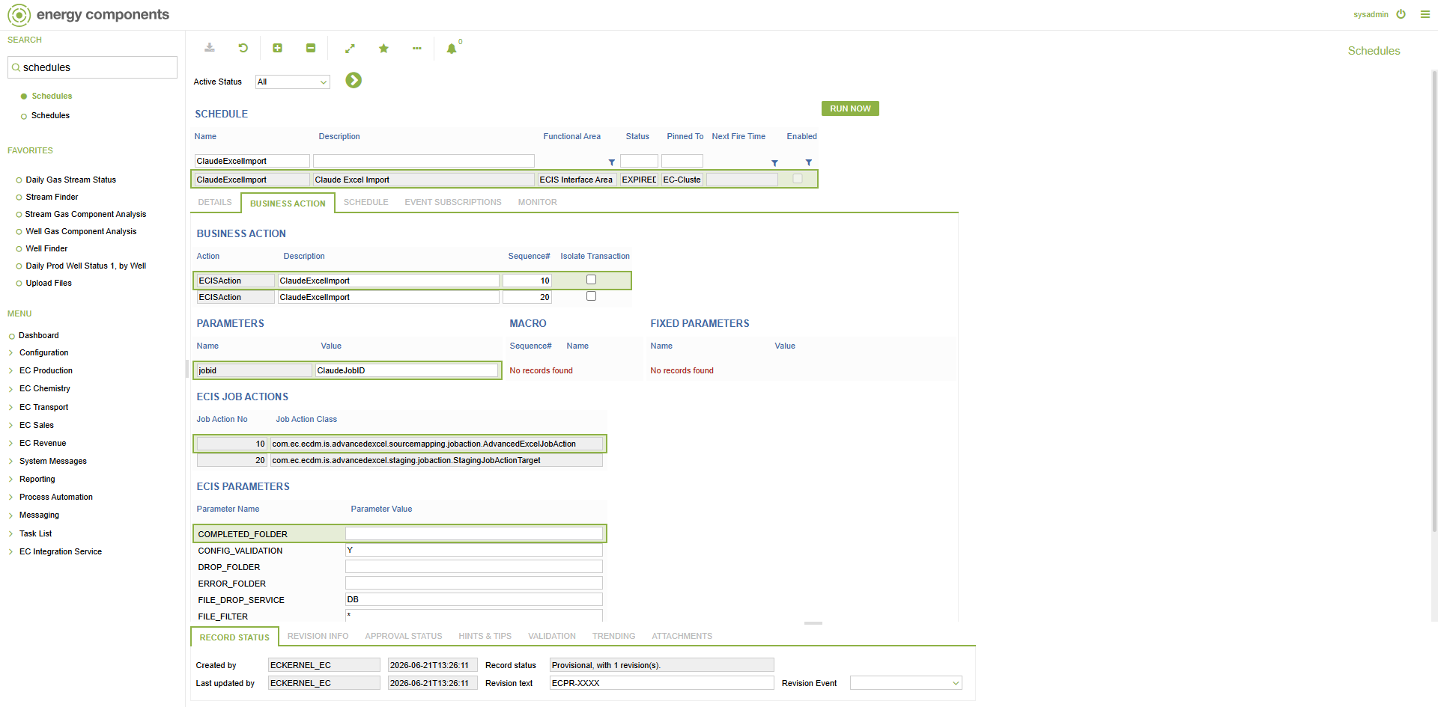

Step 3: Schedule tab - Schedule Type = Once, Valid From = 2000-01-01
Schedule definition: Schedule Type set to Once and Valid From 2000-01-01.
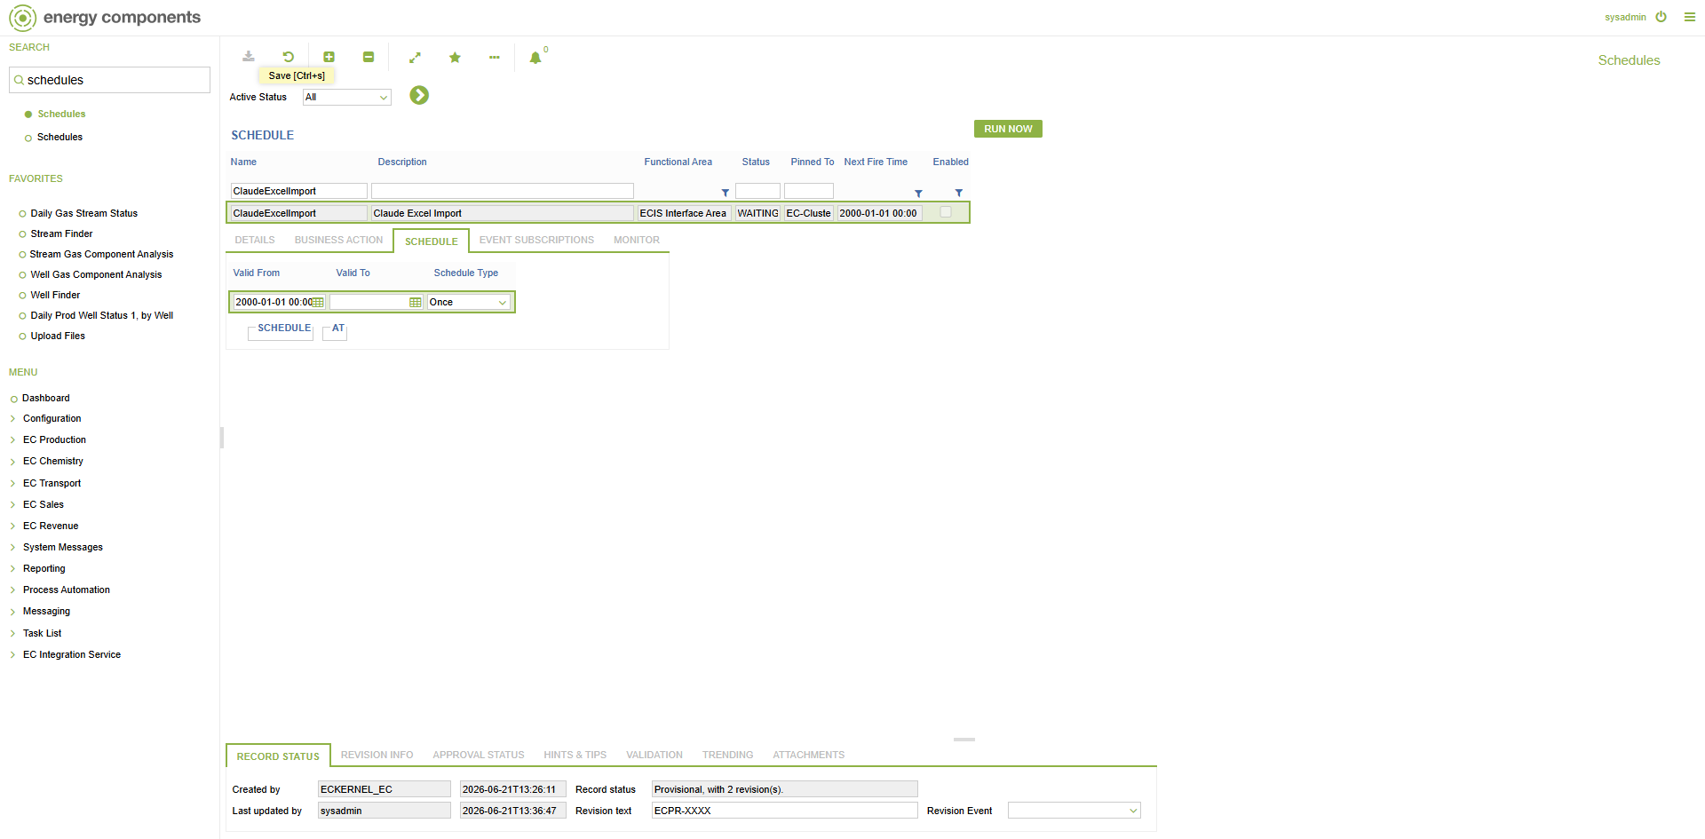

Step 4: Data BEFORE upload - Daily Prod Well Status 1, by Well (empty)
Before the upload: AVG_BH_PRESS (Downhole DHP) is empty for AS1_Well_001/002/003 @ 2003-01-10. DB ground truth: NULL/NULL/NULL.
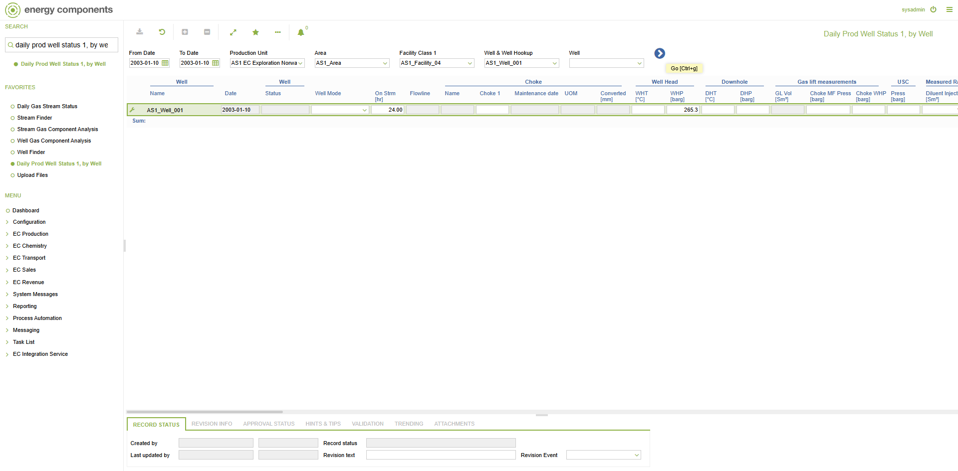

Step 5: Excel template file (sheet 'Data')
Template uploaded - sheet 'Data', columns Well | Date | Pressure (see table below).
Well | Date | Pressure
AS1_Well_001 | 2003-01-10 | 210.5
AS1_Well_002 | 2003-01-10 | 215
AS1_Well_003 | 2003-01-10 | 220.3

Step 6: Upload the Excel file (Upload Files - Claude Well Test)
The Excel uploaded into the CLAUDE_WELL_TEST filedrop (File No 16); File Status blank = not yet processed.
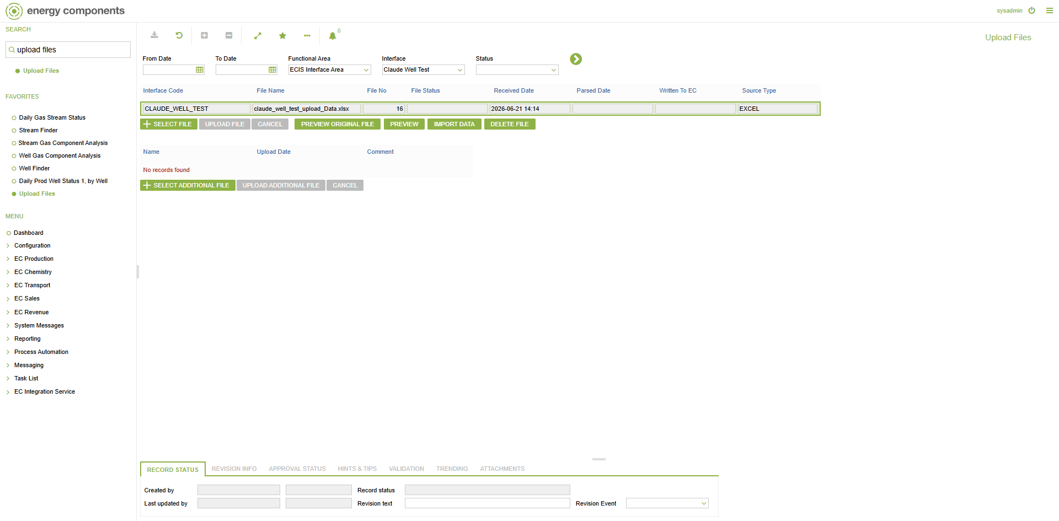

Step 7: RUN NOW - ClaudeExcelImport (schedule enabled)
With the file in the filedrop and the schedule enabled, RUN NOW is clicked; EC returns an OK confirmation.
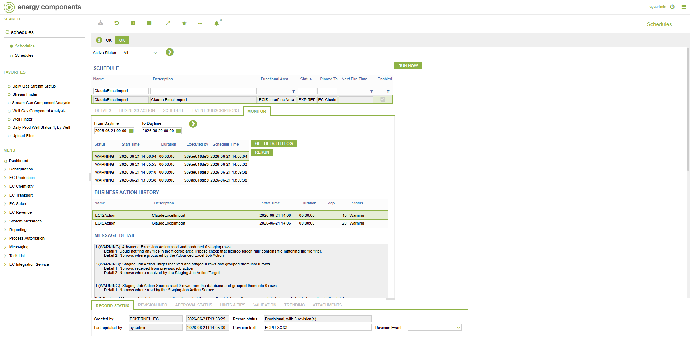

Step 8: Schedule Monitor - log status OK
The Monitor tab after refresh: the latest run shows status OK (2026-06-21 14:20:00).
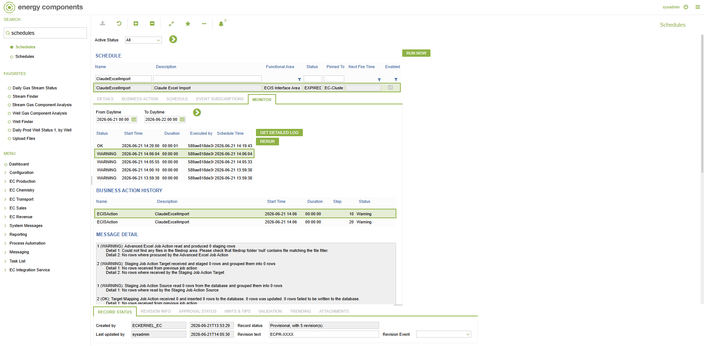

Step 9: Upload Files status - WRITTEN_TO_EC
After the run, the file shows File Status = WRITTEN_TO_EC, Parsed Date 14:20, Written To EC 14:20 - parsed and written to EC.
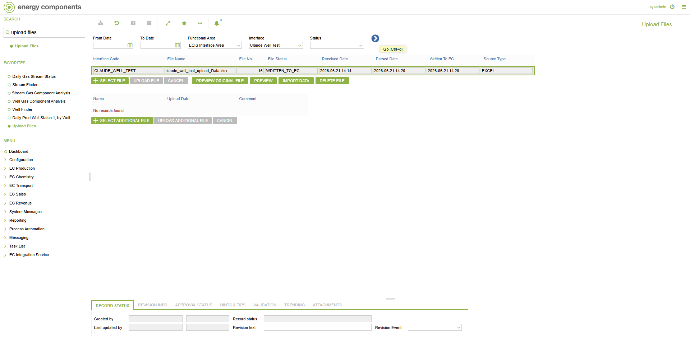

Step 10: Data AFTER upload - Daily Prod Well Status 1, by Well (filled)
After the import: Downhole DHP [barg] = 210.5 for AS1_Well_001 (the uploaded Pressure value), now visible on the screen.
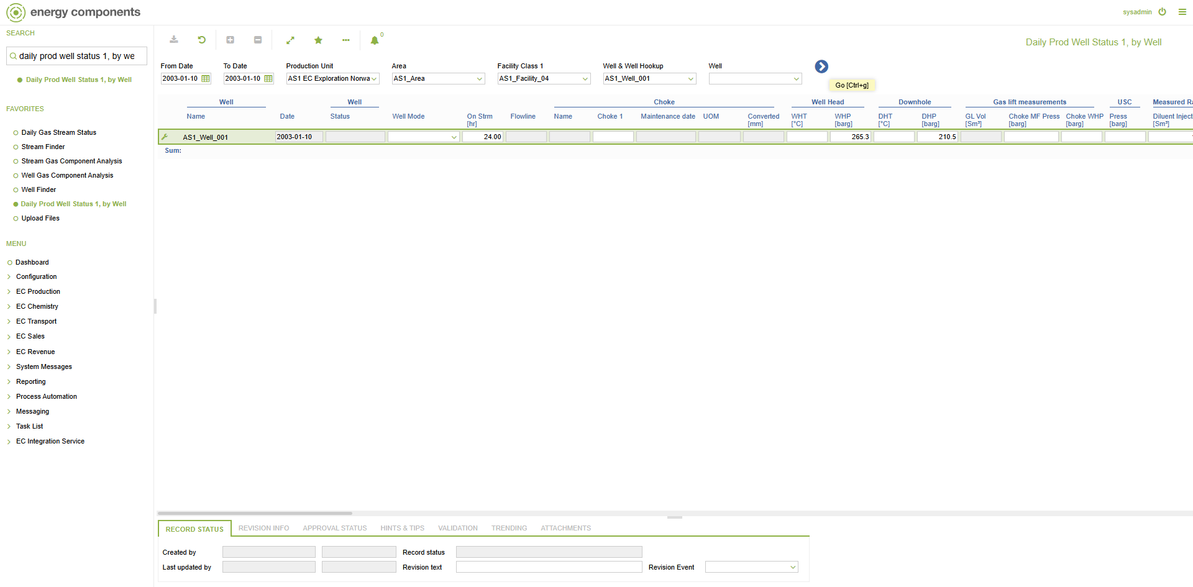

Result
PASS - End-to-end successful: Excel uploaded -> ClaudeExcelImport RUN NOW -> log OK -> file WRITTEN_TO_EC -> AVG_BH_PRESS = 210.5/215/220.3 landed and visible on the Daily Prod Well Status screen. Working sequence: upload file -> ensure schedule enabled -> RUN NOW.

