Unit Test Evidence - ECSR-35263
Daily report email: Production Date in the email subject/body did not match the attached report's date.

Document control
Ticket | ECSR-35263 (Critical / UAT_BLOCKER)
Reported by | Ruchi Doval
Environment | COPSDEV / plutodev
Report used | R_BLP_DAILY_PROD_ALLOC_PLUTO (Burrup LNG Park Daily Production - Pluto)
Fix | ZWP_P_MAIL_UTIL.getReportDate(p_message_no) - resolve the date PER MESSAGE via REPORT_SEND_LOG (was: latest report of the type)
Evidence | Same 20-May report: MSG 412 (before fix) vs MSG 414 (after fix)

Defect & fix (summary)
BEFORE: getReportDate(p_message_code) returned the latest report date of the message TYPE; the scheduled ZWP_UPD_MHM_SUBJECT_AND_BODY business action stamped that one date into {production_day} on every message of the type -> the email subject/body showed the wrong date while the attachment was correct.
AFTER: a new getReportDate(p_message_no) overload resolves the date from the message's OWN report (REPORT_SEND_LOG -> TV_REPORT_GENERATED.report_date); both refresh procedures use NVL(getReportDate(msg_no), getReportDate(type)).

BEFORE FIX

1. Outgoing Messages screen
MSG 412 - R_BLP_DAILY_PROD_ALLOC_PLUTO. The attached report is for Production Date 20 May 2026.
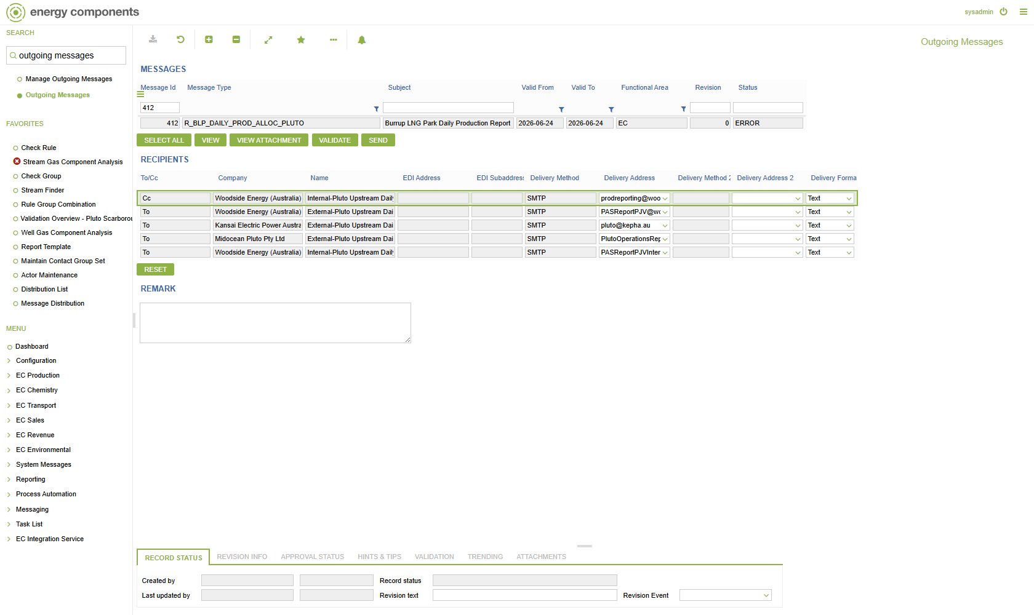

2. Rendered outgoing message (Preview)
Subject: Burrup LNG Park Daily Production Report 26 May 26
Rendered message body (MESSAGE_DRAFT):
Hi,
Please find attached Burrup LNG Park Daily Production Report (Pluto) for Production Date - 26 May 26.
Note this report is designed to meet the requirements of Burrup LNG Park Production Allocation Agreement (PAA) from the PAA Effective Date.
For any queries or issues please contact PlutoJVNotices@woodside.com.au.
Disclaimer - You are receiving this email as a designated recipient for the above-listed Report Type. If you no longer wish to receive these emails, please contact the Production & Emission Allocation Team - Australian Business.
Regards,
Prod Reporting
Production & Emission Allocation Team
[This notification is automatically generated by Pluto Hub ECaaS.]
DEFECT: the attached report is 20 May 2026, but the email subject/body show 26 May 2026 (the latest report of the type).

AFTER FIX

1. Outgoing Messages screen
MSG 414 - same R_BLP_DAILY_PROD_ALLOC_PLUTO report for Production Date 20 May 2026, after the fix.
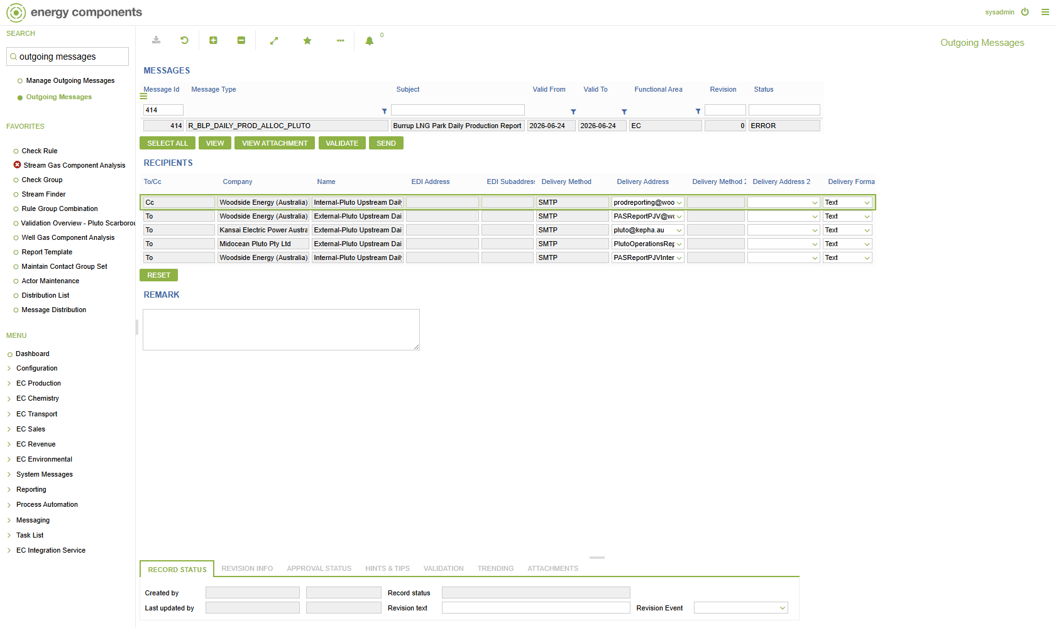

2. Rendered outgoing message (Preview)
Subject: Burrup LNG Park Daily Production Report 20 May 26
Rendered message body (MESSAGE_DRAFT):
Hi,
Please find attached Burrup LNG Park Daily Production Report (Pluto) for Production Date - 20 May 26.
Note this report is designed to meet the requirements of Burrup LNG Park Production Allocation Agreement (PAA) from the PAA Effective Date.
For any queries or issues please contact PlutoJVNotices@woodside.com.au.
Disclaimer - You are receiving this email as a designated recipient for the above-listed Report Type. If you no longer wish to receive these emails, please contact the Production & Emission Allocation Team - Australian Business.
Regards,
Prod Reporting
Production & Emission Allocation Team
[This notification is automatically generated by Pluto Hub ECaaS.]
FIXED: the email subject/body now show 20 May 2026, matching the attached report.

DB validation (per-message resolution)
getReportDate(message_no) now returns each message's OWN report date (vs the old by-type which returned the latest):
MESSAGE_NO | Own report date | Fixed getReportDate(msg) | Old getReportDate(type)
412 (before) | 20 May 2026 | 20 May 2026 (correct) | 26 May 2026 (wrong)
414 (after) | 20 May 2026 | 20 May 2026 (correct) | 26 May 2026 (wrong)
413 (after) | 22 May 2026 | 22 May 2026 (correct) | 26 May 2026 (wrong)
Package ZWP_P_MAIL_UTIL re-compiled VALID on COPSDEV; both updateMsgOutFromMsgTemplate (MESSAGE_OUT) and updateMHMFromMsgTemplate (MHM_MSG) resolve per-message; all 359 MHM_MSG.MESSAGE_ID values map to REPORT_SEND_LOG.MESSAGE_NO.

