Unit Test Evidence - ECSR-35264
Split the shared Burrup LNG Park Daily Production email configuration into a dedicated set for the Scarborough report (R_BLP_DAILY_PROD_ALLOC_SCA).
Jira (UAT): ECSR-35264 Report: R_BLP_DAILY_PROD_ALLOC_SCA Distribution/Contact set: R_BLP_DAILY_PROD_ALLOC_SCA Environment: COPSDEV (= plutodev)

1. Maintain Message Type screen
Dedicated message type R_BLP_DAILY_PROD_ALLOC_SCA for the Burrup LNG Park Daily Production Report (Scarborough). Internal Format = Free Text, Direction = Outbound — a standalone definition separate from the shared R_BLP_DAILY_PROD_ALLOC type.
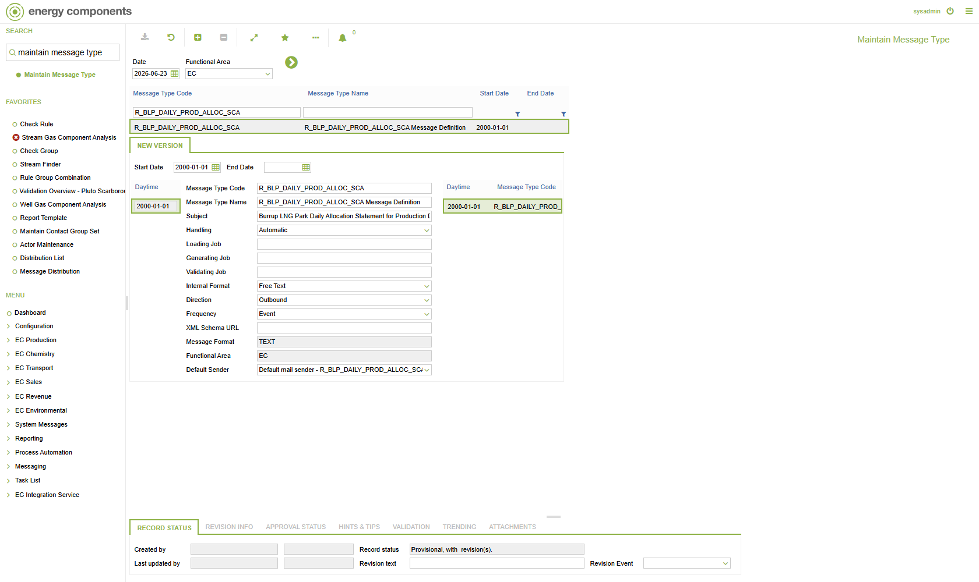

2. Message Format screen
TEXT is the Default External Format (Plain text) for message type R_BLP_DAILY_PROD_ALLOC_SCA.
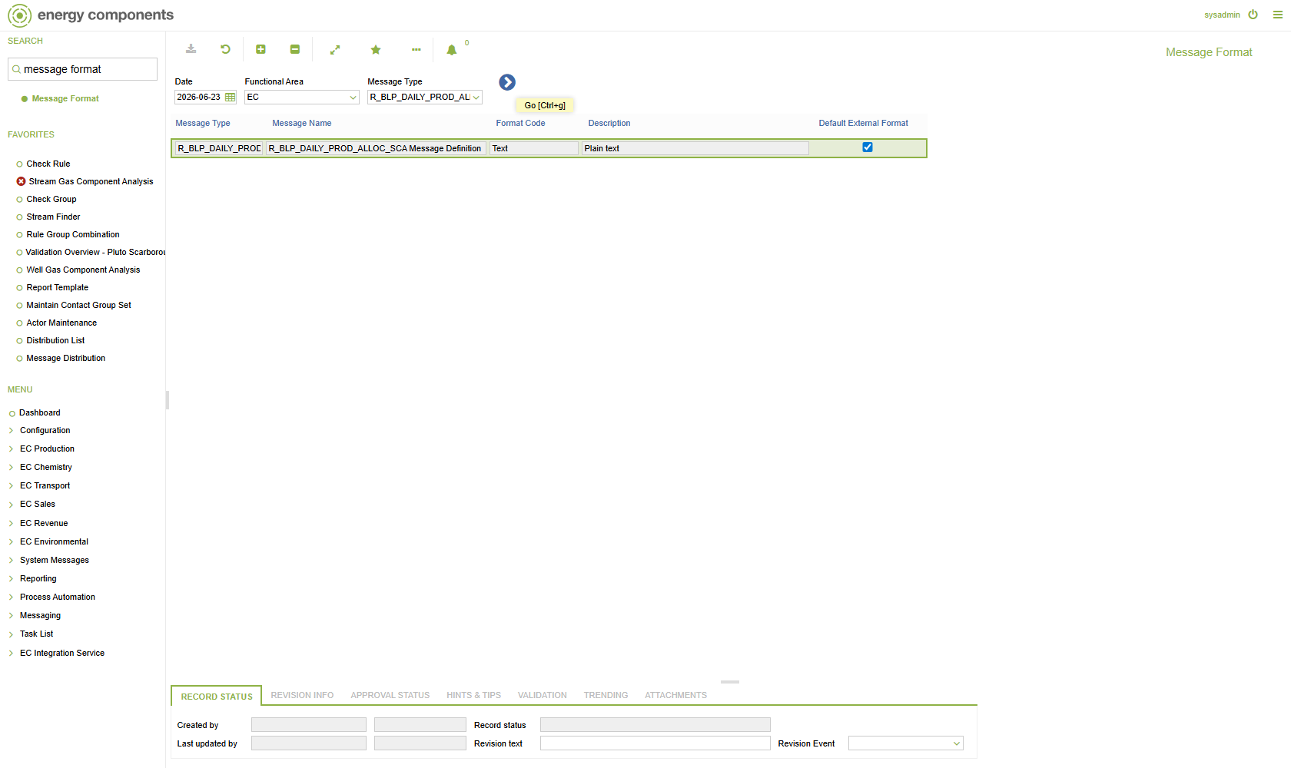

3. Freetext Message Template screen
Freetext body template for R_BLP_DAILY_PROD_ALLOC_SCA — subject ‘Burrup LNG Park Daily Production Report (Scarborough) {production_day}’. The {production_day} placeholder is resolved at send time; the body carries the Scarborough production-date narrative.
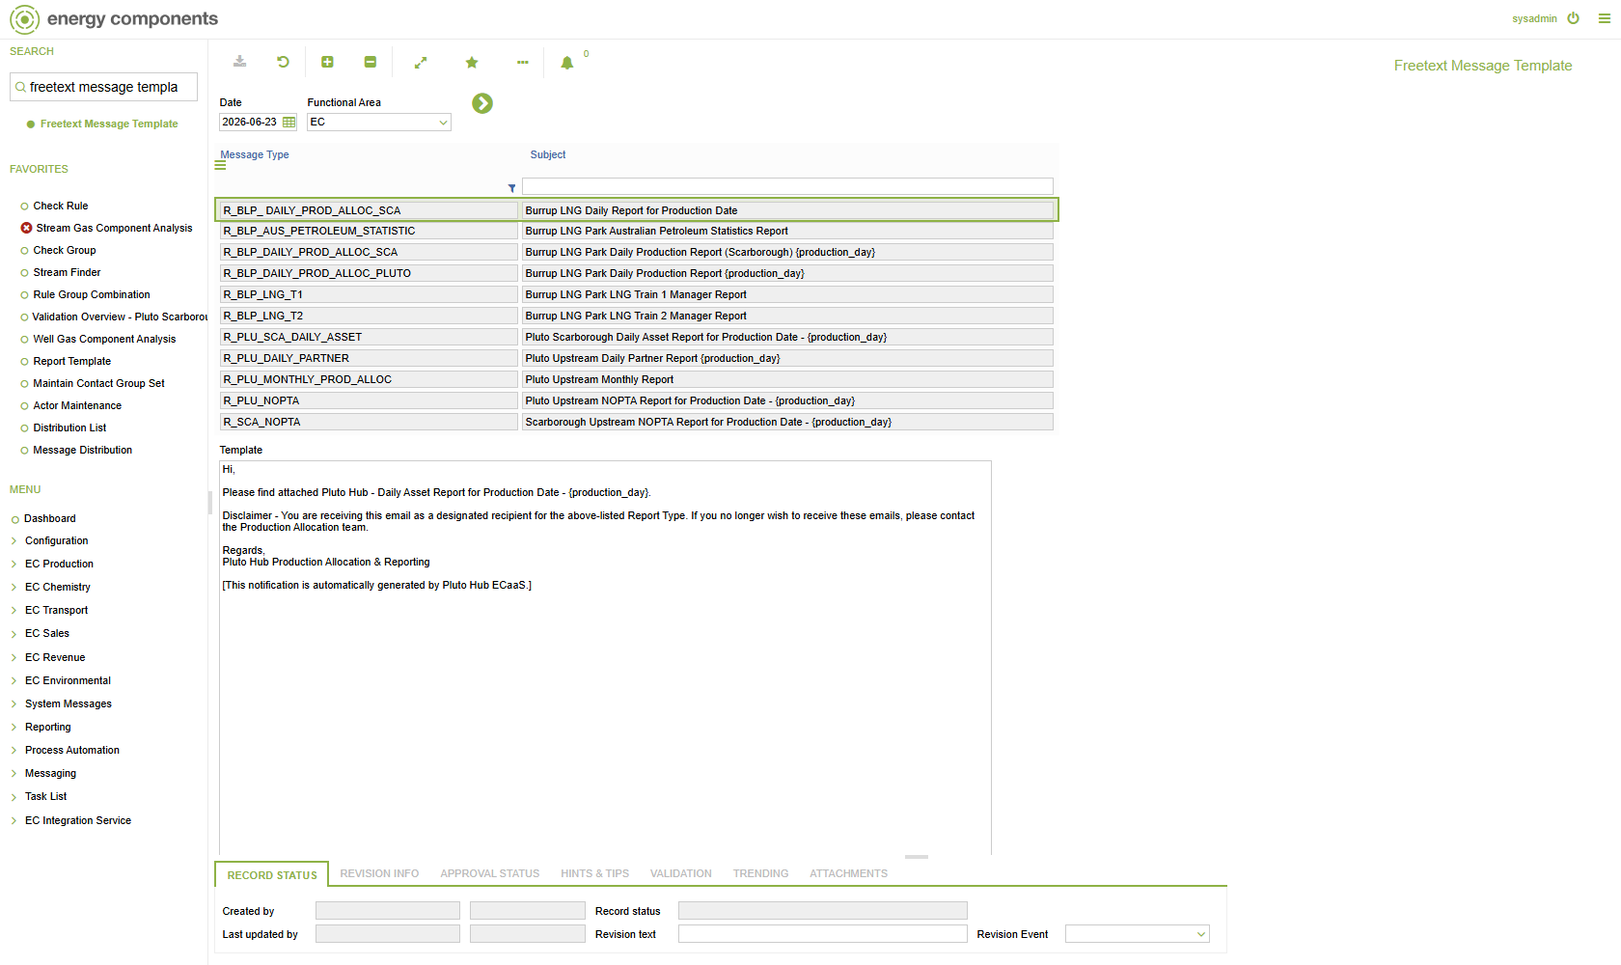

4. Maintain Contact Group Set screen
Contact Group Set R_BLP_DAILY_PROD_ALLOC_SCA — the dedicated actor set for the Scarborough report, cloned from and kept separate from the shared R_BLP_DAILY_PROD_ALLOC set.
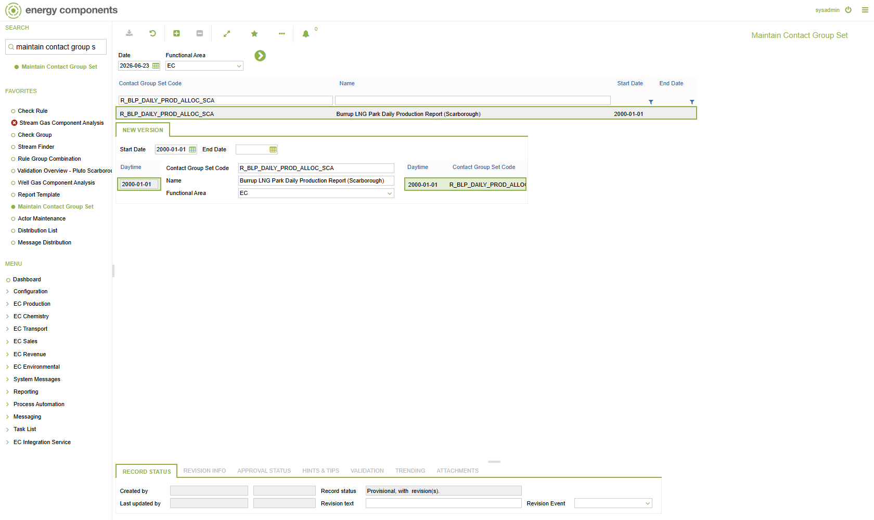

5. Actor Maintenance screen
Message contacts under the Scarborough set: the sender (From, SMTP) plus the internal/external report recipients, all SMTP.
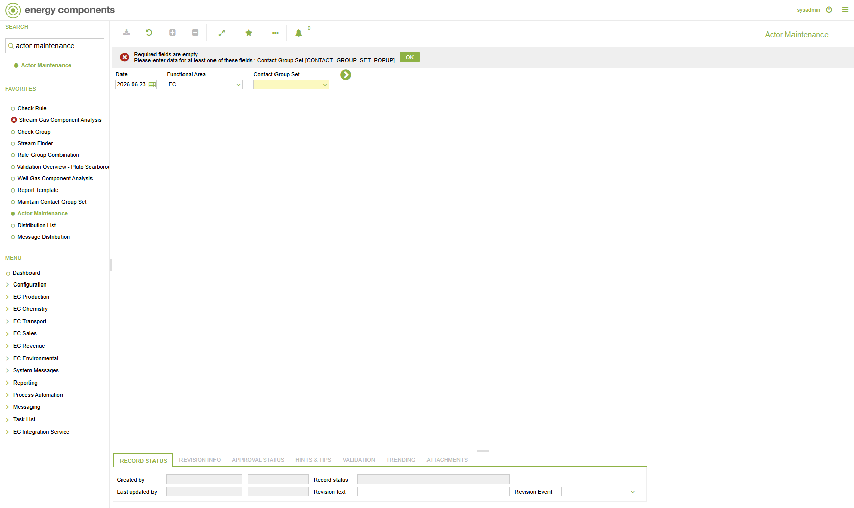

6. Distribution List screen
Distribution List R_BLP_DAILY_PROD_ALLOC_SCA — the To / From / Cc SMTP recipients for the Scarborough report; a distribution separate from the shared set so Scarborough mail is addressed independently.
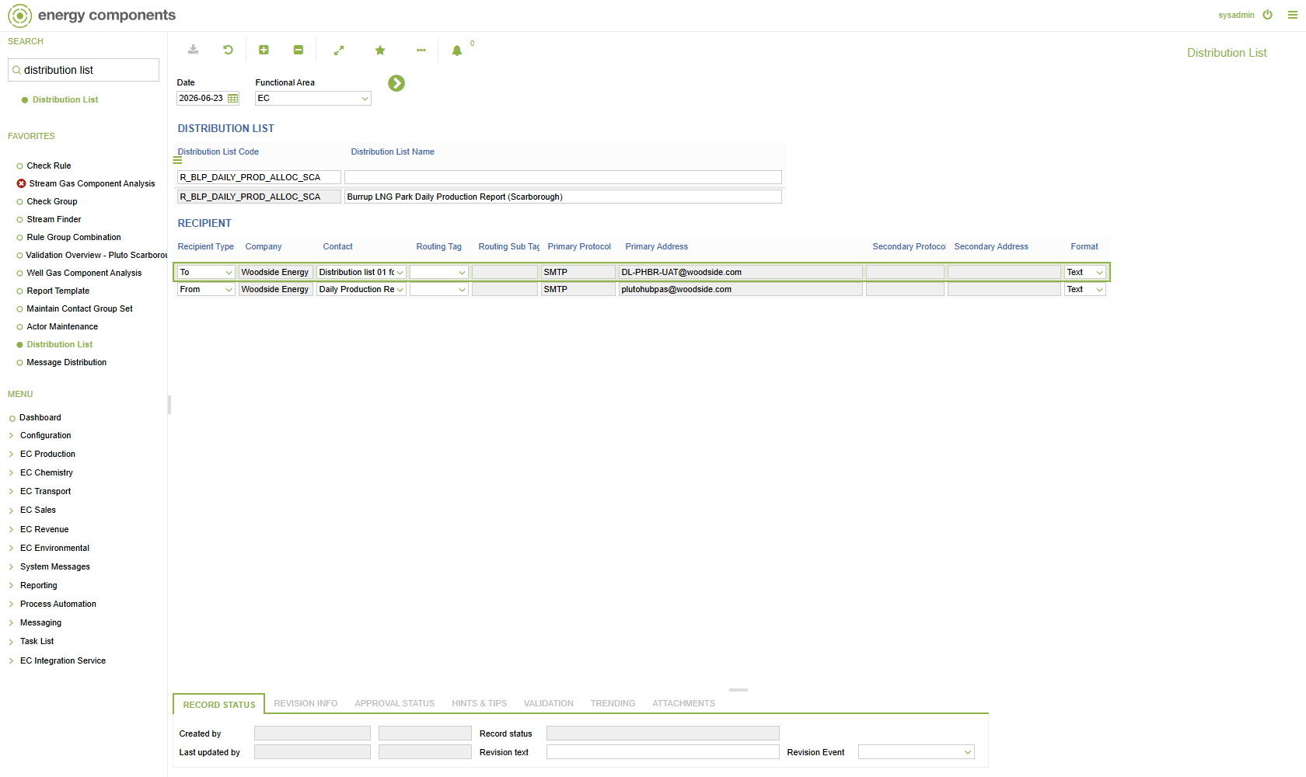

7. Message Distribution screen
Message Distribution for R_BLP_DAILY_PROD_ALLOC_SCA: Format = TEXT, linking the message definition to the Scarborough report and the R_BLP_DAILY_PROD_ALLOC_SCA distribution set.
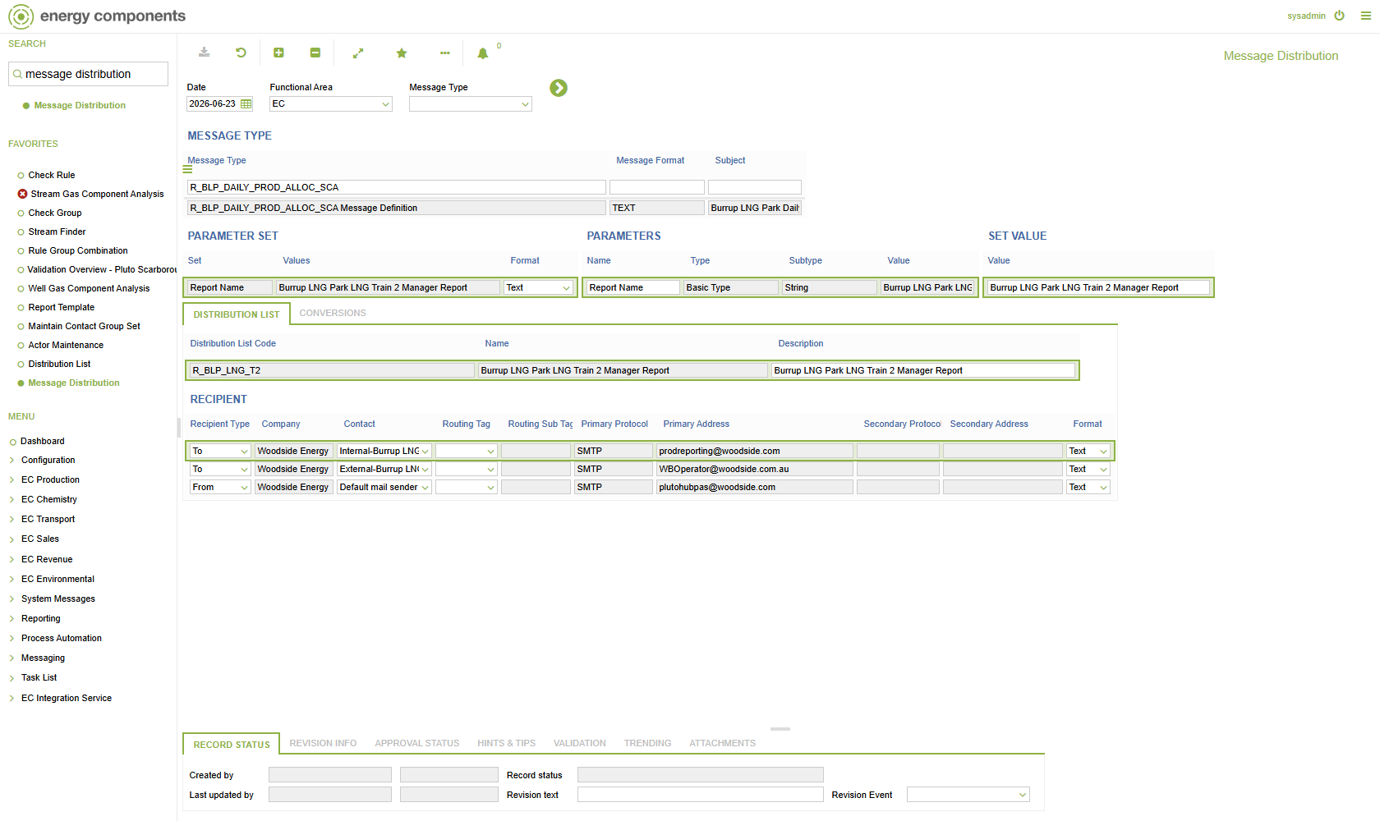

8. Report Administration screen
Burrup LNG Park Daily Production Report (Scarborough) in Report Administration — the runnable report whose SEND queues an outgoing message to the configured Scarborough recipients.
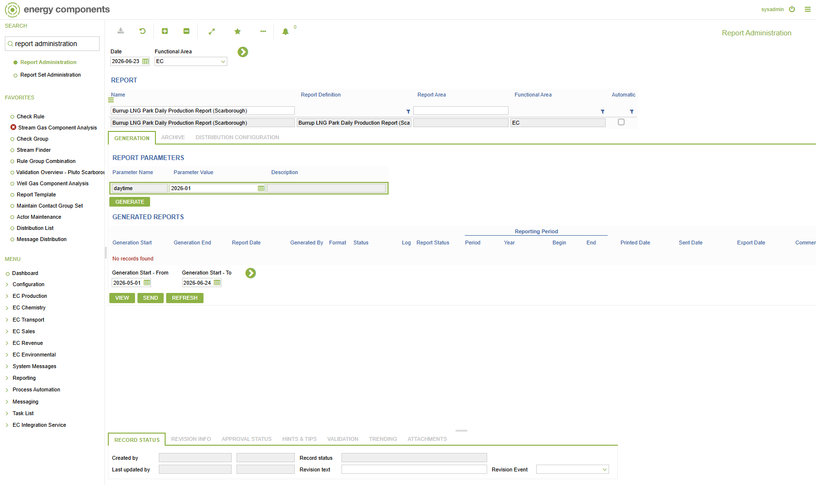

9. Schedules screen
ZWP_SEND_BPM_NOTIFICATIONS (BPM Send Notifications) — the scheduled business action that renders subject/body from the template (updateMsgOutFromMsgTemplate) and despatches MHM messages. Shared by all reports.
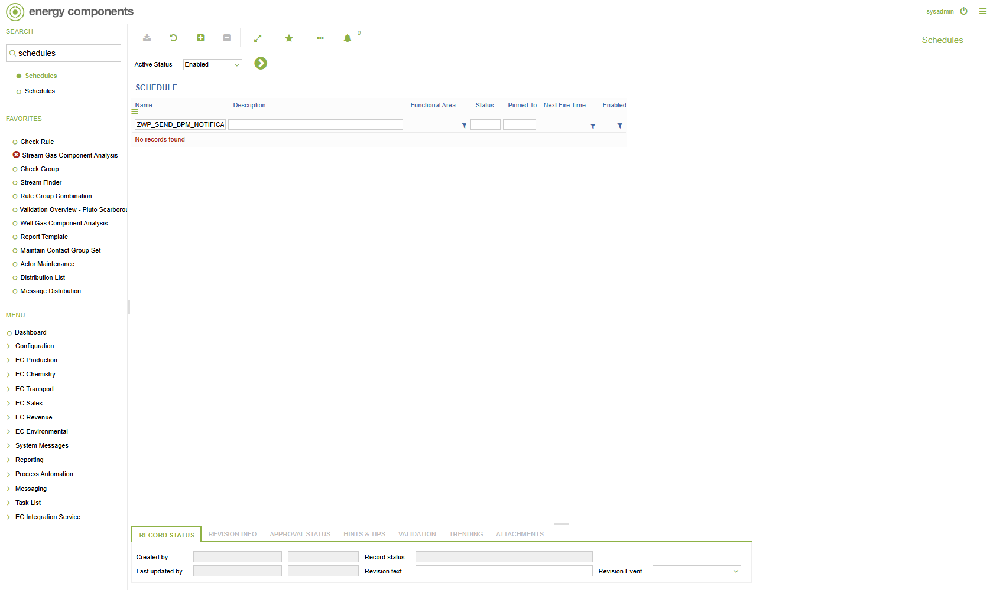

10. Outgoing Messages screen
Generated outgoing message 410: Message Type R_BLP_DAILY_PROD_ALLOC_SCA, subject ‘Burrup LNG Park Daily Production Report (Scarborough) 29 Jan 26’, addressed to the Scarborough SMTP recipients. Status = ERROR is the expected SMTP-not-configured state on COPSDEV (mail is not despatched); the message itself is built correctly with the Scarborough type, subject and recipients.
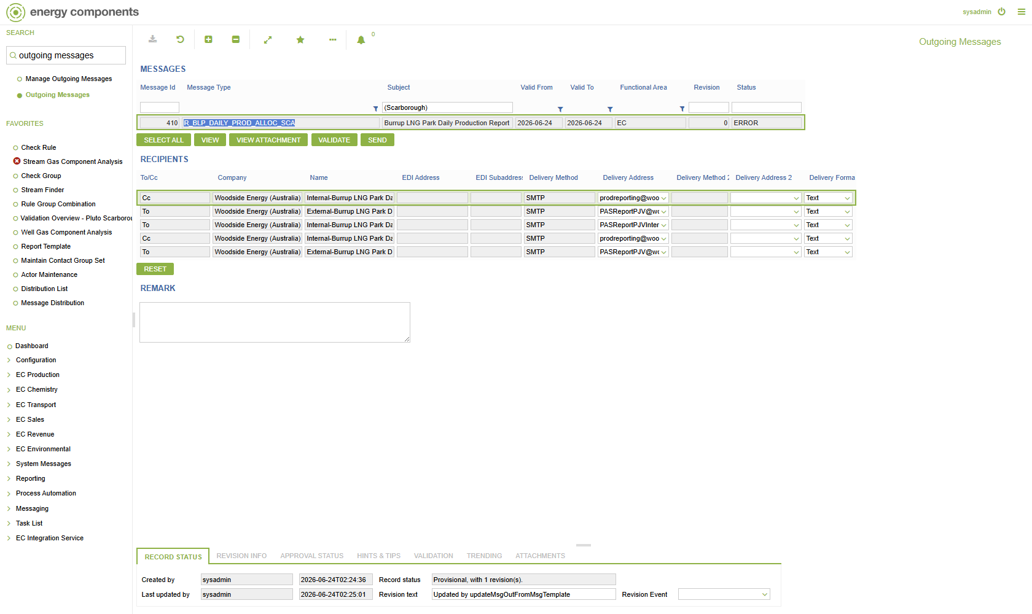

11. Preview generated outgoing message
Generated outgoing message 410 for R_BLP_DAILY_PROD_ALLOC_SCA — the rendered email below confirms the Scarborough-specific subject and body produced by this configuration.

Rendered subject: ‘Burrup LNG Park Daily Production Report (Scarborough) 29 Jan 26’
Rendered message body (MESSAGE_OUT.MESSAGE_DRAFT):
Hi,
Please find attached Burrup LNG Park Daily Production Report (Scarborough) for Production Date - 29 Jan 26.
Note this report is designed to meet the requirements of Burrup LNG Park Production Allocation Agreement (PAA) from the PAA Effective Date.
For any queries or issues please contact PlutoJVNotices@woodside.com.au.
Disclaimer - You are receiving this email as a designated recipient for the above-listed Report Type. If you no longer wish to receive these emails, please contact the Production & Emission Allocation Team - Australian Business.
Regards,
Prod Reporting
Production & Emission Allocation Team
[This notification is automatically generated by Pluto Hub ECaaS.]

