Unit Test Evidence - ECPR-31089
Enable Email Send for Pluto Upstream NOPTA Report (R_PLU_NOPTA)
Jira (UAT): ECSR-35329 Dev: ECPR-31089 Report: R_PLU_NOPTA Environment: COPSDEV
Change: Message format converted to TEXT; subject set to 'Pluto Upstream NOPTA Report for Production Date'; sender/recipients unchanged (non-destructive: XML format retained, TEXT made default).
Result: outgoing message reaches the MESSAGE_OUT stage as TEXT to prodreporting@woodside.com (Status ERROR = SMTP not configured on COPSDEV, by design for UAT).

1. Maintain Message Type screen
Message Type R_PLU_NOPTA: Internal Format = Free Text, Direction = Outbound, Frequency = Event, Message Format = TEXT, Subject = 'Pluto Upstream NOPTA Report for Production Date', Default Sender = Daily Production Reporting.
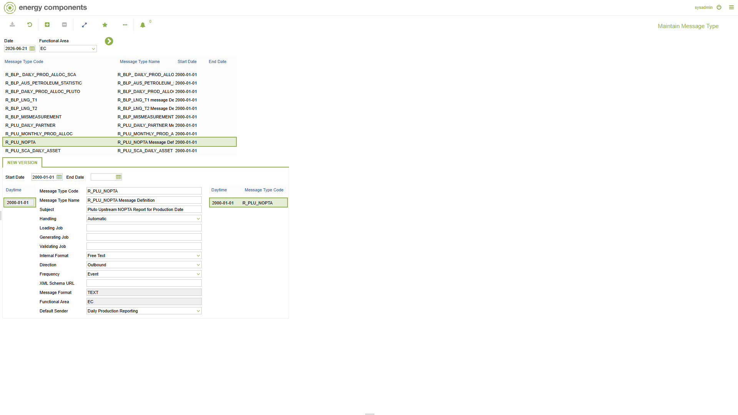

2. Message Format screen
TEXT is the Default External Format (Plain text). The legacy XML format row is retained (not default) for historical messages.
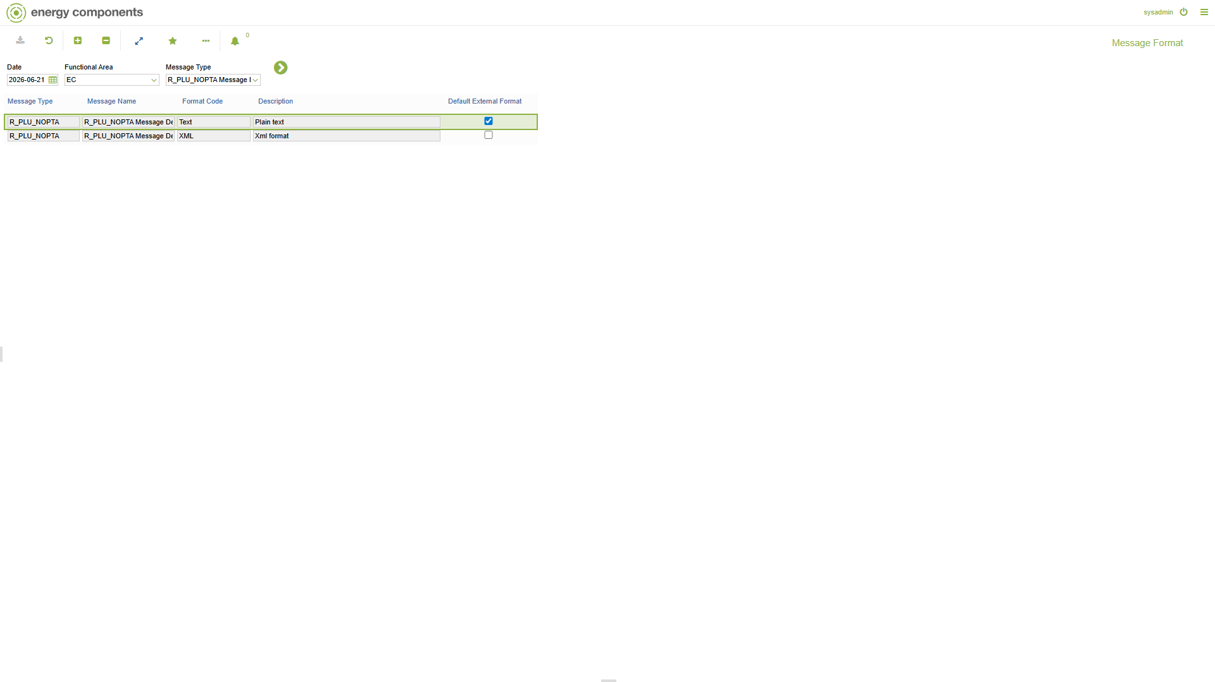

3. Freetext Message Template screen
Freetext body template for R_PLU_NOPTA (subject 'Pluto Upstream NOPTA Report for Production Date - {production_day}').
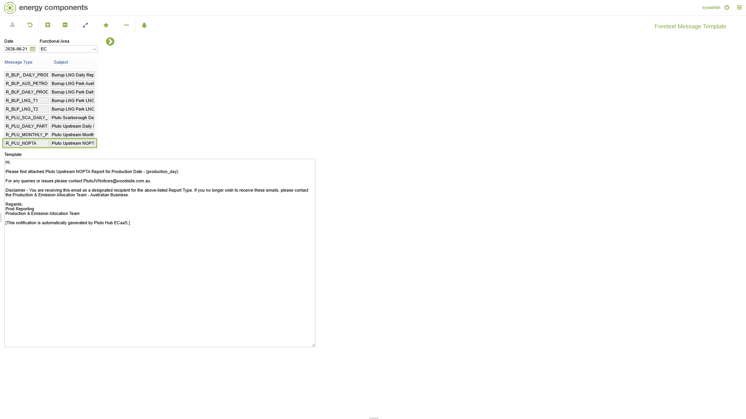

4. Maintain Contact Group Set screen
Contact Group Set R_PLU_NOPTA = 'Pluto Upstream NOPTA Report'.
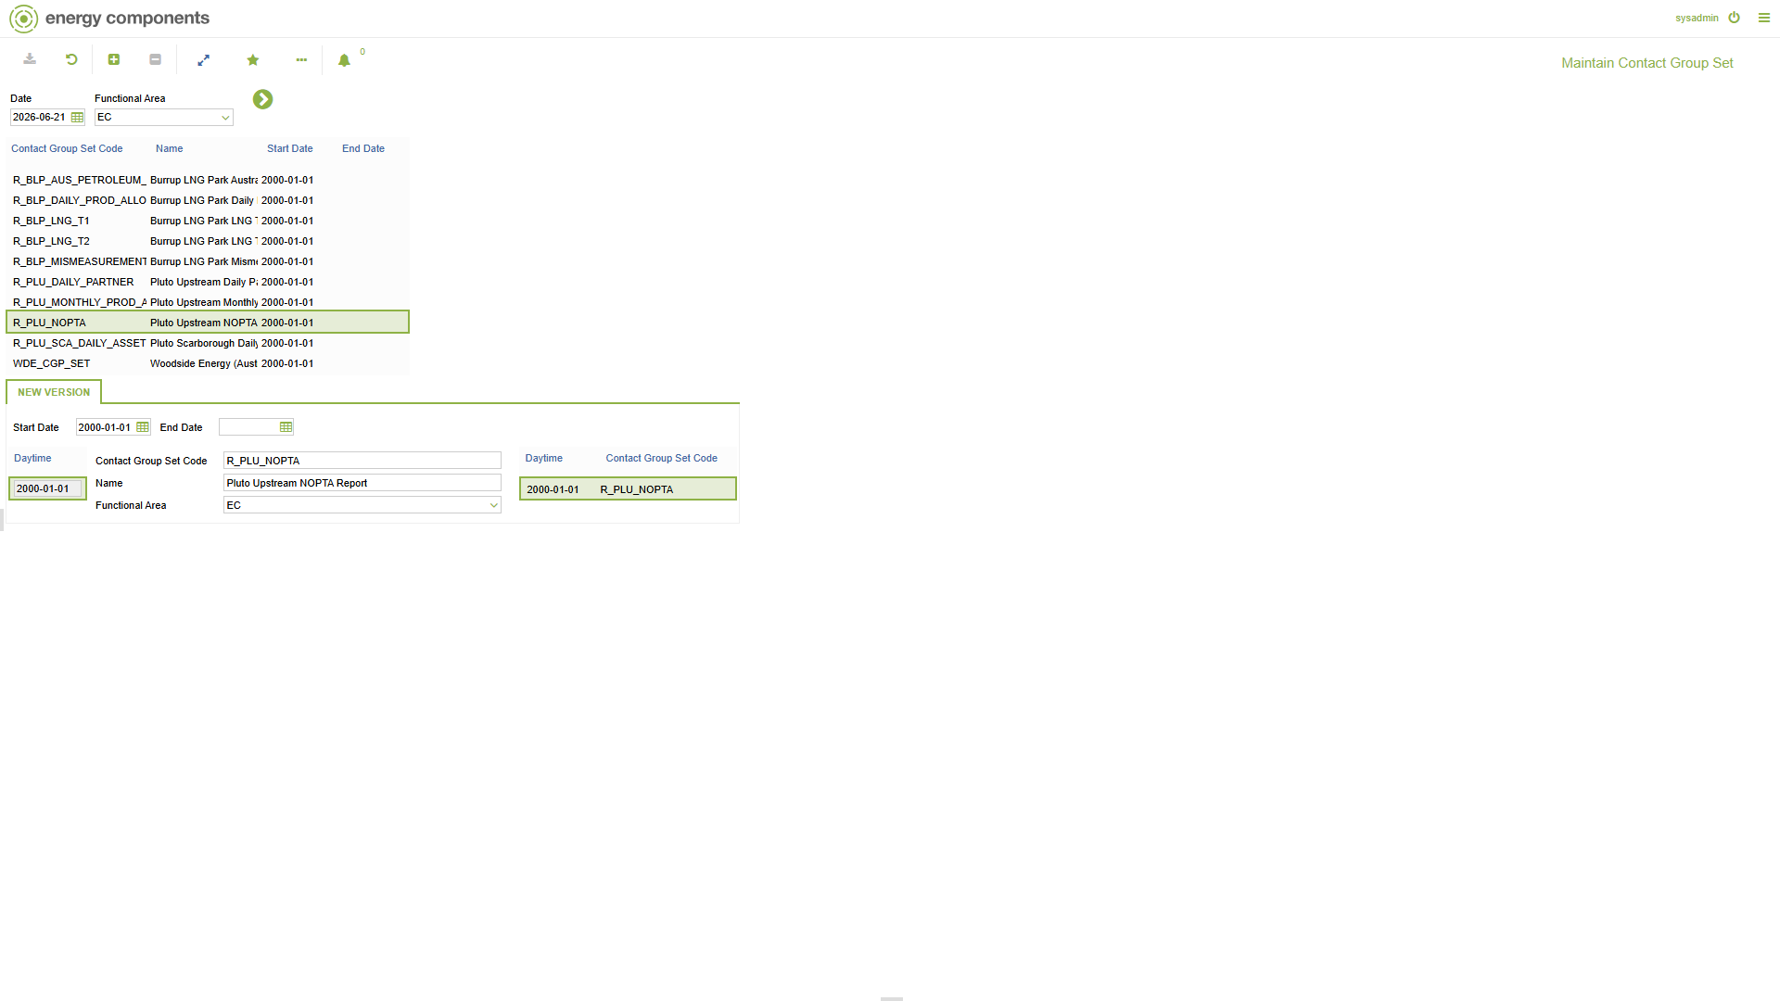

5. Actor Maintenance screen
Message contacts: DMS_R_PLU_NOPTA (sender, SMTP plutohubpas@woodside.com) and INT_R_PLU_NOPTA (recipient, SMTP prodreporting@woodside.com).
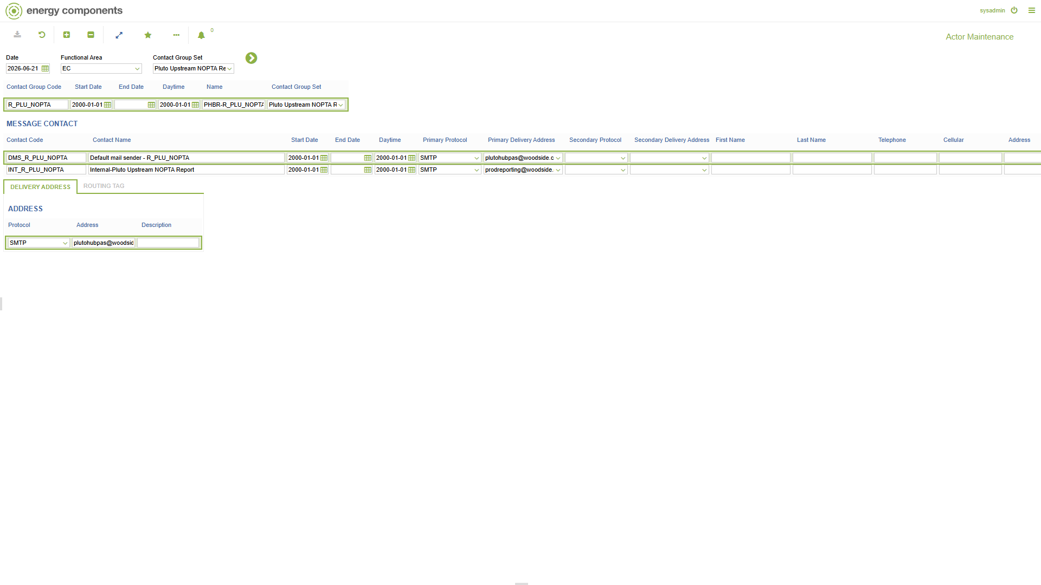

6. Distribution List screen
Distribution List R_PLU_NOPTA - To: prodreporting@woodside.com / From: plutohubpas@woodside.com, Format = Text.
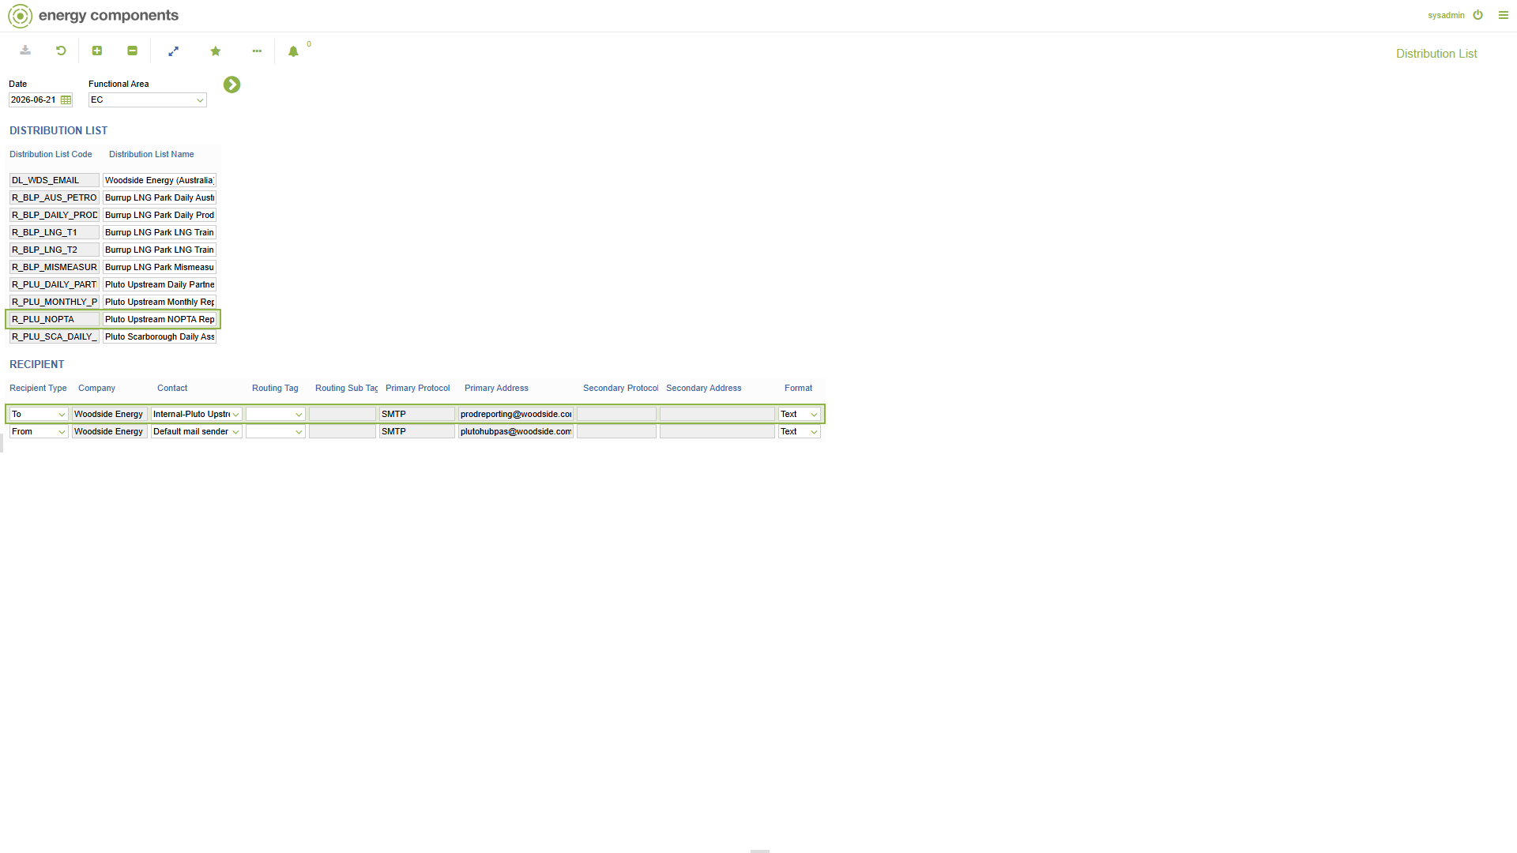

7. Message Distribution screen
Message Distribution for R_PLU_NOPTA: Format = TEXT, Report Name parameter = 'Pluto Upstream NOPTA Report', linked to distribution list R_PLU_NOPTA.
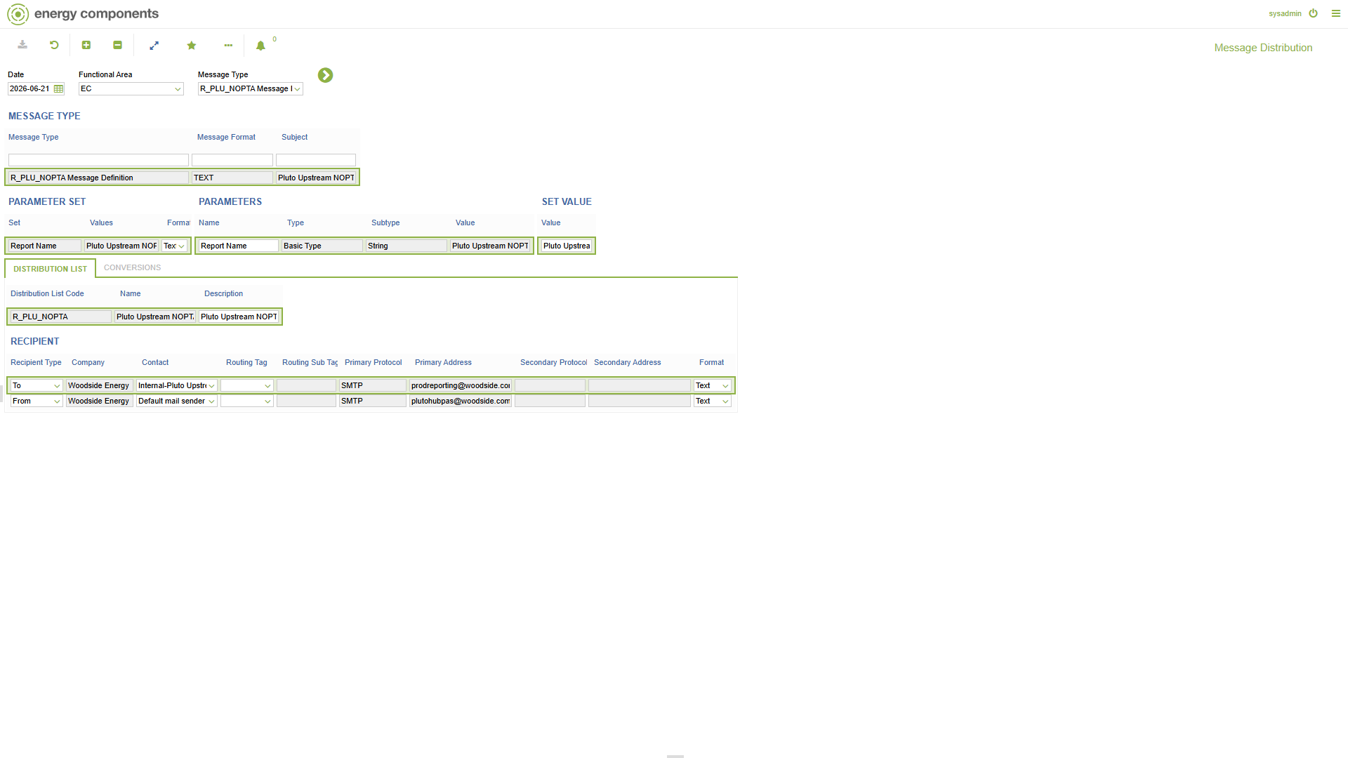

8. Report Administration screen
Pluto Upstream NOPTA Report (generated 2026-02) -> SEND -> 'Report is sent'. Messages to be sent: R_PLU_NOPTA / TEXT.
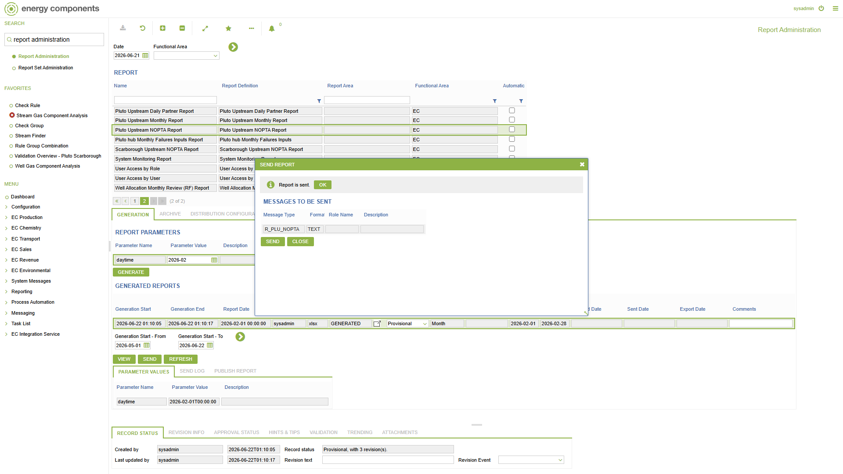

9. Schedules screen
ZWP_SEND_BPM_NOTIFICATIONS (BPM Send Notifications) - business actions ZWP_UPD_MHM_SUBJECT_AND_BODY + ZWP_SENDMAIL, runs OK on its schedule.
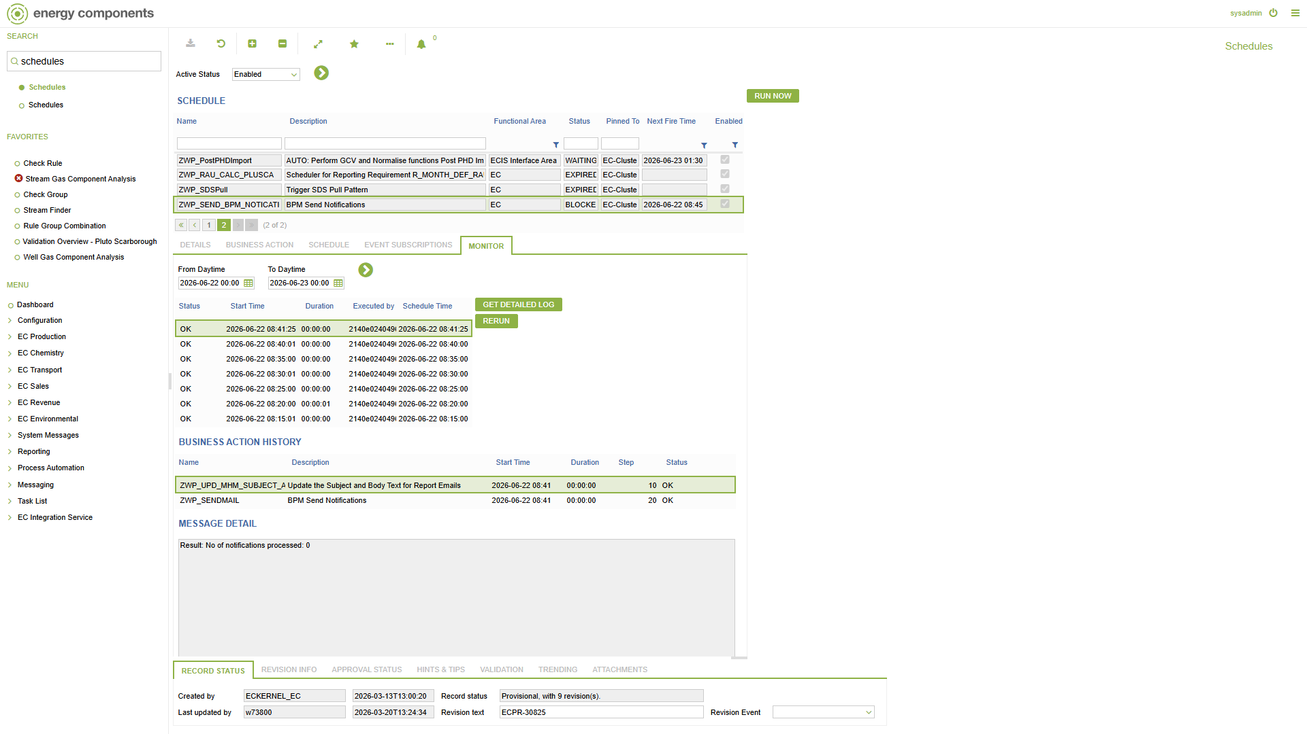

10. Outgoing Messages screen
Outgoing message 407: Message Type R_PLU_NOPTA, Subject 'Pluto Upstream NOPTA Report for Production Date', Format Text, Recipient To = prodreporting@woodside.com (SMTP). Status = ERROR (SMTP delivery not configured on COPSDEV - the message reached the outgoing-message stage as designed).
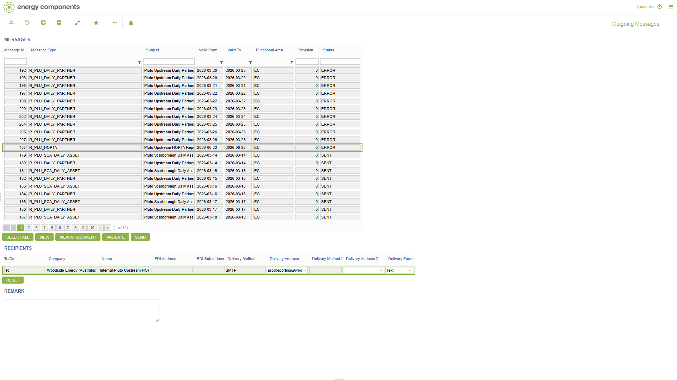

11. Preview generated outgoing message
Generated outgoing message. Rendered subject: 'Pluto Upstream NOPTA Report for Production Date - 01 Feb 26'. Rendered body below.
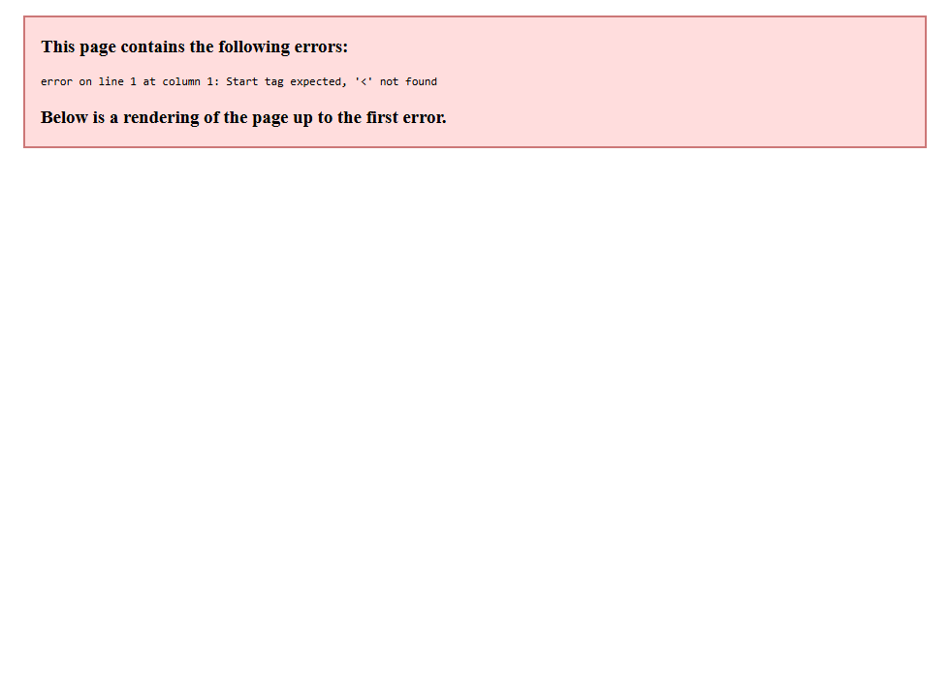
Rendered message body (MESSAGE_DRAFT):
Hi,
Please find attached Pluto Upstream NOPTA Report for Production Date - 01 Feb 26.
For any queries or issues please contact PlutoJVNotices@woodside.com.au.
Disclaimer - You are receiving this email as a designated recipient for the above-listed Report Type. If you no longer wish to receive these emails, please contact the Production & Emission Allocation Team - Australian Business.
Regards,
Prod Reporting
Production & Emission Allocation Team
[This notification is automatically generated by Pluto Hub ECaaS.]

