Unit Test Evidence - ECPR-31090
Enable Email Send for Scarborough Upstream NOPTA Report (R_SCA_NOPTA)
Jira (UAT): ECSR-35330 Dev: ECPR-31090 Report: R_SCA_NOPTA Environment: COPSDEV
Change: From-scratch MHM email-distribution config for the Scarborough NOPTA report (none existed). TEXT format; subject 'Scarborough Upstream NOPTA Report for Production Date'; sender plutohubpas@woodside.com, recipient prodreporting@woodside.com.
Result: outgoing message reaches the MESSAGE_OUT stage as TEXT to prodreporting@woodside.com (Status ERROR = SMTP not configured on COPSDEV, by design for UAT).

1. Maintain Message Type screen
Message Type R_SCA_NOPTA: Internal Format = Free Text, Direction = Outbound, Frequency = Event, Message Format = TEXT, Subject = 'Scarborough Upstream NOPTA Report for Production Date', Default Sender = Daily Production Reporting.
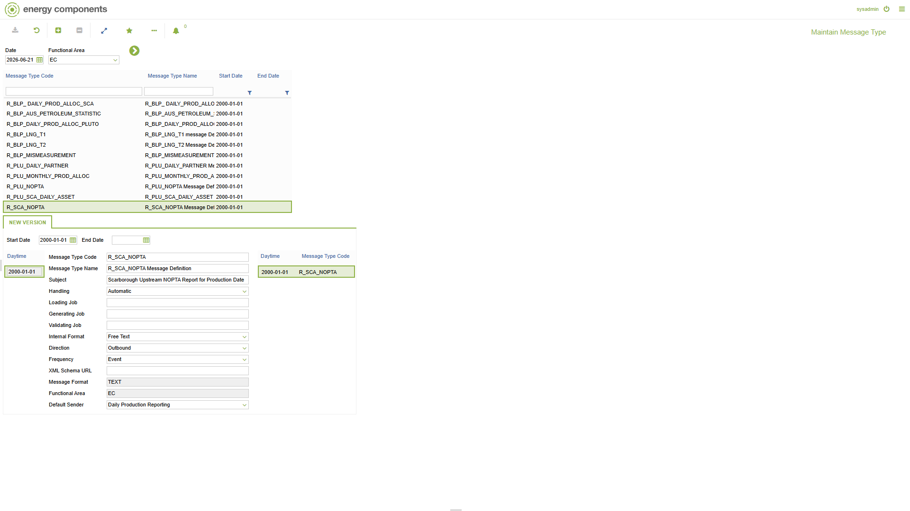

2. Message Format screen
TEXT is the Default External Format (Plain text) for R_SCA_NOPTA. (Fresh build - TEXT only, no legacy format.)
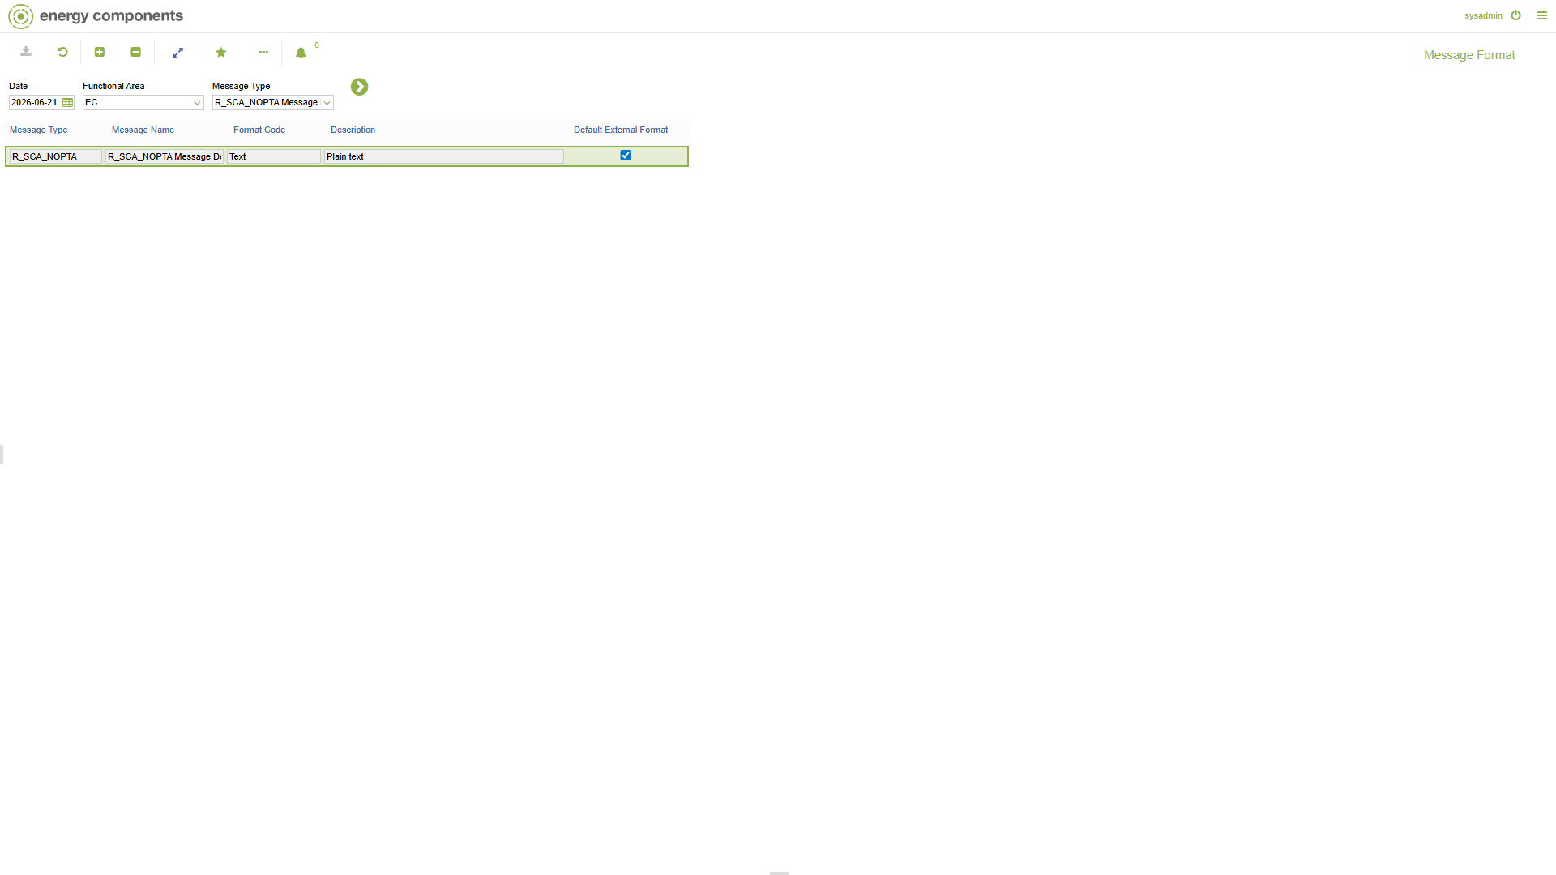

3. Freetext Message Template screen
Freetext body template for R_SCA_NOPTA (subject 'Scarborough Upstream NOPTA Report for Production Date - {production_day}').
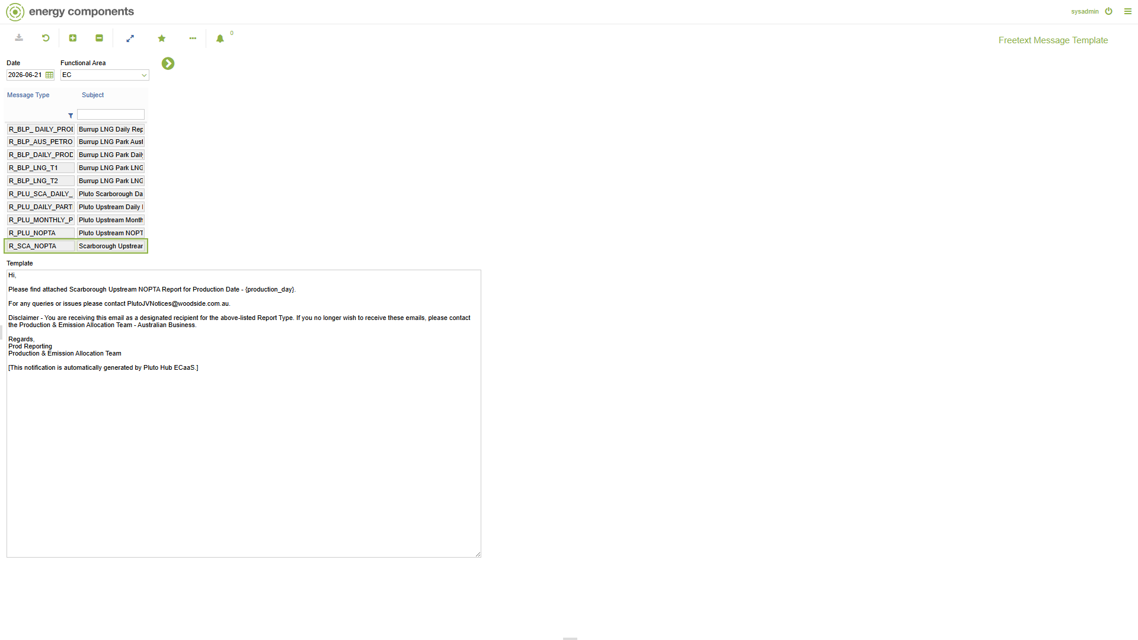

4. Maintain Contact Group Set screen
Contact Group Set R_SCA_NOPTA = 'Scarborough Upstream NOPTA Report'.
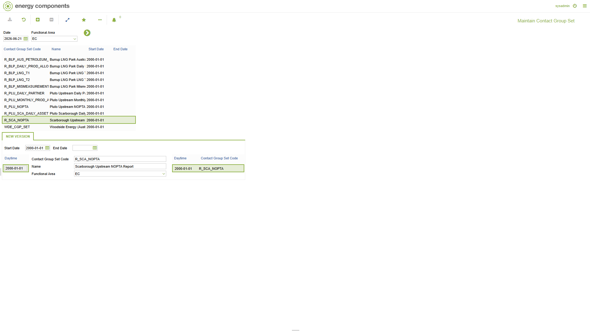

5. Actor Maintenance screen
Message contacts: DMS_R_SCA_NOPTA (sender, SMTP plutohubpas@woodside.com) and INT_R_SCA_NOPTA (recipient, SMTP prodreporting@woodside.com).
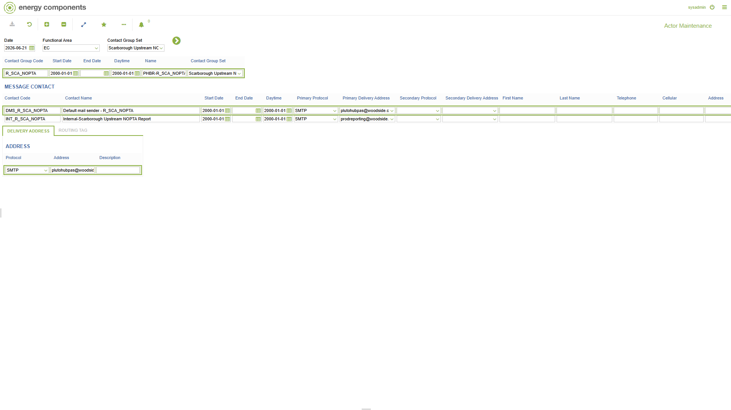

6. Distribution List screen
Distribution List R_SCA_NOPTA - To: prodreporting@woodside.com / From: plutohubpas@woodside.com, Format = Text.
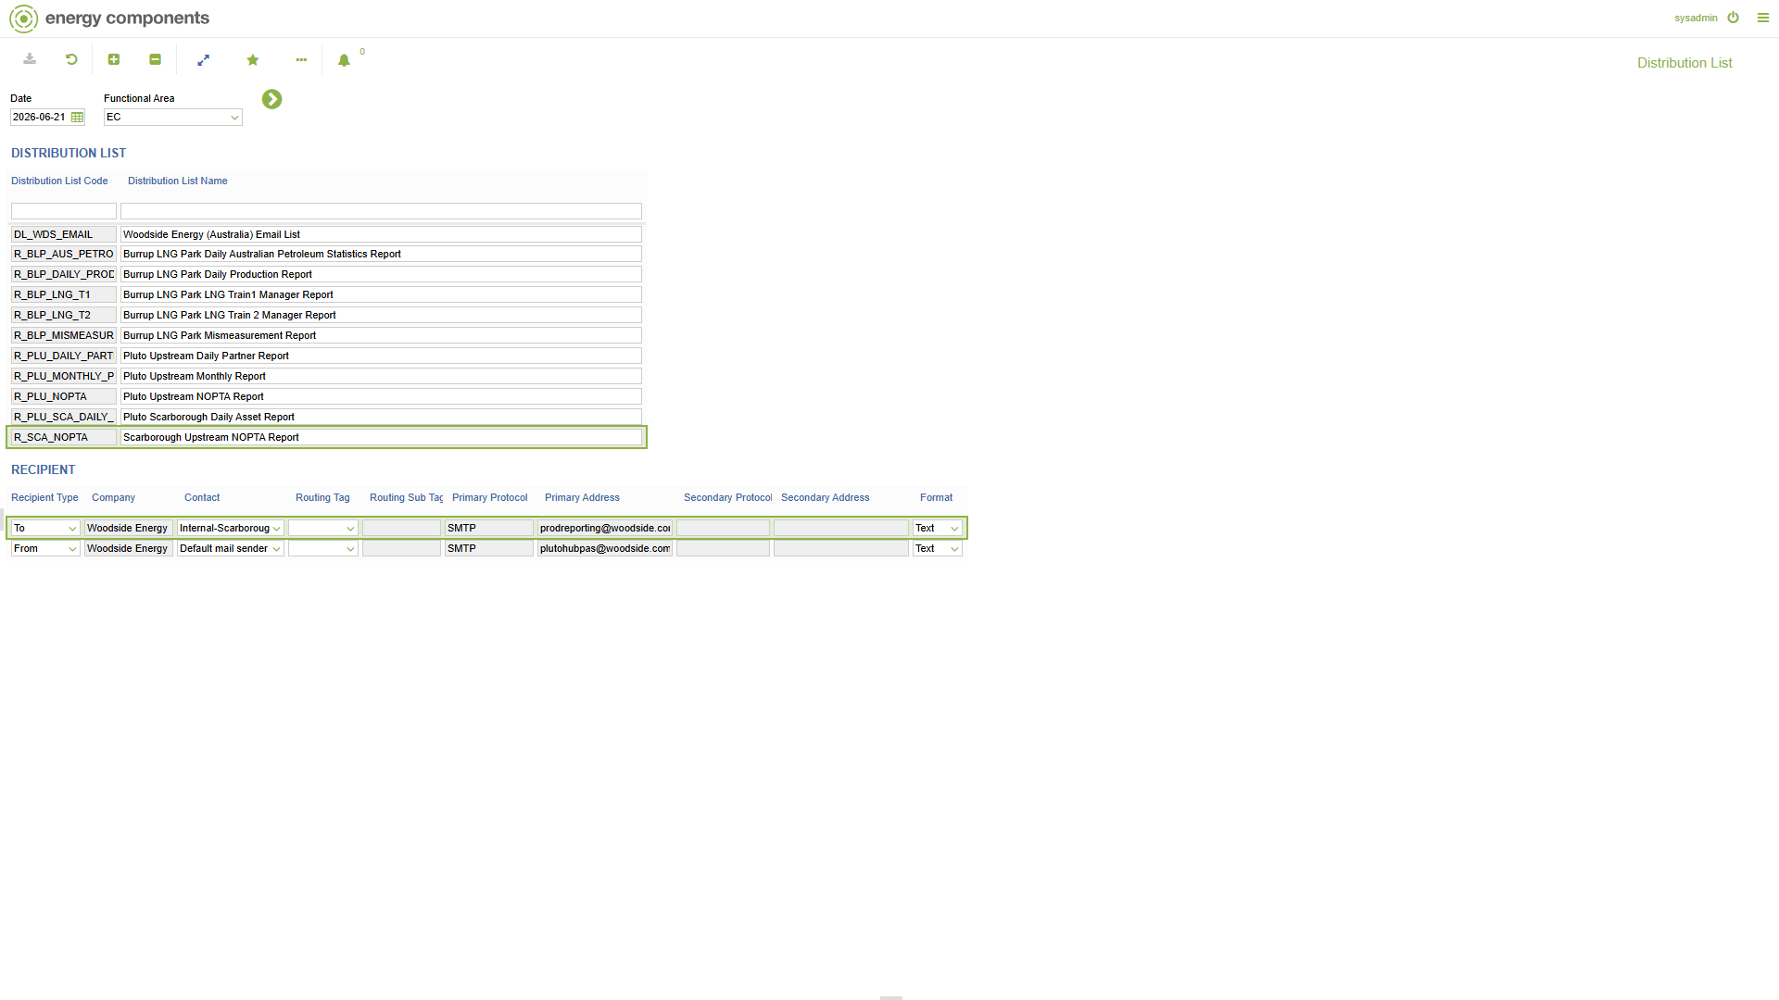

7. Message Distribution screen
Message Distribution for R_SCA_NOPTA: Format = TEXT, Report Name parameter = 'Scarborough Upstream NOPTA Report', linked to distribution list R_SCA_NOPTA.
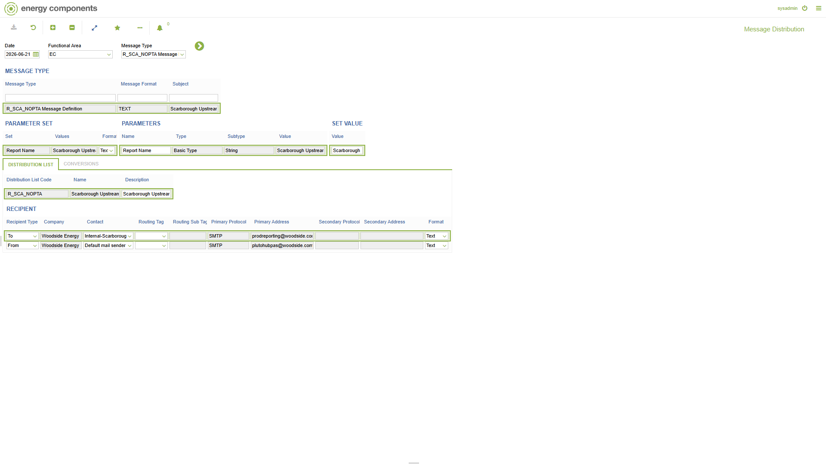

8. Report Administration screen
Scarborough Upstream NOPTA Report (generated 2026-01, status GENERATED) -> SEND -> 'Report is sent'. Messages to be sent: R_SCA_NOPTA / TEXT.
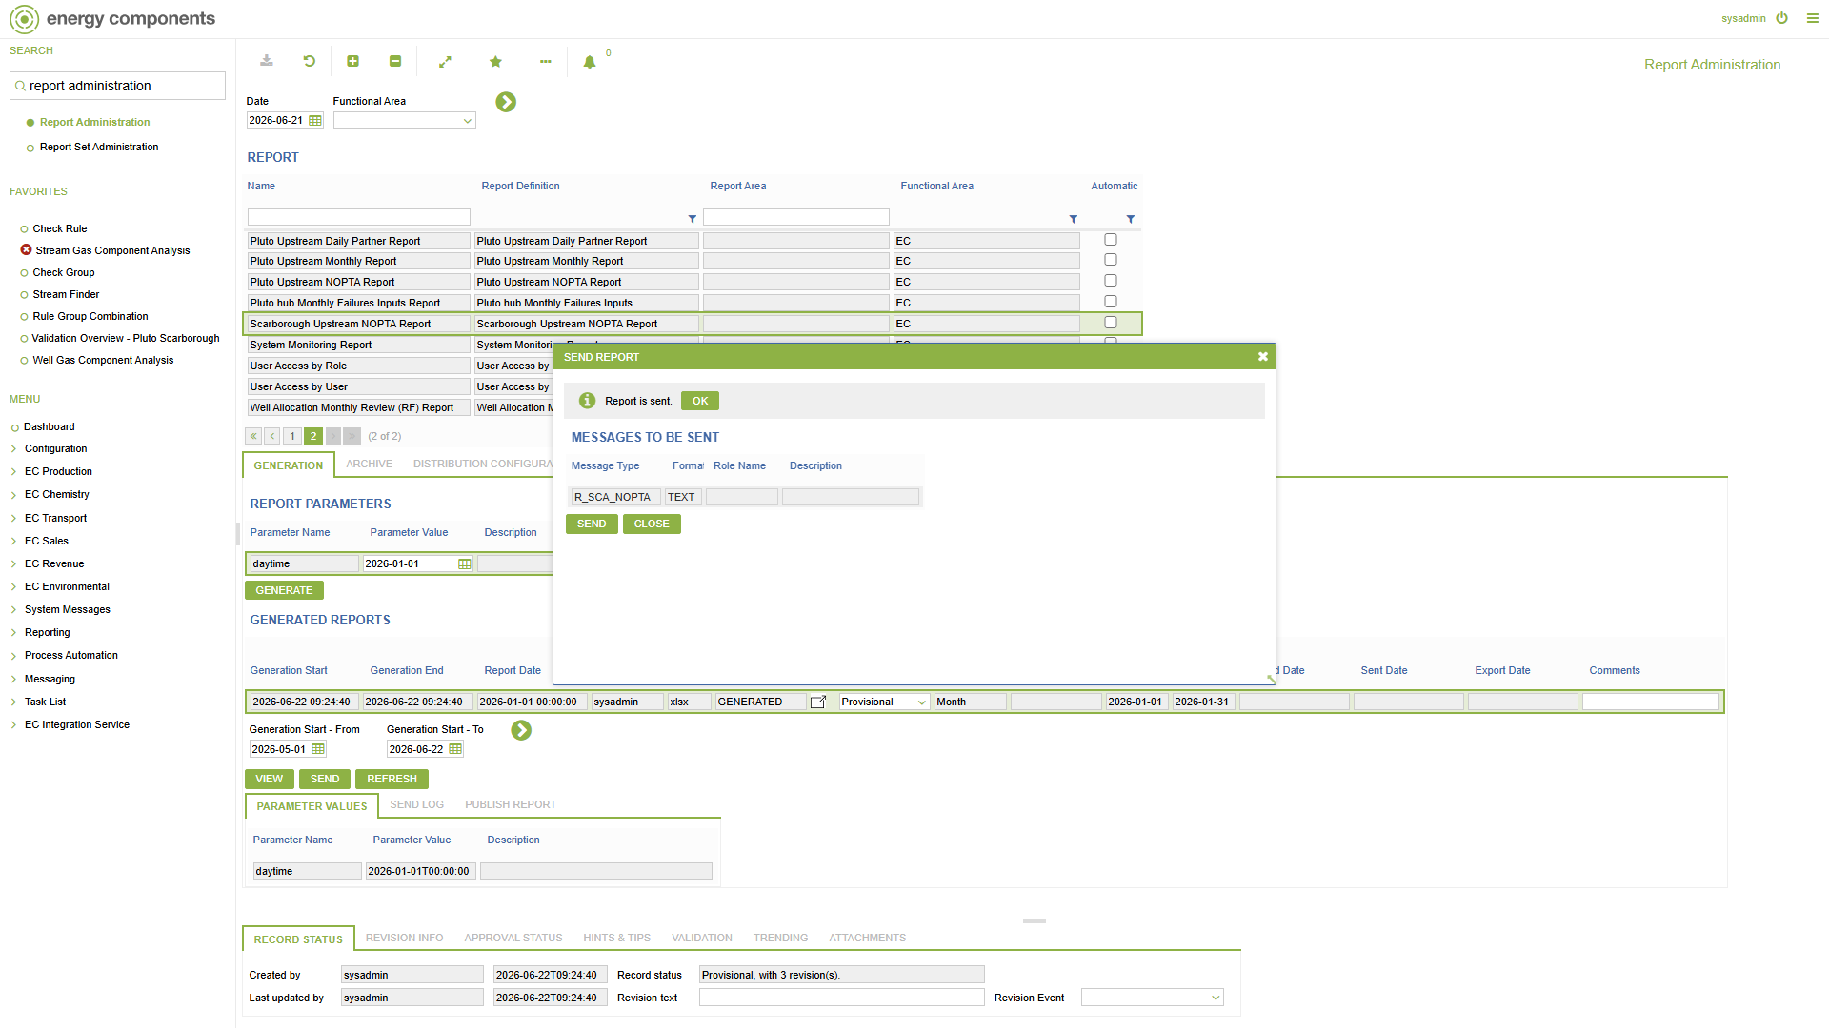

9. Schedules screen
ZWP_SEND_BPM_NOTIFICATIONS (BPM Send Notifications) - business actions ZWP_UPD_MHM_SUBJECT_AND_BODY + ZWP_SENDMAIL, runs OK on its schedule. (Shared send job, report-agnostic.)
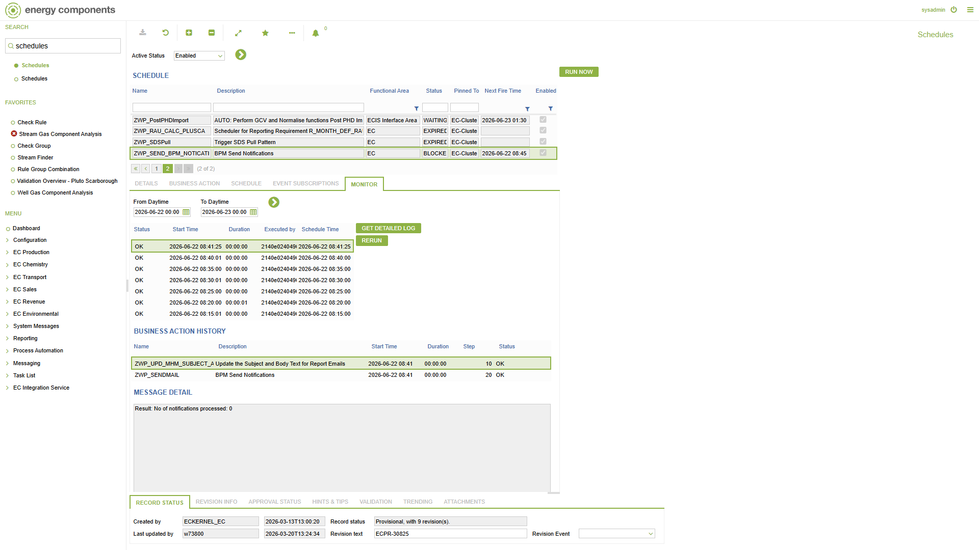

10. Outgoing Messages screen
Outgoing message 408: Message Type R_SCA_NOPTA, Subject 'Scarborough Upstream NOPTA Report for Production Date', Format Text, Recipient To = prodreporting@woodside.com (SMTP). Status = ERROR (SMTP delivery not configured on COPSDEV - the message reached the outgoing-message stage as designed).
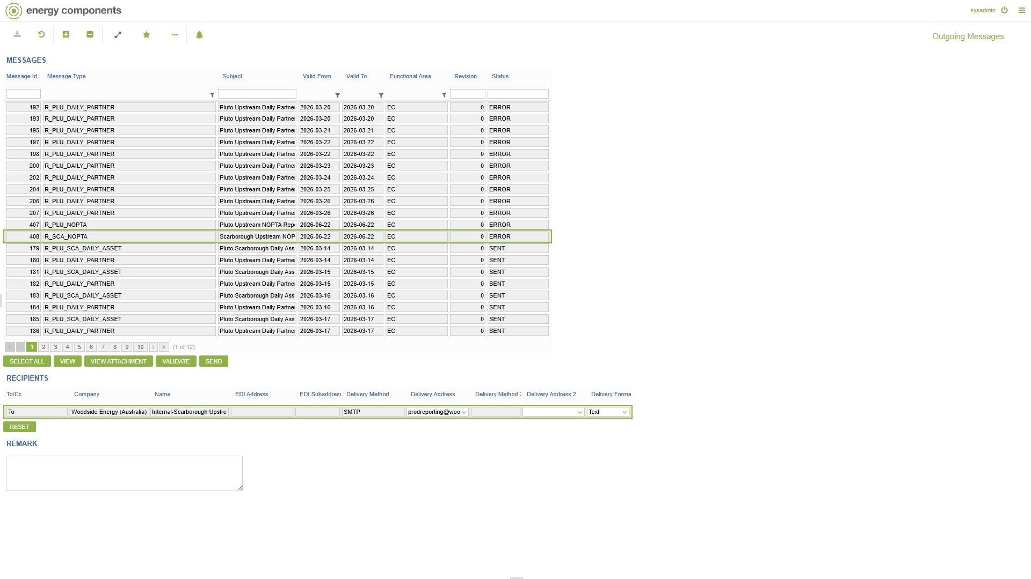

11. Preview generated outgoing message
Generated outgoing message. Rendered subject: 'Scarborough Upstream NOPTA Report for Production Date - 01 Jan 26'. Rendered body below.
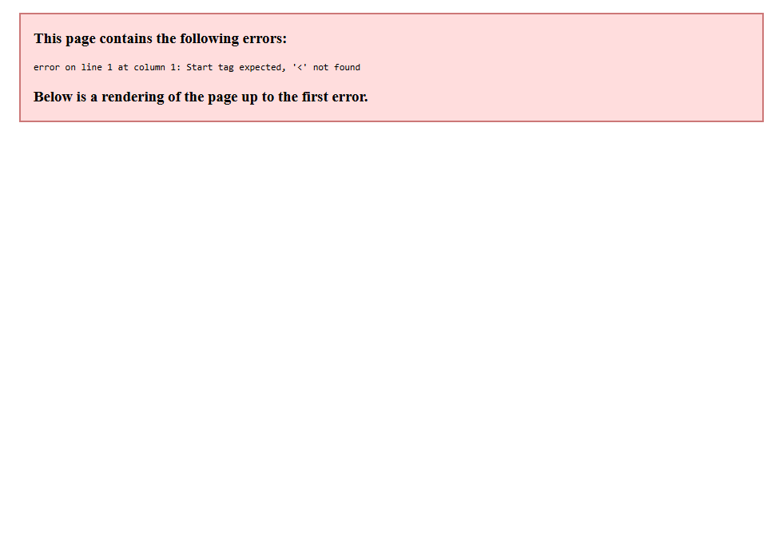
Rendered message body (MESSAGE_DRAFT):
Hi,
Please find attached Scarborough Upstream NOPTA Report for Production Date - 01 Jan 26.
For any queries or issues please contact PlutoJVNotices@woodside.com.au.
Disclaimer - You are receiving this email as a designated recipient for the above-listed Report Type. If you no longer wish to receive these emails, please contact the Production & Emission Allocation Team - Australian Business.
Regards,
Prod Reporting
Production & Emission Allocation Team
[This notification is automatically generated by Pluto Hub ECaaS.]

