Unit Test Evidence - ECSR-35236
Scope eight PHD validation check rules by measurement method / on-stream hours so they only fire when a value is genuinely expected - stopping the false-positive PHD validations raised on tags added since 1 Dec 2025 (Issue_1052 / Melanie Murray).
Author: Choong-Yin Lee / Claude Opus 4.8 Date: 2026-06-26
Test environment: COPSDEV / plutodev (read-write with rollback). Pristine cross-check: ECAASTEST (read-only).
Delivery format: idempotent Flyway SQL keyed by CHECK_NAME (env-portable; CHECK_ID is environment-local and is NOT used).

1. Requirement
Each of the eight rules currently fires whenever its value is NULL or negative, regardless of whether that value is expected. Add a criterion to each rule's WHERE_FORMULA so it only fires when the measurement method indicates the value should be present (tank GRS_MASS / STD_DENS = MEASURED; stream DENSITY / GCV = COMP_ANALYSIS) or the well is on stream (ON_STREAM_HRS > 0). Pattern mirrors the live rule PHD_STREAM_LIQUID_MEAS_VAL2 (a method ATTRIBUTE variable + a CONST_STRING variable, combined as ${Method} = ${Const}).

2. The change (per rule, keyed by CHECK_NAME)
Check rule (CHECK_NAME) | Original WHERE_FORMULA | Scoped WHERE_FORMULA (ECSR-35236)
PHD_TANK_DIP_GRS_MASS_VAL1 | (${GrsMass} IS NULL OR ${GrsMass} < 0) | (${GrsMass} IS NULL OR ${GrsMass} < 0) and ${GrsMassMethod} = ${ConstMEASURED}
PHD_TANK_DIP_STD_DENSITY_VAL1 | (${StdDensity} IS NULL OR ${StdDensity} < 0) | (${StdDensity} IS NULL OR ${StdDensity} < 0) and ${StdDensMethod} = ${ConstMEASURED}
PHD_STRM_ANALYSIS_DENSITY_VAL1 | (${Density} IS NULL OR ${Density} < 0) | (${Density} IS NULL OR ${Density} < 0) and ${DensityMethod} = ${ConstCOMP}
PHD_STRM_ANALYSIS_GCV_VAL1 | (${Gcv} IS NULL OR ${Gcv} < 0) | (${Gcv} IS NULL OR ${Gcv} < 0) and ${GcvMethod} = ${ConstCOMP}
PHD_PWEL_STATUS_NODATA_BHTEMP | (${AvgBHTemp} IS NULL OR ${AvgBHTemp} < 0) | (${AvgBHTemp} IS NULL OR ${AvgBHTemp} < 0) and ${OnStrmHrs} > 0
PHD_PWEL_STATUS_NODATA_WHTEMP | (${AvgWHTemp} IS NULL OR ${AvgWHTemp} < 0) | (${AvgWHTemp} IS NULL OR ${AvgWHTemp} < 0) and ${OnStrmHrs} > 0
PHD_PWEL_STATUS_NODATA_BHPRESS | (${AvgBHPress} IS NULL OR ${AvgBHPress} < 0) | (${AvgBHPress} IS NULL OR ${AvgBHPress} < 0) and ${OnStrmHrs} > 0
PHD_PWEL_STATUS_NODATA_WHPRESS | (${AvgWHPress} IS NULL OR ${AvgWHPress} < 0) | (${AvgWHPress} IS NULL OR ${AvgWHPress} < 0) and ${OnStrmHrs} > 0
Target table / data column per rule:
- PHD_TANK_DIP_GRS_MASS_VAL1 -> RV_TANK_DAY_DIP_STATUS.ZWP_GRS_MASS_TONNES ; criterion: GRS_MASS_METHOD = 'MEASURED'
- PHD_TANK_DIP_STD_DENSITY_VAL1 -> RV_TANK_DAY_DIP_STATUS.MEAS_STD_DENSITY_KGPERSM3 ; criterion: STD_DENS_METHOD = 'MEASURED'
- PHD_STRM_ANALYSIS_DENSITY_VAL1 -> RV_STRM_ANALYSIS.DENSITY ; criterion: STD_DENSITY_METHOD = 'COMP_ANALYSIS'
- PHD_STRM_ANALYSIS_GCV_VAL1 -> RV_STRM_ANALYSIS.GCV_MJPERSM3 ; criterion: GCV_METHOD = 'COMP_ANALYSIS'
- PHD_PWEL_STATUS_NODATA_BHTEMP -> RV_PWEL_DAY_STATUS.AVG_BH_TEMP_C ; criterion: ON_STREAM_HRS_HRS > 0
- PHD_PWEL_STATUS_NODATA_WHTEMP -> RV_PWEL_DAY_STATUS.AVG_WH_TEMP_C ; criterion: ON_STREAM_HRS_HRS > 0
- PHD_PWEL_STATUS_NODATA_BHPRESS -> RV_PWEL_DAY_STATUS.AVG_BH_PRESS_KPA ; criterion: ON_STREAM_HRS_HRS > 0
- PHD_PWEL_STATUS_NODATA_WHPRESS -> RV_PWEL_DAY_STATUS.AVG_WH_PRESS_KPA ; criterion: ON_STREAM_HRS_HRS > 0

3. Screen evidence - Validation Overview (EC Web App)
Captured live on the EC Web App (https://app-plutodev.woodside-pluto.tieto-og.cloud/), Configuration > System > Validation > "Validation Overview - Pluto Scarborough". The check group "Daily Tank Status - VCF Calc - PHD Validations" was run for 2026-06-06, BEFORE the fix and AFTER applying it - then the fix was rolled back (plutodev left in its original state).
Result on screen: the group's Summary went from 20 Errors (before) to 12 Errors (after). The 8 suppressed validations are the false positives - tank Gross Mass / Standard Density rows whose measurement method is not MEASURED (e.g. GRS_VOL_DENSITY, STREAM_SAMPLE_ANALYSIS). The genuine validations remain (the unchanged Gross Volume / Avg Temp tank rules, and any MEASURED rows that are genuinely missing a value).
BEFORE - original rules: Daily Tank Status - PHD Validations Summary
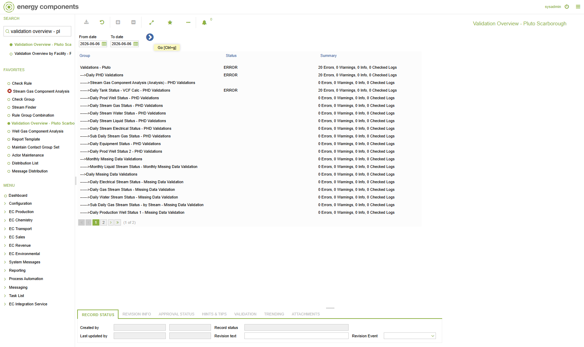
AFTER - scoping criterion applied: false positives suppressed
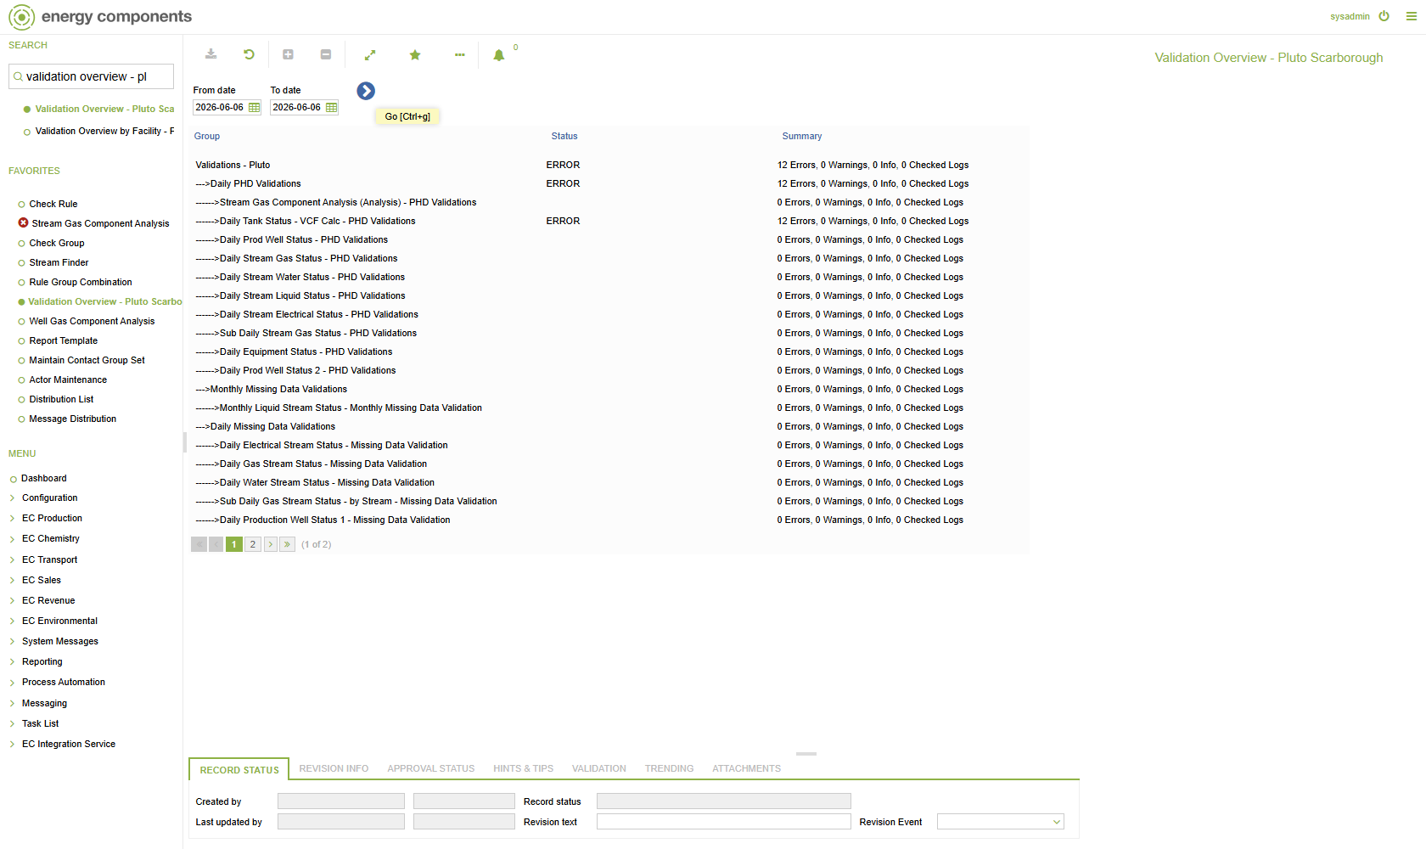

4. Deployment safety - Apply / Rollback round-trip
Snapshot the original state (S0) -> run the apply SQL -> verify all 8 rules are scoped (S1) -> run the rollback SQL -> verify the state returns exactly to S0 (S2). Result on plutodev:
S0 (before apply) : all 8 rules ORIGINAL, no method/const variables
S1 (after apply) : all 8 rules SCOPED; method/const vars added
(tank/stream: 2 vars each; PWEL: OnStrmHrs)
S2 (after rollback): IDENTICAL to S0
VERDICT: PASS - apply scopes all 8; rollback restores the original exactly.
Pristine cross-check (ECAASTEST, never touched by ECSR-35236): all 8 original WHERE_FORMULA values match the rollback's restore strings exactly, and none of the 7 method/const variables exist there - confirming they are net-new (the rollback's DELETE removes precisely the additions, with no risk to pre-existing data). Note: rollback restores formula + variables to the original; it stamps REV_TEXT = 'ECSR-35236-ROLLBACK' on the rule rows as a deliberate audit marker (behaviour is identical to the original).

5. Supporting DB detail - false-positive suppression counts (all 8 rules)
The EC check fires when SELECT Count(*) FROM <target> WHERE <formula> > 0. The table below runs the check's own count query against live data, before vs after the scoping criterion. 'Suppressed' = false positives no longer raised; the breakdown shows which method values they carried.
Check rule | Before | After | Suppressed | Flagged rows by method
PHD_TANK_DIP_GRS_MASS_VAL1 | 641 | 56 | 585 | GRS_VOL_DENSITY=585; MEASURED=56
PHD_TANK_DIP_STD_DENSITY_VAL1 | 741 | 0 | 741 | STREAM_SAMPLE_ANALYSIS=741
PHD_STRM_ANALYSIS_DENSITY_VAL1 | 1393 | 168 | 1225 | NULL=718; REF_VALUE=507; COMP_ANALYSIS=168
PHD_STRM_ANALYSIS_GCV_VAL1 | 916 | 1 | 915 | NULL=887; REF_VALUE=28; COMP_ANALYSIS=1
PHD_PWEL_STATUS_NODATA_BHTEMP | 349 | 0 | 349 | NULL=336; 0=13
PHD_PWEL_STATUS_NODATA_WHTEMP | 348 | 0 | 348 | NULL=336; 0=12
PHD_PWEL_STATUS_NODATA_BHPRESS | 348 | 0 | 348 | NULL=336; 0=12
PHD_PWEL_STATUS_NODATA_WHPRESS | 347 | 0 | 347 | NULL=336; 0=11
Every column referenced by the fix was confirmed to exist on its target table (including ON_STREAM_HRS_HRS on RV_PWEL_DAY_STATUS), so the deployed checks compile and run.

6. Observations to confirm on client test
- PHD_TANK_DIP_STD_DENSITY_VAL1 (= 'MEASURED'): on current plutodev data this suppresses 100% - the flagged standard-density rows all carry STD_DENS_METHOD = 'STREAM_SAMPLE_ANALYSIS' and none are 'MEASURED'. Implemented as specified; please confirm on test that 'MEASURED' is the intended qualifying method for standard density (vs. STREAM_SAMPLE_ANALYSIS, or an IN(...) set).
- PHD_PWEL_STATUS_NODATA_* (ON_STREAM_HRS > 0): suppress fully on current data because the flagged rows have ON_STREAM_HRS NULL or 0. Confirm NULL on-stream-hours handling is intended (NULL > 0 is UNKNOWN, so those rows are excluded).
- = vs IN: the criteria are implemented as literal equality (=) per the specification. If any check should accept more than one qualifying method, that criterion should become method IN (...).

7. Conclusion
The fix applies cleanly to all 8 rules, demonstrably suppresses the false-positive PHD validations while leaving genuine cases flagged (e.g. tank gross mass still fires for MEASURED rows; stream density/GCV still fire for COMP_ANALYSIS), is portable (keyed by CHECK_NAME), and is fully reversible (round-trip verified; rollback restores the original state, confirmed against pristine ECAASTEST). The observations in section 5 are flagged for confirmation during client testing.

