**Table S1.** Detailed experimental results on attractor-transition control of random complex BNs.

|  |  |  |  |  |  |  |  |  |
| --- | --- | --- | --- | --- | --- | --- | --- | --- |
| **Point to point** | | | | | | | | |
| **Number of elements in control inputs** | | | | | | | | |
| Network size | Average | | | | 95% confidence interval | | | |
| Proposed  algorithm | One-step control | Stable motif control | FVS control | Proposed  algorithm | One-step control | Stable motif control | FVS control |
| node_010 | 1.63 | 1.3 | 2.64 | 4.64 | 0.148311 | 0.095639 | 0.204385 | 0.183901 |
| node_020 | 1.86 | 1.285714 | 2.602041 | 6.091837 | 0.195433 | 0.103798 | 0.214931 | 0.225004 |
| node_030 | 2.11 | 1.463918 | 3.051546 | 7.463918 | 0.197205 | 0.120161 | 0.19158 | 0.265125 |
| node_040 | 2.08 | 1.5 | 3.5 | 8.5 | 0.212325 | 0.135794 | 0.741952 | 0.453008 |
| node_050 | 2.22 | 1.54717 | N/A | 9.733333 | 0.226639 | 0.183839 | N/A | 0.476751 |
| **Computational time (secs)** | | | | | | | | |
| Network size | Average | | | | 95% confidence interval | | | |
| Proposed  algorithm | One-step control | Stable motif control | FVS control | Proposed  algorithm | One-step control | Stable motif control | FVS control |
| node_010 | 0.029199 | 0.08825 | 7.228399 | 0.010599 | 0.001333 | 0.002844 | 2.399274 | 0.000727 |
| node_020 | 0.052899 | 0.488541 | 28.55952 | 0.356635 | 0.005025 | 0.088113 | 16.43326 | 0.102527 |
| node_030 | 0.213739 | 99.73753 | 2084.96 | 39.13659 | 0.203003 | 181.8864 | 1295.758 | 17.51666 |
| node_040 | 0.427908 | 382.2998 | 5652.155 | 2024.485 | 0.336508 | 166.4318 | 9307.556 | 1065.48 |
| node_050 | 2.558455 | 6820.283 | N/A | 23094.53 | 3.416093 | 2976.547 | N/A | 7406.768 |

|  |  |  |  |  |  |  |  |  |
| --- | --- | --- | --- | --- | --- | --- | --- | --- |
| **Point to cycle** | | | | | | | | |
| **Number of elements in control inputs** | | | | | | | | |
| Network size | Average | | | | 95% confidence interval | | | |
| Proposed  algorithm | One-step control | Stable motif control | FVS control | Proposed  algorithm | One-step control | Stable motif control | FVS control |
| node_010 | 1.31 | 1.360825 | 2 | N/A | 0.108111 | 0.105633 | 0.181228 | N/A |
| node_020 | 1.75 | 1.488889 | 2.241379 | N/A | 0.160469 | 0.141268 | 0.232031 | N/A |
| node_030 | 1.78 | 1.549451 | 2.270588 | N/A | 0.190403 | 0.128993 | 0.206212 | N/A |
| node_040 | 1.7 | 1.428571 | 2.603175 | N/A | 0.165652 | 0.131706 | 0.24997 | N/A |
| node_050 | 1.62 | 1.5 | N/A | N/A | 0.151298 | 0.135513 | N/A | N/A |
| **Computational time (secs)** | | | | | | | | |
| Network size | Average | | | | 95% confidence interval | | | |
| Proposed  algorithm | One-step control | Stable motif control | FVS control | Proposed  algorithm | One-step control | Stable motif control | FVS control |
| node_010 | 0.016675 | 0.060598 | 5.813827 | N/A | 0.000981 | 0.008787 | 2.192466 | N/A |
| node_020 | 0.027392 | 0.645689 | 24.56716 | N/A | 0.001705 | 0.14492 | 17.08657 | N/A |
| node_030 | 0.036949 | 24.96004 | 913.2133 | N/A | 0.001905 | 13.56912 | 769.3241 | N/A |
| node_040 | 0.046575 | 652.4675 | 2882.806 | N/A | 0.002492 | 374.5864 | 2520.818 | N/A |
| node_050 | 0.059757 | 13842 | N/A | N/A | 0.003025 | 5643.747 | N/A | N/A |

**Fig. S1.** Connectivity graph of the death receptor signaling network [63], where red edges with arrows represent activation and blue ones with bars inhibition (reproduced from Fig. 3).

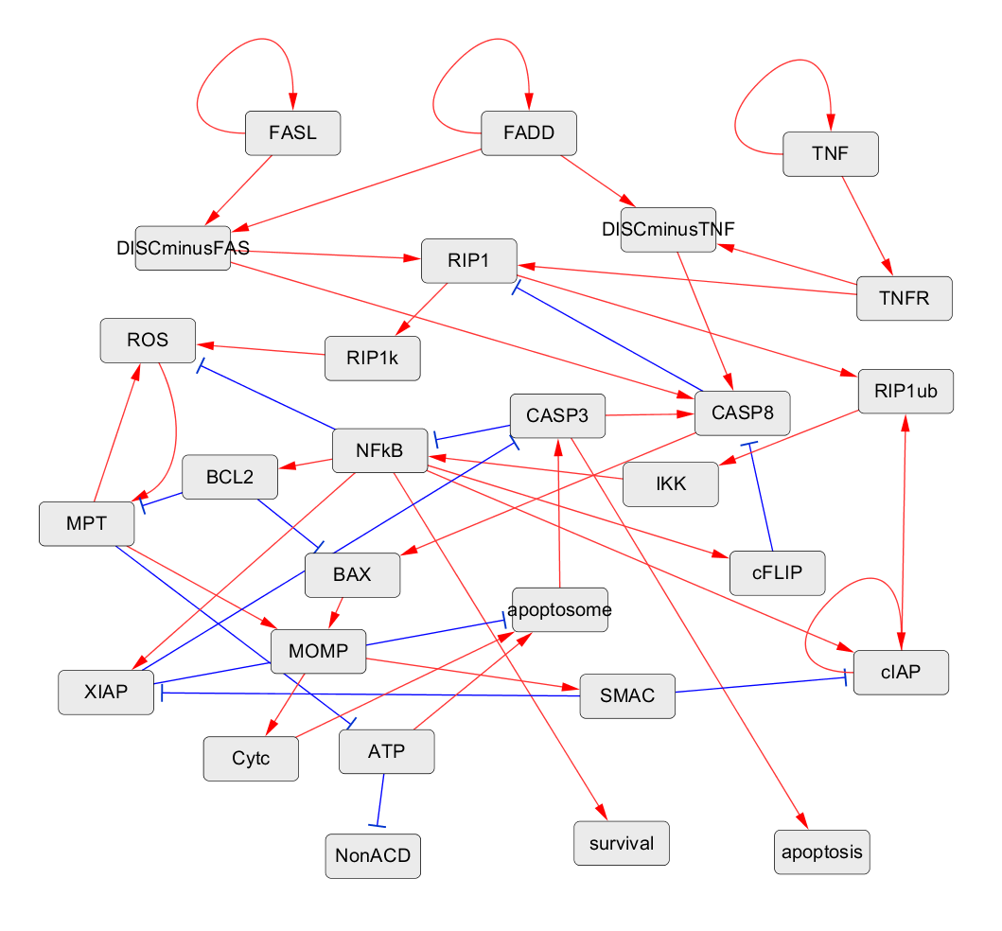

**Table S2.** Boolean logic rules provided in the .bnet file format for the death receptor signaling network.

|  |
| --- |
| FADD = FADD  FASL = FASL  TNF = TNF  ATP = ~MPT  BAX = ~BCL2 & CASP8  BCL2 = NFkB  CASP3 = ~XIAP & apoptosome  CASP8 = DISCminusTNF & ~cFLIP | DISCminusFAS & ~cFLIP | CASP3 & ~cFLIP  Cytc = MOMP  DISCminusFAS = FADD & FASL  DISCminusTNF = FADD & TNFR  IKK = RIP1ub  MOMP = MPT | BAX  MPT = ~BCL2 & ROS  NFkB = ~CASP3 & IKK  RIP1 = ~CASP8 & TNFR | ~CASP8 & DISCminusFAS  RIP1k = RIP1  RIP1ub = RIP1 & cIAP  ROS = ~NFkB & RIP1k | MPT & ~NFkB  SMAC = MOMP  TNFR = TNF  XIAP = NFkB & ~SMAC  apoptosome = ATP & Cytc & ~XIAP  cFLIP = NFkB  cIAP = ~SMAC & cIAP | NFkB & ~SMAC  NonACD = ~ATP  apoptosis = CASP3  survival = NFkB |

**Fig. S2.** Connectivity graph of the breast cancer network [64], where red edges with arrows represent activation and blue ones with bars inhibition (reproduced from Fig. 4).

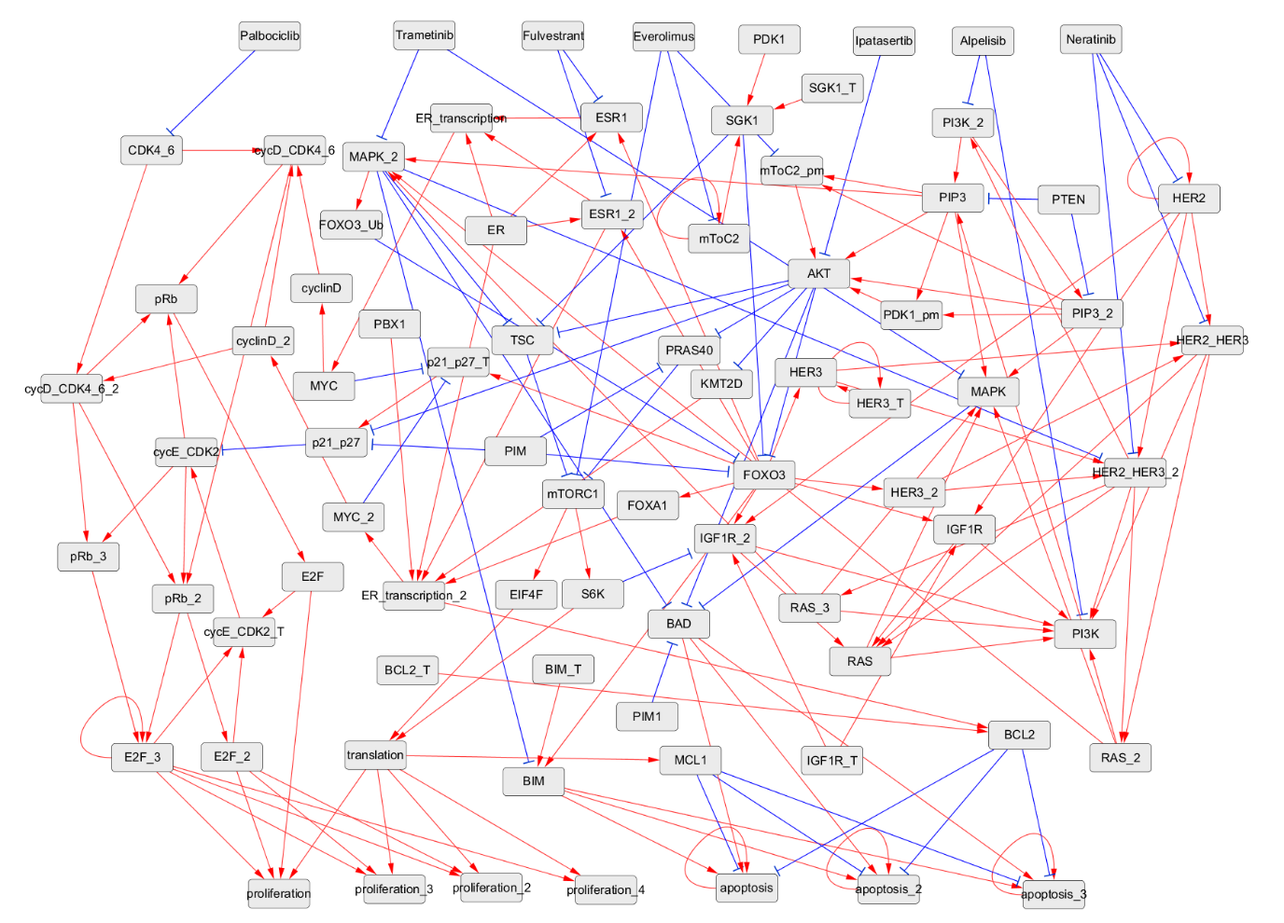

**Table S3.** Boolean logic rules provided in the .bnet file format for the breast cancer network.

|  |
| --- |
| IGF1R = IGF1R_T | (HER2 & FOXO3)  IGF1R_2 = (IGF1R_T | (HER2 & FOXO3)) & ~S6K  HER3_T = HER3_T  HER3 = FOXO3 | HER3_T  HER3_2 = FOXO3  mToC2 = mToC2 & ~Everolimus  SGK1 = SGK1_T & PDK1 & mToC2  HER2 = HER2 & ~Neratinib  HER2_HER3 = HER2 & (HER3 | HER3_2) & ~Neratinib  HER2_HER3_2 = HER2 & ((HER3 & ~MAPK_2) | HER3_2) & ~Neratinib  RAS = IGF1R | IGF1R_2 | HER2_HER3 | HER2_HER3_2  RAS_2 = HER2_HER3 | HER2_HER3_2  RAS_3 = HER2_HER3_2  MAPK = (RAS | RAS_2 | RAS_3) & (PIP3 | PIP3_2) & (~Trametinib | RAS_3)  MAPK_2 = (RAS_2 | RAS_3) & PIP3 & (~Trametinib | RAS_3)  PI3K = (IGF1R | IGF1R_2 | HER2_HER3 | HER2_HER3_2 | RAS | RAS_2 | RAS_3) & (~Alpelisib | HER2_HER3_2)  PI3K_2 = HER2_HER3_2 & ~Alpelisib  PIP3 = (PI3K | PI3K_2) & ~PTEN  PIP3_2 = PI3K_2 & ~PTEN  PDK1_pm = PIP3 | PIP3_2  mToC2_pm = (PIP3 | PIP3_2) & ~Everolimus  AKT = (PIP3 | PIP3_2) & (PDK1_pm | mToC2_pm) & (~Ipatasertib | PIP3_2)  p21_p27_T = FOXO3 | ~(MYC_2 | MYC)  p21_p27 = (~AKT & ~PIM) | p21_p27_T  cycE_CDK2_T = E2F | E2F_2 | E2F_3  cycE_CDK2 = ~p21_p27 & cycE_CDK2_T  KMT2D = ~AKT  TSC = ~AKT & ~SGK1 & ~MAPK_2  PRAS40 = ~AKT & ~PIM  mTORC1 = (~TSC | ~PRAS40) & ~Everolimus  FOXO3 = (~AKT & ~SGK1 & ~PIM) & ~FOXO3_Ub  FOXO3_Ub = MAPK_2  BIM = (FOXO3 & ~MAPK_2) | BIM_T  BAD = ~AKT & ~PIM1 & ~(MAPK | MAPK_2)  MCL1 = translation  EIF4F = mTORC1  S6K = mTORC1  translation = EIF4F & S6K  ESR1 = (ER | FOXO3) & ~Fulvestrant  ESR1_2 = ER & FOXO3 & ~Fulvestrant  FOXA1 = FOXO3  ER_transcription = ER & (ESR1 | ESR1_2)  ER_transcription_2 = KMT2D & FOXA1 & PBX1 & ER & ESR1_2  MYC = ER_transcription  MYC_2 = ER_transcription_2  cyclinD = MYC  cyclinD_2 = MYC_2  BCL2 = ER_transcription_2 | BCL2_T  CDK4_6 = ~Palbociclib  cycD_CDK4_6 = (cyclinD | cyclinD_2) & CDK4_6  cycD_CDK4_6_2 = (cyclinD_2) & CDK4_6  pRb = (cycD_CDK4_6_2 | cycD_CDK4_6) | cycE_CDK2  pRb_2 = (cycD_CDK4_6 & cycE_CDK2) | cycD_CDK4_6_2  pRb_3 = cycD_CDK4_6_2 & cycE_CDK2  E2F = pRb  E2F_2 = pRb_2  E2F_3 = pRb_3 | (pRb_2 & E2F_3)  proliferation = translation | E2F | E2F_2 | E2F_3  proliferation_2 = translation | E2F_2 | E2F_3  proliferation_3 = (translation & E2F_2) | E2F_3  proliferation_4 = translation & E2F_3  apoptosis = (BIM & ~(MCL1 & BCL2)) | (BIM & BAD) | (BAD & ~(MCL1 & BCL2)) | apoptosis  apoptosis_2 = (BIM & BAD & ~(MCL1 & BCL2)) | apoptosis_2  apoptosis_3 = ((BIM & BAD & ~(MCL1 | BCL2))) | apoptosis_3 |

**Fig. S3.** Connectivity graph of the cell cycle/apoptosis network [65], where red edges with arrows represent activation and blue ones with bars inhibition. For detailed descriptions of the nodes grouped by biological functions, refer to [65] (reproduced from Fig. 5).

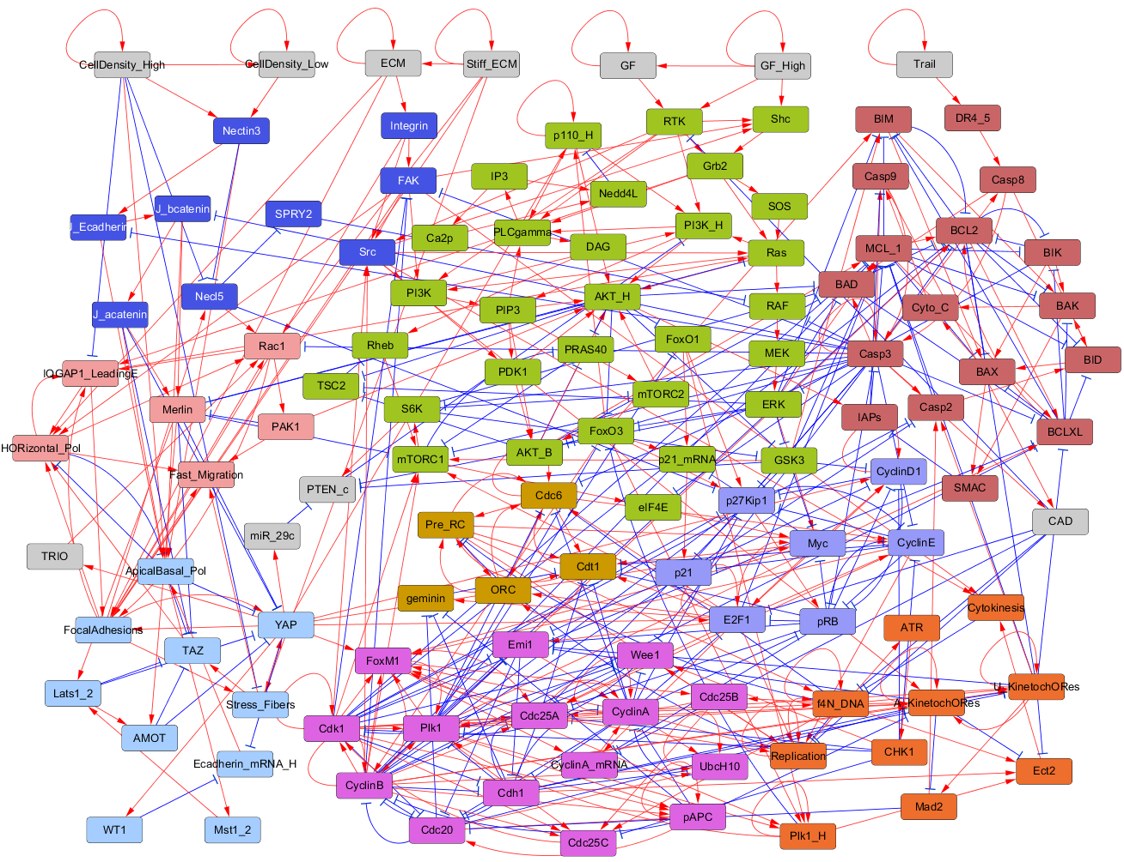

**Table S4.** Boolean logic rules provided in the .bnet file format for the cell cycle/apoptosis network.

|  |
| --- |
| CellDensity_High = CellDensity_High  CellDensity_Low = CellDensity_Low | CellDensity_High  Stiff_ECM = Stiff_ECM  ECM = ECM | Stiff_ECM  GF_High = GF_High  GF = GF | GF_High  RTK = ~CAD & (GF_High | GF)  Shc = RTK & GF_High & (FAK | Src)  Grb2 = Shc & RTK  SOS = Grb2  Ras = Grb2 & SOS & Src & (IQGAP1_LeadingE | (~Merlin) )  RAF = ~Casp3 & Ras & (~SPRY2)  MEK = RAF  ERK = MEK & ~BIK  mTORC2 = PIP3 | ~S6K  PI3K = (FAK | Src) & (Ras | RTK)  PIP3 = PI3K_H | PI3K  PDK1 = PI3K & PIP3  AKT_B = ~Casp3 & PIP3 & (PDK1 | mTORC2)  p110_H = YAP & ((FoxO3 & ~Nedd4L) | (p110_H & (FoxO3 | ~Nedd4L) ) )  PI3K_H = (~PTEN_c) & p110_H & RTK & PI3K & Ras  AKT_H = AKT_B & p110_H & PI3K_H & PIP3 & PDK1 & mTORC2 & (Ras | PAK1)  FoxO3 = ~(AKT_B | AKT_H | ERK) | ( ~(AKT_H & (Plk1 | Plk1_H | AKT_B | ERK) ) & ~(Plk1 & Plk1_H & ERK) )  PLCgamma = RTK & Grb2 & p110_H & PI3K_H & PIP3  IP3 = PLCgamma  Ca2p = IP3  Nedd4L = Ca2p & IP3  FoxO1 = ~Plk1 & ~AKT_H  p21_mRNA = (FoxO1 & FoxO3) | (~Myc & (FoxO1 | FoxO3) )  TSC2 = ~AKT_H | ~(AKT_B | ERK)  PRAS40 = ~AKT_H & (~mTORC1 | ~AKT_B)  DAG = PLCgamma  Rheb = ~TSC2 & DAG  mTORC1 = ~Casp3 & ( (Rheb & ~PRAS40 & ~Merlin) | E2F1 | (CyclinB & Cdk1 & GSK3) )  S6K = ~Casp3 & mTORC1  eIF4E = ~Casp3 & mTORC1  GSK3 = ~AKT_H & ~(S6K & ERK)  Integrin = ECM  FAK = ~Casp3 & ~(Cdk1 & CyclinB) & Integrin  Src = (Integrin & (RTK | FAK) ) | (Cdk1 & CyclinB)  Nectin3 = CellDensity_Low | CellDensity_High  Necl5 = FocalAdhesions | ~(Nectin3 & CellDensity_High)  SPRY2 = ~Necl5  J_Ecadherin = ~Casp3 & Nectin3  J_bcatenin = ~Casp3 & J_Ecadherin  J_acatenin = J_bcatenin  FocalAdhesions = Integrin & FAK & ECM & (Stiff_ECM | (YAP & Rac1 & IQGAP1_LeadingE))  Stress_Fibers = ~CellDensity_High & Stiff_ECM & FocalAdhesions  YAP = FocalAdhesions & Stress_Fibers & ~(ApicalBasal_Pol & J_acatenin & AMOT & Merlin & Lats1_2)  TRIO = YAP  WT1 = YAP  TAZ = Stress_Fibers & ~(ApicalBasal_Pol & J_acatenin & AMOT & Merlin & Lats1_2)  Ecadherin_mRNA_H = ~(YAP & WT1)  ApicalBasal_Pol = CellDensity_High & Nectin3 & J_Ecadherin & J_bcatenin & J_acatenin & (Ecadherin_mRNA_H | ~HORizontal_Pol)  Mst1_2 = ApicalBasal_Pol  Lats1_2 = Mst1_2 & Merlin  AMOT = Lats1_2 & Merlin  Merlin = J_bcatenin & J_acatenin & (~PAK1) & (~AKT_H)  IQGAP1_LeadingE = ~CellDensity_High & FocalAdhesions & (HORizontal_Pol | Rac1 | Grb2)  HORizontal_Pol = ~ApicalBasal_Pol & ECM & IQGAP1_LeadingE & FocalAdhesions & TAZ & FAK  Rac1 = ~Casp3 & Stiff_ECM & FocalAdhesions & Necl5 & HORizontal_Pol & TRIO  PAK1 = Rac1  Fast_Migration = HORizontal_Pol & Stress_Fibers & FocalAdhesions & PAK1  miR_29c = YAP  PTEN_c = ~miR_29c & ( (S6K & ~(ERK & GSK3) ) | (~ERK & ~GSK3) )  p21 = p21_mRNA & ~Casp3 & ~CyclinE  pRB = ~Casp3 & ~CyclinD1 & ~CyclinA & (p27Kip1 | ~CyclinE)  p27Kip1 = ~Casp3 & ~CyclinD1 & ~(Cdk1 & CyclinB) & ( (~(CyclinA & Necl5 & CyclinE) & (FoxO3 & FoxO1) ) | ( (~CyclinA | ~(Necl5 | CyclinE)) & (FoxO3 | FoxO1) ) | (~CyclinA & ~(Necl5 & CyclinE) ) )  Myc = ( ERK & YAP ) | ( (ERK | YAP) & (eIF4E & ~GSK3) ) | ( E2F1 & (~pRB) & (eIF4E | ERK | ~GSK3) )  CyclinD1 = ~CHK1 & ( ( ~p21 & ( (~GSK3 & YAP & (Myc | E2F1) ) | (CyclinD1 & YAP & (Myc | E2F1 ) | (Myc & E2F1) ) ) ) | ( ~pRB & E2F1 & ( (Myc & CyclinD1) | (Myc & ~GSK3) | (YAP & CyclinD1 & ~GSK3) ) ) )  E2F1 = ~(CAD | CyclinA | pRB) & ( (YAP & (E2F1 | Myc)) | (E2F1 & Myc) )  CyclinE = E2F1 & Cdc6 & Pre_RC & ~(pRB | p27Kip1 | CHK1 | Casp3)  ORC = E2F1 | (Pre_RC & Cdt1 & Cdc6)  Cdc6 = ~Casp3 & ~(f4N_DNA & CyclinA) & ( (E2F1 & ORC & ~Plk1) | (Pre_RC & ORC & Cdc6 & Cdt1) )  Cdt1 = ~geminin & ORC & Cdc6 & ~(CyclinE & CyclinA & Cdc25A) & ( (Pre_RC & (E2F1 | Myc) ) | (E2F1 & (Myc | ~pRB) ) )  Pre_RC = ORC & Cdc6 & Cdt1 & ~(Replication & f4N_DNA)  geminin = E2F1 & ~Cdh1 & ~(pAPC & Cdc20)  CyclinA_mRNA = ~CAD & ( (E2F1 & ~pRB) | FoxM1 )  Emi1 = (E2F1 | ~pRB | ~p21) & ~(Plk1 & CyclinB & Cdk1 & (U_KinetochORes | A_KinetochORes) )  FoxM1 = ((Myc | YAP) & CyclinE) | (CyclinA & Cdc25A & Cdc25B) | (Plk1 & CyclinB & Cdk1)  Cdc25A = ( (FoxM1 & E2F1 & ~pRB) | (~Cdh1 & (FoxM1 | (E2F1 & ~pRB) ) ) ) & (~(GSK3 | CHK1) | CyclinE | CyclinA | (CyclinB & Cdk1) )  CyclinA = CyclinA_mRNA & ~pAPC & ( (Cdc25A & (~Cdh1 | Emi1) ) | (CyclinA & ( (~Cdh1 & (Emi1 | ~UbcH10) ) | (Emi1 & ~UbcH10) ) ) )  Wee1 = ~Casp3 & ~(Cdk1 & CyclinB) & (Replication | CHK1) & (CHK1 | ~(Cdk1 & CyclinA & Plk1) )  UbcH10 = ~Cdh1 | (UbcH10 & (Cdc20 | CyclinA | CyclinB) )  CyclinB = (FoxM1 | (FoxO3 & CyclinB) ) & ~(Cdh1 | (pAPC & Cdc20) )  Cdc25B = FoxM1 & f4N_DNA  Plk1 = ~Cdh1 & (FoxM1 | Plk1_H) & ( (CyclinB & Cdk1) | (CyclinA & ~Wee1 & Cdc25A) )  Cdc25C = f4N_DNA & Plk1 & ( (Cdc25B & ~CHK1) | (CyclinB & Cdk1) )  Cdk1 = CyclinB & Cdc25C & ( ~CHK1 | (~Wee1 & Cdk1) )  pAPC = (CyclinB & Cdk1 & Plk1) | (CyclinB & Cdk1 & pAPC) | (pAPC & Cdc20)  Cdc20 = pAPC & ~Emi1 & ~Cdh1 & ( ~Mad2 | ( ~CyclinA & ~(CyclinB & Cdk1) ) )  Cdh1 = ~(CyclinB & Cdk1) & ~( CyclinA & (Emi1 | Cdc25A) )  Replication = ~CAD & Pre_RC & ( (E2F1 & CyclinE & Cdc25A) | (Replication & CyclinA & Cdc25A & (E2F1 | ~f4N_DNA) ) )  ATR = Replication  CHK1 = ATR  f4N_DNA = ~CAD & ( (Replication & ( (Pre_RC & CyclinA) | f4N_DNA) ) | (f4N_DNA & ~Cytokinesis) )  U_KinetochORes = f4N_DNA & ~Cdh1 & ~A_KinetochORes & ( (CyclinB & Cdk1) | U_KinetochORes )  Mad2 = U_KinetochORes & ~A_KinetochORes  A_KinetochORes = f4N_DNA & ~Cdh1 & ~(pAPC & Cdc20) & ( A_KinetochORes | (U_KinetochORes & Src & Plk1 & CyclinB & Cdk1) )  Plk1_H = Plk1 & FoxM1 & (Plk1_H | FoxO3 | FoxO1)  Ect2 = f4N_DNA & Plk1_H & Cdh1 & ~U_KinetochORes & ~A_KinetochORes  Cytokinesis = Ect2 & FAK & Src  Trail = Trail  DR4_5 = Trail  Casp8 = DR4_5 | Casp3  Casp2 = Casp3 | (U_KinetochORes & Mad2 & ~(CyclinB & Cdk1) )  MCL_1 = ~Casp3 & ~Casp2 & (~GSK3 | (AKT_B & (ERK | ~E2F1) ) ) & (~(Cdk1 & CyclinB & U_KinetochORes) )  BCLXL = ~Casp3 & (BCL2 | ~BAD) & ( ~U_KinetochORes | ( Plk1 & ( ~(CyclinB & Cdk1) | (BCL2 & MCL_1) ) ) | ( (BCL2 & MCL_1) & ~(CyclinB & Cdk1) ) )  BCL2 = ~(Casp3 | BAD | BIM | BIK) & ( ~U_KinetochORes | (MCL_1 & BCLXL) | (Plk1 & (BCLXL | MCL_1 | ~(Cdk1 & CyclinB) ) ) )  BAD = Casp3 | ~(AKT_H | AKT_B | ERK | S6K) | ( Casp8 & (~(AKT_B & ERK & S6K) & ~(AKT_H & (AKT_B | ERK) ) ) )  BIK = ~(MCL_1 | BCLXL | BCL2)  BIM = FoxO3 & GSK3 & ~(ERK | MCL_1 | BCLXL | BCL2)  BID = Casp8 | ( Casp2 & ~(BCL2 | BCLXL | MCL_1) )  BAK = (BID & (BIM | BIK | ~(BCL2 & BCLXL & MCL_1) ) ) | ( (BIM | BIK) & ~(BCLXL | MCL_1) )  BAX = (BIM & ( (BID | BIK) | ~(BCL2 & BCLXL & MCL_1) ) ) | ( (BID | BIK) & ~(BCL2 | BCLXL) )  Cyto_C = BAX | BAK  SMAC = BAX | BAK  IAPs = ~SMAC | AKT_H  Casp9 = Casp3 | (~IAPs & Cyto_C)  Casp3 = (Casp9 & Casp8) | ( Casp3 & (Casp9 | Casp8) ) | ( ~IAPs & (Casp9 | Casp8 | Casp3) )  CAD = Casp3 & Casp9 |

**Table S5.** Control input sets provided by all the applied methods for attractor-transition control of the death receptor signaling network, the breast cancer network, and the cell cycle/apoptosis network.

|  |  |
| --- | --- |
| **Control input sets for the death receptor signaling network** | |
| **Proposed algorithm** | {!MPT, CASP8}, {CASP8, !ROS}, {!MPT, !IKK}, {!IKK, !ROS}, {!MPT, !NFkB}, {!MPT, !RIP1}, {!MPT, !RIP1ub}, {!MPT, !cFLIP}, {!NFkB, !ROS}, {!RIP1, !ROS}, {!RIP1ub, !ROS}, {!cFLIP, !ROS} |
| **One-step control** | {!RIP1k, !cFLIP}, {MOMP, !RIP1k}, {!NFkB, !RIP1k}, {CASP8, !RIP1k}, {!RIP1k, SMAC}, {BAX, !RIP1k}, {!RIP1k, !RIP1ub}, {CASP3, !RIP1k}, {!RIP1, !RIP1k}, {!RIP1k, !cIAP}, {!IKK, !RIP1k} |
| **Stable motif control** | {FADD, FASL, !MPT, !TNF, !cIAP}, {FADD, FASL, !ROS, !TNF, !cIAP}, {FADD, FASL, !IKK, !MPT, !TNF}, {FADD, FASL, !IKK, !ROS, !TNF}, {FADD, FASL, !MPT, !RIP1ub, !TNF}, {FADD, FASL, !RIP1ub, !ROS, !TNF}, {FADD, FASL, !MPT, !NFkB, !TNF}, {FADD, FASL, !NFkB, !ROS, !TNF}, {FADD, FASL, !MPT, !RIP1, !TNF}, {FADD, FASL, !RIP1, !ROS, !TNF}, {FADD, FASL, !MPT, !TNF, !cFLIP}, {FADD, FASL, !ROS, !TNF, !cFLIP}, {CASP8, FADD, FASL, !MPT, !TNF}, {CASP8, FADD, FASL, !ROS, !TNF}, {BAX, FADD, FASL, !MPT, !TNF}, {CASP3, FADD, FASL, !MPT, !TNF}, {FADD, FASL, MOMP, !MPT, !TNF}, {BAX, FADD, FASL, !ROS, !TNF}, {CASP3, FADD, FASL, !ROS, !TNF}, {FADD, FASL, MOMP, !ROS, !TNF} |
| **FVS control** | {BAX, FADD, FASL, !MPT, !NFkB, !TNF, !cIAP}, {BAX, FADD, FASL, !NFkB, !ROS, !TNF, !cIAP}, {CASP3, CASP8, FADD, FASL, !MPT, !TNF, !cIAP}, {CASP3, CASP8, FADD, FASL, !ROS, !TNF, !cIAP}, {CASP3, FADD, FASL, !IKK, !MPT, !TNF, !cIAP}, {CASP3, FADD, FASL, !IKK, !ROS, !TNF, !cIAP}, {CASP3, FADD, FASL, !MPT, !NFkB, !TNF, !cIAP}, {CASP3, FADD, FASL, !MPT, !RIP1, !TNF, !cIAP}, {CASP3, FADD, FASL, !MPT, !RIP1ub, !TNF, !cIAP}, {CASP3, FADD, FASL, !MPT, !TNF, !cFLIP, !cIAP}, {CASP3, FADD, FASL, !NFkB, !ROS, !TNF, !cIAP}, {CASP3, FADD, FASL, !RIP1, !ROS, !TNF, !cIAP}, {CASP3, FADD, FASL, !RIP1ub, !ROS, !TNF, !cIAP}, {CASP3, FADD, FASL, !ROS, !TNF, !cFLIP, !cIAP}, {CASP8, FADD, FASL, !MPT, !NFkB, !TNF, !cIAP}, {CASP8, FADD, FASL, !NFkB, !ROS, !TNF, !cIAP}, {FADD, FASL, MOMP, !MPT, !NFkB, !TNF, !cIAP}, {FADD, FASL, MOMP, !NFkB, !ROS, !TNF, !cIAP} |
| **Control input sets for the breast cancer network** | |
| **Proposed algorithm** | {Alpelisib, !ER, !HER2, !PIM, !PIM1} |
| **One-step control** | N/A |
| **Stable motif control** | N/A |
| **FVS control** | {!AKT, Alpelisib, !BCL2_T, !BIM_T, !E2F_3, !ER, !Everolimus, !Fulvestrant, !HER2, HER3_T, !IGF1R_T, !Ipatasertib, !MAPK_2, !Neratinib, PBX1, !PDK1, !PIM, !PIM1, PTEN, !Palbociclib, SGK1_T, !Trametinib, apoptosis, apoptosis_2, apoptosis_3, !cycE_CDK2, mTORC2'},  {!AKT, Alpelisib, !BCL2_T, !BIM_T, !E2F_3, !ER, !Everolimus, !Fulvestrant, !HER2, HER3_T, !IGF1R_T, !Ipatasertib, !MAPK_2, !Neratinib, PBX1, !PDK1, !PIM, !PIM1, PTEN, !Palbociclib, SGK1_T, !Trametinib, apoptosis, apoptosis_2, apoptosis_3, !cycE_CDK2_T, mTORC2'} |
| **Control input sets for the cell cycle/apoptosis network** | |
| **Proposed algorithm** | {Casp3, !Cdc25C}, {Casp3, Cdh1}, {Casp3, !Cdk1}, {Casp3, !Plk1} |
| **One-step control** | N/A |
| **Stable motif control** | N/A |
| **FVS control** | N/A |

**Table S6.** Biological supporting evidences of the key control inputs identified by the proposed algorithm.

|  |  |
| --- | --- |
| **Complex biological networks** | **Biological supporting evidences** |
| **Death receptor signaling network** | IKK inhibition leads to the repression of NFkB activity, which is a principal survival factor in this model. Moreover, constitutively activated CASP8 can lead to the suppression of NFkB activation.  In the model, ROS or MPT inhibition makes the escape of non-apoptotic cell death (called necrosis), because each inhibition can maintain a high level of ATP. A high level of ATP induces CASP3 activation, which is a key component for apoptosis (PMID: 16006727).  Thus, simultaneously perturbations of these combinatorial targets are effective to repress the survival phenotype, thereby inducing the apoptosis phenotype. |
| **Breast cancer network** | Since high PIM expression induces resistance to the PI3K inhibitor (Alpelisib) in ER+ and HER2+ breast cancer cells (PMID: 27604488), our suggested targets (combinatorial targets with Alpelisib) are effective to inhibit high proliferation phenotype, thereby inducing the apoptosis phenotype. |
| **Cell cycle/apoptosis network** | Cdc25C plays a critical role in cell cycle progression, specifically during the G2 to M phase transition (PMID: 32518522).  Cdk1 (Cyclin-dependent kinase 1) is another key regulatory protein that forms complexes with different cyclin partners to control various cell cycle transitions (PMID: 32183020).  Plk1 is involved in multiple stages of the cell cycle and shows high activity during the G2 and M phases (PMID: 28953239). In the context of cancer treatment, inhibiting these molecules is effective to halt or interfere with cell cycle progression, which is often dysregulated in cancer cells.  In the same reason, Cdh1 corresponds to APC/Cdh1 (PMID: 31000600), and its activation can induce the same effect of Plk1 inhibition in this model.  Lastly, Casp3 is a key component of the caspase cascade, which is a crucial pathway for executing apoptosis (PMID: 23834359).  In summary, increasing levels of mitogenic stimulation (GFHigh) lead to cell cycle entry in cells. Under such constitutively activated input stimulus, our suggested targets (combinatorial targets with Casp3 activation) are effective in converging into an apoptosis phenotype, thereby escaping the cell cycle phenotype. |