**Table S1.** Detailed experimental results on output stabilization of complex random BNs.

|  |  |  |  |  |  |  |
| --- | --- | --- | --- | --- | --- | --- |
| **Number of elements in control inputs** | | | | | | |
| Network size | Average | | | 95% confidence interval | | |
| Proposed  algorithm | Logical  DOI | Phenotype  CK | Proposed  algorithm | Logical  DOI | Phenotyp  CK |
| node_020 | 2.55 | 2.32 | 2.13 | ±0.19615394415781728 | ±0.18681849347142382 | ±0.06706607043796466 |
| node_030 | 2.61 | 2.4 | nan | ±0.20704311555063362 | ±0.21478332084386423 | nan |
| node_040 | 2.57 | 2.25 | nan | ±0.18332665280373894 | ±0.18574036728813237 | nan |
| node_050 | 2.65 | 2.26 | nan | ±0.20986664786082854 | ±0.17298002347373384 | nan |
| node_060 | 2.67 | 2.27 | nan | ±0.21488513363229683 | ±0.1888826149431395 | nan |
| node_070 | 2.68 | 2.35 | nan | ±0.21269944170263047 | ±0.19615394415781728 | nan |
| node_080 | 2.88 | 2.35 | nan | ±0.2207729874254274 | ±0.18140763416404282 | nan |
| node_090 | 2.98 | 2.41 | nan | ±0.23592476176454155 | ±0.19558543965653777 | nan |
| node_100 | 2.8 | 2.38 | nan | ±0.22026803302731204 | ±0.19082024550581836 | nan |

|  |  |  |  |  |  |  |
| --- | --- | --- | --- | --- | --- | --- |
| **Computational time (secs)** | | | | | | |
| Network size | Average | | | 95% confidence interval | | |
| Proposed  algorithm | Logical  DOI | Phenotype  CK | Proposed  algorithm | Logical  DOI | Phenotype  CK |
| node_020 | 0.87617481 | 2.197450666 | 8.86849188 | ±0.1546169631801408 | ±0.2005205286037550 | ±2.501145234705897 |
| node_030 | 1.760011623 | 7.083526006 | nan | ±0.3942253362688133 | ±0.650861252527618 | nan |
| node_040 | 2.636284029 | 14.87135718 | nan | ±0.4646310918951629 | ±1.2556107997691939 | nan |
| node_050 | 3.875174482 | 26.08273276 | nan | ±0.7019768249325883 | ±2.196071282018834 | nan |
| node_060 | 6.36457536 | 38.67582101 | nan | ±0.9626701135968205 | ±3.667433733840889 | nan |
| node_070 | 7.557917829 | 61.7279395 | nan | ±1.483004916638953 | ±5.209546962710153 | nan |
| node_080 | 8.24216439 | 83.74899127 | nan | ±1.4850663032437692 | ±7.336180882079589 | nan |
| node_090 | 10.98200698 | 119.4476701 | nan | ±1.7441305361281485 | ±10.355157111924004 | nan |
| node_100 | 10.70974672 | 144.1488325 | nan | ±1.8585797534805835 | ±13.397912973854481 | nan |

**Fig. S1.** Connectivity graph of the cellular apoptosis network [33], where red edges with arrows represent activation and blue ones with bars inhibition.

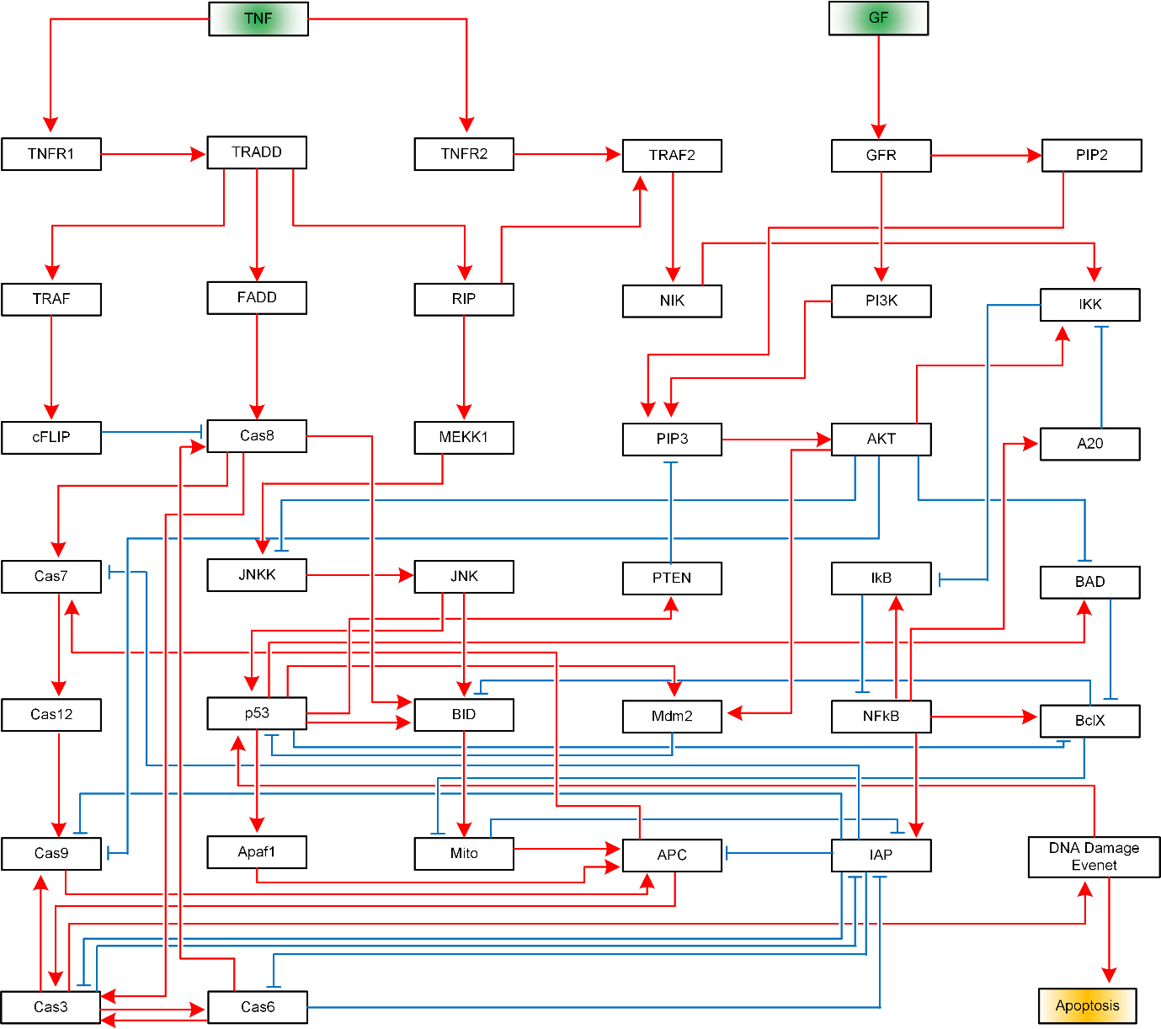

**Table S2.** Boolean logic rules of the cellular apoptosis network.

TNFR1 = TNF  
Cas8 = (Cas6 & ~cFLIP) | (FADD & ~cFLIP)  
cFLIP = TRAF  
Cas3 = (APC & ~IAP) | (Cas6 & ~IAP) | (Cas8 & ~IAP)  
PTEN = p53  
Cas6 = Cas3 & ~IAP  
NFkB = ~IkB  
TRAF2 = RIP | TNFR2  
BclX = NFkB & ~BAD & ~p53  
RIP = TRADD  
A20 = NFkB  
PI3K = GFR  
JNKK = MEKK1 & ~AKT  
AKT = PIP3  
DNADamageEvent = Cas3  
Cas9 = (Cas12 & ~AKT & ~IAP) | (Cas3 & ~AKT & ~IAP)  
TNFR2 = TNF  
PIP2 = GFR  
TRAF = TRADD  
BID = (Cas8 & p53 & ~BclX) | (JNK & p53 & ~BclX)  
APC = Apaf1 & Cas9 & Mito & ~IAP  
TRADD = TNFR1  
MEKK1 = RIP  
Mdm2 = AKT | p53  
Apaf1 = p53  
JNK = JNKK  
IKK = (AKT & ~A20) | (NIK & ~A20)  
BAD = p53 & ~AKT  
Cas12 = Cas7  
GFR = GF  
IAP = (NFkB & ~Cas3 & ~Mito) | (NFkB & ~Cas6 & ~Mito)  
Cas7 = (APC & ~IAP) | (Cas8 & ~IAP)  
NIK = TRAF2  
FADD = TRADD  
Mito = BID & ~BclX  
p53 = (DNADamageEvent & ~Mdm2) | (JNK & ~Mdm2)  
Apoptosis = DNADamageEvent  
PIP3 = PI3K & PIP2 & ~PTEN  
IkB = NFkB & ~IKK

**Fig. S2.** Connectivity graph of the MAPK signaling network [34], where red edges with arrows represent activation and blue ones with bars inhibition. This illustration is taken from [29].

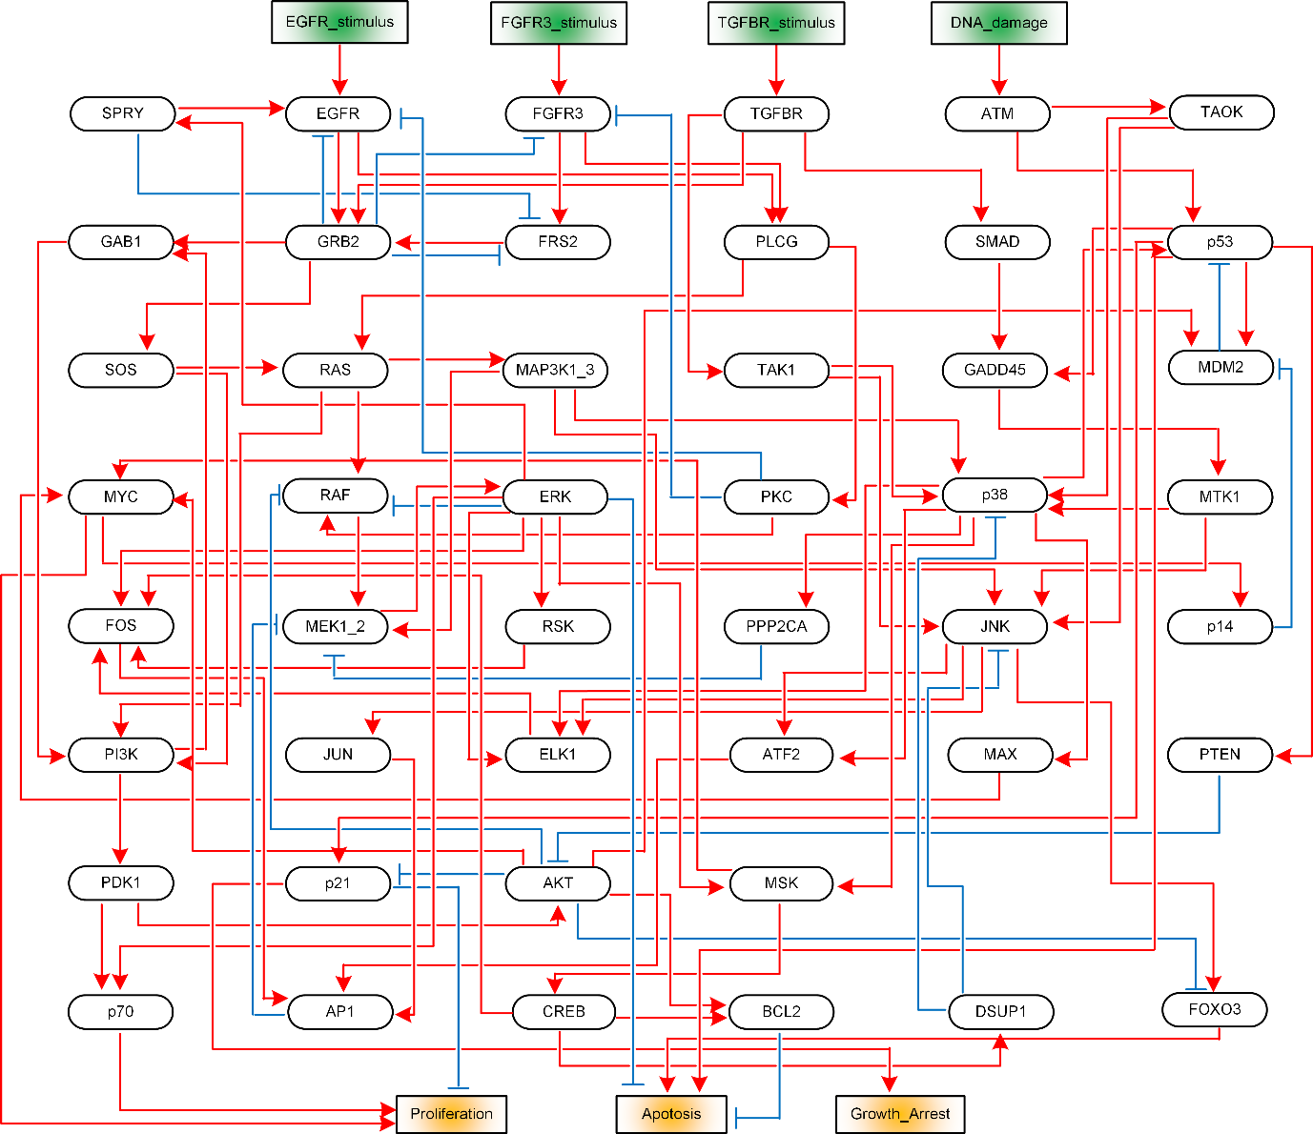

**Table S3.** Boolean logic rules of the MAPK signaling network.

AKT = PDK1 & ~PTEN  
AP1 = JUN & (FOS | ATF2)  
Apoptosis = ~BCL2 & ~ERK & FOXO3 & p53  
ATF2 = JNK | p38  
ATM = DNA_damage  
BCL2 = CREB & AKT  
CREB = MSK  
DNA_damage = DNA_damage  
DUSP1 = CREB  
EGFR = (EGFR_stimulus | SPRY) & ~(PKC | GRB2)  
EGFR_stimulus = EGFR_stimulus  
ELK1 = ERK | JNK | p38  
ERK = MEK1_2  
FGFR3 = FGFR3_stimulus & ~(GRB2 | PKC)  
FGFR3_stimulus = FGFR3_stimulus  
FOS = ERK & RSK & (ELK1 | CREB)  
FOXO3 = JNK & ~AKT  
FRS2 = FGFR3 & ~SPRY & ~GRB2  
GAB1 = GRB2 | PI3K  
GADD45 = SMAD | p53  
GRB2 = EGFR | FRS2 | TGFBR  
Growth_Arrest = p21  
JNK = (TAOK & MAP3K1_3) | (MAP3K1_3 & MTK1) | (TAOK & MTK1) | (TAK1 & MTK1) | (TAK1 & MAP3K1_3) | (TAK1 & TAOK) | ((TAOK | MTK1 | MAP3K1_3 | TAK1) & ~DUSP1)  
JUN = JNK  
MAP3K1_3 = RAS  
MAX = p38  
MDM2 = (p53 | AKT) & ~p14  
MEK1_2 = (RAF | MAP3K1_3) & ~(PPP2CA | AP1)  
MSK = ERK | p38  
MTK1 = GADD45  
MYC = (MSK & MAX) | (MSK & AKT)  
p14 = MYC  
p21 = ~AKT & p53  
p38 = (TAOK & MAP3K1_3) | (MAP3K1_3 & MTK1) | (TAOK & MTK1) | (TAK1 & MTK1) | (TAK1 & MAP3K1_3) | (TAK1 & TAOK) | ((TAOK | MTK1 | MAP3K1_3 | TAK1) & ~DUSP1)  
p53 = (ATM & p38) | ((ATM | p38) & ~MDM2)  
p70 = PDK1 & ERK  
PDK1 = PI3K  
PI3K = GAB1 | (RAS & SOS)  
PKC = PLCG  
PLCG = EGFR | FGFR3  
PPP2CA = p38  
Proliferation = p70 & MYC & ~p21  
PTEN = p53  
RAF = (RAS | PKC) & ~(ERK | AKT)  
RAS = SOS | PLCG  
RSK = ERK  
SMAD = TGFBR  
SOS = GRB2 & ~RSK  
SPRY = ERK  
TAK1 = TGFBR  
TAOK = ATM  
TGFBR = TGFBR_stimulus  
TGFBR_stimulus = TGFBR_stimulus

**Fig. S3.** Connectivity graph of the metastasis influence network [35], where red edges with arrows represent activation and blue ones with bars inhibition. This illustration is taken from [29].

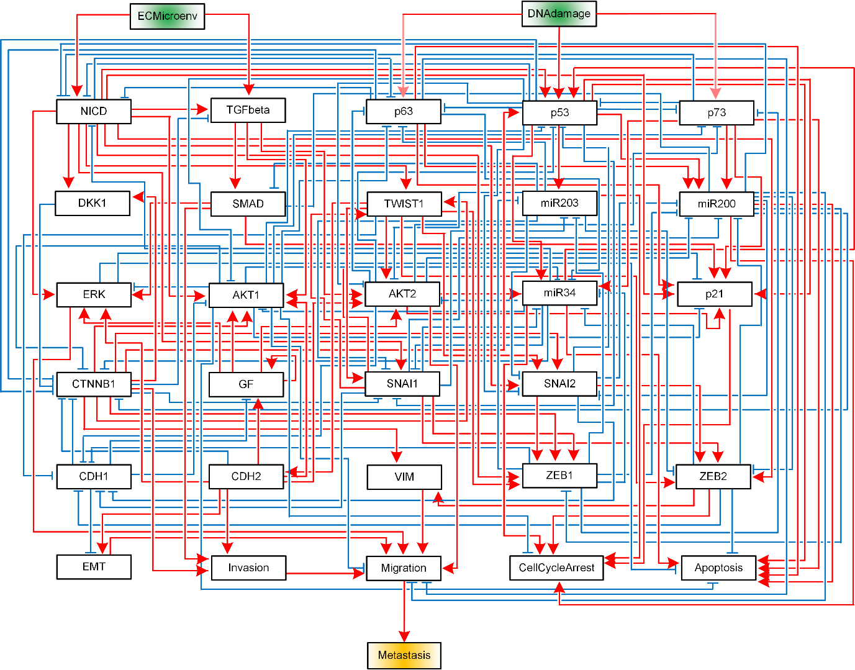

**Table S4.** Boolean logic rules of the metastasis influence network.

Metastasis = Migration  
Migration = VIM & AKT2 & ERK & ~miR200 & ~AKT1 & EMT & Invasion & ~p63  
Invasion = (SMAD & CDH2) | CTNNB1  
EMT = CDH2 & ~CDH1  
Apoptosis = (p53 | p63 | p73 | miR200 | miR34) & ~ZEB2 & ~AKT1 & ~ERK  
CellCycleArrest = (miR203 | miR200 | miR34 | ZEB2 | p21) & ~AKT1  
ECM = ECM  
DNAdamage = DNAdamage  
GF = ~CDH1 & (GF | CDH2)  
TGFbeta = (ECM | NICD) & ~CTNNB1  
p21 = ((SMAD & NICD) | p63 | p53 | p73 | AKT2) & ~(AKT1 | ERK)  
CDH1 = ~TWIST1 & ~SNAI2 & ~ZEB1 & ~ZEB2 & ~SNAI1 & ~AKT2  
CDH2 = TWIST1  
VIM = CTNNB1 | ZEB2  
TWIST1 = CTNNB1 | NICD | SNAI1  
SNAI1 = (NICD | TWIST1) & ~miR203 & ~miR34 & ~p53 & ~CTNNB1  
SNAI2 = (TWIST1 | CTNNB1 | NICD) & ~miR200 & ~p53 & ~miR203  
ZEB1 = ((TWIST1 & SNAI1) | CTNNB1 | SNAI2 | NICD) & ~miR200  
ZEB2 = (SNAI1 | (SNAI2 & TWIST1) | NICD) & ~miR200 & ~miR203  
AKT1 = CTNNB1 & (NICD | TGFbeta | GF | CDH2) & ~p53 & ~miR34 & ~CDH1  
DKK1 = CTNNB1 | NICD  
CTNNB1 = ~DKK1 & ~p53 & ~AKT1 & ~miR34 & ~miR200 & ~CDH1 & ~CDH2 & ~p63  
NICD = ~p53 & ~p63 & ~p73 & ~miR200 & ~miR34 & ECM  
p63 = DNAdamage & ~NICD & ~AKT1 & ~AKT2 & ~p53 & ~miR203  
p53 = (DNAdamage | CTNNB1 | NICD | miR34) & ~SNAI2 & ~p73 & ~AKT1 & ~AKT2  
p73 = DNAdamage & ~p53 & ~ZEB1 & ~AKT1 & ~AKT2  
miR200 = (p63 | p53 | p73) & ~(AKT2 | SNAI1 | SNAI2 | ZEB1 | ZEB2)  
miR203 = p53 & ~(SNAI1 | ZEB1 | ZEB2)  
miR34 = ~(SNAI1 | ZEB1 | ZEB2) & (p53 | p73) & AKT2 & ~p63 & ~AKT1  
AKT2 = TWIST1 & (TGFbeta | GF | CDH2) & ~(miR203 | miR34 | p53)  
ERK = (SMAD | CDH2 | GF | NICD) & ~AKT1  
SMAD = TGFbeta & ~miR200 & ~miR203

**Table S5.** Control input sets provided by the Logical DOI method for output stabilization of the cellular apoptosis network.

|  |
| --- |
| {'DNADamageEvent': True}  {'TNFR1': True, 'TRAF': False, 'NFkB': False}  {'Cas8': True, 'IkB': True}  {'APC': True, 'NFkB': False}  {'Cas3': True}  {'Cas8': True, 'NFkB': False}  {'TRADD': True, 'Mdm2': False, 'cFLIP': False, 'PIP3': False}  {'TRADD': True, 'cFLIP': False, 'NFkB': False}  {'TRADD': True, 'TRAF': False, 'NFkB': False}  {'TRADD': True, 'TRAF': False, 'IAP': False}  {'Cas7': True, 'Mito': True, 'p53': True}  {'Cas6': True, 'IAP': False}  {'APC': True, 'Mito': True}  {'p53': True, 'Cas6': True, 'cFLIP': False}  {'APC': True, 'IkB': True}  {'Cas8': True, 'IAP': False}  {'Mito': True, 'Cas6': True}  {'TNFR1': True, 'Cas9': True, 'p53': True, 'IkB': True}  {'JNK': True, 'Cas6': True, 'Mdm2': False}  {'BID': True, 'APC': True, 'BclX': False}  {'TNFR1': True, 'p53': True, 'TRAF': False}  {'Cas6': True, 'NFkB': False}  {'IkB': True, 'Cas6': True}  {'Cas8': True, 'p53': True}  {'TNF': True, 'TRAF': False, 'IAP': False}  {'APC': True, 'IAP': False}  {'Cas9': True, 'MEKK1': True, 'p53': True}  {'JNK': True, 'p53': True, 'Cas6': True}  {'TNFR1': True, 'IkB': True, 'cFLIP': False}  {'TNFR1': True, 'Mito': True, 'TRAF': False}  {'FADD': True, 'IkB': True, 'TRADD': False}  {'p53': True, 'TNF': True, 'Cas6': True}  {'Cas9': True, 'p53': True, 'TNF': True}  {'Mito': True, 'TNF': True, 'cFLIP': False}  {'BID': True, 'APC': True, 'BAD': True}  {'JNKK': True, 'TRADD': True, 'TRAF': False, 'Mdm2': False}  {'APC': True, 'TRADD': True, 'Mdm2': False, 'GFR': False}  {'Cas8': True, 'Mito': True}  {'FADD': True, 'TNF': False, 'NFkB': False}  {'MEKK1': True, 'p53': True, 'Cas6': True}  {'MEKK1': True, 'Cas12': True, 'p53': True}  {'FADD': True, 'IkB': True, 'TRAF': False}  {'FADD': True, 'cFLIP': False, 'NFkB': False}  {'p53': True, 'Cas6': True, 'TNF': False}  {'TRADD': True, 'p53': True, 'cFLIP': False}  {'BID': True, 'FADD': True, 'TRADD': False, 'BclX': False}  {'TRADD': True, 'Mito': True, 'TRAF': False}  {'TRADD': True, 'cFLIP': False, 'IAP': False}  {'Cas8': True, 'MEKK1': True, 'Mdm2': False, 'GF': False}  {'p53': True, 'Cas6': True, 'TRADD': False}  {'p53': True, 'Cas6': True, 'TNFR1': False}  {'FADD': True, 'TRAF': False, 'NFkB': False}  {'Cas9': True, 'TNF': True, 'PI3K': False, 'Mdm2': False}  {'IkB': True, 'TNF': True, 'TRAF': False}  {'TNFR1': True, 'Mito': True, 'cFLIP': False}  {'BID': True, 'Cas7': True, 'p53': True}  {'TNFR1': True, 'cFLIP': False, 'NFkB': False}  {'JNKK': True, 'Cas6': True, 'Mdm2': False}  {'MEKK1': True, 'Cas7': True, 'p53': True}  {'Cas8': True, 'MEKK1': True, 'Mdm2': False, 'GFR': False}  {'p53': True, 'TNF': True, 'TRAF': False}  {'Apaf1': True, 'Cas7': True, 'Mito': True, 'PIP2': False}  {'TRADD': True, 'p53': True, 'TRAF': False} |

**Table S6.** Control input sets provided by the Logical DOI method for output stabilization of the MAPK signaling network.

|  |
| --- |
| {'TGFBR_stimulus': True}  {'TGFBR': True}  {'JNK': True, 'p14': True, 'p38': True}  {'FGFR3': True, 'ATM': True}  {'GRB2': True, 'DNA_damage': True, 'RSK': False}  {'ATM': True, 'EGFR': True}  {'p53': True, 'EGFR': True}  {'DNA_damage': True, 'MSK': False}  {'RAS': True, 'CREB': False}  {'TAK1': True, 'DUSP1': False}  {'MYC': True, 'ATM': True, 'MEK1_2': False}  {'GADD45': True, 'DNA_damage': True}  {'p53': True, 'PLCG': True}  {'p53': True, 'CREB': False}  {'JNK': True, 'p38': True}  {'FGFR3': True, 'p53': True}  {'GADD45': True, 'TAK1': True}  {'MTK1': True, 'TAK1': True}  {'p53': True, 'SOS': True}  {'p53': True, 'MSK': False}  {'SMAD': True, 'SOS': True}  {'ATM': True, 'DUSP1': False}  {'FOXO3': True, 'AP1': True, 'p53': True}  {'ATM': True, 'ERK': False, 'MSK': False}  {'JNK': True, 'p53': True}  {'TAK1': True, 'EGFR': True}  {'FRS2': True, 'p53': True, 'ERK': False}  {'FRS2': True, 'DNA_damage': True, 'ERK': False}  {'MAP3K1_3': True, 'DNA_damage': True}  {'p53': True, 'ATM': True}  {'TAK1': True, 'CREB': False}  {'p53': True, 'TAK1': True}  {'GRB2': True, 'p38': True}  {'GADD45': True, 'p14': True, 'EGFR': True}  {'PLCG': True, 'CREB': False}  {'EGFR': True, 'CREB': False}  {'p38': True, 'PLCG': True}  {'p53': True, 'RAS': True}  {'p38': True, 'EGFR': True}  {'FOXO3': True, 'p38': True}  {'TAOK': True, 'EGFR': True, 'ERK': False}  {'TAK1': True, 'TAOK': True}  {'FGFR3': True, 'GADD45': True}  {'SMAD': True, 'DUSP1': False}  {'p53': True, 'TGFBR': True}  {'TGFBR_stimulus': True, 'PDK1': False}  {'GRB2': True, 'JNK': True, 'CREB': False} |

**Table S7.** Control input sets provided by the Logical DOI method for output stabilization of the metastasis influence network.

|  |
| --- |
| {'CTNNB1': True, 'p73': True, 'miR203': True, 'CDH2': False, 'GF': False}  {'p53': True, 'ERK': False}  {'miR200': True, 'ERK': False}  {'miR34': True, 'ERK': False}  {'p53': True, 'miR203': True, 'ERK': False}  {'CTNNB1': True, 'miR203': True, 'AKT1': False, 'ERK': False, 'DNAdamage': False}  {'miR203': True, 'miR34': True, 'GF': False}  {'miR200': True, 'CDH2': False, 'GF': False}  {'p63': True, 'miR34': True, 'GF': False}  {'miR34': True, 'GF': False, 'TGFbeta': False}  {'p53': True, 'TWIST1': False, 'ERK': False}  {'miR200': True, 'TWIST1': False, 'ERK': False}  {'miR200': True, 'TWIST1': False, 'GF': False}  {'p73': True, 'miR203': True, 'CTNNB1': False, 'GF': False}  {'p73': True, 'miR203': True, 'ZEB1': False, 'ERK': False}  {'p63': True, 'TWIST1': False, 'ERK': False}  {'miR203': True, 'miR34': True, 'ERK': False}  {'miR200': True, 'miR203': True, 'GF': False}  {'p53': True, 'GF': False}  {'p63': True, 'SNAI1': False, 'ERK': False}  {'p53': True, 'miR203': True, 'GF': False}  {'CDH1': True, 'p73': True, 'miR203': True, 'ERK': False}  {'p63': True, 'TWIST1': False, 'GF': False}  {'p63': True, 'ZEB2': False, 'ERK': False}  {'NICD': True, 'miR203': True, 'ERK': False, 'DNAdamage': False}  {'CDH1': True, 'p73': True, 'TWIST1': False, 'GF': False}  {'p53': True, 'SMAD': False, 'GF': False}  {'miR34': True, 'TWIST1': False, 'ECM': False, 'GF': False}  {'DNAdamage': True, 'SNAI1': False, 'CTNNB1': False, 'NICD': False, 'p73': False, 'ERK': False}  {'miR34': True, 'DNAdamage': False, 'GF': False}  {'CDH1': True, 'p73': True, 'SNAI1': False, 'ERK': False}  {'p63': True, 'miR203': True, 'ERK': False}  {'p53': True, 'miR200': True, 'ERK': False}  {'DKK1': True, 'p73': True, 'miR203': True, 'ERK': False}  {'miR200': True, 'miR34': True, 'ERK': False}  {'miR34': True, 'SNAI2': False, 'ERK': False}  {'miR34': True, 'ECM': False, 'GF': False}  {'CTNNB1': True, 'p53': True, 'TWIST1': False, 'GF': False} |