Grab challenge: Safety

Based on telematics data, how might we detect if the driver is driving dangerously?

1. Concatenate and read out the time series Telematics data:

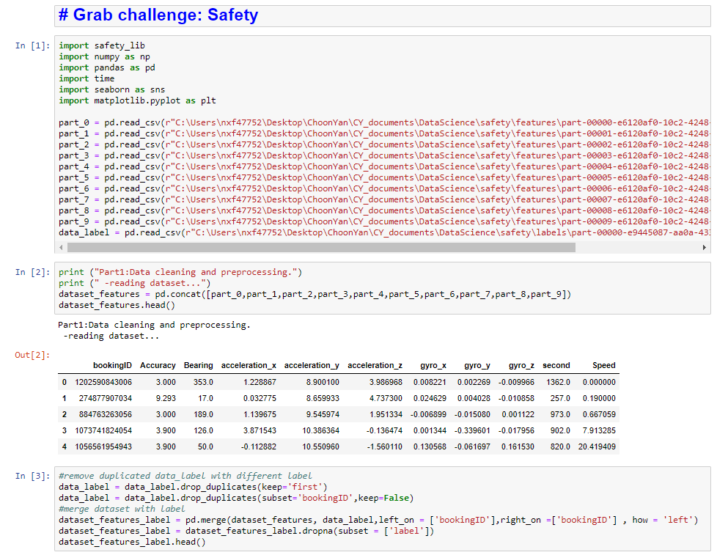

1. Duplicated booking ID with different data label were removed to avoid model accuracy impacted.



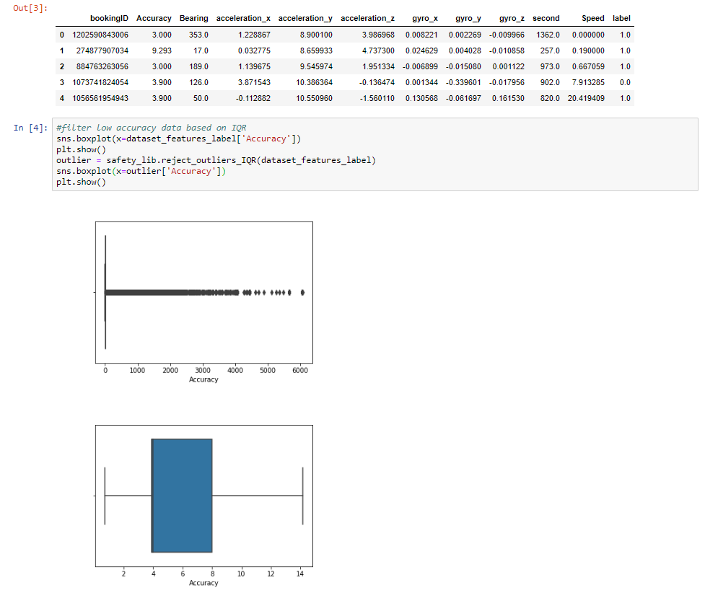

1. Telematics data with low accuracy is removed based on Interquartile range.



1. Checkout the bearing changes/differences by second by comparing current Bearing vs previous Bearing.

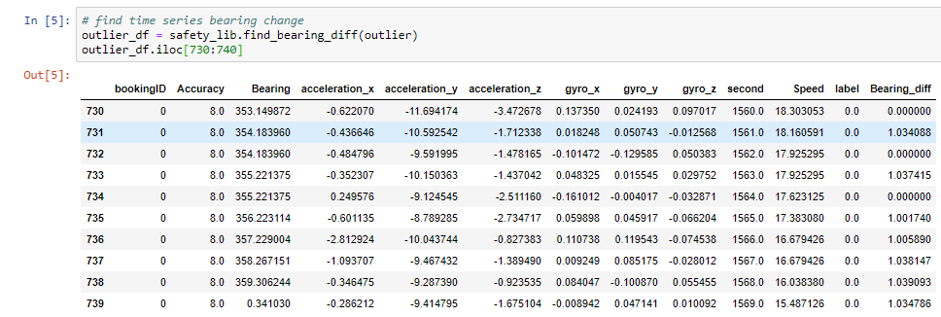

1. This step will offset the x,y,z by taking mean of data during speed and bearing different are 0. This method can normalized the data regardless of the phone angle/orientation placed in the vehicle.

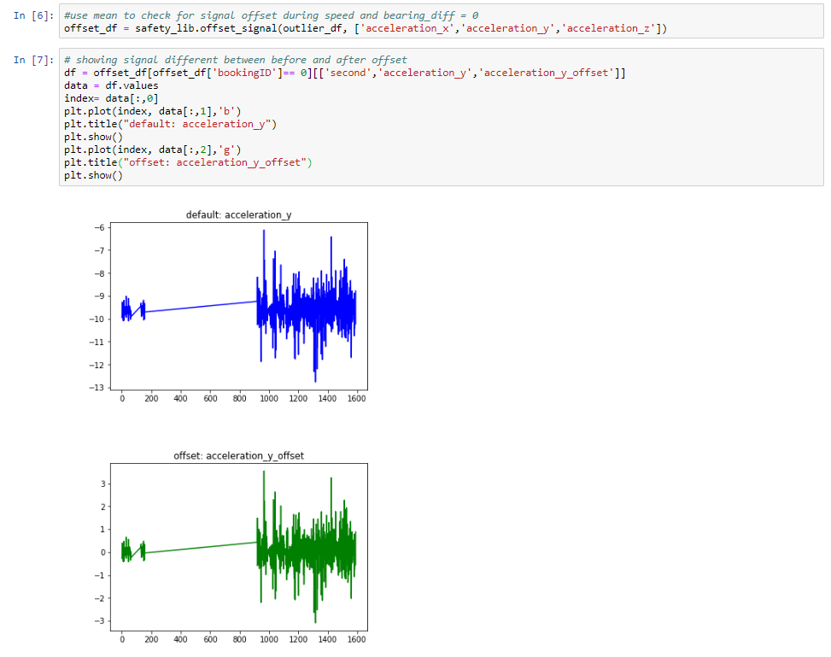

1. Create feature for magnitude of acceleration using the orientation independent method.

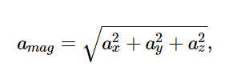

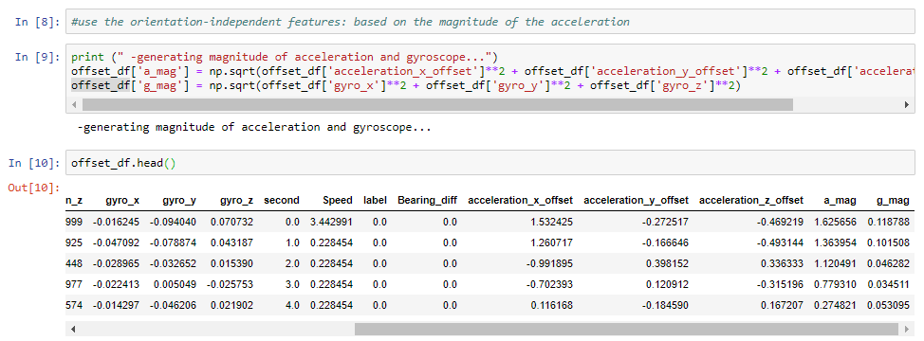

1. Modelling:

* random forest algorithm is used in this challenge as proposed in the research paper that this algorithm is the best classifier with most of feature sets in terms of accuracy and AUC.

(link: <https://www.ncbi.nlm.nih.gov/pmc/articles/PMC5948751/>)

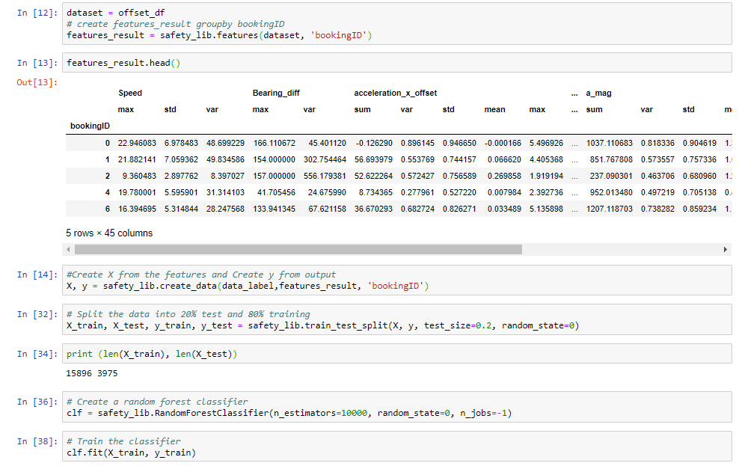

* Checking the features importance

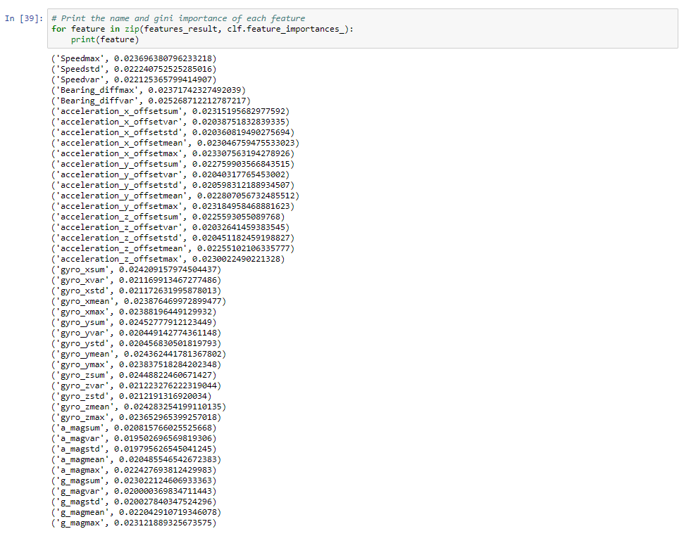

* Apply test data and check the model performance. Accuracy is up to 74.4%.

