

PPC0065: ELECTRICITY AND BASIC LOGIC

GROUP PROJECT

*****

LECTURER: THIYAGU A/L KATHIYAIAH

GROUP: FT41

|  |  |  |
| --- | --- | --- |
| NAME | ID | SIGNATURE |
| Lee Zhen Zhi | 1122702996 |  |
| Ooi Choon Ho | 1122702995 |  |
| Chong Ee Xen | 1122703183 |  |

CONTENTS

|  |  |
| --- | --- |
| TITLE | PAGE |
| Introduction | 1 |
| Task Distribution | 3 |
| Planning of the Project/Flow Chart | 4 |
| Problems Faced and Solved | 9 |
| Screenshots of the Program | 10 |
| Conclusion and Recommendation | 13 |

INTRODUCTION

Introduction of the Project

This is a project conducted on Trimester 2 2013/2014 under the subject PPC0065 Electricity and Basic Logic. In this project, we have created a program which is capable of calculating the total resistance, current and power using Visual Basic.NET. We named our program as “ElecCalc”.

How to use ElecCalc:

1. User is required to choose between series and parallel circuit.
2. Then, user can select any color for each of the band of a resistor.
3. User then have to click “Add” to add resistors into the circuit.
4. The results (value of total resistance, current and power) will be calculated and displayed.

Table below is used as the reference for the values of resistors:

|  |  |  |
| --- | --- | --- |
| **Band Location** | **Color** | **Digit** |
| **Resistance value for the first three bands** | Black  Brown  Red  Orange  Yellow  Green  Blue  Violet  Gray  White | 0  1  2  3  4  5  6  7  8  9 |
| **Tolerance value for Forth band** | Gold  Silver  No Band | 5%  10%  20% |

Table below is the formula used to calculate value of resistance:

|  |  |
| --- | --- |
|  |  |
| RT = R1 + R2 + … + Rn | .  RT  = [  **+ + … +** ]-1 |

Objective

The purpose of this project is to develop a program that is able to calculate the total resistance, current and power of a circuit with any quantity of resistor(s) for a series circuit and a parallel circuit.

Requirements to be met

The following points are the requirements for the program to be developed:

1. The input of the circuit is the color code of a resistor.
2. The output of the circuit is a total resistance, current and power of a circuit. The total resistance, current and power must be represented in decimal number.

Acknowledgment

As a team, this project was able to proceed successfully thanks to the efforts of its team members namely Lee Zhen Zhi, Ooi Choon Ho and Chong Ee Xen. Each and everyone of them has dedicated themselves to the development of the program “ElecCalc” (that's what we name it) and have tested it in every way possible to ensure that it meets the requirements given and it is error free.

Our lecturer, Mr. Thiyagu has also helped us with some answers and details regarding the problem faced by us during consultations and mandatory meetings.

TASK DISTRIBUTION

Team Leader

Lee Zhen Zhi

Ideas and Documentation

Ooi Choon Ho

Chong Ee Xen

Programmers

Lee Zhen Zhi

Ooi Choon Ho

Chong Ee Xen

Designing and Testing

Lee Zhen Zhi

Ooi Choon Ho

Chong Ee Xen

PLANNING OF THE PROJECT/FLOW CHART















PROBLEMS FACED AND SOLVED

Decimal Places

At first, we were having problem with the decimal places of the calculated total resistance, current and power. We couldn't round the answers to 2 decimal places.

The problem was a run-time error and we have spent >30 minutes to solve it.

We solved the problem by carefully converting the data type of the variables when they are passed to a function and vice versa.

Resistance Tolerance Value

We have been wondering how to calculate the total resistance with tolerance value to no avail.

This problem does not need to be solved because our lecturer said that the calculation does not need to involve the tolerance value of the resistor.

Preventing Invalid Input in the Voltage Textbox

We tried hard to figure out how to restrict the user's input to only numerals in the voltage textbox.

This was done easily. However, another problem arises, that is, the voltage textbox couldn't accept the character “.”. Thus, the user's input were limited to integers instead of both integers and decimal numbers.

We searched the Internet for the ASCII key code of the character “.” and solved the problem.

Bombastic Voltage Values

During alpha testing, we tested the function for the calculation of the total resistance, current and power recursively.

We found out that if we enter a voltage value that is too (very very very) large (e.g. 10000000000000 and above), the program will crash due to variables being overloaded.

We solved the problem by using a Try...Catch statement for that function.

SCREENSHOTS OF THE PROGRAM

(program opened in Windows 8, different OSes have different interfaces)

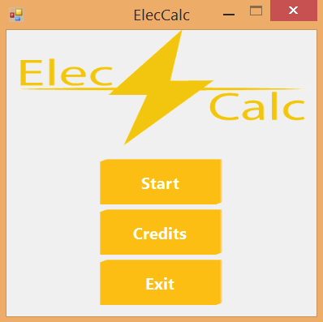

Main Menu

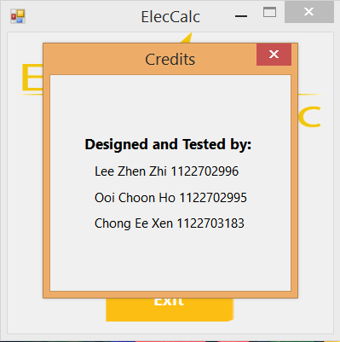

Credits

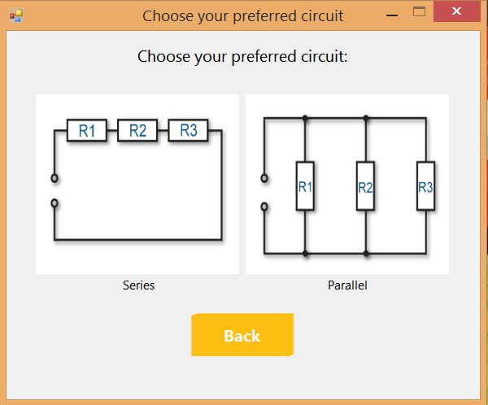

Circuit Menu

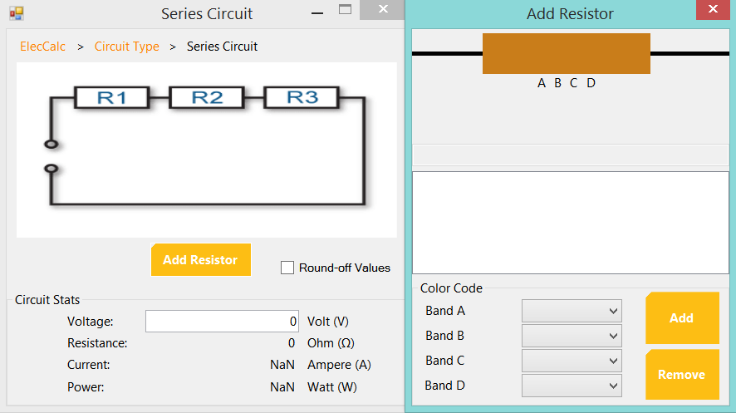

Series Circuit

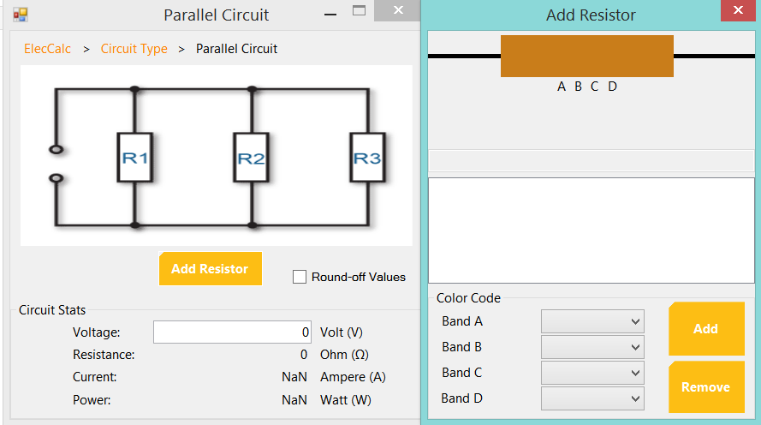

Parallel Circuit

CONCLUSION AND RECOMMENDATION

Conclusion

This project is very beneficial to us as it allows us to have a full understanding of the concept of an electric circuit whether it is a series circuit or parallel circuit when it comes to calculating the total resistance, current and power.

Recommendation and Comments

There are no comments for this project as we understand the problem and we know what we must do.

In the future, we hope that we will be able to develop a better “ElecCalc” by first implementing a feature of what we called the “Dynamic Visualization” for our circuit pictures. The concept is simple, that is, the picture changes according to the number of resistors added.