logommu

PIM0035: MULTIMEDIA PROJECT

FINAL REPORT

INTRODUCTION TO JAVA PROGRAMMING

********

LECTURER: MADAM WAHIDA

GROUP: FT41

SUBMISSION DATE: 22-01-2014

|  |  |  |
| --- | --- | --- |
| NAME | ID | SIGNATURE |
| Lee Zhen Zhi | 1122702996 |  |
| Ooi Choon Ho | 1122702995 |  |
| Chong Ee Xen | 1122703183 |  |

ACKNOWLEDGEMENT

We would like to express our special thanks of gratitude to our lecturer, Madam Wahida who had been helping us out when our project was still in progress. Madam Wahida had been advising and guiding us throughout the development of this project and we were able to finish our project within the time given.

Secondly, we would like to thank our parents for helping and supporting us throughout this project.

Last but not least, we would like to thank our friends who had been providing us ideas and also helping us in testing out our product throughout this project before we are able to produce the final product.

We are really thankful to all of them.

OBJECTIVE

The objectives of this courseware, Introduction to Java Programming is:

* To teach students the fundamentals of Java programming.
* To help students create their first Java program.
* To provide better understanding of the Java programming language.

After using this courseware, users are able to:

1. Grasp the fundamentals of Java programming.
2. Create their own Java program.
3. Have a better understanding of the Java programming language.

TABLE OF CONTENTS

Contents

ACKNOWLEDGEMENT 2

OBJECTIVE 3

TABLE OF CONTENTS 4

INTRODUCTION 5

CONTENT 7

TOPIC 1 – OVERVIEW 7

TOPIC 2 – ENVIRONMENT SETUP 7

TOPIC 3 – BASIC SYNTAX 7

TOPIC 4 – BASIC DATATYPES 7

TOPIC 5 – CONTROL FLOW 7

TOPIC 6 – CONDITIONAL LOGIC 7

QUIZZES 7

TARGET AUDIENCE 8

TASK DISTRIBUTION 9

COST ESTIMATION 10

NAVIGATION STRUCTURE 11

STORYBOARD 13

USER MANUAL 81

Main Menu 81

Topic Menu 82

Topic Page 83

Quiz Menu 84

Quiz Page 85

CONCLUSION 86

LIST OF REFERENCES 87

APPENDIX A 88

APPENDIX B 89

INTRODUCTION

This is a project conducted on Trimester 2 2013/2014 under the subject PIM0035, Multimedia Project. In this project, we have produced an educational courseware. This courseware is an **education and training product**. The title for this courseware is **Introduction to Java Programming**.

One of the reason why we choose this topic is because we think that this topic is unique and it differs from the topics that had been chosen by other groups. The main reason why we choose Java is because C++ is already included in the foundation course in MMU.

This courseware can be broken down into 2 sections which are topics and quizzes:

|  |  |
| --- | --- |
| Topics | Quizzes |
| 1. Topic 1 - Overview | 1. Quiz 1 - Overview |
| 1. Topic 2 - Environment Setup | 1. Quiz 2 – Environment Setup |
| 1. Topic 3 - Basic Syntax | 1. Quiz 3 - Basic Syntax |
| 1. Topic 4 - Basic Datatypes | 1. Quiz 4 – Basic Dataypes |
| 1. Topic 5 - Control Flow | 1. Quiz 5 – Control Flow |
| 1. Topic 6 - Conditional Logic | 1. Quiz 6 – Conditional Logic |

In topics, it includes:

* Explanations and examples - Help users to understand better about each topic.
* Graphics and animations - Demonstration purposes.

In quizzes, it includes:

* Instructions - Help users to understand how to carry out the quiz.
* Animations - To indicate whether the user has answered the quiz correctly or not.

This courseware uses a composite navigation structure where it is a combination of linear and non-linear. This enables the users to be able to navigate and control the flow of this courseware.

Developer’s perspective:

1. Content

The content in this courseware is comprehensive. The material is also useful to users and it can be understood easily as the explanations and instructions is included in this courseware.

1. Performance

This courseware does not require a high-performance machine to run. On top of that, this courseware can be run on different platforms through the Internet.

1. Delivery

Users are able to use this courseware almost immediately because it does not require any installation, there is no special configuration needed and the label on each button is clear enough to explain the function of each particular button. Users can acquire this courseware through CDs, USB thumb drives or from the Internet.

1. Interface

The interface in this courseware is also user-friendly and it works smoothly without any error occuring. Users are able to navigate freely in this courseware and this courseware is agreed to be useful to advance users as well.

CONTENT

TOPIC 1 – OVERVIEW

This topic introduces some facts about Java (e.g. who developed it, owned by who etc.) and the characteristics of the Java programming language.

TOPIC 2 – ENVIRONMENT SETUP

This topic introduces an IDE called Netbeans IDE to the user. This topic will also teach and demonstrate the way on how to start a new project with Netbeans IDE.

TOPIC 3 – BASIC SYNTAX

This topic shows some of the basic syntax of Java and provides explanation on each of its components.

TOPIC 4 – BASIC DATATYPES

This topic introduces the user to some of the basic datatypes of Java (e.g. byte, int, bool).

TOPIC 5 – CONTROL FLOW

This topic introduces the loop concept to the user. For this courseware, only two loops will be covered (the while loop and the for loop).

TOPIC 6 – CONDITIONAL LOGIC

This topic teaches the user on basic conditional logics (e.g. if…else statements).

QUIZZES

As for the quizzes, each quiz will be based on their respective topic. For example, Quiz 1 will be based on Topic 1 and so on.

TARGET AUDIENCE

Our targeted audience are students who are studying Foundation courses or Pre-U programmes and are interested in learning Java programming language.

To relate our target audience and multimedia elements used in this courseware:

1. Text - For Foundation and Pre-U students, they would prefer reading text which convey informations and instructions. The text presented is in simple language and anyone could understand easily.
2. Graphics - They also like graphics or pictures which is used as an example or demonstration because it sometime helps them to understand the information that is being conveyed by a sentence.
3. Audio - They also like listening to comfortable and suitable songs while studying.
4. Animation – Some sections of the courseware has simple animations to present the information to the users. Most Foundation and Pre-U students prefer this type of presentation.

TASK DISTRIBUTION

Our multimedia team:

|  |  |
| --- | --- |
| Lee Zhen Zhi : | Project Manager  Multimedia Programmer |
| Ooi Choon Ho: | Audio Specialist |
| Chong Ee Xen: | Multimedia Designer |

Zhen Zhi is the leader of our multimedia team in this project and he oversees the overall development of the project as well as day to day operations. In addition, he is also our multimedia programmer and he integrates all the multimedia elements using authoring system (SwishMax) and scripting language (swishscript) to make our courseware able to function. Scripting and programming sections in our courseware is taken care by him.

Choon Ho is our audio specialist and he focused on the audio production (using Audacity). He records narration, combines and produces music as well as looking for sound effects such as button sounds. The background music of this courseware is also mixed, edited and produced by him.

Ee Xen is our multimedia designer and he deals with visual aspects of the project including graphic design, illustration, animation, interface design and image processing (using Paint.NET). He makes sure that the flow of the information is maintained and navigation is clear and consistent. He designs the layout and the background for our courseware.

COST ESTIMATION

The cost we estimated during stage 1 of the multimedia development process is that we needed a longer time to produce our output as **we have only 3 members** and **our budget is limited**. The estimated time needed to develop this courseware was **12 weeks** and the estimated budget was less than **RM100**.

The duration for the development of our product we estimated during stage 1 was proven to be true as we finished our multimedia product in **12 weeks’** time (as estimated).

The amount of money spent on electricity, water and other daily necessities is **around RM70** and the amount of money spent on printing is **RM28.40**.

Therefore, the total amount of money we used is **RM98.40** and has proved our budget estimation to be true.

NAVIGATION STRUCTURE

The reason we used a navigation structure is because:

1. It helps to outline the connections / links among contents
2. It provides a table of content & a logical flowchart of the interactive surface

The navigation structure that we chose to use is a **composite navigation structure**. The reason we chose this navigation structure is:

1. To allow user to navigate freely but sometimes constrained to linear presentations
2. To allow user to go to the previous page if user missed any part of that page and skip to the next page if user wants to continue where he/she stopped previously

STORYBOARD

The reason we use a storyboard is because:

1. It enables us to work out & discuss our ideas
2. It visualizes how our project will look like
3. It describes how our project is sequenced & put together
4. It shows a step by step guide in developing our project

USER MANUAL

B3

B4

B1

B2

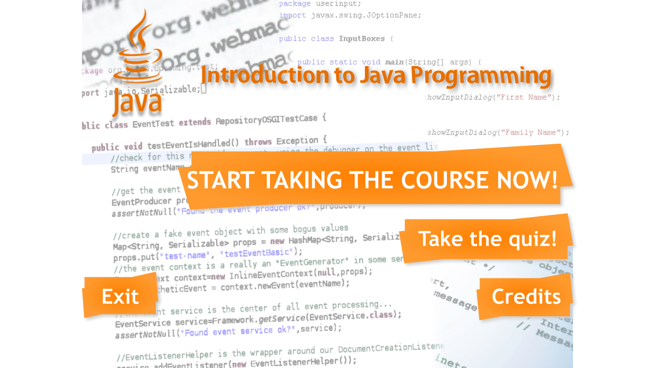

## Main Menu

1. To proceed to Topic Menu, click on B1.
2. To proceed to Quiz Menu, click on B2.
3. To proceed to Credits page, click on B3.
4. To exit this courseware, click on B4.

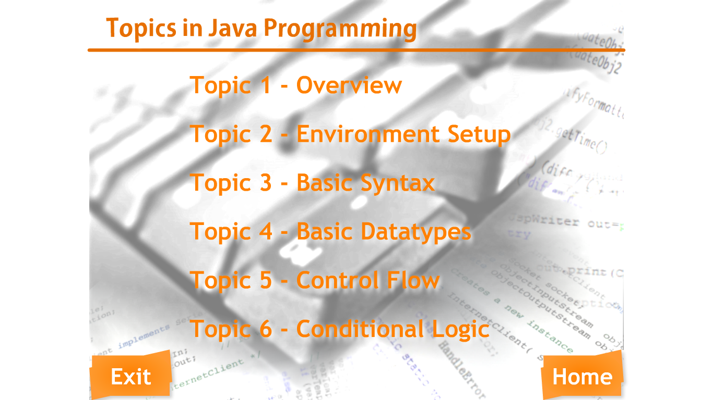

B11

B7

B8

B9

B10

B6

B5

B12

## Topic Menu

1. To proceed to “Topic 1 – Overview”, click on B5.
2. To proceed to “Topic 2 – Environment Setup”, click on B6.
3. To proceed to “Topic 3 – Basic Syntax”, click on B7.
4. To proceed to “Topic 4 – Basic Datatypes”, click on B8.
5. To proceed to “Topic 5 – Control Flow”, click on B9.
6. To proceed to “Topic 6 – Conditional Logic”, click on B10.
7. To go back to Main Menu, click on B11.
8. To exit this courseware, click on B12.

B17

B15

B16

B14

B13

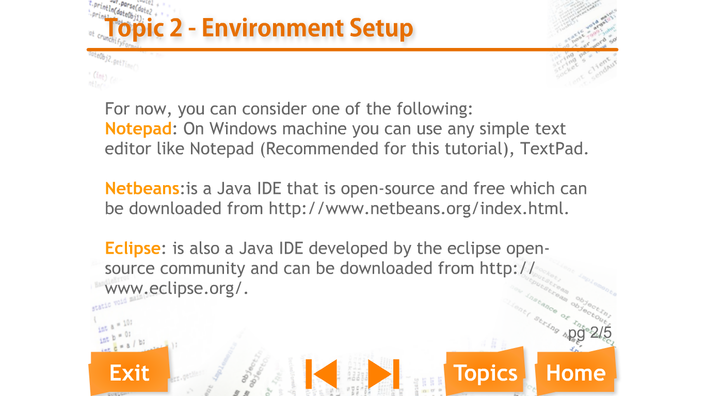

## Topic Page

1. To go back to Topic Menu, click on B13.
2. To go back to Main Menu, click on B14.
3. To proceed to next page of the same topic, click on B15.
4. (If the B15 is greyout, it indicates that it is the last page of that particular topic.)
5. To go back to previous page of the same topic, click on B16.
6. (If the B16 is greyout, it indicates that it is the first page of that particular topic.)
7. To exit this courseware, click on B17.

B22

B21

B20

B19

B18

B23

B24

B25

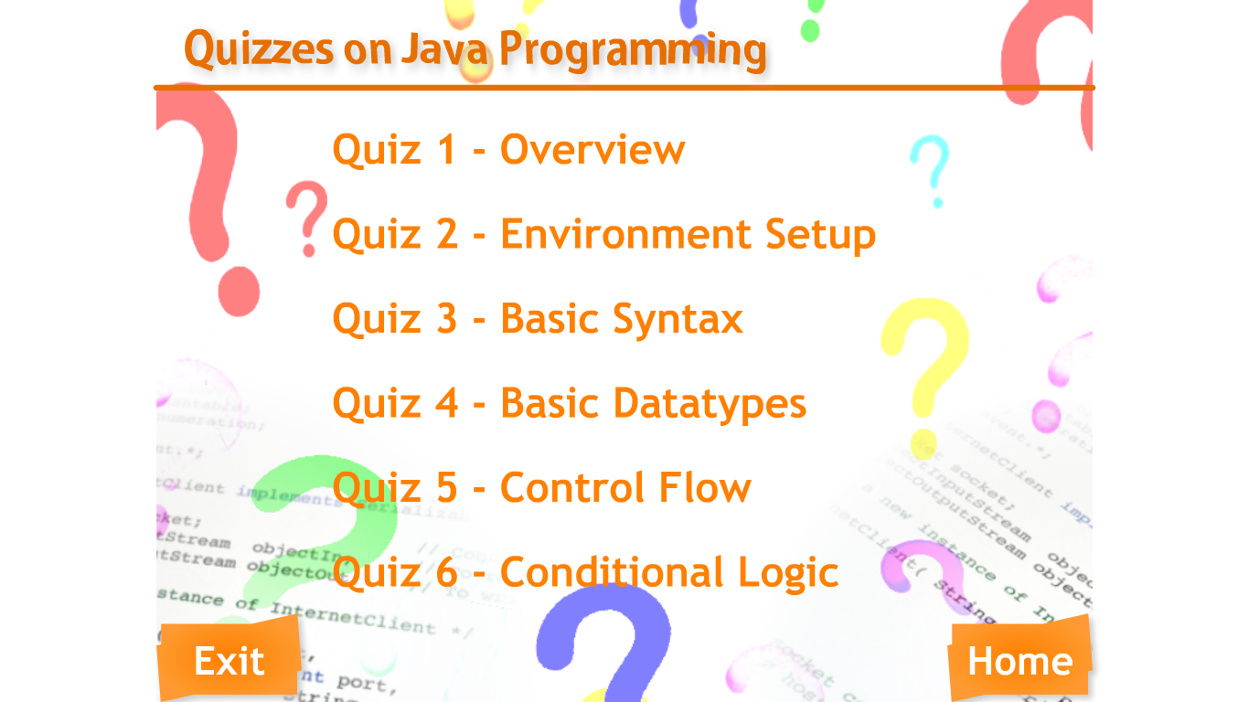

## Quiz Menu

1. To proceed to “Quiz 1 – Overview”, click on B18.
2. To proceed to “Quiz 2 – Environment Setup”, click on B19.
3. To proceed to “Quiz 3 – Basic Syntax”, click on B20.
4. To proceed to “Quiz 4 – Basic Datatypes”, click on B21.
5. To proceed to “Quiz 5 – Control Flow”, click on B22.
6. To proceed to “Quiz 6 – Conditional Logic”, click on B23.
7. To go back to Main Menu, click on B24.
8. To exit this courseware, click on B25.

B30

B27

B26

B28

B29

B31

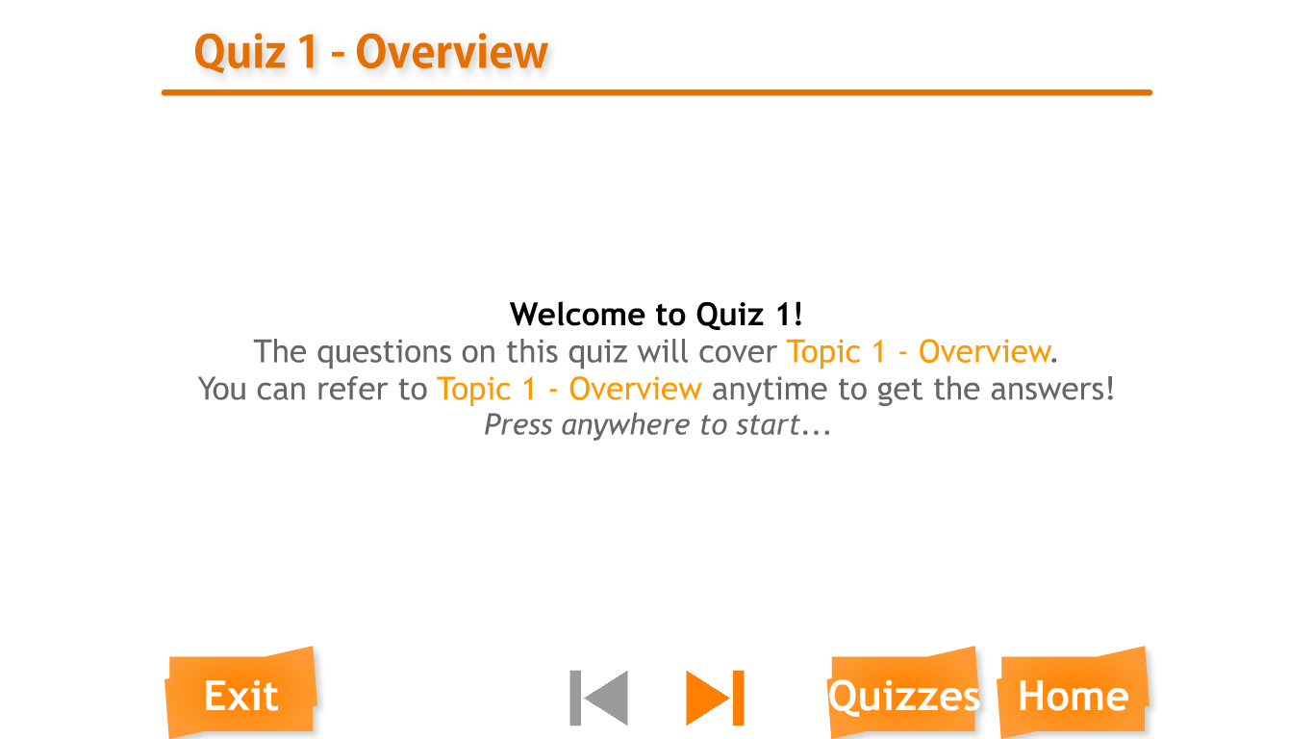

## Quiz Page

1. To go back to Quiz Menu, click on B26.
2. To go back to Main Menu, click on B27.
3. To proceed to next quiz, click on B28.
4. (If the B15 is greyout, it indicates that it is the last quiz.)
5. To go back to previous quiz, click on B29.
6. (If the B16 is greyout, it indicates that it is the first quiz.)
7. To start the quiz, click on B30. After clicking B30, read the instructions appeared on the screen, then click on anywhere to start doing the quiz.
8. To exit this courseware, click on B31.

CONCLUSION

Overall, we have learnt a lot when we are carrying out this project. We have learnt that planning and costing is important before starting a project because it determines our budget and also the outline and scope of the project that we are about to carry out.

Secondly, we have also learnt that teamwork is important when we are working as a team because each team member has his own task and in order to finish our project on time, all team members has to finish their task according to the time given.

We have also learnt that testing a product is also an important step in producing a courseware because we have to test for its user-friendliness, functions and errors before we are able to produce the final product which can function fully and error-free.

LIST OF REFERENCES

1. <http://swishscript.org/>
2. <http://www.tutorialspoint.com/java/index.htm>
3. <http://www.swishzone.com/index.php?area=products&product=max>
4. <http://perioncorner.com/?p=browse&c=sound#UI.img>
5. <https://netbeans.org/kb/articles/learn-java.html>
6. Multimedia: Making It Work by Tay Vaughan, 8th Edition 2011 McGraw Hill

APPENDIX A

APPENDIX B