Freelance3: A Privacy-Preserving Blockchain Architecture for Verifiable Freelance Credentials and Reputation
Krupa K S  Department of Computer Science and Engineering  (IoT and Cyber Security including Blockchain Technology)  BMS College of Engineering  Bengaluru, India  krupaks.csi@bmsce.ac.in | Sushma Ethadi  Department of Computer Science and Engineering  (IoT and Cyber Security including Blockchain Technology)  BMS College of Engineering  Bengaluru, India  ethadisushma.csi@bmsce.ac.in | Ashmit Gupta  Department of Computer Science and Engineering  (IoT and Cyber Security including Blockchain Technology)  BMS College of Engineering  Bengaluru, India  ashmitgupta.ci23@bmsce.ac.in
Harshit Jaiswal  Department of Computer Science and Engineering  (IoT and Cyber Security including Blockchain Technology)  BMS College of Engineering  Bengaluru, India  harshitjaiswal.ci23@bmsce.ac.in | Poorvi Rastogi  Department of Computer Science and Engineering  (IoT and Cyber Security including Blockchain Technology)  BMS College of Engineering  Bengaluru, India  poorvirastogi.ci23@bmsce.ac.in

Abstract—Decentralized freelance platforms need verifiable mechanisms for establishing trust between clients and independent contractors without exposing private behavioural histories. Conventional platforms commonly depend on centralized payment operations, platform-controlled ratings, and self-declared portfolios, which limit independent credential verification and can require disclosure of sensitive performance data. Freelance3 presents a privacy-preserving hybrid blockchain architecture that combines AI-assisted skill verification, non-transferable on-chain credentials, zero-knowledge reputation proofs, predictive dispute detection, and smart-contract escrow. The architecture keeps credential issuance, proof verification, and escrow settlement on-chain, while moving skill evaluation, zero-knowledge proof generation, behavioural-data processing, and graph analytics to controlled off-chain services. The prototype is evaluated on a local Hardhat blockchain using transaction cost, execution latency, proof-generation time, proof-verification cost, and functional correctness as evaluation metrics. The design demonstrates how separating computationally intensive processing from security-critical state transitions can preserve auditability and privacy while reducing the computational burden placed on the blockchain.
Index Terms—blockchain, decentralized freelancing, zero-knowledge proofs, verifiable credentials, smart contracts, reputation systems, skill verification, privacy-preserving systems

Introduction

Background and Motivation
Through centralised systems that handle identity, job postings, communication, reputation, and payments, digital freelance platforms usually facilitate client-worker coordination. Coordination is made easier by this centralisation, but control over user information and marketplace regulations is concentrated in the hands of one middleman. Platform-specific ratings, self-reported profiles, or portfolio content are typically used to depict a freelancer’s work history; this information is hard to transfer between platforms and does not provide independently verified proof of a claimed skill. An alternate basis for documenting specific marketplace occurrences and using smart contracts to enforce settlement requirements is provided by blockchain technology; the broader security and decentralization literature also frames blockchain as a system for reducing dependence on trusted intermediaries [23]. However, the fundamental trust issue cannot be solved by merely moving a freelance marketplace onto a blockchain.
A blockchain can record the issuance of a credential, but it cannot independently confirm that the underlying skill claim was correctly evaluated. Privacy-oriented blockchain architectures likewise emphasize keeping sensitive application data under user control rather than exposing raw records on a public ledger [24]. Similarly, releasing reputation data on-chain can increase openness while also revealing private commercial and behavioural data on clients and independent contractors. AI-based services can help with risk prediction and skill evaluation, but their outputs raise new issues with accountability, repeatability, and oracle trust that are not addressed by a strictly on-chain design. A hybrid design, in which the blockchain serves as a settlement and verification layer and carefully scoped off-chain components with clear trust boundaries handle assessment, evidence creation, and analytics, is motivated by these conflicts.
Freelance3, a hybrid architecture built around these limitations, is presented in this paper. While AI-assisted evaluation, zero-knowledge proof creation, and graph analytics operate off-chain under clear trust boundaries, the blockchain acts as a settlement and verification layer. Four related services are supported by the architecture: skill-market relationship analysis via a decentralised skill graph, escrow-based settlement with defined state transitions, privacy-preserving reputation eligibility proofs, and skill verification connected to non-transferable credential issuance. Freelance3 seeks to maintain verifiability and auditability without imposing unfeasible computational or financial costs on-chain by isolating computationally demanding processing from immutable, security-critical actions.

Problem Statement
Despite the promise of hybrid on-chain/off-chain designs, several challenges impede their practical adoption for freelance marketplaces. First, verifying that a claimed skill was genuinely assessed, rather than self-declared, requires a mechanism resistant to both collusion and brute-force gaming. Second, publishing reputation data on-chain for transparency conflicts with the freelancer’s and client’s interest in keeping granular behavioural history private. Third, escrow systems that release funds strictly on fixed milestones cannot react to early warning signs of an emerging dispute, leaving conflict resolution reactive rather than preventive. Fourth, any component that is not directly enforced by the blockchain – such as AI-driven skill assessment – introduces a semi-trusted dependency whose failure modes must be explicitly bounded.

Objectives and Contributions
The following contributions are made by this paper:
- A hybrid three-layer architecture that isolates blockchain settlement from AI-assisted skill evaluation, zero-knowledge proof generation, and graph analytics.
- A skill-verification workflow that connects the issuance of a non-transferable on-chain credential to a randomised AI-generated technical challenge.
- A zero-knowledge circuit that allows a freelancer to demonstrate reputation eligibility without disclosing underlying behavioural metrics.
- A proactive dispute-prediction mechanism that delays escrow release before a dispute escalates.
- A functional-correctness, transaction-cost, and proof-generation performance evaluation of the implemented prototype.
The remainder of this paper is organized as follows. Section II reviews related work across decentralized labor markets, verifiable credentials, zero-knowledge reputation, and on-chain graph analysis. Section III presents the system model and trust boundaries. Section IV details the four-layer architecture. Section V describes the implementation and methodology. Section VI presents the evaluation metrics and results. Section VII discusses security, privacy, and limitations. Section VIII concludes.

Related Work

Decentralized Labor Markets and Escrow
Centralised freelance platforms have high commission costs, single points of failure, and reputation systems that are susceptible to manipulation through coordinated fake reviews because they rely on proprietary databases and manual or self-reported verification. True decentralisation was limited by early blockchain-based markets that used decentralised escrow to lower fees but typically kept centralised identity verification. Secure fund-locking between mutually mistrustful parties has been developed by earlier escrow-protocol work, but these methods are static, releasing or disputing cash according to predetermined rules rather than responding to warning signs of impending conflict [20], [21]. This creates a gap between adaptive, risk-aware dispute resolution and decentralised settlement, which our study fills by integrating escrow logic with a predictive mediation trigger [22].

Verifiable Identity and AI-Assisted Credentialing
Since the transferability of ordinary NFTs clashes with the idea of a permanently earned certificate, verifiable professional identification has been investigated through non-transferable tokens. Selective-disclosure credential systems such as Coconut also demonstrate how privacy-preserving credentials can support distributed-ledger applications [28]. This led to the development of Soulbound Tokens (SBTs, ERC-5114), which have been used in earlier research to reduce academic record fraud and preserve privacy when issuing credentials [1]–[3]. However, these models do not address how the initial claim is thoroughly confirmed prior to a token being minted; instead, they usually presume that the underlying skill claim has already been certified through manual review or static third-party attestation [4], [5]. By connecting credential issuance to a dynamic AI-generated technical assessment, this work closes that gap and ensures that minting only takes place following the successful completion of an automatically validated, randomised challenge [6].

Zero-Knowledge Reputation
The conflict between reputation transparency and privacy is addressed by zero-knowledge proofs, and earlier systems have used ZK-SNARK constructs; foundational privacy systems such as Zerocoin illustrate how public-ledger applications can use cryptographic proofs to reduce information disclosure [25]. (such as Groth16 and PLONK) to create anonymous reputation schemes [7], [8]. However, these efforts are primarily focused on straightforward, single-value transactional ratings like e-commerce feedback, and they either fail to calculate or ignore multi-dimensional behavioural inputs that are necessary to represent long-term service relationships, such as response time, on-time delivery rate, revision frequency, and communication sentiment [9]. Richer inputs are addressed by other suggested multimodal ZK techniques, but the proof-generation costs are too high for a responsive, user-facing platform [10]–[13]. A circuit across several aggregated behavioural inputs intended for useful off-chain evidence production with on-chain verification is the middle ground that this study aims to achieve.

On-Chain Graphs and Sybil Defense
Previous research has demonstrated that relational data may be represented on-chain and that blockchain data, including trust-score derivation from financial lending activities, can be subjected to graph algorithms like PageRank [14]–[17]. However, there remains a gap in applying graph-native ranking to non-financial, skill-based linkages between freelancers, credentials, and job demand because this application is mainly limited to transactional or supply-chain graphs and predates dynamic skill verification. Separately, subgraph-based techniques for identifying Sybil addresses have been put forth for transactional and airdrop scenarios, but they are not tailored to the long-term, service-oriented reputation-building patterns of a labour marketplace [18], [19]. Instead of using a strictly financial graph, this work adds graph-based analysis to a skill-and-credential graph.
Although each of these four areas’ components – Soulbound credentials, ZK-based reputation, and on-chain graph analysis – is independently developed, no previous system combines skill-graph analytics, multi-dimensional ZK reputation, and dynamic AI-verified credentialing into a single, escrow-linked labor-market workflow. The exact gap found in each area and the related design response used in this work are summarised in Table I.

System Model
The well-known blockchain trilemma of decentralisation, security, and scalability is balanced in Freelance3’s hybrid system design. Direct execution of zero-knowledge proof generation or AI inference on a Layer-1 blockchain is expensive and computationally unfeasible. Privacy-preserving smart-contract research similarly motivates separating private computation from publicly auditable blockchain state transitions [26]. As a result, the system limits the blockchain to a settlement and truth layer that is only in charge of immutable state transitions, such as escrow, proof verification, and credential issuance, while shifting computationally demanding tasks, such as AI evaluation, proof generation, behavioural data processing, and graph analysis, to an off-chain service layer. For deployment, an EVM-compatible Layer-2 network is assumed, which maintains base-layer security guarantees while lowering transaction costs and boosting throughput compared to Layer-1.

Trust Boundaries and Assumptions
Actors that are trustworthy, semi-trusted, and untrusted are distinguished by the design. Smart contracts are regarded as publicly auditable and trustless. The AI Oracle service is a permissioned, semi-trusted component. Since it is the only one authorised to initiate credential minting, its accuracy directly impacts credential integrity, but its choices can still be audited using the deterministic pass/fail challenge outcome. The approach ensures that the on-chain verifier accepts only valid proofs, independent of prover behaviour. The ZK Prover is supposed to be honest but untrusted; it receives private behavioural inputs off-chain. Even if the on-chain state is examined by the public, no private information is revealed because the Reputation Registry contract only keeps verification keys and never raw behavioural data.

Architecture
A Frontend Client Layer, a Backend and Off-Chain Services Layer, and a Blockchain Layer comprise Freelance3’s three-layer design. The complete component and data-flow arrangement is shown in Fig. 1. Because of this division, computationally demanding tasks like AI inference, proof creation, and behavioural analytics are carried out off-chain, while the blockchain is limited to settlement and truth functions like credential issuance, proof verification, and escrow. The goal is to use centralised or semi-trusted services where they provide obvious efficiency improvements (AI assessment, ZK proof creation) while maximising decentralisation where it counts (credentials, reputation verification, fund settlement). This reflects the more general architectural philosophy of viewing the blockchain not as a general-purpose computation layer but as a costly, high-assurance component.

Frontend Client Layer
React/Next.js is used to implement the Frontend Client Layer, which acts as the user’s interface to the decentralised ecosystem. Identity is controlled using Web3 wallet integration (via Ethers.js and Wagmi) instead of username/password authentication, thus all crucial actions – bid submission, contract acceptance, escrow release – are started as user-signed transactions from a self-custodial wallet. In addition to displaying issued Soulbound Tokens as validated credentials and gathering the private inputs a freelancer provides locally for zero-knowledge reputation-proof generation, this layer renders data from both on-chain contracts and off-chain services without sending those raw inputs on-chain.

Backend and Off-Chain Services
Four services that would be too costly to operate on-chain are hosted by the Backend and Off-Chain Services Layer, which is based on Python/FastAPI. The AI Skill Oracle oversees communication with a generative AI API (Claude/GPT). Upon receiving a verification request, it creates a technical challenge for the required skill at random, assesses the freelancer’s response in accordance with predetermined standards, and provides a binary pass/fail result. The backend limits brute-force efforts against the assessment by enforcing a cooldown prior to re-attempt; on a pass, it functions as the authorised minter and calls the SBT contract to issue the relevant credential.
- Related Work: Research Gaps and Freelance3 Response
Area | Prior Work Limitation | Freelance3 Response
Decentralized labor markets & escrow | Escrow mechanisms are static and do not react to indicators of impending conflict. | Adds a predictive mediation trigger that can pause escrow and open a mediation window.
Verifiable credentials & SBTs | Prior models assume manual or static validation before a credential is minted. | Uses an AI-generated, randomized technical challenge before permissioned SBT minting.
ZK reputation | Existing schemes emphasize simple ratings or costly multimodal proofs rather than practical service behavior. | Generates off-chain proofs over aggregated behavioral inputs and verifies eligibility on-chain.
On-chain graphs & Sybil defense | Graph approaches focus on financial or supply-chain data, not verifiable professional skill relationships. | Maintains a skill-and-credential graph for PageRank-based authority and market analysis.

ZK Prover Service
Circom and SnarkJS are used by the ZK Prover Service to provide zero-knowledge reputation proofs. The use of Groth16 is motivated by its succinct proof size and efficient verification characteristics [27]. The service conducts a pre-compiled Groth16 circuit and produces a brief, non-interactive proof when a freelancer applies for a job without revealing their whole behavioural history. Private inputs, such as precise delivery rate, revision counts, and related metrics, are accepted as circuit witnesses. Instead of the underlying data, this proof is sent to the frontend for submission to the verification function of the Reputation Registry contract. Keeping this step off-chain maintains on-chain performance while yet enabling cryptographic assurance of the underlying claim because proof production is more computationally demanding than verification.

ML Dispute Classifier and Graph Analysis Engine
To continually track ongoing jobs, the ML Dispute Classifier applies a lightweight logistic regression model to off-chain behavioural data stored in MongoDB, including communication frequency, milestone adherence, and budget deviation. The classifier initiates the escrow contract’s mediation function through an automated transaction when a job’s calculated risk score exceeds a predetermined threshold. Using techniques like PageRank and community detection, the Graph Analysis Engine analyses the relationships noted in the on-chain Skill Graph to produce objective metrics of talent authority and market trends, which the frontend then uses for job-freelancer matching.

Blockchain Layer – Contracts
Four Solidity smart contracts make up the Blockchain Layer, which is implemented on a Layer-2 network that is compatible with EVMs. The non-transferable ERC-5114 standard is implemented by the SBT Contract, and its minting function is restricted so that credentials can only be issued by the confirmed AI Oracle backend address. Through multi-signature and time-locked procedures, the Escrow and Dispute Contract maintains client-deposited funds, releasing them upon milestone completion or diverting them to a mediation state upon a risk trigger. Related fair-exchange work also demonstrates the value of escrow-like smart-contract mechanisms for reducing reliance on trusted intermediaries [30].

Algorithm 1 Freelance3 Job Processing and Risk Response
1: Client locks budget + job parameters in escrow.
2: Freelancer requests missing skill verification.
3: Generate Groth16 proof → submit bid → verify threshold.
4: Accept job → sign transaction → Active.
5: Extract budget, timeline, communication, revision features.
6: p < τ → continue; else → cooldown + mediation.
7: Complete job → release funds → update Skill Graph + evidence.

The Reputation Registry Contract verifies submitted proofs against a job’s necessary threshold and only keeps zero-knowledge verification keys, never raw scores. The public mapping between verified skills, freelancer identifiers, and job specifications that the off-chain Graph Analysis Engine uses is stored in the Skill Graph Contract. Recent graph-based anonymous-credential research further supports the use of identity relationships and graph structures for privacy-aware blockchain credentials [29].

Implementation and Methodology
On a local Hardhat network, the prototype fully implements Freelance3’s fundamental workflows, including escrow-based settlement, proactive conflict resolution, skill verification, and zero-knowledge reputation proving. Algorithm 1 summarizes the overall job-processing and risk-response procedure, while Fig. 1 shows the corresponding system pipeline. The dispute-prediction pipeline, the AI-driven talent verification and credential-minting sequence, and the whole end-to-end job lifecycle that connects both with escrow settlement and zero-knowledge reputation verification are the three processes that demonstrate how the system works. The deployed local contracts and off-chain services detailed in Section IV were used to test each workflow, which served as the foundation for the accuracy and performance findings presented in Section VI.

Skill Verification and SBT Minting Workflow
For a requested expertise, a freelancer starts a front-end skill evaluation. Algorithm 2 specifies the skill-verification and credential-minting procedure, and Fig. 2 presents its sequence flow. This request is sent by the backend to the AI Oracle, which, instead of using a static question bank – the primary anti-cheat mechanism – generates a random, unpredictable technological challenge. The solution that the freelancer produced is sent back to the backend and sent to Oracle for automatic assessment in accordance with predetermined standards. When a verdict is passed, the backend – which is the authorised minter – invokes the mint function of the SBT contract and issues a non-transferable credential that is linked to the freelancer’s wallet. Instead, a fail verdict prevents brute-force resubmission by enforcing a cooling interval prior to the subsequent attempt.
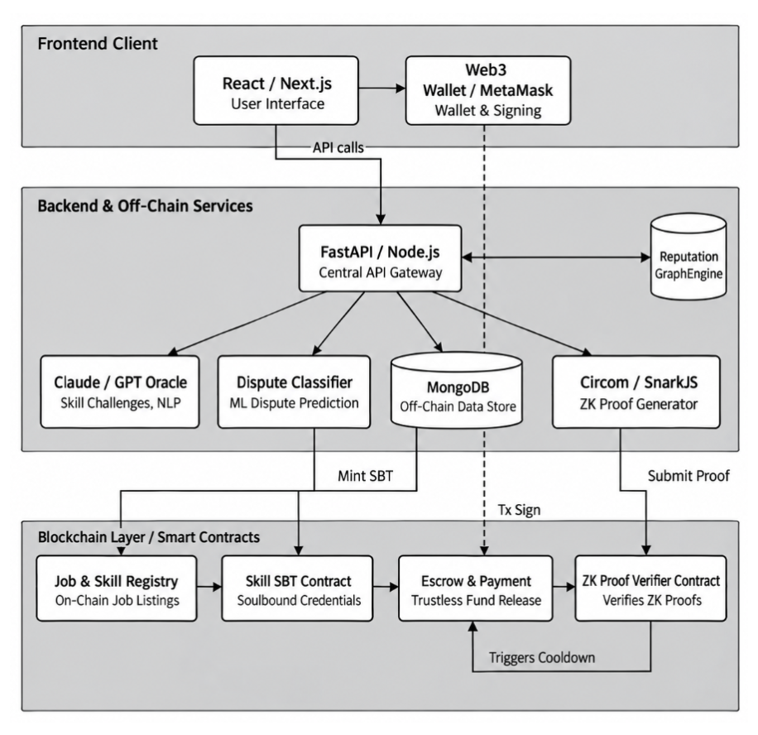
- Freelance3 System Architecture.

Dispute Prediction Workflow
While a job is active, the backend continuously extracts a feature vector from off-chain interaction data – agreed budget, projected versus actual timeline, communication frequency, and revision-request counts – and feeds it to a logistic regression classifier. The model outputs a continuous risk score representing dispute likelihood. If the score remains below a configured threshold, the job proceeds normally under standard escrow. If the threshold is met or exceeded, the system flags the job as high-risk and sends a permissioned cooldown trigger to the escrow contract, which pauses fund release and opens a mandatory mediation window before the relationship can proceed further. Algorithm 3 formalizes this decision procedure, and Fig. 3 visualizes the same risk-threshold and mediation flow.
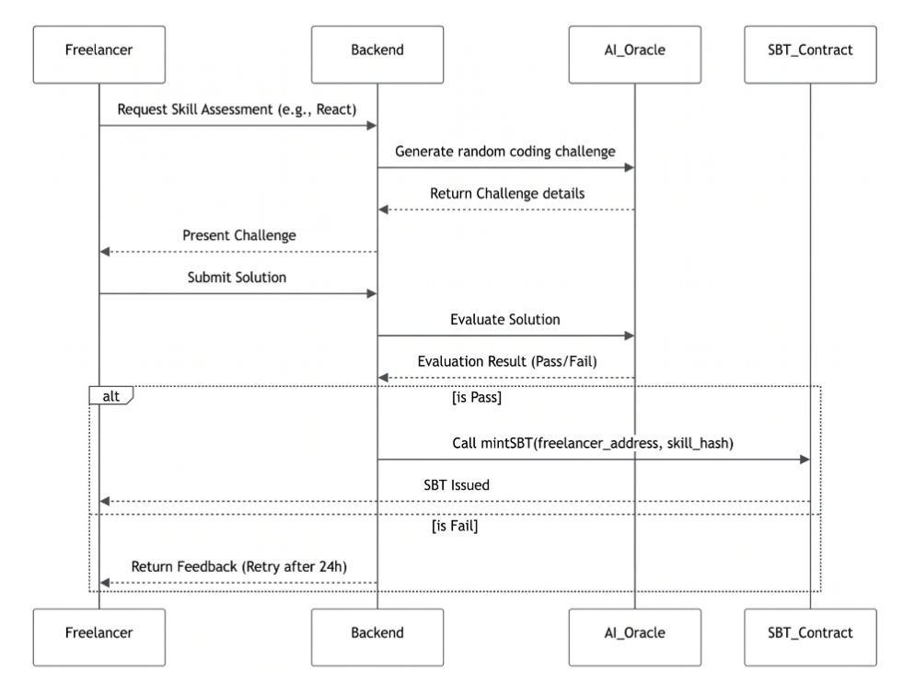
- AI skill verification and SBT minting sequence.

Algorithm 2 Skill Verification and SBT Minting
Require: Freelancer wallet address w, requested skill s
Ensure: Non-transferable SBT credential minted to w, or a rejection with cooldown
1: Freelancer requests verification for skill s from the frontend.
2: Backend forwards the request to the AI Oracle.
3: AI Oracle generates a randomized, unpredictable technical challenge c for s.
4: Freelancer submits solution r to the backend.
5: Backend forwards r and c to the AI Oracle for automatic assessment.
6: if Oracle verdict is Pass then
7: Backend (authorized minter) invokes mint(w, s) on the SBT contract.
8: Non-transferable credential is issued to w.
9: else
10: Backend returns feedback to the freelancer.
11: Backend enforces a cooldown period before re-attempt is permitted.
12: end if

Algorithm 3 Dispute Prediction and Mediation Trigger
Require: Active job J, risk threshold τ
Ensure: Job proceeds normally, or escrow is paused for mediation
1: while J is active do
2: Extract feature vector x ← (budget, timeline deviation, communication frequency, revision count).
3: Compute risk score p ← LogisticRegression(x).
4: if p < τ then
5: Continue normal escrow execution for J.
6: else
7: Flag J as high-risk.
8: Backend sends a permissioned cooldown trigger to the escrow contract.
9: Escrow contract pauses fund release and opens a mandatory mediation window.
10: end if
11: end while

End-to-End Job Lifecycle
The entire lifecycle starts when a customer uses the lock function in the escrow contract to deposit the project budget and record the job parameters (budget, duration, and necessary skills) as an immutable on-chain state. Algorithm 4 gives the complete step-by-step lifecycle, and Fig. 4 provides the corresponding end-to-end flowchart. In order to receive the matching Soulbound Token, a potential freelancer without the necessary credentials completes the AI skill-verification process mentioned above. In order to bid, the freelancer uses the pre-compiled Circom circuit to build a zero-knowledge proof off-chain. Using private behavioural metrics as witnesses, they produce a brief Groth16 proof that their overall reputation surpasses the client’s minimum threshold. The Reputation Registry contract’s verification function uses the stored verification key to verify this proof, which is submitted with the bid, on-chain without disclosing the underlying behavioural data.
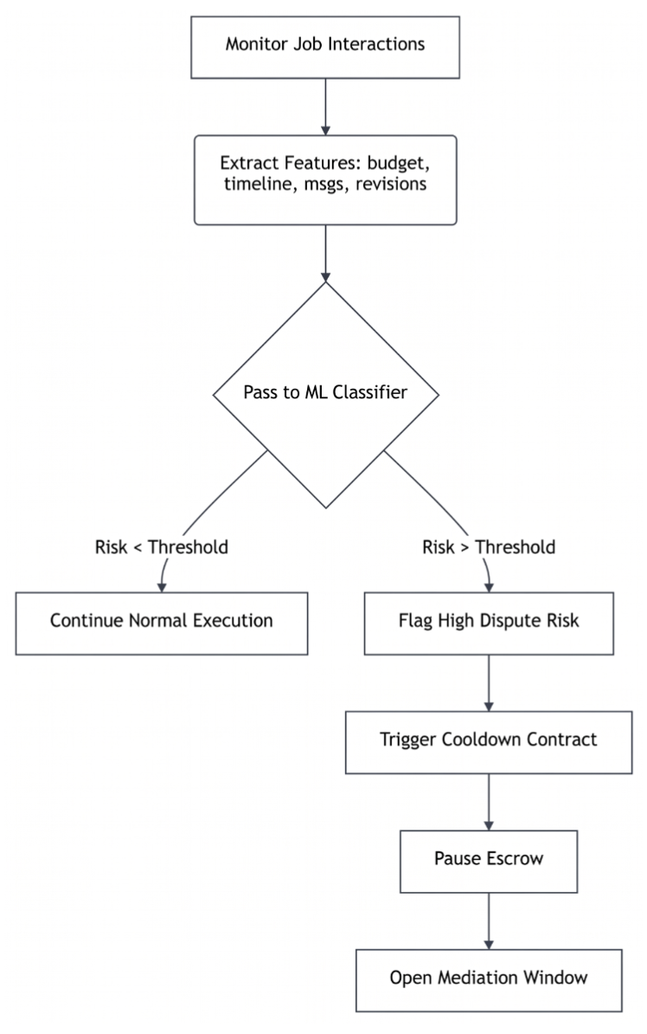
- Dispute prediction workflow.
The task is moved from a bidding state to an active state and its parameters are locked against unilateral modification after both parties cryptographically sign the job-acceptance transaction upon selection. The backend converts interaction metadata, such as communication frequency, milestone adherence, and budget deviation, into a real-time feature vector as the project moves forward. The dispute-prediction classifier discussed above receives this vector, calculates a risk score, and flags the work as high-risk if the score meets or surpasses the configured threshold. This vector is then fed straight into the mediation trigger that is explained next.
When a high-risk flag is raised, the backend uses a permissioned relayer to initiate the escrow contract’s mediation function. This stops the transfer of funds and opens a mandatory mediation window before the job can continue. In the absence of a high-risk indication, the client initiates the escrow release function, which verifies completion criteria and sends locked cash straight to the freelancer’s wallet after the freelancer provides final deliverables. The lifecycle ends with an asynchronous update: the Graph Analysis Engine adjusts the freelancer’s PageRank-based authority score in the Skill Graph to reflect the freshly finished work, and completion data is recorded off-chain for future classifier training and evidence generation.

Algorithm 4 End-to-End Job Lifecycle
Require: Client C, freelancer F, job parameters (budget, duration, required skills)
Ensure: Funds settled to F and Skill Graph updated, or job routed to mediation
1: C locks budget and job parameters in the escrow contract (immutable on-chain state).
2: if F lacks the required skill credential then
3: F completes Algorithm 2 to obtain the SBT.
4: end if
5: F builds an off-chain Groth16 reputation proof π via the Circom circuit.
6: F submits π with a bid; Reputation Registry verifies π against the client’s threshold.
7: C and F cryptographically sign the job-acceptance transaction; job moves to Active.
8: while job is Active do
9: Backend runs Algorithm 3 on the evolving interaction data.
10: if high-risk flag raised then
11: Backend relayer triggers escrow mediation; fund transfer paused.
12: else if F submits final deliverables and C approves then
13: Escrow release function verifies completion criteria.
14: Locked funds are transferred to F’s wallet.
15: end if
16: end while
17: Graph Analysis Engine updates F’s PageRank-based authority score in the Skill Graph.
18: Completion data is recorded off-chain for classifier training and evidence generation.

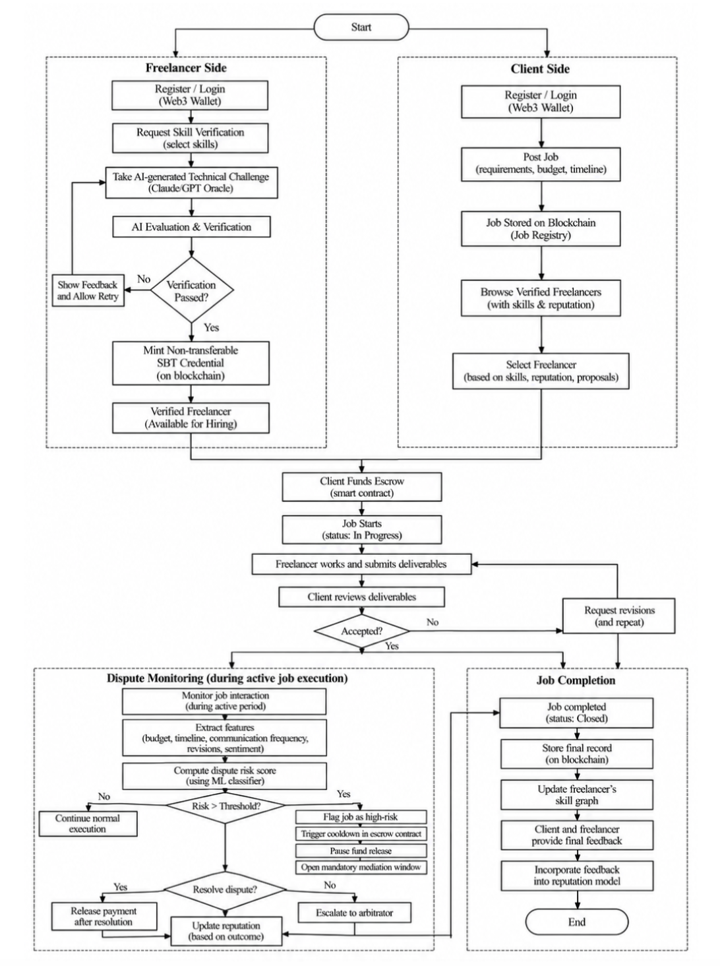
- End-to-end job lifecycle flowchart.

Evaluation
In keeping with its current pre-deployment condition, the prototype was tested on a local Hardhat network as opposed to a public testnet. Along with the off-chain AI Oracle, ZK Prover, and ML Dispute Classifier services, all four smart contracts – SBT, Escrow and Dispute, Reputation Registry, and Skill Graph – were installed on this local network. At the expense of not yet accurately representing real-world Layer-2 gas prices or network latency – a restriction specifically addressed in Section VII – this configuration enables deterministic, repeatable assessment of gas cost and timing without variance induced by public network congestion.

Metrics Defined
The prototype is evaluated using five metrics. The computational cost of each state-changing contract call (credential minting, escrow lock/release, proof verification, mediation trigger) is measured by gas cost. Proof-generation time quantifies how long it takes to compute Groth16 witnesses off-chain and prove for the reputation circuit. The gas used to validate a given proof on-chain is measured by the proof-verification cost. Wall-clock time for a single job-lifecycle cycle is measured by end-to-end latency. A test suite spanning valid-path execution and rejection of invalid or adversarial inputs (e.g., unauthorised minting attempts, malformed proofs) is used to evaluate functional correctness.
- Measured Performance Results
Operation / Metric | Measured Value
Escrow lock – gas cost | 49,027 gas
Escrow release – gas cost | 63,714 gas
Reputation proof generation time | 0.002521 ms
Reputation proof size (bytes) | 64 bytes
End-to-end lifecycle latency (local network) | 2.763 ms
Correctness tests passed / total | 15/15
Invalid-input tests correctly rejected | 9/9

Results
Table II summarizes the measured results from the local prototype. Escrow lock and release used 49,027 and 63,714 gas, respectively. The reputation-proof routine averaged 0.002521 ms and produced a 64-byte proof artifact. The complete lifecycle averaged 2.763 ms across five runs. All 15 functional tests passed, and 9/9 invalid-input cases were correctly rejected.

Security, Privacy, and Limitations
To mitigate reentrancy attacks against escrow and minting operations, smart contracts use OpenZeppelin’s ReentrancyGuard in conjunction with the checks-effects-interactions pattern. The built-in checked arithmetic in Solidity 0.8+ keeps financial or reputation-related states from being corrupted by integer overflow or underflow. Unauthorised issuance is limited to a breach of that one credential rather than an open attack surface since credential minting is limited to a single permissioned address (the AI Oracle backend). Because the Reputation Registry contract only stores verification keys rather than raw scores, even a complete public examination of the on-chain state does not reveal any personal behavioural information, protecting privacy through construction rather than just access control.

Stated Limitations
There are still a few restrictions. Although the on-chain minting stage is trustless, a biased or compromised Oracle could admit an unqualified credential because the AI Oracle is a semi-trusted, permissioned component and its assessment correctness is not cryptographically confirmed. Currently, the dispute-prediction classifier only employs a small set of features (budget, timeframe, number of revisions, and frequency of contact); comprehensive sentiment analysis is scheduled for Phase 2. Measured gas and latency numbers might not accurately reflect production Layer-2 conditions because the evaluation was done on a private network rather than a public testnet or mainnet. Instead of a specific identity-uniqueness mechanism, which has not yet been fully addressed, Sybil resilience depends on wallet-level credential binding.

Conclusion
Freelance3, a hybrid blockchain architecture for privacy-preserving decentralised freelancing, was introduced in this paper. It enables zero-knowledge reputation eligibility proofs, integrates proactive dispute prediction with smart-contract escrow, and links AI-assisted skill verification to non-transferable credentials. The contribution is found in its combined design and implementation inside a single, cohesive labor-market workflow, validated by a functional local prototype that covers the entire job lifecycle from posting to settlement, rather than in any one underlying primitive.
The prototype shows that separating computationally demanding off-chain services from security-critical on-chain operations is a workable architecture for this workflow; however, larger-scale correctness testing, mainnet-representative gas costs, and full validation under public-network conditions are still necessary. Future work will involve formalising Sybil resistance beyond wallet-level credential binding, deploying to a public Layer-2 testnet, and integrating sentiment-based characteristics into the dispute classifier.

References
- S. Reddy and D. S. Kushwaha, “Framework for Privacy-Preserving Credential Issuance and Verification System Using Soulbound Token,” ITM Web of Conferences, vol. 56, p. 06002, 2023. [Online]. Available: https://www.researchgate.net/publication/373014258
- D. M. F. Rehtaliani, “Blockchain-Based Credential Models: Enhancing Verification With Soulbound Tokens,” ResearchGate, 2025. [Online]. Available: https://www.researchgate.net/publication/394696172
- R. Pericàs-Gornals, M. Mut-Puigserver, M. M. Payeras-Capellá, M. Á. Cabot-Nadal, and J. Ramis-Bibiloni, “Digital Credentials Management System Using Rejectable Soulbound Tokens,” Annals of Telecommunications, vol. 79, pp. 843–855, 2024. [Online]. Available: https://link.springer.com/article/10.1007/s12243-024-01032-6
- J. A. Berrios Moya, J. Ayoade, and M. A. Uddin, “A Zero-Knowledge Proof-Enabled Blockchain-Based Academic Record Verification System (ZKBAR-V),” Sensors (MDPI), vol. 25, no. 11, p. 3450, 2025. [Online]. Available: https://www.mdpi.com/1424-8220/25/11/3450
- M. Al Hemairy, M. Abu Talib, A. Khalil, A. Zulfiqar, and T. Mohamed, “Blockchain-Based Framework for Validation and Authentication of Academic Credentials,” Education and Information Technologies, 2024. [Online]. Available: https://link.springer.com/article/10.1007/s10639-024-12493-6
- G. Caldarelli, “Can Artificial Intelligence Solve the Blockchain Oracle Problem?,” Frontiers in Blockchain, 2025. [Online]. Available: https://www.frontiersin.org/journals/blockchain/articles/10.3389/fbloc.2025.1682623/full
- H. Yuan, “A Scalable Privacy-Preserving Decentralized Identity Framework Based on ZKPs,” arXiv, 2025. [Online]. Available: https://arxiv.org/abs/2510.09715
- R. Lavin, X. Liu, H. Mohanty, L. Norman, G. Zaarour, and B. Krishnamachari, “A Survey on the Applications of Zero-Knowledge Proofs,” arXiv, 2024. [Online]. Available: https://arxiv.org/abs/2408.00243
- R. Shashidhara, R. Chirakarotu Nair, and P. Kumar Panakalapati, “Promise of Zero-Knowledge Proofs (ZKPs) for Blockchain Privacy and Security: Opportunities, Challenges, and Future Directions,” Security and Privacy (Wiley), vol. 8, no. 1, 2025. [Online]. Available: https://onlinelibrary.wiley.com/doi/10.1002/spy2.461
- C. Udokwu, “Zero Knowledge Proof Solutions to Linkability Problems in Blockchain-Based Collaboration Systems,” Mathematics (MDPI), vol. 13, no. 15, p. 2387, 2025. [Online]. Available: https://www.mdpi.com/2227-7390/13/15/2387
- O. Hasan, L. Brunie, and E. Bertino, “Privacy Preserving Reputation Systems Based on Blockchain and Other Cryptographic Building Blocks: A Survey,” HAL CNRS Technical Report, 2020. [Online]. Available: https://hal.science/hal-03034994
- M. A. Bouchiha, “Advancing Blockchain-Based Reputation Systems (DARS): ZK-SNARKs for Anonymous Reputation,” Ph.D. dissertation, HAL Theses, 2024. [Online]. Available: https://theses.hal.science/tel-04874759
- A. S. Almasoud, F. K. Hussain, and O. K. Hussain, “Smart Contracts for Blockchain-Based Reputation Systems: A Systematic Literature Review,” ScienceDirect, 2020. [Online]. Available: https://www.sciencedirect.com/science/article/abs/pii/S108480452030285X
- P. Zhang, Y. Yuan, J. Song, et al., “Introducing On-Chain Graph Data to Consortium Blockchain for Commercial Transactions,” Frontiers of Computer Science (Springer), vol. 18, p. 182608, 2024. [Online]. Available: https://link.springer.com/content/pdf/10.1007/s11704-023-3523-9.pdf
- S. Wang, C. Huang, J. Li, Y. Yuan, and F.-Y. Wang, “Decentralized Construction of Knowledge Graphs for Deep Recommender Systems Based on Blockchain-Powered Smart Contracts,” IEEE Access, vol. 7, pp. 136951–136961, 2019. [Online]. Available: https://www.researchgate.net/publication/337995397
- M.-T. Nguyen, T.-D. Trinh, and V.-B. Pham, “A Reputation Scoring Framework for Lending Protocols Using the PageRank Algorithm,” in Int. Symp. on Information and Communication Technology, Springer, 2024, pp. 478–494. [Online]. Available: https://link.springer.com/chapter/10.1007/978-981-96-4282-3_38
- S. Imig, “Trustworthiness and PageRank on the Ethereum Blockchain: Technical Report,” SSRN, 2023. [Online]. Available: https://papers.ssrn.com/sol3/papers.cfm?abstract_id=4590362
- Q. Liu, Q. Huang, F. Fan, H. Wu, and X. Tang, “Detecting Sybil Addresses in Blockchain Airdrops: A Subgraph-Based Feature Propagation and Fusion Approach,” arXiv, 2025. [Online]. Available: https://arxiv.org/abs/2505.09313
- Y. Wang and M. Tan, “Defense Against Sybil Attack in Blockchain Based on Improved Consensus Algorithm,” in Proc. IEEE ICCECT, 2023. [Online]. Available: https://ieeexplore.ieee.org/document/10140278
- P. Deshmukh, S. T. Kalwaghe, A. Appa, and A. Pawar, “Decentralised Freelancing Using Ethereum Blockchain,” in Proc. Int. Conf. on Communication and Signal Processing (ICCSP), 2020, pp. 881–883. [Online]. Available: https://www.researchgate.net/publication/344063404
- A. Asgaonkar and B. Krishnamachari, “Solving the Buyer and Seller’s Dilemma: A Dual-Deposit Escrow Smart Contract for Provably Cheat-Proof Delivery and Payment for a Digital Good without a Trusted Mediator,” in Proc. IEEE ICBC, 2019, pp. 262–267. [Online]. Available: https://www.semanticscholar.org/paper/4d478bca1e6ec610ddcd6a9d0216eac8302b0502
- S. N. Khan, F. Loukil, C. Ghedira-Guegan, E. Benkhelifa, and A. Bani-Hani, “Blockchain Smart Contracts: Applications, Challenges, and Future Trends,” Peer-to-Peer Networking and Applications, vol. 14, pp. 2901–2925, 2021. [Online]. Available: https://pmc.ncbi.nlm.nih.gov/articles/PMC8053233
- J. Bonneau, A. Miller, J. Clark, A. Narayanan, J. A. Kroll, and E. W. Felten, “SoK: Research Perspectives and Challenges for Bitcoin and Cryptocurrencies,” in Proc. IEEE Symposium on Security and Privacy (SP), 2015, pp. 104–121, doi: 10.1109/SP.2015.14. [Online]. Available: https://doi.org/10.1109/SP.2015.14
- G. Zyskind, O. Nathan, and A. Pentland, “Decentralizing Privacy: Using Blockchain to Protect Personal Data,” in Proc. IEEE Security and Privacy Workshops (SPW), 2015, pp. 180–184, doi: 10.1109/SPW.2015.27. [Online]. Available: https://doi.org/10.1109/SPW.2015.27
- I. Miers, C. Garman, M. Green, and A. D. Rubin, “Zerocoin: Anonymous Distributed E-Cash from Bitcoin,” in Proc. IEEE Symposium on Security and Privacy (SP), 2013, pp. 397–411, doi: 10.1109/SP.2013.34. [Online]. Available: https://www.ieee-security.org/TC/SP2013/papers/4977a397.pdf
- A. E. Kosba, A. Miller, E. Shi, Z. Wen, and C. Papamanthou, “Hawk: The Blockchain Model of Cryptography and Privacy-Preserving Smart Contracts,” in Proc. IEEE Symposium on Security and Privacy (SP), 2016, pp. 839–858, doi: 10.1109/SP.2016.55. [Online]. Available: https://eprint.iacr.org/2015/675
- J. Groth, “On the Size of Pairing-Based Non-interactive Arguments,” in Advances in Cryptology – EUROCRYPT 2016, LNCS 9666, Springer, 2016, pp. 305–326, doi: 10.1007/978-3-662-49896-5_11. [Online]. Available: https://doi.org/10.1007/978-3-662-49896-5_11
- A. Sonnino, M. Al-Bassam, S. Bano, S. Meiklejohn, and G. Danezis, “Coconut: Threshold Issuance Selective Disclosure Credentials with Applications to Distributed Ledgers,” in Proc. IEEE Symposium on Security and Privacy (SP), 2019, pp. 1767–1782. [Online]. Available: https://sonnino.com/papers/coconut.pdf
- W. Tang, S. S. Mukherjee, S. Park, C. Chenli, H. Oh, J. Kim, and T. Jung, “GrAC: Graph-Based Anonymous Credentials from Identity Graphs on Blockchain,” in Proc. IEEE International Conference on Blockchain (Blockchain), 2024, pp. 113–122, doi: 10.1109/Blockchain62396.2024.00024. [Online]. Available: https://ieeexplore.ieee.org/abstract/document/10664262/
- O. Ersoy, Z. A. Genç, Z. Erkin, and M. Conti, “Practical Exchange for Unique Digital Goods,” in Proc. IEEE International Conference on Decentralized Applications and Infrastructures (DAPPS), 2021, pp. 49–58, doi: 10.1109/DAPPS52256.2021.00011. [Online]. Available: https://research.tudelft.nl/en/publications/practical-exchange-for-unique-digital-goods/

