Table of Contents

Affiliate Frontend 3

1) Main page 4

2) Player Report -> Profit & Loss Report 5

3) Player Report -> Deposit & Withdrawal 6

4) Player Report -> Bonus Report 7

5) Player Report -> New Registration 9

6) Player Report -> Player Activity Report 10

7) Affiliate Report -> Commission Report 12

YSB Admin Backend -> Affiliate Manager 14

1) Affiliate Player Search 14

2) Commission Settling 15

2.1) Commission Setting – Add New 16

3) Client Bonus Claim 17

4) Affiliate Adjustment 18

5) Affiliate Player Data Entry and Approval 19

6) Affiliate Player Data Entry and Approval 21

7) Monthly Report (Summary) 22

8) Commission Report (Summary) 23

9) Commission Report (Monthly) 24

10) Activity Report 26

11) Vendor Bonus Report 29

12) Manual Bonus Adjustment Report 30

13) Loss Carry Forward Adjustment Report 31

14) Commission Rate Report 32

15) Vendor Player Report (Monthly) 33

16) Vendor Player Report (Daily) 34

17) Vendor Player Report (Detail) 35

18) Vendor Player Bonus Report 36

19) Sportbook Transaction Summary Report 37

YSB Admin Backend -> Client Manager 39

YSB Admin Backend -> Report Manager 40

# Affiliate Frontend

Stage 1: Affiliate Settlement are in RMB

Betting in Sportsbook and Luzi are in USDT. Marketing request to follow finance rate, to convert USDT to USD and then convert USD to RMB.

For casino which are in USD. Marketing request to follow finance rate, to convert USD convert to RMB.

In Affiliate frontend, when affiliate view USDT amount, show a remark to indicate the USDT amount are after converted to RMB.

" 备注：此USDT/USD 已经依照当月汇率进行兑换成人民币货币。”

Stage 2: Affiliate Settlement are in RMB and USDT/USD separately

In Affiliate frontend, when affiliate view USDT amount, those are USDT amount.

Remove the " 备注：此USDT/USD 已经依照当月汇率进行兑换成人民币货币。”

## 1) Main page

* Add 2 tabs. – “人民币（RMB）” and “**泰达币/美金 (USDT/USD)”**
* Click “人民币（RMB）”is existing logic. Those are RMB transaction.
* Click “**泰达币/美金 (USDT/USD)”**is USDT/USD transaction.
* Betting in Sportsbook and Luzi are in USDT. Marketing request to follow finance rate, to convert USDT to USD and then convert USD to RMB.
* For casino which are in USD. Marketing request to follow finance rate, to convert USD convert to RMB.
* In Affiliate frontend, when affiliate view USDT amount, show a remark to indicate the USDT amount are after converted to RMB.

" 备注：此USDT/USD 已经依照当月汇率进行兑换成人民币货币。”

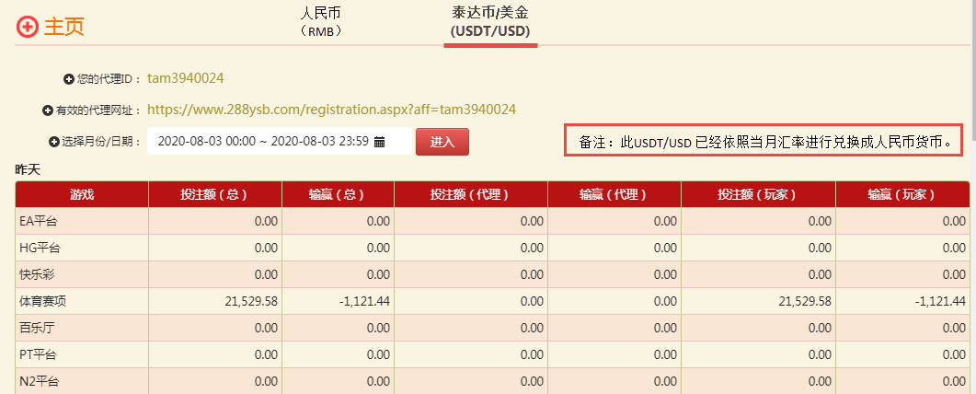

## 2) Player Report -> Profit & Loss Report

* Add 2 tabs. – “人民币（RMB）” and “**泰达币/美金 (USDT/USD)”**
* Click “人民币（RMB）”is existing logic. Those are RMB transaction.
* Click “**泰达币/美金 (USDT/USD)”**is USDT/USD transaction.
* Betting in Sportsbook and Luzi are in USDT. Marketing request to follow finance rate, to convert USDT to USD and then convert USD to RMB.
* For casino which are in USD. Marketing request to follow finance rate, to convert USD convert to RMB.
* In Affiliate frontend, when affiliate view USDT amount, show a remark to indicate the USDT amount are after converted to RMB.

" 备注：此USDT/USD 已经依照当月汇率进行兑换成人民币货币。”

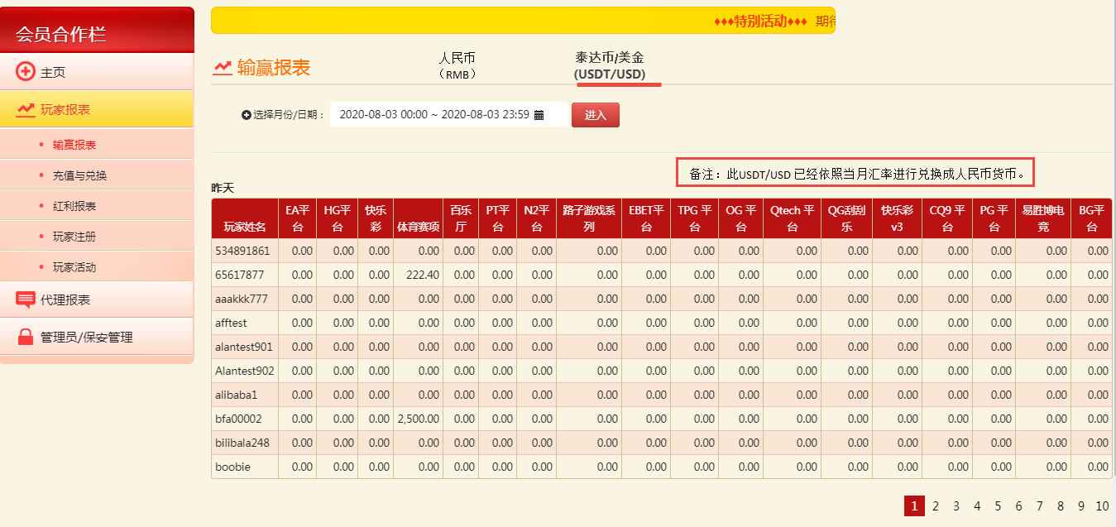

## 3) Player Report -> Deposit & Withdrawal

* Add 2 tabs. – “人民币（RMB）” and “**泰达币 (USDT)”**
* Click “人民币（RMB）”is existing logic. Those are RMB transaction.
* Click “**泰达币 (USDT)”**is Deposit and Withdrawal in USDT transaction.

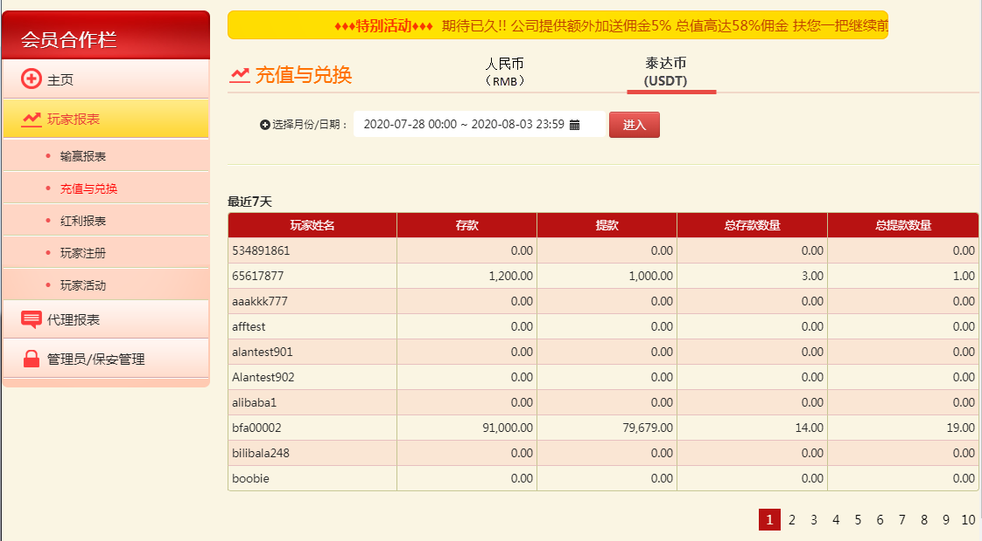

## 4) Player Report -> Bonus Report

* Add 2 tabs. – “人民币（RMB）” and “**泰达币/美金 (USDT/USD)”**
* Click “人民币（RMB）”is existing logic. Those are RMB transaction.
* Click “**泰达币/美金 (USDT/USD)”**is USDT/USD transaction.
* Bonus in Sportsbook and Luzi are in USDT. Follow finance rate, to convert USDT to USD and then convert USD to RMB.
* Bonus in casino are in USD. Marketing request to follow finance rate, to convert USD convert to RMB.
* When affiliate view USDT amount, show a remark to indicate the USDT amount are after converted to RMB.

" 备注：此USDT/USD 已经依照当月汇率进行兑换成人民币货币。”

Raining Rewards are grouped under “Others” column.

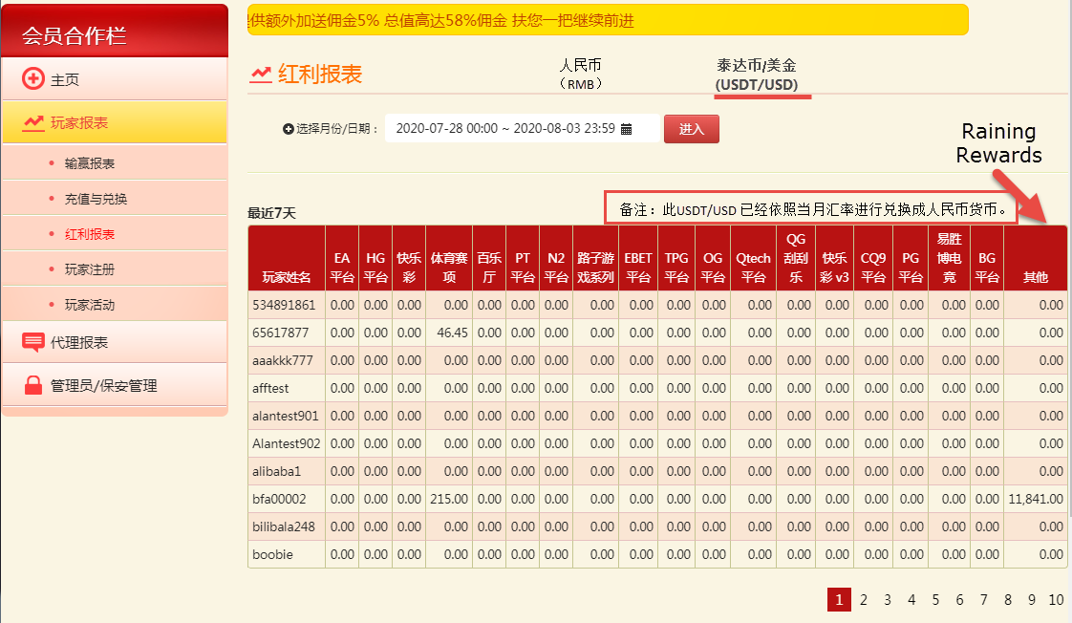

## 5) Player Report -> New Registration

* Show the login ID that is being used to mapping rmb login id and usdt login id

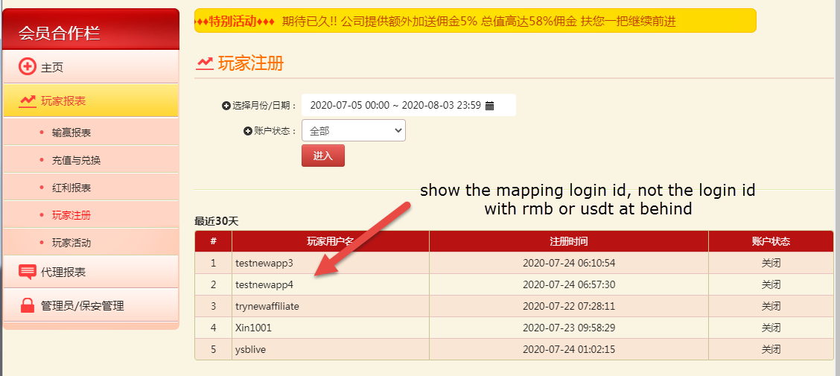

## 6) Player Report -> Player Activity Report

* Rename existing stake column to be 投注额(RMB). Add 2 new stake column as 投注额(USDT) and 总投注额(RMB).
* 投注额(USDT) is stake in USDT/USD transaction. Follow finance rate, to convert USDT to USD and then convert USD to RMB. Click amount of a product to show list of players.
* 总投注额(RMB) is total stake. Click amount of a product to show list of players.
* Total player are unique player. Same player who plays in RMB and USDT are count as ONE.
* Show a remark to indicate the USDT amount are after converted to RMB.

" 备注：此USDT/USD 已经依照当月汇率进行兑换成人民币货币。”

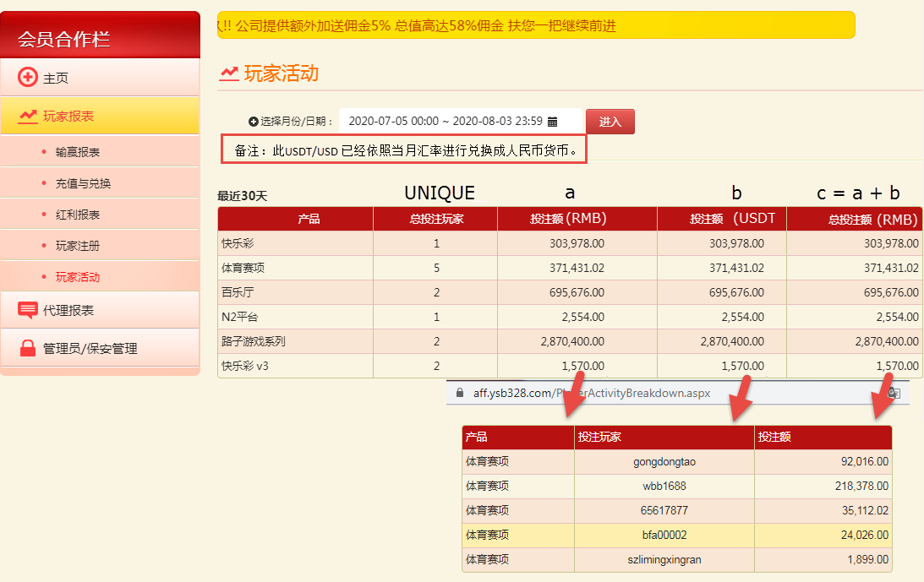

## 7) Affiliate Report -> Commission Report

* Rename existing amount column to be 数额(RMB). Add 2 new stake column as数额(USDT) and总数额(RMB).
* 数额(USDT) is amount in USDT/USD transaction. Follow finance rate, to convert USDT to USD and then convert USD to RMB. Click amount of a product to show list of players.
* 总数额(RMB) is total amount. Click amount to show list of players’ profit and loss.
* Show a remark to indicate the USDT amount are after converted to RMB.

" 备注：此USDT/USD 已经依照当月汇率进行兑换成人民币货币。”

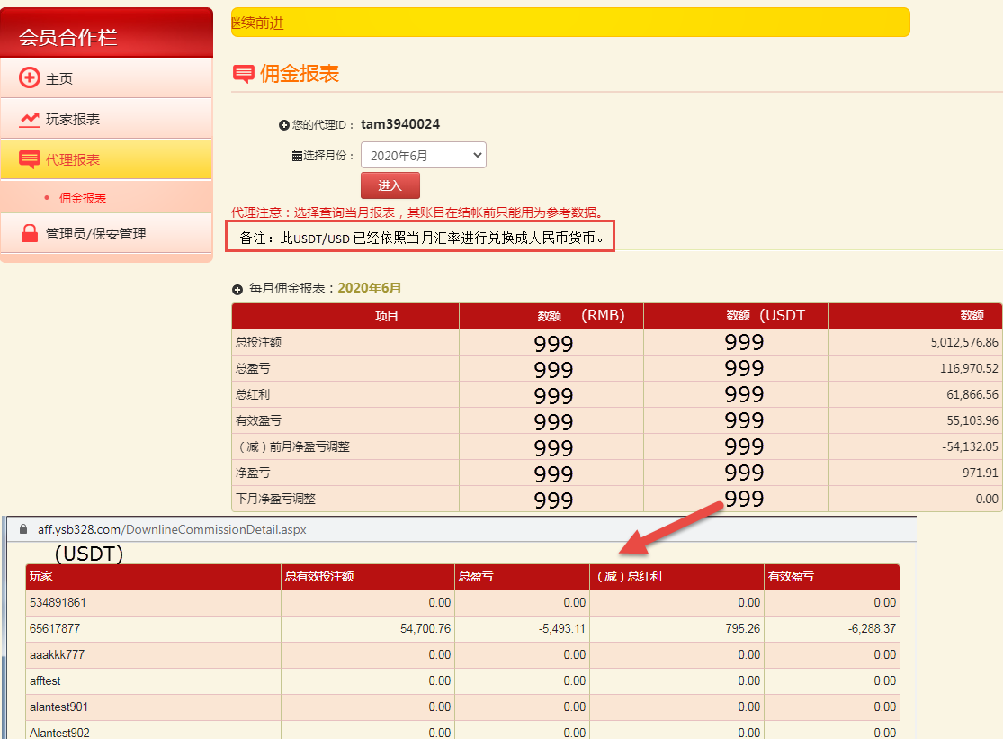

# YSB Admin Backend -> Affiliate Manager

## 1) Affiliate Player Search

* Add player’s currency. If a player has RMB and USDT account then show both records.

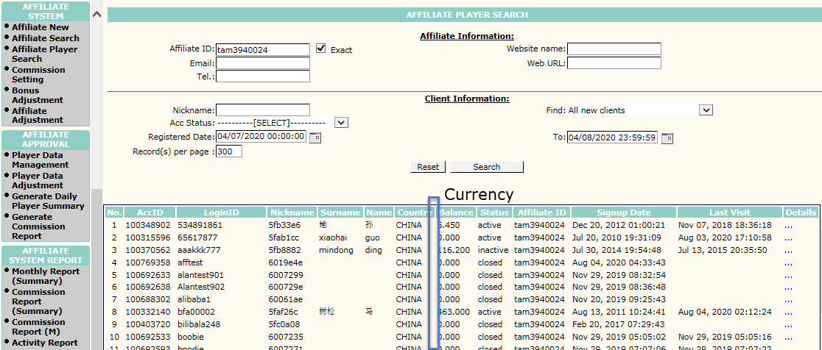

## 2) Commission Settling

* Add currency. View commission for RMB and USDT.

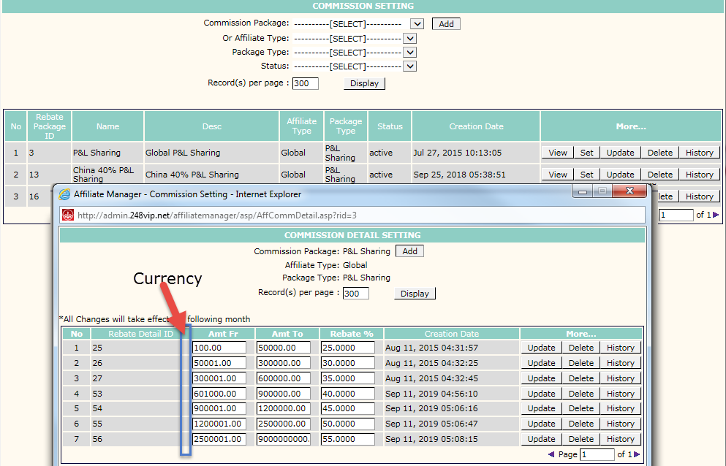

### 2.1) Commission Setting – Add New

* Add currency. Allow user to choose currency. User can set commission for RMB and USDT.

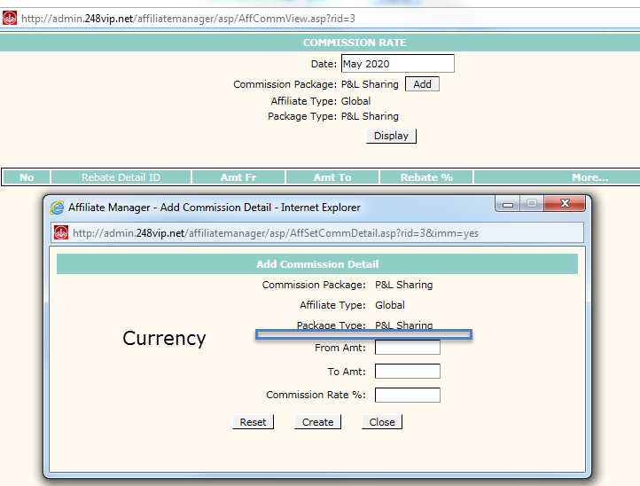

## 3) Client Bonus Claim

Add RMB and USDT tabs. Click RMB tab is existing logic. Click USDT shows sportsbook and Luzi in USDT currency while other casinos in USD.

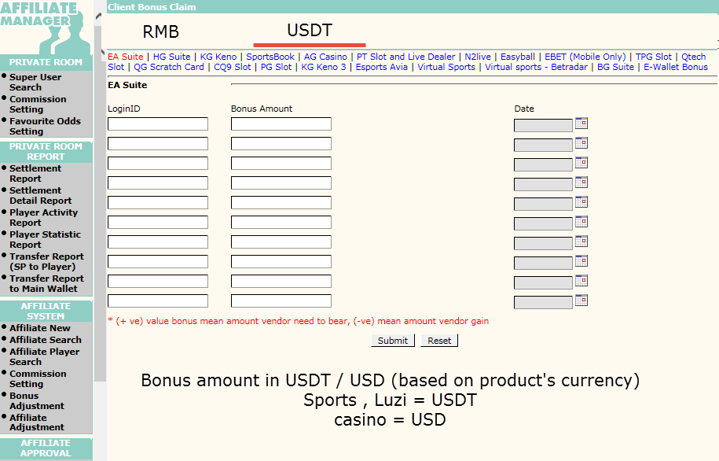

## 4) Affiliate Adjustment

Adjust Affiliate Total Loss Carry Forward in RMB.

If RMB is lose -2000, USDT is win 1000. then the adjustment need to adjust the sum of loses I,e, -2000 + 1000 = -1000.

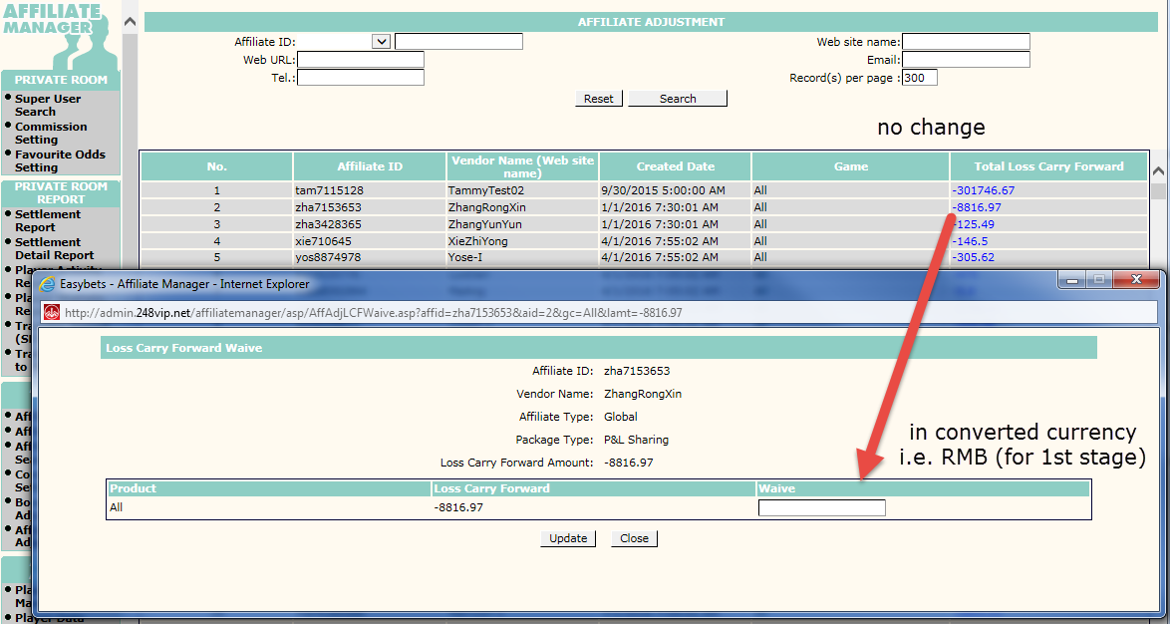

## 5) Affiliate Player Data Entry and Approval

Add USDT currency. Allow user filter by USDT data.

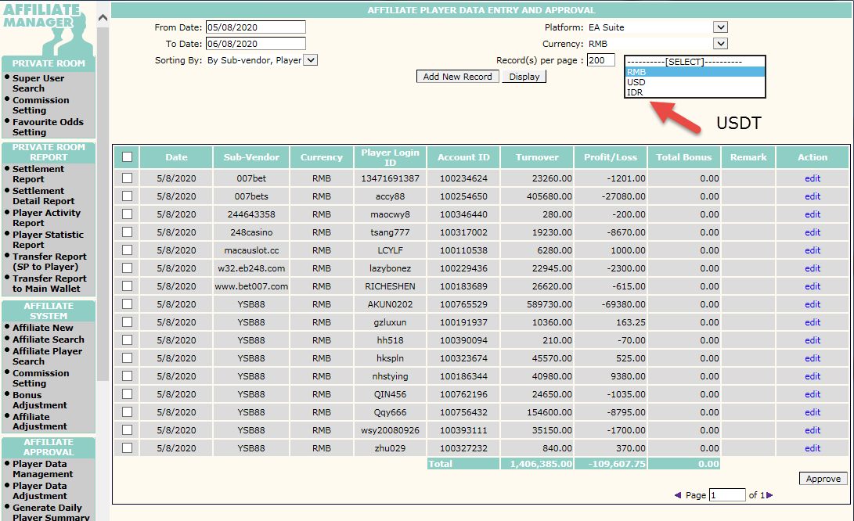

Add USDT currency. Allow user to input USDT data.

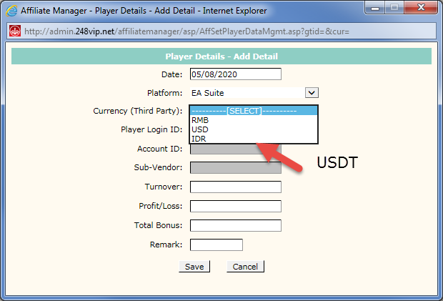

## 6) Affiliate Player Data Entry and Approval

Add USDT currency. Allow user to adjust USDT record.

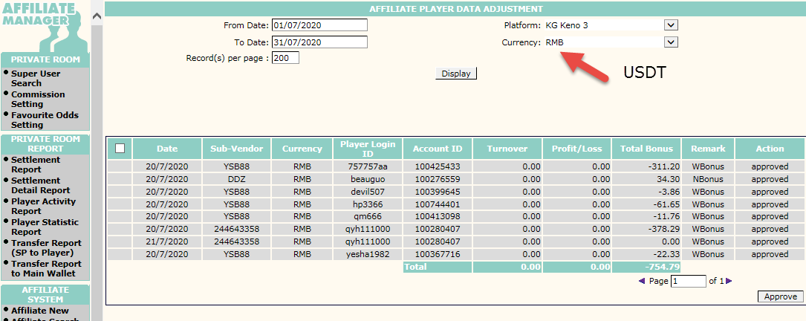

## 7) Monthly Report (Summary)

* Rename existing column to be “RMB”. Add “USDT (convert to RMB)” and “Grand Total (RMB)” columns
* Show Total Commission, Total Stake, Total P&L and Total Bonus Awarded in RMB (convert from USDT to USD then from USD to RMB)
* Grand Total (RMB) = RMB + USDT (convert to RMB)

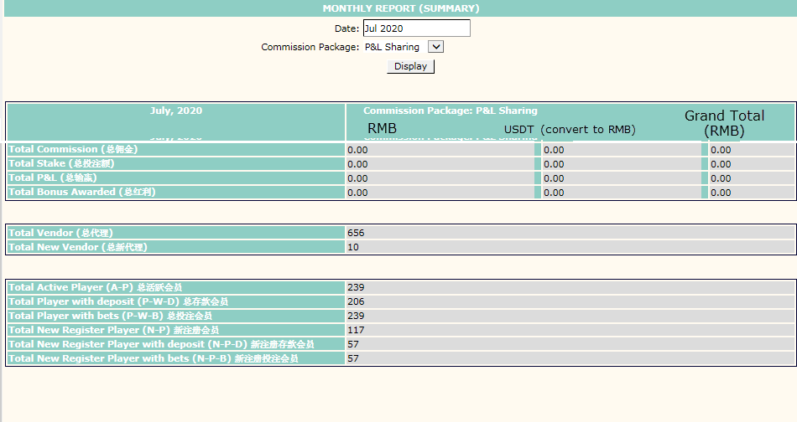

## 8) Commission Report (Summary)

* Rename existing column to be “RMB”. Add “USDT (convert to RMB)” and “Grand Total (RMB)” columns
* Show Total Commission, Total Stake, Total P&L and Total Bonus Awarded in RMB (convert from USDT to USD then from USD to RMB)
* Grand Total (RMB) = RMB + USDT (convert to RMB)

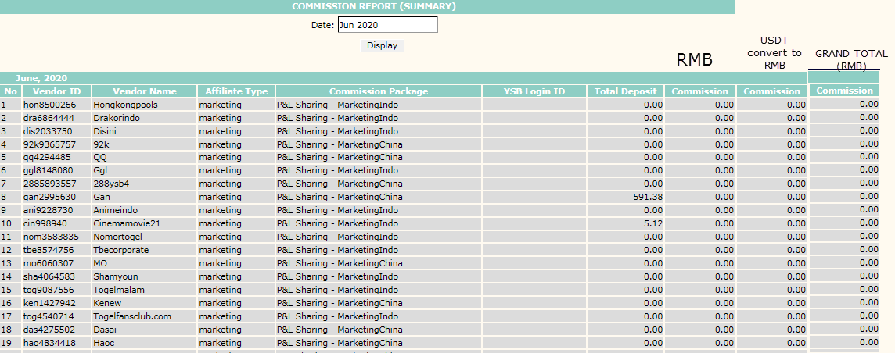

## 9) Commission Report (Monthly)

* Add “RMB”. “USDT (convert to RMB)” and “Grand Total (RMB)” tabs.
* Click “RMB” tab is existing logic. Click USDT (convert to RMB) tab to records in RMB (convert from USDT to USD then from USD to RMB)
* Click Grand Total (RMB) = RMB + USDT (convert to RMB)
* Loss Carry Forward. If RMB lose -2000 and USDT P/L is +1000. Total waive is -1000. But when view in RMB tab and USDT tab, don’t show the last 5 columns. When choose Grand Total then show Lose Bring Forward Waive as 1000 and calculate other 4 columns.

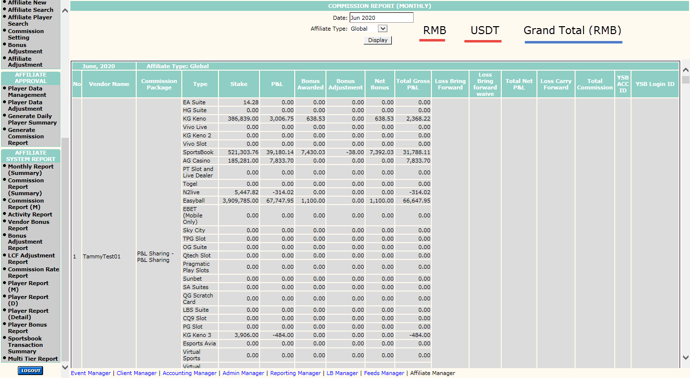

Multi Tier

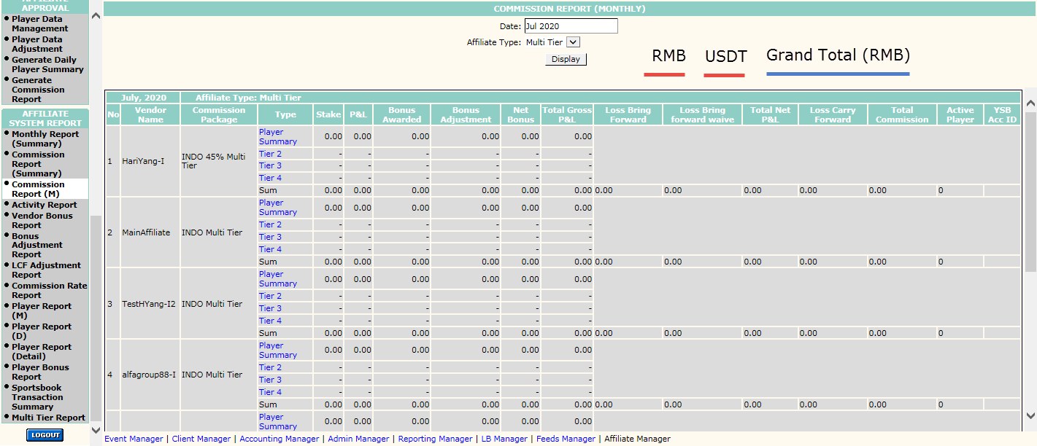

## 10) Activity Report

* Add “RMB”. “USDT (convert to RMB)” and “Grand Total (RMB)” tabs.
* Player Summary section is not affected by RMB, USDT and Grand Total (RMB) selection
* Total Deposit section is based on RMB, USDT and Grand Total (RMB) filtering.

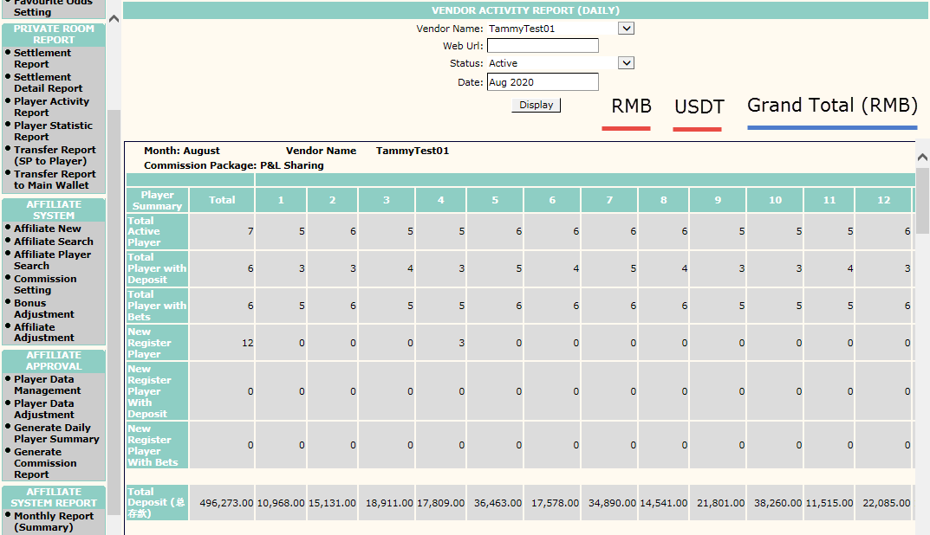

* Total Stake section is based on RMB, USDT and Grand Total (RMB) filtering.

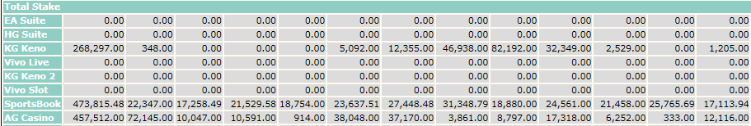

* Total P&L section is based on RMB, USDT and Grand Total (RMB) filtering.

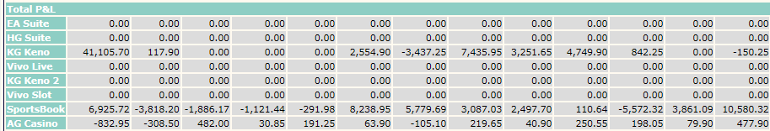

* Total Bonus section is based on RMB, USDT and Grand Total (RMB) filtering.

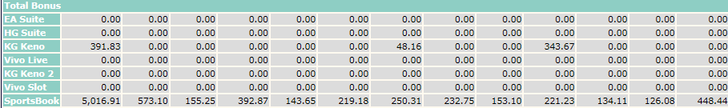

* Total Bonus Adjustment section is based on RMB, USDT and Grand Total (RMB) filtering.

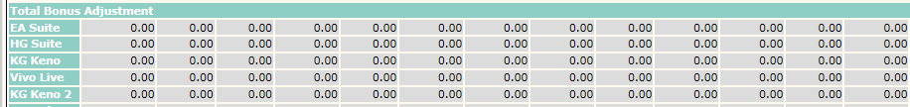

* Total Net Bonus section is based on RMB, USDT and Grand Total (RMB) filtering.

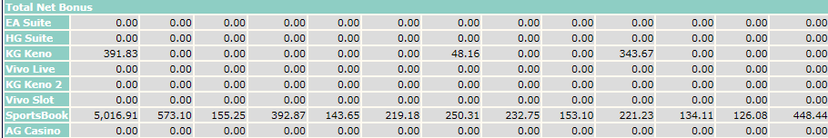

# 11) Vendor Bonus Report

* Add “RMB”. “USDT (convert to RMB)” and “Grand Total (RMB)” tabs.
* Amount are based on RMB, USDT and Grand Total (RMB) filtering.

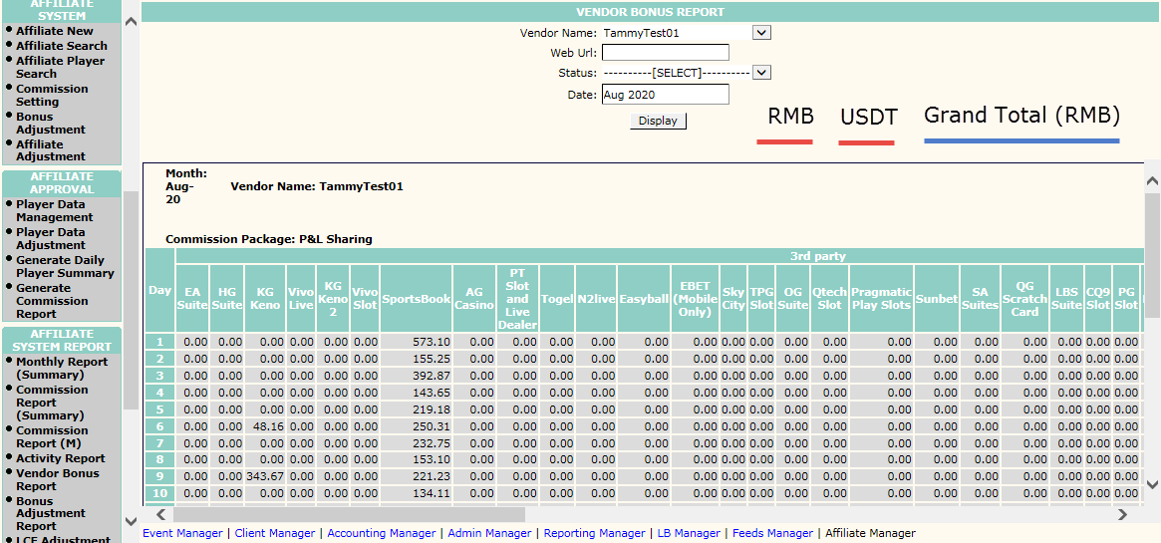

# 12) Manual Bonus Adjustment Report

* Add “RMB”. “USDT (convert to RMB)” and “Grand Total (RMB)” tabs.
* Amount are based on RMB, USDT and Grand Total (RMB) filtering.

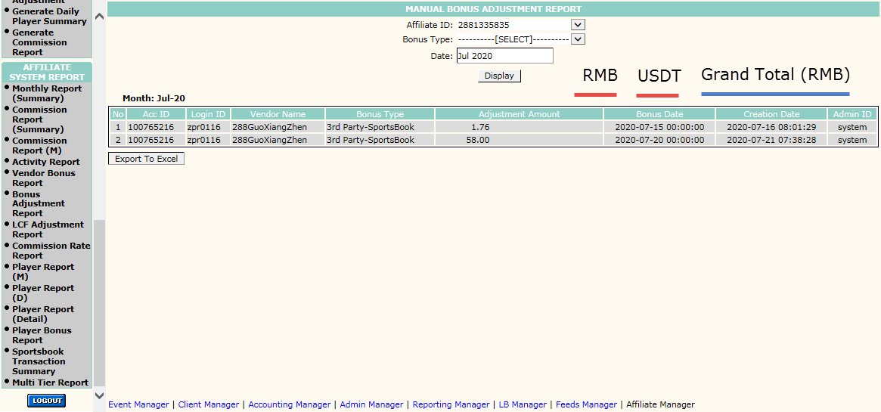

# 13) Loss Carry Forward Adjustment Report

No change for stage 1

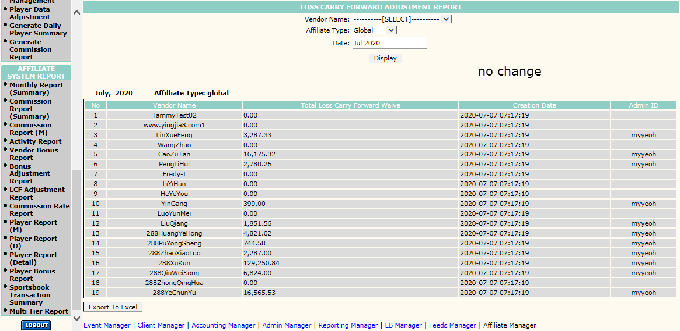

# 14) Commission Rate Report

* Add Currency dropdown. Options are RMB, USDT/USD
* Amount are based on RMB, USDT and Grand Total (RMB) filtering.

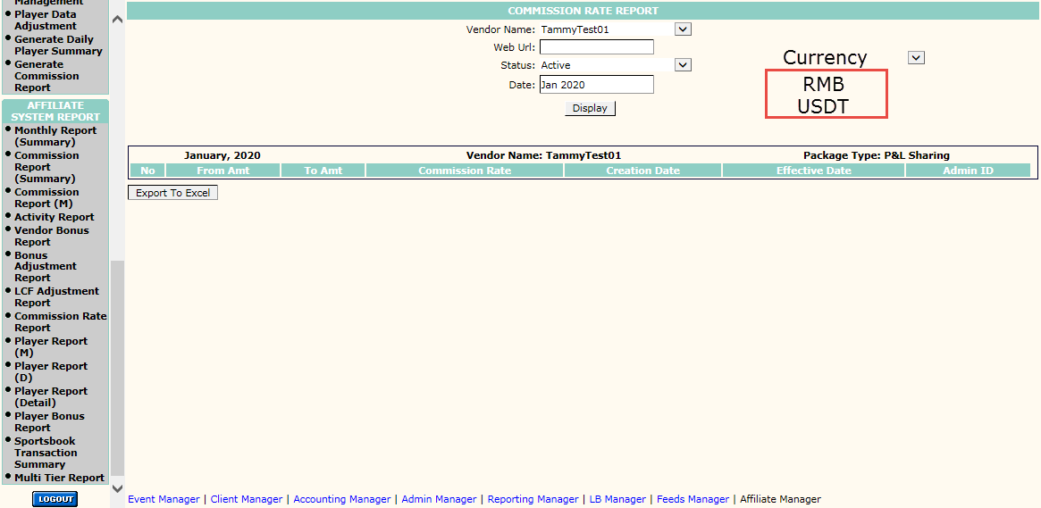

# 15) Vendor Player Report (Monthly)

No change for stage 1

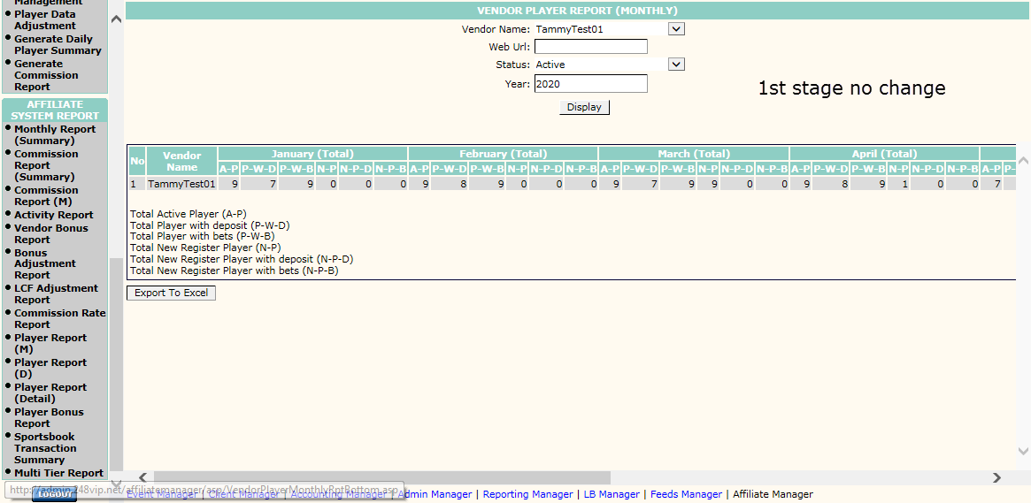

# 16) Vendor Player Report (Daily)

No change for stage 1

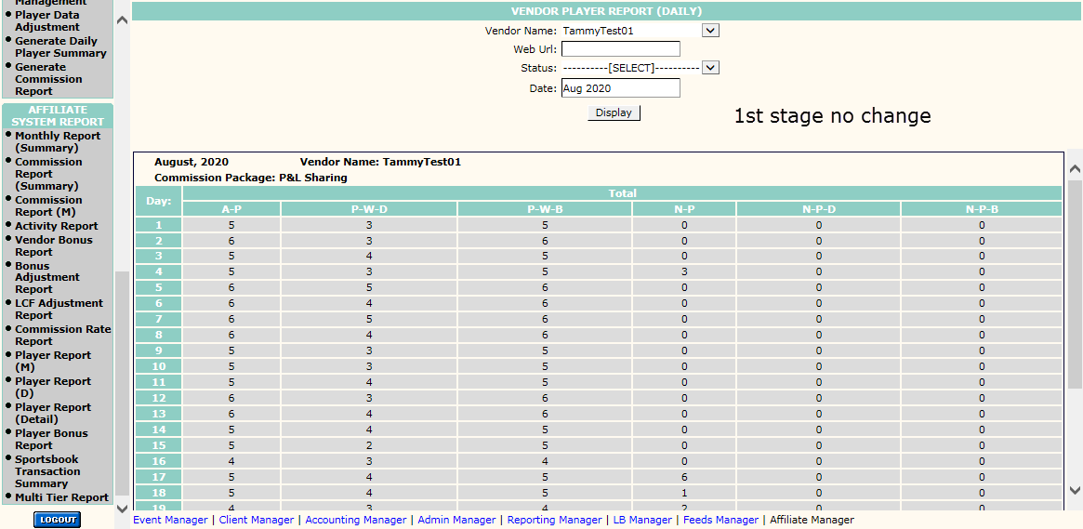

# 17) Vendor Player Report (Detail)

* Add “RMB”. “USDT (convert to RMB)” and “Grand Total (RMB)” tabs.
* Amount are based on RMB, USDT and Grand Total (RMB) filtering.

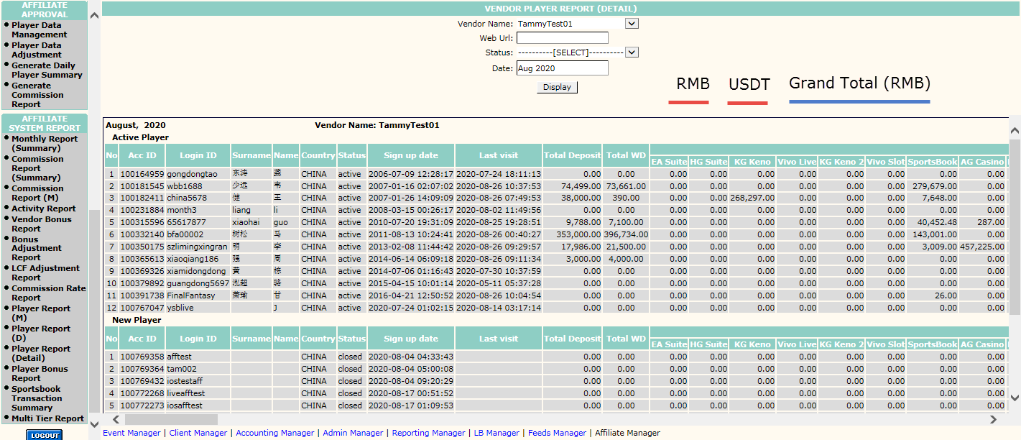

# 18) Vendor Player Bonus Report

* Add “RMB”. “USDT (convert to RMB)” and “Grand Total (RMB)” tabs.
* Amount are based on RMB, USDT and Grand Total (RMB) filtering.

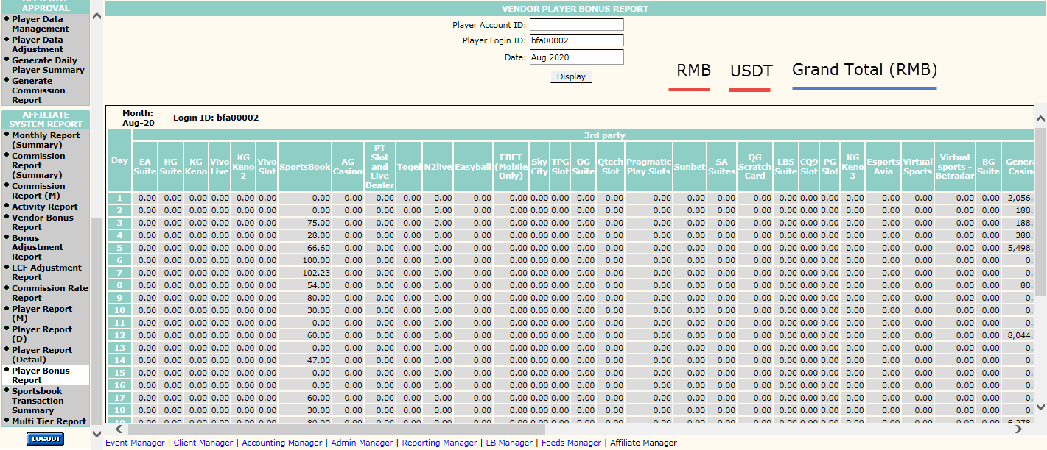

# 19) Sportbook Transaction Summary Report

* Add Currency dropdown. Options are RMB, USDT/USD
* Amount are based on RMB, USDT and Grand Total (RMB) filtering.

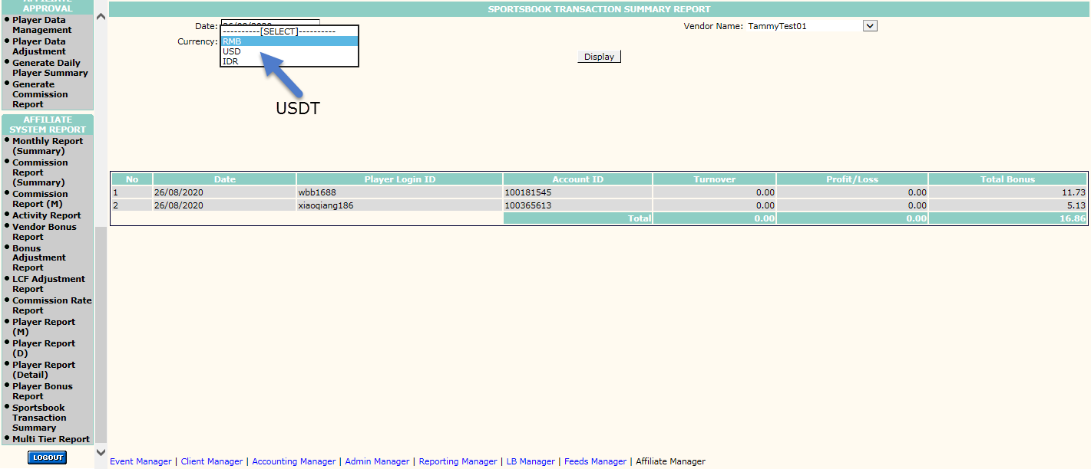

20) Multi Tier Report

* Add “RMB”. “USDT (convert to RMB)” and “Grand Total (RMB)” tabs.
* Amount are based on RMB, USDT and Grand Total (RMB) filtering.

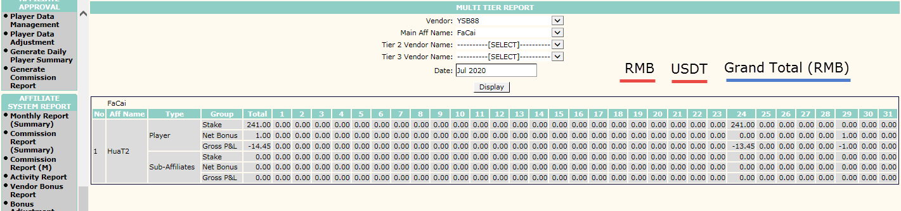

# YSB Admin Backend -> Client Manager

* Client statistics old account/new account need to have a button “RMB Acc” / “USDT Acc”  
    
  Eg:

Client “heying” switch to USDT, another account auto created “heyingusdt”.  
If go to “heyingusdt” client statistics page, able to click on “RMB Acc” button to see his RMB account to view his total win/loss and other history figures

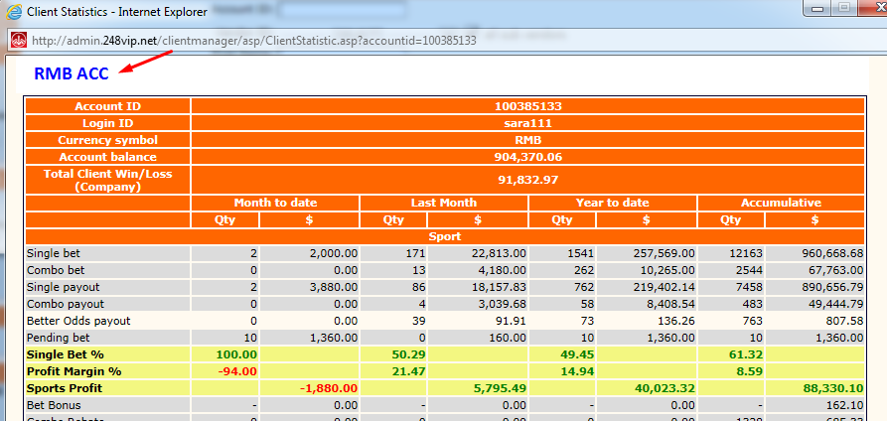

# YSB Admin Backend -> Report Manager

* Able to search report by USDT
* Add in currency filter (eg: RMB, USDT, USD - All)
* Need to include both method data (W_USDT_EWALLET, ADJ_USDT_EWALLET) into below report
  1. Active Client
  2. Daily New Depositor
  3. Daily Month Operation

