1. Write a short essay talking about your understanding of transactions, locks and isolation levels.

* Transactions is a sequence of operations performed as a single logical unit of work. 4 properties are included to qualify as a transaction: Atomicity, consistency, isolation, durability. There are two outcomes of Transactions: Committed and Rollbacked.
* Locks is for synchronizing access by multiple users to the same source of data at the same time. Lock have different modes including shared and exclusive mode, which define the level of dependency the transaction has on the data.
* Isolation Levels defines the degree to which one transaction must be isolated from resource or data modifications made by other transactions.

1. Write a short essay, plus screenshots talking about performance tuning in SQL Server. Must include Tuning Advisor, Extended Events, DMV, Logs and Execution Plan.

**Extended Events** is a performance monitoring system. It enables users to collect data needed to monitor and troubleshoot problems in SQL Server.

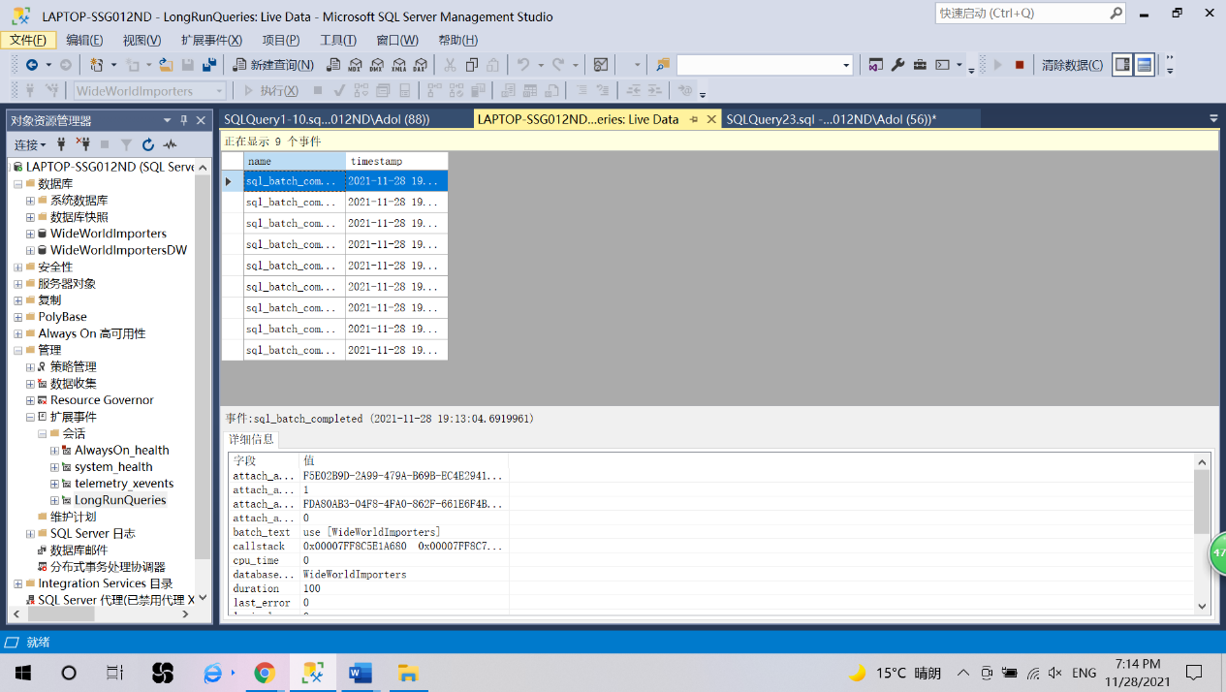

**DMV (Dynamic Management View)** is a collection of views. It returns server state information that can be used to monitor the health of a server instance, diagnose problems and tune performance.

**Logs** contains user-defined events and certain system events that can be used for troubleshooting.

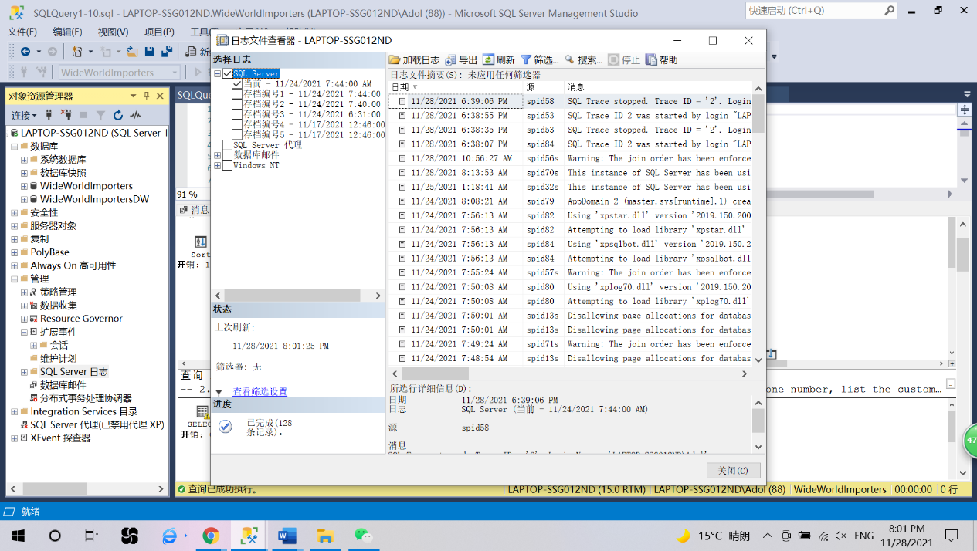

**Execution Plan**

An execution plan is the physical processing plan SQL Server produces for a query, with the set of instrctions describing which objects to access, in what order, which indexes to user, how to access them, which join algorithms to use, and so on. High percentage of execution step means no system resource has been costed.

