Procedure for AVN Roaches before deployment

Provide power to the Valon by connecting to the power leads off the switch mode for the ROACH. See photo below. Valon requires ~+5.1V which can be supplied here. We should verify that this doesn't add unwanted additional phase noise.

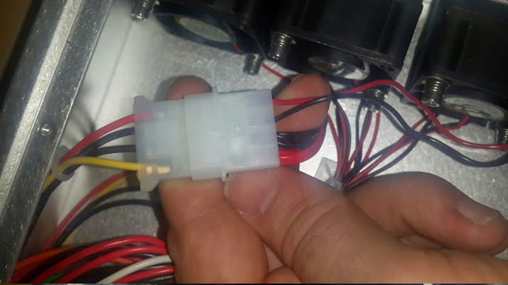

A) Configure Valon to output 200MHz at ~on both SYN 1 and SYN 2. Verify this with software. Power level should be Level 1 (i.e 1dBm)
B) Verify that the KatADC is on ZDOK 0. If not put it there and screw it down.

Check that the Roach has the monitor LED lines connected up as per photo
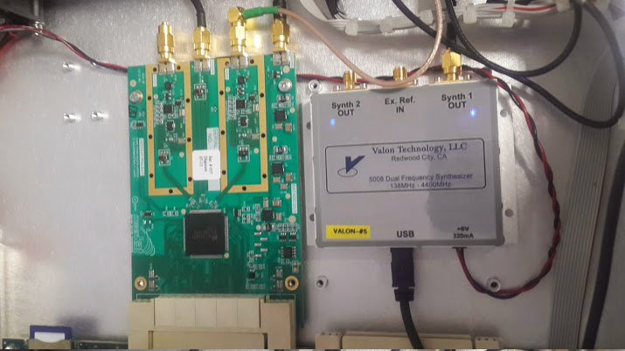

Check the ROACH has GPIO and monitor lines connected up as per photo below

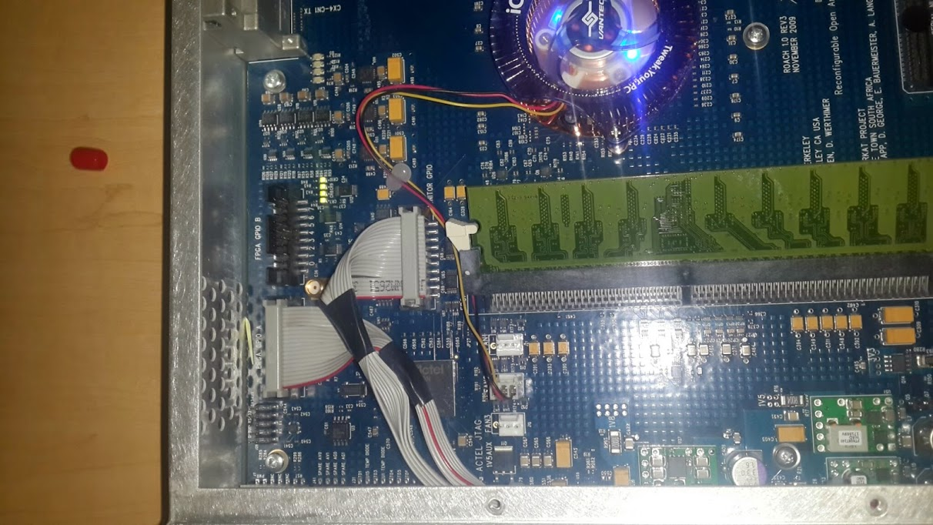

C) Note KatADC, Roach, and Valon serial numbers.

D) Configure the Boot process to auto-power on. This is done by
- Connecting a network cable between the XPORT connector on the back of the ROACH and a network switch
- Connecting a PC running linux to the network switch
- Manually setting the PC to have a static IP address = 192.168.4.1
Add the following lines to /etc/network/interfaces
auto eth0
iface eth0 inet static
address 192.168.4.1
netmask 255.255.255.0
Then do
$ sudo /etc/init.d/networking stop
$ sudo /etc/init.d/networking start
Verify the static IP (192.168.4.1) has been set by using ifconfig

- The ROACH XPORT has a default IP address of 192.168.4.20. You can connect to it using the roach_monitor.py script once you have set the PC IP address to the static value as above. If you cannot connect, it is likely that your PC is being assigned an IP on a different sub-net and this needs to be remedied.

- Connecting using roach_monitor.py script.
- Toggle the auto-power setting
ROACH MONITOR CONTROL
=====================================

1) Retrieve details
2) Reset crashlog counter
3) Power-up ROACH
4) Reset ROACH, but not Actel
5) Toggle safety-shutdown defeat
6) Power down ROACH
7) Toggle PPC EEPROM boot (config H)
8) Toggle auto power-on after hard-reset.
=>8
Automatic power-up after reset is currently disabled. ENABLING... done.
When Actel Fusion is hard-reset (cold reboot), it will automatically power-on ROACH immediately.
- Verify this is working by disconnecting power to the ROACH and reconnecting power. NOTE THAT THE ROACH MUST BE POWERED ON BEFORE PULLING THE POWER TO IT. IF IT ISN'T POWERED ON IT WILL NOT AUTOMATICALLY RESTART

E) Verify that the ROACH can get an IP address using NFS and has a control PC for this purpose. If the serial number of the ROACH is 040406 then the MAC address of the 1gbe ROACH connector will default to 02:00:00:04:04:06
sudo vim /etc/dnsmasq.conf

add an appropriate line at
dhcp-host=02:00:00:04:04:06,169.254.128.113 #Roach name

sudo /etc/init.d/dnsmasq restart

You will also need to change the boot command in the U-BOOT bootloader. To do this you do the following:

- connect up serial port (baud rate 115200)
- Reboot the Roach
- Press a key to get into the UBOOT configuration
- printenv bootcmd
bootcmd=run mmcboot
- We need to change this to run netboot
- setenv bootcmd run netboot
- saveenv
- Verify by rebooting on the front panel, or by typing boot in U-BOOT.
- Roach Login is be default root (with no password)

Verification procedure:
- Load 'tut3_katadc.bof' into Roach filesystem (/boffiles) if not already present.
- Run 'python tut3_katadc <roach_ip_address>' in a terminal window (X forwarding required if done via ssh).
- A noise spectrum plus the 200 MHz tone of the Valon should be seen within a minute, updating every few seconds. It will look something like this:

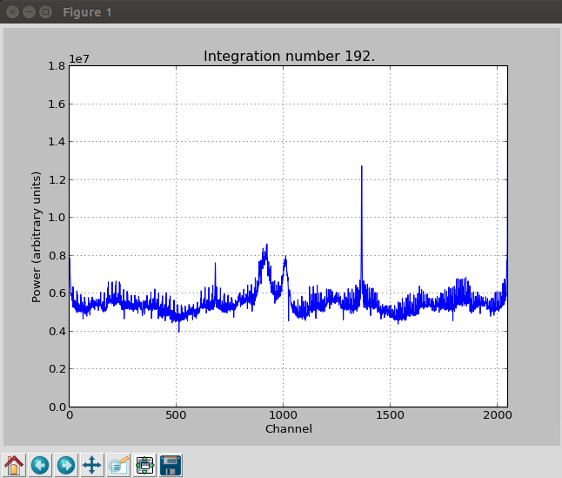

If the Valon needs to be configured, this can be done in Linux using ipython.
First plug the Valon into the computer via USB, and run dmesg to determine the ttyUSB* (usually 0 or 1).

Run sudo chmod 777 /dev/ttyUSB0 (or 1), in order to make the Valon usable by ipython, then from within ipython
import valon_synth
a = valon_synth.Synthesizer('/dev/ttyUSB0')
a.get_frequency(valon_synth.SYNTH_A) #show current freq
a.set_freqyency(valon_synth.SYNTH_A, 200) #set freq A to 200 MHz.
# valon_synth.SYNTH_A and valon_synth.SYNTH_B can be used to
# get and set frequencies for the two synthesizers.

