

Client : NRF (National Research Foundation)
Project : African VLBI Network (AVN)
Type : Operations Manual

avn roach setup guide

Document number A0215-1000-0000 DRAFT B
Revision DRAFT B
Classification Commercial in Confidence
Author James Smith/Charles Copley
Date 28 April 2015
DOCUMENT APPROVAL
 | Name | Designation | Affiliation | Date | Signature
Submitted | Charles Copley | AVN science processing | SKA SA
Approved | Anita Loots | Associate Director | SKA SA

DOCUMENT HISTORY
Revision | Date Of Issue | ECN Number | Comments
A
B | 31/7/2015 |  | Added cage nuts to packing list
DOCUMENT SOFTWARE
 | Package | Version | Filename
Wordprocessor | Libre Office | 3.5.7.2
COMPANY DETAILS
Name | SKA-SA
Physical/Postal  Address | The Park, 3rd Floor  Park Rd  Pinelands  7405
Tel. | +27 21 506 7300
Fax. | +27 21 506 7375
Website | www.ska.ac.za

TABLE OF CONTENTS

a.REFERENCES 6
Document scope 7
Materials and Tools required 7
Procedure for AVN Roaches before deployment 7
Hardware setup 7
Software Setup 10
Procedure for AVN Roaches during deployment 15
High Resolution Spectrometer Design SCREENSHOTS 18

LIST OF TABLES

LIST OF FIGURES

LIST OF TBDs

ABBREVIATIONS

AVN African VLBI Network
CDR Critical Design Review
DST Department of Science and Technology
DIRCO Department of Industrial Relations and Cooperation
NRF National Research Foundation
PDR Preliminary Design Review
RFI Request for Information
RFP Request for Proposal
SKA Square Kilometre Array
SKA-SA Square Kilometer Array – South Africa
SOW Statement of Work
VLBI Very Long Baseline Interferometery
WBS Work Breakdown Structure

REFERENCES
  - A0200-0000-001, AVN Ghana: URS – Revision 2 (TBD)

Document scope
This document is intended for use in ROACH preparation at SKA South Africa in Pinelands and eventual deployment at an AVN site. The resources available there are presumed, though it will be useful as a reference at an AVN site.

Materials and Tools required
- ROACH
- Kettle-cable to power the ROACH
- Control computer
- Kettle cable to power the computer
- Monitor
- Monitor VGA cable
- Kettle cable to power the monitor
- Power supply for the monitor
- Screwdrivers
- 3x female-to-male SMA cables (panel to ADC)
- 1x male-to-male SMA cable (Valon to ADC)
- USB mini-B cable for connecting Valon to PC
- USB-to-serial converter & Serial cable (DB-9 plug, female to female)
- Standard Cat5e network flylead
- Computer with Windows operating system
- Computer with Linux operating system (virtualbox is useable if that’s all that’s available)
- Broadband power meter capable of DC-1GHz operation
- Spectrum analyser capable of DC-1GHz operation
- XAUI 10gbe cable
- 2x SMA Cables for Rx to ROACH connection
- SMA Torque wrench
- Masking tape for emergency labelling
- Pen
- Cage Nuts and screws (x10)

Procedure for AVN Roaches before deployment

Hardware setup
- Remove the screws from the top of the ROACH enclosure, and remove the top panel. Remove any packing foam and / or masking tape from the inside of the enclosure if any is present.
- Unwrap the Valon from its bubble-wrap and crimp the ends of its included cable with Molex male crimps.
- Connect the Valon to the power supply by inserting the crimped pins into the corresponding holes in the Molex 8981, and the small black connector into the corresponding socket on the Valon itself. The red (5V) and black (GND) wires should correspond, as shown.

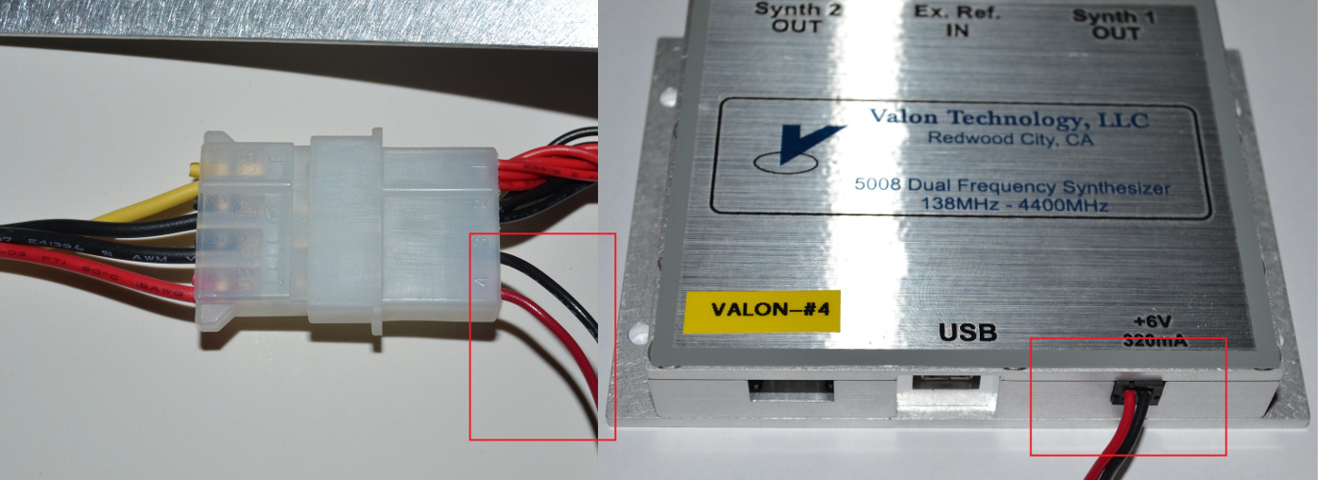

Verify that the power supply doesn't add unwanted additional phase noise to the Valon.

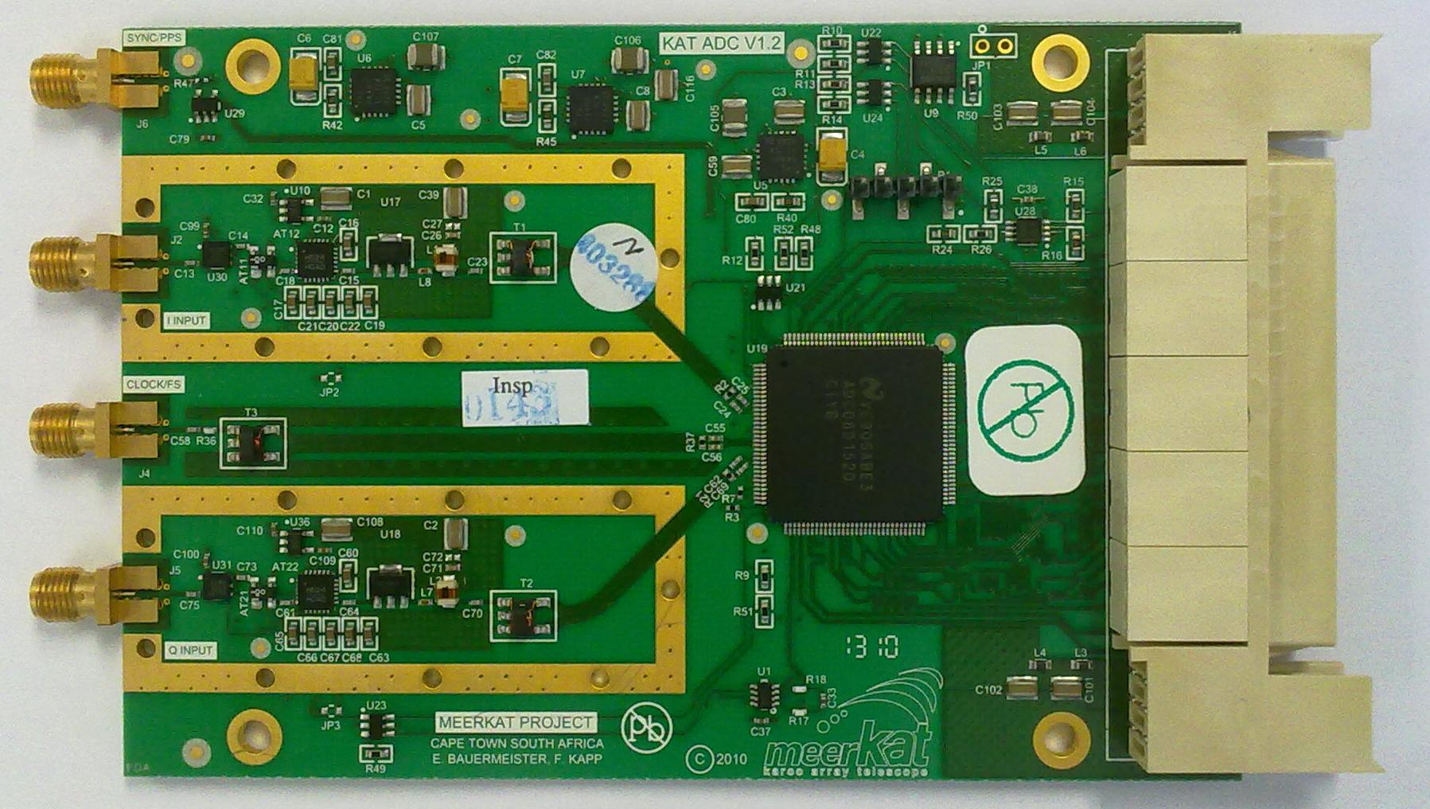
- Verify that the KatADC is plugged into ZDOK0 as shown. If this is not the case, carefully unscrew and shift it, and fasten it down again afterwards. Do not overtighten the screws. The KatADC can handle RF inputs up to 0dBm. Don’t apply signals above this limit to either the Q or I inputs.

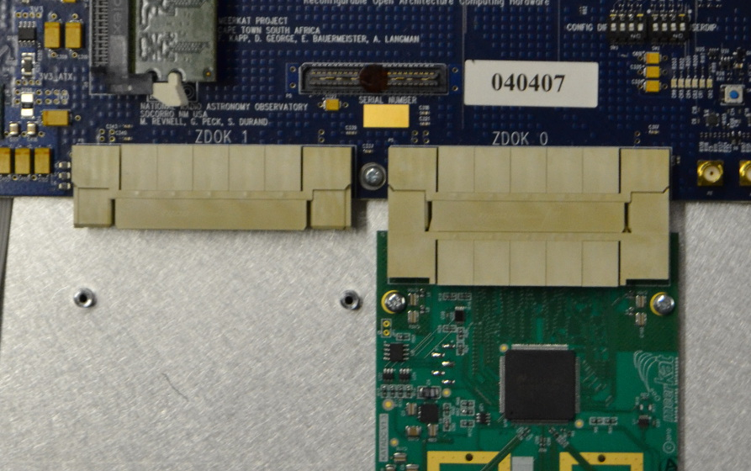

- Once the Valon is connected as described above, and the KatADC is in the correct place, fasten the plates down.
- Verify that the ribbon cables are correctly placed. These should be fastened with cable-organisers down the side of the ROACH enclosure, but if not, make corrections as necessary. Note the positions of the red wires in the photos below. Verification can be performed visually, continuity testing with a multimeter can be performed if uncertain but should not be necessary. In the photos, the ribbon cables are labelled as follows:
A -
B - FPGA GPIO A
C - Monitor GPIO
D - Chassis LEDs
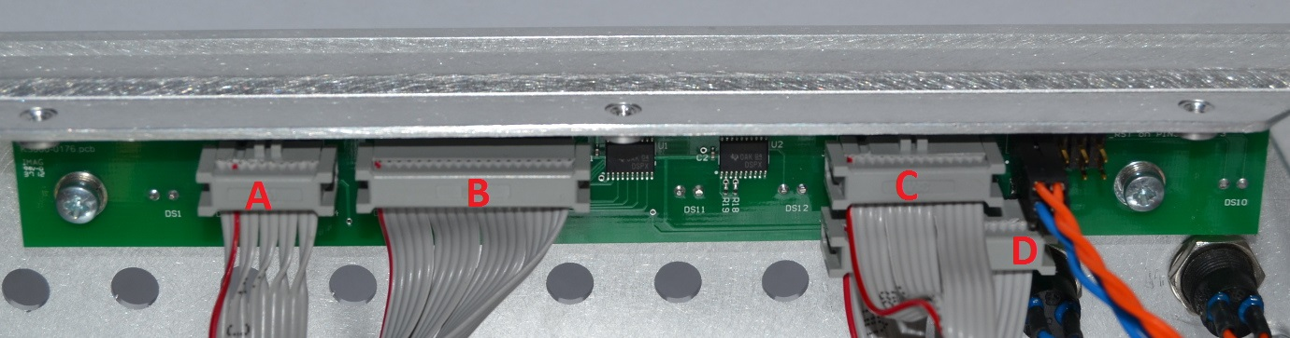
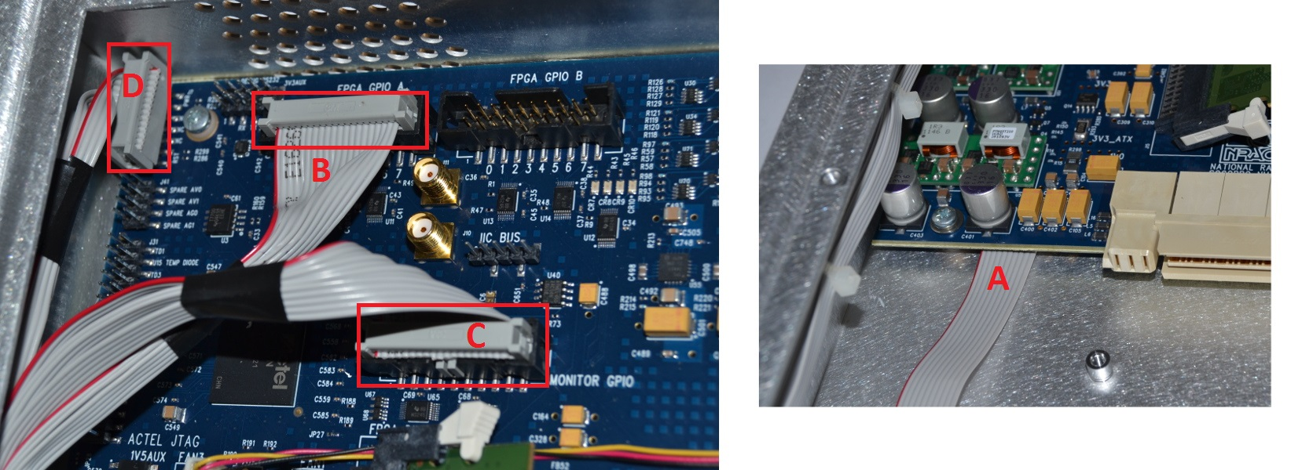

- Attach the RF SMA cables.

Before beginning with software setup, note the serial numbers of the ROACH, the KatADC and the Valon.

Software Setup
- Connect the kettle cable to the ROACH to provide power.
- Configure the output frequencies and power levels of the Valon.

  - On a Windows PC (if not already present), download the driver (CDM v2.12.00 WHQL Certified.exe) and control application (5007 Config Mgr - Admin Version 1.6.1 Setup.zip) from the following link: (Install the driver first, then the control application)
https://github.com/chopley/AVNDigitalBackendDocumentation/tree/master/roachAcceptanceTests/ValonSoftware
After the above software is installed, you may need to reboot the computer before the Valon will be correctly detected.
  - Use the USB mini-B cable to connect the Valon to the PC.
  - Start the 5007 Config Manager software. You may see an error message as shown in the screenshot below. If this is the case, click on “Ignore” to open the application anyway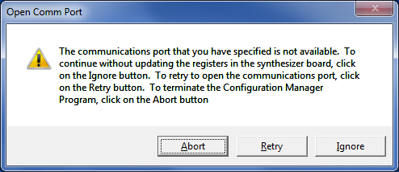
  - In the start menu, right-click on “Computer” and select “Manage”.
  - Select Device Manager from the list on the left, and look under “Ports” for a USB Serial Port device. In the screenshot below it is shown as COM6, make a note of this number.
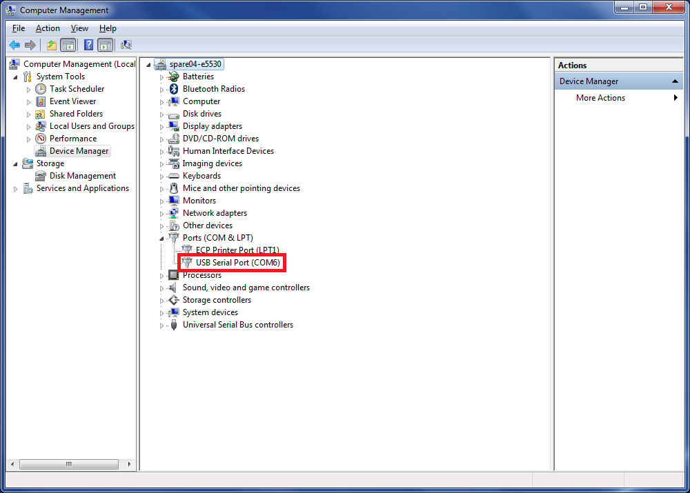
  - Return to the 5007 Config Manager software. In the Comm Ports menu, select the port number corresponding to the USB Serial Port noted earlier, as shown:
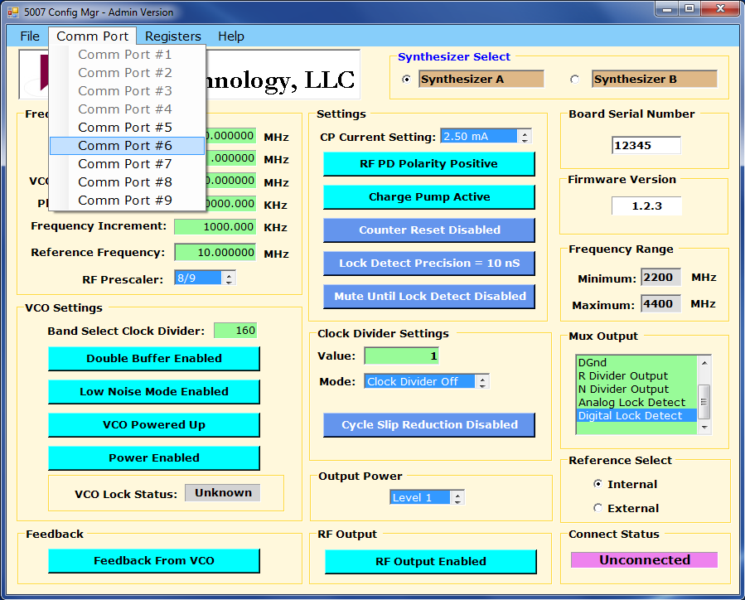
  - Under the File menu, click “Read Registers” to load the configuration currently saved in the Valon. If not already the case, set both the Synthsesisers to a Desired Frequency of 800 MHz and output power of Level 1 (corresponding to 1 dBm).
  - Under the file menu, click “Write Registers” to save the configuration and “Write Flash” to save it permanently. Verify that it is correctly stored by closing and restarting the application and reading the registers again.
  - If this is correct,

- Configure the boot process to auto-power on. This is done by
- Connecting the network cable between the XPORT connector on the back of the ROACH and a network switch
- Connecting the Linux PC (Not the control PC) to the network switch
- Manually setting the PC to have a static IP address = 192.168.4.1
Add the following lines to /etc/network/interfaces
auto eth0
iface eth0 inet static
address 192.168.4.1
netmask 255.255.255.0
Then do
$ sudo /etc/init.d/networking stop
$ sudo /etc/init.d/networking start
Verify the static IP (192.168.4.1) has been set by using ifconfig

- The ROACH XPORT has a default IP address of 192.168.4.20. You can connect to it using the roach_monitor.py (available at https://github.com/chopley/AVNDigitalBackendDocumentation/blob/master/roachAcceptanceTests/roach_monitor.py) script once you have set the PC IP address to the static value as above. If you cannot connect, it is likely that your PC is being assigned an IP on a different sub-net and this needs to be remedied. Note: Some distributions (e.g. Ubuntu) use a network manager which may either ignore or overwrite the /etc/network/interfaces file. In this case, the distribution’s preferred means of setting the IP address must be used.
- Connecting to the ROACH:
$ python roach_monitor.py
- Toggle the auto-power setting. This is option 8 in the menu which is shown:
ROACH MONITOR CONTROL
=====================================

1) Retrieve details
2) Reset crashlog counter
3) Power-up ROACH
4) Reset ROACH, but not Actel
5) Toggle safety-shutdown defeat
6) Power down ROACH
7) Toggle PPC EEPROM boot (config H)
8) Toggle auto power-on after hard-reset.
=>8<enter>
Automatic power-up after reset is currently disabled. ENABLING... done.

- Verify this is working by disconnecting power to the ROACH and reconnecting power. NOTE THAT THE ROACH MUST BE POWERED ON BEFORE PULLING THE POWER TO IT. IF IT ISN'T POWERED ON IT WILL NOT AUTOMATICALLY RESTART
- Remove the network cable from the XPORT port on the ROACH and connect the 1GbE port as normal.
- On the control PC: verify that the ROACH can get an IP address. If the serial number of the ROACH is 040406 then the MAC address of the 1gbe ROACH connector will default to 02:00:00:04:04:06. Edit the following file:
sudo vim /etc/dnsmasq.conf
- add an appropriate line at
dhcp-host=02:00:00:04:04:06,169.254.128.113 #Roach name
- Restart the dnsmasq service.
sudo /etc/init.d/dnsmasq restart

- Change the boot command in the U-BOOT bootloader. To do this you do the following:
- Connect the serial port of the ROACH to the Windows PC using the USB-to-serial converter and establish a serial connection using Putty or similar software (baud rate 115200). Remember to check the COM port using the technique described above.
- Power up (or reboot) the ROACH, keeping an eye on the terminal
- Press a key on to get into the UBOOT configuration. Typing help lists the possible commands.
Input: printenv bootcmd
Output: bootcmd=run mmcboot
- Change this to run netboot
Input: setenv bootcmd run netboot
Input: saveenv
- Verify that the ROACH is booting from NFS rebooting on the front panel, or by typing boot in U-BOOT.

- Login to the ROACH. The default login is root with no password.

- Verification procedure:
  - Connect Synth1 from the Valon to the KAT-ADC port labelled CLOCK/FS. This provides a 800MHZ at 1dBm clock signal for the KAT-ADC. This is divided by 4 for the Xilinx Virtex 5clock speed of 200MHZ. Load 'tut3_katadc.bof' into Roach filesystem (/boffiles) if not already present.
- Run 'python tut3_katadc <roach_ip_address>' in a terminal window (X forwarding required if done via ssh).
- A noise spectrum plus the 200 MHz tone of the Valon should be seen within a minute, updating every few seconds. It will look something like this:

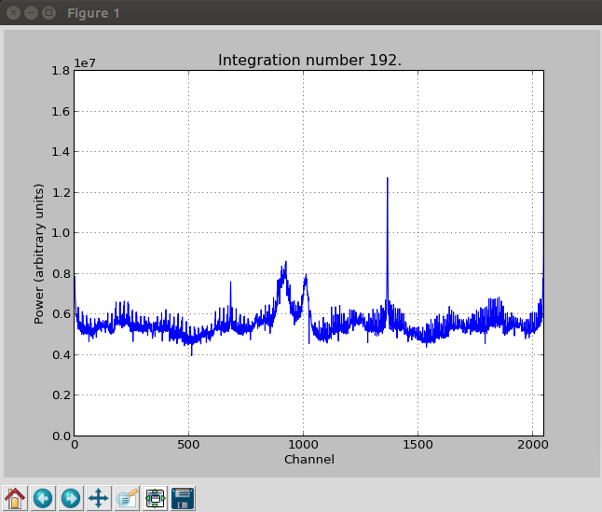

If the Valon needs to be configured, this can be done in Linux using ipython.
First plug the Valon into the computer via USB, and run dmesg to determine the ttyUSB* (usually 0 or 1).

Run sudo chmod 777 /dev/ttyUSB0 (or 1), in order to make the Valon usable by ipython, then from within ipython

import valon_synth
a = valon_synth.Synthesizer('/dev/ttyUSB0')
a.get_frequency(valon_synth.SYNTH_A) #show current freq
a.set_freqyency(valon_synth.SYNTH_A, 800) #set freq A to 800 MHz.
# valon_synth.SYNTH_A and valon_synth.SYNTH_B can be used to
# get and set frequencies for the two synthesizers.

Procedure for AVN Roaches during deployment

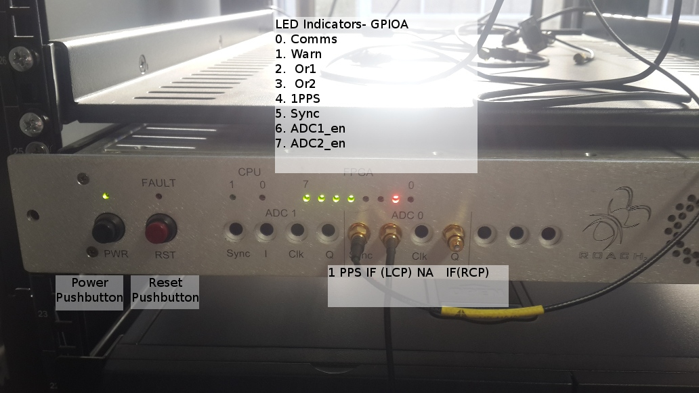

- Verify IF Power Level from Receiver output is between -20 and -27dBm by measurement with a broadband power meter. Note down power level.
- Verify IF frequency band is in appropriate band by measurement with a spectrum analyser. Note power level and 3dB frequencies.
- Tune receiver line up to appropriate values for Methanol Maser detection. This would be such that the 6.7GHz Methanol maser line appears at ~200MHz in the ROACH input. Verify detection of Maser by pointing antenna appropriately, and monitoring the IF using a spectrum analyser (this may require some playing with the RBW). Take a photograph of the spectrum analyser screen, and note maser IF frequency.
- Verify detection of a bright astronomical source by monitoring IF signal power and driving antenna over an appropriate astronomical source. Choices could be CygA, casA, TauA, moon etc.
- Verify network connections of digital backend equipment
  - Connect 1gbe RJ45 cable from ROACH to network switch, and 1gbe RJ45 cable from control PC to network switch. Visually verify that the correct port is connected (there are three).
  - Connect station LAN to the control PC. Visually verify that correct port is connected.
  - Verify ROACH network connection by powering ROACH, and ping appropriate ROACH IP address from control PC- nominally 169.254.128.91
  - Verify ROACH borph is operating over NFS by ssh into ROACH ssh root@169.254.128.91
  - Verify ntp time acquisition is working (ntpq -p on Roach and control PC)
  - Finally, check all IP addresses are properly allocating. The private LAN should be on subnet 169.254.128.xxx on the PC, and the public LAN should be receiving an IP address.
  - Verify that a PC connected on the Private LAN is allocated with an IP, and is able to access the public LAN. Verify by test, i.e connect up a laptop to private network switch, and ping www.google.com
- Connect IF LCP cable (SMA) to Roach I input- SMA cable
- Connect IF RCP cable (SMA) to Roach Q input- SMA cable
- Connect up 1PPS cable to Roach Sync Input. SMA cable
- Start up Roach Narrowband Spectrometer mode using ipython
  - James to add this notes.
- Verify 1PPS detection by visual inspection of LED on front panel (4th LED from the Left)
- Verify Pulse detection by visual inspection of LED on the front panel (3rd LED from the left)
- Connect 10gbe Cable from ROACH to standard PC and verify operations using wireshark
  - James to add his notes.
- Verify remote access to PC and static IP address is assigned.

High Resolution Spectrometer Design SCREENSHOTS
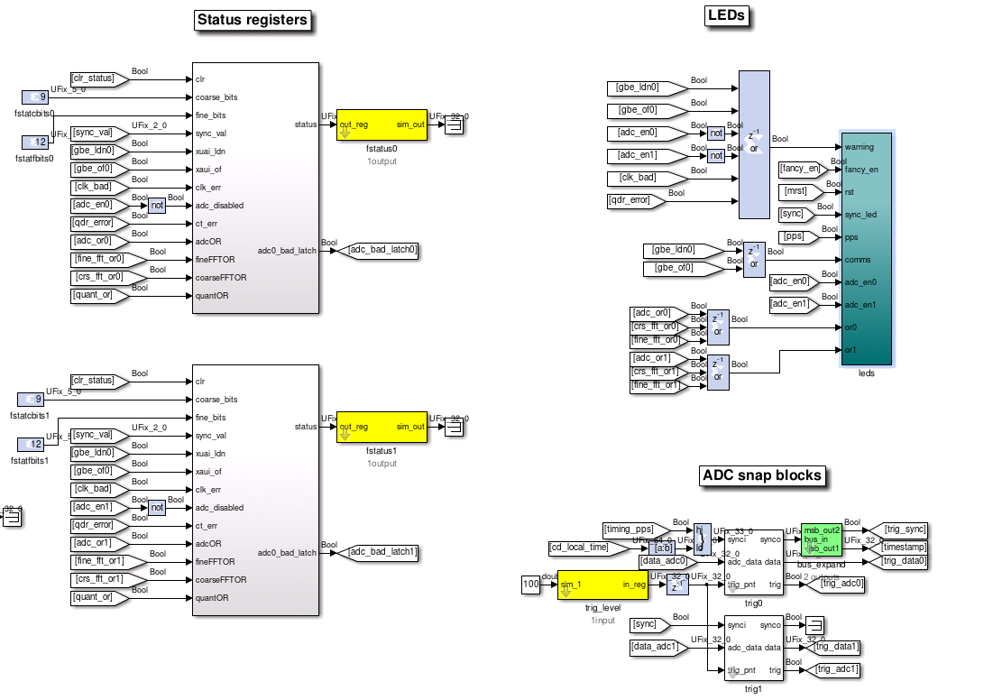Illustration 1: High Level context of LED, ADC Snap Blocks, and Status Registers

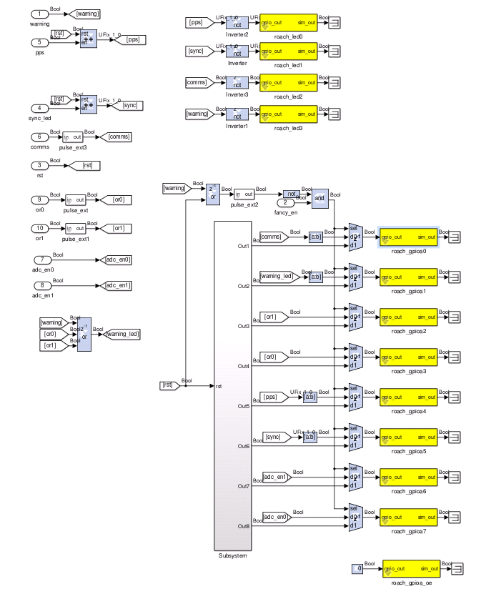Illustration 2: Low Level description of the LEDs on the front panel (they are connected to GPIOa pins via ribbon cable inside)
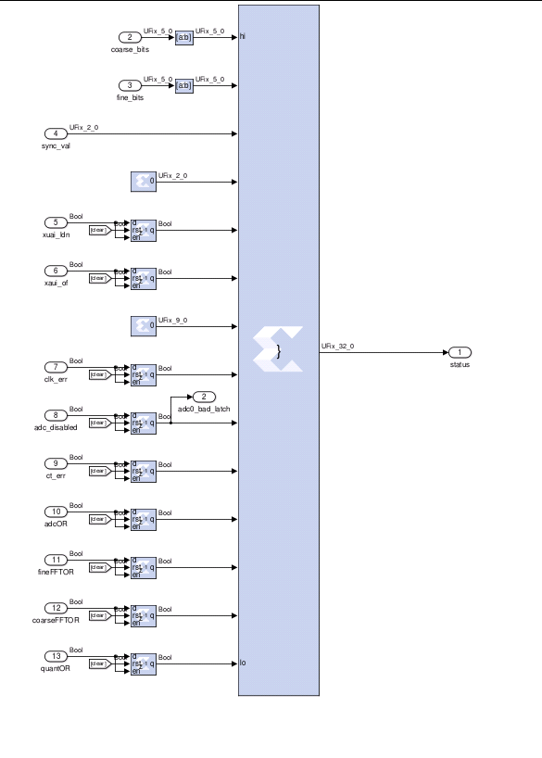Illustration 3: Layout of Status registers

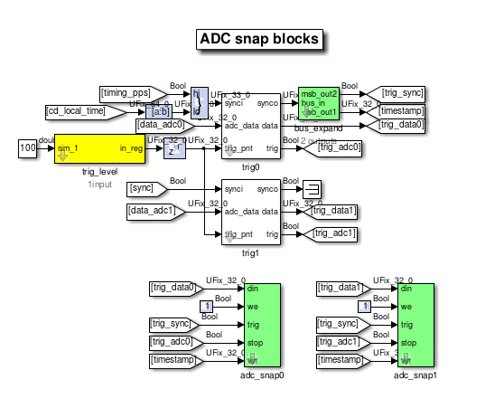Illustration 4: ADC Snap Block registers

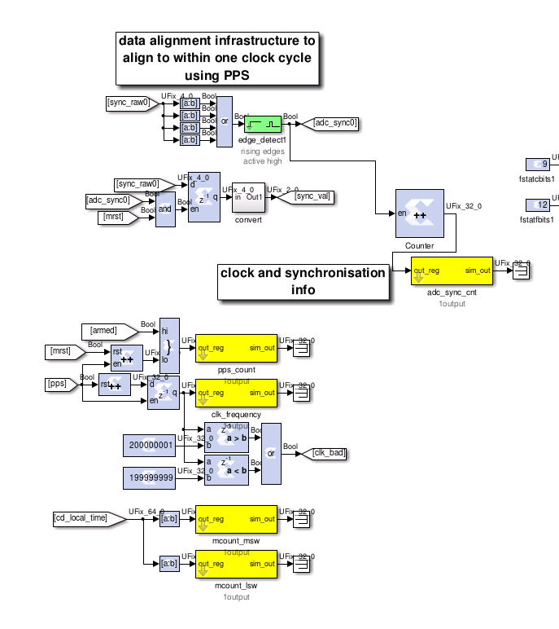Illustration 5: Timing description
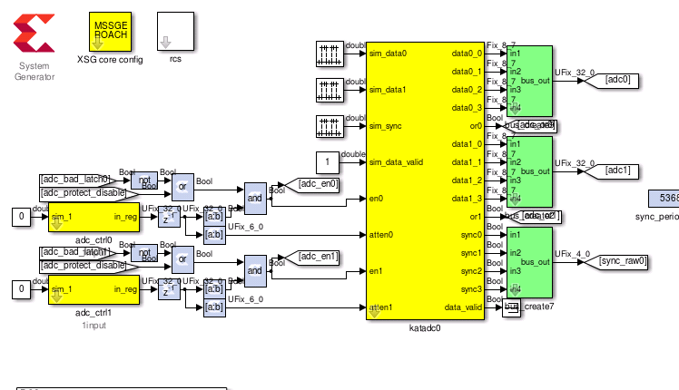Illustration 6: ADC controllers and registers

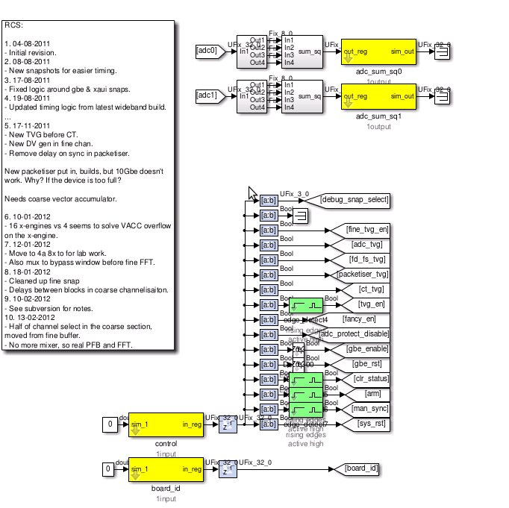Illustration 7: Control register for the design

