**STRUCTURAL SEISMIC DESIGN IN CONDITIONS OF TOPOGRAPHIC COMPLEXITY**

**I.Timchenko**(1)

1. *Ilia State University; ‘Progresi’ Ltd. Engineering Center, Tbilisi, Georgia,* [*igortimchenko@gmail.com*](mailto:igortimchenko@gmail.com)

***Abstraсt:*** *The influence of complex topography on the site-specific seismic response was studied in order to adjust the input parameters for seismic design of high rise buildings; a practical design methodology is proposed in the paper.*

**ТОПОГРАФИЯЛЫК ТАТААЛДЫК БОЮНЧА КУРУЛУШТУК СЕЙСМИКАЛЫК ДОЛБООРЛОО**

**И.Э.Тимченко**(1)

(1) *Мамлекеттик университет. И.Чавчавадзе; «Прогреси» инженердик борбору, Тбилиси, Грузия,* [*igortimchenko@gmail.com*](mailto:igortimchenko@gmail.com)

***Аннотация:*** *Көп кабаттуу үйлөрдүн сейсмикалык туруктуулугунун параметрлерин тактоо үчүн конкреттүү аймактын сейсмикалык реакциясына татаал рельефтин таасири изилденген; Макала практикалык ыкманы сунуш кылат.*

**ПРОЕКТИРОВАНИЕ СЕЙСМОСТОЙКИХ КОНСТРУКЦИЙ В УСЛОВИЯХ СЛОЖНОГО РЕЛЬЕФА**

**И.Э.Тимченко**(1)

1. *Государственный Университет им. И.Чавчавадзе; Инженерный центр «Прогреси», Тбилиси, Грузия,* [*igortimchenko@gmail.com*](mailto:igortimchenko@gmail.com)

***Аннотация:*** *Влияние сложной топографии на сейсмическую реакцию конкретного участка изучено с целью уточнения входных параметров для сейсмического проектирования высотных зданий; в статье предложена практическая методика.*

The rational development of territories with complex terrain has great artistic advantages in comparison with construction on flat surface. But one should also take into account the negative aspects of the location of the building on steep slopes. These include the construction cost increasing due to the use of special types of buildings, more complex excavation, construction and reinforcement technology. On the characteristics of the relief, the upcoming costs of construction and the choice of the future house project are largely dependent. The relief is determined by the slope of the surface, which is calculated as the ratio of the difference in height of two points of the terrain to the distance between them horizontally, which is the tangent of the inclination angle of slope. The slope is measured in fractions or percentages. Usually, the area is flat with slope not more than 3%, small slope - from 3 to 8%, medium - to 20% and steep - over 20%. With a slope of more than 15-20%, it is necessary to develop a special design. The disadvantages of the slope can be turned into advantages if you design a multi-story dwelling with separate blocks. On the slope you can also arrange a terrace for rest, with a wonderful view.

Currently, the housing resources for the perspective and general development of Tbilisi intend the intensive development of mountain slopes and gorges. As a rule, the terrain is not favorable for construction. In most cases, the slope angle is within 12-15°, and in some cases it 30° and more - see the studied multistory building, Panaskerteli str., Tbilisi (Fig. 1). With such deviations as the existing norms in ther country and in other countries, the construction of buildings and structures on a complex terrain (with a slope of 12-15 ° and more) is not recommended (due to frequent collapses caused by gravitational forces, damage to buildings and structures, etc.).

In Eurocode the topography amplification factor is presented for slope stability issues as informative annex [1] to be considered independent of the fundamental period of vibration - multiply as a constant scaling factor the ordinates of the elastic design response spectrum. The values of this factors are in range of 1-1.4. For average slope angles of less than 15° the topography effects may be neglected, while a specific study is recommended in the case of strongly irregular local topography.

In Italian seismic code [2] there are four topographic categories depending on inclination angle ***i*** of slope with factor from 1.0 (***i***<=15o, flat surface, slope and isolated ridge) to 1.4(***i***>30o, ridges with crest much smaller than the base). The hight of slope is not defined in this classification.

In French seismic code [3] the topographic factor **t** (also from 1.0 to 1.4) is taken into account for structures situated at the crest edge, the height **H** of the slope and its angle ***a*** mainly define the value of **t**.The maximum value of **t** is near the crest edge at the distance **b** which isminimum of two values: **b** = min{20tg***a*;**(**H** +10)/4} (Fig. 2).

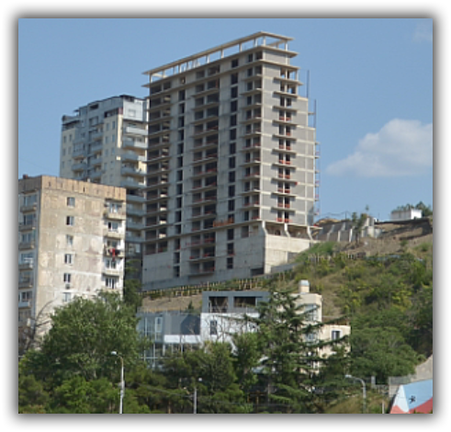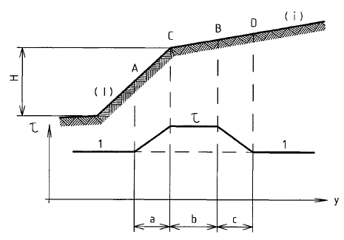

Fig. 1 The multistory building on the slope Fig. 2 The topography factor definition (from [3])

In Georgian seismic code [4] construction sites with slopes more than 150 require special design measures on foundation, structural strengthening and adjustment of seismic hazard with microzonation. The reason - frequent collapses caused by gravitational forces, damages of buildings and structures etc.

Thus, for the complex terrain the seismic codes propose the topographic factor depending on slope geometry and the building location on the slope. The local construction practice shows that required in [4] seismic microzonation is not usually carried out and does not give the necessary data for structural analyses, e.g. site-specific accelerogram package. According to the analyses results of earthquake consequences, the real behavior of structures on the complex terrain is underestimated using the topography factor proposed in codes, e.g. [5]. It is natural to assume that other factors can also significantly increase the dynamic response on the construction site - soil conditions, dynamic parameters of the construction site topography.

**Methodology**

The proposed numerical methodology of the seismic response assessment on construction sites in complex terrain conditions includes the consideration of the relief geometry, geological data and the dynamic features of the construction site area. In our case the GeoStudio computer software was used for site-specific soil dynamic analyses [6] and LIRA SAPR software [7] was used for detailed calculations of the structural bearing system. The equivalent linear dynamic approach was used for analyses of soil response [8]. A dynamic analysis starts with the specified soil stiffness. The soil stiffness *G* is modified in each element in response to computed strains at each iteration according to specified *G r*eduction function. This iterative procedure continues until the required *G* modifications are within a specified tolerance  *(G* is a constant during one iterative pass through the earthquake record). The static soil initial stress-strain condition is calculated before the dynamic analyses. The *G r*eduction function (G function vs. strain level and vs. stress) is specified in initial conditions for different soils compiled from existing experimental data [9, 10]. E.g. for clay material it is shown on Fig. 3.

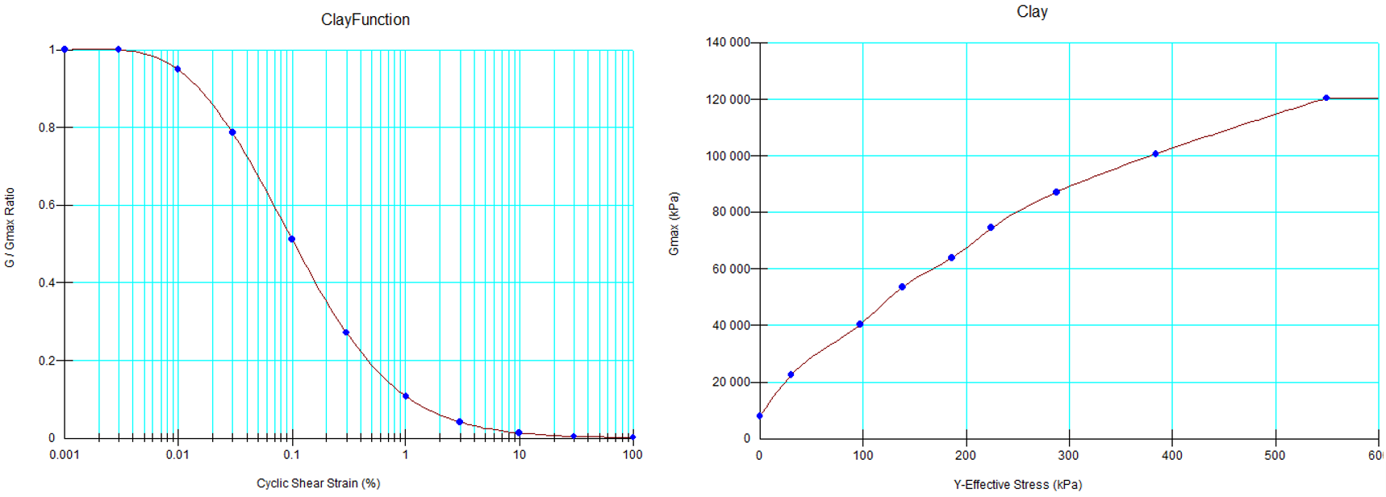

Fig. 3 The *G r*eduction function vs. strain (left) level and vs. stress (right) for clay

In calculations a staged approach with the load history has been used and it is the following. The initial stress-strain state was defined in statical conditions for the soil massif without a building. The second stage represents the stress-strain state calculation with constructed building in statical conditions. At the next stage the time history equivalent linear (iterative) analyses are performed with recorded data in key points – at the base level where the input accelerogram as applied; on the surface near the bottom level of the slope; at some points of the construction site on the slope top level. The last stage – the stability assessment of slope performed both in time domain and in limit equilibrium conditions. Then, for structural calculations of the building the response accelerograms at the foundation level are used as input data for structural calculations of the building. Another approach – a package of generated accelerograms can be used for the building structural analyses on the basis of calculated site-specific response spectra. Below some results demonstrate the significance of the complex relief consideration in design.

With the Equivalent Linear model a dynamic analysis starts with the specified soil stiffness, then steps through the entire earthquake record and identifies the peak shear strains at each numerical integration point in each element. The shear modulus is then modified according a specified *G r*eduction function and the process is repeated. This iterative procedure continues until the required *G* modifications are within a specified tolerance. The *G* is a constant while stepping through the earthquake record andmay be modified for each pass through the record, but remains constant during one pass.

**Numerical Modelling & Results**

The design model (Fig. 4) includes the relief geometry, geological data, designed building at the top of slope of 15m height. Key points (base, surface, edge of slope) where the necessary calculated parameters are recorded are specified as well. The second model with rocky material (Rock1) instead of clay is the same, except the lithology; it is used for the comparison of results.

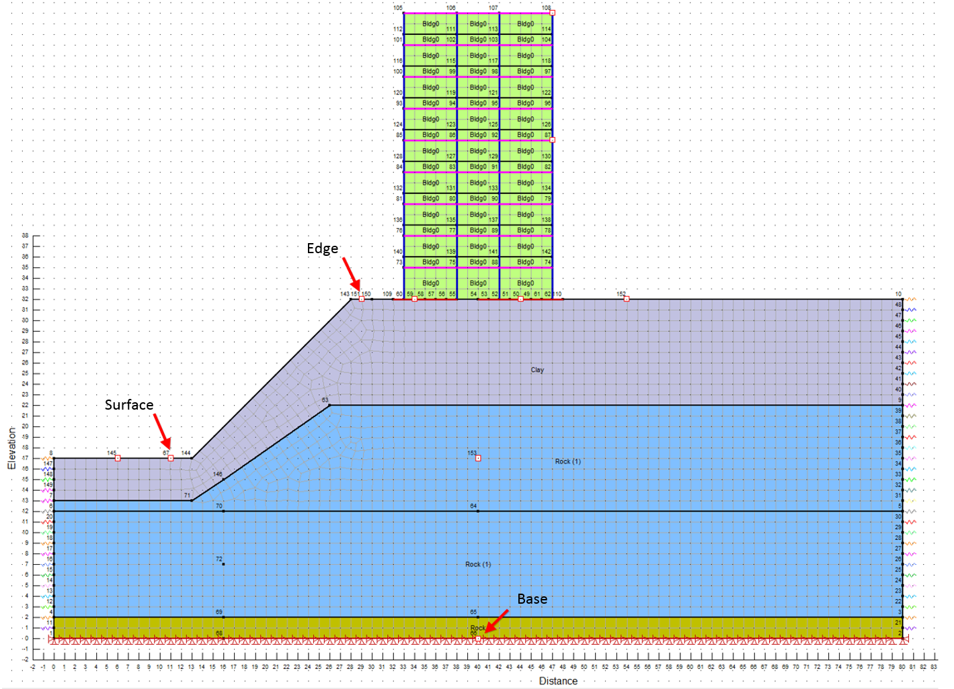

Fig. 4 Design model with ground massif, building, specified key points (Base, Surface, Edge)

For numerical simulations the following accelerograms were used, see Table 1. The presented below results are obtained with El Centro NS input record which may not represent the high frequency components of the ground motion[11].

The soil initial parameters- Clay sand: **r**=18kN/m3, **c**=25kPa, **f**=150,**m**=0.4; Rock(1): **r**=21kN/m3, **c**=200kPa, **f**=350,**m**=0.25.

Table 1 Earthquake records used in calculations

|  |  |  |  |  |  |  |
| --- | --- | --- | --- | --- | --- | --- |
| # | Title | Comp. | pga [g] | Date | Site | Note |
| 1 | Tbilisi | NS | 0.10 | 25.04.2002 | Nutsubidze str. | On rock |
| 2 | El Centro | NS | 0.35 | 18.05.1940 | Term. Substation Bldg | RC slab |
| 3 | HKD087 | EW | 0.24 | 26.09.2003 | Futamata | On rock |
| 4 | HKD087 | NS | 0.14 | 02.02.2013 | Futamata | On rock |
| 5 | ISK003 | NS | 0.56 | 25.03.2007 | Wajima | On rock |
| 6 | MYG011 | NS | 0.25 | 02.12.2001 | Oshika | On rock |
| 7 | SAG001 | EW | 0.35 | 20.03.2005 | Chinzei | On rock |
| 8 | MYG011 | NS | 0.38 | 04.08.2013 | Oshika | On rock |
| 9 | MYG011 | EW | 0.24 | 04.08.2013 | Oshika | On rock |
| 10 | AKT017 | NS | 0.22 | 14.06.2008 | Yokote | On rock |

All accelerograms were recorded on rocky foundation except #2. ##3-10 records are from the perfectly organized Japan K-NET strong-motion seismograph network [12]. Accelerograms recorded on the baserock are the most useful tool in our case for the further computation of the soil seismic response at any construction site with known geological data. In numerical simulation all records were scaled to pga=0.2g corresponding to the normative seismicity level in the Tbilisi territory.

Fig. 5 shows the Y-stresses at first stage of calculations, without a building; Fig. 6- after the second stage, with the erected building.

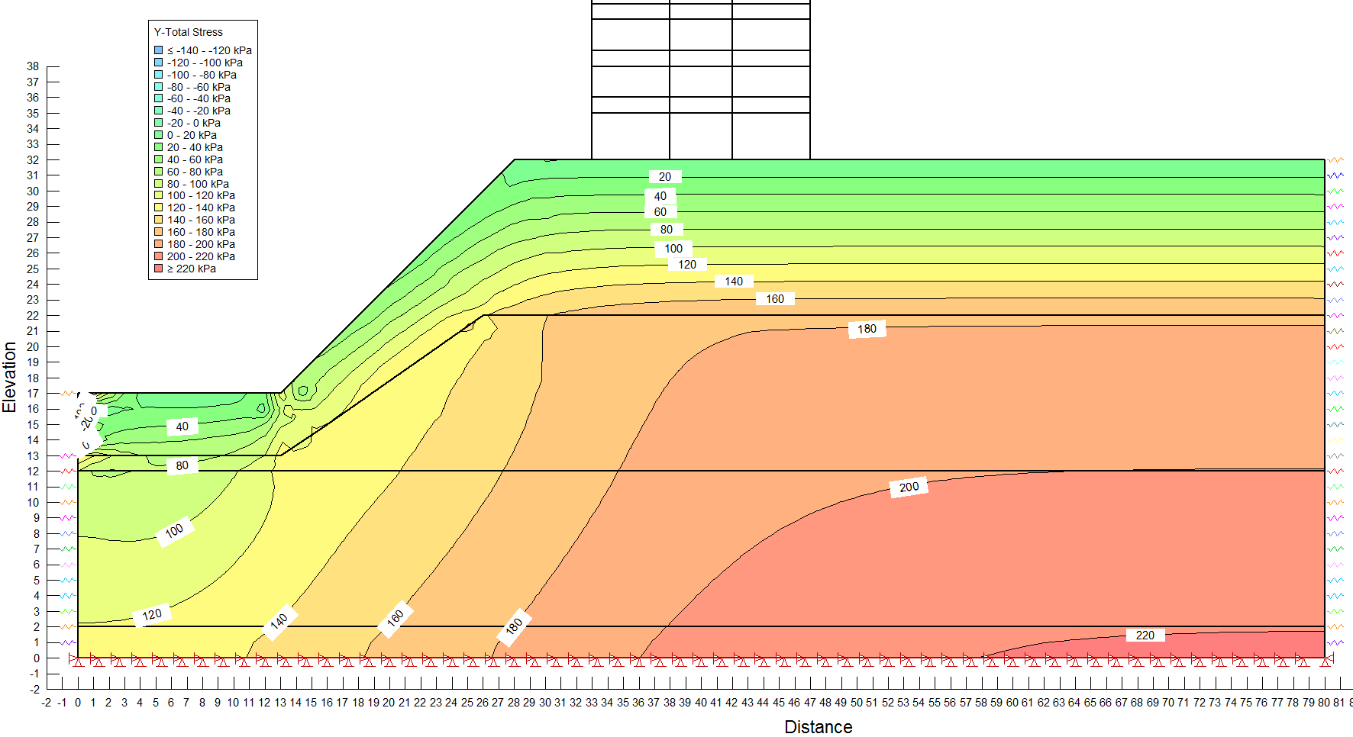

Fig. 5 Y-stresses in soil massif at initial stage of calculations

The dynamic response – accelerations in key points are presented in Fig. 7 for both cases of geological conditions.

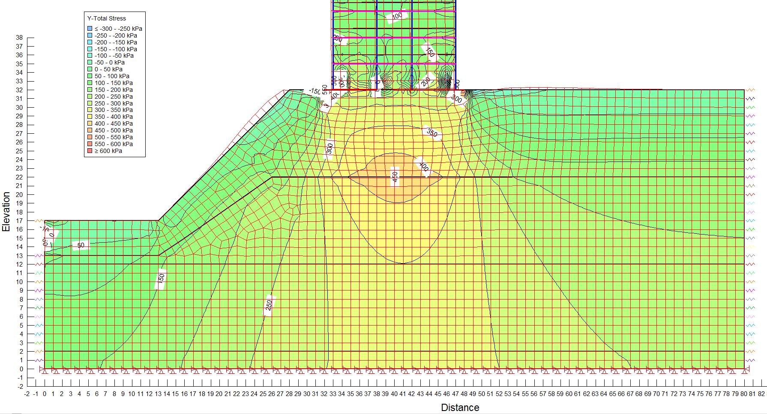

Fig. 6 Y-stresses in soil massif at second stage of calculations – with erected multystory building (the fragment of the building is shown)

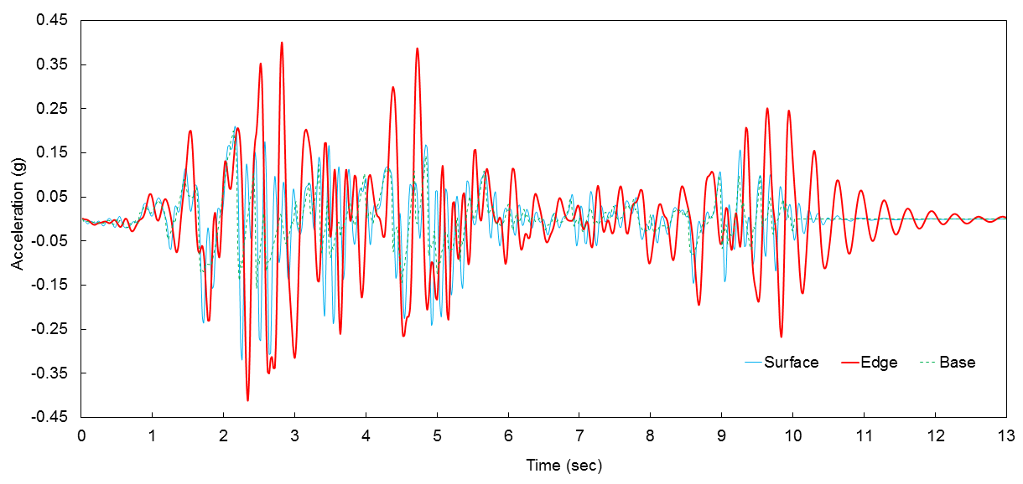

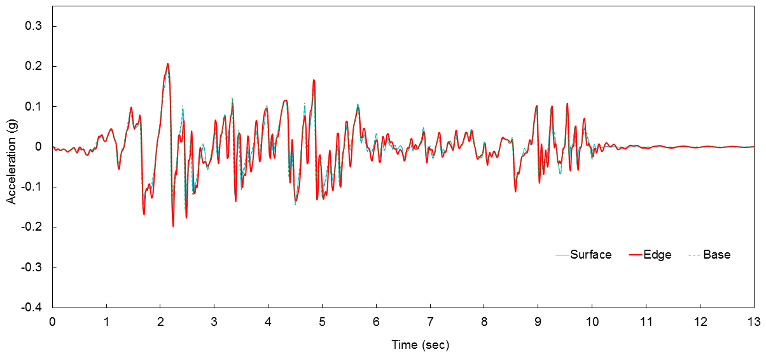

Fig. 7 Response accelerations in key points: the massif with clay-sand upper layer (above); the massif with rocky soil (below)

The acceleration response spectra in key points are presented in Fig. 8, 9 for both cases of geological conditions. The spectral amplification factor in the Edge key point relative to the Surface key point are shown in Fig. 10.

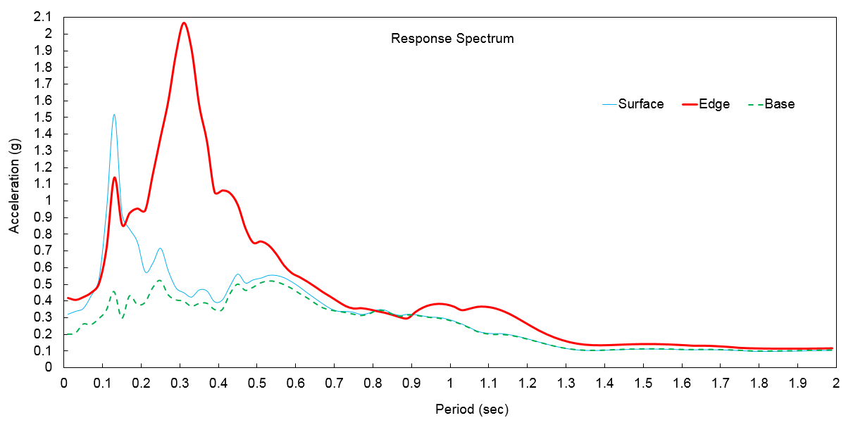

Fig. 8. The acceleration response spectra in key points of massif with clay-sand upper layer

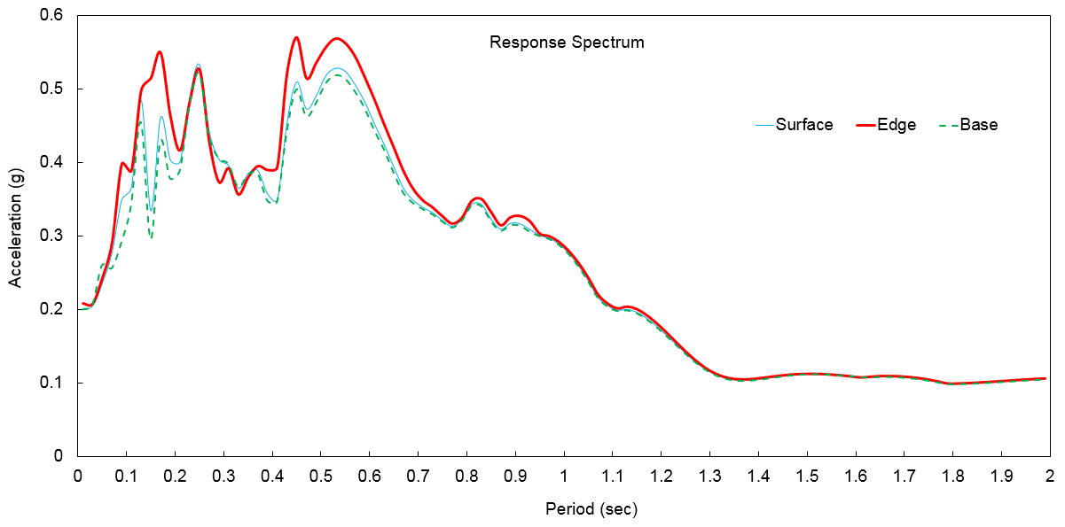

Fig. 9. The acceleration response spectra in key points of massif with rocky soil

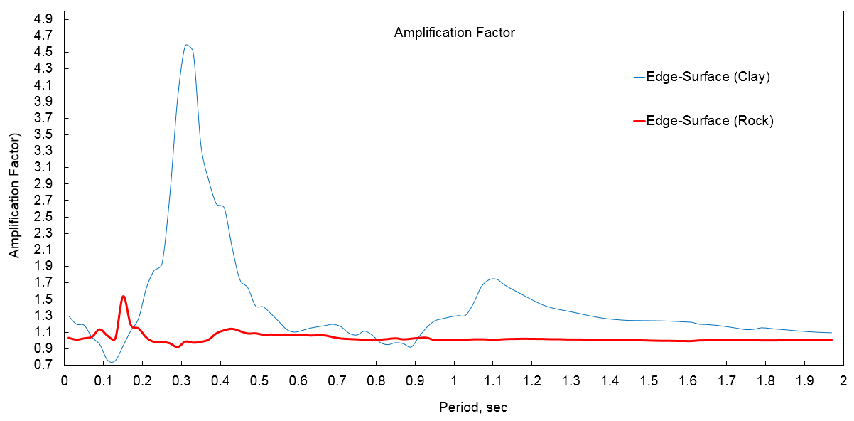

Fig. 10. The spectral amplification factor in the Edge key point relative to the Surface key point

In our case, the maximum value of amplification factor is 4.6 at T=3.2s; for rocky massif this value is more than 1.5 at T=0.15s that also exceeds the maximum normative value 1.4 of the topography factor.

**Conclusions**

Based on the obtained results of numerical modelling we can conclude the following:

1. The design regulations for construction in complex terrain conditions should be developed in details, including not only the topography factor (multiplier for seismic forces depending on the relief geometry) but the other factors – soil parameters, dynamic behavior of soil massif with its own natural modes of vibrations which may significantly increase the soil seismic response on construction site.
2. The results of numerical simulation show that the soil seismic response amplification on a construction site situated on a complex terrain depends not only on the relief geometric characteristics but more significantly on soil parameters of slope and shape of relief that should be considered in design.
3. In case of relief composed of homogeneous rock formations, some results of numerical simulation are generally consistent with the normative data [2, 3] related to the values of topographic factor but in most cases they significantly exceed the normative values that requires a careful interpretation and development of normative regulations and procedures especially for design of multistory buildings in complex terrain conditions.
4. The slope stability assessment should be, as a rule, an essential, inseparable part of design in a complex terrain, preferably performed in time domain which gives, on our opinion, more conservative results comparing to the results of limit equilibrium methods.

**References**

[1] EN 1998-5 : 2004/ Eurocode 8: Design of structures for earthquake resistance Part 5: Foundations, retaining structures and geotechnical aspects. Annex A

[2] NTC (2008). Norme Tecniche per le costruzioni. D. M. 14/01/2008 by the Ministry of Public Works of Italy. G.U. 04/02/2008

[3] NF P 06-013. Earthquake resistant construction rules - earthquake resistant rules applicable to buildings, called PS 92

[4] PN 01.01-09 Earthquake resistant construction. Norms and rules, 2009, 167 pp

[5] Gallipoli, M. R., Bianca, M., Mucciarelli, M. et al. (2013): Topographic versus stratigraphic amplification: mismatch between code provisions and observations during the L'Aquila (Italy 2009) sequence. ‐ Bulletin of Earthquake Engineering, 11, 5, 1325‐1336

[6] GeoStudio 2016 (R8.16.1.13452). Geoslope International, Ltd., Trial License. Internet link: <https://www.geo-slope.com>

[7] LIRA SAPR 2021 (R2), Internet link: [www.liraland.ru](http://www.liraland.ru)

[8] Dynamic Modeling with QUAKE/W an Engineering Methodology October 2014 Edition GEO-SLOPE International Ltd., 2014

[9] Seed, H.B. and Idriss, I.M. (1970) Soil Moduli and Damping Factors for Dynamic Response Analysis, Report No. UCB/EERC-70/10, Earthquake Engineering Research Center, University of California, Berkeley, December, 48p

[10] Seed, H.B., Wong, R.T., Idriss, I.M. at al. (1986) Moduli and Damping Factors for Dynamic Analyses of Cohesionless Soils, Journal of the Geotechnical Engineering Division, ASCE, Vol. 11 2, No. GTI 1, November, pp.1016-1032

[11] Internet link: <http://www.vibrationdata.com/elcentro.htm>

[12] Internet link: <http://www.kyoshin.bosai.go.jp>