GAME IDEA

-Rhythm

-Grid based

Object of game: survive for as much time as possible

Lose: If you enter the same square as an enemy or vis versa you lose a life. 3 lives and your out.

Core Mechanic:

Must move on beat to the music.

Stick option:

\*If you are off beat you will be punished (maybe your time takes a hit, or you simply don’t move if you input off beat.)

Carrot Option:

\*I could also do a reward for being on beat. Maybe there is a bar that fills up slowly as you are on beat more. When the bar is full a power up spawns.

Castle Crashers back off barbarian is a game where you move on a grid away from enemies. The movement isn’t the actual direction however, it is the arrow that is shown. I might create a randomized input system like this to make my game a little more interesting. 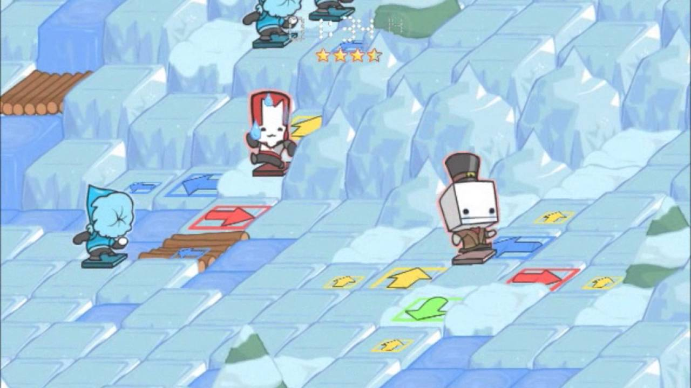

Enemies:

Enemies will move around the board on beat. (Simple AI. Maybe they pick a random space to move to but it is more likely they pick a space closer to the player if game is to easy)

Enemy states:

Active : move around the board

Inactive : do nothing and don’t be visible

Enemy spawning Options:

-Spawn on designated tiles the player can not enter.

-Random tiles but make a 2 beat warning or something to let the player move away

(Want to avoid unfair spawning)

Tile type options:

Simple

-walkable

-not walkable

Complex (if time permits)

-2 beats to get off of

-portal tiles (bassicly move the player to where the other portal tile is.) maybe give

portal tiles a cooldown

-breaking tiles (after player leaves them they are no longer walkable for a period of time)

Powerups:

Powerups will spawn on a tile for a limited time.

Type ideas: (probably will have time for 1 or 2)

-Time slow

-Laser that clears a row/column of the grid of enemies

-freezes enemies

-gives player an extra life

-expands grid

EXTENDED GOALS:

Make it two player co-op

Team revival – can enter same space as dead teammate to revive them.

Image of prototype

Game will be 2D built in Monogame. Timer will be top middle and lives with be in top left. Maybe addition art on the sides to make it feel like an old arcade console.