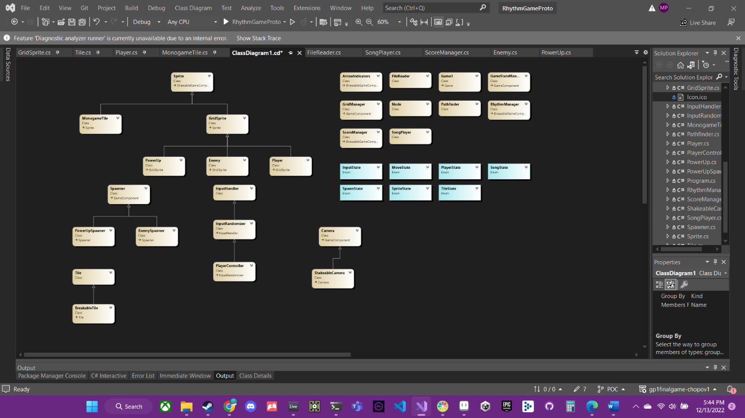

Two of the main dependencies is the rhythm manager and grid manager. Both are used by almost every other class, as everything in the game needs information about the music as well as info about the grid. I made these depend on very little so that they could be leaders so to speak, and everyone else can depend on them.

I think my class/component design worked out great! If I had more time I would change add states for different screens. However I did not have time to implement screens.

I’d guess about 70% of the code is game specific and 30% is monogame specific. 10% is also dependent on another library called CSCore. I used this for more complex audio as it allowed me to read the audio buffer data to create a more accurate timer.

So far it is super easy to add more enemies and pickups, as well as add more spawners for different items to!

I am very satisfied with the progress I made on my game. It wasn’t the exact game from the GDD but I didn’t expect to finish all of that. I am happy I was able to get the game to the state it is in before the deadline. Most of the main systems are built and adding things like other power ups would not require to much extra work. I do wish I could make better art though.