Project Title | REAL TIME PATIENT HEALTH MONITORING USING ESP32
Project ID
Academic Year | 2026
Batch Number | 014
Product Domain | ROBOTICS
Functional Domain | HEALTHCARE
Mentor Name | MS.H.YASHASWINI
Department | DATA SCIENCE
Team Members | CH.YASWANTH (25491A5416)  B.GOPI KRISHNA REDDY (25491A5407)  D.HEMA ANANTH KUMAR(25491A5420)  B.POOJITHA (25491A5408)  B.KALYANI (25491A5410)  CH.REVATHI (25491A5418)
SDG Mapping | Sensor Data Collection (SDC) Mapping defines how each sensor’s data flows into the ESP32. Vital signs (HR, SpO₂, ECG, temperature, fall detection, GPS) are mapped via I²C, ADC, UART, and GPIO pins. ESP32 processes, displays on LCD, triggers buzzer alerts, and syncs data to the cloud for remote monitoring.

Project Datasheet

Project Abstract (150 Words)
The project “Real-Time Patient Health Monitoring Using ESP32” presents a low-cost, IoT-based healthcare solution designed to continuously track vital parameters and provide timely alerts. The system integrates an ESP32 microcontroller with Wi-Fi for cloud connectivity, coupled with sensors such as MAX30102 for heart rate and SpO₂, AD8232 for ECG, and MLX90614 for non-contact temperature measurement. To enhance patient safety, the MPU6050 detects falls or abnormal movement, while the NEO-6M GPS provides location tracking during emergencies. Data is displayed locally on a 16×2 LCD with I²C interface, and critical alerts are issued via a buzzer and LEDs. Supporting modules like breadboards, connectors, and a rechargeable battery with TP4056 ensure portability and reliability. With an estimated cost of ₹3,200, this system enables real-time monitoring, cloud-based dashboards, and predictive anomaly detection, thereby reducing hospital visits, improving decision-making, and supporting remote healthcare for patients and caregivers.

Semester Objectives
- To design an IoT-based system using ESP32 for continuous patient monitoring.
- To integrate multi-sensor data (HR, SpO₂, ECG, temperature, fall detection, GPS)
- To implement real-time alerts via LCD, buzzer, and cloud dashboards.
- To develop a cost-effective prototype (~₹3,200) for accessible healthcare.
- To validate remote monitoring and predictive anomaly detection for improved decision-making.

CPBL Target for this Semester
Target TRL | To complete the software part starting prototype
Expected Semester Outcome | To stimulate the response in the designed website

Proposed Block Diagram

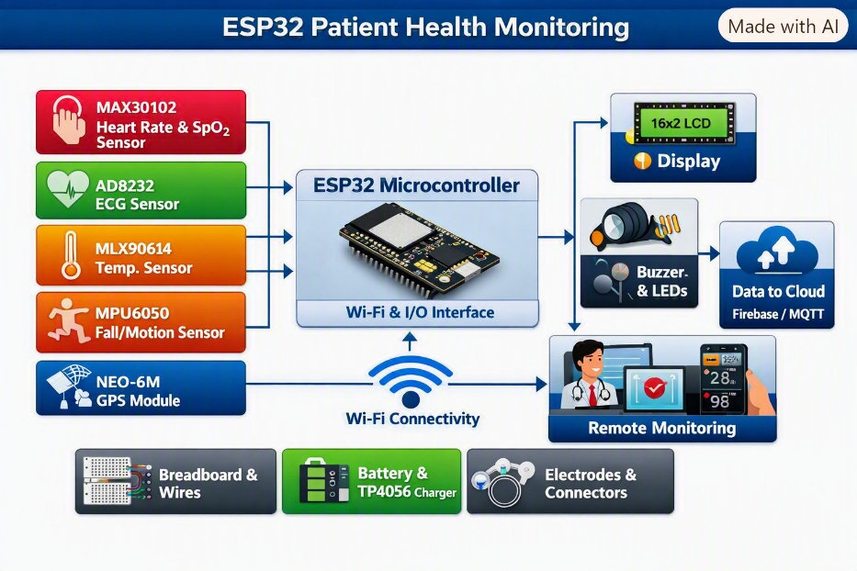

Proposed Functional Layout / Architecture

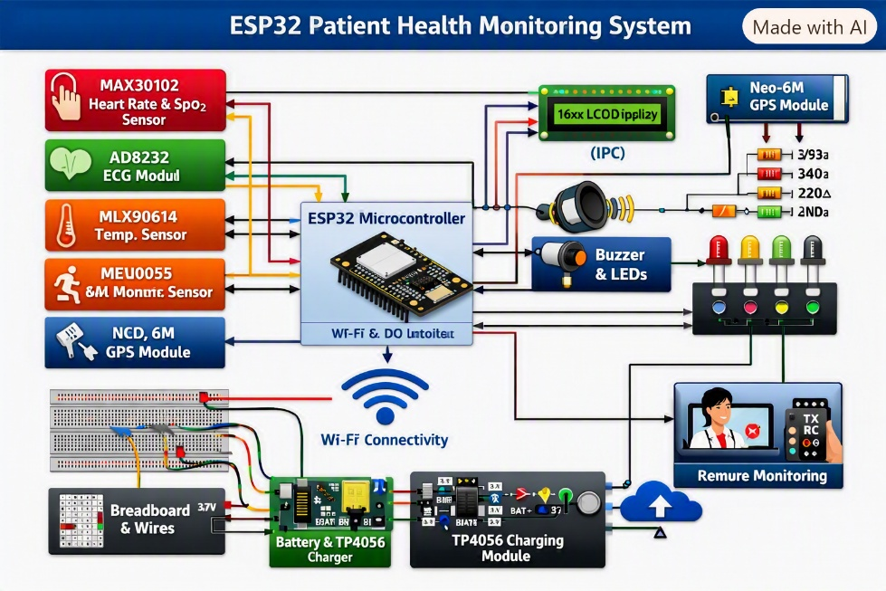

Major Components / Software Planned
Component / Software | Purpose | Remarks
ESP32 | Acts as the main controller; handles sensor data and Wi-Fi communication | Low-cost, high-performance microcontroller with built-in Wi-Fi and Bluetooth
MAX30102 | Measures heart rate and SpO₂ levels | Compact optical sensor; ideal for wearable or portable health devices
AD8232 | Captures ECG signals for cardiac monitoring | Provides accurate electrical heart activity; requires electrodes
MLX90614 | Measures body temperature without contact | Infrared sensor suitable for hygienic temperature measurement
MPU6050 | Detects motion and falls | Enhances safety by identifying sudden movements or falls
NEO-6M GPS | Tracks patient location during emergencies | Useful for remote or mobile health monitoring
16×2 LCD + I²C | Displays real-time sensor readings | Simple, low-power display for local visualization
Buzzer + LEDs | Provides audible and visual alerts | Triggers alarms for abnormal readings or emergencies
Breadboard + Wires | Used for circuit prototyping and connections | Ensures flexible testing and easy modifications
Battery ( TP4056) | Powers the system and enables charging | Portable and rechargeable setup for continuous operation

Semester Activity Schedule
Week | Planned Activity
1-2 | Literature review, component selection, and procurement of hardware modules.
3-5 | Circuit design, sensor interfacing, and ESP32 firmware development using Arduino IDE.
6-8 | Data acquisition testing, calibration of sensors, and debugging communication protocols.
9-11 | Integration of cloud services (Firebase/MQTT) and development of real-time monitoring dashboard.
12-15 | Final testing, performance evaluation, report preparation, and presentation documentation.

Mentor Approval
Remarks:
Mentor Signature: ____________________

