wAY26/27 Semester 1
C237 Software Application Development
Continuous Assessment 2 (CA2)
Team Development Journal
Submit ONE Journal per team. Include one Individual Reflection (SECTION D) for EACH team member.
INSTRUCTIONS
- Document features in the order they were developed.
- Complete one Feature Development Record for each major feature.
- Keep responses concise and use point form where appropriate.
- Be prepared to explain any documented feature during the presentation.
SECTION A – Team Information
Item | Details
Application Name | Bookit – meeting rooms planner
Team Members (Name & Student ID) | LWIN HTOO MYAT (ID: 25037106)  ZAW MYO PAING (ID: 25038913)  GOH KHOON YONG (ID: 25039467)  FARIS DHIYAULHAQ BIN SUKOR (ID: 25046710)  CARISSA CHNG SHI TING (ID: 25051079)FARIS  ELISHA AU YI KEAN (ID: 25020380)
Application Theme | Productivity and Organization
Target Users | Corporate employees, admins, and staff members
GitHub Repository | https://github.com/choppedtomato277/C237_CA2_TEAM5
Website URL | C237_C002_TEAM5_CA2
Test Accounts | Admin Username: | admin1@gmail.com
 | Admin Password: | 12345678 (SHA1)
 | User Username: | employee1@gmail.com
 | User Password: | 12345678 (SHA1)
 | Staff Username: | stafftest@gmail.com
 | Staff Password: | 12345678(SHA1)
Additional Test Instructions (if any)

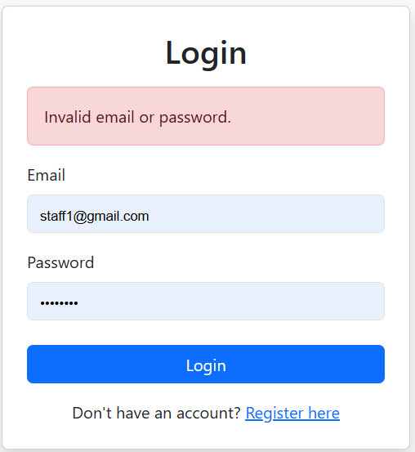
SECTION B – Feature Development Record
Duplicate this table for each major feature (e.g. Login, Registration, CRUD, Search, Authentication, Authorisation, etc.).
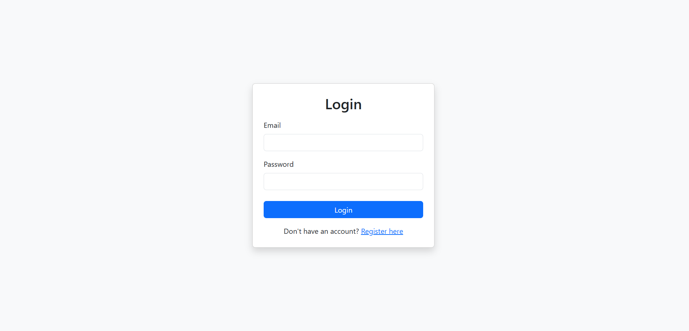
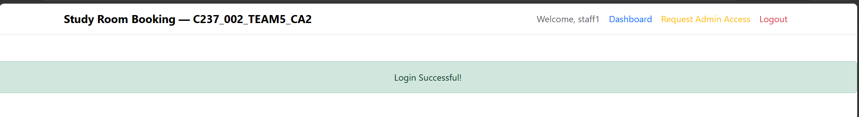
Section | Response
Feature Name | Login
Team Member(s) Responsible | Lwin Htoo Myat
Purpose of this Feature | To securely check user details and allow new users to create accounts.
Initial Design / Approach | The first design only had a login form. We later added a quick link to the registration page so new users could easily sign up.
Challenge(s) Encountered | Passing success and error messages across different pages without losing the data.
AI Prompt(s) Used (if any) | "Explain how req.flash works in Node.js."  "How do I pass these flash messages to my front-end view?"
How the Team Modified or Improved the AI Response | The AI provided a general, basic example, adapted the code to fit our exact login routes and applied the own variable structure to pass the data: {message: req.flash('success'), error: req.flash('error')}.
Important Code Snippet (3–6 lines) | 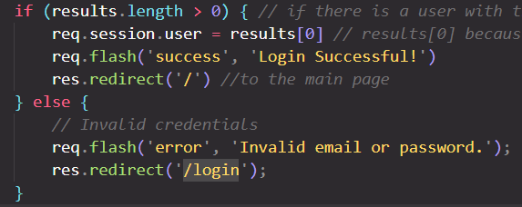
Explain the Code in Your Own Words | If the database finds a matching user, we save their details in a session.  We then store a success message using req.flash and send the user to the home page (/).  If no match is found, we store an error message in req.flash and send the user back to the login page (/login) to try again.
Key Learning / Design Decision | learned how to use req.flash to show temporary pop-up alerts (like errors or success messages) after sending a user to a new page.

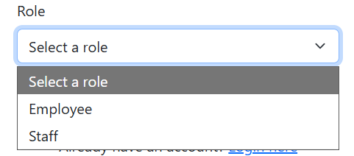
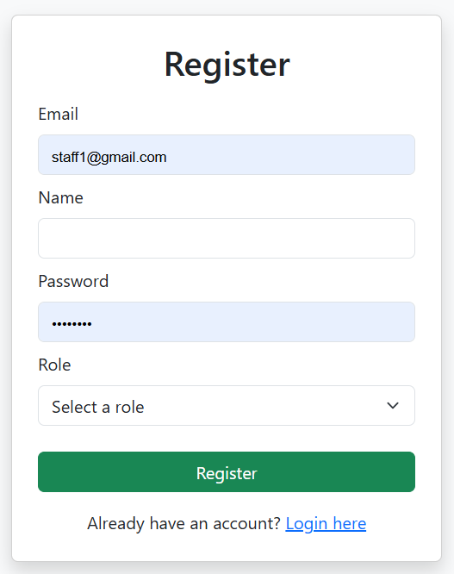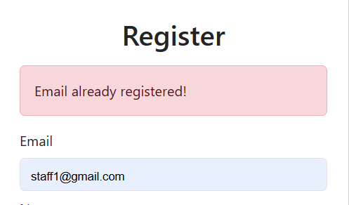
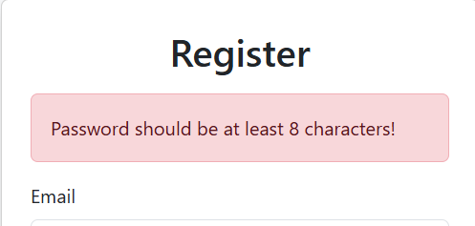
Section | Response
Feature Name | Registration Form
Team Member(s) Responsible | Lwin Htoo Myat
Purpose of this Feature | To allow new users to securely create an account and enjoy our service.
Initial Design / Approach | Originally, the "admin" role was an option in the sign-up dropdown. We removed this because it was a security risk to let normal users make themselves admins.
Challenge(s) Encountered | Keeping the user's typed information on the screen if registration fails, so they do not have to type everything again.
AI Prompt(s) Used (if any) | "How do I keep form data filled in when redirecting back to the register page in Node.js?"
How the Team Modified or Improved the AI Response | The AI suggested we can also use req.flash to store the data temporarily not just passing in error messages. So, we adapted this to fit our exact route and view setup.
Important Code Snippet (3–6 lines) | 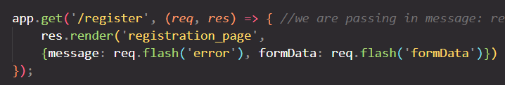  const validateRegistration:  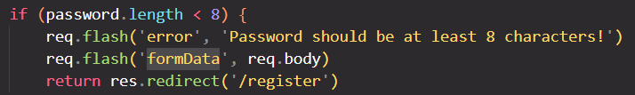
Explain the Code in Your Own Words | When the user goes to /register, we render the registration page.  We pass req.flash('error') to show alerts if the email already exists or if passwords do not match.  We pass req.flash('formData') back to the view so the form stays filled out if an error happens.  (Note: We also built a validateRegistration function to check that all required fields and password rules are met before saving.)
Key Learning / Design Decision | We learned that saving form data in temporary flash sessions greatly improves the user experience, and that user roles (like "admin") should be strictly controlled on the backend (more about this later), not just in the front-end form.

(staff account with admin role)
(Employee account
without admin role)
Section | Response
Feature Name | Reusable Header
Team Member(s) Responsible | LWIN HTOO MYAT
Purpose of this Feature | To show different navigation menu links depending on the user's specific role (like admin, staff, or normal user).
Initial Design / Approach | The first design showed the exact same links to everyone. We changed it so the header is smart and adapts to show only what the user is allowed to see.
Challenge(s) Encountered | Deciding the correct security permissions and mapping out exactly which navigation links each role (admin, staff, employee) should be allowed to click on.
AI Prompt(s) Used (if any) | N/A
How the Team Modified or Improved the AI Response | N/A
Important Code Snippet (3–6 lines) | <% if (user.role === 'admin') { %>  <a class="nav-item nav-link text-success" href="/view_users">View Users</a>  <a class="nav-item nav-link text-info" href="/manage_admin_access_requests">Admin Access Requests</a>  <% } else { %>  <a class="nav-item nav-link text-primary" href="/dashboard">Dashboard</a>  <% if (user.role === 'staff' || user.role === 'employee') { %>  <a class="nav-item nav-link text-warning" href="/request-admin_access">Request Admin Access</a>  <% } %>  <% } %>
Explain the Code in Your Own Words | The user object is passed into the header.ejs file to check the user's role.  If the user is an 'admin', they see links to "View Users" and "Admin Access Requests".  If they are not an admin, they see a "Dashboard" link.  If they are a 'staff' or 'employee' (without admin role yet), they also get an extra link to "Request Admin Access".
Key Learning / Design Decision | Learned how to use EJS if/else logic to hide or show on the header itself. The main design decision was to keep the header as one single, reusable file that adapts, rather than creating separate header files for every single role.
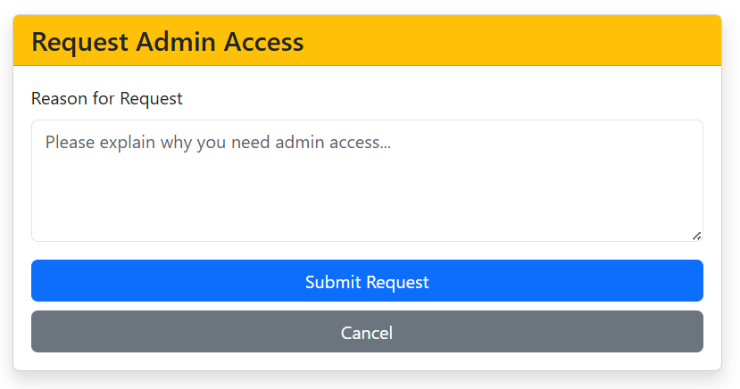
Section | Response
Feature Name | Admin Access Request
Team Member(s) Responsible | LWIN HTOO MYAT
Purpose of this Feature | To allow staff or employees to securely request admin rights from an existing admin.
Initial Design / Approach | At first, anyone could simply choose the 'admin' role during sign-up. We changed this to a request-based system to fix that major security risk.
Challenge(s) Encountered | Setting up the new database table for tracking requests was tricky. We had to carefully update our database structure to link these new requests to existing users without breaking our old tables.
AI Prompt(s) Used (if any) | Pasted in few Errors and asked for some guidance.
How the Team Modified or Improved the AI Response | We used the AI's tips to safely set up our admin_requests table. We did not need AI for the HTML or routing, as we already built those ourselves using what we learned in CA1.
Important Code Snippet (3–6 lines) | app.post('/request-admin_access', checkAuthenticated, (req, res) => {  const reason = req.body.reason;  const sql = 'INSERT INTO admin_requests (reason, email, status, requested_at) VALUES (?, ?, "pending", NOW())';  db.query(sql, [reason, req.session.user.email], (error, results) => {  if (error) {  throw error;  } else {  req.flash('success', 'The request has been successfully submitted.');  res.redirect('/');
Explain the Code in Your Own Words | First, checkAuthenticated makes sure the user is actually logged in before they can submit.  The code grabs the reason the user typed in the POST form.  It saves the reason, the user's email, and a "pending" status into the database.  If it saves correctly, a success message is stored in req.flash and the user goes back to the home page.
Key Learning / Design Decision | The key learning was recalling lessons from previous C207 modules. The key design decision was to hold requests safely in the database until a real admin can review them, rather than giving out access automatically.

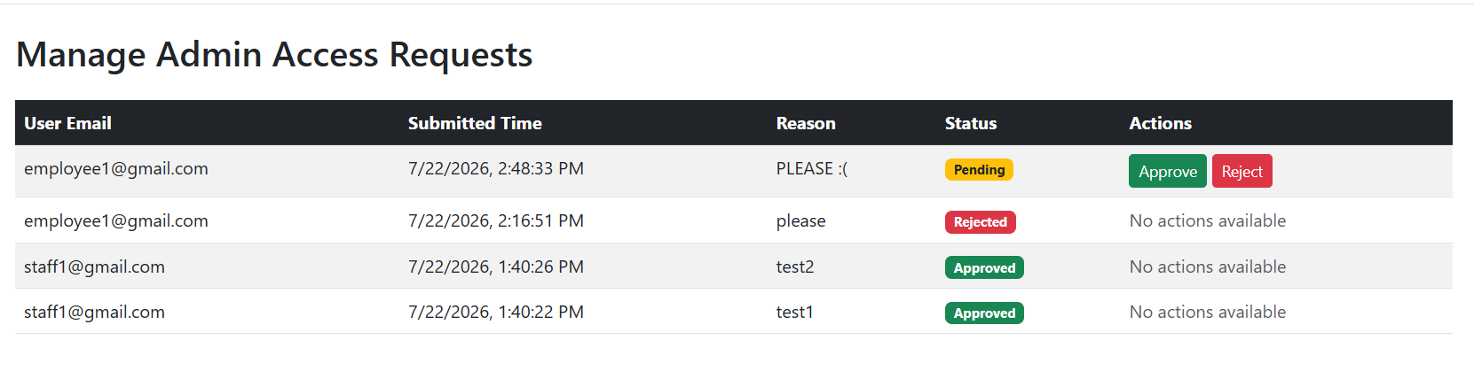
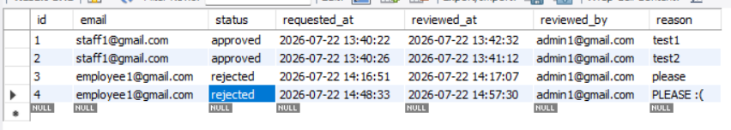
Section | Response
Feature Name | Manage Admin Access Requests
Team Member(s) Responsible | LWIN HTOO MYAT
Purpose of this Feature | To let existing admins view, approve, or reject admin access requests from other users.
Initial Design / Approach | At first, the design did not track request reasons, times, or keep a history of rejected requests. We improved it by adding review by and reviewed at to the database so we can keep a complete, secure history of all actions.
Challenge(s) Encountered | Updating two different database tables at the same time (changing the request status and updating the user's role) was tricky. It was also challenging to decide whether to use one single route or two separate routes for the "Approve" and "Reject" actions.
AI Prompt(s) Used (if any) | Should I use one route or two separate routes for approve and reject buttons in Express?" and "How do I safely update two different MySQL tables back-to-back?"
How the Team Modified or Improved the AI Response | The AI suggested that using two separate routes (/approve and /reject) is cleaner than using one big route with lots of if/else checks. We adopted this structure.
Important Code Snippet (3–6 lines) | 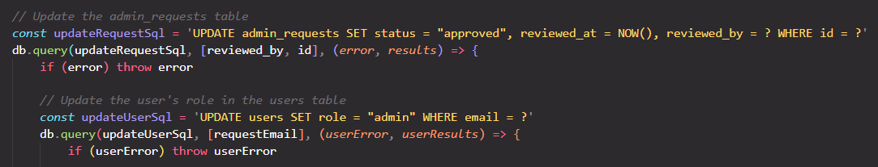
Explain the Code in Your Own Words | The GET route fetches all requests from the database and sends them to the webpage to be displayed in a table.  If the admin clicks Approve, the POST route updates the request status to "approved". Once that succeeds, it immediately runs a second query to change the user's role to "admin" in the users table.  If the admin clicks Reject, a different POST route simply updates the request status to "rejected" without changing any user roles.
Key Learning / Design Decision | learned how to run nested database queries (running one query inside the success block of another). The main design decision was choosing to keep all historical requests in the database (even rejected ones) for security tracking, rather than deleting them.

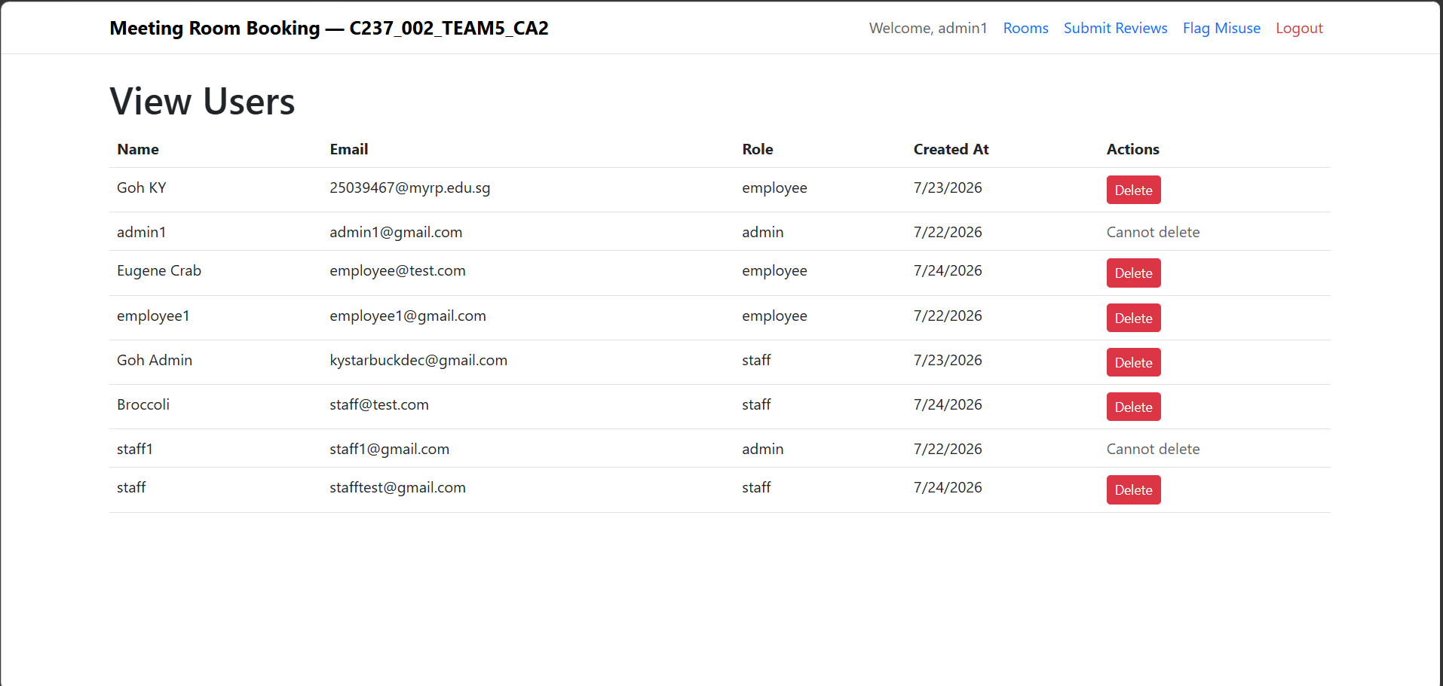
Section | Response
Feature Name | Manage Users
Team Member(s) Responsible | LWIN HTOO MYAT
Purpose of this Feature | To allow admins to view a list of all users and delete user accounts if needed.
Initial Design / Approach | The first plan was to simply list the users, without showing when their accounts were created or adding a delete button.
Challenge(s) Encountered | MySQL sent the creation date as a long text string. I did not know how to turn that string into a proper datetime, and extract the date only from that datetime.
AI Prompt(s) Used (if any) | Asked AI how to format a MySQL date string into a clean, short date inside an EJS file.
How the Team Modified or Improved the AI Response | AI suggested using new Date(). I improved this by adding a safety check (? :) to display 'N/A' if the date is missing in the database, which stops the page from crashing.
Important Code Snippet (3–6 lines) | <td><%= userItem.created_at ? new Date(userItem.created_at).toLocaleDateString() : 'N/A' %></td>
Explain the Code in Your Own Words | We loop through the database results to show every user. The delete button is easy to set up because we just send the user's email as ID to the ‘/delete-users’ route to remove them. I also added a rule so that an admin cannot delete another admin.
Key Learning / Design Decision | Decision: Prevented admins from deleting other admins for better security.  Learning: Deleting items using a real database Primary Key (like email) is much easier than deleting from the in-memory arrays we used in CA1.

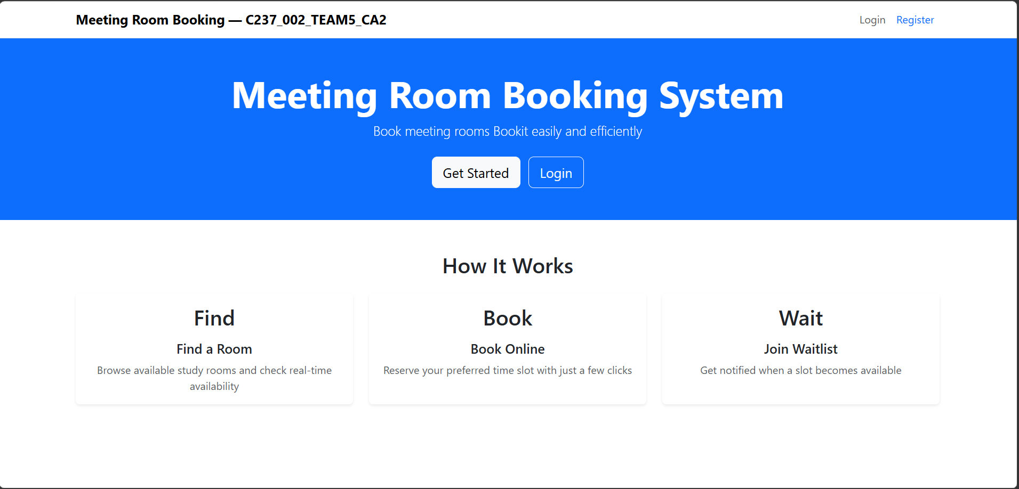
landing page before login

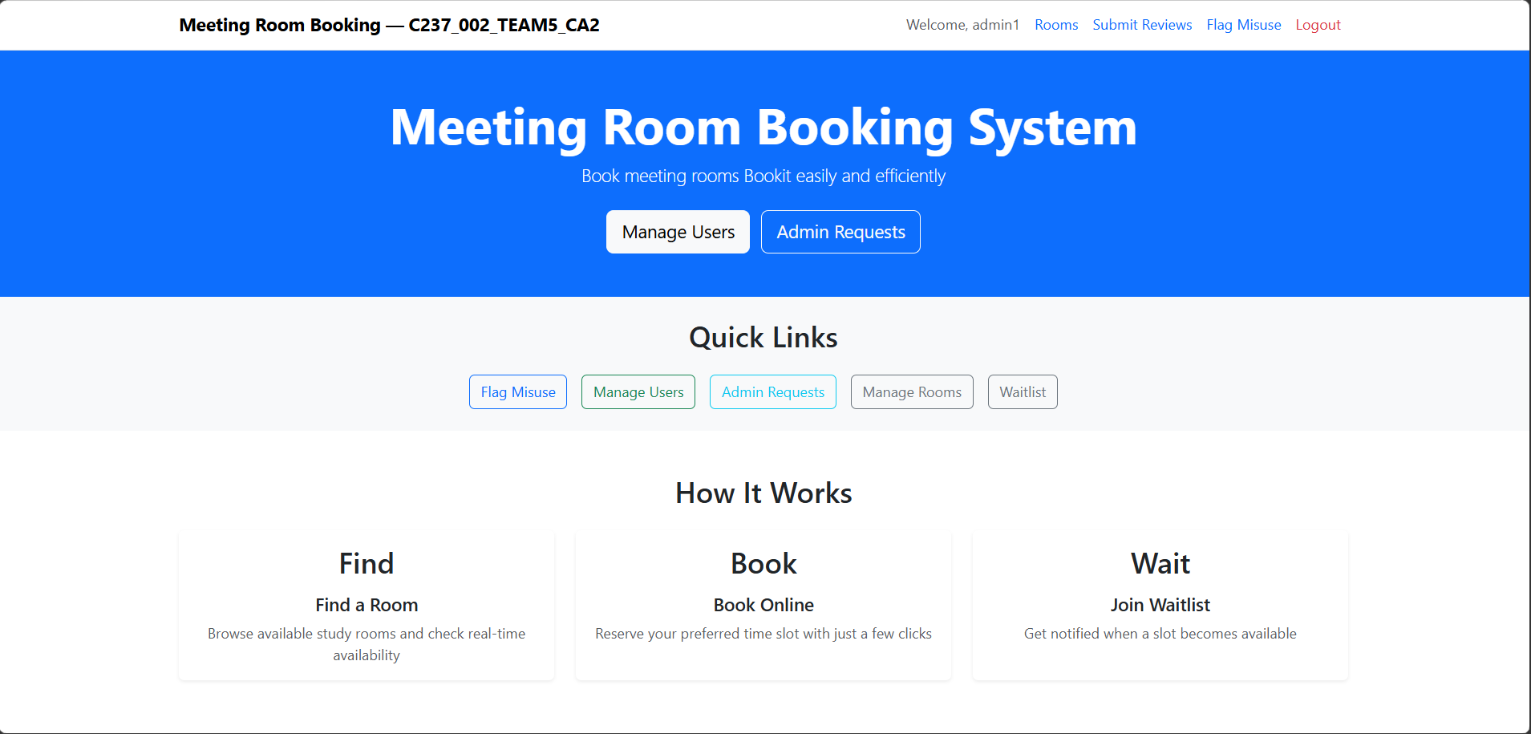
admin home page
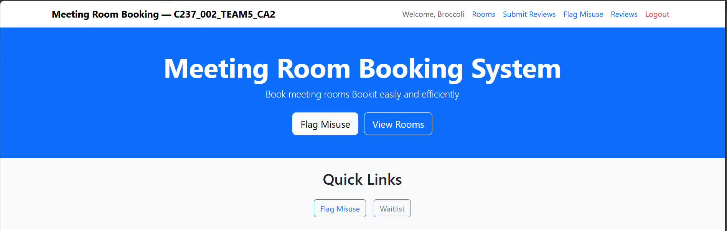
staff homepage
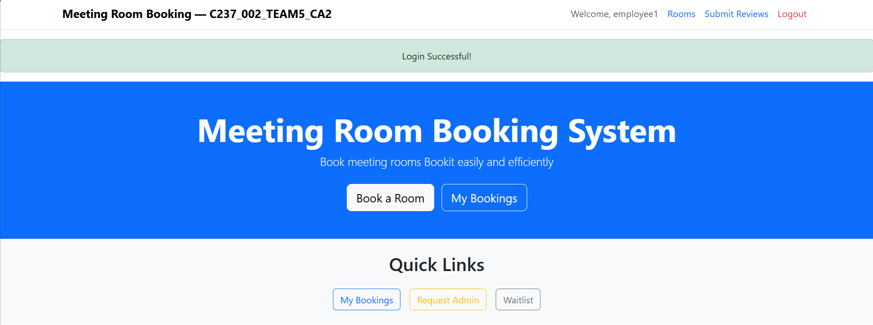
employee landing page
Section | Response
Feature Name | Landing Page (‘/’), (‘index.ejs’)
Team Member(s) Responsible | LWIN HTOO MYAT
Purpose of this Feature | To explain what the website does and provide role-based "Quick Links" so users can navigate the site easily.
Initial Design / Approach | The first version only had a top header. The links on the page were hard-coded and did not change based on who was logged in.
Challenge(s) Encountered | Putting all the navigation links in the top header made it look too crowded and messy, especially for admins who have many features.
AI Prompt(s) Used (if any) | Asked AI to help brainstorm a clean layout for the landing page.
How the Team Modified or Improved the AI Response | I took the basic layout from AI and added EJS if/else statements to show or hide specific Quick Links based on the user's role.
Important Code Snippet (3–6 lines) | 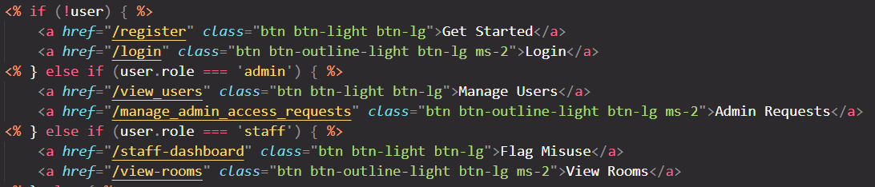
Explain the Code in Your Own Words | The code checks if a user is logged in. It uses simple if/else rules to check their role (admin, staff, or employee) and only shows the buttons they are allowed to click.
Key Learning / Design Decision | Decision: I created a "Quick Links" section on the home page instead of stuffing every link into the top header.  Learning: Using EJS logic on the home page makes the website feel much cleaner and easier for the user to navigate.

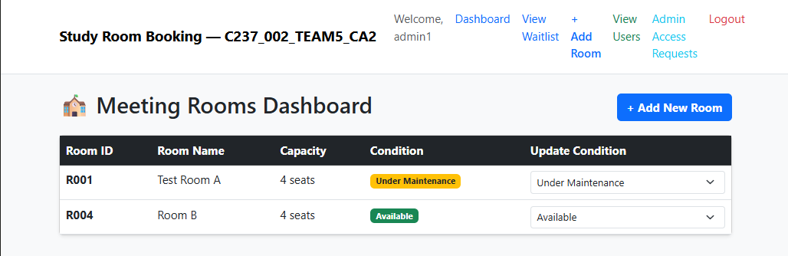
Section | Response
Feature Name | View Meeting Rooms
Team Member(s) Responsible | Faris
Purpose of this Feature | To display all meeting rooms and their current operational conditions from the database.
Initial Design / Approach | Built a GET /view-rooms route that queries the MySQL database and passes the results to an EJS template for rendering.
Challenge(s) Encountered | Ensuring room statuses (e.g., Available vs. Maintenance) render clearly for users.
AI Prompt(s) Used (if any) | "How do I fetch all rows from MySQL and render them in an EJS table using Express?"
How the Team Modified or Improved the AI Response | Adapted the SQL query to select room details like capacity and condition, structuring the response object to feed directly into the view layout.
Important Code Snippet (3–6 lines) | 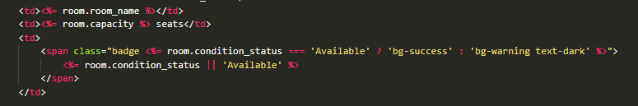
Explain the Code in Your Own Words | The GET /view-rooms route executes a SELECT * query on the rooms table. Once the query returns the rows, it passes the data array to the EJS template to dynamically render each room row.
Key Learning / Design Decision | Learned how to pass database query results directly to EJS views to keep the dashboard continuously updated with real-time room availability.

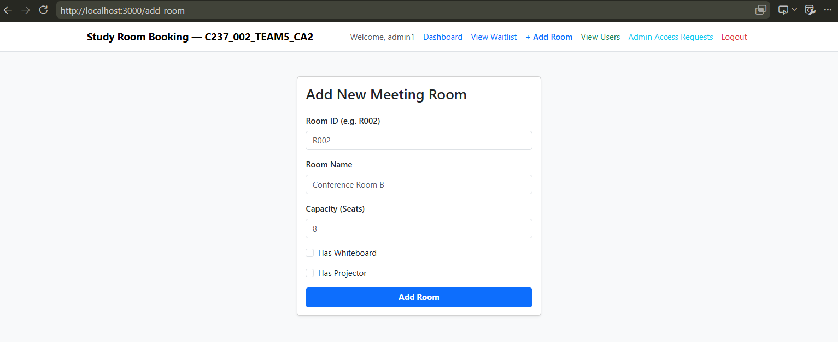

Section | Response
Feature Name | Add New Meeting Room
Team Member(s) Responsible | Faris
Purpose of this Feature | To allow Admins to securely add new study rooms with details like ID, name, capacity, and amenities (whiteboard/projector) into the database.
Initial Design / Approach | Created GET /add-room to render the add-room page and POST /add-room to process form submissions. Used checkAdmin middleware to restrict access to administrators.
Challenge(s) Encountered | Converting form checkbox inputs into MySQL-compatible binary integers (1 or 0) and handling form validation failures gracefully
AI Prompt(s) Used (if any) | "How do I handle form checkboxes and insert them as binary integers in Express MySQL parameterized queries?"
How the Team Modified or Improved the AI Response | Added explicit backend validation for capacity (parseInt(capacity) <= 0) and integrated flash error messages to notify admins when submission inputs are missing or invalid.
Important Code Snippet (3–6 lines) | 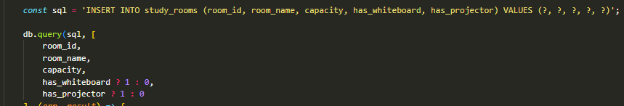
Explain the Code in Your Own Words | The route runs a parameterized SQL INSERT query on the study_rooms table. It uses ternary operators (has_whiteboard ? 1 : 0) to convert frontend form checkboxes into database-ready integer flags, and redirects to /view-rooms upon completion.
Key Learning / Design Decision | Learned how to secure administrator-only routes using custom middleware (checkAdmin) and properly parse boolean checkbox inputs into database data.
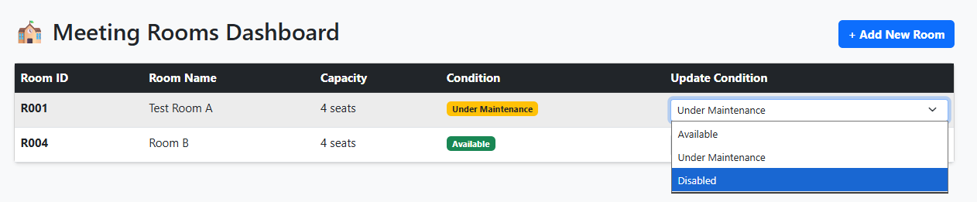
Section | Response
Feature Name | Update Room Status
Team Member(s) Responsible | Faris
Purpose of this Feature | To allow Staff and Admins to update the operational status of a study room (e.g., "Available", "Under Maintenance", "Disabled") in real time.
Initial Design / Approach | Implemented a POST /update-room-status route protected by checkStaffOrAdmin middleware that receives room_id and condition_status submitted directly from the dashboard view.
Challenge(s) Encountered | Ensuring only authorized staff or admin roles can execute status modifications and providing instant visual feedback on submission.
AI Prompt(s) Used (if any) | "How do I protect an Express POST route using custom role middleware and run a parameterized MySQL UPDATE query?"
How the Team Modified or Improved the AI Response | Integrated custom checkStaffOrAdmin authorization middleware and added flash alerts (req.flash('success')) to confirm status updates upon redirecting to /view-rooms.
Important Code Snippet (3–6 lines) | 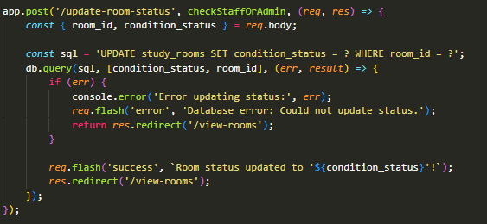
Explain the Code in Your Own Words | The route checks user authorization via checkStaffOrAdmin, extracts room_id and condition_status from req.body, executes a parameterized SQL UPDATE query on study_rooms, sets a success flash message, and refreshes the dashboard view.
Key Learning / Design Decision | Learned how to combine custom role-checking middleware with dynamic SQL update operations to secure database actions against unauthorized access.

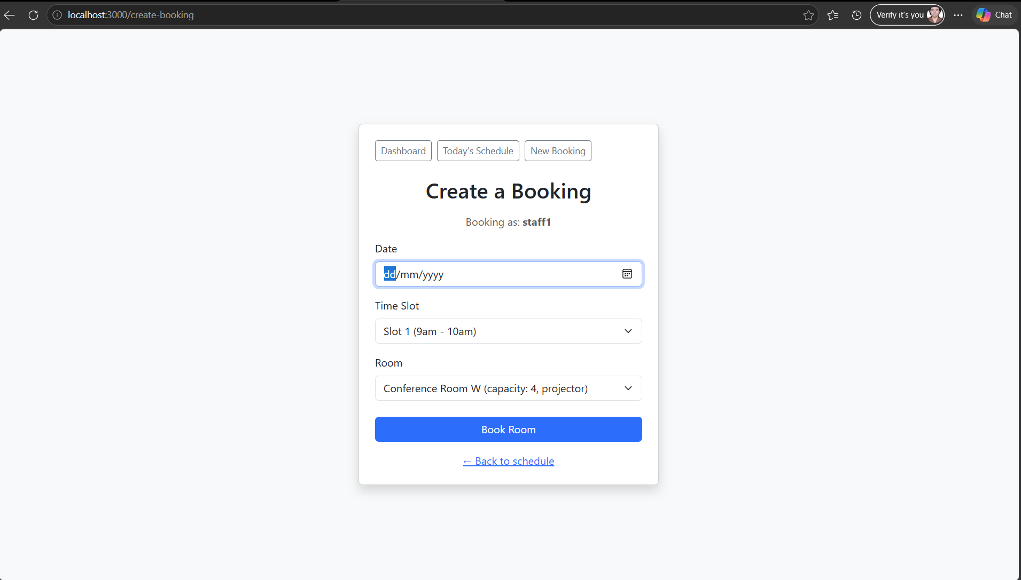

Section | Response
Feature Name | View schedules & user dashboards.
Team Member(s) Responsible | Create a Booking
Purpose of this Feature | Lets an employee book a study room for a specific date, time slot, and room.
Initial Design / Approach | Builds as my second required routes .The form initally asked the users to maually type a Bookin ID
Challenge(s) Encountered | Hit a foreign key constraint error when testing, because my temporary test session used an email that didn't exist in the users table — this taught me how foreign keys enforce data integrity even when application code doesn't explicitly check it.
AI Prompt(s) Used (if any) | "What happens if two people try to book the same room at the same time?"
How the Team Modified or Improved the AI Response | The AI suggested a SELECT check before the INSERT to catch conflicts. I extended this myself after realizing the first version only excluded cancelled bookings — I added no-show to the exclusion list too, since a no-show should also free up the room.
Important Code Snippet (3–6 lines) | 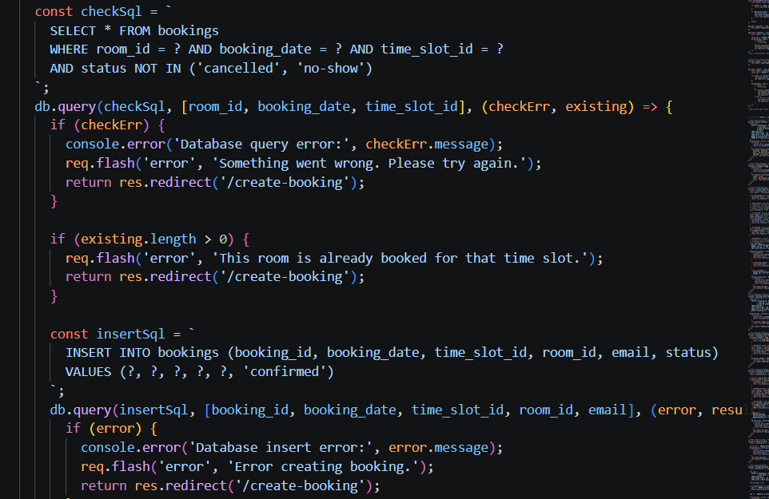
Explain the Code in Your Own Words | Before saving a new booking, this checks whether an active (not cancelled or no-show) booking already exists for the same room, date, and time ,preventing double-booking.
Key Learning / Design Decision | I leaned to replace the manually-typed Booking ID with an auto-generated one ('BK' + Date.now()), since user-typed IDs risked collisions and had no real meaning.this was a deliberate design improvement, not just following AI suggestions.
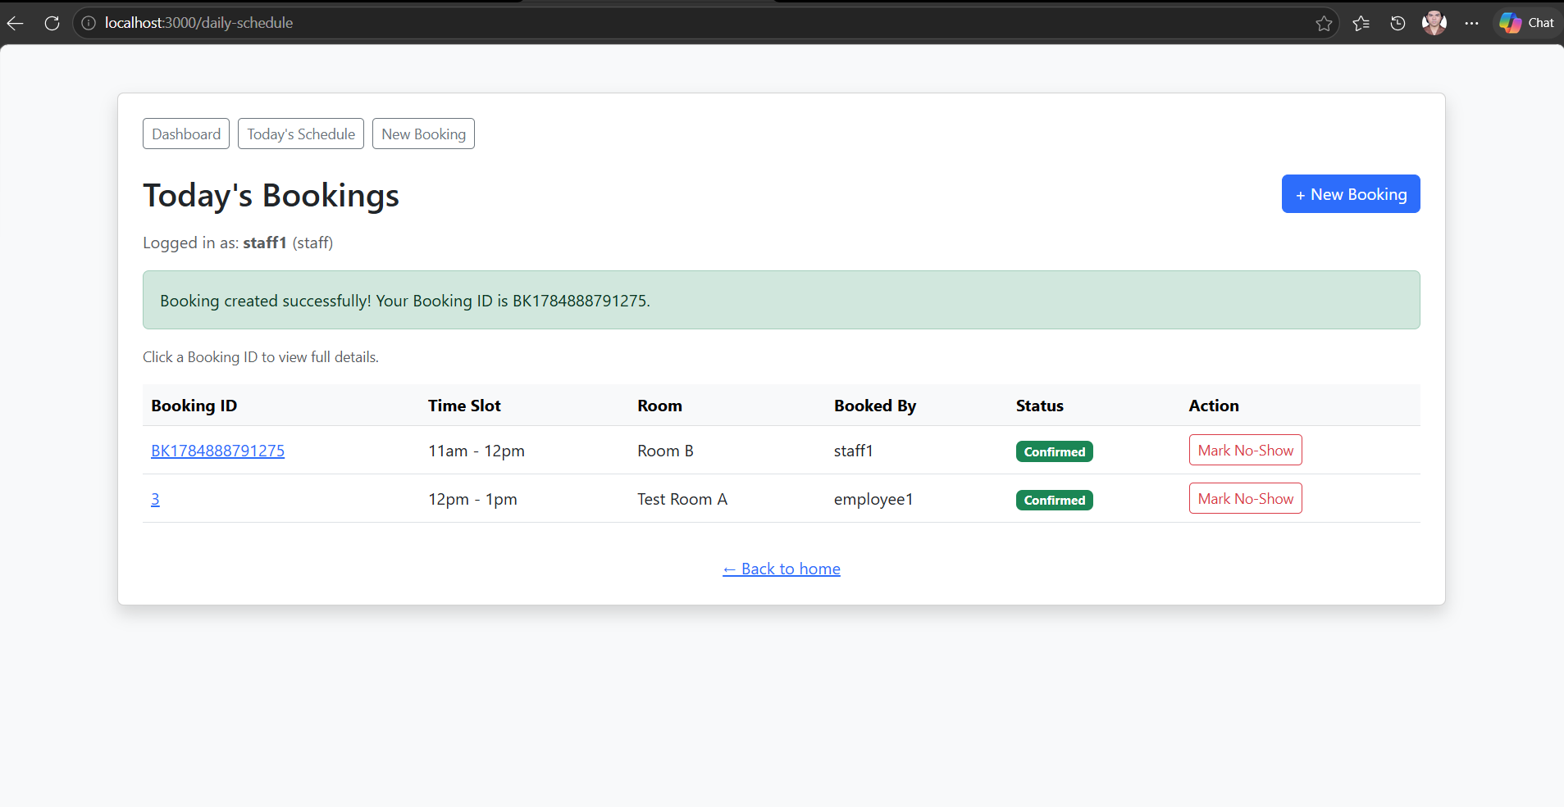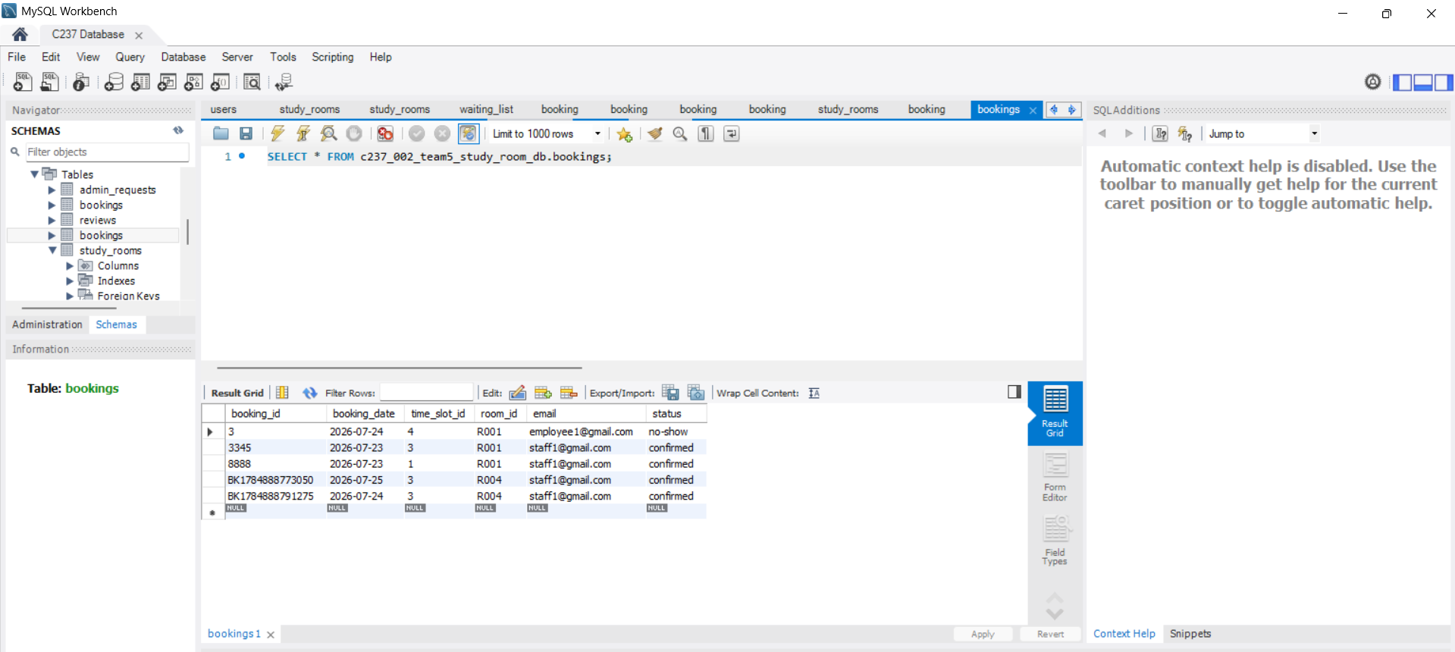
Section | Response
Feature Name | View Today Schedule
Team Member(s) Responsible | Zaw Myo Paing
Purpose of this Feature | Let any logged in user see all room bookings for the current day in one place.
Initial Design / Approach | Built as the first of my three required routes. Uses a SELECT query with JOINS across bookings, study_rooms and users so the page shows readable room names and the booker name instead of raw database id.
Challenge(s) Encountered | The bookings table was renamed mid project by a teammate from booking to bookings whixh broke my route wih a “table doesn’t exist error” I had to trace the issue with using SHOW TABLES in my workbench and update all querries to mathc the new name.
AI Prompt(s) Used (if any) | Write a GET route to show all bookings for the day with the room name and booker's name instead of raw IDs.
How the Team Modified or Improved the AI Response | The initial version only selected raw IDs. I asked for JOINs to be added so the page displays human-readable information, which is more usable for a real front-desk view.
Important Code Snippet (3–6 lines) | 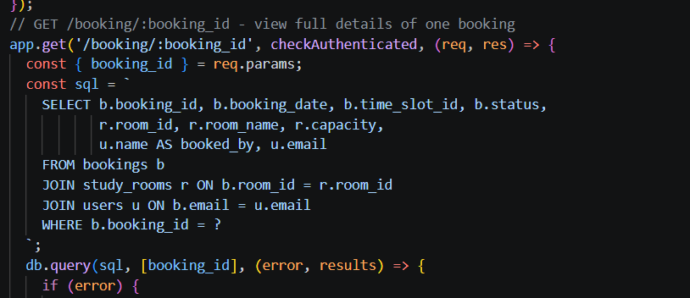
Explain the Code in Your Own Words | This pulls every booking for today's date, joining in the room's real name and the booker's real name so the page is readable, instead of just showing internal IDs.
Key Learning / Design Decision | I learned that a shared database schema can change without warning when multiple people are working on it at once, and that I need to verify table names directly (e.g. with SHOW TABLES) rather than assuming they're stable.

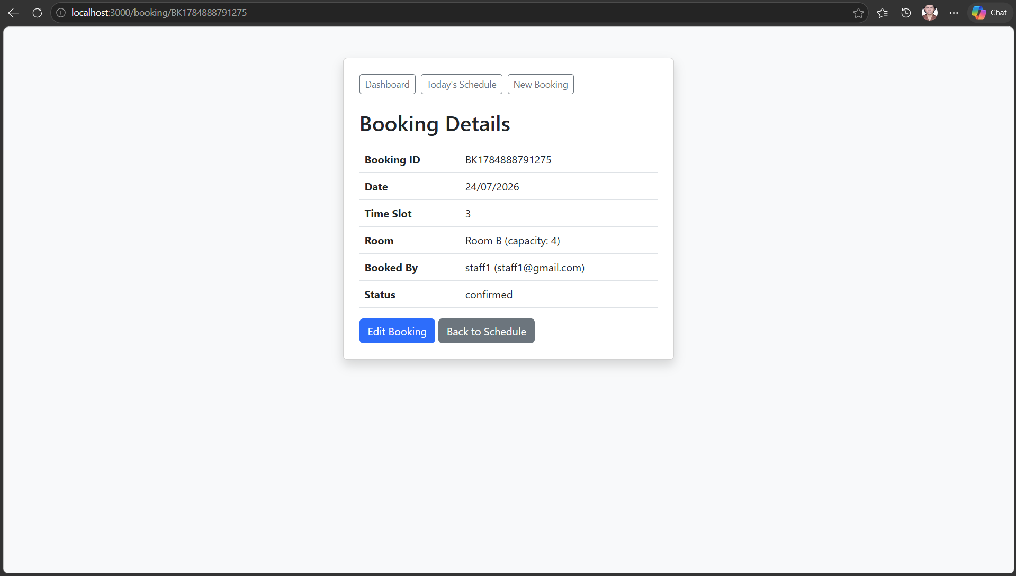
Section | Response
Feature Name | View Booking Details
Team Member(s) Responsible | Zaw Myo Paing
Purpose of this Feature | Lets a user click into a specific booking to see its full details (date, time, room, capacity, booked by)
Initial Design / Approach | Added beyond my original 3 required routes, to give the app proper full CRUD (Read for a single record, not just a list).
Challenge(s) Encountered | The database connection dropped (ECONNRESET) after a long testing session, causing this route to fail with "table doesn't exist" even though the table was fine I learned this was a stale connection issue, resolved by restarting the server
AI Prompt(s) Used (if any) | How do I know if my database connection dropped versus the table actually being missing?
How the Team Modified or Improved the AI Response | Learned to distinguish connection issues from schema issues by checking Workbench directly (SHOW TABLES) alongside the app's error output, rather than assuming the first explanation was correct.
Important Code Snippet (3–6 lines) | 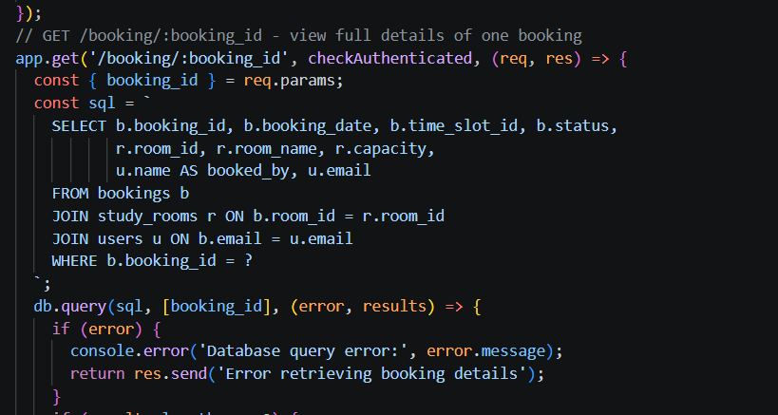
Explain the Code in Your Own Words | Uses a route parameter (:booking_id) to fetch one specific booking's full details, joined with room and user info.
Key Learning / Design Decision | Learned that "table doesn't exist" errors can have multiple different causes (renamed table vs. dropped connection), and to check both possibilities before assuming the schema changed.

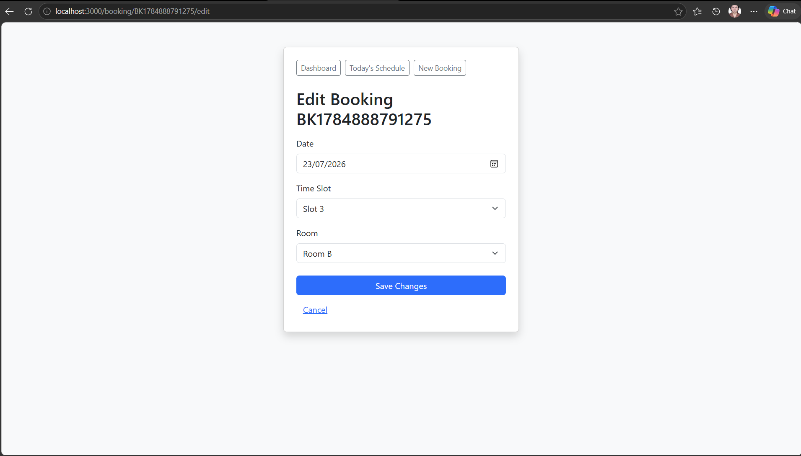
Section | Response
Feature Name | Edit a Booking
Team Member(s) Responsible | Zaw Myo Paing
Purpose of this Feature | Lets the booking's owner (or staff) change the date, time slot, or room of an existing booking.
Initial Design / Approach | Added as part of completing full CRUD. Initially had no restriction on who could edit a booking.
Challenge(s) Encountered | Realized during review that any logged-in user could edit any booking, not just their own.
AI Prompt(s) Used (if any) | "How do I make sure a user can't edit someone else's booking?"
How the Team Modified or Improved the AI Response | Implemented an ownership check that compares the booking's stored email to the logged-in user's email, with an exception for staff (who should be able to manage any booking, consistent with their no-show permission).
Important Code Snippet (3–6 lines) | 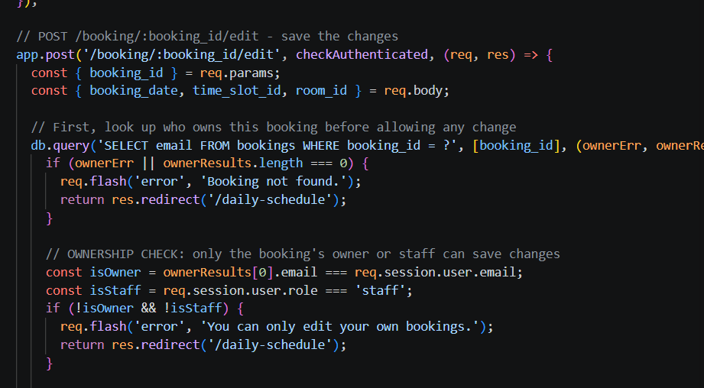
Explain the Code in Your Own Words | Before showing or saving the edit form, this checks whether the logged-in user either owns the booking or is staff, anyone else is redirected away with an error message.
Key Learning / Design Decision | Learned that access control needs to be checked at the route level for every sensitive action, not assumed from the UI alone — someone could bypass the interface and hit the route directly.

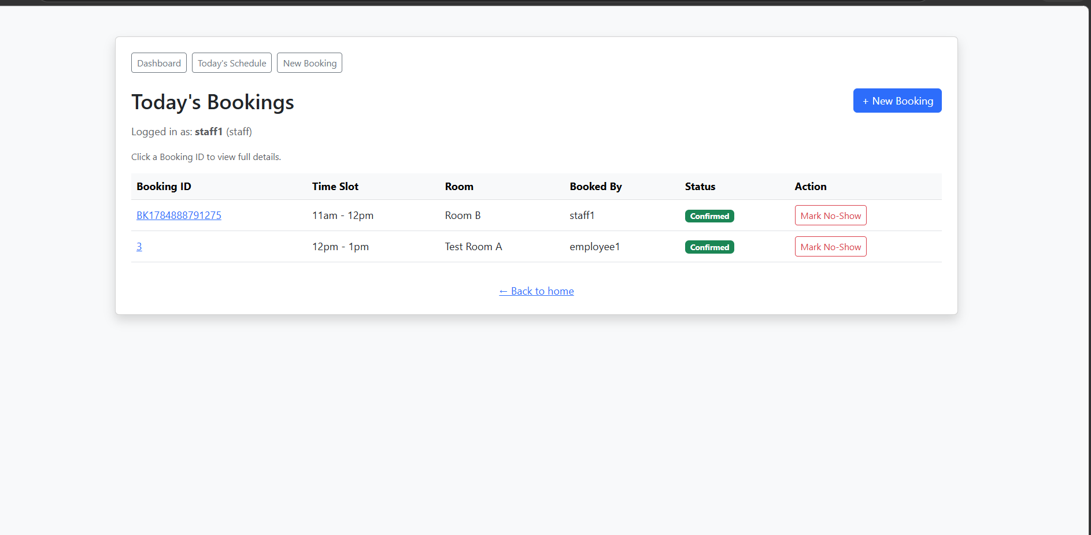
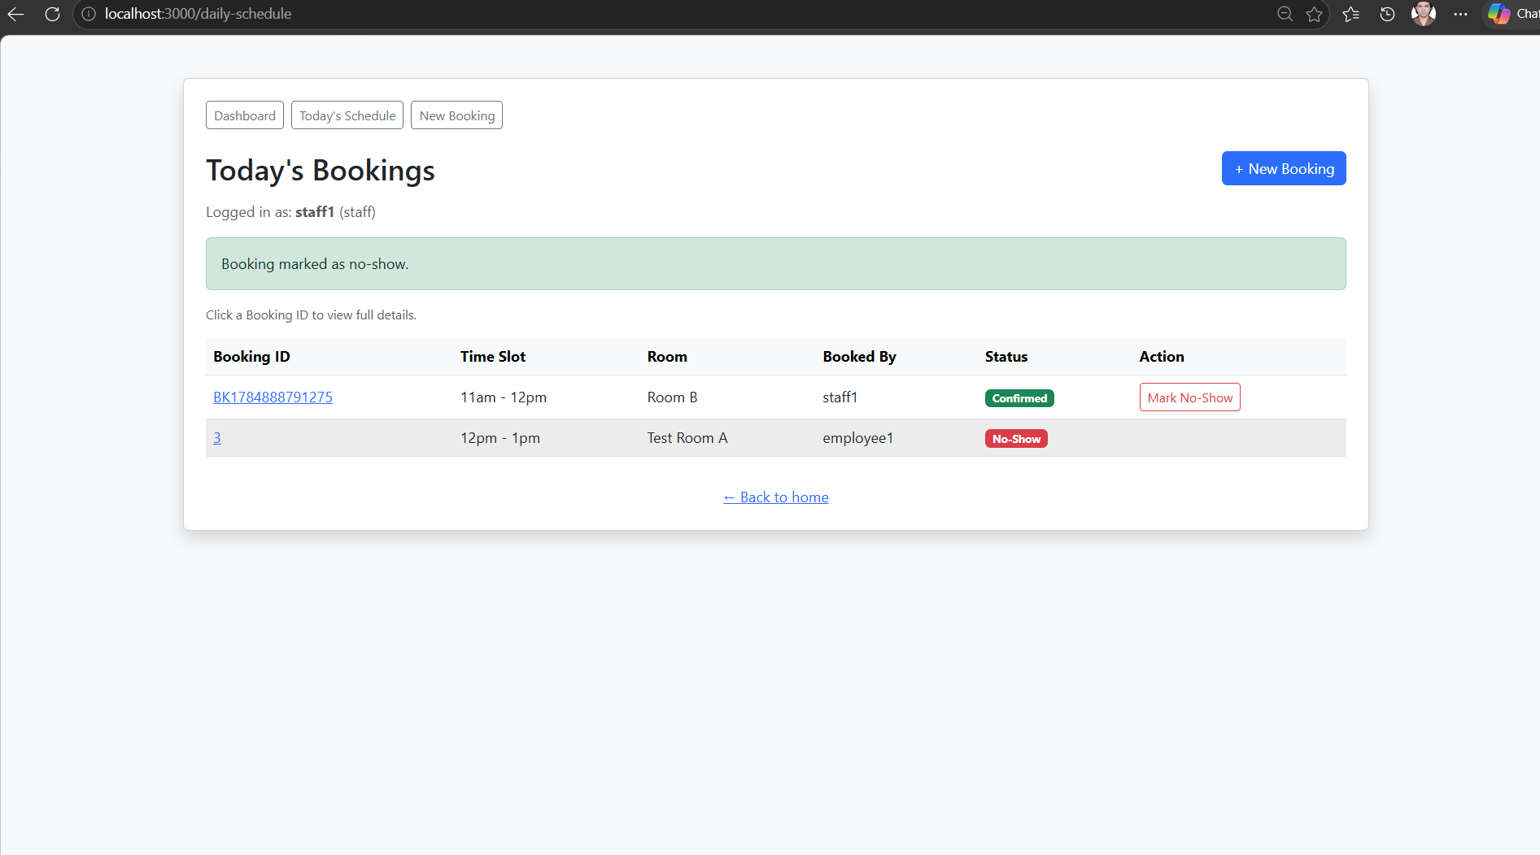

Section | Response
Feature Name | Mark a Booking as No-Show
Team Member(s) Responsible | Zaw Myo Paing
Purpose of this Feature | Lets staff free up a room when the person who booked it doesn't show up.
Initial Design / Approach | Built as my third required route. Uses an UPDATE rather than a DELETE, so the booking record is preserved for history.
Challenge(s) Encountered | Had to confirm this route was restricted to staff only, since a generic checkAuthenticated check alone would let any role trigger it.
AI Prompt(s) Used (if any) | Should marking a booking as no-show delete it or just change its status?"
How the Team Modified or Improved the AI Response | Chose to update the status rather than delete, so staff can see a history of no-shows rather than losing the record entirely — a deliberate design choice over the simpler delete approach.
Important Code Snippet (3–6 lines) | 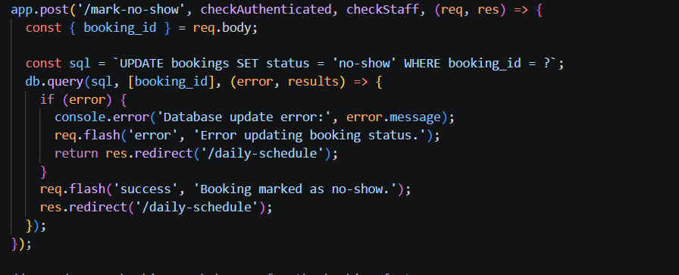
Explain the Code in Your Own Words | Only staff can trigger this route (enforced by checkStaff), and it updates the booking's status rather than deleting the row, preserving a record of what happened.
Key Learning / Design Decision | Learned that UPDATE-based soft state changes (rather than DELETE) are often better for real systems, since they preserve history for later reporting or accountability.
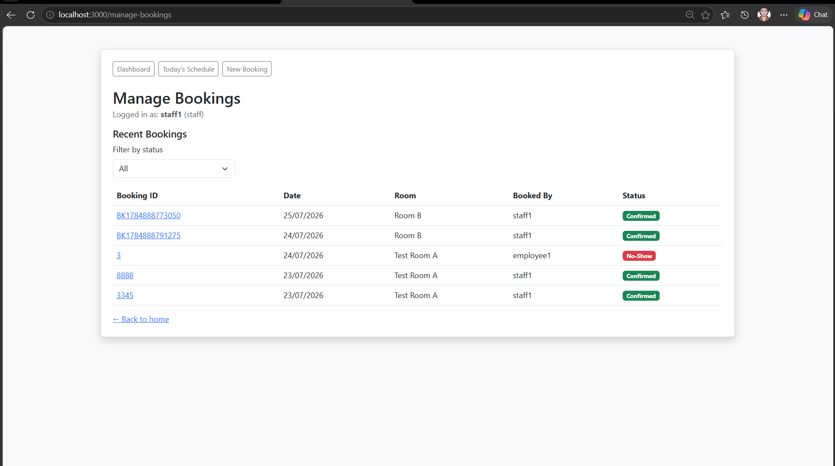
Section | Response
Feature Name | Dashboard
Team Member(s) Responsible | Zaw Myo Paing
Purpose of this Feature | A hub page showing recent bookings across all dates (not just today), with the ability to filter by status and search,satisfying the project's requirement for a way to find information.
Initial Design / Approach | Added last, after realizing the app lacked any search or filter functionality, which is an explicit project requirement.
Challenge(s) Encountered | My earlier queries always used a fixed SQL string, but this route needed the query to change depending on user input. I had to switch from a plain const sql = ... to a let sql that I build up in pieces, and keep a separate params array in the exact same order as the ? placeholders I added — if the array order didn't match the placeholders, the wrong values would get inserted into the wrong spots.
AI Prompt(s) Used (if any) | Why do my query parameters need to be in a specific order when using placeholders?
How the Team Modified or Improved the AI Response | The AI explained that ? placeholders are filled in the exact order the parameters appear in the array, left to right. I made sure to push() each value into params at the same point I added its matching ? into the SQL string, so the two always stayed in sync.
Important Code Snippet (3–6 lines) | 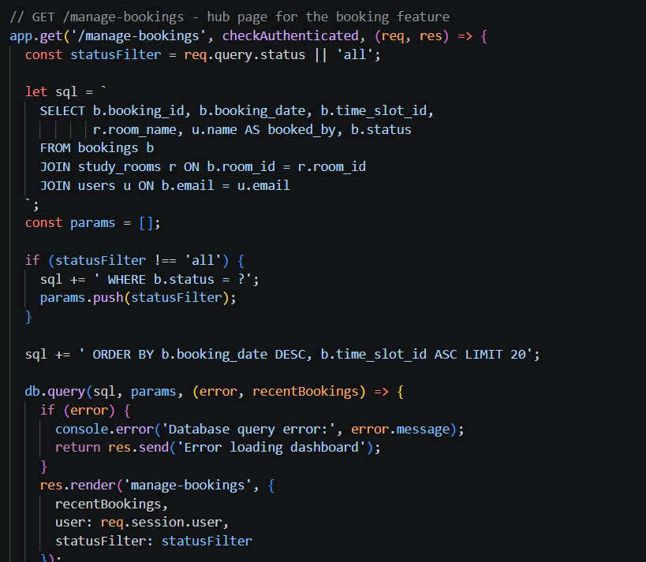
Explain the Code in Your Own Words | Unlike my other routes, which use a fixed query string, this one builds the SQL step by step using let instead of const. I start with the base query, then only add a WHERE clause if the user picked a specific status — and every time I add a ? placeholder to the string, I add the matching value to the params array right after it, so they stay lined up correctly when the query actually runs
Key Learning / Design Decision | I learned that dynamic queries need a let variable (not const) so the SQL string can be built conditionally, and that the params array must stay in the exact same order as the ? placeholders added to the string, or the wrong values get inserted into the wrong spots.

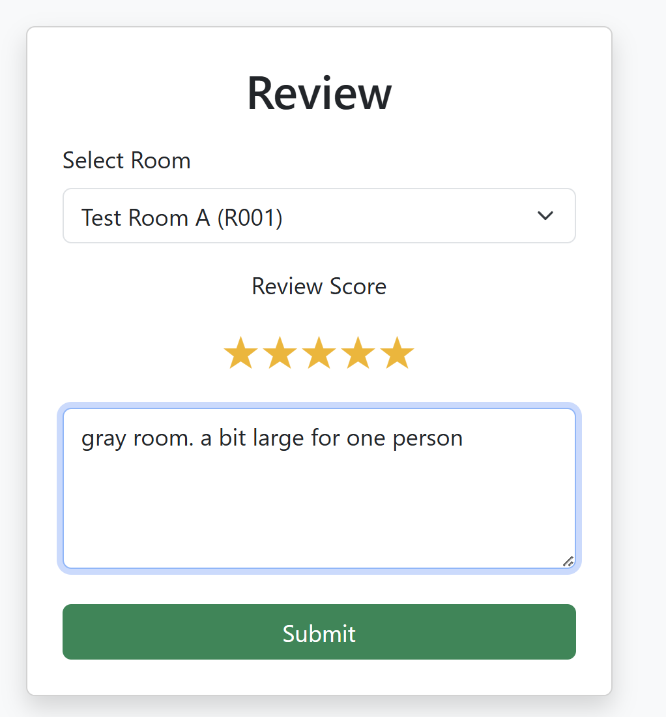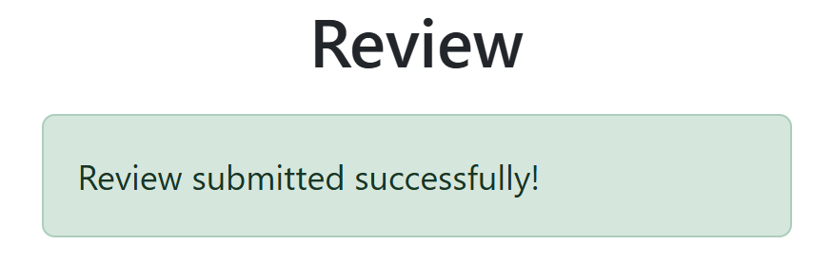
Section | Response
Name | Submit a review
Team Member(s) Responsible | Elisha
Purpose of this Feature | Review a room to inform admins / staff on what could be improved / what was done well
Initial Design / Approach | Dropdown options to select user score
Challenge(s) Encountered | Star system
AI Prompt(s) Used (if any) | Add a star system to select a review score
How the Team Modified or Improved the AI Response | We added as many star ‘buttons’ as we needed (5) to suit our score system
Important Code Snippet (3–6 lines) | 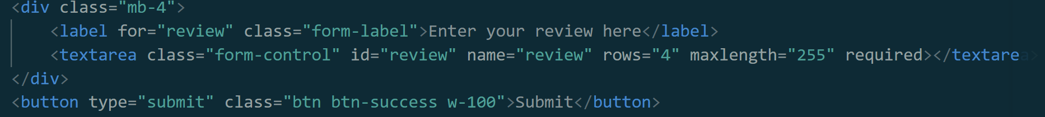
Explain the Code in Your Own Words | Button to submit a review once a form is filled in and a textbox that maxes at 255 words for the user to input a review
Key Learning / Design Decision | Learnt to validate all fields of a form through utilizing basic javascript
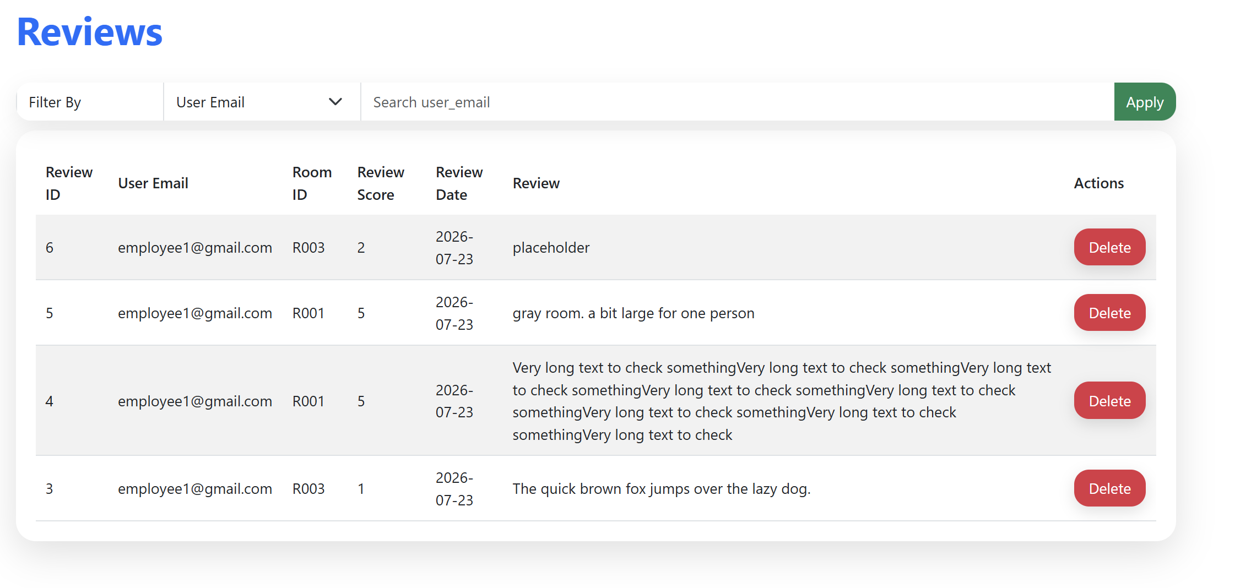
Section | Response
Feature Name | View Reviews
Team Member(s) Responsible | Elisha Au
Purpose of this Feature | Users to review rooms before booking and staff to delete spam/ fake reviews
Initial Design / Approach | Pull results from sql and display using table
Challenge(s) Encountered | Table would not fit review description properly
AI Prompt(s) Used (if any) | Pop the table out and add shadows, keep the colour scheme
How the Team Modified or Improved the AI Response | AI did not create a pleasant looking delete button, so I changed it to a round and red nicer looking version
Important Code Snippet (3–6 lines) | 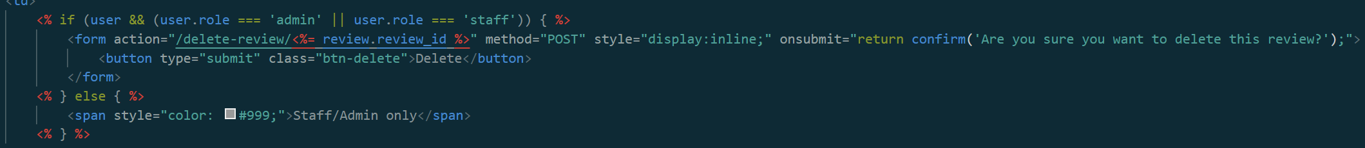
Explain the Code in Your Own Words | Delete button does not show up if user is not admin/staff. If user is employee, a message “Staff/Admin only” is shown. Otherwise, once the button is pressed, the user is prompted with a confirm message. If the user proceeds, the review is successfully deleted.
Key Learning / Design Decision | Finalize all variables before making a table. I had to review the code multiple times as I did not think of all the features when I first created the form, resulting in lots of back and forth until I finalized my features.

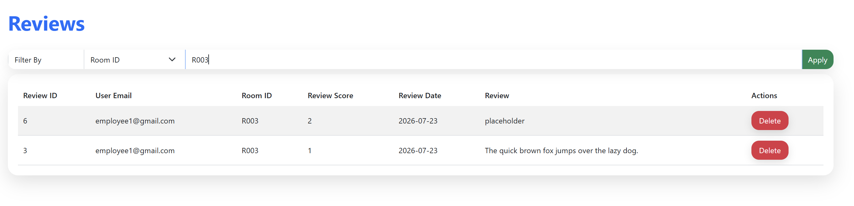
Section | Response
Feature Name | Search and filter through reviews
Team Member(s) Responsible | Elisha Au
Purpose of this Feature | Filter through low score reviews to check what employees have problems with, check if employees are spamming reviews, check if a certain room has many bad reviews
Initial Design / Approach | Search by filter with dropdown options
Challenge(s) Encountered | User email did not function as intended, E.g,if p was entered under user email all reviews with users with the word p in their email would show up
AI Prompt(s) Used (if any) | to review form: add a search / filter bar that shows options (user_email, room_id, review_score) to choose form.
How the Team Modified or Improved the AI Response | Changed the search function for email to be exact rather than approximate using “===”
Important Code Snippet (3–6 lines) | 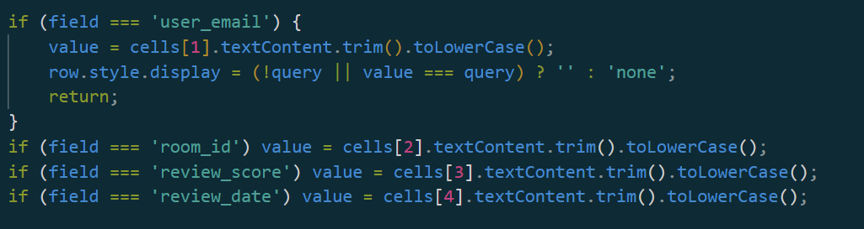
Explain the Code in Your Own Words | Depending on the field the user is filtering by, the code reads the correct cell's text and normalizes it, then shows/hides the row based on whether it matches what the user’s parameters in the search box.
Key Learning / Design Decision | Cleaned up text makes searching easier as not many parameters are needed to be checked.

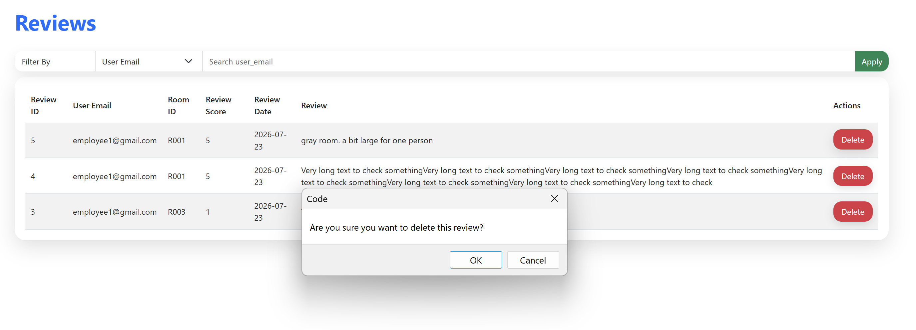
Section | Response
Feature Name | Delete review
Team Member(s) Responsible | Elisha
Purpose of this Feature | Delete spam / fake / inappropriate reviews
Initial Design / Approach | Button that deletes the row
Challenge(s) Encountered | No pop-up appears once the user successfully deletes a review
AI Prompt(s) Used (if any) | show a user a success pop up once a deleted review happens
How the Team Modified or Improved the AI Response
Important Code Snippet (3–6 lines) | 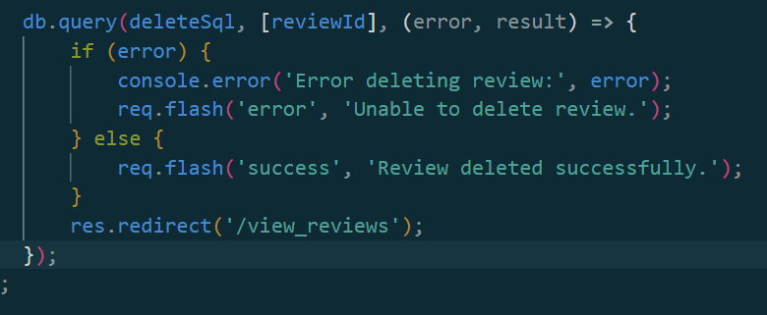
Explain the Code in Your Own Words | Flashes the user a message once a request to delete a review is processed, then redirects the user back to the view table
Key Learning / Design Decision | Ensure flash messages are rendered in the respective EJS file for one of these kinds of popups to show up.

Section | Response
Feature Name | Delete rooms & cancel bookings
Team Member(s) Responsible | Carissa
Purpose of this Feature
Initial Design / Approach
Challenge(s) Encountered
AI Prompt(s) Used (if any)
How the Team Modified or Improved the AI Response
Important Code Snippet (3–6 lines)
Explain the Code in Your Own Words
Key Learning / Design Decision

- ENHANCEMENTS - ROOM BOOKING WAITLIST

Section | Response
Feature Name | potential enhancements if time allows:  1. prevent double bookings  2. waitlist system  3. Up to a maximum of 3 named IDs for joining waitlisting
Team Member(s) Responsible | Goh Khoon Yong  (25039467)
Purpose of this Feature | To allow users to join a waitlist (max 3 people) for fully booked rooms and dynamically display their status without double-booking.
Initial Design / Approach | Built Express CRUD routes interacting with a SQL database, using EJS and Bootstrap to dynamically render the waitlist UI.
Challenge(s) Encountered | Preventing double-booking and strictly enforcing the maximum limit of 3 named IDs per waitlist during concurrent user requests.
AI Prompt(s) Used (if any) | Write Node.js Express routes and SQL queries to manage a room waitlist (max 3 IDs) with EJS and Bootstrap, preventing double-booking.
How the Team Modified or Improved the AI Response | Added strict backend SQL validation and frontend checks to enforce the 3-person limit and handle race conditions that could cause double-booking.
Important Code Snippet (3–6 lines) | if (rows.some((row) => row.email === email)) {  return res.status(409).json({ error: 'You are already on this waitlist.' });  }  if (rows.length >= MAX_WAITLIST_SIZE) {  return res.status(409).json({ error: 'This waitlist is full (maximum 3 people).' });  }  const insertSql = `  INSERT INTO waiting_list  (waitlist_booking_date, time_slot_id, room_id, email, is_waiting, is_cancelled)  VALUES (?, ?, ?, ?, ?, ?)`;  const MAX_WAITLIST_SIZE = 3;
Explain the Code in Your Own Words | checks the current waitlist count for a room, adds the user only if it's under the 3-person limit and prompt error msg.
Key Learning / Design Decision | Combining backend SQL constraints with frontend validation is essential to prevent double-booking and enforce strict business rules like the 3-person limit.

SECTION C – Contribution Table Summary
Summarise the primary contribution of each team member.
Example:
Team Member (Student ID) | Feature Ownership | Routes Implemented | Database Operations | Key Technical Concepts | Key Challenges / Decisions | Evidence of Ownership
Mary Tan (24012345) | Product Creation | /addProduct | INSERT | Create new data, Forms. File Upload | Modified image upload process to retain the existing image when no replacement was selected. | Adapted example code and independently resolved upload issues.
Peter Ho (24054321) | Product Listing | /, /products, /product/:id | SELECT | EJS, Bootstrap, Dynamic Rendering | Introduced sorting to improve usability. | Developed and refined the application interface and page display layouts.

Contribution Table
Team Member (Student ID) | Feature Ownership | Routes Implemented | Database Operations | Key Technical Concepts | Key Challenges / Decisions | Evidence of Ownership
Faris(25046710) | Add new rooms& create new bookings | GET /add-room  POST /add-room  POST /update-room-status | INSERT: Add new room details into study_rooms  UPDATE: Modify condition_status by room_id | • Custom Role Middleware (checkAdmin, checkStaffOrAdmin)  • Parameterized SQL queries (?)  • Checkbox boolean-to-integer conversion (1/0)  • Express flash notification messages | • Converting frontend checkbox inputs (has_whiteboard, has_projector) into MySQL integer flags  • Restricting status updates and room creation exclusively to authorized roles | Implemented POST /add-room and POST /update-room-status routes in app.js, created add-room.ejs form template, and Git commits on branch 25046710.
Faris(25046710) | View schedules & user dashboards. | GET /view-rooms | SELECT: Fetch all room records from study_rooms | • EJS templating & forEach loop array rendering  • Dynamic Bootstrap badges using EJS ternary logic  • Conditional UI rendering based on user.role | • Dynamically showing/hiding admin action controls (like the + Add New Room button) based on logged-in user role  • Handling empty database states gracefully in EJS | Implemented GET /view-rooms route in app.js, built dynamic EJS table layout with conditional status badges, and Git commits on branch 25046710.
Elisha | Edit bookings or room status (e.g., Staff updating database if a room is not usable)
Carissa | Delete rooms & cancel bookings
 | Search & filter available rooms by date/timeslot
Lwin Htoo Myat  (25037106) | 1. User Login & Registration | GET /login  POST /login  GET /register  POST /register | SELECT: Check if user/email exists.  INSERT: Add new user to database. | Sessions: Using req.session to keep users logged in.  Flash Messages: Using req.flash to show success/error alerts and keep form data on the screen if registration fails. | Decision: Removed "admin" from the sign-up dropdown to prevent normal users from giving themselves admin rights.  Challenge: Passing temporary error messages to the front-end views without losing data. | Wrote the custom validateRegistration function and the exact req.flash logic to pass {message, error, formData} to the views.
Lwin Htoo Myat  (25037106) | 2. Reusable Role-Based Header | Renders on all pages (e.g., /dashboard, /view_users). | N/A (Reads user details directly from the active session). | EJS Logic: Using <% if/else %> statements to dynamically show or hide HTML elements based on user.role. | Decision: Built one single, smart header file (header.ejs) that adapts to the user, rather than creating separate header files for every single role. | Created the EJS template that checks if a user is 'admin', 'staff', or 'employee' and shows the correct navigation links.
Lwin Htoo Myat  (25037106) | 3. Request Admin Access | POST /request-admin_access | NSERT: Add a new request with reason, email, and "pending" status. | Authentication: Using a checkAuthenticated middleware to ensure only logged-in users can submit a request. | Decision: Created a new database table (admin_requests) to safely hold requests in a "pending" state until a real admin can review them. | Designed the form and wrote the SQL query to insert the user's email, reason, and NOW() timestamp into the database.
Lwin Htoo Myat  (25037106) | 4. Manage Admin Requests | GET /manage_admin_access_requests  POST /admin_access_requests/:id/approve  POST /admin_access_requests/:id/reject | SELECT: Fetch all requests.  UPDATE: Change request status to approved/rejected and update the user's role. | Route Parameters: Using /:id to target specific requests.  Nested Queries: Running a second SQL query inside the success block of the first one. | Challenge: Figuring out how to safely update two different database tables back-to-back when approving a request.  Decision: Decided to use two separate routes (approve and reject) for cleaner code. | Implemented the double SQL update logic (updating admin_requests then updating users) and built the EJS table to show request history.
Lwin Htoo Myat  (25037106) | 5. Landing Page & Quick Links  (index.ejs) | GET / | N/A  (Reads user role from session data) | EJS if/else logic, Bootstrap grid layout, Session data. | Decision: Created a "Quick Links" section on the page so the top header would not look too crowded with buttons. | Wrote the index.ejs code to show or hide specific buttons based on if the user is an admin, staff, or employee.
Lwin Htoo Myat  (25037106) | Manage Users | GET /view_users  POST /delete-users | SELECT: Fetch all users.  DELETE: Remove user using email. | Looping arrays in EJS, Date formatting, Primary Keys. | Challenge: Turning messy SQL date text into a clean, readable date format.  Decision: Blocked admins from deleting other admins for security. | Built the HTML table to loop through the user data, and wrote the new Date() logic with the 'N/A' safety check.
Goh Khoon Yong (25039467) | Create waitlist,  View waitlist,  Join waitlist (up to a max of 3 named id),  Cancel waitlist | /create-waitlist  /view-waitlist  / join-waitlist  /cancel-waitlist  app.post('/join-waitlist', (req, res) => { /* creates a waitlist row automatically / });  app.post('/cancel-waitlist', (req, res) => { / sets is_cancelled to '1' / });  app.get('/view-waitlist', checkAuthenticated, (req, res) => { / displays waitlist */ }); | SELECT : Fetch all waitlist  UPDATE/DELETE: Cancel waitlist | EJS, Bootstrap, Dynamic Rendering | Preventing double-booking and strictly enforcing the maximum limit of 3 named IDs per waitlist during concurrent user requests. . | Developed and refined the application interface with corresponding query to SQL for waitlisting and avoid double-booking.
Zaw Myo Paing  (25038913) | View Today's Schedule | /daily-schedule | SELECT: Join bookings with rooms and users to show readable names. | JOINs: Combining 3 tables into one readable query. Session auth: Route protected by checkAuthenticated | Show room name and booker name instead of raw IDs, for readability. Challenge: A teammate renamed the bookings table mid-project, breaking this query without warning. | Wrote and fixed the JOIN query myself; diagnosed and resolved the table rename issue using MySQL Workbench.
Zaw Myo Paing  (25038913) | 2. Create a Booking | GET/POST /create-booking | SELECT: Check for room availability and existing conflicts. INSERT: Save new booking. | Validation: Past-date and time-slot range checks. Auto-generated IDs: Date.now()-based, no user input. | Decision: Auto-generate Booking IDs instead of letting users type them, to remove collision risk. Challenge: Original double-booking check only excluded cancelled bookings — I found and fixed the gap so no-shows also free the room. | Personally identified the no-show gap in my own logic and corrected it without being told.
Zaw Myo Paing(25038913) | 3. View & Edit Booking Details | GET /booking/:id, GET/POST /booking/:id/edit | SELECT: Fetch one booking's full details. UPDATE: Save edited date/time/room | Route parameters: Dynamic lookup by ID. Ownership checks: Comparing session email to booking email. | Decision: Restrict editing to the booking's owner or staff only. Challenge: Originally any logged-in user could edit any booking — I found this gap during review and fixed it myself. | Independently identified and closed this access-control gap in both the GET and POST edit routes.
Zaw Myo Paing  (25038913) | 4. Mark Booking as No-Show | POST /mark-no-show | UPDATE: Change booking status to "no-show". | Role middleware: checkStaff restricts this route to staff only. | Decision: Update the status instead of deleting the booking, to preserve a history record for staff. | Wrote the route to match the exact role restriction ("Staff only") from the original assignment spec.
Zaw Myo Paing  (25038913) | 5. Manage Bookings Dashboard | GET /manage-bookings | SELECT: Dynamic query with optional status filter. | Dynamic SQL: Built with let instead of const; parameters array kept in sync with ? placeholders. | Decision: Added this page after realizing the app had no way to search or filter bookings, which is a project requirement. Challenge: Keeping the params array in the correct order to match the placeholders. | Built the filtering logic myself, including researching how parameterized queries handle ordering.

SECTION D – Individual Reflection
Duplicate this section once for each team member.
Team Member Name #1: LWIN HTOO MYAT
Question | Response
What features did you contribute most to? | I focused mostly on User Authentication (Login and Registration) and Role Management (the dynamic header, requesting admin access, and managing those requests).
One feature I can confidently explain during the presentation | Managing Admin Access Requests. I can explain how the code fetches pending requests and how clicking "Approve" runs a nested SQL query to update both the request status and the user's role.
One technical challenge I helped solve | A teammate wrote their code using a local database, and it stopped working when we merge the code. So, I helped to manually check their routes and SQL queries to fix the table names and database connections so their features would work correctly on the live server.
One thing I learned from this project | I learned how to use req.flash effectively to pass temporary data between routes, like showing success or error messages and keeping user inputs on the screen if a form fails.
How did AI help your learning during this project? | I mostly used AI to help me with Bootstrap styling so the website would look nice. I also asked it for small hints when I got stuck on SQL errors, but its main help was for the front-end design.
Can you confidently explain your contribution without AI? (Yes / Partially / No) Explain Why? | Yes. I used AI to guide me when I was stuck, but I wrote the actual logic routes and SQL queries myself based on what I already learned. I fully understand the code I wrote.
Declaration: I understand and can explain the work I contributed. | Yes, I declare that I understand the work and can confidently explain the code I wrote.

MANAGE MEETING ROOMS
Team Member Name #2: Faris
Question | Response
What features did you contribute most to? | Manage Meeting Rooms — To allow users to view room availability, enable Admins to add new rooms with amenities, and allow Staff/Admins to update room operational conditions.
One feature I can confidently explain during the presentation | Updating room conditions dynamically using an inline dropdown form (onchange="this.form.submit()") that auto-submits a POST request to update the database in real time.
One technical challenge I helped solve | Converting frontend form checkbox values (has_whiteboard, has_projector) into binary integer flags (1 or 0) for MySQL storage, and securing routes with custom middleware (checkAdmin, checkStaffOrAdmin).
One thing I learned from this project | Built Express CRUD routes interacting with a MySQL database using parameterized queries (?), EJS templating for dynamic badges, and role-based backend authorization.
How did AI help your learning during this project? | AI helped me construct the initial parameterized SQL queries for INSERT/UPDATE routes and suggested client-side form triggering methods for EJS dropdown menus.
Can you confidently explain your contribution without AI? (Yes / Partially / No) Explain Why? | Yes, because I implemented the backend routes in app.js, created the add-room.ejs view, and tested all role authorization and status updating logic myself.
Declaration: I understand and can explain the work I contributed. | Yes

Team Member Name #3: ZAW
Question | Response
What features did you contribute most to? | I built the whole booking system, viewing today's schedule, creating a booking, viewing and editing booking details, marking no-shows for staff, and a search/filter page for browsing all bookings.
One feature I can confidently explain during the presentation | The double booking check when someone creates a booking. I know exactly why it's there and why it checks for cancelled and no-show bookings differently from active ones.
One technical challenge I helped solve | Midway through building, the shared bookings table got renamed twice without anyone telling me, and my routes kept breaking with "table doesn't exist" errors. I had to check the database directly to figure out what actually changed and fix my queries to match.
One thing I learned from this project | That just because a page hides a button doesn't mean the action is actually protected . I found out any logged-in user could still edit someone else's booking by going straight to the URL, so I had to add a real check in the route itself, not just the page.
How did AI help your learning during this project? | AI helped me write and debug my code faster, but I still had to catch the actual problems myself like realizing my double-booking check had a gap, or that editing needed an ownership check. It explained things like why a foreign key error happens or why a database connection can drop, which helped me understand what was actually going wrong instead of just copying a fix blindly.
Can you confidently explain your contribution without AI? (Yes / Partially / No) Explain Why? | Partially. I can explain the overall flow and why my main features exist, but I used AI heavily for the actual code, so there may be parts I'd need to double check before explaining in detail.
Declaration: I understand and can explain the work I contributed. | Yes

Team Member Name #4: ___________________
Question | Response
What features did you contribute most to?
One feature I can confidently explain during the presentation
One technical challenge I helped solve
One thing I learned from this project
How did AI help your learning during this project?
Can you confidently explain your contribution without AI? (Yes / Partially / No) Explain Why?
Declaration: I understand and can explain the work I contributed.

Team Member Name #5: ___________________
Question | Response
What features did you contribute most to?
One feature I can confidently explain during the presentation
One technical challenge I helped solve
One thing I learned from this project
How did AI help your learning during this project?
Can you confidently explain your contribution without AI? (Yes / Partially / No) Explain Why?
Declaration: I understand and can explain the work I contributed.

- ENHANCEMENTS - ROOM BOOKING WAITLIST
Team Member Name #6: Goh Khoon Yong
Question | Response
What features did you contribute most to? | Room Booking Waitlist - To allow users to join a waitlist (max 3 people) for fully booked rooms and dynamically display their status without double-booking.
One feature I can confidently explain during the presentation | Pop-up prompt to manage waitlist up to a max of 3 persons to manage the booking effectively.
One technical challenge I helped solve | Preventing double-booking and strictly enforcing the maximum limit of 3 named IDs per waitlist during concurrent user requests.
One thing I learned from this project | Built Express CRUD routes interacting with a SQL database, using EJS and Bootstrap to dynamically render the waitlist UI
How did AI help your learning during this project? | AI helped me generate the initial SQL queries for counting waitlist entries and debug the EJS for loops used to dynamically render the list of names on the frontend.
Can you confidently explain your contribution without AI? (Yes / Partially / No) Explain Why? | Yes, because I designed the page on Waitlisting UI and SQL schema and rigorously tested the 3-person limit logic myself.
Declaration: I understand and can explain the work I contributed. | Yes

