Testing

|  |  |  |  |  |
| --- | --- | --- | --- | --- |
| Test Item | Test Data | Expected Result | Result | Description of actual result (if applicable) |
| Menu System | 1 | Runs the function to add a book | Pass |  |
| 2 | Runs the function to sort and display all books | Pass |  |
| 3 | Runs the function to search for a book by title | Pass |  |
| 4 | Runs the function to delete a book | Pass |  |
| 5 | Runs the function to display all books | Pass |  |
| 6 | Exits the program | Pass |  |
| 0 | Displays “Not an integer. Please try again.” | Pass |  |
| abc | Displays “The allowed minimum value is 1. Please try again.” | Pass |  |

|  |  |  |  |  |
| --- | --- | --- | --- | --- |
| Test Item | Test Data | Expected Result | Result | Description of actual result (if applicable) |
| Enter the price for a book | abc | Displays “Not a floating point value. Please try again | Pass |  |

|  |  |  |  |  |
| --- | --- | --- | --- | --- |
| Test Item | Test Data | Expected Result | Result | Description of actual result (if applicable) |
| Menu System | 1 | Runs the function to add a book | Pass |  |
| 2 | Runs the function to sort and display all books | Pass |  |
| 3 | Runs the function to search for a book by title | Pass |  |
| 4 | Runs the function to delete a book | Pass |  |
| 5 | Runs the function to display all books | Pass |  |
| 6 | Exits the program | Pass |  |
| 0 | Displays “Not an integer. Please try again.” | Pass |  |
| abc | Displays “The allowed minimum value is 1. Please try again.” | Pass |  |

|  |  |  |  |  |
| --- | --- | --- | --- | --- |
| Test Item | Test Data | Expected Result | Result | Description of actual result (if applicable) |
| Delete: Enter an ISBN | abc | Displays “No such book was found” | Pass |  |

Proof of debugger use while hovering a variable:

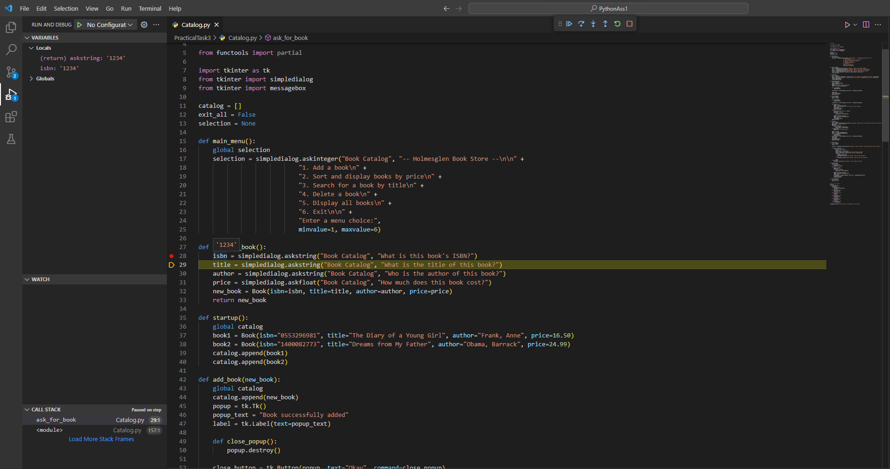

Figure The variable ISBN is currently '1234'