JRecipe – Keeping your recipes safe and searchable.

Revision History
Date | Revision | Author | Description | Document Tracking
1-17-16 | 1.0 | Chris Horlick | Genesis
1-18-16 | 1.1 | Chris Horlick | Changes based on Feedback
1-23-16 | 1.2 | Chris Horlick | Added Domain Objects to Project
1-28-16 | 1.3 | Chris Horlick | Added service overview, class diagram, and development directory layout

Contents
1 Introduction 4
1.1 Intent 4
1.2 High Level Requirements 4
1.2.1 Enter Recipe 4
1.2.2 Add Ingredients 4
1.2.3 Add Recipe to Shopping List 4
1.2.4 Step by Step Recipe Playback 4
1.2.5 Edit Recipe 5
1.2.6 Edit Shopping List 5
1.2.7 Key Technology Standards 5
1.2.8 Future Enhancements 5
2 JRecipe Use Cases 6
2.1 Intent 6
2.2 Customer Interacting Use Cases 6
2.2.1 Use Case Diagram 6
3 Fully Dressed Use Case 8
3.1 Intent 8
3.2 Create New Recipe 8
4 Class Diagram 10
4.1 Description 10
4.2 Domain Layer Class Diagram 10
5 Directory Structure Layout 11
5.1 Description 11
6 High Level Diagram 12
6.1 Description 12
7 Summary 13

Introduction

Intent
This document is meant to describe the JRecipe application and list its requirements.

High Level Requirements
The JRecipe application is an application that allows its user to add recipes to the recipe database and curate those recipes. Additionally, the application will allow the user to “playback” the recipes one step at a time. That means the recipe will display each step until the user press the next button, somewhat like a power point presentation. The application will also allow the user to add recipes

Enter Recipe
The most basic operation for JRecipe will be to allow users to create new recipe. This allows the user to make a new entry in the recipe database.

Add Ingredients
Once a user has entered in a recipe the user will need to edit the recipe and add ingredients one by one to the recipe. They will also need add the amounts for each recipe along with the ingredient name.

Add Recipe to Shopping List
The shopping list feature allows the user to add recipes to a shopping list. This shopping list will temporarily hold the names of all the ingredients from each recipe. This is meant to be an aid to the user as they go to the store to collect ingredients for each recipe.

Step by Step Recipe Playback
The recipe playback feature will allow the user to select a recipe then each step for the recipe will be displayed one by one allowing the user to press Next or Back to see the next or previous step. This feature is a UI feature that is meant to make it easier for the user to cook with.

Edit Recipe
This feature allows a user to edit a recipe and either delete or add ingredients or delete and add steps in the recipe.

Edit Shopping List
The edit shopping list feature allows the user to delete ingredients from the shopping list. This allows the user to ignore ingredients that they may already have or delete them from the list as they pick up the items off the shelf.

Key Technology Standards
The standards defined by OWASP (www.owasp.org) will be closely followed during the development of the JRecipe application.

Future Enhancements
The next set of features would be to create a web enabled version of the application that can be accessed from a mobile device. This would allow users to shop or work with the recipes on the go.

JRecipe Use Cases

Intent
This section lists the various uses cases pertained to customer interaction with the system.

Customer Interacting Use Cases

Following are the customer interacting use cases by priority:

Create New Recipe
Playback Cooking Steps
Manage Shopping List
Manage Recipe Groups

Use Case Diagram
The following diagram is a quick sketch of the use cases for the user interactions with the application.
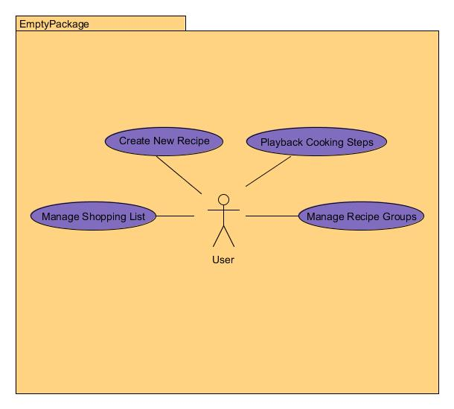

Figure 2-1 JRecipe use cases

Fully Dressed Use Case

Intent
This section documents a fully dressed use case for creating a new recipe in the JRecipe application.

Create New Recipe
Primary Actor: User

Assumptions:
- User has the application installed on their computer.

Stakeholders:
- User

Pre-conditions:
- User has access to JRecipe application.
- The application is a fresh install with no previous configuration.

Post-conditions (Success Guarantee):
- The user is able to successfully create a new recipe with ingredients and step by step instructions.

Flow of Events:
1. User will click on “Create New Recipe” button.
2. The application will then launch the Create New Recipe dialog box.
3. The user will then enter the recipe name.
Alternate Flow 3.A1
- If the recipe name is invalid (alphanumeric only) the application will highlight the recipe name in red and disable the “Save” button.
4. The user will now enter the group name for the recipe.
Alternate Flow 4.A1
- If the user has not yet created the recipe group, the user can click “Create New Group” and a dialog will prompt the user for group name.
- The user will enter the group name and click save
Alternate Flow 4.B1
- If the recipe group name is invalid the application will highlight the input box in read and disable the “Save” button.
5. The user will now add ingredients one by one. The user will enter the text for measurement and ingredient name. The ingredient is saved automatically there is no need to save after each ingredient.
*Validation for these field is disabled as “/” or “.” maybe valid symbols i.e. ¼ Tblspn
Alternate Flow 5.A1
- The user will click the “+” button to add ingredients additional ingredients until they have entered all ingredients.
6. Next the user will enter the first step for the recipe.
*Validation is disabled for these fields as symbols may needed to convey meaning in the steps.
Alternate Flow 6.A1
- The user will click the “+” button to add additional steps until all steps have been added to the recipe.
7. After all fields have been populated the user will then click “Save” and the recipe will be added to the database.
Alternate Flow 7.A1
- The recipe will be finally validated before saving. Every field must be populated except the “Recipe Group” field. If those fields are empty they will be highlighted and a modal dialog will be displayed informing the user to populate the fields.

Class Diagram

Description
This section illustrates the class layer diagram for the domain layer

Domain Layer Class Diagram
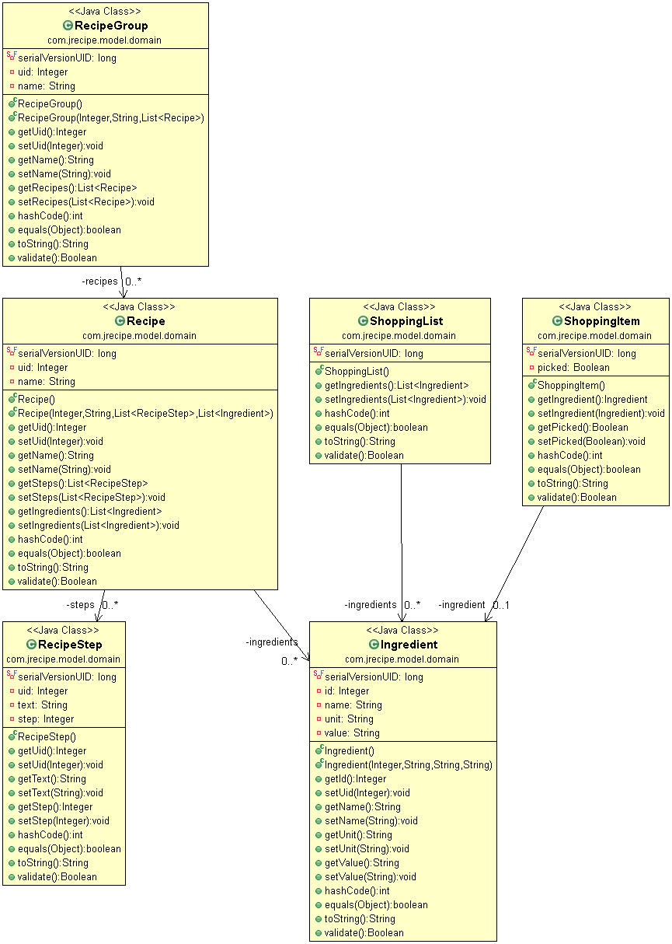

Directory Structure Layout

Description
The following section has been added to show the layout and various folders and files as they are on the disk for the jrecipe project. A simple screenshot has been included to show this.

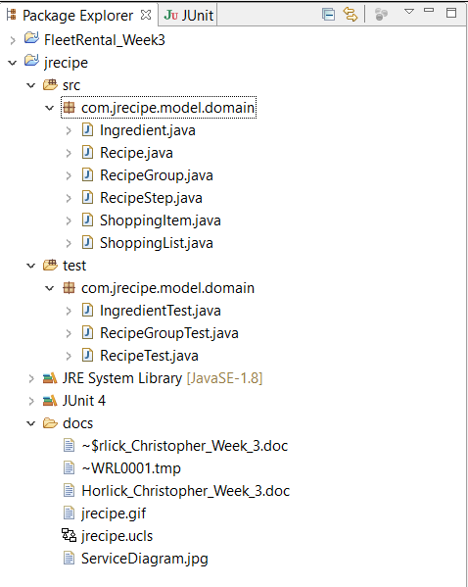

High Level Diagram

Description
The following section contains a diagram of the current UML relationships of the service layer for the jrecipe application. Note that this is only for Use Case 1 contained in the Fully Dressed Use Case section.

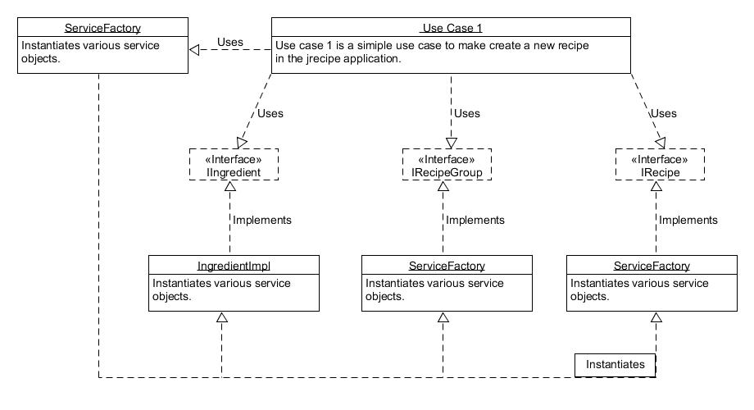

Summary

This document details the requirements, highlights use cases and flushes out a fully dressed use case and design details of the jrecipe application

- End -

