**Python for Windows users**

**1. Instalation:**

* download Python 3.11.5 (or higher) from

<https://www.python.org/downloads/>

* install it (double click) – "basic" installation (not customized), follow the instructions
* online tutorial available: <https://docs.python.org/3.11/tutorial/index.html>
* online documentation: <https://docs.python.org/3.11/index.html>
* user guide for Python on Windows: <https://docs.python.org/3.11/using/windows.html>

**2a. How to run the validator (with Windows PowerShell):**

My recommendation is to start in a sandbox folder you will create somewhere on your PC ☺ :

* copy the validate.py script from the github repository to your sandbox folder
* collect your files for validation in the same folder
* open Windows PowerShell (from the Windows Menu)
* move to the sandbox folder (use the cd command)
* write the command "python validate.py "
* it will tell you that "No module named 'regex'."
* write the command "pip" … it serves for installing missing libraries and will give you basic help (which you probably will not understand:-)
* nevertheless, write the command "pip install regex" … hopefully, in this way, the regex library will be installed (Successfully installed regex-2023.xxx)

Now it should be prepared!

* write the command "python .\validate.py <name_of_file_you_want_to validate>" (tip: start with one of the released files)

You can ask for less strict options:

* + --allow-trailing-whitespace (do not report extra spaces)
  + --allow-forward-references (do not report forward node references within a sentence level graph)
* the final command looks as the following:

python .\validate.py --allow-trailing-whitespace --allow-forward-references .\english_umr-0001.txt

(output: ***FAILED *** with 3 errors for english_umr-0001.txt :-((

**2b. Alternative (if there are issues with the Windows PowerShell )**

* copy the validate.py script from the github repository to your sandbox folder
* collect your files for validation in the same folder

use the Windows command line (press the Windows key + R, then type "cmd.exe" and press Enter)[1]

* in Windows Settings, you must define the path to your python app
  + Start 🡪 Settings 🡪 System 🡪 About (last item in the left menu) 🡪 (scroll down and find) Advanced system settings
  + It opens "System properties" dialog box, click on "Environment Variables"

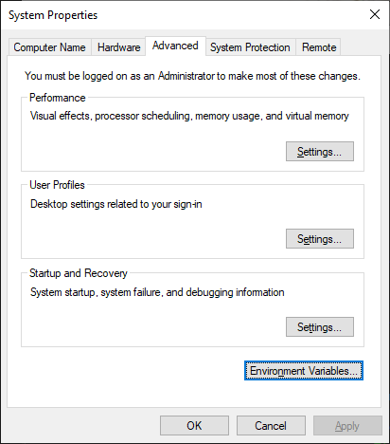

* + It opens the "Environment Variables" dialogue box, focus on the "User variables for <your profile>" (upper part):
    - 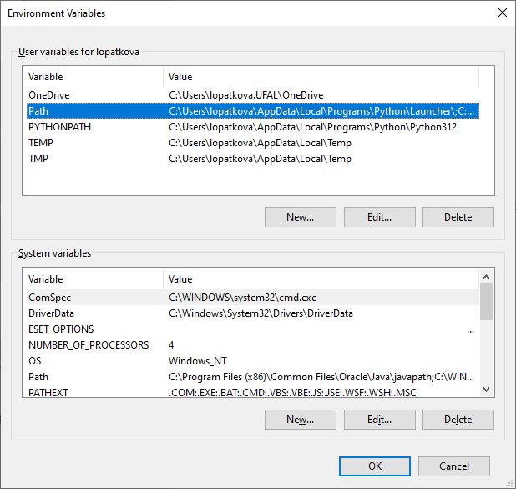 mark "Path" (by single L click)k and then open "Edit"
      * Click on "New" and
      * enter the path where your Python is installed[2]
      * confirm by OK

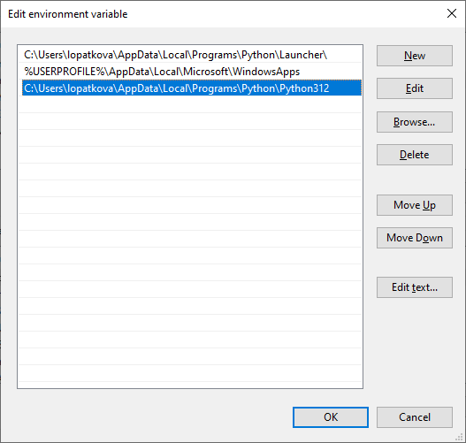

* + Back in the "Environment Variables" dialogue box, "User variables for <your profile>" (upper part):
    - 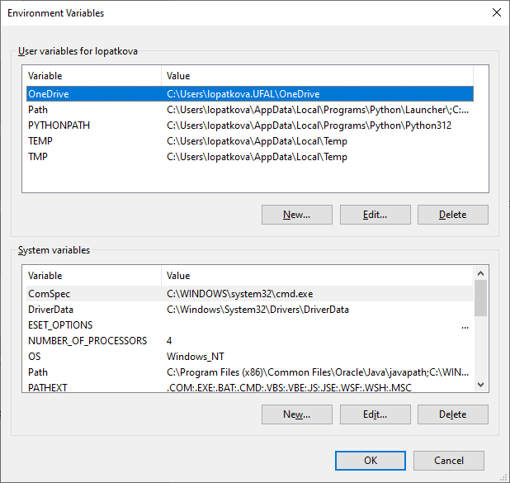Click on "New"
      * Insert Variable name PYTHONPATH
      * 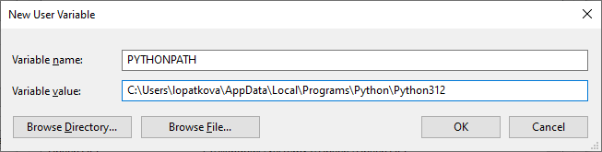Insert Variable Value … the path where your Python is installed (as above)
      * confirm by OK

Now your computer knows from where python should be launched!

* move to the sandbox folder (use the cd command)
* write the command "python validate.py "
* it will tell you that "No module named 'regex'."
* write the command "python -m pip install regex"

… hopefully, in this way, the regex library will be installed (Successfully installed regex-2023.xxx)

Now everything should be prepared!

* write the command "python .\validate.py <name_of_file_you_want_to validate>" (tip: start with one of the released files)

You can ask for less strict options:

* + --allow-trailing-whitespace (do not report extra spaces)
  + --allow-forward-references (do not report forward node references within a sentence level graph)
* the final command looks as the following:

python .\validate.py --allow-trailing-whitespace --allow-forward-references .\english_umr-0001.txt

(output: ***FAILED *** with 3 errors for english_umr-0001.txt :-((

1. Warning: there might be an issue with proper display of Unicode characters.
2. In my case … C:\Users\lopatkova\AppData\Local\Programs\Python\Python312

   Tip: when you find the place on our PC, R click to the address field and select copy address :-)