**Messenger Program**

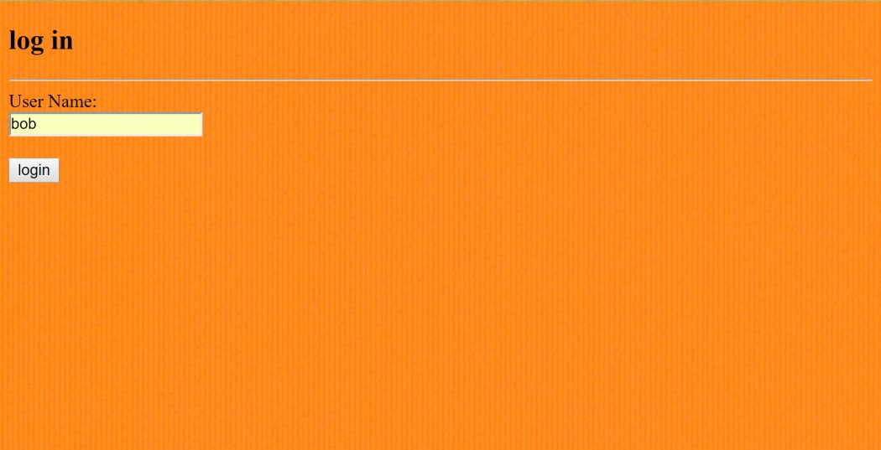The Messenger Program allows the user to login and add themselves to different message streams and post messages to them. Users can also view the message streams and apply settings to those streams such as sorting by date or in alphabetical order or marking all messages as read. As the user reads the streams the website automatically marks different messages as read so that when the user opens a stream again they see the newest unread messages first. Users are only allowed to post and view the streams that they are added into. All data is stored in an SQL database. There is only one PHP file because the rest gets generated as the user browses the website. The template for each webpage is written in a made up language called wpml.

