Civic Density: How The Supply of Civic Opportunity Shapes Political Participation
Christian Hosam
Norris Davis
2026-08-22

Introduction
Few concepts within the study of politics hold as much purchase as the critical nature of civic life in shaping citizen’s political engagement. When individuals are recruited, convened, and informed by civic organizations, participation is thought to follow. While this foundational truism is oft-repeated as a logical and necessary truth, historically it has been limited empirically by measures of the demand side of civic engagement: individual trust, networks, and dispositions, all of which have been in decline for some time (Citrin and Stoker 2018; Hetherington 2005). Far less attention is placed on the supply side of civic opportunity; the civic infrastructure that may be available or present in a community, regardless of individual membership.
Generally, this demand side of civic engagement focuses on the effects of membership in civic associations has to an individual’s propensity to be an active participant in democratic processes (Andrews et al. 2010; Hooghe 2003). But to what extent do the meso-level features of civic organizations; the features that constitute the communities that they are embedded in, shape this propensity in ways that are distinct from individual-level membership?
Contemporary scholarship on civic associations, by focusing on the characteristics of those who join, necessarily dial in on the ways that this membership can predict other types of behavior. But as recent work by Stephanie Ternullo argues, “place politics - or the correlation between where people live and their partisanship - exists at multiple geographic scales.” One way at getting at this, which is Ternullo’s approach, is to compare similarly situated locations with differing partisan affiliations. Another approach, the one we take here, is to connect data on civic organizations aggregated to a local level with individual level survey data to track how the features of living within a community with a different composition of civic associations affects canonical measures of political participation, namely voter turnout and presidential vote choice.
To do this, we construct a dataset that merges data recently compiled by Martin de Vries, Hahrie Han, and Jae Yeon Kim that measures civic opportunity at the county level (Vries, Kim, and Han 2024) to the 2024 wave of the Cooperative Post-Election Study (CMPS) (Frasure, Masuoka, and Ocampo n.d.) to more deeply understand what they call the supply-side of the component parts of developing social capital . We find that living in a county with a higher density of civic opportunities predicts an increase in voter turnout, with a particularly strong impact for younger voters.
While previous literature has ably and thoughtfully explored the relationship between social capital and political engagement, we believe that we are the first to pair data on the universe of civic organizations with rich, fine-grained data on political behavior, giving us leverage to mine key insights into a question that is similar, yet distinct to what is currently asked in the literature. Rather than asking how civic organizations drive political participation, we ask how living in a place that is more concentrated with these organizations shape that participation.
This contributes to the literature on social capital by articulating an alternative story that goes beyond the individual-level effects of civic bonds as driving these effects, instead focusing on ways that the formation of these bonds might be endogenous to the type of community in which they are forged. It contributes the literature on political behavior by exploring new tools to understand how local context shapes political decision-making in ways that are tied and untied from cognitive, psychologically-based models.

Why Study the Supply Side of Social Capital?
The features of a local community and their ability to shape a person’s ability, desire, and choices of political participation are well-documented in the literature (Han 2014; Knack and Keefer 1997; Putnam 1995). There has been a recent suite of literature, however, that has raised questions about whether local features are being supplanted in importance by the importance of national-level trends. Work by scholars like Dan Hopkins which argue that much of the information that was previously gathered at the local level is now eaten up by heuristics about partisan cues that are largely generated through gathering information about federal-level elections (Hopkins 2018). However, this type of information is only one dimension and, as other literature suggests, sidesteps rather than disputes the argument of if and under what conditions local and residential context matters (Sharkey and Faber 2014). Part of the reason for this relative lack of scholarly attention is the lack of tools to do so. The demand side measures are largely drawn from self-reported survey measures that reflect individual’s perception of their relationship to the state and their energy (or lack thereof) to participate in the democratic process. This is both substantively important and methodologically intuitive. Understanding the dynamics of local politics is thus important not only to evaluate demographic comparisons but also to understand what are the conditions under which people’s decisions can be changed.
Another dimension of local politics that could very well matter are the composite features of a community that shape access, facilitate conversation and political awareness, and provide opportunities to take part in civic activities that could be understood by those who participate in them as important for reasons either partially relevant or fully orthogonal to those national trends. This therefore can be seen as a form of resistance to an approach in which presidential electioneering absorbs all political behavior, particularly when it comes to the formation and maintenance of ideology (Cramer 2016; Rodden 2019). Further, given the federalist nature of the United States, there are also particular forms of economic dispossession that take place at the local level that can shape a variety of political outcomes and attitudes (Cummings and Boutcher 2009; Hankinson, Magazinnik, and Weissman 2024).
Put together, there is a need to connect the universe of civic associations and its distinct impacts on American politics with how these impacts are shaping political attitudes and, perhaps most importantly of all, if it drives political behavior.
To that end, recent work by Milan de Vries, Jae Yeon Kim, and Hahrie Han argues that without fine grained data on the resources available to different communities, we can know that social capital is a necessary precursor for social trust and cohesion but don’t have anyway to know “without knowing where to go to cultivate it, or being able to ex ante anticipate where it might be strong or weak.” (Vries, Kim, and Han 2024)
To get at this problem, the authors construct a dataset that takes a census of all civic organizations registered as non-profits with the IRS and pulls in information about the type of activities and opportunities for participation that they provide in order to track how civic opportunity is spread out across the country. And, in fact, they find that civic opportunity is itself correlated to many of the major forms of economic and political dispossession in the country. Their key variable of interest, civic opportunity (more on how they construct this measure below in the Methods section), is more concentrated in higher-income areas, areas with a higher proportion of non-Hispanic white residents, and a higher proportion of college graduates. Put another way, the chance to even take part in things that would serve as the pretext for forming civic bonds is itself tied to the ways that political opportunities are allocated.
But this leaves an open question on the table: to what extent does this inequality in civic opportunity shape political decisions for those people that are embedded within these locations? Is it the case that because civic opportunity and the density of that opportunity is tied to demographic and social factors that it is unhelpful in giving us insight, which ironically would undercut the need for such a measure to have been constructed? Or, alternatively, is it the case that by identifying the relationship between outcomes such as voting, we are able to assess the importance of civic opportunity in a stronger, more forceful way?
Our interpretation of the follow-up to de Vries, Kim, and Han is that they were using the measures that they constructed as outcome measures; dependent variables that they used to track the component features that predict living in a place that nurture or repel civic engagement. Our intervention is to instead use their measure as an input; an independent variable that we use to see how living in a place with more or less civic opportunities shapes political behavior, which we believes help pay off the promise of what they discuss in their article. What are the political manifestations of living in a place with a high concentration of organizations that give you the opportunity to develop your civic identity and practice? Does that opportunity translate into action?

Data Collection
To investigate the relationship between civic opportunity and political behavior, we merge the dataset constructed by de Vries, Kim, and Han to the 2024 wave of the Collaborative Post-Election Study (CMPS) (Frasure, Masuoka, and Ocampo n.d.). We used the CMPS because it provided us with two critical advantages. First, it has an oversample of respondents from communities of color, allowing us a higher degree of leverage into the particularistic impact that race could have to the question at hand. In addition, each respondent also identified the county that they lived in, giving us the ability to merge to the civic opportunity dataset at the level of the county. Each row of our dataset thus includes all information from the CMPS wave at the respondent level along with all information for the composite opportunity measure constructed by de Vries et al at the county level.
For our purposes, civic opportunity refers to an index that each organization that the de Vries et al collected information on that includes whether that organization:
- provides volunteer opportunities,
- offers membership,
- offers ways to take civic or political action, or
- holds community events
They had an overall universe for their dataset of 564,559 organizations. They then constructed an index for civic opportunity by creating a dummy score for each of the four items, re-scaling it from 0 to 1 (1 being an organization doing all and 0 being it doing none), summing those scores and normalizing them, and categorizing them into equally sized quintiles to be able to differentiate between higher and lower civic density. We think this measure allows us to credibly quantify a distinct measure for the study of politics because it is substantively relevant to the study of civic engagement while also being parsimonious with respect to a consistent yet robust construction of factors that extant literature already says serves as an anchor for civic engagement and social cohesion.
We use this measure of what the authors call an opportunity score (but for the purposes of this paper will be called civic density) as an independent variable to ask questions that can guide a different, yet incredibly relevant set of questions about the aftermath of the 2024 presidential election. In this paper, we focus particularly on the question of the decision to vote or, more specifically, impact of civic density on voter turnout in the 2024 election.

Research Question
- Did living in a county with a higher civic density lead to higher voter turnout in the 2024 Election?

Hypotheses
We argue here that civic density will be associated with higher voter turnout. Existing literature in the space of field experiments suggest that organizations can play a key role in increasing voter turnout, even in spite of a secular decline in political participation (Gerber, Green, and Shachar 2003; Green and Gerber n.d.; Han 2016). Our work does not wish to or expect to supplant that role. Rather, we anticipate that it will help to suggest another channel through which the importance of organizations might flourish, namely through identifying county-level rather than individual level features of civic density, highlighting another pathway through which civic engagement and the work of organizers creating conditions that might allow for that civic engagement to rise and to matter. Thus:
$H_{1}$: Higher levels of civic density will be associated with higher voter turnout
In our analysis, we also consider that, in keeping with the initial findings by de Vries et al, this increase in turnout will not be uniform: it will be associated with baseline differences in race. However, given recent work on race and the important interventions that highlight the fact that Black and Latino voters are more likely to vote once other controls are included in turnout models (Fraga 2018; Hayes et al. 2022) as well as the fact that the 2024 election included a candidate of color, which is likely to create ceiling effects for the impact of civic density in this particular election (more on what we think the impact of race will be in the future in the Discussion Section) we also predict that we will not see a differential impact with respect to civic density’s impact on turnout across racial groups.
$H_{2}$: Civic Density’s Relationship to turnout will not be differentiated across racial groups

Model
In order to get at the question of voter turnout, we estimate a model that regresses self-reported voter turnout on civic opportunity (for the purposes of this paper, we use the term civic density instead of civic density given the way that the term is operationalized in our study) along with a vector of relevant covariates: age, race, gender, education, income, and partisan identification.
$$VoterTurnout_{i}=α_{i}+β(opc_{i})+ΦX_{i}+ε_{i}:$$

Does Civic Density Predict Turning Out to Vote?
Table 1: Regression Table for Models on Relationship between Civic Density and Voter Turnout
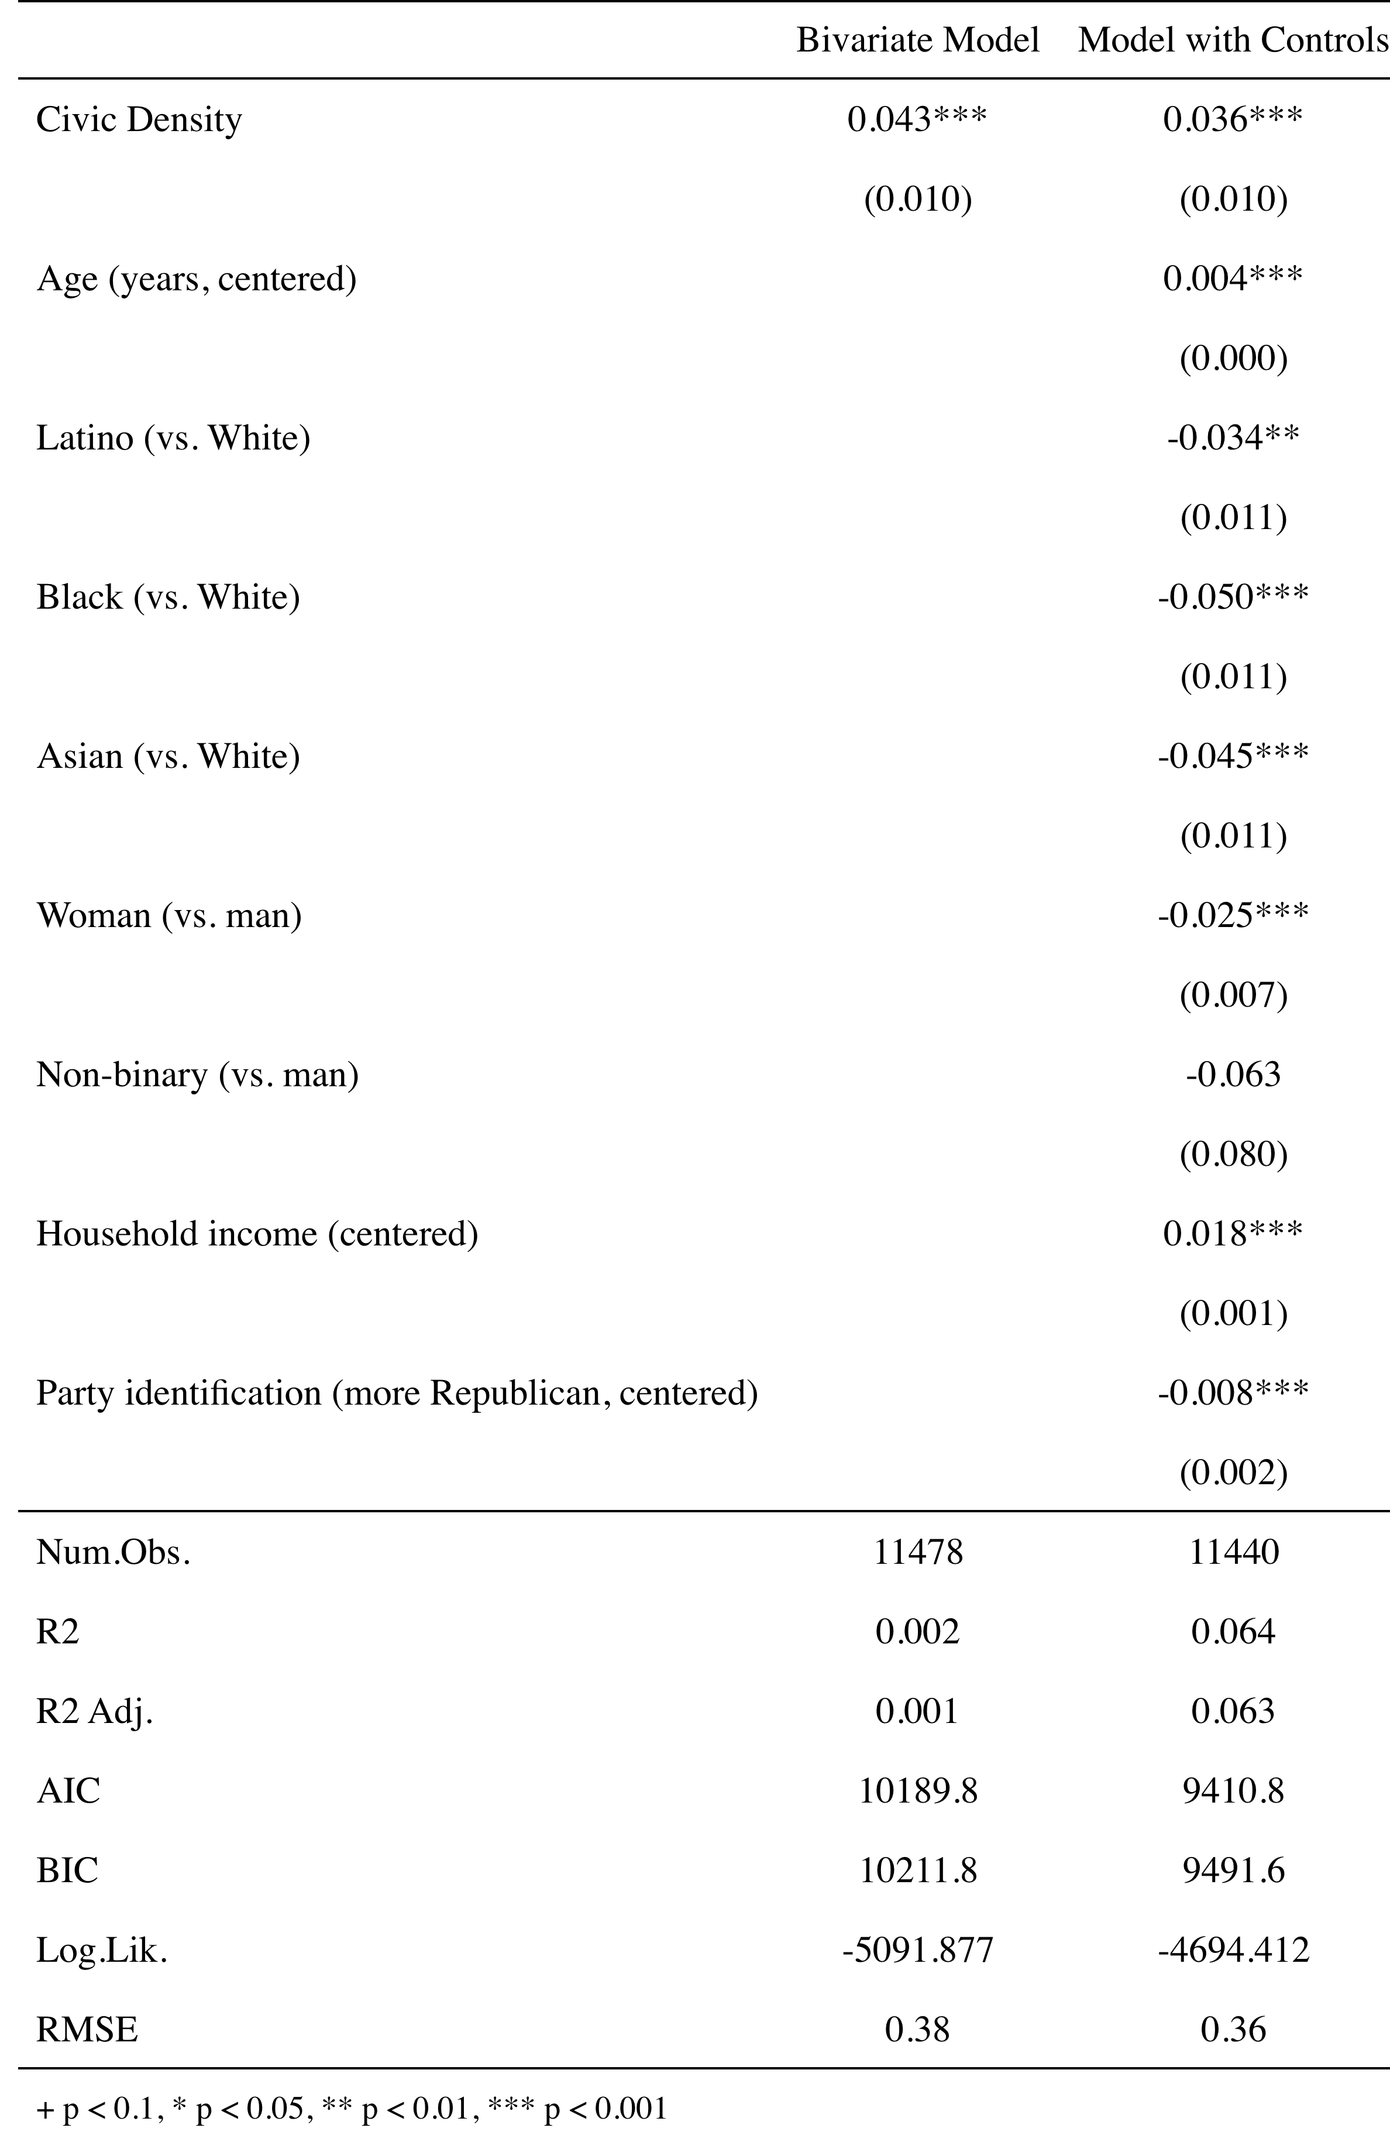
Across a range of specifications, civic density clearly predicts an increase in voter turnout. As shown in Table 1, a one-unit increase in civic density is associated with a 4.3 percentage point increase in the likelihood of voter turnout in the bivariate model (β = 0.043, p = .010). It is also associated with a 3.6 percentage point increase controlling for age, race, income, gender, and partisanship (β = 0.036, p = .010), thus confirming our priors in $H_{1}$. Civic density is indeed a proxy for the type of community that has a higher propensity for turning out to vote.
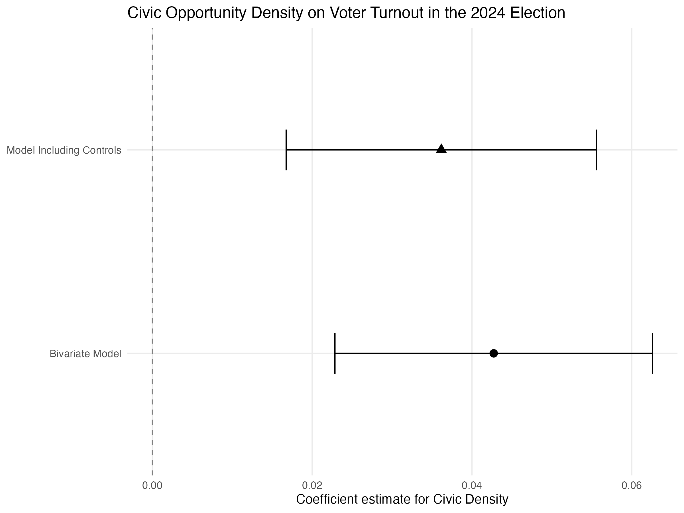
Figure 1: Coefficient Plots for Bivariate and Controlled Civic Density Models
However, because of the initial findings in de Vries et al showing that civic density was associated with community-level characteristics that suggested higher proportion of white, upper-class, and highly-educated residents, we wanted to know if this effect was disproportionately shaping the turnout of people from different demographic backgrounds. Thus, we ran analyses in which we evaluated the impact of race, gender, age, and income to see if that relationship was associated with different levels of strength for different groups. We find no evidence of differential impact of living in an area with higher civic density across race or gender, also confirming $H_{2}$. Higher income is associated with higher turnout but because this tends to comport with the existing literature (Schattschneider 1960; Verba, Schlozman, and Brady 1995) we do not go into deeper analysis of this link within this paper (though we report the results visually across income groups in the Appendix). Interestingly, increased levels of civic density is associated with a decline in voter turnout for those who have higher levels of affiliation with the Republican Party. Future work will deal with this further but it is beyond the scope of this paper. What we did find interesting in terms of our findings and are able to follow-up on here was the effect that age had on this relationship.
We find that, on average, a one unit increase in distance from the sample mean is associated with a 4 percentage point increase in turnout (β = 0.004, p = .000). But this lead us to investigate for what period of the life course was this relationship most important. To that end, we ran a model that interacted age and civic density.
Table 2: Regression Summary for Interaction between Age and Civic Density
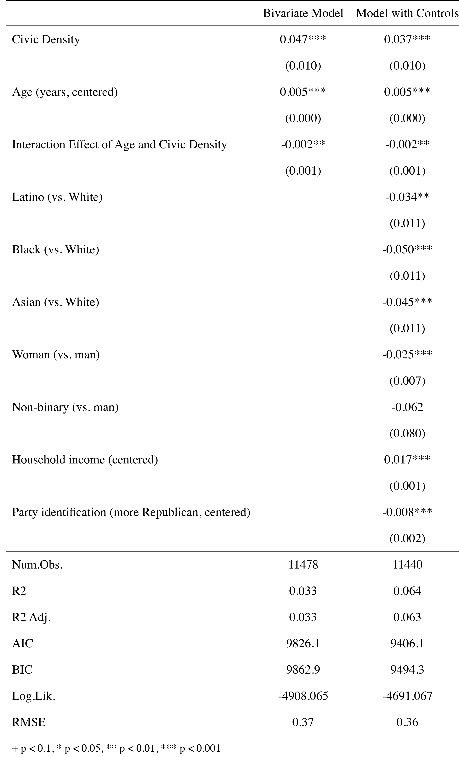
Turning our attention to Table 2, we see that there is a statistically significant and negative coefficient for the interaction effect between age and civic density (β = -0.002, p = .0001). This means that the relationship between civic density and voter turnout weakens as respondents age. We also bin respondents into age categories in Figure 2 to understand this relationship visually and the results are striking: the importance of civic density on turnout is most pronounced among the youngest categories and is in fact statistically insignificant for respondents 45 and above. Living in a community rich in opportunities for civic life has important effects for young people that are not replicated at different stages of the life course.
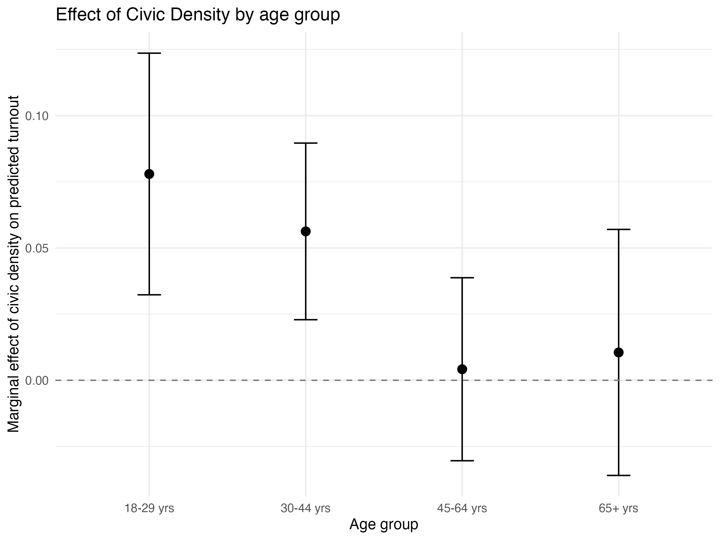
Figure 2: Effect of Civic Density on Turnout, Stratified by Age Groups
But why does civic density serve such a distinct function for young people when it comes to voter turnout? In the context of stunning victories in recent years for the Democratic Socialists of America (DSA) movement, with the touchstone of the election of New York Mayor Zohran Mamdani, we might imagine that there is perhaps a growing youth movement that could be correlated to the kind of civic density that we find. But even if this were true, young people like any other group are diverse in their politics, financial backgrounds, and policy preferences, so it stands to reason that there must be a link in the chain between age and civic density that leads to the specific effect that the interaction of these variables has on voter turnout. To try to more cleanly understand this, we propose three potential explanations that have analogues in the battery: economic pessimism, civic trust, and political interest.

Civic Density and Youth Politics
A recent study by the SNF Agora Institute at Johns Hopkins University finds that young people are more likely to be deeply dissatisfied with the political system, with sixty percent of Gen-Z respondents agreeing with the idea that the structure of the government needs significant change regardless of who is elected (Winner, Warren, and Mason 2026). That same report also shows that 47% of respondents between 18 and 29 and 54% of respondents between the ages of 30 and 44 believe that “the people who really ‘run’ the country are not known to the voters.” Finally, with respect to media consumption, there is a dramatic difference between 18-29 year olds (25%) and those who are over 65 (54%) who state that they follow the news several times a day. All of these data points speak to the ways that youth is associated with a presumed lack of interest, knowledge, and enthusiasm in the political sphere, which our argument seems to complicate.
Therefore, to understand the nature of the interaction between youth and civic density with respect to voter turnout, we ran three different models that interacted age and civic density with three different dependent variables. Fortunately, the CMPS 2024 battery has questions relating to a number of themes relevant to the idea of differential relationships to politics that could be indexed by this increased propensity to voting in ways that aren’t anchored to conventional understandings of voter behavior.
For economic pessimism, we proxy this question by using the survey response: “When you think about the next few years and your family’s income, savings, and jobs, how would you describe yourself?” with the answer: “Pessimistic that things are getting worse.”
The second is trust in government, which is here understood as the question: “How much of the time do you think you can trust the federal government to do what is right?” which is scaled from 1-4, with 1 corresponding to ‘Always’ and 4 corresponding to ‘Never’.
Finally, we use political interest as an outcome variable, which is understood in the survey as the question: “Thinking back to last year, how often did you follow news and information about the 2024 presidential election?”, which is scaled from 1-5 with 1 corresponding to “Never” and 5 corresponding to “Every single day.”
We measure the importance of these variables in two ways. The first is by running a linear model with all of the same variables as in the controlled model above, but stratified only to respondents 40 and under and with one of the three variables as the outcome variable instead of voter turnout (we thus omit age as a variable in these analyses). The second specification does this for the entire sample but as interaction model between age and civic density on the outcome variable of interest.
One of these explanations clearly stands out. In Table 3, we see that political interest is the only explanation with a statistically significant outcome associated with civic density across both the full interaction model and the model stratified to just younger respondents. A couple of things stick out for further analysis: first is the magnitude of the relationship for young people and political interest. Living in a county with higher civic density is associated with a 16 percentage point increase in following the news every day for younger respondents, a clear and striking finding that is corroborated by an 8% relative increase in the interaction model (β = 0.159, p = .042; β = 0.086, p = .016). Civic density is associated with a weakly significant decline in trust in government in the young model but that goes away in the full sample and also doesn’t reach significance in the interaction term (and is in fact a nearly precise null effect).
Key to the story is the importance of economic pessimism. While it does not reach significance in either model, it does have a significant interaction term coefficient. However, this term is positive and significant, suggesting that in counties with higher civic density, economic pessimism actually is more pronounced for older respondents relative to younger respondents. This is the opposite effect of political interest, which has a significant negative interaction term, suggesting that as respondents get older, the importance of civic density gets weaker and weaker as a predictor of political interest.
Table 3: Regression Tables for Competing Explanations for Youth’s Distinct Impact on Civic Density
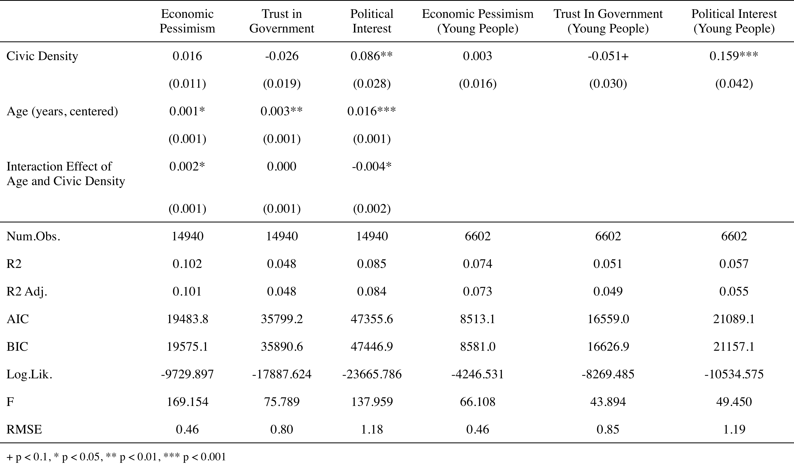
While we feel confident in removing trust in government as an explanation given the null results above, the opposite substantive directions of economic pessimism and political interest (which we highlight visually below in Figure 3 - a chart showing the conditional predicted association of civic density with political interest and economic pessimism across age) led us to construct a final table looking at the importance that economic pessimism and political interest have on each other. We ran two models that contained economic pessimism and political interest as outcome variables, respectively, in an interaction model between civic density and age, including the other variable in the model as a control. We then re-ran the models without age as a control but stratifying the sample to just young people. Our goal here was to see if one explanation was stronger than the other in predicting the impact of civic density.
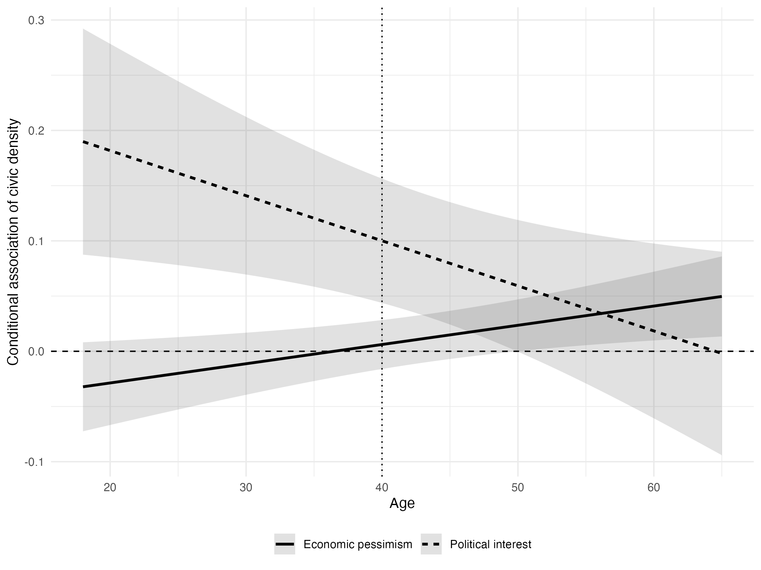
Figure 3: Scatter Plot on Relationship Between Age, Economic Pessimism, and Political Interest

Table 4: Pitting Economic Pessimism and Political Interest Against One Another
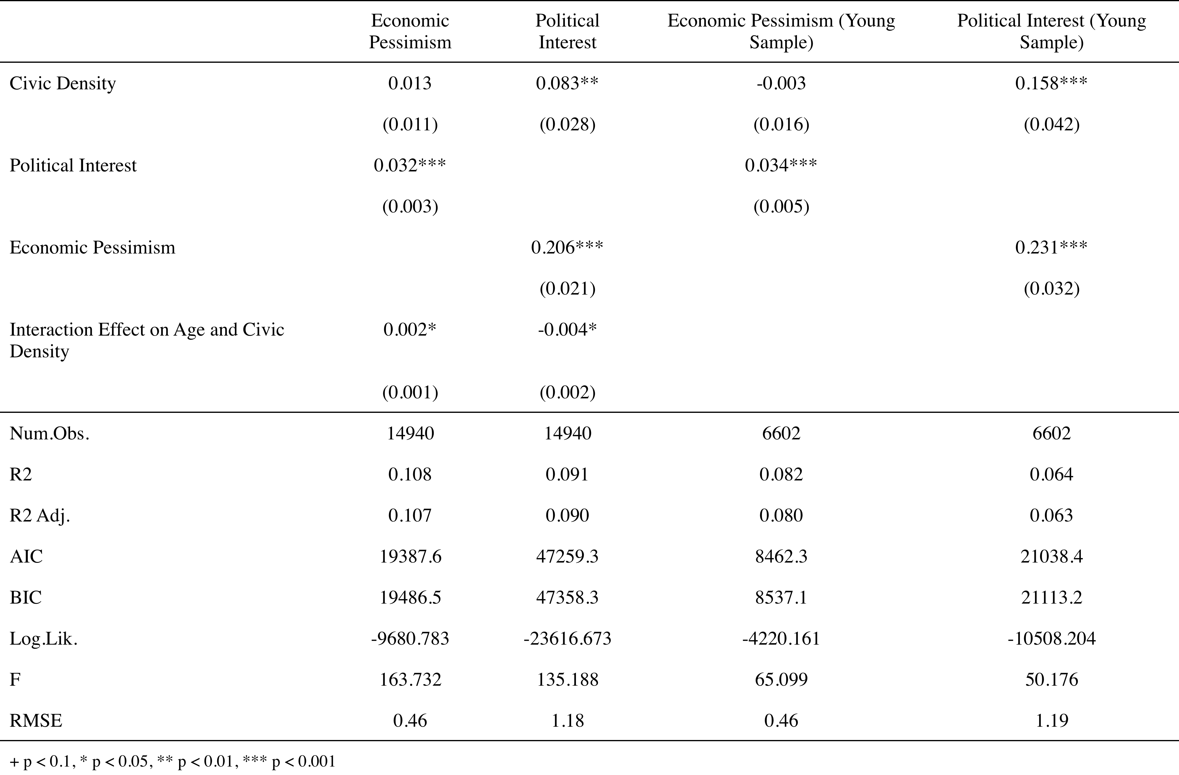
And we find just that. In Table 4, we see that civic density does not have a statistically significant relationship to economic pessimism in either the full interaction model or in the young respondents’ model (β = 0.013, p = .011; β = -0.003, p = .016) but it predicts political interest in both models with a high level of statistical significance (β = 0.083, p = .028; β = 0.158, p = .042). This suggests that there is perhaps both a direct and indirect channel through which civic density is shaping political participation: while it very likely has direct effects on propensity to vote, it may also cultivate attentiveness and engagement before translating into electoral participation. Among people under 40, higher levels of civic opportunity in the local environment are significantly associated with greater political/news attentiveness. In substantive terms, higher civic opportunity structure is associated with more frequent news-following most strongly among younger respondents, with the relationship attenuating across the life course.
Taken together, we argue that civic density is working in ways that are distinct and go beyond just the civic bonds that they help to form. For young people, living in these areas seems to be correlated with an environment that encourages following the news and keeping yourself abreast of what’s going on politically, which then in turn leads to higher turnout for young people. Interestingly, this does not cohere with the argument of higher anger or dispossession among young people. Civic density’s association with pessimism tends to be more pronounced among older people, who are more likely to associate civic density with frustration with their economic lives.
As a final analytical check, we re-ran our controlled turnout model but added political interest as an additional co-variate. Civic density remains positively associated with turnout (β = 0.029, p = .002), while the civic density × age interaction remains negative and statistically significant (β = −0.0013, p = .035). Political interest itself is strongly associated with turnout (β = 0.080, p < .001). Thus, controlling for political interest reduces but does not eliminate the age-conditional association between civic density and turnout.
Civic density’s impact on turnout is strong and robust to multiple specifications across the full sample of respondents but with a distinct and important effect for younger voters. We believe that this more than proves its importance as a measure for other scholars to add to their toolkit when investigating the importance of civic engagement on canonical political outcomes.

Limitations
A couple of limitations to our study that we’d like to flag: first, the de Vries et al dataset was constructed in 2020 while the responses were fielded and gathered in 2024. We could imagine that there was some level of attrition and addition to the universe of civic organizations in the intervening years. We are limited because the original authors only did that pull the one time so in replicating we can’t be sure that the organizations are absolutely the most up-to-date. However, given that reporting on the establishment of non-profits suggest that it increases a net rate of 1.9-2% in a given year in addition to the fact that these organizations are inclusive of those organizations that would not provide any civic opportunities, we are confident that any results we find will nonetheless provide legitimate insight into our research questions.
Second, while we think that there are important insights to be drawn from understanding the type of organizations that are present within these measures, because its not present within the original dataset, we stick to just using the composite measure as our independent variable without any disaggregation under the hood in terms of if a county has a higher proportion of religious organizations, for example. It might very well be the case that there are certain types of organizations that are specifically shaping the interaction between youth politics and civic density. However, we still feel like this composite measure, given the benefits that we outline above, is still insightful in its own right and testing its predictive power is a worthwhile endeavor to further our understanding of how civic engagement shapes American politics.
Finally, while what we offer is a mechanism that could be construed as causal, the fact that the dependent variable was self-reported voting was important to our story. The magnitude of the interaction effect drops right under statistical significance when stratified to just those who said they were “100% sure” that they voted and not inclusive of those who also said that they were “pretty sure” that they voted. This speaks to a limitation of our study, that we did not use a validated voter file as the dependent variable rather than self-report, even as the growing gold standard for studies like this one are validated voter turnout data, such as the one collected by a firm (e.g. Catalist). While we are heartened by the increased rigor that this type of analysis brings, we believe that self-reported turnout is helpful on its own terms because while the outcome measures might be self-reported, the civic opportunity measure is not and given that what we’re after is a better sense how individuals make sense of their political resources, we think of this as a benefit rather than a drawback for the purposes of this study. We believe that these results are important at least to the extent that they highlight both the importance of the civic density measure and in that it highlights in another way that political interest is likely a key factor in driving the relationship between civic density and turnout for younger people because the importance of social desirability bias is likely playing out in ways that are differentiated for younger vs older respondents.

Discussion/Conclusion
Civic density is associated with stronger and more robust voter turnout. The strength of the relationship is sustained even after accounting for multiple covariates. Of particular note is the fact that in spite of unprecedented partisan polarization, the relationship is still significant, suggesting an independent relationship that goes even beyond group-based animosity, contrary to existing, influential literature on the importance of groups in the construction of partisanship (Mason 2018; Mason and Kalmoe 2022; Schlozman 2015).
We don’t think our results overturn that vein of research and is in fact doing something different: showing that civic density is a distinct and valid construct that has impacts on political outcomes in ways that aren’t eaten up by partisanship in the way that so much else is. That said, we did find that Republicans were on balance less likely to turnout than Democrats when in an area with high civic density. One thing we also found but did not report here was that civic density was also associated with lower support for President Trump in the 2024 election. While we did not have the time to deal with this in this paper, what we can say here is that this opens up a pathway to think through the ways in which, similar to de Vries et al, the local features of a community are still informationally rich in terms of the ways that people come to their political lives and make political decisions, even as (discussed earlier) more and more of our behavioral information is coming from the federal level. This adds to and extends our understanding, then of how partisan considerations are likely being shaped by and not just shaping, local effects and community characteristics.
In addition, our findings that confirm our second hypothesis on the lack of a difference with respect to race and gender are certainly important. What we can’t do within this paper is suggest what the scope conditions for that importance are. Given that we only studied turnout in one election, we can’t know, for example, if there are race and gender differences in terms of something like cumulative voting as an outcome with respect to civic density. In addition, while we certainly extend the analysis of scholars like Bernard Fraga who speak to the conditions under which racialized turnout gaps sustain themselves, civic density could be conceptualized in many ways as a response to this work. One is as a defense mechanism, meaning that in contexts in which civic density is high, there is a larger suite of resources to defend against things like voter suppression, undercutting the structural and racialized reasons that communities of color are often disenfranchised. It could also mean that communities of color are reaching a form of political maturation in which the kinds of outcomes that a generation ago would have been stumbling blocks to participation like a more sparse civic environment are no longer as relevant, reducing the gap in the relationship that civic density has to turnout. This is our argument, though it is one we cannot substantiate given the fact that we only use the most recent wave of the CMPS survey.
Finally, of course, is our analysis on age. Young people’s politics are often discussed in terms of the fear that they might not live up to the expectations or the conventional approaches to politics that generations before them have enacted. But, given that civic density was actually associated not with economic pessimism but with political interest, it is likely that neither the most breathless or the most defensive take is quite true. Instead, the communities that young people find themselves in is likely a key indicator of interest with respect to how they are able to make sense of their political environments. This stands to reason as young people are still in the process of articulating their political ideologies and belief systems relative to their older counterparts.
Similar to our arguments about race and gender, we demur on a more sweeping statement about what this means other than to say that our findings indicate that following the news seems to be a big intervention that civic density can provide. Living in a location with high civic density is associated both with higher turnout and with higher likelihood of following the news on a consistent basis, with suggestive evidence that the latter outcome leads to the former. Future work will explore this further but we do want to highlight the importance of a finding that situates many of the more recent effects of youth activism and participation (especially in terms of participation in campaigns for progressive candidates). While we can’t know if, like many other findings in the literature, these effects will attenuate over time, that there is such a sharp and distinct interaction between age and civic density highlights the hunger that younger people have for civic bonds, which might be an explanation for why civic density is not associated with economic pessimism. Maybe if you have those bonds available to you, you have a window through which to view politics that is energizing rather than enraging. We can only hope here but future scholars can push this work and help prove it beyond reproach.

Works Cited
Andrews, Kenneth, Marshall Ganz, Matthew Baggetta, Hahrie Han, and Chaeyoon Lim. 2010. “Leadership, Membership, and Voice: Civic Associations That Work.” American Journal of Sociology 115(4). https://www.journals.uchicago.edu/doi/full/10.1086/649060.
Citrin, Jack, and Laura Stoker. 2018. “Political Trust in a Cynical Age.” Annual Review of Political Science 21: 49–70. doi:10.1146/annurev-polisci-050316-092550.
Cramer, Katherine J. 2016. The Politics of Resentment: Rural Consciousness in Wisconsin and the Rise of Scott Walker. Chicago, IL: University of Chicago Press. https://press.uchicago.edu/ucp/books/book/chicago/P/bo22879533.html.
Cummings, Scott L., and Steven A. Boutcher. 2009. “Mobilizing Local Government Law for Low-Wage Workers.” University of Chicago Legal Forum 2009(1): 187–246. https://access.heinonline.com/HOL/P?h=hein.journals/uchclf2009&i=195.
Fraga, Bernard L. 2018. The Turnout Gap: Race, Ethnicity, and Political Inequality in a Diversifying America. Cambridge, United Kingdom: Cambridge University Press.
Frasure, Lorrie, Natalie Masuoka, and Angela Ocampo. “Collaborative Multi-Racial Post-Election Survey (CMPS).”
Gerber, Alan S., Donald P. Green, and Ron Shachar. 2003. “Voting May Be Habit-Forming: Evidence from a Randomized Field Experiment.” American Journal of Political Science 47(3): 540–50. doi:10.1111/1540-5907.00038.
Green, Donald P., and Alan Gerber. Get Out the Vote. Brookings Institution Press. https://www.brookings.edu/books/get-out-the-vote-2/.
Han, Hahrie. 2014. How Organizations Develop Activists: Civic Associations and Leadership in the 21st Century. Oxford University Press. doi:10.1093/acprof:oso/9780199336760.001.0001.
Han, Hahrie. 2016. “The Organizational Roots of Political Activism: Field Experiments on Creating a Relational Context.” American Political Science Review 110(2): 296–307. doi:10.1017/S000305541600006X.
Hankinson, Michael, Asya Magazinnik, and Anna Weissman. 2024. “When Do Local Interest Groups Participate in the Housing Entitlement Process?” Journal of Political Institutions and Political Economy 5(1): 47–69. doi:10.1561/113.00000093.
Hayes, Matthew, Cara Wong, Andrew Bloeser, Mark Frederickson, and Chera LaForge. 2022. “Elected Officials, Empowered Voters: The Impact of Descriptive Representation on Voter Turnout.” Political Behavior. doi:https://doi-org.libproxy.berkeley.edu/10.1007/s11109-022-09823-0.
Hetherington, Marc J. 2005. Why Trust Matters: Declining Political Trust and the Demise of American Liberalism. Princeton University Press.
Hooghe, Marc. 2003. “Participation in Voluntary Associations and Value Indicators: The Effect of Current and Previous Participation Experiences.” Nonprofit and Voluntary Sector Quarterly 32(1): 47–69. doi:10.1177/0899764003251198.
Hopkins, Daniel J. 2018. The Increasingly United States: How and Why American Political Behavior Nationalized. Chicago, IL: University of Chicago Press. https://press.uchicago.edu/ucp/books/book/chicago/I/bo27596045.html.
Knack, Stephen, and Philip Keefer. 1997. “Does Social Capital Have an Economic Payoff? A Cross-Country Investigation.” The Quarterly Journal of Economics 112(4): 1251–88. doi:10.1162/003355300555475.
Mason, Lilliana. 2018. Uncivil Agreement: How Politics Became Our Identity. Chicago, IL: The University of Chicago Press.
Mason, Lilliana, and Nathan Kalmoe. 2022. Radical American Partisanship: Mapping Violent Hostility, Its Causes, and the Consequences for Democracy. Chicago, IL: The University of Chicago Press.
Putnam, Robert D. 1995. “Bowling Alone: America’s Declining Social Capital.” Journal of Democracy 6(1): 65–78. https://muse.jhu.edu/pub/1/article/16643.
Rodden, Jonathan A. 2019. Why Cities Lose: The Deep Roots of the Urban-Rural Political Divide. Basic Books.
Schattschneider, E. E. 1960. The Semi-Sovereign People: A Realist’s View of Democracy in America. 1st ed. New York, NY: Holt, Rinehart; Winston.
Schlozman, Daniel. 2015. When Movements Anchor Parties: Electoral Alignments in American History.
Sharkey, Patrick, and Jacob W. Faber. 2014. “Where, When, Why, and for Whom Do Residential Contexts Matter? Moving Away from the Dichotomous Understanding of Neighborhood Effects.” Annual Review of Sociology 40(1): 559–79. doi:10.1146/annurev-soc-071913-043350.
Verba, Sidney, Kay Lehman Schlozman, and Henry E. Brady. 1995. Voice and Equality: Civic Voluntarism in American Politics. Harvard University Press. doi:10.2307/j.ctv1pnc1k7.
Vries, Milan de, Jae Yeon Kim, and Hahrie Han. 2024. “The Unequal Landscape of Civic Opportunity in America.” Nature Human Behaviour 8(2): 256–63. doi:10.1038/s41562-023-01743-1.
Winner, Sophia, Scott Warren, and Lilliana Mason. 2026. “Examining Generational Divides - Political Attitudes and Behavior.” https://snfagora.jhu.edu/resources/examining-generational-divides-political-attitudes-and-behavior/.

A third regression also including education, regional location, and urbanicity was also run and while it reduced the magnitude of the relationship, the relationship between civic density and turnout remained strong and significant as well.
Because the decision to vote could also be construed as a binary yes/no decision (though it is not in the CMPS), we also ran all of the models as logit regressions as well. The relationship remains strong and highly statistically significant (.0001) in both the bivariate and controlled models. Relevant tables can be found in the Appendix.
It should be noted that we rescaled the variable and flipped the orientation of the variable from the original CMPS codebook for analytical clarity

