Problem Statement #39
Second-Hand Product Escrow Marketplace
Name: Sumukh D Hegde
SRN: PES1UG24AM293

1. System Overview
The system is a secure peer-to-peer trading marketplace in which buyer payments are held in escrow. An independent third-party inspection agent certifies product condition, and funds are released only after buyer sign-off.
Target stakeholders / actors specified in the problem statement:
- Buyer
- Inspection Agent

2. Requirements Table
ID | Priority | Requirement | Description | Acceptance Criteria | Rationale
FR-001 | High | Escrow Payment Lock | The system shall lock buyer payment in escrow when an order is placed and transition the order state to “Under Inspection” until an inspection agent submits physical verification sign-off. | Pass: Payment is held in escrow and the order becomes “Under Inspection” until verification is submitted. Fail: Payment is released before verification. | This directly implements the problem statement’s core escrow and inspection control.
FR-002 | High | Physical Product Verification | The system shall allow an inspection agent to record physical verification of the product and submit a certification/sign-off for the order. | Pass: A valid inspection record and sign-off are stored against the order. Fail: The order proceeds without inspection-agent verification. | Independent inspection is required before buyer sign-off and fund release.
FR-003 | High | Buyer Sign-Off and Fund Release | The system shall release escrowed buyer funds to the seller only after both inspection verification and buyer sign-off have been recorded. | Pass: Funds are released only after dual verification. Fail: Funds are released when either verification or buyer sign-off is missing. | The problem statement requires funds to release only upon buyer sign-off after independent inspection.
FR-004 | High | Dispute Initiation | The system shall allow the buyer to open a dispute for an order and mark the order as under investigation. | Pass: A dispute ticket is created and the order enters an investigation state. Fail: A dispute is recorded without freezing the relevant escrow process. | Dispute handling is necessary to support the stated escrow-protection requirement.
FR-005 | Medium | Order and Escrow Status Tracking | The system shall display the current order and escrow state to the buyer, including relevant states such as “Under Inspection”, “Disputed”, and “Released”. | Pass: The displayed state matches the stored order/escrow state. Fail: The buyer sees a stale or contradictory state. | Clear state visibility supports controlled buyer sign-off and prevents premature release.

3. Non-Functional Requirements
ID | Type | Priority | Description | Acceptance Criteria | Rationale
NFR-001 | Performance & Security | High | Dispute resolution tickets must freeze escrow funds immediately and prevent account withdrawals during active investigation. | Pass: Benchmarking and security tests confirm the freeze is applied within the defined operational target under simulated peak load, with no unauthorized withdrawal. Fail: Funds or withdrawals remain available during an active investigation. | This follows the supplied NFR guideline and protects funds while a dispute is investigated.
NFR-002 | Security & Reliability | High | Escrow state transitions and verification/sign-off records shall be protected against unauthorized modification and shall remain consistent across the order lifecycle. | Pass: Security and consistency tests show that unauthorized users cannot alter escrow state or verification records and that every valid transition is persisted correctly. Fail: An unauthorized or inconsistent state transition is accepted. | Escrow decisions depend on trustworthy inspection, sign-off, and state information.

4. UML Use-Case Diagram
Actors are the Buyer and Inspection Agent, as specified in the problem statement. The diagram includes multiple «include» relationships and an «extend» relationship as required.
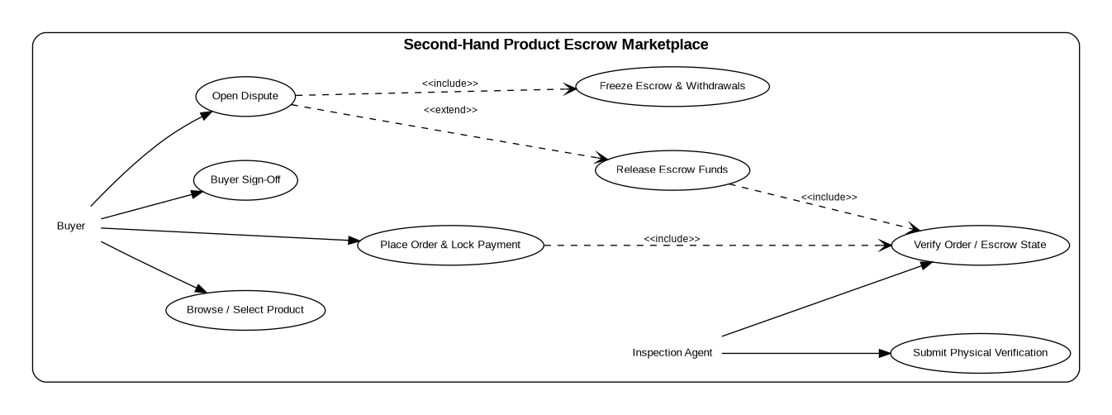
Relationship notes:
- Place Order & Lock Payment «include» Verify Order / Escrow State.
- Release Escrow Funds «include» Verify Order / Escrow State.
- Open Dispute «include» Freeze Escrow & Withdrawals.
- Open Dispute «extend» Release Escrow Funds, because a dispute condition interrupts/extends the normal release flow.

5. Use-Case Flow Specification — Release Escrow Funds
Core use case: Release Escrow Funds
Primary Actor | Buyer (with the system enforcing the escrow rules; inspection verification is supplied by the Inspection Agent).
Preconditions | 1. A valid order exists.  2. Buyer payment is locked in escrow.  3. The inspection agent has submitted physical verification sign-off.  4. The buyer has completed sign-off.  5. No active dispute is freezing the escrow.
Postconditions | 1. Escrow funds are released to the seller.  2. The order/escrow state is updated to “Released”.  3. The release event is recorded for auditability.
Main Success Scenario | 1. The system retrieves the order’s current escrow state.  2. The system verifies that buyer payment is locked in escrow.  3. The system verifies that the inspection agent has submitted physical verification sign-off.  4. The system verifies that the buyer has provided sign-off.  5. The system verifies that no active dispute is freezing the escrow.  6. The system releases the escrowed funds to the seller.  7. The system changes the order/escrow state to “Released”.  8. The system records the successful release.
Alternate Flow | A1. If an active dispute exists at Step 5, the system does not release the escrowed funds.  A2. The system freezes the escrow funds and prevents account withdrawals while the dispute is under investigation.  A3. The order remains in the dispute/investigation state until the dispute is resolved.  A4. After resolution, the system re-evaluates the release conditions before any funds are released.

6. Submission Checklist
- Exactly 5 Functional Requirements: FR-001 to FR-005.
- Exactly 2 Non-Functional Requirements: NFR-001 and NFR-002.
- Every requirement includes ID, Type/Priority as applicable, Description, Acceptance Criteria, and Rationale.
- UML use-case diagram includes all specified actors, primary use cases, at least one «include», and at least one «extend».
- One-page use-case flow specification includes Preconditions, Postconditions, Main Success Scenario, and one Alternate Flow.

Source note: The solution is derived from the uploaded Problem Statement #39 and keeps its core terminology and constraints.

