Author: Emanuel Ramirez Alsina

Date: 07/24/2020

Course: CS 290 – Summer Term 2020

**Project Proposal**

**Project Theme:**

The theme of my webpage will be based on the game Apex Legends, a free Battle Royale FPS shooter game for the Playstation, Xbox and PC. In particular, the website will be focused in retrieving player’s information. An external game API will be used to retrieve the requested data.

**Project Structure/Layout:**

The website will consist of a main webpage with general information and a carousel animation with featured player’s banners pictures. Will contain at least 3 subpages with different types of forms to send and received game information.

*Banner Example* (Some featured player’s will have their banners on the main page carousel animation):

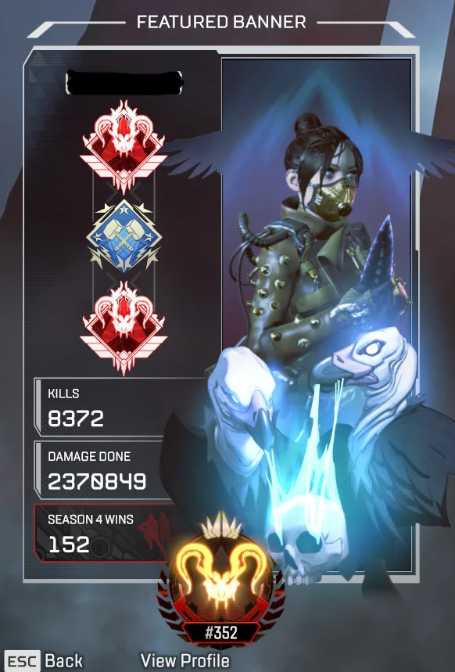

**Homepage Layout:**

|  |  |  |  |  |
| --- | --- | --- | --- | --- |
| Website Title   |  |  |  |  | | --- | --- | --- | --- | | Subpage 1 Subpage 2 Subpage 3 Subpage 4 (With current highligted)   |  | | --- | | Carousel Animation: Featured Banners |  |  | | --- | | GET Submissions: |  |  | | --- | | Footer with external Links | | |

**Subpages Layout:**

|  |  |  |  |
| --- | --- | --- | --- |
| Website Title   |  | | --- | | Subpage 1 Subpage 2 Subpage 3 Subpage 4 (With current highlighted) |  |  | | --- | | Current Subpage Information (Stats, Store items, Server Status etc.) |  |  | | --- | | Footer with external links | |