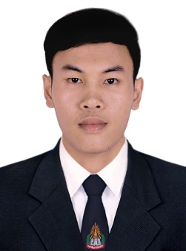
Mr. Hormphaeng HIENGPHOTHICHACK
Tanmixay village, Xaythany district, Vientiane capital, Lao PDR
Tel: 02056541699, 02076354760
GitHub: github.com/Hormphaeng
Email: hormphaengdev@gmail.com

About me
Hello! My name is Hormphaeng, I’m a final year student of the Faculty of Natural Science, Department of Computer Science, National University of Laos. I want to seek experience before graduation.
Education
- 2017 – 2021: University
Bachelor of computer science in faculty of natural science,
National University of Laos.
- 2016 – 2014: Senior High School
Saka Senior High School.
- 2010 – 2013: Junior High School
Napho Junior High School
- 2009 – 2005: Primary School
Napho Tai Primary School
Experiences
September – October 2020
Lao Social Security Organization nssf.gov.la
Internships - Information of Technology and IT Support.
Skills
Programming Languages
C#, VB.net, JavaScript (ES6), Dart.
Libraries & Frameworks
Node.js, Express, Flutter.
Databases
MySQL, MSSQL.
Language
Lao: Native language.
English: fair.

