Final Paper

Chou-Chun Wu

2021-12-08

## Load packages

# Add additional packages you need  
#library(psych)  
library(here) # makes reading data more consistent  
library(tidyverse) # for data manipulation and plotting  
library(haven) # for importing SPSS/SAS/Stata data  
library(lme4) # for multilevel analysis  
library(lattice) # for dotplot (working with lme4)  
library(sjPlot) # for plotting effects  
library(MuMIn) # for computing r-squared  
library(r2mlm) # for computing r-squared  
library(broom.mixed) # for summarizing results  
library(modelsummary) # for making tables  
library(dplyr)  
library(skimr)  
library(readxl)  
library(mediation)  
library(lmerTest)

## Import Data

Read data and define two variables of interest treated: patient in the treatment group (intervention group) and in the post period anysymptom: has any symptom using the Geriatric Depression Scale - Short Form (GDS-SF) Empowerment_Scale: Diabetes Empowerment Scale – Short Form (DES-SF) Activation_Measure: Patient Activation Measure (PAM-13)

mydata <- read_excel("MatchedData.xlsx")  
mydata$treated = mydata$treatment * mydata$post  
mydata$anysymptom = ifelse(mydata$Depression_Scale > 0, 1, 0)  
mydata$Empowerment_Scale = mydata$s9_1 +mydata$s9_2 +mydata$s9_3 +mydata$s9_4 +mydata$s9_5 +mydata$s9_6 +mydata$s9_7 +mydata$s9_8   
mydata$Activation_Measure = mydata$s10_1 +mydata$s10_2 +mydata$s10_3 +mydata$s10_4 +mydata$s10_5 +mydata$s10_6 +mydata$s10_7 +mydata$s10_8 +mydata$s10_9 +mydata$s10_10 +mydata$s10_11 +mydata$s10_12 +mydata$s10_13

## Intraclass Correlations (ICC)

1. Proportion of variance due to the higher (subclass) level
2. Average correlation between observations (patient) in the same cluster (subclass) s8q1: How many of the last SEVEN DAYS have you followed a healthful eating plan? s8q6: On how many of the last SEVEN DAYS did you participate in a specific exercise session (such as swimming, walking, biking) other than what you do around the house or as part of your work?  
   s8q7: On how many of the last SEVEN DAYS did you test your blood sugar? subclass: Matched pair label using MatchIt package with propensity score and nearest one to one matching (most similar patient in intervention group to control group)

ran_int <- lmer(s8q1 ~ 1 + (1 | subclass), data = mydata)  
summary(ran_int)

## Linear mixed model fit by REML. t-tests use Satterthwaite's method [  
## lmerModLmerTest]  
## Formula: s8q1 ~ 1 + (1 | subclass)  
## Data: mydata  
##   
## REML criterion at convergence: 2713.5  
##   
## Scaled residuals:   
## Min 1Q Median 3Q Max   
## -2.0561 -0.7077 0.3257 0.8257 1.1990   
##   
## Random effects:  
## Groups Name Variance Std.Dev.  
## subclass (Intercept) 0.410 0.6403   
## Residual 5.713 2.3903   
## Number of obs: 584, groups: subclass, 146  
##   
## Fixed effects:  
## Estimate Std. Error df t value Pr(>|t|)   
## (Intercept) 4.8185 0.1122 145.0000 42.94 <2e-16 ***  
## ---  
## Signif. codes: 0 '***' 0.001 '**' 0.01 '*' 0.05 '.' 0.1 ' ' 1

variance_components <- as.data.frame(VarCorr(ran_int))  
between_var <- variance_components$vcov[1]  
within_var <- variance_components$vcov[2]  
(icc <- between_var / (between_var + within_var))

## [1] 0.06695736

ran_int <- lmer(s8q6 ~ 1 + (1 | subclass), data = mydata)  
summary(ran_int)

## Linear mixed model fit by REML. t-tests use Satterthwaite's method [  
## lmerModLmerTest]  
## Formula: s8q6 ~ 1 + (1 | subclass)  
## Data: mydata  
##   
## REML criterion at convergence: 2747.2  
##   
## Scaled residuals:   
## Min 1Q Median 3Q Max   
## -1.9411 -0.7778 0.2120 0.8489 1.4490   
##   
## Random effects:  
## Groups Name Variance Std.Dev.  
## subclass (Intercept) 0.7929 0.8905   
## Residual 5.7814 2.4045   
## Number of obs: 584, groups: subclass, 146  
##   
## Fixed effects:  
## Estimate Std. Error df t value Pr(>|t|)   
## (Intercept) 4.3476 0.1238 145.0000 35.11 <2e-16 ***  
## ---  
## Signif. codes: 0 '***' 0.001 '**' 0.01 '*' 0.05 '.' 0.1 ' ' 1

variance_components <- as.data.frame(VarCorr(ran_int))  
between_var <- variance_components$vcov[1]  
within_var <- variance_components$vcov[2]  
(icc <- between_var / (between_var + within_var))

## [1] 0.1206068

ran_int <- lmer(s8q7 ~ 1 + (1 | subclass), data = mydata)  
summary(ran_int)

## Linear mixed model fit by REML. t-tests use Satterthwaite's method [  
## lmerModLmerTest]  
## Formula: s8q7 ~ 1 + (1 | subclass)  
## Data: mydata  
##   
## REML criterion at convergence: 2722.8  
##   
## Scaled residuals:   
## Min 1Q Median 3Q Max   
## -1.2967 -0.7441 -0.3392 0.4867 2.1061   
##   
## Random effects:  
## Groups Name Variance Std.Dev.  
## subclass (Intercept) 0.6298 0.7936   
## Residual 5.6393 2.3747   
## Number of obs: 584, groups: subclass, 146  
##   
## Fixed effects:  
## Estimate Std. Error df t value Pr(>|t|)   
## (Intercept) 2.1096 0.1182 145.0000 17.85 <2e-16 ***  
## ---  
## Signif. codes: 0 '***' 0.001 '**' 0.01 '*' 0.05 '.' 0.1 ' ' 1

variance_components <- as.data.frame(VarCorr(ran_int))  
between_var <- variance_components$vcov[1]  
within_var <- variance_components$vcov[2]  
(icc <- between_var / (between_var + within_var))

## [1] 0.1004635

## Test Random Slope

Since we used the matched data (with propensity score), we started with a simple model and tested random slope. Model equations: Lv-1:

$${\text{s8q7}}_{ij}=β_{0j}+e_{ij}$$

Lv-2:

$$β_{0j}=γ_{00}+γ_{01}{\text{treated}}_{j}+u_{0j}$$

# First, no random slopes  
m0 <- lmer(s8q1 ~ treated + (1| subclass), data = mydata)  
summary(m0)

## Linear mixed model fit by REML. t-tests use Satterthwaite's method [  
## lmerModLmerTest]  
## Formula: s8q1 ~ treated + (1 | subclass)  
## Data: mydata  
##   
## REML criterion at convergence: 2709.7  
##   
## Scaled residuals:   
## Min 1Q Median 3Q Max   
## -2.2264 -0.6560 0.2760 0.8317 1.1700   
##   
## Random effects:  
## Groups Name Variance Std.Dev.  
## subclass (Intercept) 0.4228 0.6503   
## Residual 5.6622 2.3795   
## Number of obs: 584, groups: subclass, 146  
##   
## Fixed effects:  
## Estimate Std. Error df t value Pr(>|t|)   
## (Intercept) 4.6918 0.1258 224.0868 37.298 <2e-16 ***  
## treated 0.5068 0.2274 437.0000 2.229 0.0263 *   
## ---  
## Signif. codes: 0 '***' 0.001 '**' 0.01 '*' 0.05 '.' 0.1 ' ' 1  
##   
## Correlation of Fixed Effects:  
## (Intr)  
## treated -0.452

# Then test random slopes   
m11 <- lmer(s8q1 ~ treated + (treated| subclass), data = mydata)

## boundary (singular) fit: see ?isSingular

summary(m11)

## Linear mixed model fit by REML. t-tests use Satterthwaite's method [  
## lmerModLmerTest]  
## Formula: s8q1 ~ treated + (treated | subclass)  
## Data: mydata  
##   
## REML criterion at convergence: 2703.8  
##   
## Scaled residuals:   
## Min 1Q Median 3Q Max   
## -2.2533 -0.5918 0.3234 0.7684 1.3375   
##   
## Random effects:  
## Groups Name Variance Std.Dev. Corr   
## subclass (Intercept) 0.9127 0.9554   
## treated 0.8222 0.9068 -1.00  
## Residual 5.4008 2.3240   
## Number of obs: 584, groups: subclass, 146  
##   
## Fixed effects:  
## Estimate Std. Error df t value Pr(>|t|)   
## (Intercept) 4.6918 0.1363 145.0361 34.418 <2e-16 ***  
## treated 0.5068 0.2344 247.9910 2.162 0.0316 *   
## ---  
## Signif. codes: 0 '***' 0.001 '**' 0.01 '*' 0.05 '.' 0.1 ' ' 1  
##   
## Correlation of Fixed Effects:  
## (Intr)  
## treated -0.572  
## optimizer (nloptwrap) convergence code: 0 (OK)  
## boundary (singular) fit: see ?isSingular

ranova(m11) #

## ANOVA-like table for random-effects: Single term deletions  
##   
## Model:  
## s8q1 ~ treated + (treated | subclass)  
## npar logLik AIC LRT Df Pr(>Chisq)   
## <none> 6 -1351.9 2715.8   
## treated in (treated | subclass) 4 -1354.8 2717.7 5.8981 2 0.05239 .  
## ---  
## Signif. codes: 0 '***' 0.001 '**' 0.01 '*' 0.05 '.' 0.1 ' ' 1

It is statistically significant at 0.05 alpha level after we divided the p-value by 2.

# First, no random slopes  
m0 <- lmer(s8q6 ~ treated + (1| subclass), data = mydata)  
summary(m0)

## Linear mixed model fit by REML. t-tests use Satterthwaite's method [  
## lmerModLmerTest]  
## Formula: s8q6 ~ treated + (1 | subclass)  
## Data: mydata  
##   
## REML criterion at convergence: 2746.8  
##   
## Scaled residuals:   
## Min 1Q Median 3Q Max   
## -1.9129 -0.7481 0.2329 0.8524 1.4434   
##   
## Random effects:  
## Groups Name Variance Std.Dev.  
## subclass (Intercept) 0.7947 0.8915   
## Residual 5.7742 2.4030   
## Number of obs: 584, groups: subclass, 146  
##   
## Fixed effects:  
## Estimate Std. Error df t value Pr(>|t|)   
## (Intercept) 4.2763 0.1365 210.8135 31.333 <2e-16 ***  
## treated 0.2854 0.2296 437.0000 1.243 0.215   
## ---  
## Signif. codes: 0 '***' 0.001 '**' 0.01 '*' 0.05 '.' 0.1 ' ' 1  
##   
## Correlation of Fixed Effects:  
## (Intr)  
## treated -0.421

# Then test random slopes   
m16 <- lmer(s8q6 ~ treated + (treated| subclass), data = mydata)

## boundary (singular) fit: see ?isSingular

summary(m16)

## Linear mixed model fit by REML. t-tests use Satterthwaite's method [  
## lmerModLmerTest]  
## Formula: s8q6 ~ treated + (treated | subclass)  
## Data: mydata  
##   
## REML criterion at convergence: 2742.6  
##   
## Scaled residuals:   
## Min 1Q Median 3Q Max   
## -1.9521 -0.7606 0.1981 0.8074 1.4927   
##   
## Random effects:  
## Groups Name Variance Std.Dev. Corr   
## subclass (Intercept) 1.1976 1.0944   
## treated 0.4707 0.6861 -1.00  
## Residual 5.6295 2.3727   
## Number of obs: 584, groups: subclass, 146  
##   
## Fixed effects:  
## Estimate Std. Error df t value Pr(>|t|)   
## (Intercept) 4.2763 0.1451 146.5408 29.470 <2e-16 ***  
## treated 0.2854 0.2337 310.8911 1.221 0.223   
## ---  
## Signif. codes: 0 '***' 0.001 '**' 0.01 '*' 0.05 '.' 0.1 ' ' 1  
##   
## Correlation of Fixed Effects:  
## (Intr)  
## treated -0.531  
## optimizer (nloptwrap) convergence code: 0 (OK)  
## boundary (singular) fit: see ?isSingular

ranova(m16) #

## ANOVA-like table for random-effects: Single term deletions  
##   
## Model:  
## s8q6 ~ treated + (treated | subclass)  
## npar logLik AIC LRT Df Pr(>Chisq)  
## <none> 6 -1371.3 2754.6   
## treated in (treated | subclass) 4 -1373.4 2754.8 4.1944 2 0.1228

It is not statistically significant at 0.05 alpha level (on the boundary (0.0614) after we divided the p-value by 2).

# First, no random slopes  
m0 <- lmer(s8q7 ~ treated + (1| subclass), data = mydata)  
summary(m0)

## Linear mixed model fit by REML. t-tests use Satterthwaite's method [  
## lmerModLmerTest]  
## Formula: s8q7 ~ treated + (1 | subclass)  
## Data: mydata  
##   
## REML criterion at convergence: 2700.9  
##   
## Scaled residuals:   
## Min 1Q Median 3Q Max   
## -1.6882 -0.7045 -0.3819 0.4678 2.2817   
##   
## Random effects:  
## Groups Name Variance Std.Dev.  
## subclass (Intercept) 0.6993 0.8363   
## Residual 5.3612 2.3154   
## Number of obs: 584, groups: subclass, 146  
##   
## Fixed effects:  
## Estimate Std. Error df t value Pr(>|t|)   
## (Intercept) 1.8402 0.1305 212.1027 14.10 < 2e-16 ***  
## treated 1.0776 0.2213 437.0000 4.87 1.56e-06 ***  
## ---  
## Signif. codes: 0 '***' 0.001 '**' 0.01 '*' 0.05 '.' 0.1 ' ' 1  
##   
## Correlation of Fixed Effects:  
## (Intr)  
## treated -0.424

# Then test random slopes   
m17 <- lmer(s8q7 ~ treated + (treated| subclass), data = mydata)  
summary(m17)

## Linear mixed model fit by REML. t-tests use Satterthwaite's method [  
## lmerModLmerTest]  
## Formula: s8q7 ~ treated + (treated | subclass)  
## Data: mydata  
##   
## REML criterion at convergence: 2697.1  
##   
## Scaled residuals:   
## Min 1Q Median 3Q Max   
## -1.3854 -0.6425 -0.3310 0.4679 2.3083   
##   
## Random effects:  
## Groups Name Variance Std.Dev. Corr   
## subclass (Intercept) 0.9923 0.9962   
## treated 2.0386 1.4278 -0.41  
## Residual 4.8539 2.2032   
## Number of obs: 584, groups: subclass, 146  
##   
## Fixed effects:  
## Estimate Std. Error df t value Pr(>|t|)   
## (Intercept) 1.8402 0.1337 145.0005 13.762 < 2e-16 ***  
## treated 1.0776 0.2414 144.9996 4.463 1.61e-05 ***  
## ---  
## Signif. codes: 0 '***' 0.001 '**' 0.01 '*' 0.05 '.' 0.1 ' ' 1  
##   
## Correlation of Fixed Effects:  
## (Intr)  
## treated -0.468

ranova(m17) #

## ANOVA-like table for random-effects: Single term deletions  
##   
## Model:  
## s8q7 ~ treated + (treated | subclass)  
## npar logLik AIC LRT Df Pr(>Chisq)  
## <none> 6 -1348.5 2709.1   
## treated in (treated | subclass) 4 -1350.4 2708.9 3.786 2 0.1506

It is not statistically significant at 0.05 alpha level (on the boundary (0.075) after we divided the p-value by 2).

## Association between Receiving Digital Intervention and Weekly Number of healthful eating plan

# Plot first 10 items  
sjPlot::plot_model(m11, type = "pred", terms = "treated",   
 show.data = TRUE, title = "",   
 dot.size = 0.5) +   
 # Add the group means  
 stat_summary(data = mydata, aes(x = treated, y = s8q1),   
 fun = mean, geom = "point",  
 col = "red",  
 shape = 17,  
 # use triangles  
 size = 3,   
 alpha = 0.7)

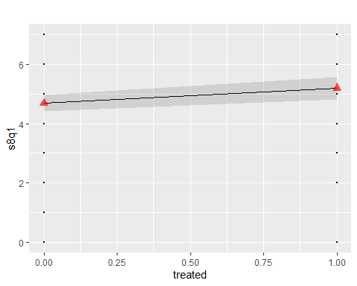 This plots shows that receiving digital intervention would increase number of times following healthful eating plans among older adults in Taiwan.

## Association between Receiving Digital Intervention and Weekly Number of exercise events

# Plot first 10 items  
sjPlot::plot_model(m16, type = "pred", terms = "treated",   
 show.data = TRUE, title = "",   
 dot.size = 0.5) +   
 # Add the group means  
 stat_summary(data = mydata, aes(x = treated, y = s8q6),   
 fun = mean, geom = "point",  
 col = "red",  
 shape = 17,  
 # use triangles  
 size = 3,   
 alpha = 0.7)

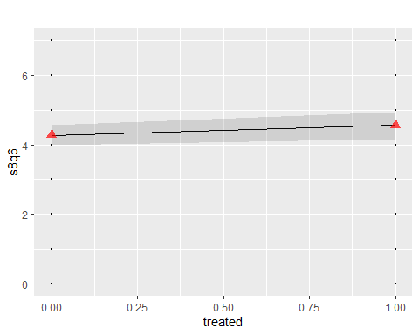 This plots shows that receiving digital intervention would increase number of exercise events among older adults in Taiwan.

## Association between Receiving Digital Intervention and Weekly Number of Blood Sugar Testing

# Plot first 10 items  
sjPlot::plot_model(m17, type = "pred", terms = "treated",   
 show.data = TRUE, title = "",   
 dot.size = 0.5) +   
 # Add the group means  
 stat_summary(data = mydata, aes(x = treated, y = s8q7),   
 fun = mean, geom = "point",  
 col = "red",  
 shape = 17,  
 # use triangles  
 size = 3,   
 alpha = 0.7)

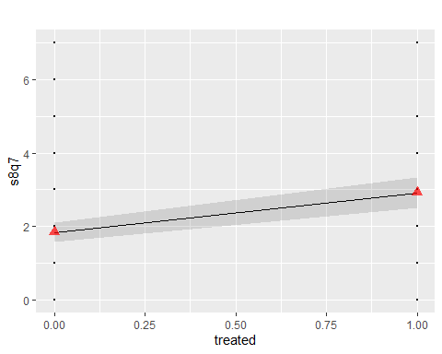 This plots shows that receiving digital intervention would increase number of blood sugar testing among older adults in Taiwan.

detach_package <- function(pkg, character.only = FALSE)  
{  
 if(!character.only)  
 {  
 pkg <- deparse(substitute(pkg))  
 }  
 search_item <- paste("package", pkg, sep = ":")  
 while(search_item %in% search())  
 {  
 detach(search_item, unload = TRUE, character.only = TRUE)  
 }  
}  
detach_package(lmerTest)

## Is Empowerment A Mediator for Diet?

fit.totaleffect <- lmer(s8q1 ~ treated+(treated| subclass), data = mydata)

## boundary (singular) fit: see ?isSingular

fit.mediator <- lmer(Empowerment_Scale ~treated+(treated| subclass), data = mydata)

## boundary (singular) fit: see ?isSingular

fit.dv <- lmer(s8q1 ~ Empowerment_Scale + treated+(treated| subclass), data = mydata)

## boundary (singular) fit: see ?isSingular

msummary(list("(1)" = fit.totaleffect,   
 "(2)" = fit.mediator,  
 "(3)" = fit.dv))

|  | (1) | (2) | (3) |
| --- | --- | --- | --- |
| (Intercept) | 4.692 | 31.470 | 0.667 |
|  | (0.136) | (0.173) | (0.840) |
| treated | 0.507 | 0.804 | 0.404 |
|  | (0.234) | (0.379) | (0.231) |
| sd__(Intercept) | 0.955 | 0.000 | 0.941 |
| cor__(Intercept).treated | -1.000 |  | -1.000 |
| sd__treated | 0.907 | 1.895 | 0.883 |
| sd__Observation | 2.324 | 3.613 | 2.279 |
| Empowerment_Scale |  |  | 0.128 |
|  |  |  | (0.026) |
| AIC | 2715.8 | 3205.0 | 2700.1 |
| BIC | 2742.0 | 3231.2 | 2730.7 |
| Log.Lik. | -1351.894 | -1596.509 | -1343.055 |
| REMLcrit | 2703.787 | 3193.018 | 2686.110 |

resultsE1 <- mediate(fit.mediator, fit.dv, treat='treated', mediator='Empowerment_Scale')  
summary(resultsE1)

##   
## Causal Mediation Analysis   
##   
## Quasi-Bayesian Confidence Intervals  
##   
## Mediator Groups: subclass   
##   
## Outcome Groups: subclass   
##   
## Output Based on Overall Averages Across Groups   
##   
## Estimate 95% CI Lower 95% CI Upper p-value   
## ACME 0.10043 -0.00495 0.22 0.064 .  
## ADE 0.40603 -0.06838 0.87 0.100 .  
## Total Effect 0.50646 0.02087 0.98 0.032 *  
## Prop. Mediated 0.18893 -0.03242 1.17 0.080 .  
## ---  
## Signif. codes: 0 '***' 0.001 '**' 0.01 '*' 0.05 '.' 0.1 ' ' 1  
##   
## Sample Size Used: 584   
##   
##   
## Simulations: 1000

plot(summary(resultsE1))

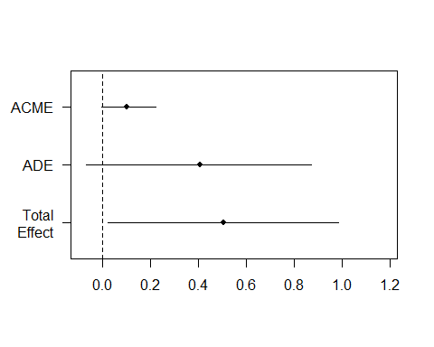

MuMIn::r.squaredGLMM(fit.totaleffect)

## Warning: 'r.squaredGLMM' now calculates a revised statistic. See the help page.

## R2m R2c  
## [1,] 0.007865893 0.1195593

MuMIn::r.squaredGLMM(fit.mediator)

## R2m R2c  
## [1,] 0.008621814 0.07242992

MuMIn::r.squaredGLMM(fit.dv)

## R2m R2c  
## [1,] 0.04496383 0.1533683

Since ACME and total effect are statistically significant (ADE is not), it shows that empowerment is a strong mediator.

## Is Empowerment A Mediator for Exercise?

fit.totaleffect <- lmer(s8q6 ~ treated+(treated| subclass), data = mydata)

## boundary (singular) fit: see ?isSingular

fit.mediator <- lmer(Empowerment_Scale ~treated+(treated| subclass), data = mydata)

## boundary (singular) fit: see ?isSingular

fit.dv <- lmer(s8q6 ~ Empowerment_Scale + treated+(treated| subclass), data = mydata)  
msummary(list("(1)" = fit.totaleffect,   
 "(2)" = fit.mediator,  
 "(3)" = fit.dv))

|  | (1) | (2) | (3) |
| --- | --- | --- | --- |
| (Intercept) | 4.276 | 31.470 | -0.112 |
|  | (0.145) | (0.173) | (0.867) |
| treated | 0.285 | 0.804 | 0.173 |
|  | (0.234) | (0.379) | (0.229) |
| sd__(Intercept) | 1.094 | 0.000 | 1.074 |
| cor__(Intercept).treated | -1.000 |  | -1.000 |
| sd__treated | 0.686 | 1.895 | 0.653 |
| sd__Observation | 2.373 | 3.613 | 2.321 |
| Empowerment_Scale |  |  | 0.139 |
|  |  |  | (0.027) |
| AIC | 2754.6 | 3205.0 | 2736.2 |
| BIC | 2780.8 | 3231.2 | 2766.8 |
| Log.Lik. | -1371.296 | -1596.509 | -1361.103 |
| REMLcrit | 2742.591 | 3193.018 | 2722.205 |

resultsE6 <- mediate(fit.mediator, fit.dv, treat='treated', mediator='Empowerment_Scale')  
summary(resultsE6)

##   
## Causal Mediation Analysis   
##   
## Quasi-Bayesian Confidence Intervals  
##   
## Mediator Groups: subclass   
##   
## Outcome Groups: subclass   
##   
## Output Based on Overall Averages Across Groups   
##   
## Estimate 95% CI Lower 95% CI Upper p-value   
## ACME 0.11048 -0.00297 0.25 0.054 .  
## ADE 0.17959 -0.28600 0.63 0.428   
## Total Effect 0.29007 -0.17230 0.74 0.224   
## Prop. Mediated 0.29745 -2.77974 2.87 0.266   
## ---  
## Signif. codes: 0 '***' 0.001 '**' 0.01 '*' 0.05 '.' 0.1 ' ' 1  
##   
## Sample Size Used: 584   
##   
##   
## Simulations: 1000

plot(summary(resultsE6))

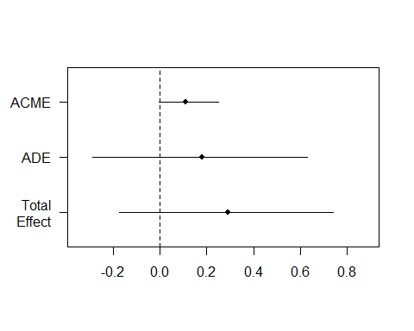

MuMIn::r.squaredGLMM(fit.totaleffect)

## R2m R2c  
## [1,] 0.002323169 0.1450625

MuMIn::r.squaredGLMM(fit.mediator)

## R2m R2c  
## [1,] 0.008621814 0.07242992

MuMIn::r.squaredGLMM(fit.dv)

## R2m R2c  
## [1,] 0.04343091 0.1816227

All effects are not statistically significant

## Is Empowerment A Mediator for Blood Sugar Testing?

fit.totaleffect <- lmer(s8q7 ~ treated+(treated| subclass), data = mydata)  
fit.mediator <- lmer(Empowerment_Scale ~treated+(treated| subclass), data = mydata)

## boundary (singular) fit: see ?isSingular

fit.dv <- lmer(s8q7 ~ Empowerment_Scale + treated+(treated| subclass), data = mydata)  
msummary(list("(1)" = fit.totaleffect,   
 "(2)" = fit.mediator,  
 "(3)" = fit.dv))

|  | (1) | (2) | (3) |
| --- | --- | --- | --- |
| (Intercept) | 1.840 | 31.470 | 0.250 |
|  | (0.134) | (0.173) | (0.854) |
| treated | 1.078 | 0.804 | 1.037 |
|  | (0.241) | (0.379) | (0.241) |
| sd__(Intercept) | 0.996 | 0.000 | 1.012 |
| cor__(Intercept).treated | -0.413 |  | -0.393 |
| sd__treated | 1.428 | 1.895 | 1.427 |
| sd__Observation | 2.203 | 3.613 | 2.191 |
| Empowerment_Scale |  |  | 0.051 |
|  |  |  | (0.027) |
| AIC | 2709.1 | 3205.0 | 2713.0 |
| BIC | 2735.3 | 3231.2 | 2743.6 |
| Log.Lik. | -1348.546 | -1596.509 | -1349.489 |
| REMLcrit | 2697.093 | 3193.018 | 2698.978 |

resultsE7 <- mediate(fit.mediator, fit.dv, treat='treated', mediator='Empowerment_Scale')  
summary(resultsE7)

##   
## Causal Mediation Analysis   
##   
## Quasi-Bayesian Confidence Intervals  
##   
## Mediator Groups: subclass   
##   
## Outcome Groups: subclass   
##   
## Output Based on Overall Averages Across Groups   
##   
## Estimate 95% CI Lower 95% CI Upper p-value   
## ACME 0.04113 -0.00498 0.12 0.12   
## ADE 1.04531 0.53727 1.58 <2e-16 ***  
## Total Effect 1.08644 0.58423 1.61 <2e-16 ***  
## Prop. Mediated 0.03304 -0.00423 0.12 0.12   
## ---  
## Signif. codes: 0 '***' 0.001 '**' 0.01 '*' 0.05 '.' 0.1 ' ' 1  
##   
## Sample Size Used: 584   
##   
##   
## Simulations: 1000

plot(summary(resultsE7))

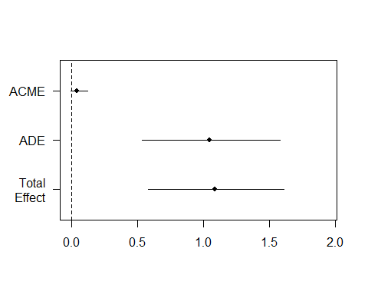

MuMIn::r.squaredGLMM(fit.totaleffect)

## R2m R2c  
## [1,] 0.03472923 0.2271352

MuMIn::r.squaredGLMM(fit.mediator)

## R2m R2c  
## [1,] 0.008621814 0.07242992

MuMIn::r.squaredGLMM(fit.dv)

## R2m R2c  
## [1,] 0.04024658 0.238327

Since ACME (average causal mediation effects) is not statistically significant, it shows that empowerment may not be a good mediator.

## Is Activation A Mediator for Diet?

fit.totaleffect <- lmer(s8q1 ~ treated+(treated| subclass), data = mydata)

## boundary (singular) fit: see ?isSingular

fit.mediator <- lmer(Activation_Measure ~treated+(treated| subclass), data = mydata)

## boundary (singular) fit: see ?isSingular

fit.dv <- lmer(s8q1 ~ Activation_Measure + treated+(treated| subclass), data = mydata)

## boundary (singular) fit: see ?isSingular

msummary(list("(1)" = fit.totaleffect,   
 "(2)" = fit.mediator,  
 "(3)" = fit.dv))

|  | (1) | (2) | (3) |
| --- | --- | --- | --- |
| (Intercept) | 4.692 | 42.909 | 1.180 |
|  | (0.136) | (0.287) | (0.744) |
| treated | 0.507 | 1.639 | 0.373 |
|  | (0.234) | (0.540) | (0.231) |
| sd__(Intercept) | 0.955 | 1.239 | 0.993 |
| cor__(Intercept).treated | -1.000 | 1.000 | -1.000 |
| sd__treated | 0.907 | 0.694 | 0.920 |
| sd__Observation | 2.324 | 5.618 | 2.269 |
| Activation_Measure |  |  | 0.082 |
|  |  |  | (0.017) |
| AIC | 2715.8 | 3717.8 | 2701.6 |
| BIC | 2742.0 | 3744.0 | 2732.2 |
| Log.Lik. | -1351.894 | -1852.903 | -1343.783 |
| REMLcrit | 2703.787 | 3705.806 | 2687.566 |

resultsA1 <- mediate(fit.mediator, fit.dv, treat='treated', mediator='Activation_Measure')  
summary(resultsA1)

##   
## Causal Mediation Analysis   
##   
## Quasi-Bayesian Confidence Intervals  
##   
## Mediator Groups: subclass   
##   
## Outcome Groups: subclass   
##   
## Output Based on Overall Averages Across Groups   
##   
## Estimate 95% CI Lower 95% CI Upper p-value   
## ACME 0.1344 0.0428 0.25 0.004 **  
## ADE 0.3790 -0.0701 0.85 0.110   
## Total Effect 0.5134 0.0513 0.99 0.024 *   
## Prop. Mediated 0.2550 0.0644 1.47 0.028 *   
## ---  
## Signif. codes: 0 '***' 0.001 '**' 0.01 '*' 0.05 '.' 0.1 ' ' 1  
##   
## Sample Size Used: 584   
##   
##   
## Simulations: 1000

plot(summary(resultsA1))

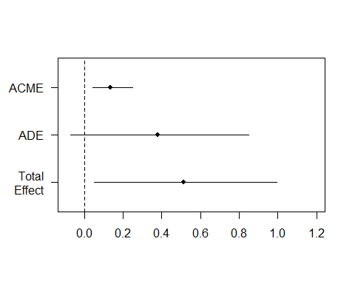

MuMIn::r.squaredGLMM(fit.totaleffect)

## R2m R2c  
## [1,] 0.007865893 0.1195593

MuMIn::r.squaredGLMM(fit.mediator)

## R2m R2c  
## [1,] 0.01477703 0.07586323

MuMIn::r.squaredGLMM(fit.dv)

## R2m R2c  
## [1,] 0.04435005 0.164614

Since ACME and total effect are statistically significant (ADE is not), it shows that activation is a strong mediator.

## Is Activation A Mediator for Exercise?

fit.totaleffect <- lmer(s8q6 ~ treated+(treated| subclass), data = mydata)

## boundary (singular) fit: see ?isSingular

fit.mediator <- lmer(Activation_Measure ~treated+(treated| subclass), data = mydata)

## boundary (singular) fit: see ?isSingular

fit.dv <- lmer(s8q6 ~ Activation_Measure + treated+(treated| subclass), data = mydata)

## boundary (singular) fit: see ?isSingular

msummary(list("(1)" = fit.totaleffect,   
 "(2)" = fit.mediator,  
 "(3)" = fit.dv))

|  | (1) | (2) | (3) |
| --- | --- | --- | --- |
| (Intercept) | 4.276 | 42.909 | 1.860 |
|  | (0.145) | (0.287) | (0.778) |
| treated | 0.285 | 1.639 | 0.193 |
|  | (0.234) | (0.540) | (0.233) |
| sd__(Intercept) | 1.094 | 1.239 | 1.127 |
| cor__(Intercept).treated | -1.000 | 1.000 | -1.000 |
| sd__treated | 0.686 | 0.694 | 0.703 |
| sd__Observation | 2.373 | 5.618 | 2.345 |
| Activation_Measure |  |  | 0.056 |
|  |  |  | (0.018) |
| AIC | 2754.6 | 3717.8 | 2753.0 |
| BIC | 2780.8 | 3744.0 | 2783.5 |
| Log.Lik. | -1371.296 | -1852.903 | -1369.478 |
| REMLcrit | 2742.591 | 3705.806 | 2738.957 |

resultsA6 <- mediate(fit.mediator, fit.dv, treat='treated', mediator='Activation_Measure')  
summary(resultsA6)

##   
## Causal Mediation Analysis   
##   
## Quasi-Bayesian Confidence Intervals  
##   
## Mediator Groups: subclass   
##   
## Outcome Groups: subclass   
##   
## Output Based on Overall Averages Across Groups   
##   
## Estimate 95% CI Lower 95% CI Upper p-value   
## ACME 0.0936 0.0198 0.19 0.002 **  
## ADE 0.2025 -0.2677 0.68 0.398   
## Total Effect 0.2962 -0.1745 0.77 0.220   
## Prop. Mediated 0.2504 -2.6772 2.35 0.222   
## ---  
## Signif. codes: 0 '***' 0.001 '**' 0.01 '*' 0.05 '.' 0.1 ' ' 1  
##   
## Sample Size Used: 584   
##   
##   
## Simulations: 1000

plot(summary(resultsA6))

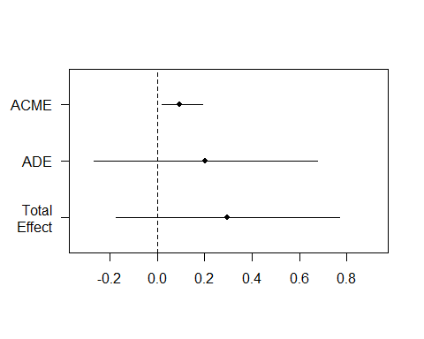

MuMIn::r.squaredGLMM(fit.totaleffect)

## R2m R2c  
## [1,] 0.002323169 0.1450625

MuMIn::r.squaredGLMM(fit.mediator)

## R2m R2c  
## [1,] 0.01477703 0.07586323

MuMIn::r.squaredGLMM(fit.dv)

## R2m R2c  
## [1,] 0.01840197 0.1691993

While the total effect is not statistically significant, the ACME is indeed statistically significant. It shows that activation mediates the intervention effect.

## Is Activation A Mediator for Blood Sugar Testing?

fit.totaleffect <- lmer(s8q7 ~ treated+(treated| subclass), data = mydata)  
fit.mediator <- lmer(Activation_Measure ~treated+(treated| subclass), data = mydata)

## boundary (singular) fit: see ?isSingular

fit.dv <- lmer(s8q7 ~ Activation_Measure + treated+(treated| subclass), data = mydata)  
msummary(list("(1)" = fit.totaleffect,   
 "(2)" = fit.mediator,  
 "(3)" = fit.dv))

|  | (1) | (2) | (3) |
| --- | --- | --- | --- |
| (Intercept) | 1.840 | 42.909 | -0.723 |
|  | (0.134) | (0.287) | (0.747) |
| treated | 1.078 | 1.639 | 0.980 |
|  | (0.241) | (0.540) | (0.235) |
| sd__(Intercept) | 0.996 | 1.239 | 1.025 |
| cor__(Intercept).treated | -0.413 | 1.000 | -0.336 |
| sd__treated | 1.428 | 0.694 | 1.255 |
| sd__Observation | 2.203 | 5.618 | 2.181 |
| Activation_Measure |  |  | 0.060 |
|  |  |  | (0.017) |
| AIC | 2709.1 | 3717.8 | 2705.8 |
| BIC | 2735.3 | 3744.0 | 2736.4 |
| Log.Lik. | -1348.546 | -1852.903 | -1345.894 |
| REMLcrit | 2697.093 | 3705.806 | 2691.788 |

resultsA7 <- mediate(fit.mediator, fit.dv, treat='treated', mediator='Activation_Measure')  
summary(resultsA7)

##   
## Causal Mediation Analysis   
##   
## Quasi-Bayesian Confidence Intervals  
##   
## Mediator Groups: subclass   
##   
## Outcome Groups: subclass   
##   
## Output Based on Overall Averages Across Groups   
##   
## Estimate 95% CI Lower 95% CI Upper p-value   
## ACME 0.0999 0.0297 0.19 0.002 **   
## ADE 0.9869 0.4948 1.49 <2e-16 ***  
## Total Effect 1.0867 0.5929 1.58 <2e-16 ***  
## Prop. Mediated 0.0906 0.0265 0.21 0.002 **   
## ---  
## Signif. codes: 0 '***' 0.001 '**' 0.01 '*' 0.05 '.' 0.1 ' ' 1  
##   
## Sample Size Used: 584   
##   
##   
## Simulations: 1000

plot(summary(resultsA7))

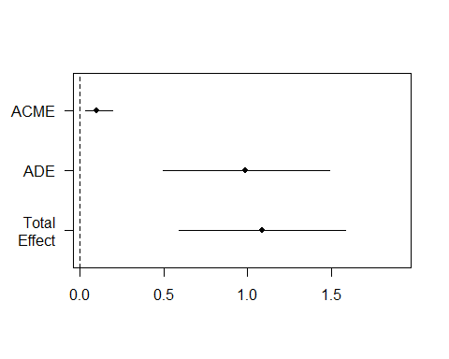

MuMIn::r.squaredGLMM(fit.totaleffect)

## R2m R2c  
## [1,] 0.03472923 0.2271352

MuMIn::r.squaredGLMM(fit.mediator)

## R2m R2c  
## [1,] 0.01477703 0.07586323

MuMIn::r.squaredGLMM(fit.dv)

## R2m R2c  
## [1,] 0.05344931 0.2478267

Since ACME (average causal mediation effects) is statistically significant, it shows that activation is a possible mediator.