
BRAND IDENTITY GUIDELINES
The way in, and the way up.
The visual and verbal identity of Gate79: logo suite, colour, typography, imagery and the website system.

BRAND | EDITION | SIGNATURE
Gate79 | 02 · October 2026 | Marketplace growth agency
Created by Choudary Hussain Ali · Founder, Devoid Solutions

CONTENTS
01 Essence | Who we are, personality and tone of voice
02 Logo | The logo suite, clear space, minimum size and misuse
03 Colour | The palette, colour balance and accessible pairings
04 Typography | Typefaces and the type scale
05 Imagery | Photography, treatment and data
06 Website | Layout, title highlight, components, icons and motion
07 Assets | The brand board and logo files
ABOUT THIS DOCUMENT
How Gate79 looks and sounds everywhere: website, proposals, reports, social and print. Edition 02 matches the live website. If something isn’t covered, choose more space, fewer colours and the supplied artwork.

01 — ESSENCE

Who we are
A marketplace growth agency for brands on Amazon. One accountable team for listings, creative, advertising, operations and analytics, judged by the sales it earns.
“A gate is a way in. Seventy-nine is our standard. We open the door to Amazon, then keep every metric pointing up.”
MISSION | PROMISE
To give ambitious brands a clear, measurable path to growth on Amazon and on the marketplaces that come next. | Senior people, plain reporting and work you can see. Every month you know what we did, what it earned and what comes next.

Brand personality
Precise | Data-led and exact. Numbers before adjectives, evidence before opinion.
Assured | The calm confidence of people who have done this before. No hype, no pressure.
Ambitious | Always pointing up and to the right, like the arrows in the mark.
Open | Transparent reporting in plain English. Clients always know where they stand.

Tone of voice
Like a senior consultant talking to a founder: clear, specific, calm.
HOW WE SOUND | HOW WE NEVER SOUND
“Your ad spend fell 22% while sales held. Here is what changed, and the two tests we run next.” | “10X YOUR SALES OVERNIGHT!!! Guaranteed #1 ranking!”
Lead with the result, then the reason. Use real numbers, dates and names. Short sentences, plain words, sentence case. | No shouting or exclamation marks. No guaranteed rankings or results. No jargon or empty superlatives.

Writing rules
Numbers | Use figures, not words: 12 brands, 4.5 stars, 30 days. Show % and currency symbols.
Amazon terms | Write them as sellers know them (ACoS, TACoS, Buy Box, A+ Content) and explain on first use.
Independence | Never imply we are Amazon or endorsed by Amazon. Never use Amazon logos or colours.
The name | Always “Gate79”: one word, capital G, no space. Never “Gate 79”, “GATE79” in running text or “G79”.
Calls to action | Short and specific: “Book a growth audit”, “See the case study”. Never “Click here”.

02 — LOGO

The mark
A gateway arch, two rising arrows and the 79 at its heart. Always use the supplied files. Never redraw it.
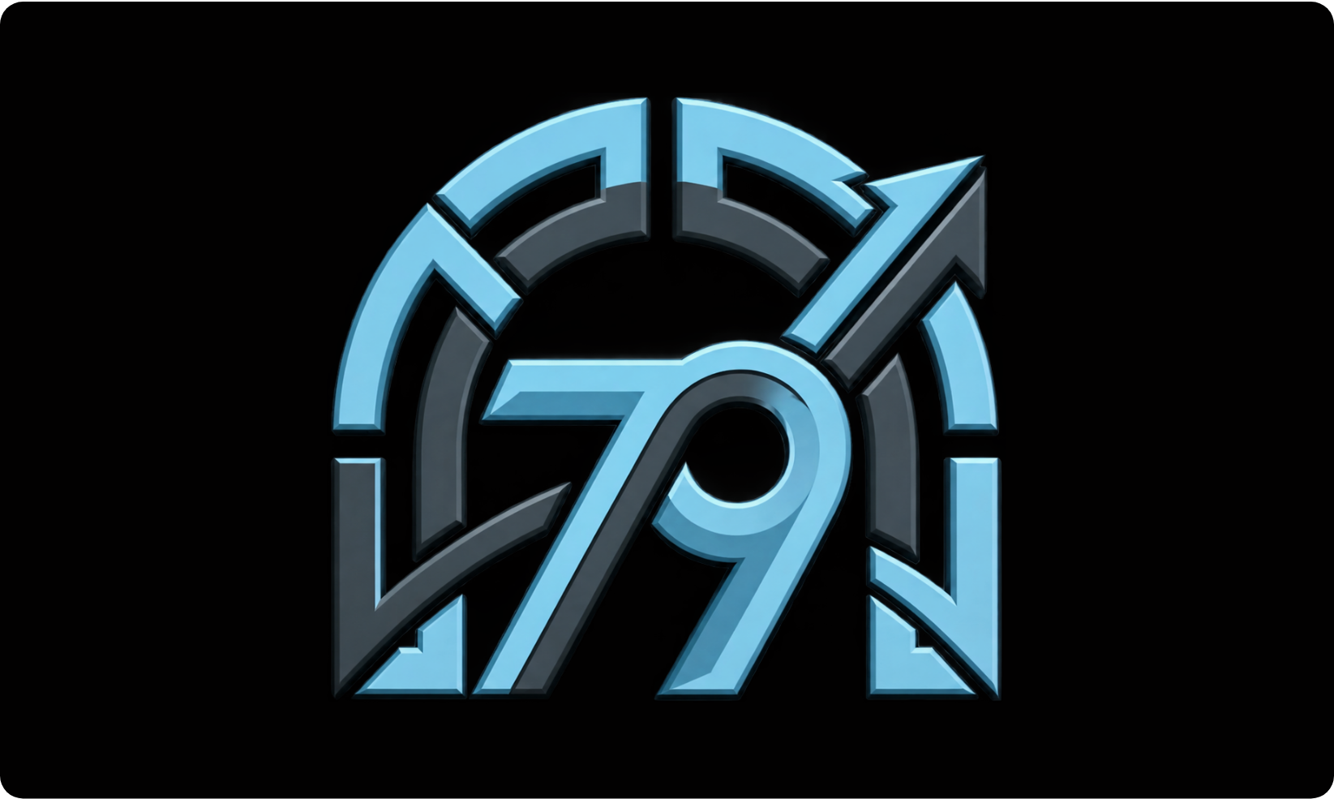
1 The gate | The outer arch is a gateway: we bring brands into Amazon and through to growth.
2 The layers | Two rings of segments in Ice and Graphite: the disciplines we run together.
3 The arrows | Two arrows break out of the arch, up and to the right: growth that keeps going.
4 The 79 | The name, and the standard we hold ourselves to.

The logo suite
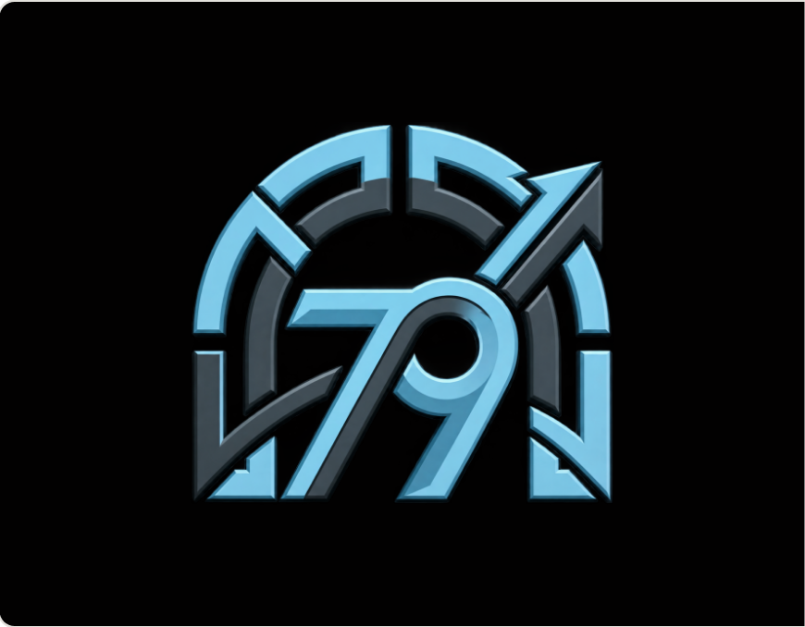 | The mark  Master. Social avatars, covers, signage, anywhere the mark stands alone.  gate79-mark.png
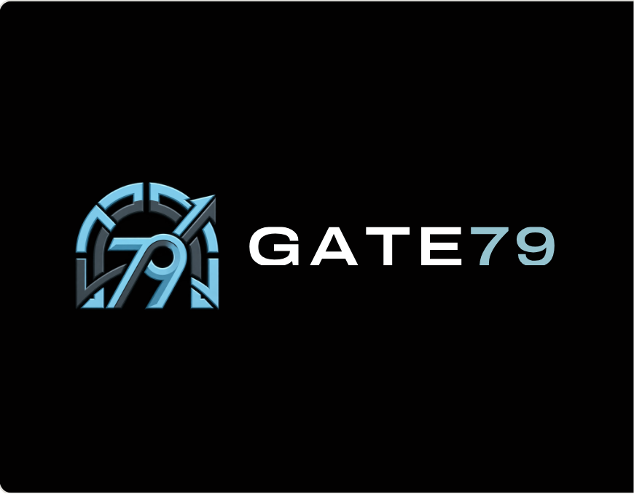 | Horizontal logo  Email signatures, invoices, report headers.  gate79-horizontal-on-dark.png · -on-light.png
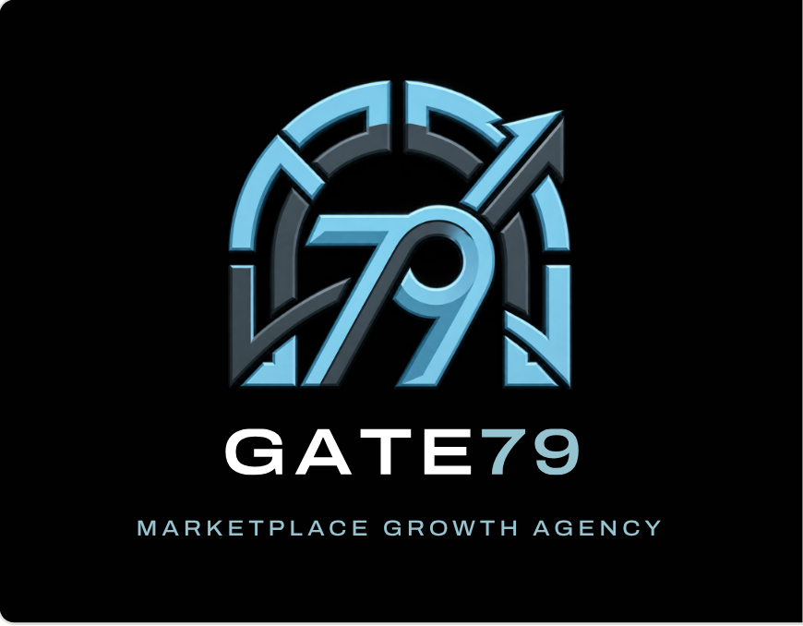 | Stacked logo  Proposals, about pages, covers and print.  gate79-stacked-on-dark.png
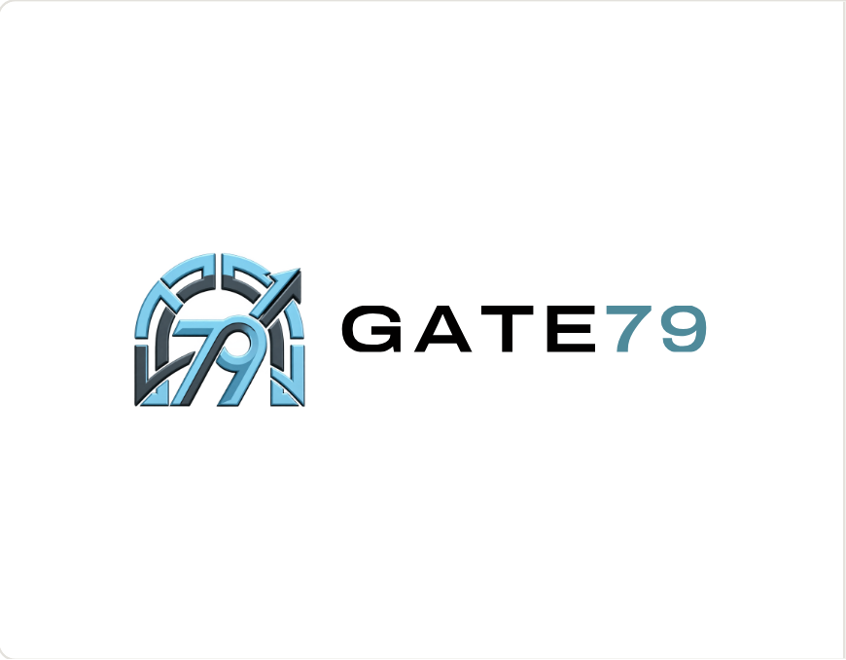 | On White  Only the wordmark switches to Black, with 79 in Ice Deep.  gate79-horizontal-on-light.png
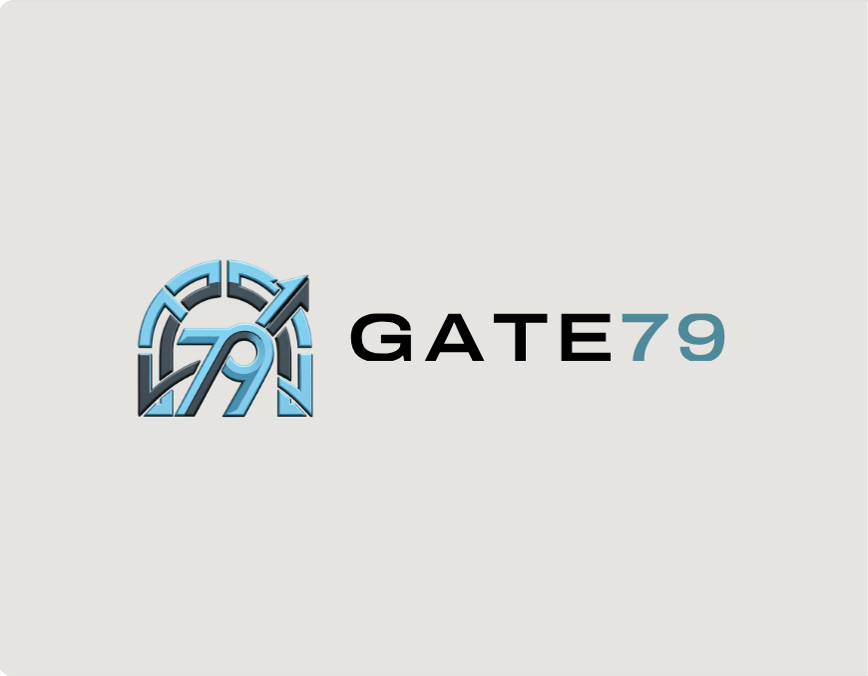 | On Stone  The light version on Stone. Keep the ground flat.  gate79-horizontal-on-light.png
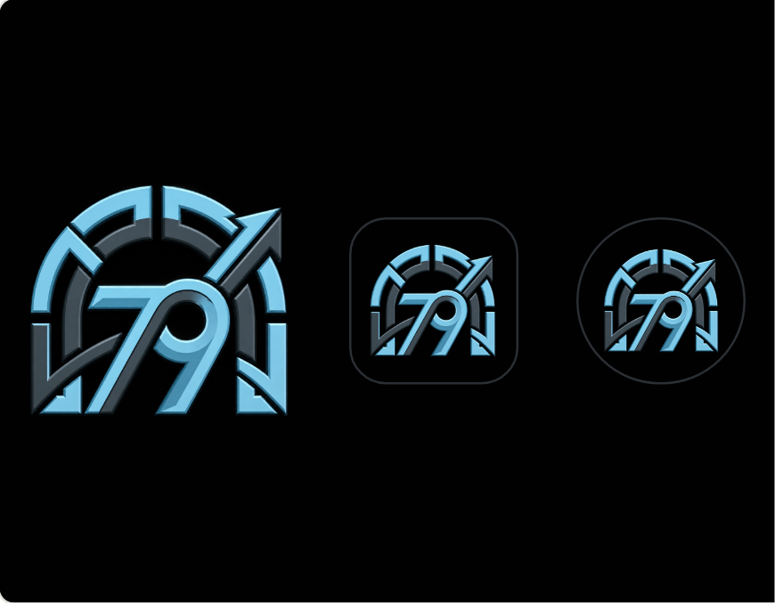 | Avatar and app icon  The mark centred on Black, with clear space all round.  gate79-app-icon.png · gate79-avatar.png · favicon

Clear space
Keep x (a quarter of the mark’s height) clear on every side.
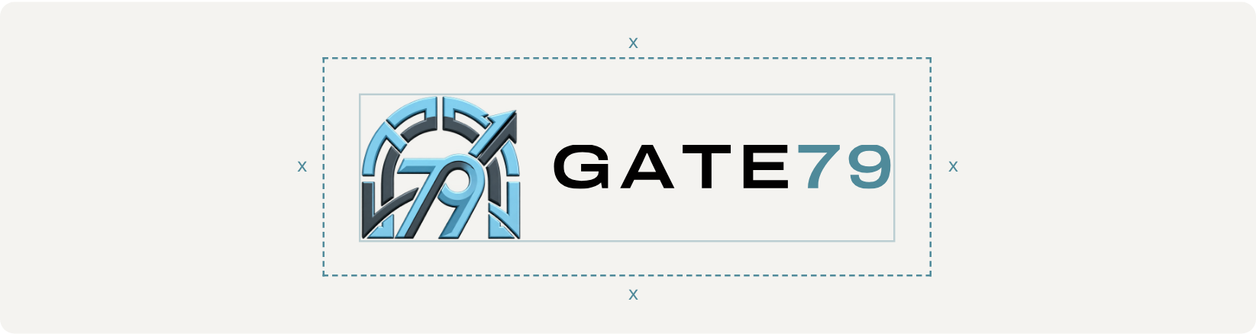

Minimum size
Never smaller than these sizes.
VERSION | USE FOR | DIGITAL | PRINT
Mark | Avatars, covers, signage | 64 px tall | 18 mm tall
Horizontal logo | Headers, signatures | 32 px tall | 9 mm tall
Stacked logo | Covers, print | 120 px tall | 30 mm tall
App icon / favicon | Browser tabs, home screens | 32 px | Not for print
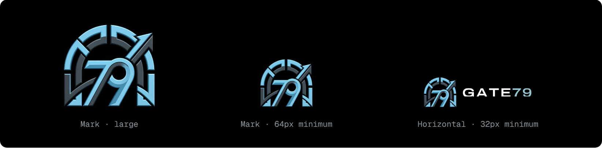

Logo don’ts
Use the supplied files as they are.
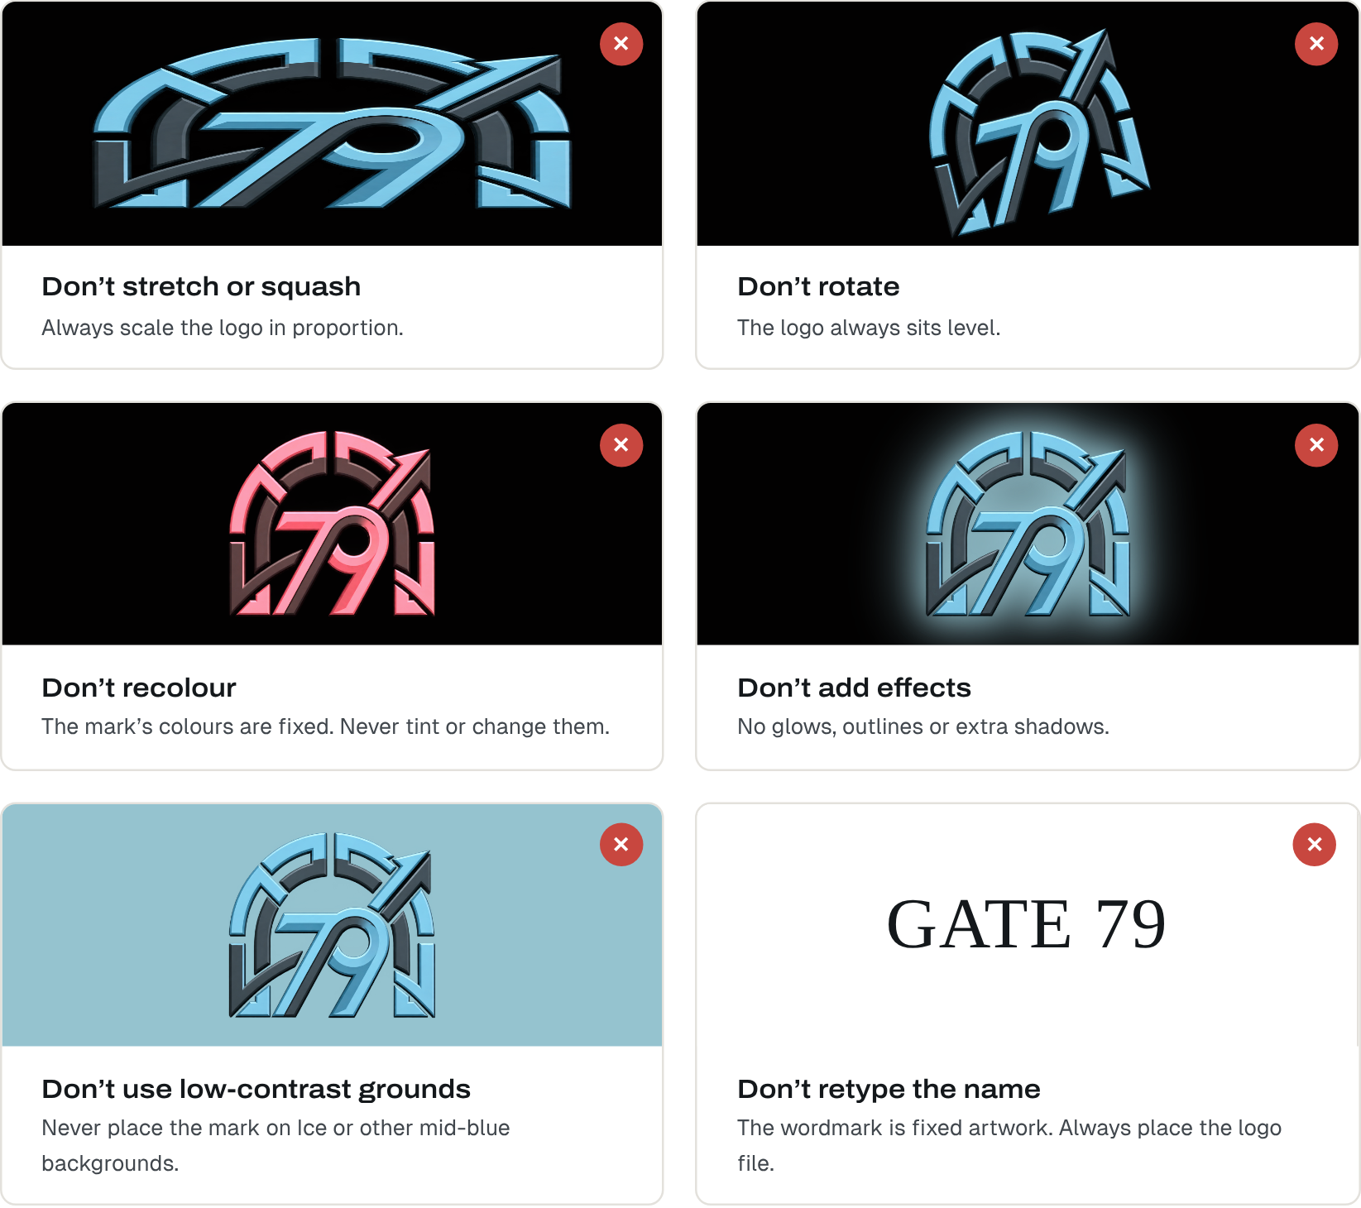
- Don’t stretch, squash or rotate.
- Don’t recolour or add glows, outlines or shadows.
- Don’t place the mark on Ice or other mid-blue grounds.
- Don’t retype the name: always place the logo file.

03 — COLOUR

White, Ice and Black
Four core colours, two support tones, two interface tones. White breathes, Ice energises, Black adds depth.
COLOUR | HEX | RGB | ROLE
Black | #020101 | 2 · 1 · 1 | 25%. Header, CTA and dark cards, footer frame. Text on White, Stone and Ice.
Ice | #95C3CF | 149 · 195 · 207 | 35%. Section bands, footer panel, primary buttons, title highlight.
Stone | #E6E4E0 | 230 · 228 · 224 | Part of the 40%. Hero frame, alternate bands, navigation pill.
White | #FFFFFF | 255 · 255 · 255 | 40% with Stone. Pages, cards, long reading. Text on Black.
Graphite | #5B6168 | 91 · 97 · 104 | Secondary text on light grounds, chart gridlines.
Ice Deep | #4F8A9A | 79 · 138 · 154 | Ice on light grounds: eyebrows, metrics, links, the 79. Highlight stroke on Black.
Carbon | #111416 | 17 · 20 · 22 | Dark service cards, menus, inputs.
Line | #2A2F34 | 42 · 47 · 52 | Borders on dark surfaces.

Colour balance
White and Stone 40%, Ice 35%, Black 25%. The logo never sits on Ice.

Accessible pairings
WCAG 2.2: 4.5 : 1 for body text, 3 : 1 for large text and icons. Ice Deep is Ice darkened to read on White and Stone.
PAIRING | SAMPLE | CONTRAST | RESULT
White on Black | Aa Sample | 20.8 : 1 | AAA · all text
Ice on Black | Aa Sample | 10.9 : 1 | AAA · headlines, links, numbers
Black on Ice | Aa Sample | 10.9 : 1 | AAA · buttons, text on Ice bands
Black on Stone | Aa Sample | 16.4 : 1 | AAA · all text
Ice Deep on White | Aa Sample | 3.9 : 1 | AA large · links, large text
White on Ice Deep | Aa Sample | 3.9 : 1 | AA large · highlighted title words only
Graphite on White | Aa Sample | 6.3 : 1 | AA · ledes and secondary text
White on Ice | Aa Sample | 1.9 : 1 | Fail · never use
Ice on White | Aa Sample | 1.9 : 1 | Fail · never use

04 — TYPOGRAPHY

Sharp, wide and calm
Archivo for headlines, Geist for reading, Geist Mono for data. All free Google Fonts.
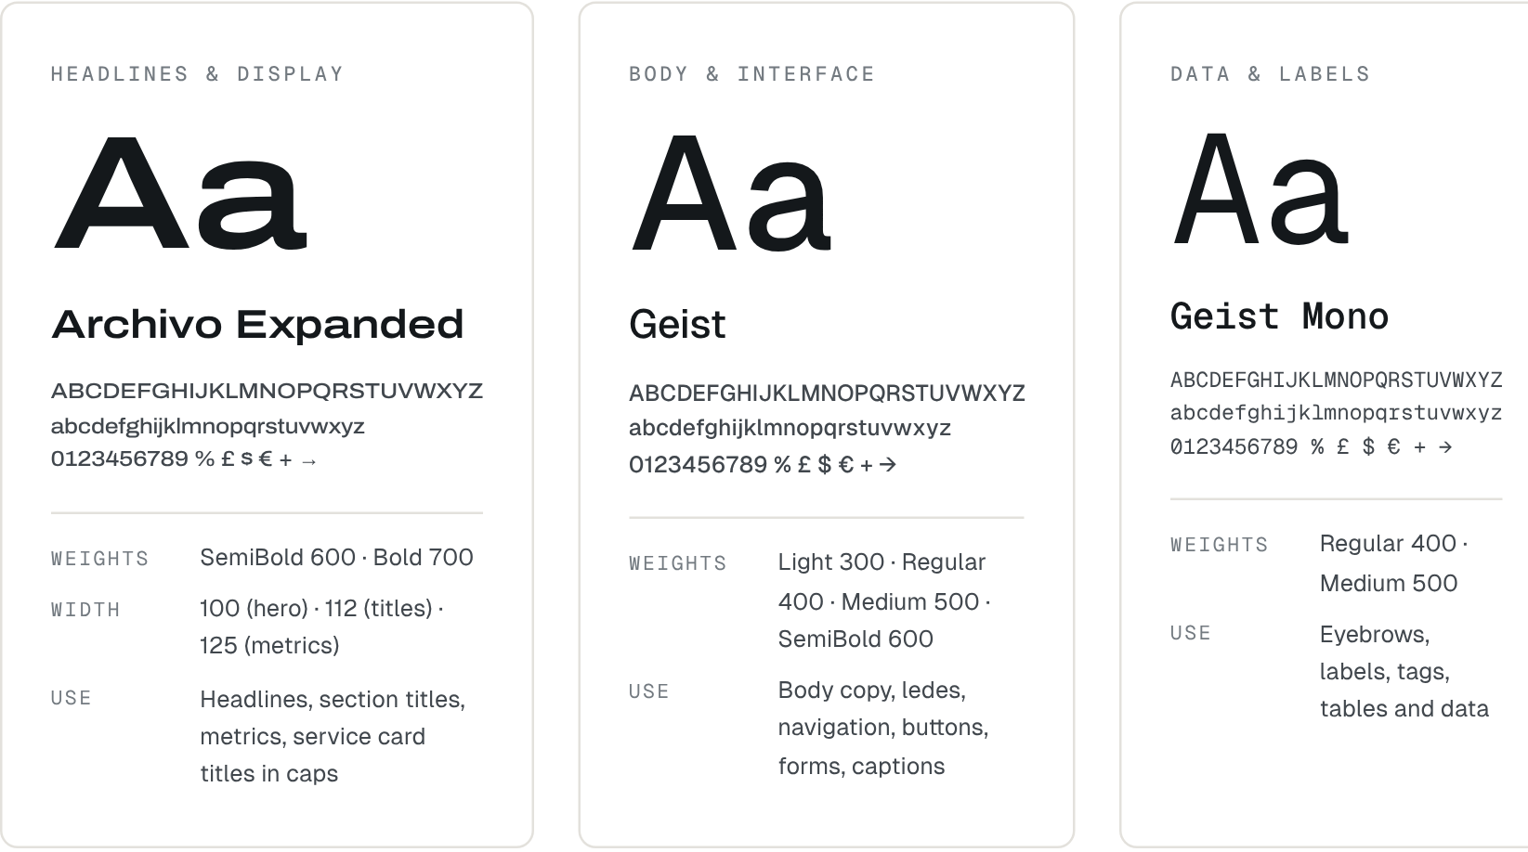
TYPEFACE | WEIGHTS | USE
Archivo (Expanded) | SemiBold 600 · Bold 700 · width 100 / 112 / 125 | Headlines, section titles, metrics, service card titles in caps
Geist | Light 300 · Regular 400 · Medium 500 · SemiBold 600 | Body copy, ledes, navigation, buttons, forms, captions
Geist Mono | Regular 400 · Medium 500 | Eyebrows, labels, tags, tables and data
Why: the wordmark is drawn from Archivo, so headlines and logo speak with one voice. In Microsoft Office, where these fonts may not be installed, use Arial for body text and Arial Black for headlines.

Type scale
As used on the live site. Sizes scale from mobile to desktop.
ROLE | SPECIFICATION
Display | Archivo 600 · width 100 · 40–112 px · line 0.98 · −3%
Section title | Archivo 700 · width 112 · 30–44 px · line 1.12 · −1.5%
Card title | Archivo 700 · width 100 · 20 px · caps · +8%
Heading 3 | Geist 600 · 18–20 px · line 1.3
Body and lede | Geist 400 · 16–17 px · line 1.6
Eyebrow | Geist Mono 500 · 12 px · caps · +14% · 24 px rule before
Metric | Archivo 600 · width 125 · 28–44 px · tabular figures
Button | Geist 600 · 15 px · pill · 48 px tall (56 px in the hero)
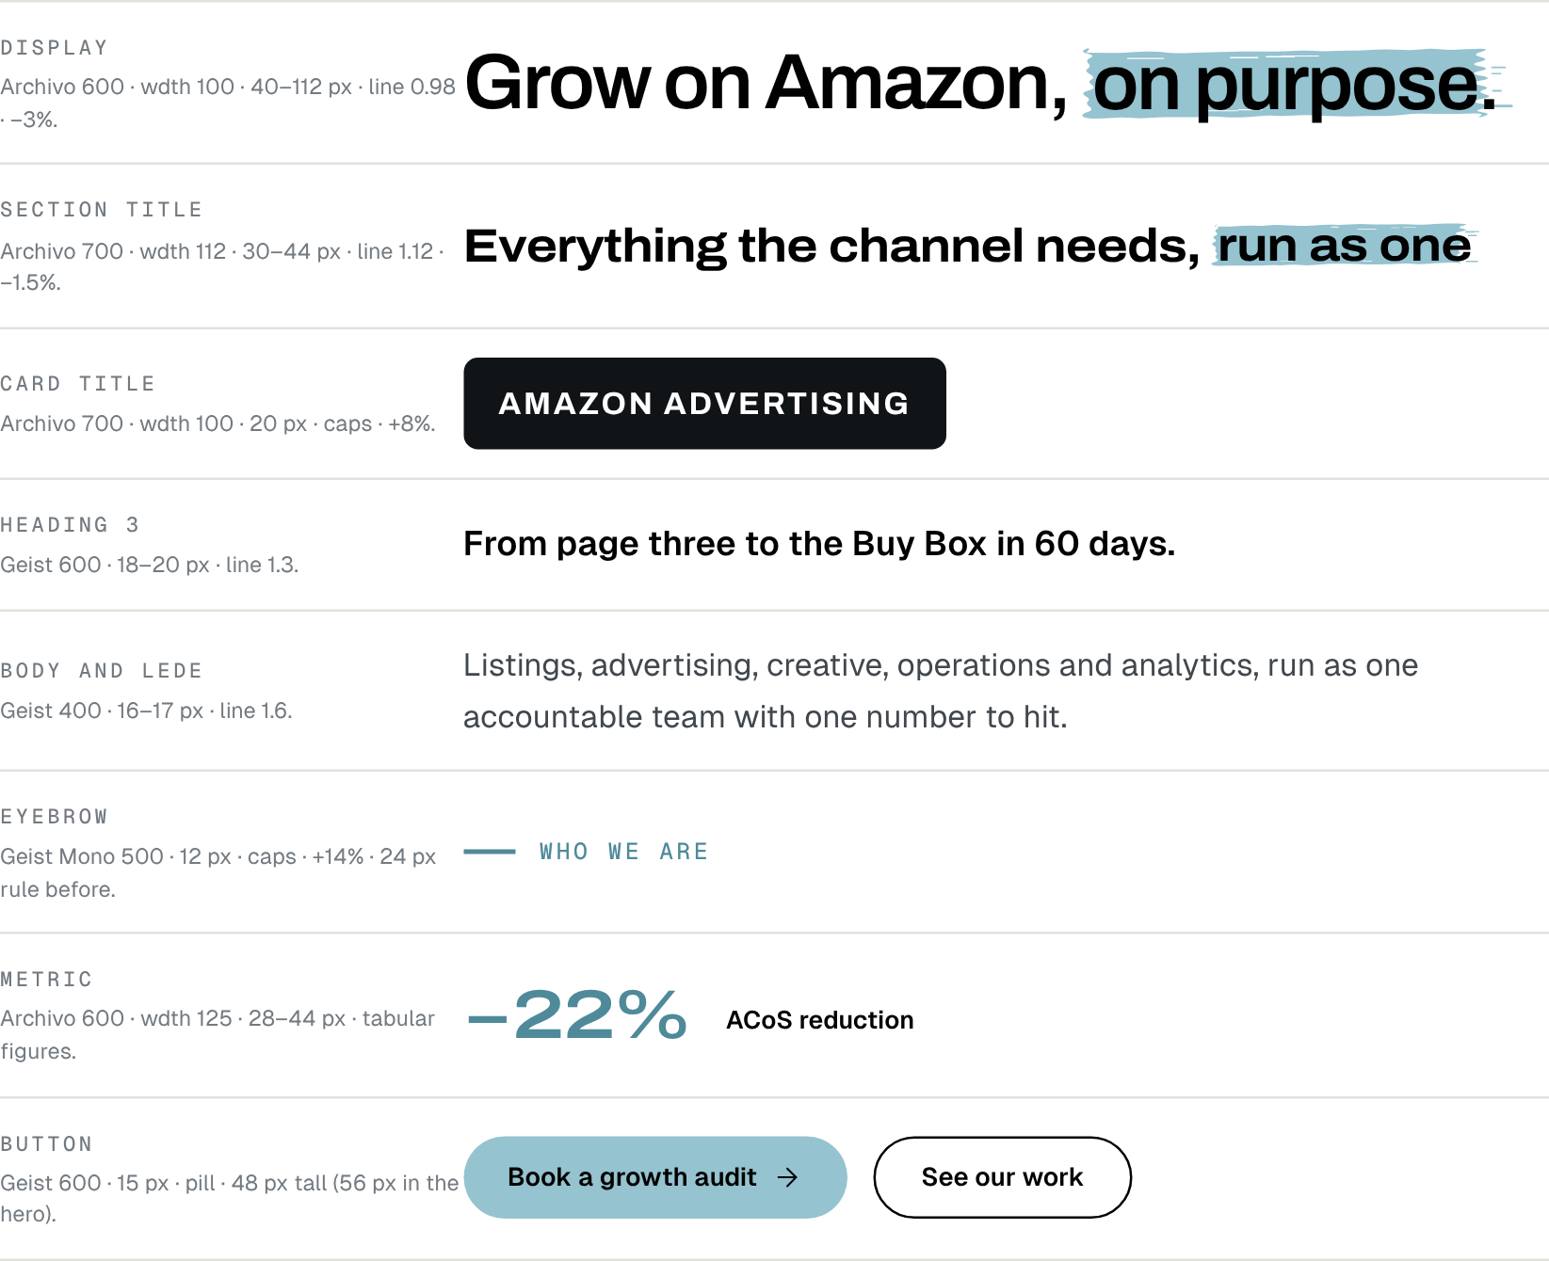

05 — IMAGERY

Real people, real work
Real photography, clean rounded crops, no filters.
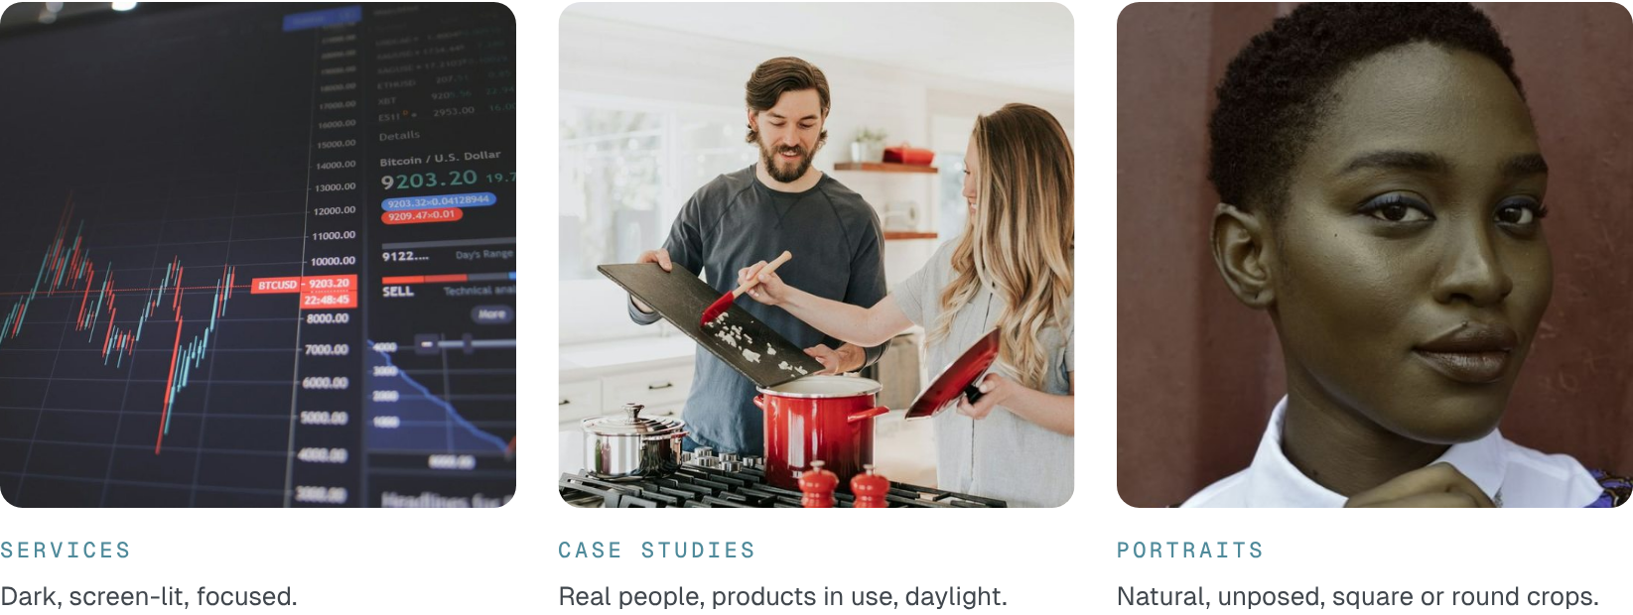
Services | Dark, screen-lit, focused.
Case studies | Real people, products in use, daylight.
Portraits | Natural, unposed, square or round crops.

Art direction
Photography | Real people, workspaces and products. No handshakes, rockets, cash or Amazon branding.
Treatment | No filters, tints, overlays or text on photos.
Crops | 16:10 cards, 4:5 team, 1:1 avatars. Corners 12–24 px.
Data | Stat tiles, not decorative charts. Charts: thin lines, Ice for what matters.
Sources | Demo uses Unsplash and Pexels. Replace with own shoots before launch.

06 — WEBSITE

One system, every page
The rules of the final build. Every new page follows them.
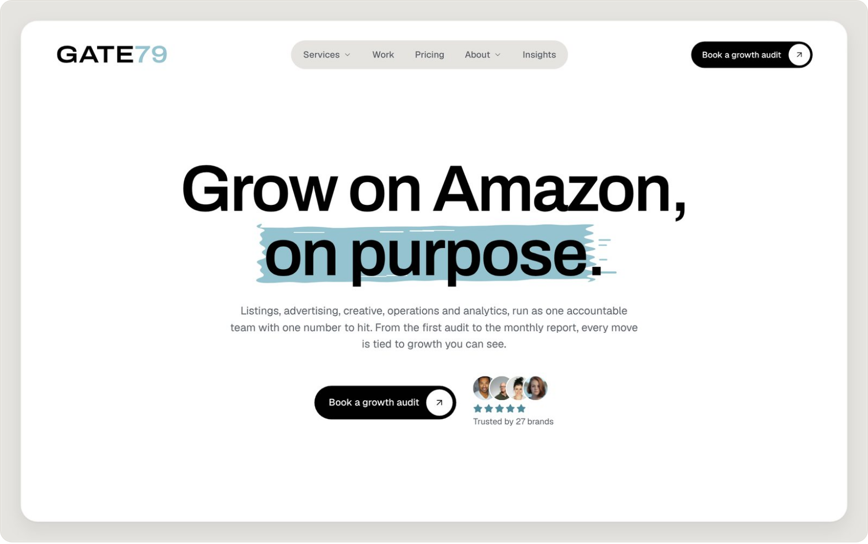
Header | Wordmark, Stone nav pill, Black CTA pill. 79 in Ice Deep on light.
Hero | Centred. One headline, one highlight, one action.
Footer | Ice panel, 24 px corners, inset on Black.

Layout and rhythm
Full-width bands. Ice every second or third band. Black comes in through cards and the footer frame.
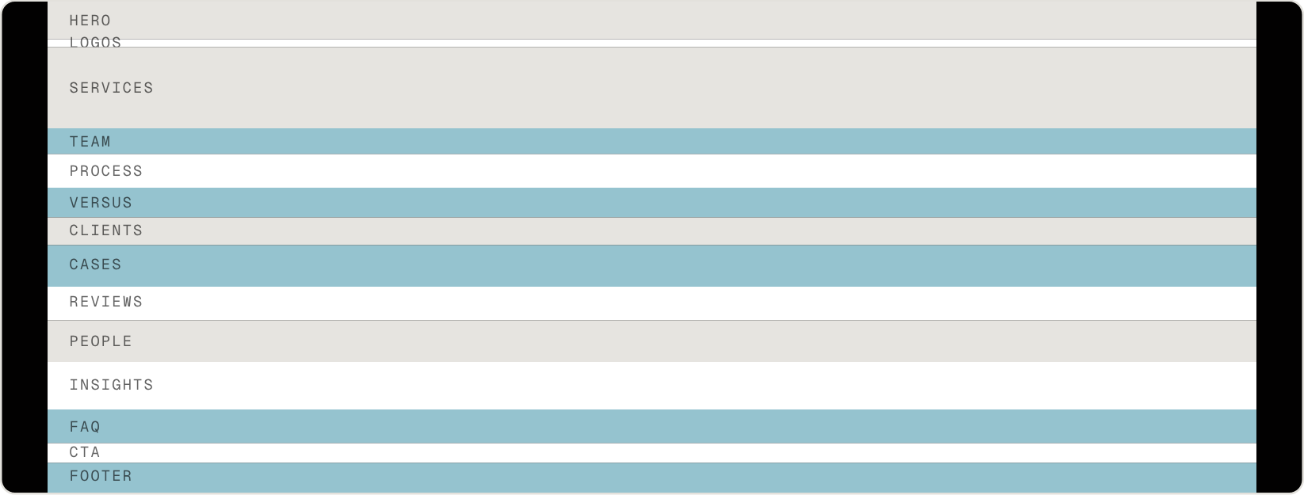
TOKEN | VALUE | USE
Container | 1200 px max | Gutters 16 · 24 · 32 px
Grid | 4 · 8 · 12 columns | Mobile · 768 · 1024 px
Section spacing | 72–128 px | Band padding (64 px tight)
Spacing scale | 4 8 12 16 24 32 40 48 64 80 96 128 160 | All gaps and padding
Corners | 12 · 16 · 24 · pill | Media · cards · feature cards · buttons
Shadow | 0 12 32 / 8% | White cards only
Section head | 720 px · centred | Eyebrow, title, lede

Title highlight
One hand-painted stroke behind the payoff words of each section title.
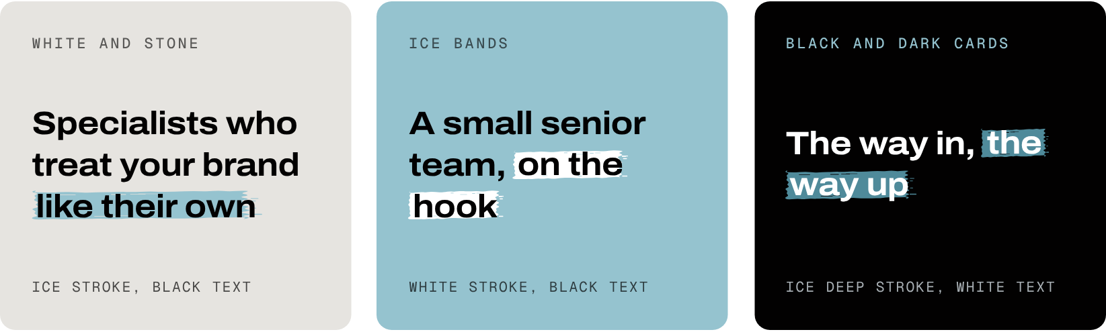
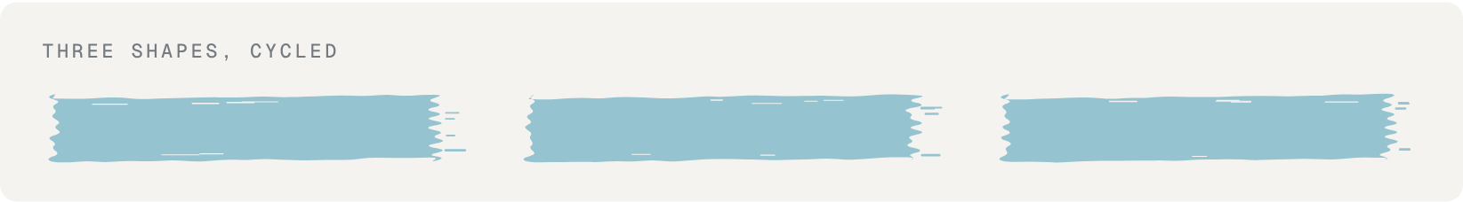
One per title | 1–3 words, at the end of the title.
Colour by ground | Ice stroke on White and Stone, White stroke on Ice, Ice Deep stroke with White text on Black.
Fit | 1 em tall. Each wrapped line gets its own stroke.
Motion | Paints in once, left to right, 700 ms.
Never | On body text, buttons or numbers. No boxes, gradients or Ice on Ice.

Components
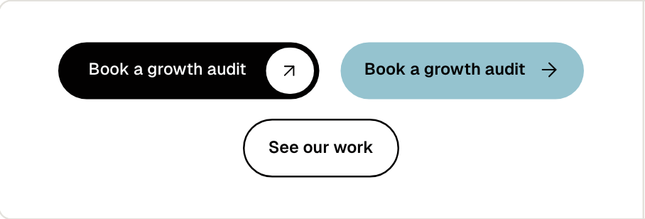
Buttons | Pills, 48 px. Black with dot on light, Ice on Black, outline for second choice. Main CTA: “Book a growth audit”.
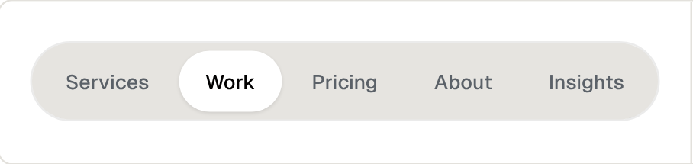
Navigation | Stone pill, Graphite links, White chip when active.
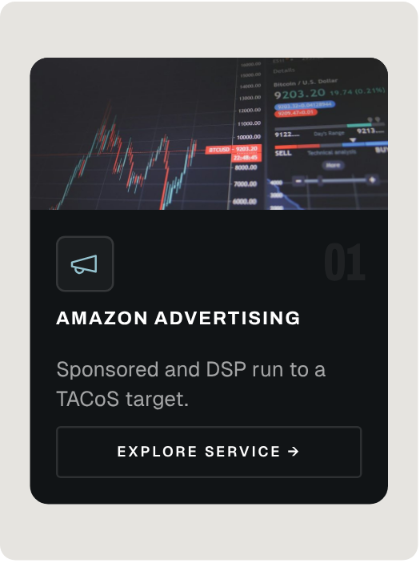 | 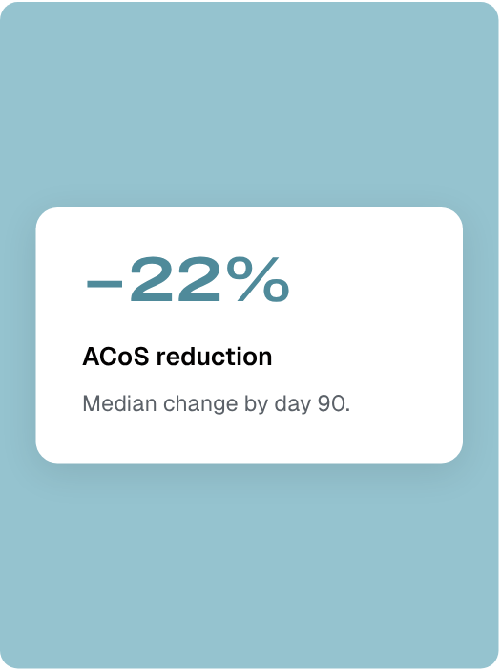 | 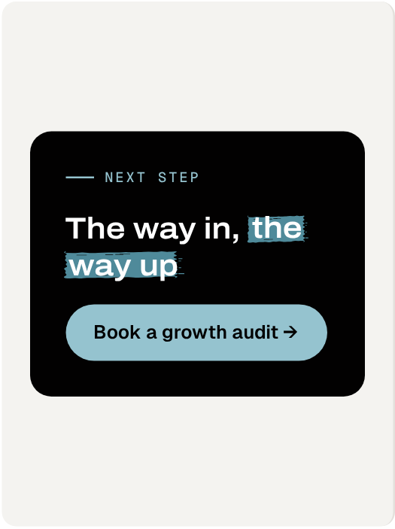
Service card  Carbon, photo, Ice icon, caps title. | Stat tile  White card, Ice Deep metric. | CTA card  Black, 24 px corners. Ends every page.

Icons
One quiet line-icon family.
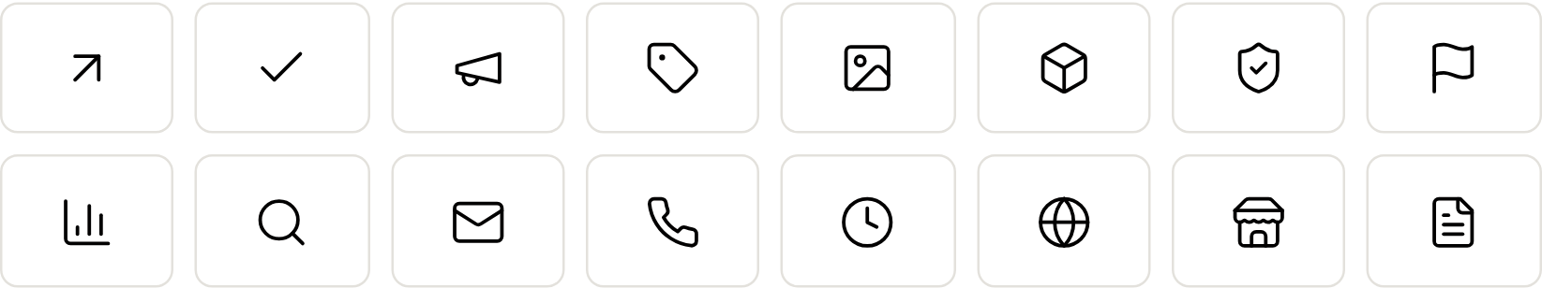

Drawing | 24 px grid, 1.5 px stroke, round ends.
Sizes | 16 buttons · 20 cards · 24 lists.
Colour | Black on light, Ice on dark. No emoji.
Holders | Square on dark cards, circle on light.

Motion
MOMENT | TIMING | BEHAVIOUR
Reveal | 500 ms · ease-out | Rise and fade, once
Title highlight | 700 ms | Paints in, once
Hover | 150–240 ms | Arrow nudge, card lift
Counters | 900 ms | Numbers 10+ only
Logo marquee | 40 s · linear | Pauses on hover
Reduced motion | 0 ms | Everything static

07 — ASSETS

Brand board
Logo, lockups, icons and palette at a glance.
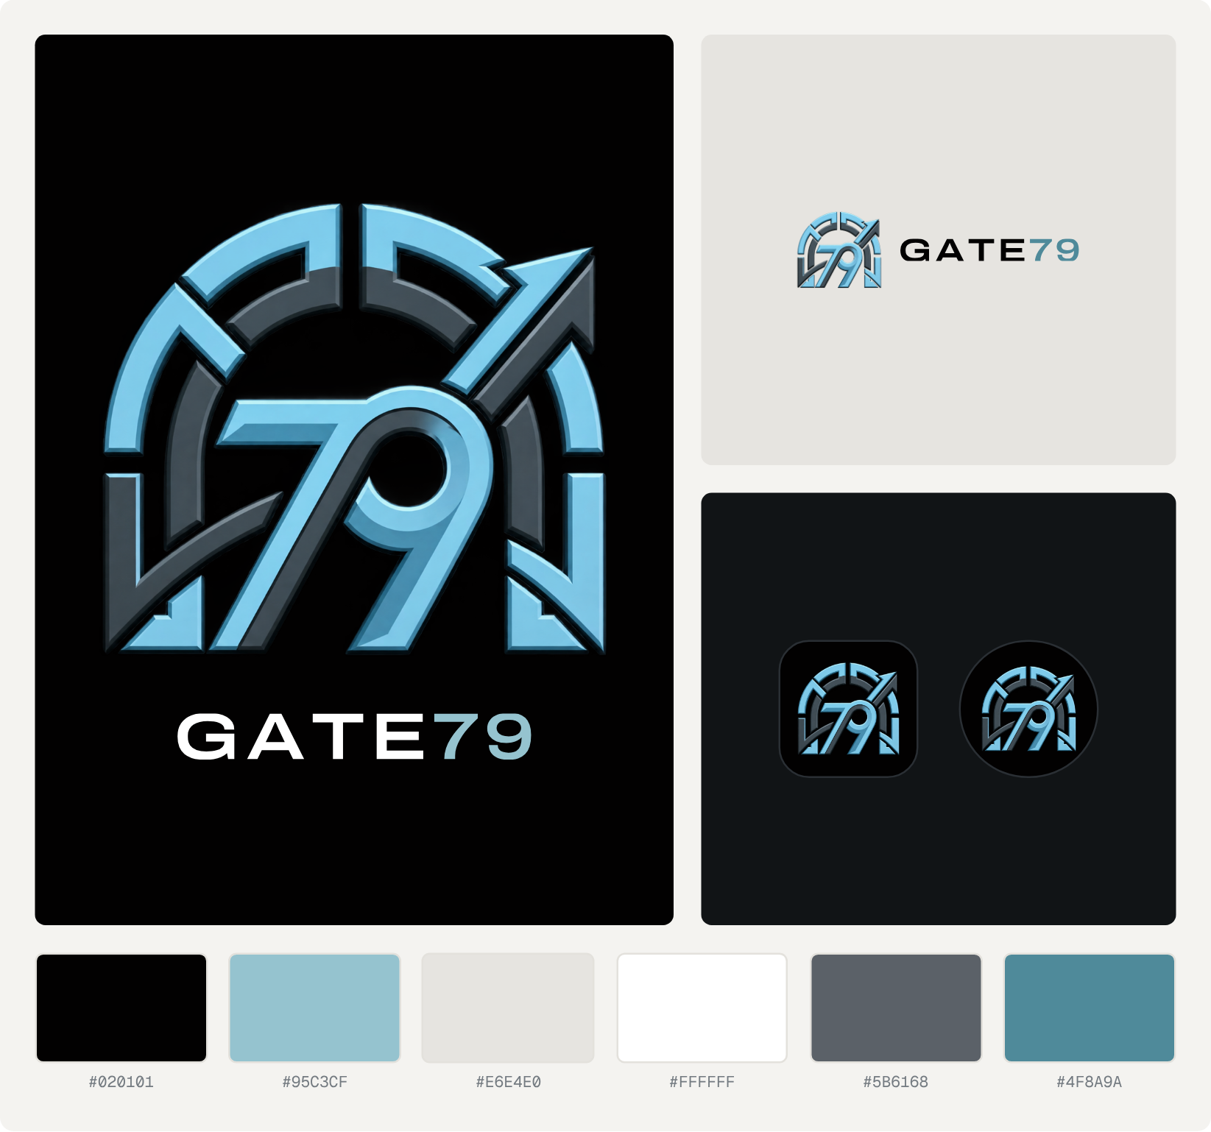
FILE | USE
gate79-mark.png | The master mark, exactly as approved
gate79-horizontal-on-dark.png | Email signature and headers on dark
gate79-horizontal-on-light.png | Documents, invoices, light pages
gate79-stacked-on-dark.png | Covers, about page, presentations
gate79-wordmark-on-dark.svg · -on-light.svg | Where the mark already appears nearby
gate79-app-icon.png · gate79-avatar.png | App icon, Instagram, LinkedIn
favicon-32.png · favicon-180.png | Browser tab, home screen
When in doubt: more space, fewer colours, the supplied logo files.

