# INTRODUCTION

The Domain “Bank Management System” keeps the day by day tally records as a complete banking. It can keep the records of Account type, account opening form, Deposit, Withdrawal, Transaction report, accounts opening form. The exciting part of this project is it displays Transactions report,.

# SYNOPSIS

The Domain “Bank Management System” keeps the day by day tally records as a complete banking. It can keep the records of Account type, account opening form, Deposit, Withdrawal, Transaction report, accounts opening form. The exciting part of this project is it displays Transactions report,.

### ADMINISTRATIVE MODULE

This module is the main module which performs all the main operations in the system. The major operations in the system are:

* Add Account
* Deposit Money
* Withdrawal Money
* Account type
* Perform Transaction
* View Transaction

# SYSTEM STUDY AND ANALISYS

### SYSTEM ANALYSIS

System analysis is a process of gathering and interpreting facts, diagnosing problems and the information to recommend improvements on the system. It is a problem solving activity that requires intensive communication between the system users and system developers. System analysis or study is an important phase of any system development process. The system is studied to the minutest detail and analyzed. The system analyst plays the role of the interrogator and dwells deep into the working of the present system. The system is viewed as a whole and the input to the system are identified. The outputs from the organizations are traced to the various processes. System analysis is concerned with becoming aware of the problem, identifying the relevant and decisional variables, analyzing and synthesizing the various factors and determining an optimal or at least a satisfactory solution or program of action.

A detailed study of the process must be made by various techniques like interviews, questionnaires etc. The data collected by these sources must be scrutinized to arrive to a conclusion. The conclusion is an understanding of how the system functions. This system is called the existing system. Now the existing system is subjected to close study and problem areas are identified. The designer now functions as a problem solver and tries to sort out the difficulties that the enterprise faces. The solutions are given as proposals. The proposal is then weighed with the existing system analytically and the best one is selected. The proposal is presented to the user for an endorsement by the user. The proposal is reviewed on user request and suitable changes are made. This is loop that ends as soon as the user is satisfied with proposal.

Preliminary study is the process of gathering and interpreting facts, using the information for further studies on the system. Preliminary study is problem solving activity that requires intensive communication between the system users and system developers. It does various feasibility studies. In these studies a rough figure of the system activities can be obtained, from which the decision about the strategies to be followed for effective system study and analysis can be taken.

**EXISTING SYSTEM**

In the existing system the transactions are done only manually but in proposed system we have to computerize all the banking transaction using the software Banking system.

### 1.1 PROBLEMS WITH EXISTING SYSTEM

* + Lack of security of data.
  + More man power.
  + Time consuming.
  + Consumes large volume of pare work.
  + Needs manual calculations.
  + No direct role for the higher officials.
  + Damage of machines due to lack of attention.

To avoid all these limitations and make the working more accurately the system needs to be computerized.

### PROPOSED SYSTEM

The aim of proposed system is to develop a system of improved facilities. The proposed system can overcome all the limitations of the existing system. The system provides proper security and reduces the manual work.

### 2. 1 ADVANTAGES OF THE PROPOSED SYSTEM

The system is very simple in design and to implement. The system requires very low system resources and the system will work in almost all configurations. It has got following features

* + Security of data.
  + Ensure data accuracy’s.
  + Proper control of the higher officials.
  + Reduce the damages of the machines.
  + Minimize manual data entry.
  + Minimum time needed for the various processing.
  + Greater efficiency.
  + Better service.
  + User friendliness and interactive.
  + Minimum time required.

### FEASIBILITY STUDY

Feasibility study is made to see if the project on completion will serve the purpose of the organization for the amount of work, effort and the time that spend on it. Feasibility study lets the developer foresee the future of the project and the usefulness. A feasibility study of a system proposal is according to its workability, which is the impact on the organization, ability to meet their user needs and effective use of resources. Thus when a new application is proposed it normally goes through a feasibility study before it is approved for development.

The document provide the feasibility of the project that is being designed and lists various areas that were considered very carefully during the feasibility study of this project such as Technical, Economic and Operational feasibilities. The following are its features:

### TECHNICAL FEASIBILITY

The system must be evaluated from the technical point of view first. The assessment of this feasibility must be based on an outline design of the system requirement in the terms of input, output, programs and procedures. Having identified an outline system, the investigation must go on to suggest the type of equipment, required method developing the system, of running the system once it has been designed.

Technical issues raised during the investigation are:

Does the existing technology sufficient for the suggested one? Can the system expand if developed?

The project should be developed such that the necessary functions and performance are achieved within the constraints. The project is developed within latest technology. Through the technology may become obsolete after some period of time, due to the fact that never version of same software supports older versions, the system may still be used. So there are minimal constraints involved with this project. The system has been developed using Java the project is technically feasible for development.

### ECONOMIC FEASIBILITY

The developing system must be justified by cost and benefit. Criteria to ensure that effort is concentrated on project, which will give best, return at the earliest. One of the factors, which affect the development of a new system, is the cost it would require.

The following are some of the important financial questions asked during preliminary investigation:

* + - * The costs conduct a full system investigation.
      * The cost of the hardware and software.
      * The benefits in the form of reduced costs or fewer costly errors.

Since the system is developed as part of project work, there is no manual cost to spend for the proposed system. Also all the resources are already available, it give an indication of the system is economically possible for development.

### BEHAVIORAL FEASIBILITY

This includes the following questions:

* Is there sufficient support for the users?
* Will the proposed system cause harm?

The project would be beneficial because it satisfies the objectives when developed and installed. All behavioral aspects are considered carefully and conclude that the project is behaviorally feasible.

## SYSTEM DESIGN

### INTRODUCTION

Design is the first step into the development phase for any engineered product or system. Design is a creative process. A good design is the key to effective system. The term “design” is defined as “the process of applying various techniques and principles for the purpose of defining a process or a system in sufficient detail to permit its physical realization”. It may be defined as a process of applying various techniques and principles for the purpose of defining a device, a process or a system in sufficient detail to permit its physical realization. Software design sits at the technical kernel of the software engineering process and is applied regardless of the development paradigm that is used. The system design develops the architectural detail required to build a system or product. As in the case of any systematic approach, this software too has undergone the best possible design phase fine tuning all efficiency, performance and accuracy levels. The design phase is a transition from a user oriented document to a document to the programmers or database personnel. System design goes through two phases of development: Logical and Physical Design.

### LOGICAL DESIGN:

The logical flow of a system and define the boundaries of a system. It includes the following steps:

* + - Reviews the current physical system – its data flows, file content, volumes , frequencies etc.
    - Prepares output specifications – that is, determines the format, content and frequency of reports.
    - Prepares input specifications – format, content and most of the input functions.
    - Prepares edit, security and control specifications.
    - Specifies the implementation plan.
    - Prepares a logical design walk through of the information flow, output, input, controls and implementation plan.
    - Reviews benefits, costs, target dates and system constraints.

### PHYSICAL DESIGN:

Physical system produces the working systems by define the design specifications that tell the programmers exactly what the candidate system must do. It includes the following steps.

* + - Design the physical system.
    - Specify input and output media.
    - Design the database and specify backup procedures.
    - Design physical information flow through the system and a physical design Walk through.
    - Plan system implementation.
    - Prepare a conversion schedule and target date.
    - Determine training procedures, courses and timetable.
    - Devise a test and implementation plan and specify any new hardware/software.
    - Update benefits , costs , conversion date and system constraints

**E-R Diagram**

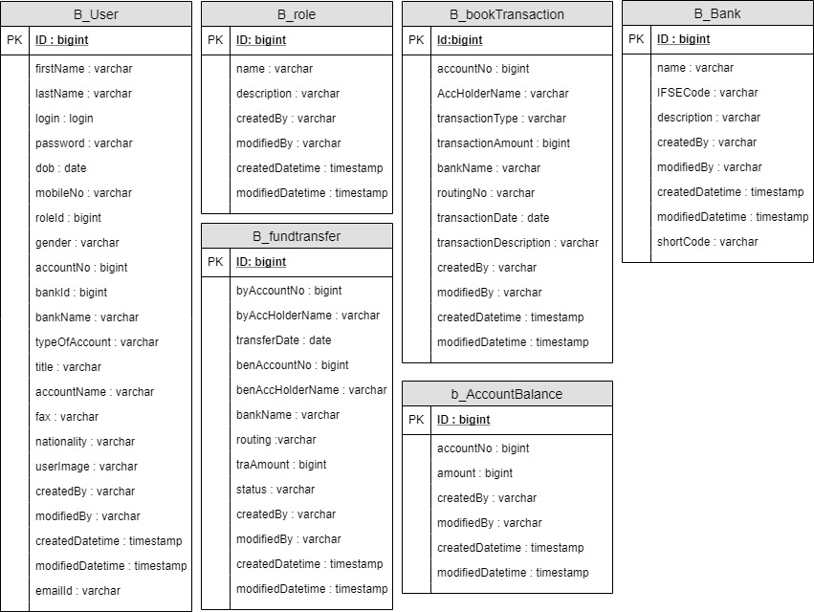

DFD Diagram

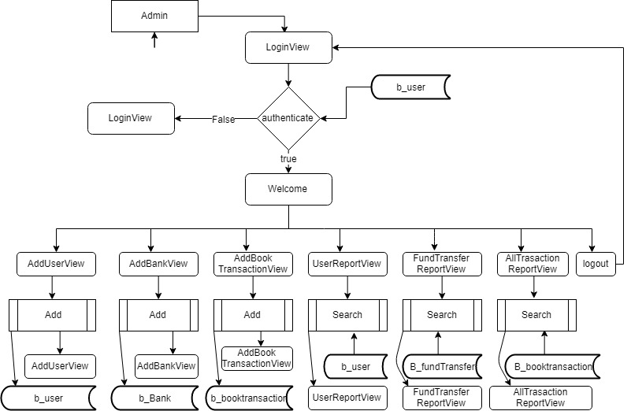

ER for Manager



### Design/Specification activities:

* + - Concept formulation.
    - Problem understanding.
    - High level requirements proposals.
    - Feasibility study.
    - Requirements engineering.
    - Architectural design.

### MODULE DESIGN

Design/Specification activities:

• Concept formulation.

• Problem understanding.

• High level requirements proposals.

• Feasibility study.

• Requirements engineering.

• Architectural design.

**MODULE DESIGN**

**Admin**

The Admin can login in the application after verifying user name and password.

INPUT

The design of input focuses on controller the amount of input required, controlling the errors and invlid data. The input is designed in such a way so that it provide verfication and validation and. Input Design considered the following things:

o Input validation?

o How the data should be arranged or coded?

o Validation message should be display.

o Methods for preparing input validations and steps to follow when error occur.

**OUTPUT DESIGN**

A error free output is one, which meets the requirements of the system user and presents the information clearly in detail. In output design it is determined how the information is to be displaced for the request. It is the most important and direct source data to the user.

Designing computer output should proceed in an organized manner or format, the right output must be display while ensuring that each output element is designed so that people will find the system can use easily and effective way. When analysis design computer output, they should :

❖ Error free.

❖ With out logical error.

❖ Output format should be proper and easy to understand for new users.

### DATABASE DESIGN

A database is an organized mechanism that has the capability of storing information through which a user can retrieve stored information in an effective and efficient manner. The data is the purpose of any database and must be protected.

The database design is a two level process. In the first step, user requirements are gathered together and a database is designed which will meet these requirements as clearly as possible. This step is called Information Level Design and it is taken independent of any individual DBMS.

In the second step, this Information level design is transferred into a design for the specific DBMS that will be used to implement the system in question. This step is called Physical Level Design, concerned with the characteristics of the specific DBMS that will be used. A database design runs parallel with the system design. The organization of the data in the database is aimed to achieve the following two major objectives.

* + - Data Integrity
    - Data independence

Normalization is the process of decomposing the attributes in an application, which results in a set of tables with very simple structure. The purpose of normalization is to make tables as simple as possible. Normalization is carried out in this system for the following reasons.

* To structure the data so that there is no repetition of data , this helps in saving.
* To permit simple retrieval of data in response to query and report request.
* To simplify the maintenance of the data through updates, insertions, deletions.
* To reduce the need to restructure or reorganize data which new application requirements arise.

### RELATIONAL DATABASE MANAGEMENT SYSTEM (RDBMS):

A relational model represents the database as a collection of relations. Each relation resembles a table of values or file of records. In formal relational model terminology, a row is called a tuple, a column header is called an attribute and the table is called a relation. A relational database consists of a collection of tables, each of which is assigned a unique name. A row in a tale represents a set of related values.

### RELATIONS, DOMAINS & ATTRIBUTES:

A table is a relation. The rows in a table are called tuples. A tuple is an ordered set of n elements. Columns are referred to as attributes. Relationships have been set between every table in the database. This ensures both Referential and Entity Relationship Integrity. A domain D is a set of atomic values. A common method of specifying a domain is to specify a data type from which the data values forming the domain are drawn. It is also useful to specify a name for the domain to help in interpreting its values. Every value in a relation is atomic, that is not decomposable.

### RELATIONSHIPS:

Table relationships are established using Key. The two main keys of prime importance are Primary Key & Foreign Key. Entity Integrity and Referential Integrity Relationships can be established with these keys.Entity Integrity enforces that no Primary Key can have null values.Referential Integrity enforces that no Primary Key can have null values.

Referential Integrity for each distinct Foreign Key value, there must exist a matching Primary Key value in the same domain. Other key are Super Key and Candidate Keys.

Relationships have been set between every table in the database. This ensures both Referential and Entity Relationship Integrity.

### NORMALIZATION:

As the name implies, it denoted putting things in the normal form. The application developer via normalization tries to achieve a sensible organization of data into proper tables and columns and where names can be easily correlated to the data by the user. Normalization eliminates repeating groups at data and thereby avoids data redundancy which proves to be a great burden on the computer resources. These includes:

* + - Normalize the data.
    - Choose proper names for the tables and columns.
    - Choose the proper name for the data.

### First Normal Form:

The First Normal Form states that the domain of an attribute must include only atomic values and that the value of any attribute in a tuple must be a single value from the domain of that attribute. In other words 1NF disallows “relations within relations” or “relations as attribute values within tuples”. The only attribute values permitted by 1NF are single atomic or indivisible values.

The first step is to put the data into First Normal Form. This can be donor by moving data into separate tables where the data is of similar type in each table. Each table is given a Primary Key or Foreign Key as per requirement of the project. In this we form new relations for each nonatomic attribute or nested relation. This eliminated repeating groups of data.

A relation is said to be in first normal form if only if it satisfies the constraints that contain the primary key only.

### Second Normal Form:

According to Second Normal Form, For relations where primary key contains multiple attributes, no nonkey attribute should be functionally dependent on a part of the primary key.

In this we decompose and setup a new relation for each partial key with its dependent attributes. Make sure to keep a relation with the original primary key and any attributes that are fully functionally dependent on it. This step helps in taking out data that is only dependant on apart of the key.

A relation is said to be in second normal form if and only if it satisfies all the first normal form conditions for the primary key and every non-primary key attributes of the relation is fully dependent on its primary key alone.

### Third Normal Form:

According to Third Normal Form, Relation should not have a nonkey attribute functionally determined by another nonkey attribute or by a set of nonkey attributes. That is, there should be no transitive dependency on the primary key.

In this we decompose and set up relation that includes the nonkey attributes that functionally determines other nonkey attributes. This step is taken to get rid of anything that does not depend entirely on the Primary Key.

A relation is said to be in third normal form if only if it is in second normal form and more over the non key attributes of the relation should not be depend on other non key attribute.

## SYSTEM IMPLEMENTATION AND TESTING

Implementation is the stage of the project where the theoretical design is turned into a working system. It can be considered to be the most crucial stage in achieving a successful new system gaining the users confidence that the new system will work and will be effective and accurate. It is primarily concerned with user training and documentation. Conversion usually takes place about the same time the user is being trained or later. Implementation simply means convening a new system design into operation, which is the process of converting a new revised system design into an operational one.

## SYSTEM TESTING

Software Testing is the process of executing software in a controlled manner, in order to answer the question - Does the software behave as specified?. Software testing is often used in association with the terms verification and validation. Validation is the checking or testing of items, includes software, for conformance and consistency with an associated specification. Software testing is just one kind of verification, which also uses techniques such as reviews, analysis, inspections, and walkthroughs. Validation is the process of checking that what has been specified is what the user actually wanted.

Validation **:** Are we doing the right job? Verification **:** Are we doing the job right?

Software testing should not be confused with debugging. Debugging is the process of analyzing and localizing bugs when software does not behave as expected. Although the identification of some bugs will be obvious from playing with the software, a methodical approach to software testing is a much more thorough means for identifying bugs. Debugging is therefore an activity which supports testing, but cannot replace testing.

Other activities which are often associated with software testing are static analysis and dynamic analysis. Static analysis investigates the source code of software, looking for problems and gathering metrics without actually executing the code. Dynamic analysis

looks at the behavior of software while it is executing, to provide information such as execution traces, timing profiles, and test coverage information.

Testing is a set of activity that can be planned in advanced and conducted systematically. Testing begins at the module level and work towards the integration of entire computers based system. Nothing is complete without testing, as it vital success of the system testing objectives, there are several rules that can serve as testing objectives. They are

Testing is a process of executing a program with the intend of finding an error.A good test case is one that has high possibility of finding an undiscovered error.A successful test is one that uncovers an undiscovered error.

If a testing is conducted successfully according to the objectives as stated above, it would uncovered errors in the software also testing demonstrate that the software function appear to be working according to the specification, that performance requirement appear to have been met.

There are three ways to test program.

* + - * For correctness
      * For implementation efficiency
      * For computational complexity

Test for correctness are supposed to verify that a program does exactly what it was designed to do. This is much more difficult than it may at first appear, especially for large programs.

## TEST PLAN

A test plan implies a series of desired course of action to be followed in accomplishing various testing methods. The Test Plan acts as a blue print for the action that is to be followed. The software engineers create a computer program, its documentation and related data structures. The software developers is always responsible for testing the individual units of the programs, ensuring that each performs the function for which it was designed. There is an independent test group (ITG) which is to remove the inherent problems associated with letting the builder to test the thing that has been built. The specific objectives of testing should be stated in measurable terms. So that the mean time to failure, the cost to find and fix the defects, remaining defect density or frequency of occurrence and test work-hours per regression test all should be stated within the test plan.

The levels of testing include:

* + - * Unit testing
      * Integration Testing
      * Data validation Testing
      * Output Testing

### UNIT TESTING

Unit testing focuses verification effort on the smallest unit of software design – the software component or module. Using the component level design description as a guide, important control paths are tested to uncover errors within the boundary of the module. The relative complexity of tests and uncovered scope established for unit testing. The unit testing is white-box oriented, and step can be conducted in parallel for multiple

components. The modular interface is tested to ensure that information properly flows into and out of the program unit under test. The local data structure is examined to ensure that data stored temporarily maintains its integrity during all steps in an algorithm’s execution. Boundary conditions are tested to ensure that all statements in a module have been executed at least once. Finally, all error handling paths are tested.

Tests of data flow across a module interface are required before any other test is initiated. If data do not enter and exit properly, all other tests are moot. Selective testing of execution paths is an essential task during the unit test. Good design dictates that error conditions be anticipated and error handling paths set up to reroute or cleanly terminate processing when an error does occur. Boundary testing is the last task of unit testing step. Software often fails at its boundaries.

Unit testing was done in Sell-Soft System by treating each module as separate entity and testing each one of them with a wide spectrum of test inputs. Some flaws in the internal logic of the modules were found and were rectified.

### INTEGRATION TESTING

Integration testing is systematic technique for constructing the program structure while at the same time conducting tests to uncover errors associated with interfacing. The objective is to take unit tested components and build a program structure that has been dictated by design. The entire program is tested as whole. Correction is difficult because isolation of causes is complicated by vast expanse of entire program. Once these errors are corrected, new ones appear and the process continues in a seemingly endless loop.

After unit testing in Sell-Soft System all the modules were integrated to test for any inconsistencies in the interfaces. Moreover differences in program structures were removed and a unique program structure was evolved.

### VALIDATION TESTING OR SYSTEM TESTING

This is the final step in testing. In this the entire system was tested as a whole with all forms, code, modules and class modules. This form of testing is popularly known as Black Box testing or System testing.

Black Box testing method focuses on the functional requirements of the software. That is, Black Box testing enables the software engineer to derive sets of input conditions that will fully exercise all functional requirements for a program.

Black Box testing attempts to find errors in the following categories; incorrect or missing functions, interface errors, errors in data structures or external data access, performance errors and initialization errors and termination errors.

### OUTPUT TESTING OR USER ACCEPTANCE TESTING

The system considered is tested for user acceptance; here it should satisfy the firm’s need. The software should keep in touch with perspective system; user at the time of

developing and making changes whenever required. This done with respect to the following points

* Input Screen Designs,
* Output Screen Designs,
* Online message to guide the user and the like.

The above testing is done taking various kinds of test data. Preparation of test data plays a vital role in the system testing. After preparing the test data, the system under study is tested using that test data. While testing the system by which test data errors are again uncovered and corrected by using above testing steps and corrections are also noted for future use.

### TRAINING

Once the system is successfully developed the next important step is to ensure that the administrators are well trained to handle the system. This is because the success of a system invariably depends on how they are operated and used. The implementation depends upon the right people being at the right place at the right time. Education involves creating the right atmosphere and motivating the user. The administrators are familiarized with the run procedures of the system, working through the sequence of activities on an ongoing basis.

Implementation is the state in the project where the theoretical design is turned into a working system. By this, the users get the confidence that the system will work effectively. The system can be implemented only after through testing.

The systems personnel check the feasibility of the system. The actual data were inputted to the system and the working of the system was closely monitored. The master option was selected from the main menu and the actual data were input through the corresponding input screens. The data movement was studied and found to be correct queries option was then selected and this contains various reports. Utilities provide various data needed for inventory was input and the module was test run. Satisfactory results were obtained. Reports related to these processes were also successfully generated. Various input screen formats are listed in the appendix.

Implementation walkthroughs ensure that the completed system actually solves the original problem. This walkthrough occurs just before the system goes into use, and it should include careful review of all manuals, training materials and system documentation. Again, users, the analyst and the members of the computer services staff may attend this meeting.

**Screenshot**

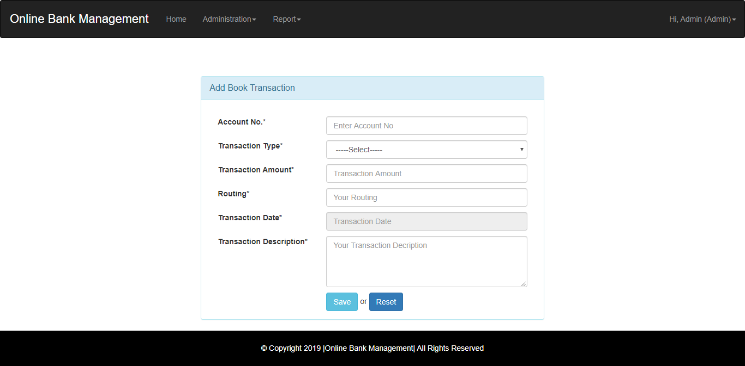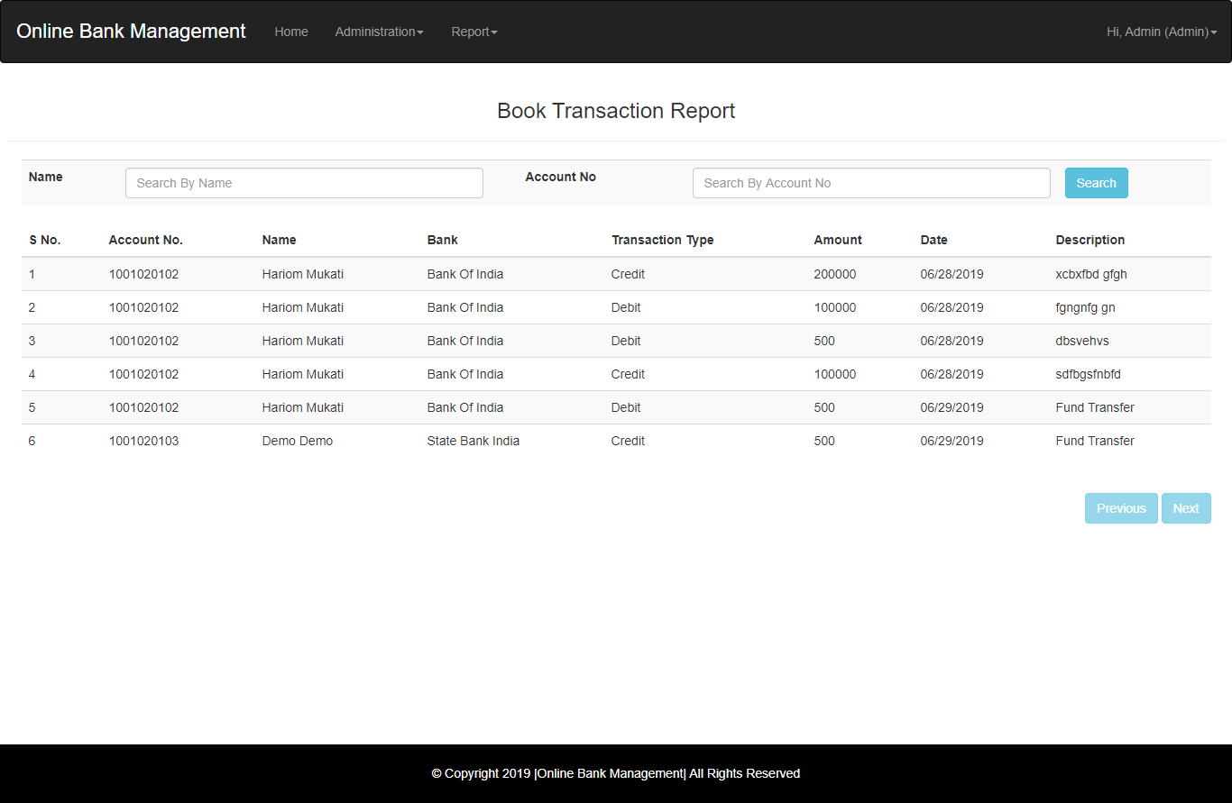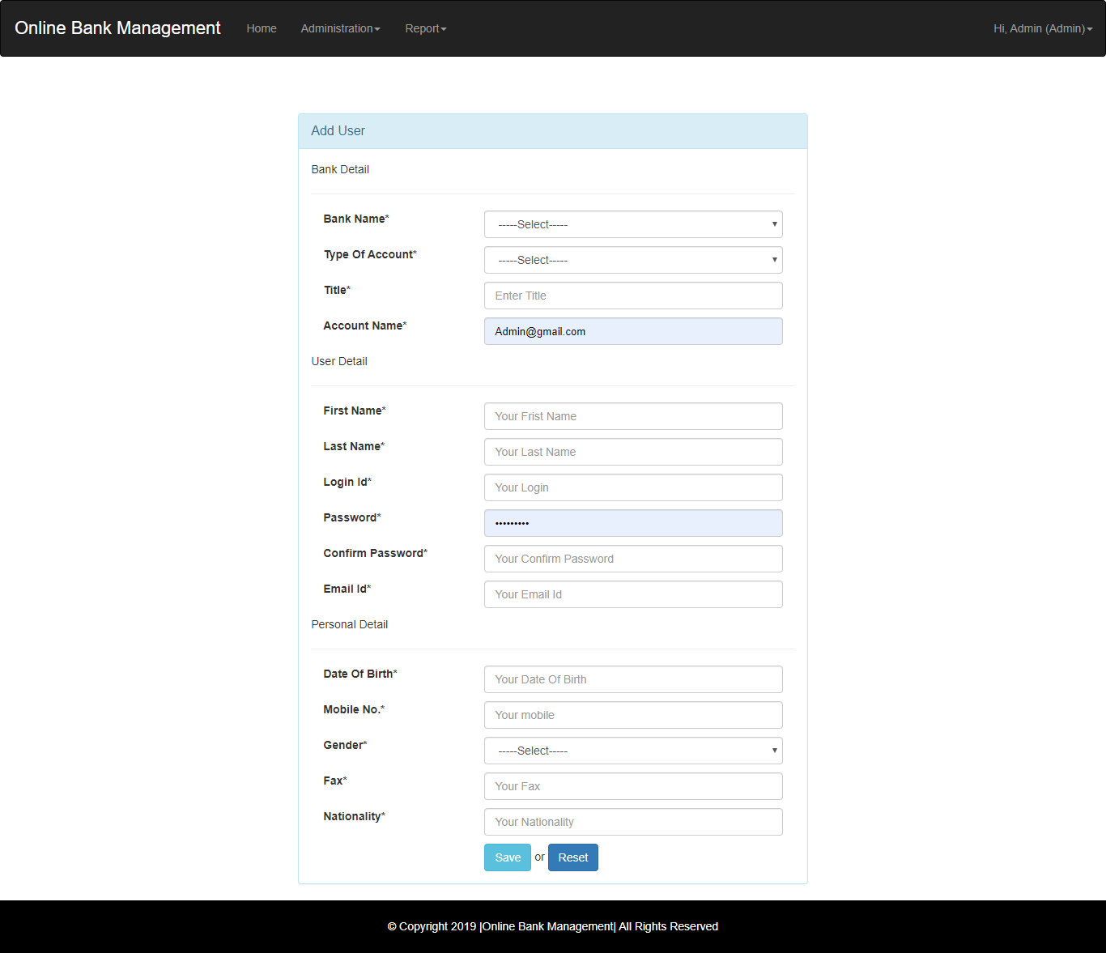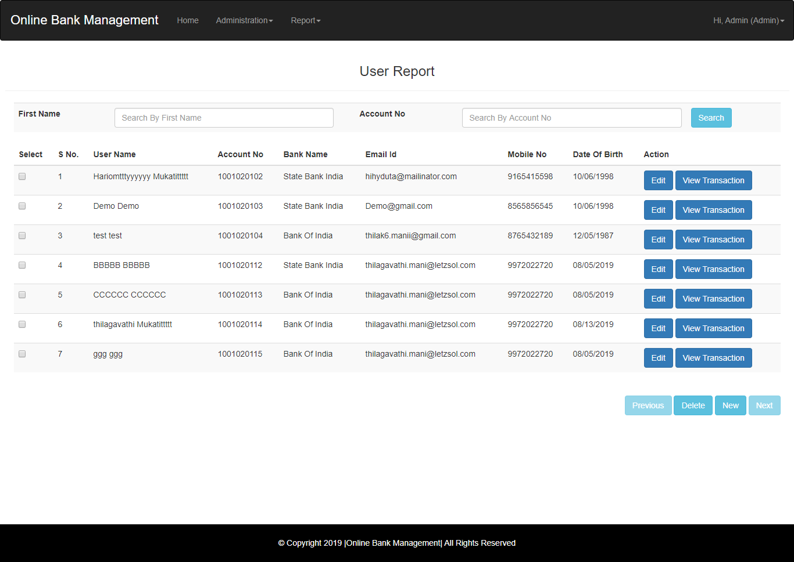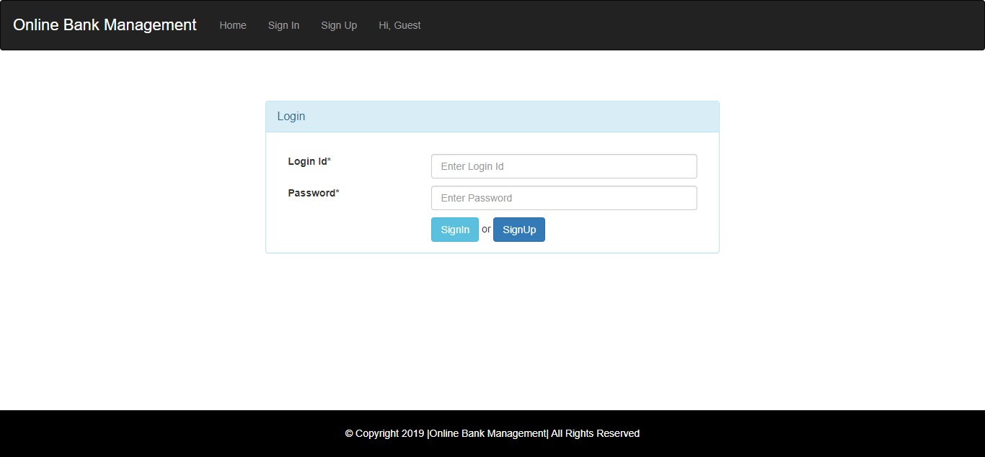

**Source code**

Controller

package in.co.online.bank.mgt.controller;

import java.io.IOException;

import javax.servlet.ServletException;

import javax.servlet.annotation.WebServlet;

import javax.servlet.http.HttpServlet;

import javax.servlet.http.HttpServletRequest;

import javax.servlet.http.HttpServletResponse;

import javax.servlet.http.HttpSession;

import org.apache.log4j.Logger;

import in.co.online.bank.mgt.bean.AccountBalanceBean;

import in.co.online.bank.mgt.bean.BankBean;

import in.co.online.bank.mgt.bean.UserBean;

import in.co.online.bank.mgt.exception.ApplicationException;

import in.co.online.bank.mgt.model.AccountBalanceModel;

import in.co.online.bank.mgt.model.BankModel;

import in.co.online.bank.mgt.model.BookTransactionModel;

import in.co.online.bank.mgt.util.DataUtility;

import in.co.online.bank.mgt.util.ServletUtility;

/**

* Servlet implementation class AccountBalanceCtl

*/

@WebServlet(name = "AccountBalanceCtl", urlPatterns = { "/ctl/AccountBalanceCtl" })

public class AccountBalanceCtl extends BaseCtl {

private static final long serialVersionUID = 1L;

private static Logger log=Logger.getLogger(AccountBalanceCtl.class);

/**

* @see HttpServlet#doGet(HttpServletRequest request, HttpServletResponse response)

*/

protected void doGet(HttpServletRequest request, HttpServletResponse response) throws ServletException, IOException {

log.debug("AccountBalanceCtl doGet method start");

AccountBalanceModel model = new AccountBalanceModel();

HttpSession session=request.getSession();

UserBean uBean=(UserBean) session.getAttribute("user");

AccountBalanceBean bean;

try {

bean = model.findByAcoountNo(uBean.getAccountNo());

ServletUtility.setOpration("Edit", request);

ServletUtility.setBean(bean, request);

} catch (ApplicationException e) {

ServletUtility.handleException(e, request, response);

return;

}

ServletUtility.forward(getView(), request, response);

log.debug("AccountBalanceCtl doGet method end");

}

@Override

protected String getView() {

// TODO Auto-generated method stub

return OBMView.ACCOUNT_BALANCE_VIEW;

}

}

Database Madel

package in.co.online.bank.mgt.model;

import java.sql.Connection;

import java.sql.PreparedStatement;

import java.sql.ResultSet;

import org.apache.log4j.Logger;

import in.co.online.bank.mgt.bean.AccountBalanceBean;

import in.co.online.bank.mgt.bean.RoleBean;

import in.co.online.bank.mgt.exception.ApplicationException;

import in.co.online.bank.mgt.exception.DatabaseException;

import in.co.online.bank.mgt.exception.DuplicateRecordException;

import in.co.online.bank.mgt.util.JDBCDataSource;

public class AccountBalanceModel {

private static Logger log = Logger.getLogger(AccountBalanceModel.class);

/**

* Find next PK of Role

*

* @throws DatabaseException

*/

public Integer nextPK() throws DatabaseException {

log.debug("Model nextPK Started");

Connection conn = null;

int pk = 0;

try {

conn = JDBCDataSource.getConnection();

PreparedStatement pstmt = conn.prepareStatement("SELECT MAX(ID) FROM B_AccountBalance");

ResultSet rs = pstmt.executeQuery();

while (rs.next()) {

pk = rs.getInt(1);

}

rs.close();

} catch (Exception e) {

log.error("Database Exception..", e);

throw new DatabaseException("Exception : Exception in getting PK");

} finally {

JDBCDataSource.closeConnection(conn);

}

log.debug("Model nextPK End");

return pk + 1;

}

public long add(AccountBalanceBean bean) throws ApplicationException, DuplicateRecordException {

log.debug("Model add Started");

Connection conn = null;

int pk = 0;

try {

conn = JDBCDataSource.getConnection();

pk = nextPK();

// Get auto-generated next primary key

System.out.println(pk + " in ModelJDBC");

conn.setAutoCommit(false); // Begin transaction

PreparedStatement pstmt = conn.prepareStatement("INSERT INTO B_AccountBalance VALUES(?,?,?,?,?,?,?)");

pstmt.setInt(1, pk);

pstmt.setLong(2, bean.getAccountNo());

pstmt.setLong(3, bean.getAmount());

pstmt.setString(4, bean.getCreatedBy());

pstmt.setString(5, bean.getModifiedBy());

pstmt.setTimestamp(6, bean.getCreatedDatetime());

pstmt.setTimestamp(7, bean.getModifiedDatetime());

pstmt.executeUpdate();

conn.commit(); // End transaction

pstmt.close();

} catch (Exception e) {

e.printStackTrace();

log.error("Database Exception..", e);

try {

conn.rollback();

} catch (Exception ex) {

throw new ApplicationException("Exception : add rollback exception " + ex.getMessage());

}

throw new ApplicationException("Exception : Exception in add AccountBalance");

} finally {

JDBCDataSource.closeConnection(conn);

}

log.debug("Model add End");

return pk;

}

public AccountBalanceBean findByPK(long pk) throws ApplicationException {

log.debug("Model findByPK Started");

StringBuffer sql = new StringBuffer("SELECT * FROM B_AccountBalance WHERE ID=?");

AccountBalanceBean bean = null;

Connection conn = null;

try {

conn = JDBCDataSource.getConnection();

PreparedStatement pstmt = conn.prepareStatement(sql.toString());

pstmt.setLong(1, pk);

ResultSet rs = pstmt.executeQuery();

while (rs.next()) {

bean = new AccountBalanceBean();

bean.setId(rs.getLong(1));

bean.setAccountNo(rs.getLong(2));

bean.setAmount(rs.getLong(3));

bean.setCreatedBy(rs.getString(4));

bean.setModifiedBy(rs.getString(5));

bean.setCreatedDatetime(rs.getTimestamp(6));

bean.setModifiedDatetime(rs.getTimestamp(7));

}

rs.close();

} catch (Exception e) {

log.error("Database Exception..", e);

throw new ApplicationException("Exception : Exception in getting AccountBalance by pk");

} finally {

JDBCDataSource.closeConnection(conn);

}

log.debug("Model findByPK End");

return bean;

}

public AccountBalanceBean findByAcoountNo(long pk) throws ApplicationException {

log.debug("Model findByPK Started");

StringBuffer sql = new StringBuffer("SELECT * FROM B_AccountBalance WHERE AccountNo=?");

AccountBalanceBean bean = null;

Connection conn = null;

try {

conn = JDBCDataSource.getConnection();

PreparedStatement pstmt = conn.prepareStatement(sql.toString());

pstmt.setLong(1, pk);

ResultSet rs = pstmt.executeQuery();

while (rs.next()) {

bean = new AccountBalanceBean();

bean.setId(rs.getLong(1));

bean.setAccountNo(rs.getLong(2));

bean.setAmount(rs.getLong(3));

bean.setCreatedBy(rs.getString(4));

bean.setModifiedBy(rs.getString(5));

bean.setCreatedDatetime(rs.getTimestamp(6));

bean.setModifiedDatetime(rs.getTimestamp(7));

}

rs.close();

} catch (Exception e) {

log.error("Database Exception..", e);

throw new ApplicationException("Exception : Exception in getting AccountBalance by pk");

} finally {

JDBCDataSource.closeConnection(conn);

}

log.debug("Model findByPK End");

return bean;

}

public void update(AccountBalanceBean bean) throws ApplicationException, DuplicateRecordException {

log.debug("Model update Started");

Connection conn = null;

try {

conn = JDBCDataSource.getConnection();

conn.setAutoCommit(false); // Begin transaction

PreparedStatement pstmt = conn.prepareStatement(

"UPDATE B_AccountBalance SET AccountNo=?,Amount=?,CREATEDBY=?,MODIFIEDBY=?,CREATEDDATETIME=?,MODIFIEDDATETIME=? WHERE ID=?");

pstmt.setLong(1, bean.getAccountNo());

pstmt.setLong(2, bean.getAmount());

pstmt.setString(3, bean.getCreatedBy());

pstmt.setString(4, bean.getModifiedBy());

pstmt.setTimestamp(5, bean.getCreatedDatetime());

pstmt.setTimestamp(6, bean.getModifiedDatetime());

pstmt.setLong(7, bean.getId());

pstmt.executeUpdate();

conn.commit(); // End transaction

pstmt.close();

} catch (Exception e) {

log.error("Database Exception..", e);

try {

conn.rollback();

} catch (Exception ex) {

throw new ApplicationException("Exception : Delete rollback exception " + ex.getMessage());

}

throw new ApplicationException("Exception in updating Role ");

} finally {

JDBCDataSource.closeConnection(conn);

}

log.debug("Model update End");

}

}

# Hibernate configuration

<?xml version=*"1.0"* encoding=*"UTF-8"*?>

<!DOCTYPE hibernate-configuration PUBLIC

"-//Hibernate/Hibernate Configuration DTD 3.0//EN"

"http://www.hibernate.org/dtd/hibernate-configuration-3.0.dtd">

<hibernate-configuration>

<session-factory>

<property name=*"hibernate.connection.driver_class"*>com.mysql.jdbc.Driver</property>

<property name=*"hibernate.connection.url"*>jdbc:mysql://localhost:3306/Bank_mgt_hib</property>

<property name=*"hibernate.connection.username"*>root</property>

<property name=*"hibernate.connection.password"*>root</property>

<property name=*"hibernate.dialect"*>org.hibernate.dialect.MySQLDialect</property>

<property name=*"hibernate.show_sql"*>true</property>

<property name=*"hibernate.hbm2ddl.auto"*>update</property>

<property name=*"hibernate.c3p0.min_size"*>10</property>

<property name=*"hibernate.c3p0.max_size"*>100</property>

<property name=*"hibernate.c3p0.acquire_increment"*>10</property>

<property name=*"hibernate.c3p0.timeout"*>10</property>

<property name=*"hibernate.c3p0."*>10</property>

<mapping class=*"in.co.online.bank.mgt.bean.UserBean"* />

<mapping class=*"in.co.online.bank.mgt.bean.RoleBean"* />

<mapping class=*"in.co.online.bank.mgt.bean.AccountBalanceBean"* />

<mapping class=*"in.co.online.bank.mgt.bean.BankBean"* />

<mapping

class=*"in.co.online.bank.mgt.bean.BookTransactionBean"* />

<mapping class=*"in.co.online.bank.mgt.bean.FundTransferBean"* />

</session-factory>

</hibernate-configuration>

# CONCLUSION

“Banking Management System " keeps the day by day tally record as a complete banking. It can keep the information of Account type, account opening form, Deposit, Withdrawal, and Searching the transaction, Transaction report, Individual account opening form, Group Account. The exciting part of this project is; it displays Transaction reports, Statistical Summary of Account type and Interest Information.

# BIBLIOGRAPHY

BOOKS:

* + 1. Charles Hampfed (2000) ‘Visual Basic’ University of Toronto
    2. Herbert Schildt (2000) ‘Visual Basic 6.0’ Tata McGraw Hill
    3. John Zukowski (2000) ‘Visual Basic 6.0’ ‘BPB Publications
    4. Jamie Jaworsky ‘Visual Basic 6.0’Techmedia
    5. Stefen Denninger ‘Visual Basic 6.0’Author’s Press
    6. Ian Somerville ‘Software engineering’
    7. Rajeev mall ‘Software engineering’
    8. Elmasri Navathe ‘Fundamentals of database systems’

### ONLINE REFERENCE:

[www.w3schools.com](http://www.w3schools.com/) [www.theserverside.com](http://www.theserverside.com/) [www.visual.com](http://www.visual.com/)