**7) Anti-Corruption Cases and Arrests**

There are two CSV Files - **23_Anti_corruprion_cases, 24_Anti_corruption_arrests.** In these two csv files that are taken

**SELECT abc.Area_Name, abc.Registered_Cases, abd.Arrested_Persons**

**FROM**

**(SELECT Area_Name, SUM(AC02_No_of_cases_registered_during_the_year) as Registered_Cases**

**FROM "23_Anti_corruprion_cases"**

**GROUP BY Area_Name) abc**

**INNER JOIN**

**(SELECT Area_Name, SUM(ACA02_No_of_persons_arrested_during_the_year) as Arrested_Persons**

**FROM "24_Anti_corruption_arrests"**

**GROUP BY Area_Name) abd**

**ON abc.Area_Name = abd.Area_Name**

**ORDER BY abc.Registered_Cases DESC;**

Maharashtra has highest Cases (4638) registered and Persons (6602) arrested. Daman & Diu has lowest Cases (1) registered and no persons were arrested.

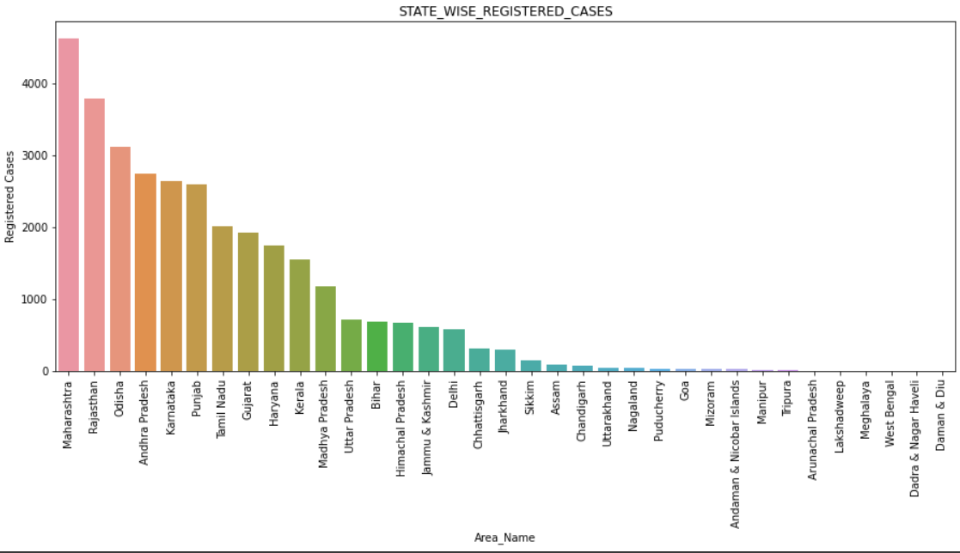

**SELECT abc.Area_Name, abc.Convicted_Cases, abd.Arrested_Convicted_Persons**

**FROM**

**(SELECT Area_Name, SUM(AC23_No_of_cases_convicted_during_the_year) as Convicted_Cases**

**FROM "23_Anti_corruprion_cases"**

**GROUP BY Area_Name) abc**

**INNER JOIN**

**(SELECT Area_Name, SUM(ACA11_No_of_persons_convicted_during_the_year) as Arrested_Convicted_Persons**

**FROM "24_Anti_corruption_arrests"**

**GROUP BY Area_Name) abd**

**ON abc.Area_Name = abd.Area_Name**

**ORDER BY abc.Convicted_Cases DESC;**

Maharashtra has highest Convicted Cases (1107) and Convicted Persons (1345) arrested.

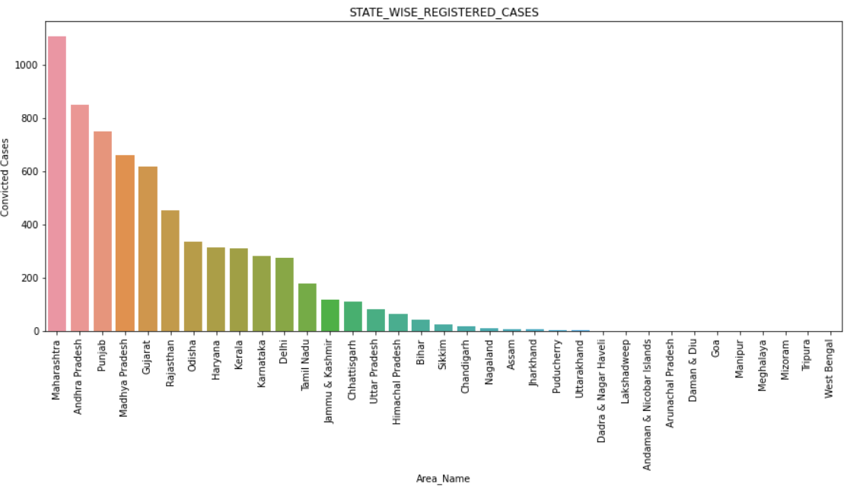

**SELECT abc.Area_Name, abc.Registered_Cases, abd.Arrested_Persons, abc.Convicted_Cases, abd.Arrested_Convicted_Persons**

**FROM**

**(SELECT Area_Name, SUM(AC02_No_of_cases_registered_during_the_year) as Registered_Cases,SUM(AC23_No_of_cases_convicted_during_the_year) as Convicted_Cases**

**FROM "23_Anti_corruprion_cases"**

**GROUP BY Area_Name) abc**

**INNER JOIN**

**(SELECT Area_Name, SUM(ACA02_No_of_persons_arrested_during_the_year) as Arrested_Persons,SUM(ACA11_No_of_persons_convicted_during_the_year) as Arrested_Convicted_Persons**

**FROM "24_Anti_corruption_arrests"**

**GROUP BY Area_Name) abd**

**ON abc.Area_Name = abd.Area_Name**

**ORDER BY abc.Registered_Cases ASC LIMIT 1;**

Daman & Diu has the Zero Convicted Cases and Zero Convicted Persons arrested.

**SELECT abc.Area_Name, abc.Acquitted_Cases, abd.Arrested_Acquitted_Persons**

**FROM**

**(SELECT Area_Name, SUM(AC02_No_of_cases_registered_during_the_year) as Registered_Cases, SUM(AC24_No_of_cases_acquitted_or_discharged_during_the_year) as Acquitted_Cases**

**FROM "23_Anti_corruprion_cases"**

**GROUP BY Area_Name) abc**

**INNER JOIN**

**(SELECT Area_Name, SUM(ACA12_No_of_persons_acquitted_during_the_year) as Arrested_Acquitted_Persons**

**FROM "24_Anti_corruption_arrests"**

**GROUP BY Area_Name) abd**

**ON abc.Area_Name = abd.Area_Name**

**ORDER BY abc.Registered_Cases DESC, abc.Acquitted_Cases DESC;**

**Maharashtra has highest acquitted Cases and persons acquitted. Daman & Diu has no Acquitted Case and no persons acquitted.**

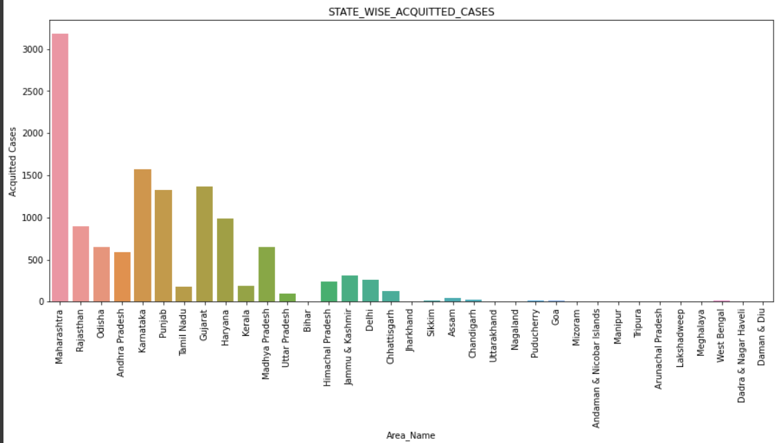

**SELECT abc.Area_Name, abc.Total_No_Of_Cases_For_Trial, abd.Total_No_Of_Persons_Under_Trial**

**FROM**

**(SELECT Area_Name, SUM(AC02_No_of_cases_registered_during_the_year) as Registered_Cases,**

**SUM(AC20_Total_No_of_cases_for_trial_during_the_year) as Total_No_Of_Cases_For_Trial**

**FROM "23_Anti_corruprion_cases"**

**GROUP BY Area_Name) abc**

**INNER JOIN**

**(SELECT Area_Name, SUM(ACA07_Total_No_of_persons_under_trial_during_the_year) as Total_No_Of_Persons_Under_Trial**

**FROM "24_Anti_corruption_arrests"**

**GROUP BY Area_Name) abd**

**ON abc.Area_Name = abd.Area_Name**

**ORDER BY abc.Registered_Cases DESC, abc.Total_No_Of_Cases_For_Trial DESC;**

**Maharashtra has highest cases for going trial in all years and persons under trail. Daman & Diu has lowest Cases for going trial in all years and persons under trial.**

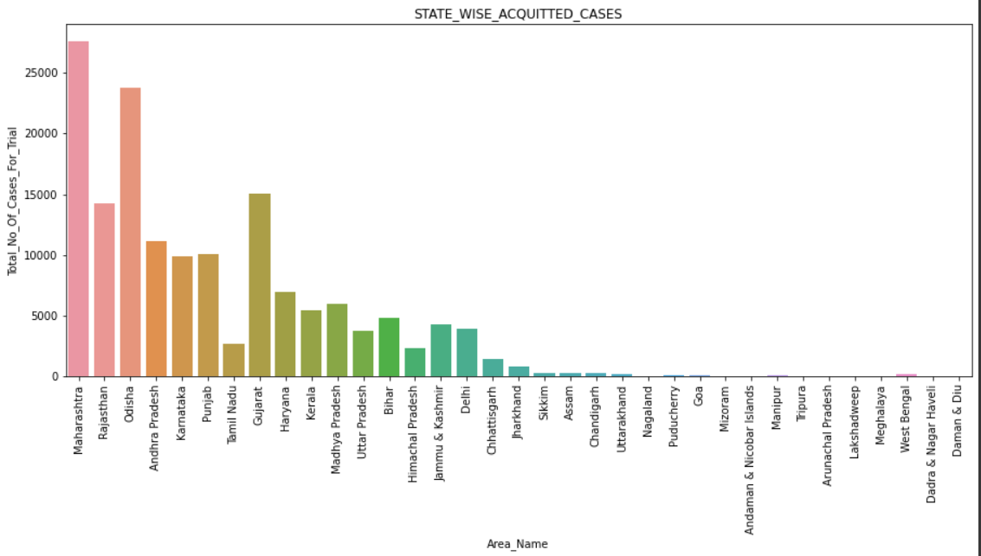

**SELECT abc.Area_Name, abc.No_of_Cases_Withdrawn_Or_Disposed_Off, abd.No_Of_Persons_who_Cases_withdrawn_or_Disposed_Off**

**FROM**

**(SELECT Area_Name,**

**SUM(AC21_No_of_cases_withdrawn_or_other_wise_disposed_off_on_account_of_death_of_the_accused_during_the_year) as No_of_Cases_Withdrawn_Or_Disposed_Off**

**FROM "23_Anti_corruprion_cases"**

**GROUP BY Area_Name) abc**

**INNER JOIN**

**(SELECT Area_Name,**

**SUM(ACA08_No_of_persons_whose_cases_were_withdrawn_or_otherwise_disposed_off_during_the_year) as No_Of_Persons_who_Cases_withdrawn_or_Disposed_Off**

**FROM "24_Anti_corruption_arrests"**

**GROUP BY Area_Name) abd**

**ON abc.Area_Name = abd.Area_Name**

**ORDER BY abc.No_of_Cases_Withdrawn_Or_Disposed_Off DESC , abd.No_Of_Persons_who_Cases_withdrawn_or_Disposed_Off DESC;**

Punjab is the one that highest cases were withdrawn or disposed off.

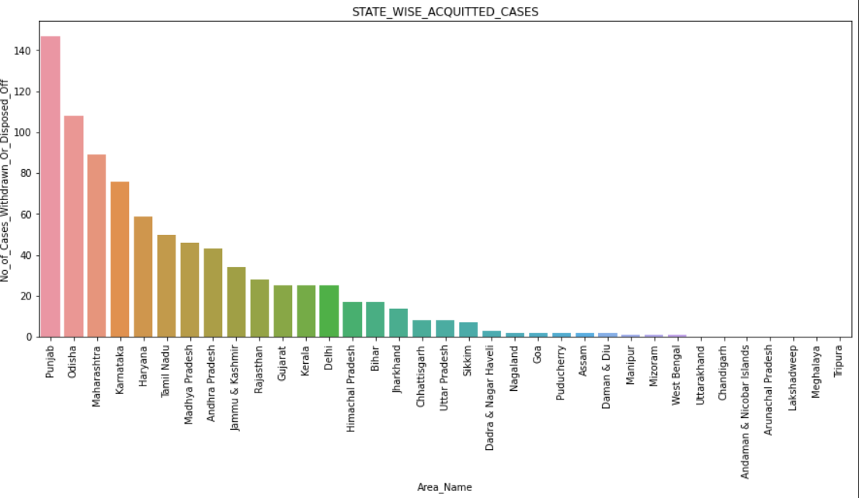

**SELECT abc.Area_Name, abc.Registered_Cases, abd.Arrested_Persons, abc.Convicted_Cases, abd.Arrested_Convicted_Persons,**

**abc.Acquitted_Cases, abd.Arrested_Acquitted_Persons, abc.Total_No_Of_Cases_For_Trial, abd.Total_No_Of_Persons_Under_Trial,**

**abc.No_of_Cases_Withdrawn_Or_Disposed_Off, abd.No_Of_Persons_who_Cases_withdrawn_or_Disposed_Off,**

**abc.No_of_cases_in_which_trials_were_completed, abd.No_of_persons_in_whose_cases_trials_were_completed,**

**abc.Percentage_of_cases_convicted_to_cases, abd.Percentage_of_persons_convicted_to_total_persons**

**FROM**

**(SELECT Area_Name, SUM(AC02_No_of_cases_registered_during_the_year) as Registered_Cases, SUM(AC23_No_of_cases_convicted_during_the_year) as Convicted_Cases,**

**SUM(AC24_No_of_cases_acquitted_or_discharged_during_the_year) as Acquitted_Cases, SUM(AC20_Total_No_of_cases_for_trial_during_the_year) as Total_No_Of_Cases_For_Trial,**

**SUM(AC21_No_of_cases_withdrawn_or_other_wise_disposed_off_on_account_of_death_of_the_accused_during_the_year) as No_of_Cases_Withdrawn_Or_Disposed_Off,**

**SUM(AC22_No_of_cases_in_which_trials_were_completed_during_the_year) as No_of_cases_in_which_trials_were_completed,**

**SUM(AC26_Percentage_of_cases_convicted_to_cases_in_which_trials_were_completed_during_the_year) as Percentage_of_cases_convicted_to_cases**

**FROM "23_Anti_corruprion_cases"**

**GROUP BY Area_Name) abc**

**INNER JOIN**

**(SELECT Area_Name, SUM(ACA02_No_of_persons_arrested_during_the_year) as Arrested_Persons, SUM(ACA11_No_of_persons_convicted_during_the_year) as Arrested_Convicted_Persons,**

**SUM(ACA12_No_of_persons_acquitted_during_the_year) as Arrested_Acquitted_Persons, SUM(ACA07_Total_No_of_persons_under_trial_during_the_year) as Total_No_Of_Persons_Under_Trial,**

**SUM(ACA08_No_of_persons_whose_cases_were_withdrawn_or_otherwise_disposed_off_during_the_year) as No_Of_Persons_who_Cases_withdrawn_or_Disposed_Off,**

**SUM(ACA10_No_of_persons_in_whose_cases_trials_were_completed_during_the_year) as No_of_persons_in_whose_cases_trials_were_completed,**

**SUM(ACA13_Percentage_of_persons_convicted_to_total_persons_in_whose_cases_trials_were_completed_during_the_year) as Percentage_of_persons_convicted_to_total_persons**

**FROM "24_Anti_corruption_arrests"**

**GROUP BY Area_Name) abd**

**ON abc.Area_Name = abd.Area_Name**

**ORDER BY abc.Registered_Cases DESC;**

**Among all the States, Maharashtra has highest number of anti-corruption cases and anti-corruption arrests happened. Daman & Diu has lowest number of anti-corruption cases and anti-corruption arrests happened.**