OPERATING SYSTEMS PROJECT REPORT
Producer–Consumer Conveyor System
A Physical Demonstration of the Producer–Consumer Synchronization Problem
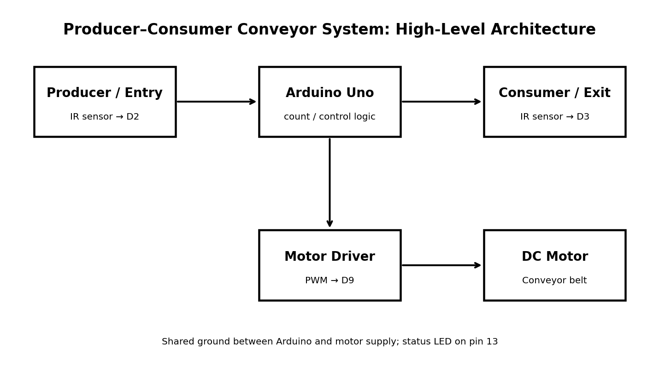
Submitted by
Lalit Choudhary (Ch.sc.u4cys25046) and Mohamad Nisar (Ch.sc.u4cys25053)
Department of CSE – Cyber Security
Amrita Vishwa Vidyapeetham
Academic Year 2026

Certificate
This is to certify that the project titled “Producer–Consumer Conveyor System” is a course project demonstrating the Producer–Consumer synchronization problem using an Arduino-controlled physical conveyor model. The work integrates operating-system concepts with embedded hardware and sensor-based automation.
Project Team: Lalit Choudhary (Ch.sc.u4cys25046) and Mohamad Nisar (Ch.sc.u4cys25053)
Faculty Signature: ____________________ Date: ____________________

Abstract
The Producer–Consumer problem is a fundamental operating-system synchronization problem in which a producer generates items and a consumer processes them through a shared bounded buffer. This project converts that abstract concept into a physical conveyor-belt system controlled by an Arduino Uno. Two IR obstacle sensors represent the producer-side entry and consumer-side exit. A variable named count represents the number of items currently present on the conveyor and acts as a semaphore-like resource counter. The conveyor is allowed to move only when items are available, while new items are blocked when the configured buffer capacity is reached. A status LED provides a simple visual indication of the buffer state. The implementation demonstrates overflow prevention, underflow prevention, sensor debouncing, motor control, and real-time event logging through the Arduino Serial Monitor.
Keywords: Producer–Consumer Problem, Operating Systems, Synchronization, Bounded Buffer, Semaphore, Arduino Uno, IR Sensor, Conveyor Belt, Embedded Systems

1. Introduction
Operating systems use synchronization mechanisms to coordinate concurrent activities that share resources. The Producer–Consumer problem is a classic example: a producer adds items to a finite buffer while a consumer removes them. If the buffer becomes full, the producer must wait; if the buffer is empty, the consumer cannot remove anything.
This project presents a tangible interpretation of that problem using a small conveyor-belt model. The Arduino acts as the controller, the conveyor acts as the bounded shared buffer, the entry station acts as the producer, and the exit station acts as the consumer.

2. Problem Statement
Design and implement a low-cost physical system that demonstrates the Producer–Consumer synchronization problem. The system must track the number of items on a conveyor, prevent the producer from adding items when the buffer is full, prevent the conveyor from operating when there are no items, and stop the belt when an item reaches the consumer station.

3. Objectives
- Design a working conveyor-based material-handling model.
- Map the Producer–Consumer problem onto a physical system.
- Use sensors to detect item entry and item removal.
- Maintain a bounded buffer with a default capacity of three items.
- Prevent buffer overflow and underflow.
- Control a DC motor using PWM through a motor driver.
- Provide visual status using the Arduino built-in LED.
- Log production and consumption events through the Serial Monitor.

4. Operating-System Concepts
OS Concept | Physical Representation | Role
Producer | Entry station / entry IR sensor | Places or detects new items.
Consumer | Exit station / exit IR sensor | Removes or detects completed items.
Bounded Buffer | Conveyor belt | Stores a maximum of three items.
Semaphore / Counter | count variable | Tracks current items on the belt.
Synchronization | Sensor-driven control logic | Coordinates entry, movement and removal.
Mutual Exclusion | One item at a sensor gate at a time | Avoids conflicting state changes.
Overflow Prevention | count == BUFFER_SIZE | Rejects new items and signals WAIT.
Underflow Prevention | count > 0 condition | Prevents invalid consumption and empty-belt motion.

5. System Architecture
The entry sensor is connected to D2, the exit sensor to D3, and the motor control signal to D9. The built-in LED on pin 13 communicates the buffer state. The motor uses a separate power supply, while the Arduino and motor supply share a common ground.

6. Hardware and Software Requirements

6.1 Hardware
Component | Qty. | Purpose
Arduino Uno | 1 | Central controller
IR obstacle sensor module | 2 | Entry and exit item detection
DC motor | 1 | Drives the conveyor belt
Motor driver / TIP120 or L298N | 1 | Motor switching/control
1N4007 diode | 1 | Flyback protection when applicable
1 kΩ resistor | 1 | Transistor base resistor when using TIP120
9 V battery / separate motor supply | 1 | Motor power source
Conveyor belt/model | 1 | Physical bounded buffer

6.2 Software
- Arduino IDE
- Arduino C/C++ sketch
- Serial Monitor at 9600 baud
- Optional Tinkercad simulation using pushbuttons as sensor substitutes

7. Pin Configuration and Wiring
Connection | Arduino Pin / Source | Purpose
Entry IR sensor OUT | D2 | Detects producer-side item entry
Exit IR sensor OUT | D3 | Detects consumer-side item removal
Motor driver PWM / input | D9 | Controls conveyor motor speed
Status LED | Built-in D13 | Shows empty, active and full states
Sensor VCC | 5V | Sensor supply
Sensor GND | GND | Common reference
Motor supply | Separate supply | Powers DC motor
Ground | Shared GND | Common reference between controller and motor circuit
The DC motor should not be powered directly from an Arduino I/O pin. A suitable driver/transistor stage and separate motor supply are used, with a shared ground.

8. Working Principle
1. Initialization: the Arduino configures the two sensor inputs, motor output and built-in LED, then starts serial communication at 9600 baud.
2. Producer detection: when the entry sensor detects an item, the program checks whether count is below BUFFER_SIZE.
3. Buffer update: if space exists, count is incremented and a PRODUCE event is printed.
4. Overflow control: when count reaches the buffer limit, new entries are rejected and an OVERFLOW message is logged.
5. Conveyor movement: the motor runs only when count is greater than zero and no item is waiting at the exit sensor.
6. Consumer detection: when the item leaves the exit sensor, count is decremented if at least one item is present.
7. Status indication: LED OFF means empty, solid LED means items are present, and fast blinking indicates a full buffer.
8. Repeat: the controller continuously monitors both sensors and repeats the cycle.

9. Algorithm and Control Logic
The core state variable is count. The default BUFFER_SIZE is 3. Sensor readings are debounced for 40 ms to reduce false transitions.

9.1 Pseudocode
START
Initialize entry sensor D2, exit sensor D3, motor D9 and LED D13
Set count = 0
Set BUFFER_SIZE = 3
LOOP:
Read and debounce entry sensor
IF new item detected at entry:
IF count < BUFFER_SIZE:
count = count + 1
log PRODUCE
ELSE:
log OVERFLOW BLOCKED
Read and debounce exit sensor
IF item removed from exit:
IF count > 0:
count = count - 1
log CONSUME
IF count > 0 AND no item is waiting at exit:
run motor at PWM 180
ELSE:
stop motor
IF count == 0:
LED OFF
ELSE IF count == BUFFER_SIZE:
LED FAST BLINK
ELSE:
LED SOLID
END LOOP

10. Implementation Details
The Arduino sketch defines ENTRY_PIN = 2, EXIT_PIN = 3, MOTOR_PIN = 9 and LED_PIN = 13. BUFFER_SIZE is set to 3 and MOTOR_SPEED is set to 180 on a 0–255 PWM scale. SENSOR_ACTIVE_LOW is enabled for common IR modules that report detection as LOW. A 40 ms debounce interval is used.
A Sensor structure stores the pin, stable state, previous raw state and the timestamp of the most recent raw-state change. The updateSensor function uses these values to identify stable state transitions.
The belt control condition runs the motor when there is at least one item on the belt and the exit sensor is not occupied. This ensures that the consumer station can remove an item before the next item is delivered.

11. Testing and Expected Results
Test Case | Condition | Expected State | Expected Result
Empty buffer | count = 0 | Motor OFF; LED OFF | No item moves.
Single item produced | count = 1 | Motor ON; LED solid | Item is transported.
Item reaches exit | Exit sensor active | Motor OFF | Consumer can remove item.
Item consumed | count decreases | Motor resumes if count > 0 | Next item can advance.
Buffer reaches 3 | count = 3 | LED fast blink | Additional producer input is blocked.
Producer attempts 4th item | count = 3 | OVERFLOW blocked message | Buffer remains safe.
No items available | count = 0 | Motor remains OFF | Underflow is prevented.

12. Applications
- Industrial packaging and sorting lines
- Warehouse and inventory automation
- Assembly-line material movement
- Educational demonstration of synchronization and bounded buffers
- Small-scale automation prototypes

13. Limitations
- The prototype has a small fixed buffer capacity.
- Basic IR sensors can be affected by alignment, object reflectivity and ambient conditions.
- A single Arduino controller limits scalability for large industrial systems.
- The model does not include advanced load sensing or network monitoring.
- The physical prototype is intended as an educational demonstration rather than an industrial safety-certified conveyor.

14. Future Scope
- Add IoT connectivity for remote monitoring and event logging.
- Support multiple producers and consumers.
- Add load cells or additional sensors for better item tracking.
- Introduce a queue display or LCD/OLED showing buffer occupancy.
- Add emergency-stop and fault-detection mechanisms for a more realistic industrial prototype.
- Compare semaphore, mutex and queue-based implementations in software alongside the physical model.
- Add a dashboard for real-time statistics such as throughput and waiting time.

15. Conclusion
The Producer–Consumer Conveyor System successfully connects a fundamental operating-system synchronization problem with a physical automation model. The Arduino controller maintains a bounded item count, prevents overflow when the conveyor is full, prevents underflow by refusing to run an empty belt, and coordinates production and consumption using sensor events. The project demonstrates that synchronization principles used in operating systems can be applied directly to real-world automation systems such as packaging, warehousing and assembly lines.
The project therefore provides both conceptual and practical understanding of bounded buffers, synchronization, resource tracking, sensor-driven control and embedded-system programming.

16. References
- Project repository: https://github.com/choudharylalit366-oss/OS-Project
- Repository file: conveyor_producer_consumer_ino file.ino
- Repository file: conveyor_wiring_diagram.svg
- Arduino documentation and Arduino IDE resources.
- Operating Systems course material covering the Producer–Consumer problem, bounded buffers and synchronization.

