Name: Ritik

UID :20BCA1250

Section : BCA 4/A

Assignment: 2

Question 1: Create the portfolio using HTML

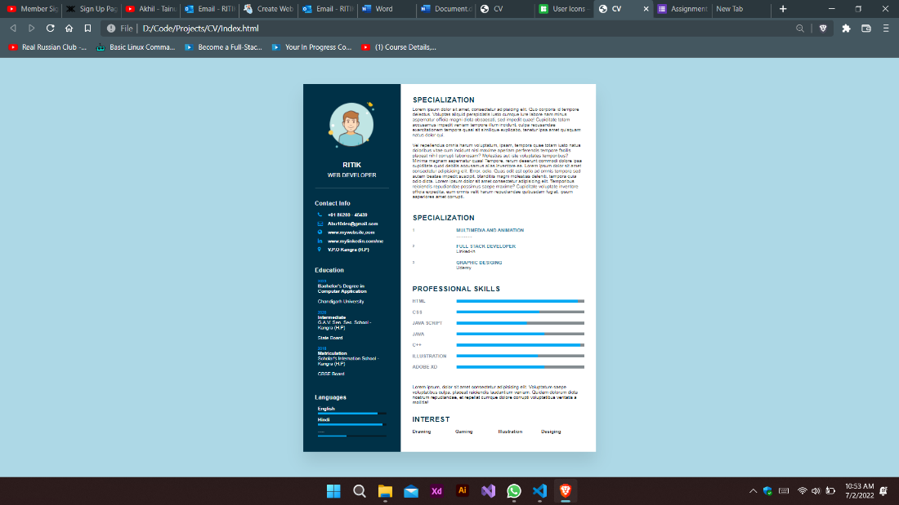

Question 2: Step to create a portfolio:

1.First go to Azure account and create a resources

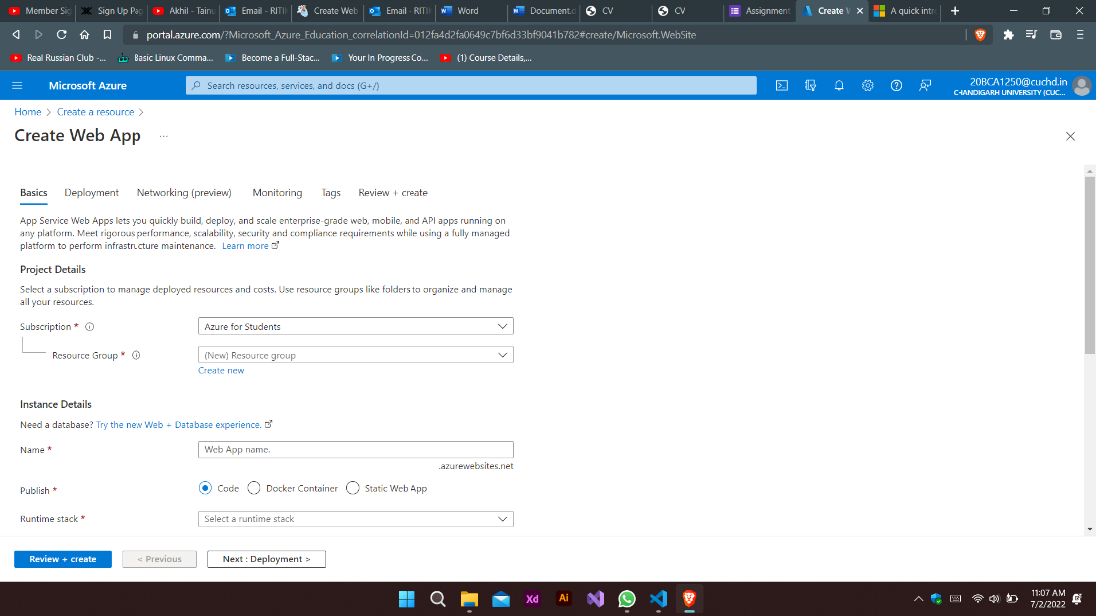

Then go to web app and click create:

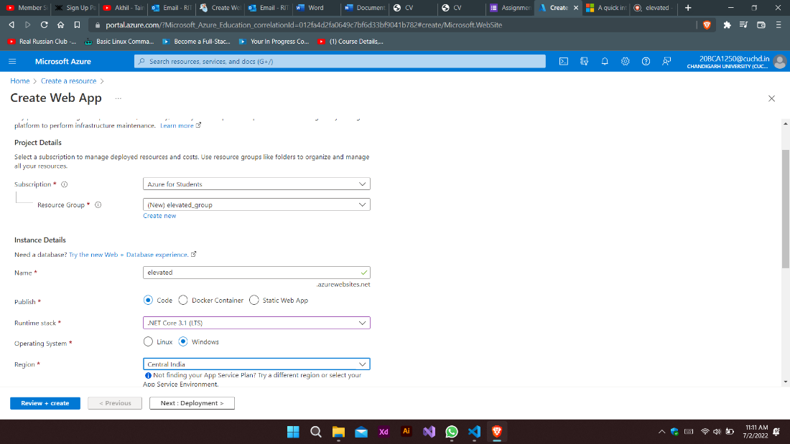

And the Create web App

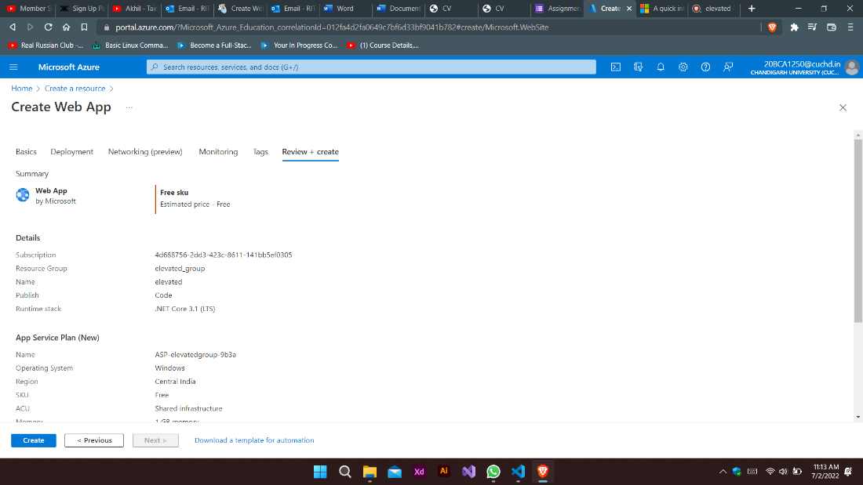

And then go to resources

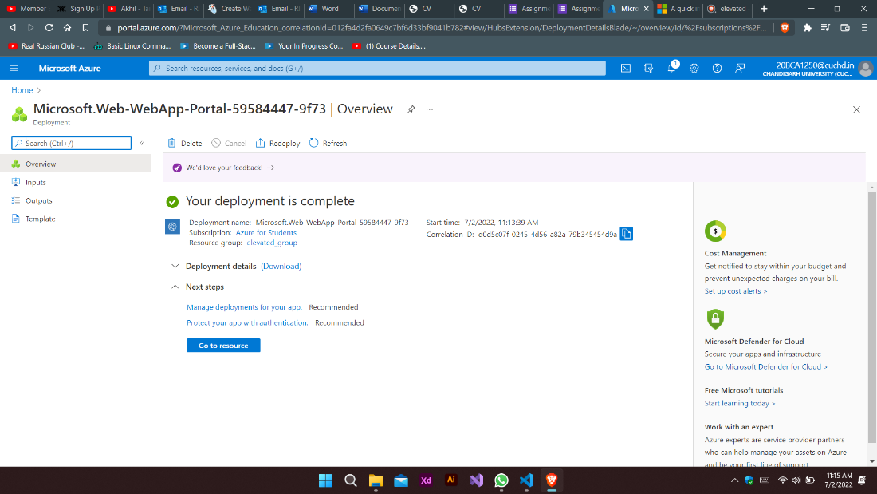

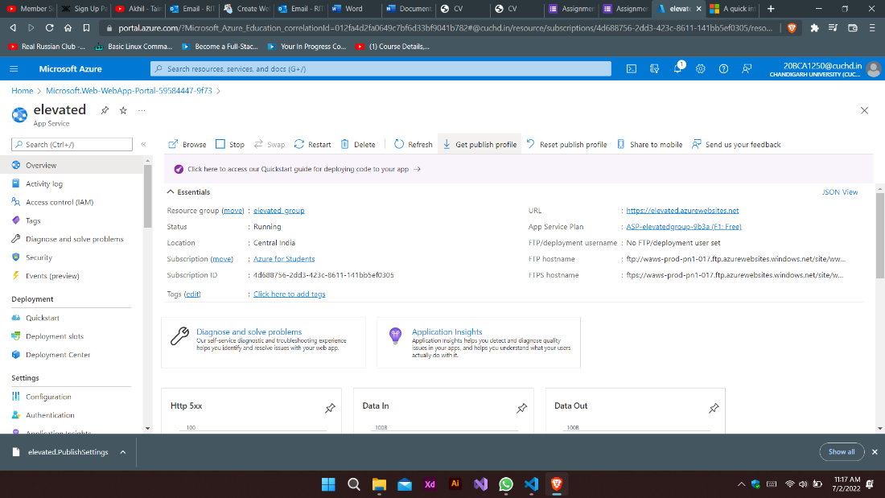

Copy ftp link form the notepad file which we download from the resources:

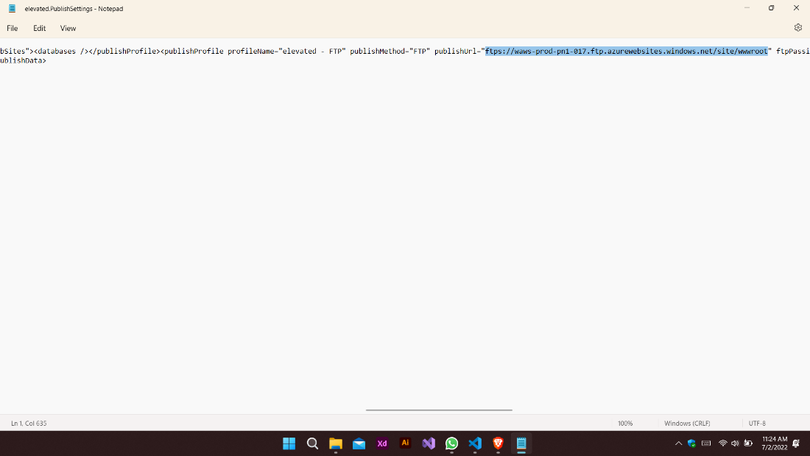

And Copy username and password and paste here:

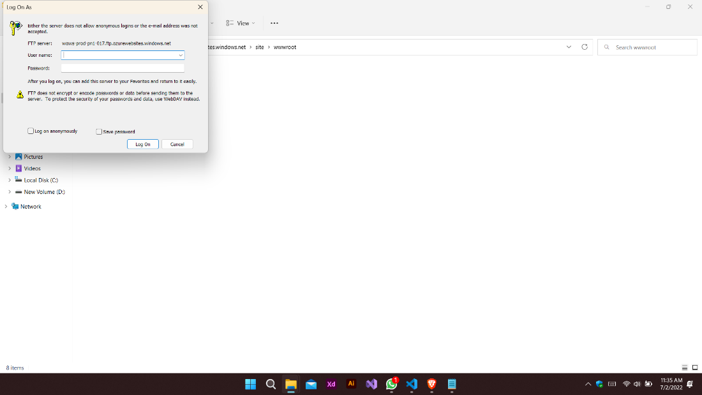

And paste here index.html file :

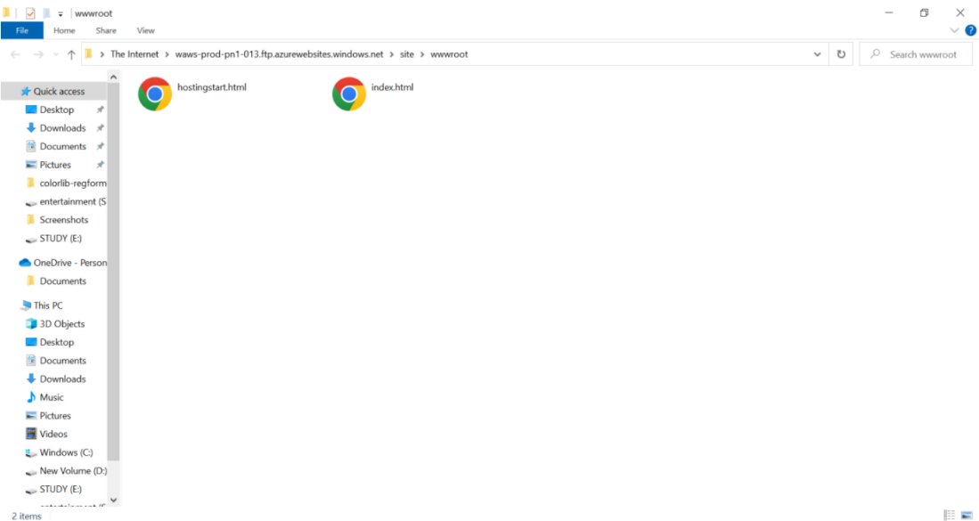

Then final webapp Here

