1. Footprinting and Reconnaissance

* Find the IP address : Using command prompt ping command

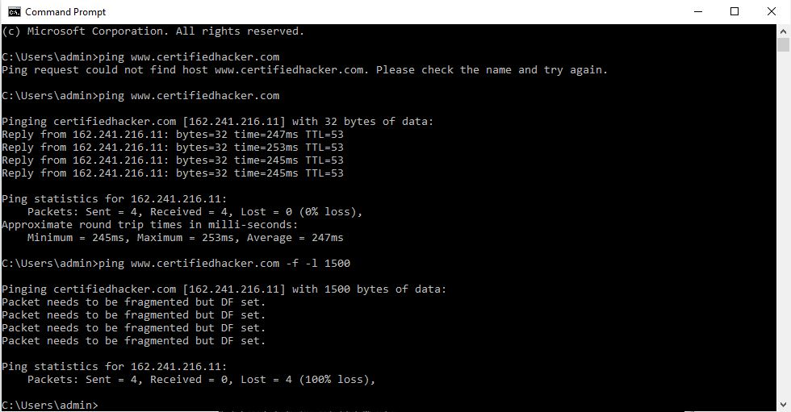

* Tracert : This command trace route network configuration information of target domain.

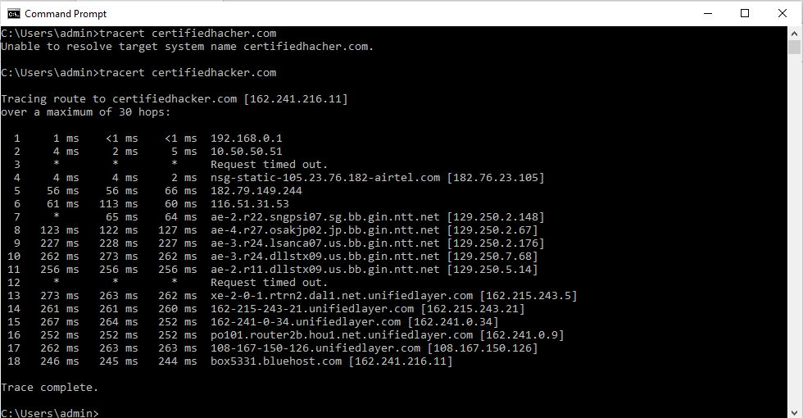

* nslookup : to obtain IP address of target domain.

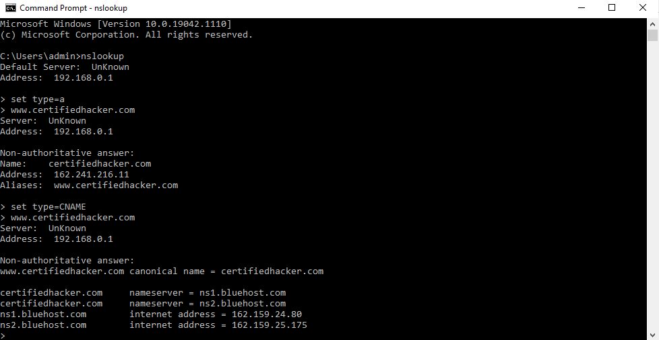

* Finding companies Sub domains

using Sublist3r

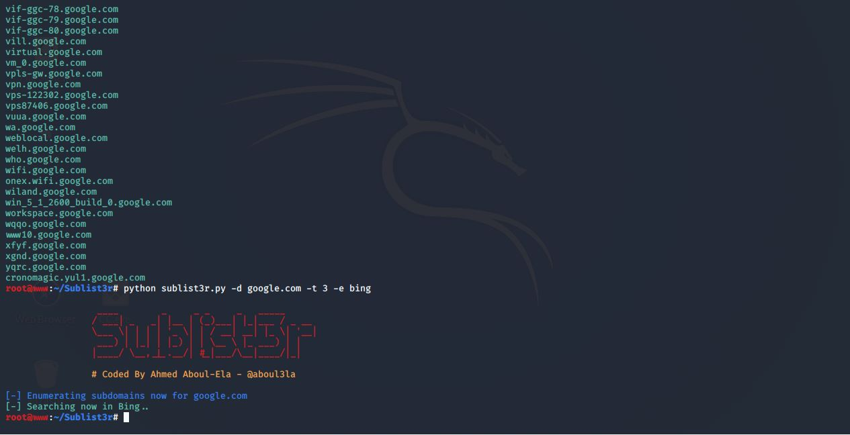

* Gathering information from LinkedIn through InSpy

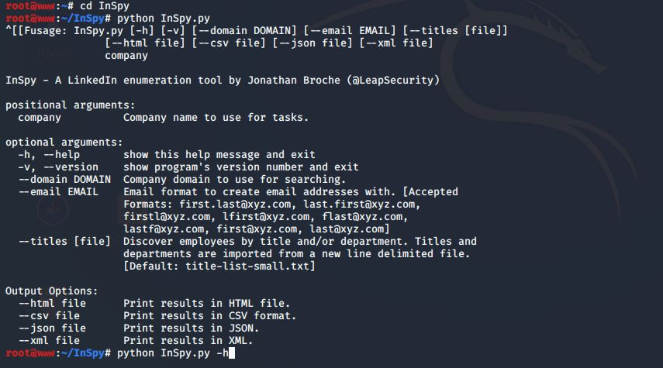

* Extracting data from webpage using WebDataExtractor

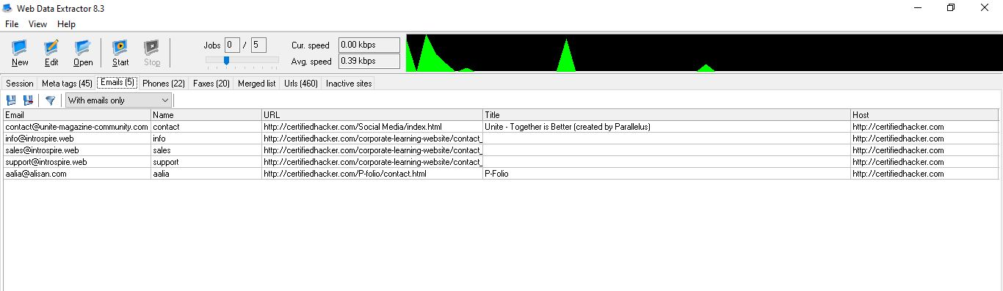

* Host discovery and personal information using recon-ng

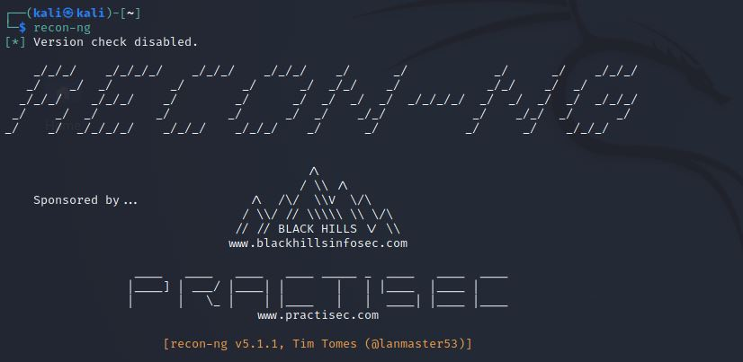

* The Harvester gives us domains,emails,subdomains

