**Enumeration**

1. NetBIOS Enumeration by NetBIOS Enumerator

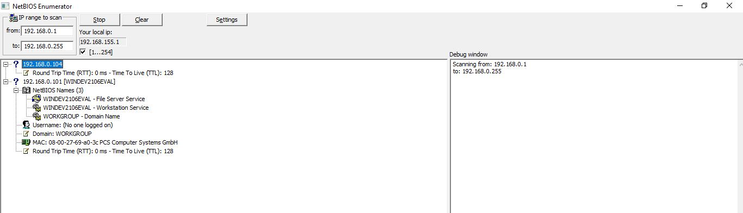

2. SNMP (Simple Network Management Protocol) using SoftPerfectNetwork Scanner

