**1. MAC flooding using macof**

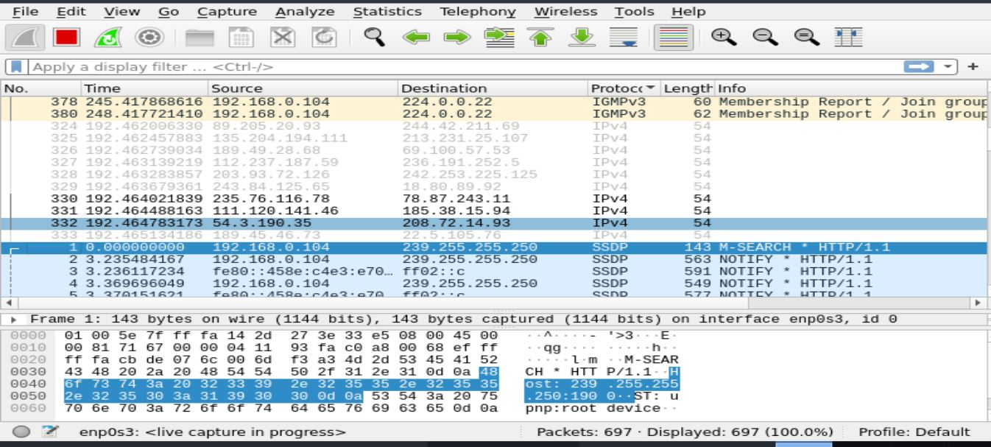

**2. DHCP starvation attack**

