WEEK 3 TASK REPORT
Front-End Implementation and Functionality Demonstration
E-Governance Citizen Service Portal
CitizenConnect
HTML5 • CSS3 • JavaScript

1. Introduction
CitizenConnect is a self-contained E-Governance front-end prototype created for the Week 3 task. It demonstrates responsive design and interactive browser-side functionality without requiring a backend database.

2. Objectives
- Create a structured citizen-service portal.
- Implement at least three interactive components.
- Support desktop and mobile layouts.
- Use JavaScript for dynamic content, validation and modal interaction.
- Provide screenshots, technical explanation, testing evidence and future improvements.

3. Technology Used
- HTML5 for page structure and forms.
- CSS3 for responsive layouts, cards, modal styling and mobile breakpoints.
- JavaScript for menu interaction, dynamic fields, form validation, modal status display and theme behavior.
- No external libraries or backend are required.

4. Project Structure
e_governance_week3/
├── index.html
├── services.html
├── status.html
├── css/style.css
├── js/script.js
├── assets/screenshots/
└── README.txt

5. Interactive Components

5.1 Responsive Navigation Menu
The desktop navigation changes to a mobile hamburger menu below the responsive breakpoint. JavaScript toggles the open state and updates aria-expanded.
const open = navMenu.classList.toggle("open");
menuToggle.setAttribute("aria-expanded", String(open));

5.2 Dynamic Service Form
Selecting Birth Certificate, Income Certificate or Residence Certificate replaces the dynamic-fields area with service-specific fields. The form also validates the service, applicant name and 10-digit mobile number before showing a demonstration reference number.
serviceType.addEventListener("change", () => {
dynamicFields.innerHTML = templates[serviceType.value] || emptyMessage;
});

5.3 Application Status Modal
The status page accepts a reference number and opens a modal containing the sample application status. The popup can be closed using the close control or Done button.
modal.classList.add("show");
modal.setAttribute("aria-hidden", "false");

5.4 Theme Toggle
An additional theme button demonstrates another simple interaction and can be extended with persistent localStorage settings.

6. Responsive Design
- CSS Grid is used for the main desktop layouts.
- Service cards collapse to one column on narrow screens.
- The navigation becomes a hamburger menu on mobile.
- Form controls expand to the available viewport width.
- The viewport meta tag is included on every page.

7. Screenshots
Figure 1. Desktop home page
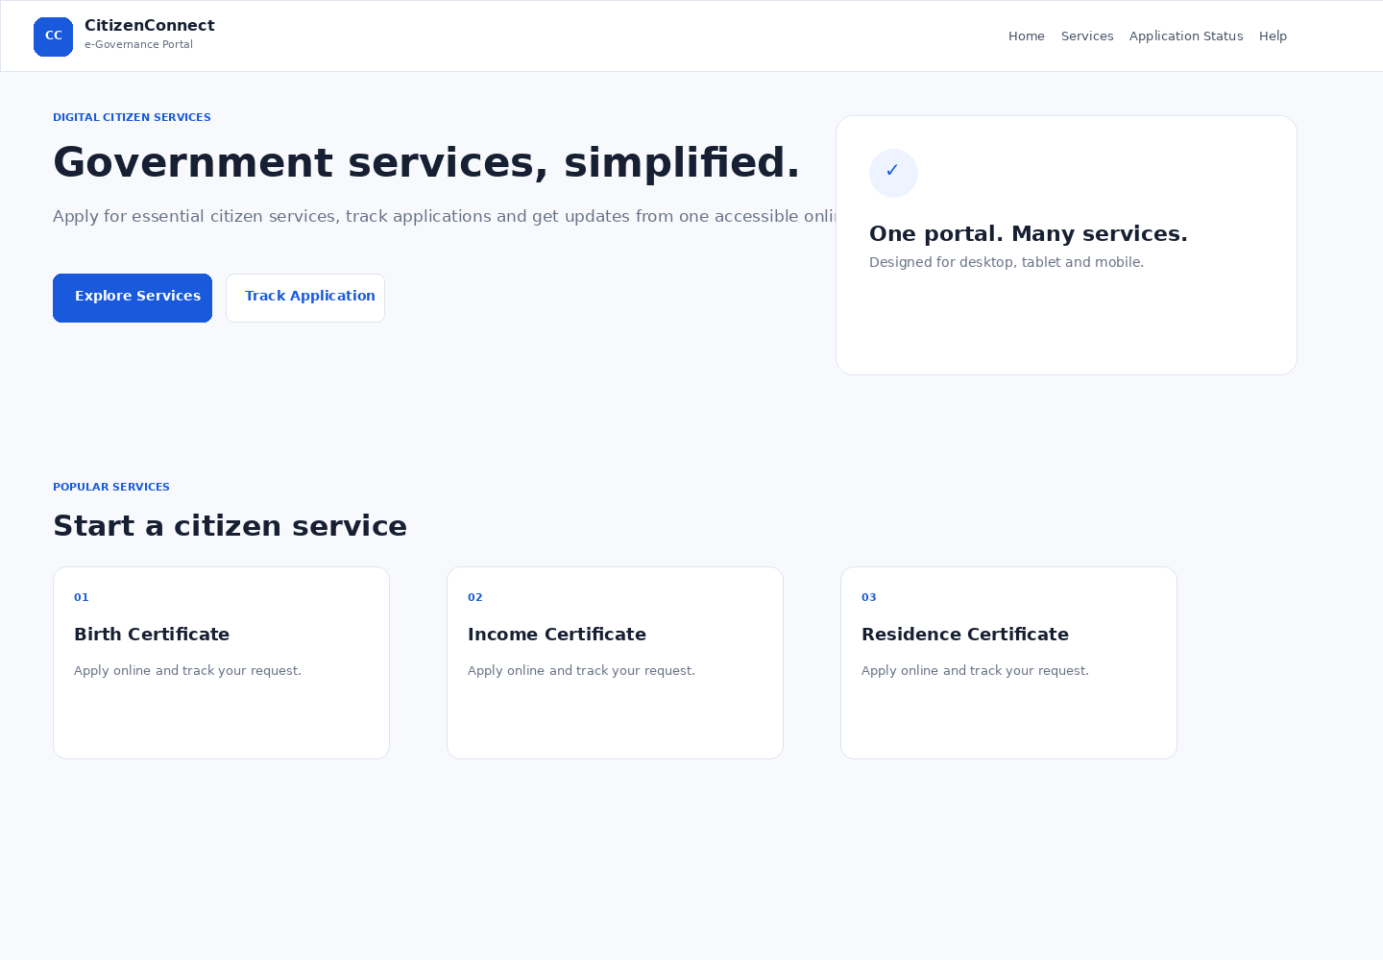
Figure 2. Desktop dynamic service form
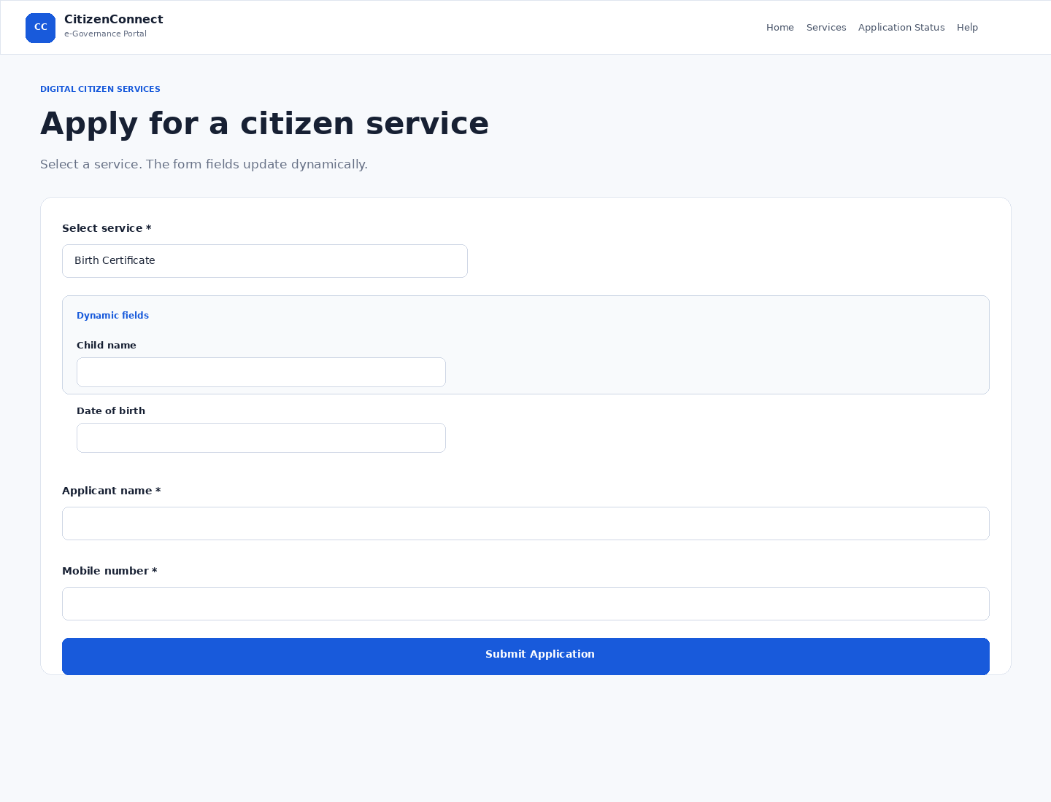
Figure 3. Application status modal
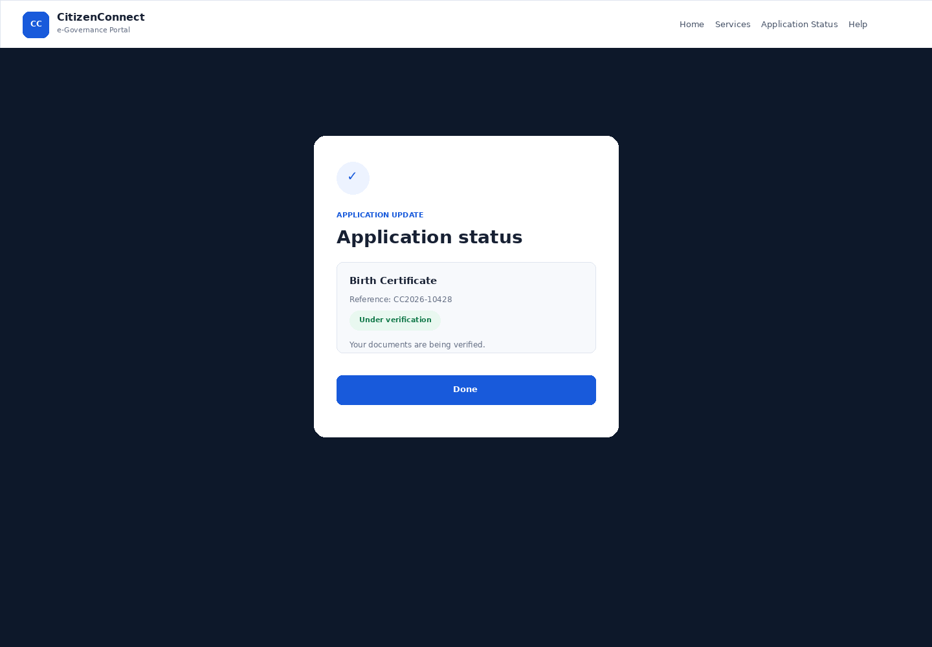
Figure 4. Mobile responsive home page
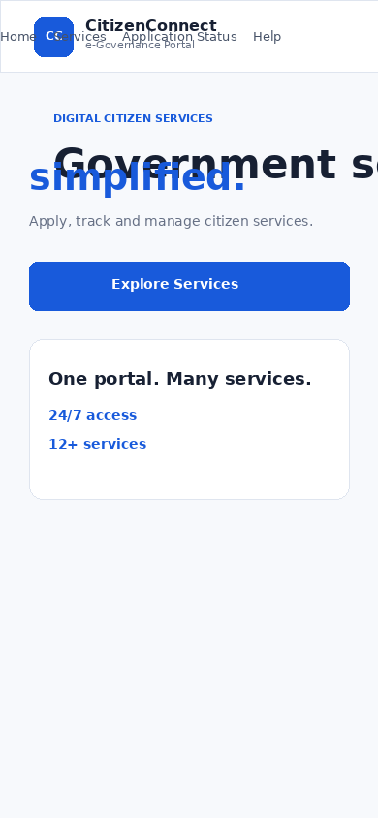
Figure 5. Mobile responsive service form
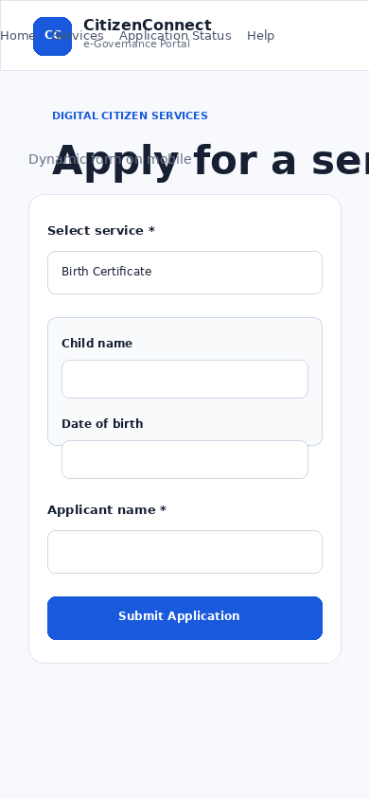

8. Testing
Test | Expected | Result | Status
Navigation | Correct page/menu state | Verified | Pass
Dynamic service fields | Fields change by selection | Verified | Pass
Form validation | Invalid data rejected | Verified | Pass
Form submission | Reference displayed | Verified | Pass
Status modal | Status opens in popup | Verified | Pass
Modal close | Popup closes | Verified | Pass
Responsive layout | Works on mobile width | Verified | Pass

9. Challenges and Solutions
Dynamic UI without backend: JavaScript template strings provide realistic dynamic fields and sample status data entirely in the browser.
Mobile navigation: A CSS media query and JavaScript class toggle convert the desktop menu into a mobile menu.
Input validation: Required service/name checks and a regular expression for a 10-digit mobile number provide immediate feedback.
Modal interaction: The status popup uses a dedicated overlay and close controls so the interaction is isolated from the main page.

10. Potential Improvements
- Connect the application form to a secure backend and database.
- Add authentication for citizens and administrators.
- Add document upload and real government API integration.
- Add server-side validation and secure storage.
- Add multilingual support and accessibility audits.
- Add real-time status updates, SMS/email notifications and downloadable certificates.
- Perform automated testing across Chrome, Edge, Firefox and Safari.

11. Conclusion
The project meets the Week 3 front-end objective by combining HTML, CSS and JavaScript into a responsive citizen-service portal with multiple working interactions. The implementation is intentionally self-contained so it can be demonstrated easily and extended later with backend services.

