WEEK 2 TASK
Designing and Wireframing the User Interface
E-Governance and Digital Services Web Application
Proposed System: e-SevaConnect
UI/UX Design & Wireframing Document
Prepared by: Soni Choudhary
B.Tech – Computer Science and Engineering
Date: 25 August 2026

1. Design Overview
This document defines the user-interface and user-experience design for e-SevaConnect, the e-governance portal proposed in Week 1. The design translates the earlier functional requirements into a clear, accessible and task-oriented interface. Five high-fidelity-style wireframes are included for the homepage, service details, application form, citizen dashboard and application tracking.
The interface is designed around a simple principle: a citizen should be able to discover a service, understand what is required, submit an application and see its progress without needing to understand internal government processes.

2. User Research & UX Analysis
The design considers common e-governance needs: service discoverability, clear eligibility information, document requirements, application status, notifications, help and grievance handling. Accessibility is treated as a core requirement rather than an optional feature.

2.1 Design Principles
- Clarity over visual complexity
- Mobile-first responsive layout
- Consistent navigation and terminology
- Progressive disclosure for long forms
- Visible status and next actions
- Error prevention and helpful validation
- Accessible keyboard and assistive-technology use
- Multilingual-ready content structure
- Trust through transparent timelines and confirmations

2.2 Accessibility Basis
The design follows the spirit of W3C Web Content Accessibility Guidelines (WCAG), including keyboard operability, sufficient time for users to complete tasks, clear structure and accessible interaction patterns. WCAG guidance specifically addresses keyboard operation and avoiding keyboard traps. citeturn0search12

3. Visual Design System
Element | Design Decision | Rationale
Primary colour | Deep blue/indigo with white surfaces | Communicates trust and keeps government-service UI professional.
Accent colour | Green for successful/completed actions | Provides a clear positive state without relying only on colour.
Warning/Error | Amber/red with text labels and icons | Makes important states understandable to colour-blind users.
Typography | Clean sans-serif, 16px+ body target | Improves readability across devices.
Buttons | One prominent primary action per screen | Reduces decision overload.
Cards | Light borders and generous spacing | Groups services and information without visual clutter.
Icons | Simple familiar icons paired with text | Supports scanning without making icons the only label.
Status | Text + icon + visual timeline | Makes application progress understandable at a glance.

4. Information Architecture
Primary navigation: Home → Services → Track Application → Help/Grievance → Login/Profile. After login, the dashboard becomes the user's central workspace.
Core navigation flow:
Homepage → Service Search → Service Details → Application Form → Review → Confirmation → Dashboard → Application Tracking → Feedback/Grievance

5. Wireframe 1 — Homepage
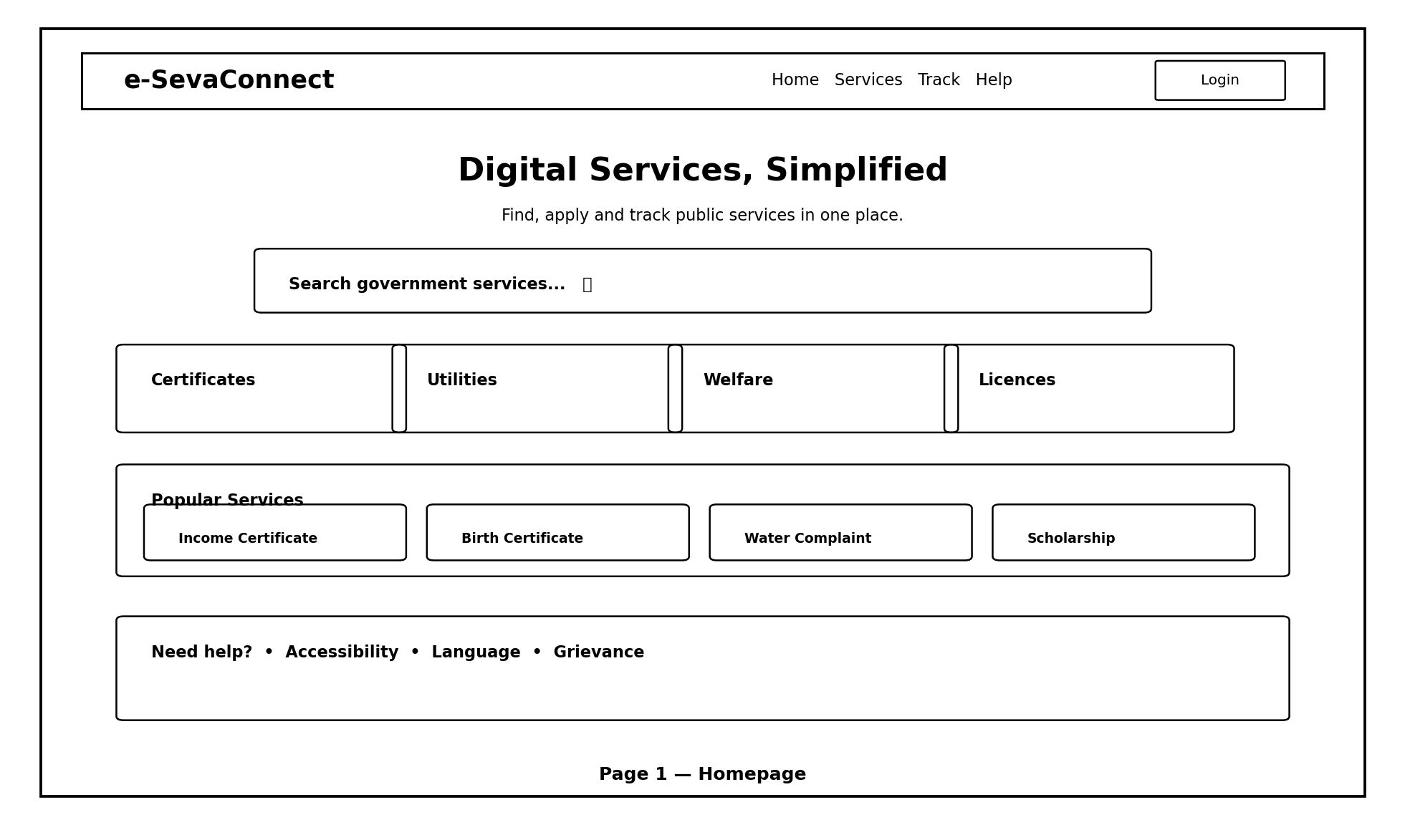
Annotations: (1) Persistent brand/navigation area builds familiarity. (2) Large search field supports users who know the service name. (3) Category cards help users who do not know the exact service. (4) Popular services reduce time-to-task. (5) Help, accessibility, language and grievance links remain easy to find.
Design rationale: The homepage prioritises service discovery rather than promotional content. This is appropriate for an e-governance portal where the user's main goal is completing a task.

6. Wireframe 2 — Service Details
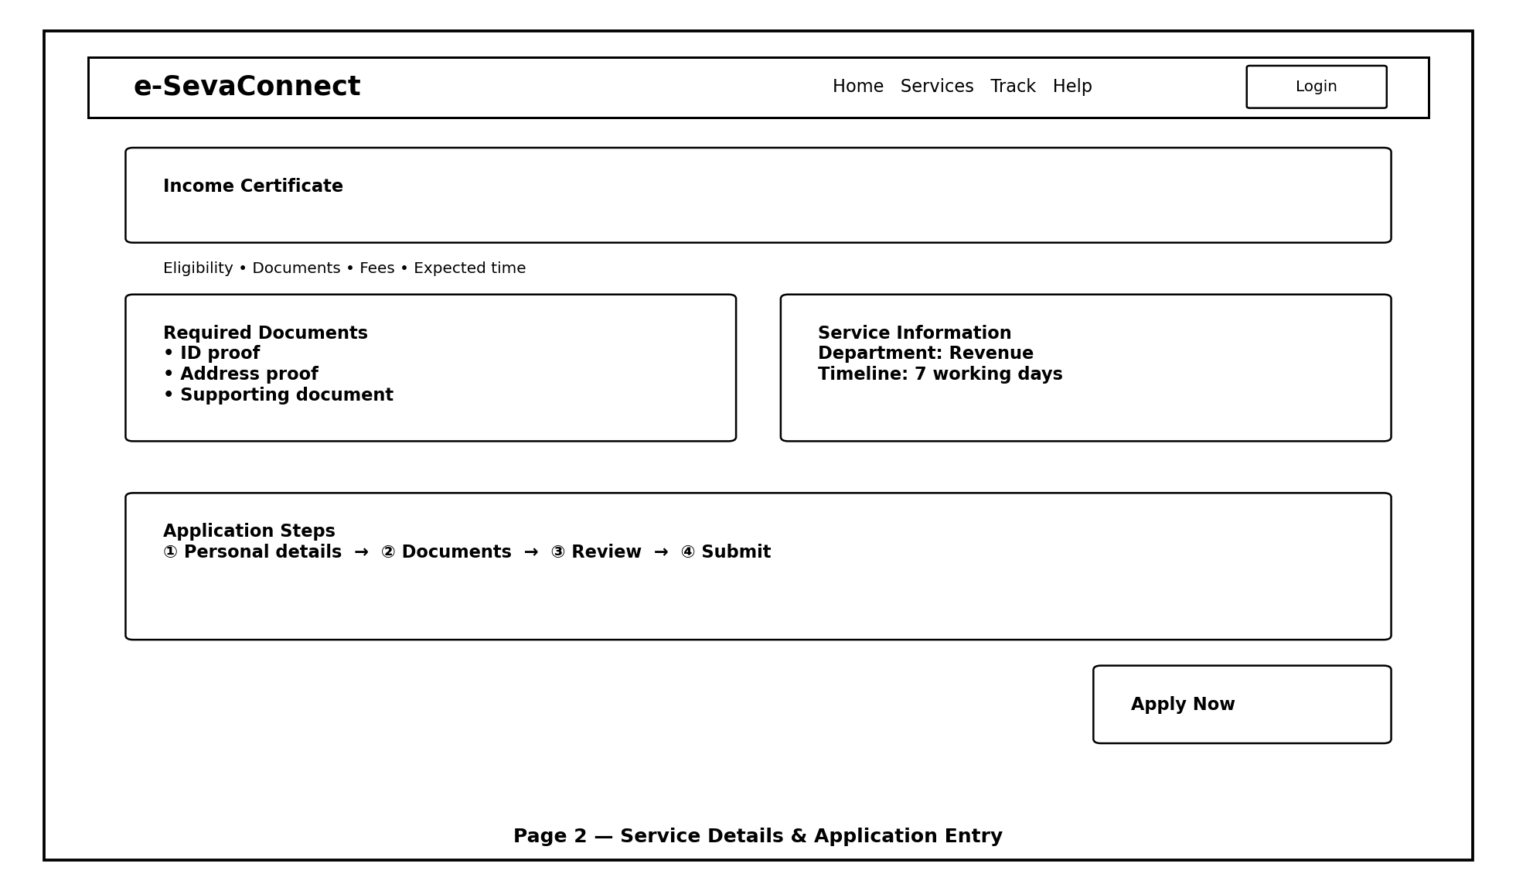
Annotations: The page exposes eligibility, documents, fees, expected processing time and application steps before the user commits to applying. The prominent “Apply Now” action appears only after the requirements are visible.
Design rationale: Pre-application transparency reduces failed submissions and helps citizens prepare documents in advance.

7. Wireframe 3 — Service Request Form
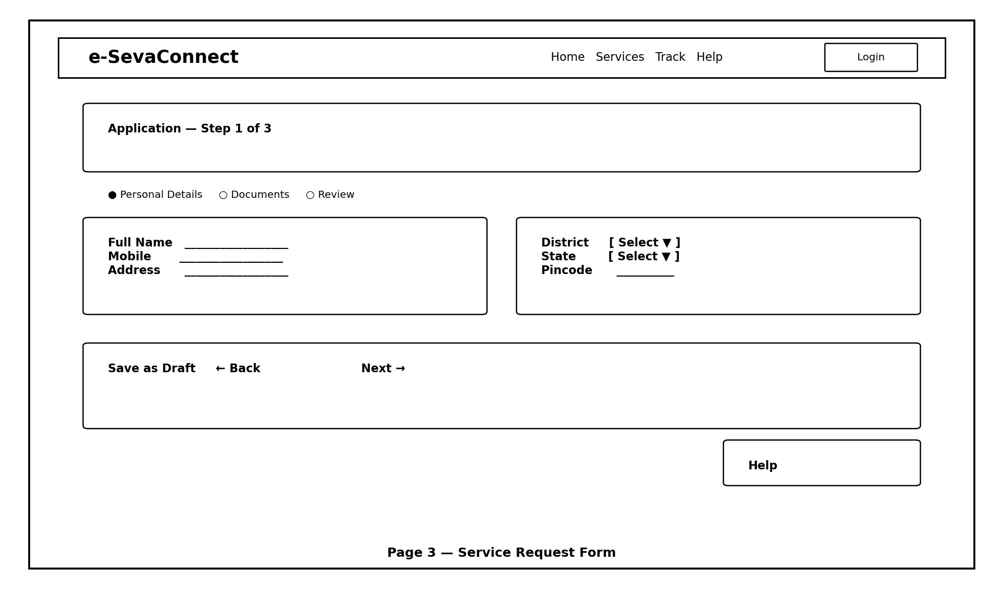
Annotations: A three-step progress indicator communicates where the user is. Fields are grouped logically, and “Save as Draft” supports users who need more time or documents. Back/Next controls create a predictable flow.
Design rationale: Breaking a long form into manageable steps reduces cognitive load. Validation should appear close to the relevant field and explain how to correct errors.

8. Wireframe 4 — Citizen Dashboard
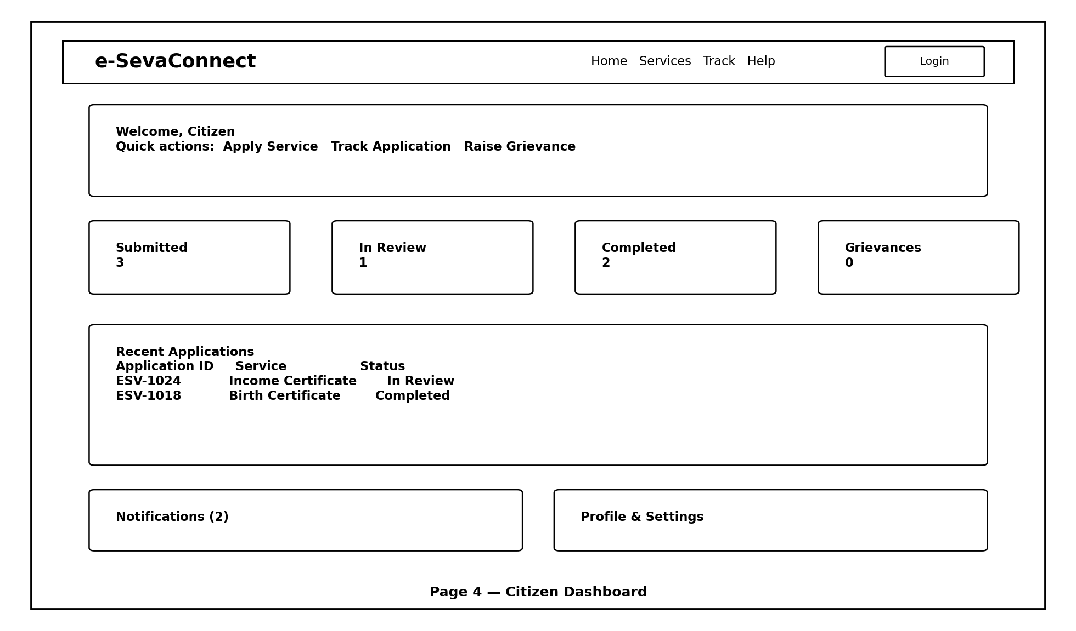
Annotations: Summary cards show submitted, in-review and completed requests. Recent applications are displayed with service names and statuses. Quick actions provide direct access to the most common tasks.
Design rationale: The dashboard acts as a personal service centre, reducing the need to repeatedly search for an application or service.

9. Wireframe 5 — Application Tracking
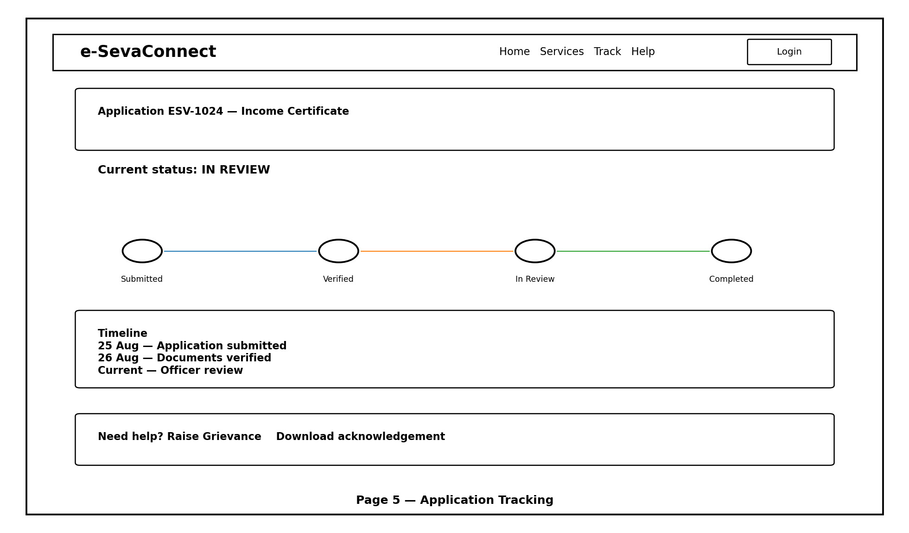
Annotations: The timeline communicates completed and current stages. A written event history provides detail, while help/grievance actions remain available. Status is communicated with both words and visual indicators.
Design rationale: Citizens should never have to guess whether an application is progressing. The timeline provides transparency and a clear expectation of the next step.

10. Interaction & Navigation Specification
Interaction | Expected Behaviour
Service search | Shows matching services as the user types; supports category/filter refinement.
Apply Now | Opens the application flow after displaying service requirements.
Save as Draft | Stores incomplete application and returns the user to dashboard.
Next/Back | Moves through form steps while preserving entered data.
Submit | Shows review/confirmation before final submission.
Status timeline | Highlights current stage and exposes relevant timestamps.
Notification | Links directly to the affected application or grievance.
Grievance | Opens a guided complaint form with category, description and attachment options.
Language | Changes interface labels and content to a selected supported language.
Accessibility | Supports keyboard navigation, focus visibility and readable labels.

11. Responsive Design Strategy
- Desktop: two-column layouts can be used where information density is high.
- Tablet: cards and form sections collapse to maintain comfortable reading width.
- Mobile: single-column layouts, sticky primary actions and large touch targets are preferred.
- Forms: avoid horizontal scrolling; group fields vertically and retain progress indication.
- Tables: convert to cards or horizontally scroll only where necessary.
- Navigation: use a compact menu on small screens while keeping critical actions visible.

12. Accessibility Checklist
- All interactive controls have visible labels or accessible names.
- Keyboard users can reach and operate every function.
- Keyboard focus remains visible.
- Forms have associated labels and meaningful error messages.
- Colour is not the only method used to communicate status.
- Text and controls have adequate contrast.
- Images/icons that convey meaning have appropriate alternatives.
- Headings follow a logical hierarchy.
- Users are not forced to complete time-limited steps without an appropriate alternative.
- Content can be zoomed/reflowed without losing essential functionality.

13. Usability Considerations
Potential Problem | Design Response
User does not know service name | Category browsing + search suggestions.
User starts application without documents | Show requirements before Apply.
Long form causes abandonment | Multi-step form + save draft.
User forgets application ID | Dashboard stores all applications.
Status terminology is confusing | Plain-language status labels + timeline.
User makes a mistake | Inline validation and correction guidance.
User needs assistance | Help, FAQ and grievance/support entry points.
Low digital literacy | Simple language, guided steps and assisted-access design.

14. Prototype Flow
Prototype scenario: A citizen wants an Income Certificate.
- Open homepage.
- Search “Income Certificate”.
- Open service details and review eligibility/documents.
- Select Apply Now.
- Complete personal details.
- Upload documents.
- Review the information and submit.
- Receive acknowledgement.
- Open dashboard and select the application.
- View the status timeline.
- After completion, submit a rating or feedback.

15. Design Challenges and Solutions
Challenge | Solution
Balancing simplicity with many services | Use search, categories and progressive disclosure.
Serving users with different digital skills | Guided workflows, plain language and help entry points.
Large amount of application information | Multi-step forms and clear grouping.
Communicating complex departmental processes | Citizen-facing status labels and timeline.
Accessibility across devices | Responsive layouts and keyboard-friendly controls.
Future multilingual support | Design components with flexible text lengths and language switch.
Trust in online government services | Show department identity, requirements, timelines and confirmations clearly.

16. Design-to-Development Handoff
The wireframes provide the structure that developers can convert into reusable UI components. The next implementation stage should define component states such as default, hover, focus, loading, success, error and disabled. Form validation rules and API response states should also be mapped to the screens.
Suggested reusable components: Header, ServiceCard, SearchBar, FilterPanel, FormField, FileUploader, Stepper, StatusBadge, ApplicationCard, NotificationItem, Modal/Confirmation, Alert, Footer and HelpWidget.

17. Conclusion
The Week 2 design converts the e-SevaConnect requirements into a practical user experience. The five wireframes establish a consistent journey from service discovery to application submission and tracking. The design prioritises clarity, accessibility, transparency and reduced user effort, while remaining flexible enough for multilingual support, mobile devices and future service integrations.

18. References
1. W3C Web Accessibility Initiative — Web Content Accessibility Guidelines (WCAG).
2. Government of India / Digital India — e-Governance and citizen-centric digital service resources.
3. e-SevaConnect Week 1 Strategic Planning and Requirements document — project requirements baseline.

