**Problem 01** – (Consider a city of 10 square kilometers. A macro cellular system design divides the city up into square cells of 1 square kilometer, where each cell can accommodate 100 users. Find the total number of users that can be accommodated in the system and the length of time it takes a mobile user to traverse a cell (approximate time needed for a handoff) when moving at 30 Km/hour. If the cell size is reduced to 100 square meters and everything in the system scales so that 100 users can be accommodated in these smaller cells, find the total number of users the system can accommodate and the length of time it takes to traverse a cell.):

* Cell Size 🡪 1 km2
* Maximum transverse traveled distance 🡪 sqrt (2) km
* Handoff time 🡪 (sqrt (2) / 30) x 60 x 60 = 169.705 seconds
* 100 users per macro-cells in the city.
* Therefore the total number of users in the city 🡪 10 x 100 = 1000

In the reduced cell size setup:

* #. Of cells 🡪 105 microcells
* Total # of users 🡪 1000 x 103 = 106 users
* Handoff Time 🡪 ((sqrt (2) x10)/ (30x103)) x 60 x 60 = 1.697 seconds

The total number of users that can be accommodated in the system now is increased by 104 and the handoff time decreases by 10-3

**Problem 02** – Consider a cellular system with diamond-shaped cells of radius R = 100 meter. Suppose the minimum distance between cell centers using the same frequency must be D = 600 m to maintain the required SINR.

* Diamond-shaped cells of radius (R) = 100 meters
* Reuse distance (D) = 600 meters

(a). Find the required reuse factor N and the number of cells per cluster.

D = 2KR

K = D / (2R) = (600)/(2x100) = 3

N = K2 = 9: Required reuse factor

(b). If the total number of channels for the system is 450, find the number of channels that can be assigned to each cell.

*Total number of channels per cluster:*

(Total channels for the system) / (reuse factor) = 450/9 = 50

**Problem 03** - Consider a cellular system with hexagonal cells of radius R = 1 Km. Suppose the minimum distance between cell centers using the same frequency must be D = 6 Km to maintain the required SINR.

(a). Find the required reuse factor N and the number of cells per cluster.

Radius (R) = 1 km

Reuse distance (D) = 6 km

N = (Acluster) / (Acell) = (1/3) x (D/R)2 = (1/3) x 62 = 12

Number of cells per cluster: N = 12

(b) If the total number of channels for the system is 1200, ﬁnd the number of channels that can be assigned to each cell.

Number of channels in each cell 🡪 (Total # of Channels) / (# of cells per cluster)

1200 /12 = 100

Therefore; there will be 100 channels that will be assigned to each cell

**Problem 04** - Using MATLAB or LabVIEW, plot S/I (i.e. CCI) in dB versus Cluster Size, N, when N takes on the acceptable values between 1 and 30. Plot curves for exponential path loss equal to 2, 3, 4 and 5.

Following is the Matlab code to achieve the CCI [dB] vs Cluster size – N; N ranging between 1 to 30 and path loss exponent as 2, 3, 4 & 5.

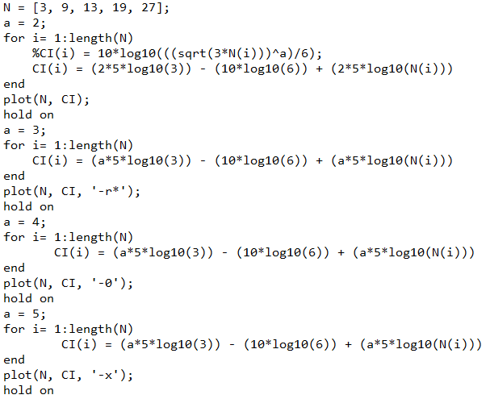

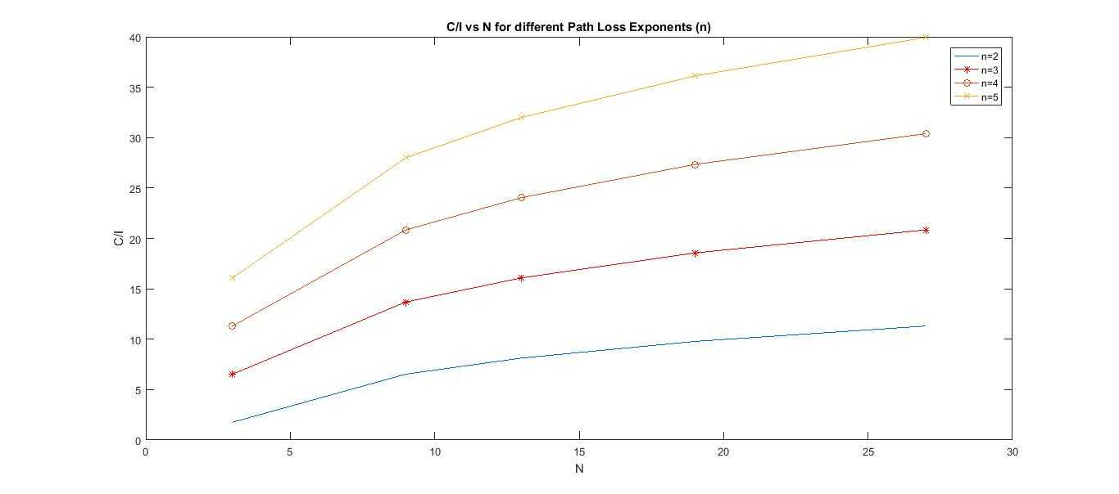

**Problem 05** - **Video URL**: https://www.youtube.com/watch?v=GEx_d0SjvS0

**5G – DISCOVER THE FASTEST WIRELESS PATH**

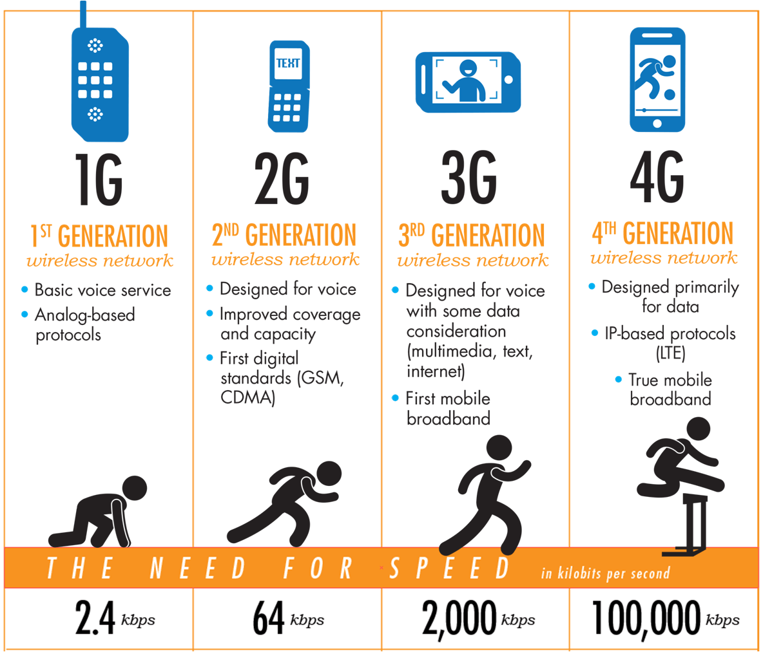The wireless data transmission has developed into an essential part of the 21st century life. Ongoing research is working to achieve a thousand times more efficient wireless data transmission with greator capacity.

**Everything You Need to Know About 5G**

A few of the technologies that could enable ultrafast 5G networks

* 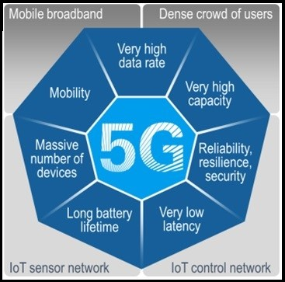**Millimeter waves**
* **Massive MIMO**
* **Full duplex**
* **Beamforming**
* **Small cells**

