Ahsanul Choudhury

Tea Packaging Factory Simulation

Data 604  
Simulation and Modeling Techniques

Final Project

Contents

Background 2

Flowchart 2

Data 3

Simulation Model 4

Verification and Validation 5

Status Quo Model 5

Interventional Model 5

Comparison of Results via Statistical Methods 6

Conclusion 7

Lessons learned 7

Appendix 8

Bibliography 8

# Background

XYZ Tea Packaging company located in Bangladesh is a semi-automatic tea packaging factory. The factory uses both manual labor and machines to pack pre-blended tea in single use disposable tea bags and sell them to a local distributor. The factory has two packaging machines which pours and seals 3 grams of Assam blend black tea in each tea bag. The sealed tea bags are collected from conveyer belt by 6 workers who put 50 tea bags in a box and send it to cellophane warping machine through another conveyer belt. The cellophane wrapping Machine wraps the boxes in cellophane paper and that completes the production process.

Due to increase in demand from the distributor the management of the factory is looking to increase the daily output. Their target is to double the existing daily production of 1500 boxes to 3000 boxes and they want to achieve this by utilizing the current resources and schedule because they think current output does not utilize the full capacity of the factory.

The purpose of this project is to simulate the status quo to find current resource utilization and then identify an incremental model that will help reach management’s targeted daily output using SIMIO.

# Flowchart

The packaging process starts by loading the loose tea in the two packaging machines. The factory receives the loose tea in bags of 600 grams and they are loaded in the packaging machines by an automatic loader. The packaging machines pack 3 grams of tea in each tea bag. The tea bags are then sent to the 6 packers to put 50 tea bags in a box, and the boxes are sent to cellophane wrapping machine and that completes the production flow.

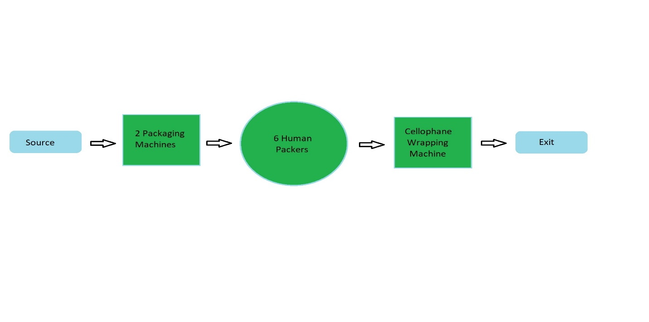

Figure 1: Production Flow

# Data

The following data is collected to run the simulation:

* Loose tea interarrival time: 2.5 minutes
* Entities per arrival: 2
* Packaging machine speed: 45 bags per minute
* Packers processing time: Uniform, min = 0.367, max = 0.45 (minutes)
* Cellophane machine processing time = Triangular, min = 0.1, mode = 0.2, max = 0.3 (minutes)
* Packaging machine refill time: Uniform, min = 8, max = 10.5 (minutes)

The factory operates 8am to 5pm every day, five days a week. The human workers work in two shifts with an hour break in between. Workers shift:

* 1st shift: 8am to 12pm
* 2nd shift: 12pm to 5pm

The machines run throughout the factory operating hours without any scheduled break, however the two packaging machines need refill of packaging paper during which the machines must stop running. With each refill each packaging machine produces 6000 tea bags. The factory currently produces about 1500 boxes every day.

# Simulation Model

The figure below shows the facility view of the model for the tea packaging factory.

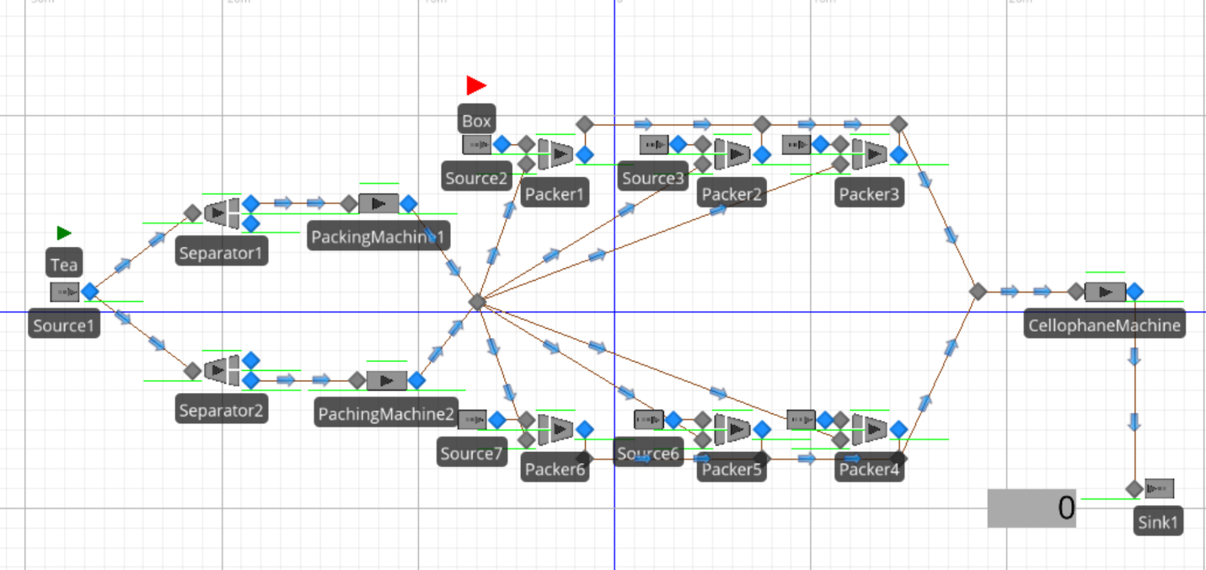

Figure 2: SIMIO facility view

The SIMIO model was created based in the data provided and was run for 9 hours with 25 replications.

# Verification and Validation

## Status Quo Model

The Initial run of the model provided the following results:

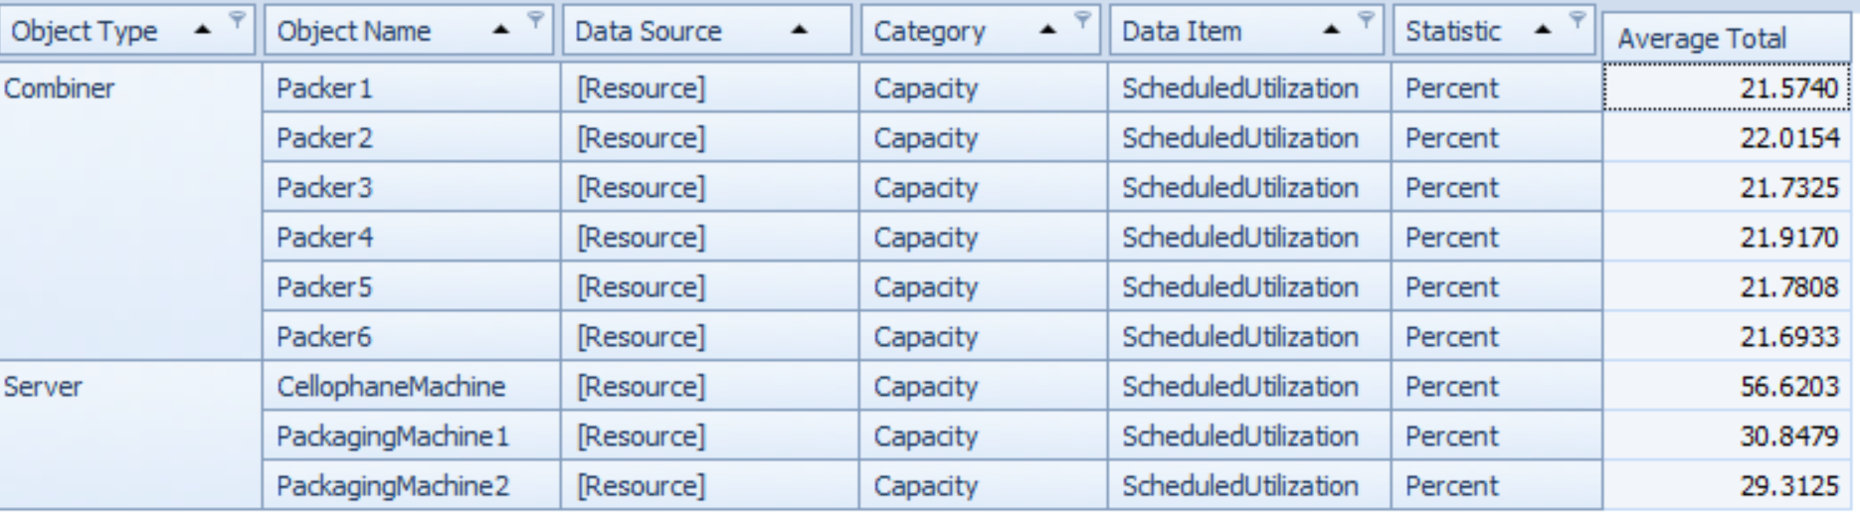

Figure 3: Status Quo Resource Utilizations

At status quo the factory is utilizing about 30 percent of the packaging machines capacity, the packers’ capacity are severely underutilized and the cellophane machine was utilizing at 56 percent of its capacity. The output for the model was 1536 boxes which is close to the data provided.

The factory has the capacity to increase its daily output using the existing resources and schedule. Since the production starts from the packaging machines, and which has around 70 percent of their capacity remaining we will try increasing the output by changing entity per arrival or the batches of loose tea loaded every 2.5 minutes. As the rest of the production line depends on the output of the two packaging machine, increasing their utilization will increase all the other resource utilization.

## Interventional Model

For the interventional model the same SIMIO model was used as we are trying to optimize the production using the same resources and schedule. We will experiment with OptQuest to find our optimal solution. For OptQuest we used the number of batch loaded per arrival as the control variable.

The following figure shows the experiments with OptQuest:

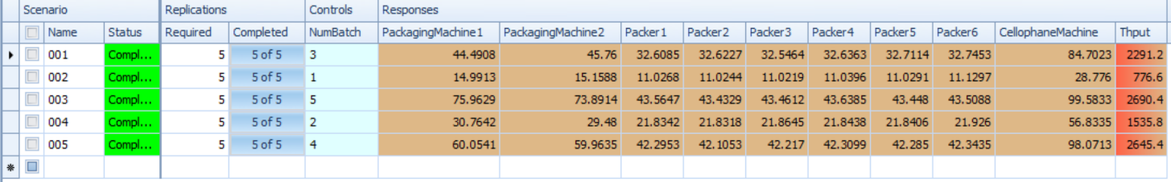

Figure 4: Experiment with OptQuest

OptQuest provided with five different scenarios, out of the five scenarios we will pick scenario 3, which uses 5 batches of loose tea per loading as our Interventional model.

# Comparison of Results via Statistical Methods

The following table shows comparison between status quo model and interventional model via statistical methods:

|  |  |  |  |
| --- | --- | --- | --- |
|  | Status Quo | Interventional | Change |
| Packaging Machine 1 utilization | 30.76% | 75.96% | +45.2% |
| Packaging Machine 2 utilization | 29.48% | 73.89% | +44.41% |
| Packer 1 utilization | 21.83% | 43.56% | +21.73% |
| Packer 2 utilization | 21.83% | 43.34% | +21.51% |
| Packer 3 utilization | 21.86% | 43.46% | +21.6% |
| Packer 4 utilization | 21.84% | 43.64% | +21.8% |
| Packer 5 utilization | 21.84% | 43.44% | +21.6% |
| Packer 6 utilization | 21.93% | 43.51% | +21.58% |
| Cellophane Machine utilization | 56.83% | 99.58% | +42.75 |
| Total Output | 1536 | 2690 | +1154 |

The interventional model increases the packaging machines’ utilization 45.2 percent and 44.41 percent; it nearly doubles the packers’ utilization from almost 22 percent to almost 44 percent and the cellophane machine runs in full capacity. The output increases by 1154 boxes, which takes the total output to 2690 boxes.

# Conclusion

The interventional model significantly increases the resource utilization form status quo model. By increasing the resource utilization, the interventional model should give the packaging factory more efficiency. However, as the cellophane machine reaches its capacity with interventional model at 2690 boxes it will be impossible to double the existing output to 3000 boxes using the existing resource and schedule.

# Lessons learned

Simulation is a risk-free way of experimenting and validating processes and resource allocation before applying it in real life. SIMIO is a powerful software to simulate real life situation. There are vast array of tools available within SIMIO to simulate virtually any situation that can be imagined but as a beginner in simulation and SIMIO I still learning to use the most basic tools.

My first take away from this project is that complete and valid data is a must to conduct an accurate simulation. Care should be taken during the data collection process to make sure they are accurate and relevant. We should also have a clear and precise idea of the processes and resources involved, entity diagrams and flowcharts can be an immense help at this step.

Even with complete and accurate data and idea about the processes involved completing the project was not easy. My first challenge was to simulate the two packaging machines, I had to accomplish this by using a separator and a server for each machine. The second challenge was to make sure the packers has a box available as soon as they are done filling one, for that I had to use a combiner and source for each packer with a custom process. I would love to solve this problems in a more sophisticated manner in the future.

# Appendix

SIMIO Model Link: <https://github.com/choudhury1023/DATA-604/blob/master/Final_Project/Choudhury_Ahsanul_Final_Project.spfx>

PowerPoint Presentation Link: <https://github.com/choudhury1023/DATA-604/blob/master/Final_Project/Choudhruy_Ahsanul.pptx>

# Bibliography

Basan, N. P., Coccola, M. E., & Mendez, C. A. (2014). Optimizing The Design And Operation of Beer Packaging Line Through An Advance Simio-Based DES Tool. *Proceedings of the 2014 Winter Simulation Conference* (pp. 1989-2000). Santa Fe, Argentina: INTEC(UNL-CONICET).

Colledania, M., Pedrielliab, G., Terkajb, W., & Urgoa, M. (ELSEVIER). Integrated Virtual Platform for Manufacturing Systems Design. *Procedia CIRP, Volume 7*, 425-430.

Dukalskia, R., Çençena, A., Aschenbrennerb, D., & Verlinden, J. (2017). Portable Rapid Visual Workflow Simulation Tool for Human Robot Coproduction. *Procedia Manufacturing, Volume 11*, 185-197.

Mourtzis, D., Doukas, M., & Bernidaki, D. (2014). Simulation in Manufacturing: Review and Challenges. *Procedia CIRP, Volume 25*, 213-229.

Tolioab, T., Saccob, M., Terkajb, W., & Urgoa, M. (2013). Virtual Factory: An Integrated Framework for Manufacturing Systems Design and Analysis. *Procedia CIRP, Volume 7*, 25-30.