1. Cachegrind测试结果：

其中I1为1级指令缓存，D1为1级数据缓存，LL为末级缓存（测试机只有L2 Cahe，没有L3 Cache，故为二级缓存），Miss rate为命中失败率（越低则cache命中率越高）

遵循CACHE局部性的cachegrind结果：

I refs: 7,954,350,721

I1 misses: 65,151

LLi misses: 21,510

I1 miss rate: 0.00%

LLi miss rate: 0.00%

D refs: 4,232,803,387 (2,873,581,635 rd + 1,359,221,752 wr)

D1 misses: 55,539,674 ( 28,774,598 rd + 26,765,076 wr)

LLd misses: 27,043,375 ( 14,409,854 rd + 12,633,521 wr)

**D1 miss rate: 1.3% ( 1.0% + 2.0% )**

**LLd miss rate: 0.6% ( 0.5% + 0.9% )**

LL refs: 55,604,825 ( 28,839,749 rd + 26,765,076 wr)

LL misses: 27,064,885 ( 14,431,364 rd + 12,633,521 wr)

LL miss rate: 0.2% ( 0.1% + 0.9% )

不遵循CACHE局部性的cachegrind结果：

I refs: 8,064,214,833

I1 misses: 47,532

LLi misses: 16,454

I1 miss rate: 0.00%

LLi miss rate: 0.00%

D refs: 4,340,971,103 (2,930,260,087 rd + 1,410,711,016 wr)

D1 misses: 130,446,936 ( 72,290,051 rd + 58,156,885 wr)

LLd misses: 87,374,857 ( 37,204,037 rd + 50,170,820 wr)

**D1 miss rate: 3.0% ( 2.5% + 4.1% )**

**LLd miss rate: 2.0% ( 1.3% + 3.6% )**

LL refs: 130,494,468 ( 72,337,583 rd + 58,156,885 wr)

LL misses: 87,391,311 ( 37,220,491 rd + 50,170,820 wr)

LL miss rate: 0.7% ( 0.3% + 3.6% )

1. Intel性能计数监视器测试结果：

为了简化测试结果，将CPU强制改为单核工作状态，测试系统WIN7 64位，CPU为 i7 7500U

其中L2HIT为L2 CACHE命中率，L3HIT为L3 CACHE命中率，MEM READ/WRITE为对内存的读写量，明显是遵循局部性的结果缓存命中率高，对内存读写更少，顺便更环保，最后一项是CPU的能耗，采样时间是1秒，即1秒的热功耗，单位是焦耳

遵循CACHE局部性的测试结果：

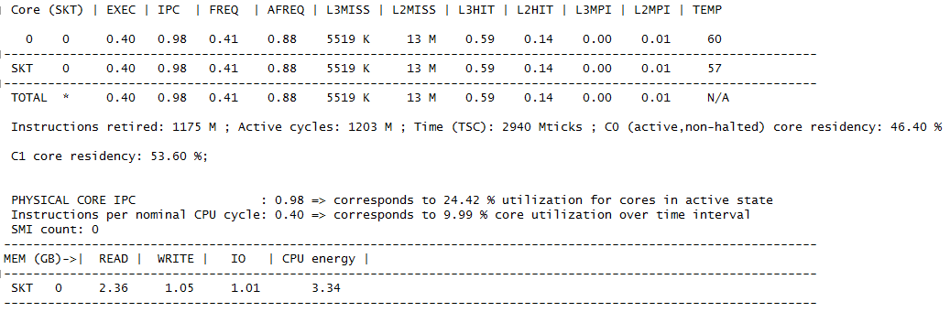

不能遵循CACHE局部性的测试结果：

