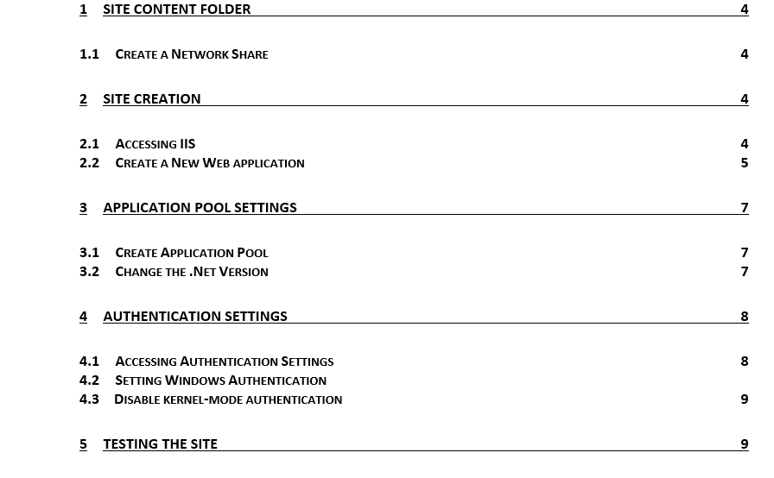

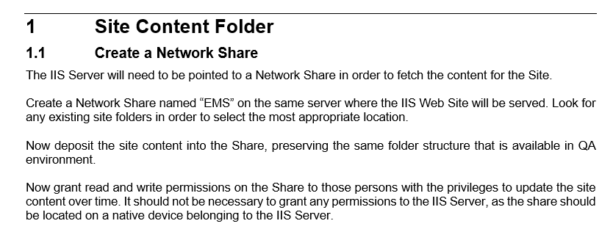

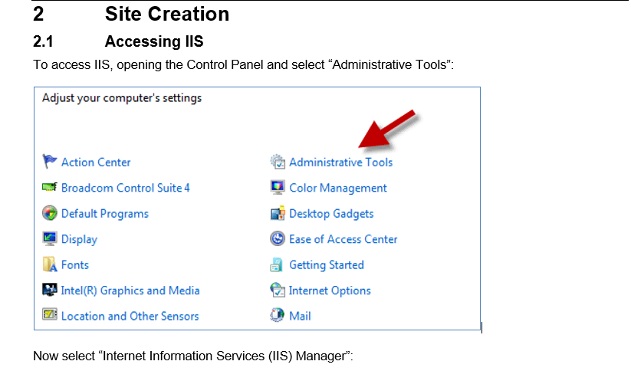

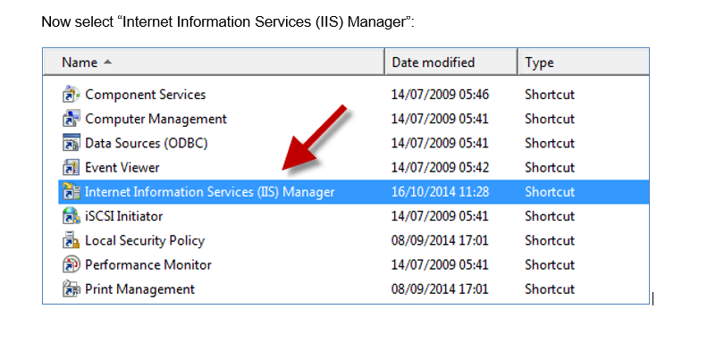

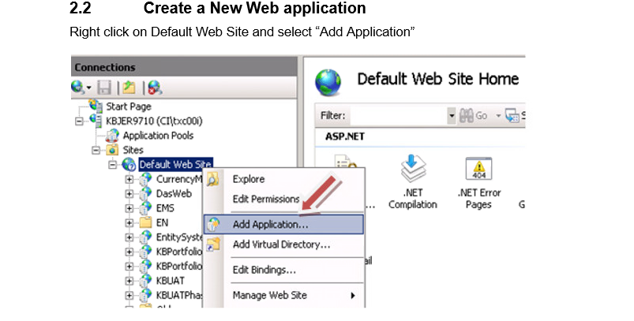

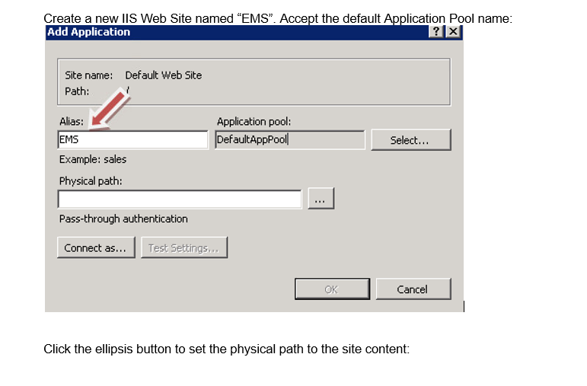

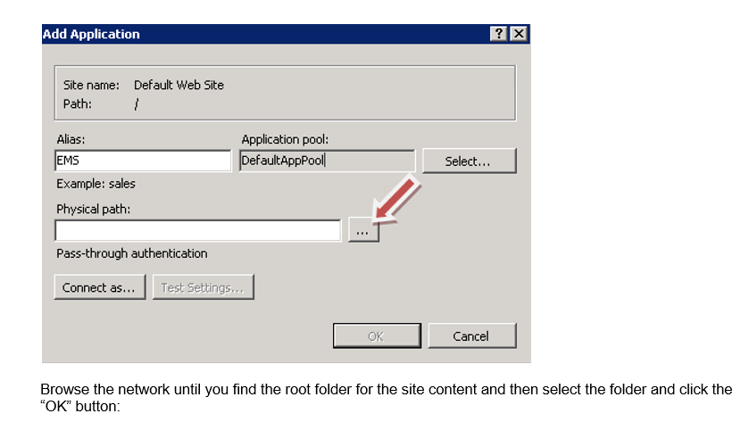

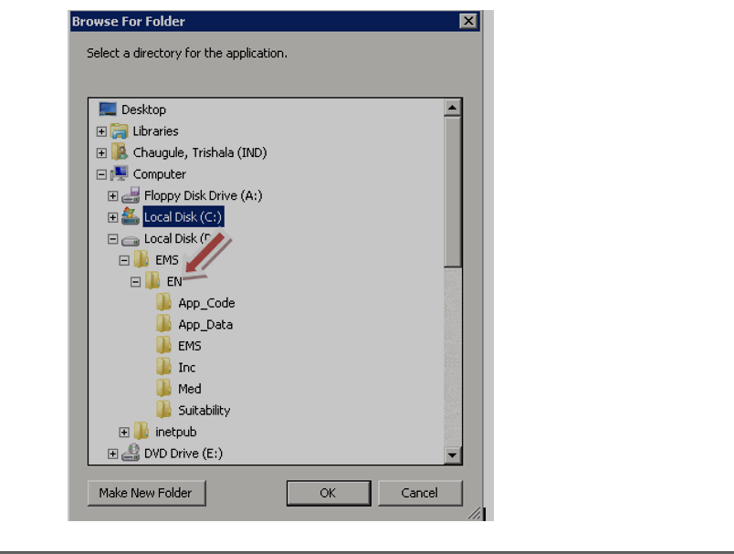

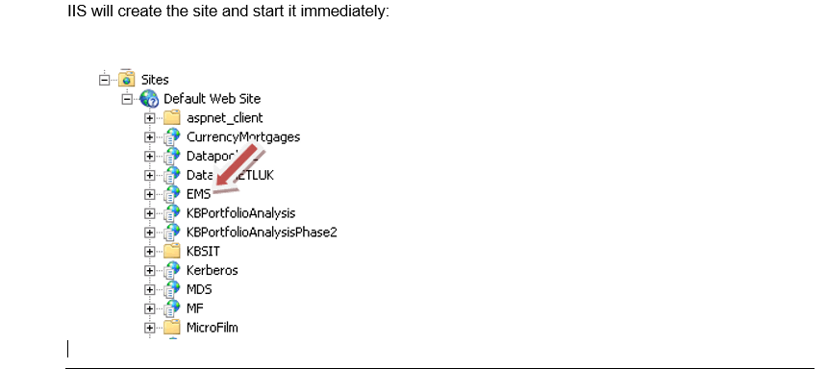

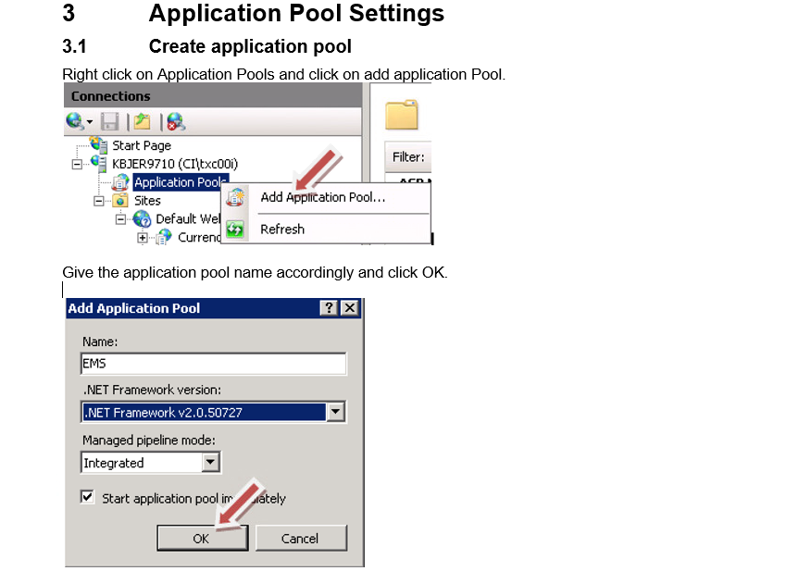

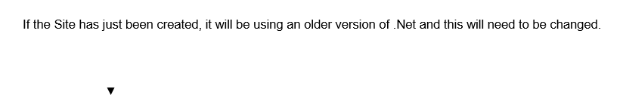

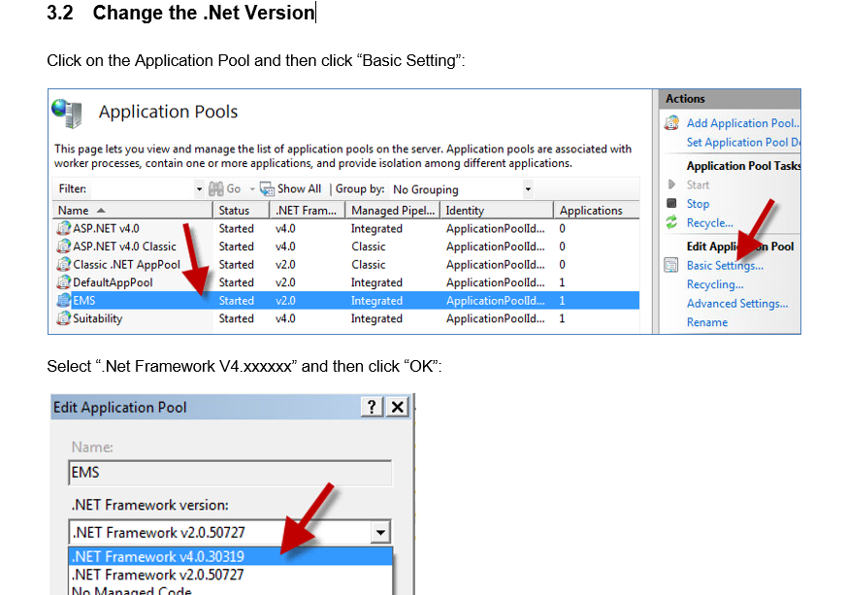

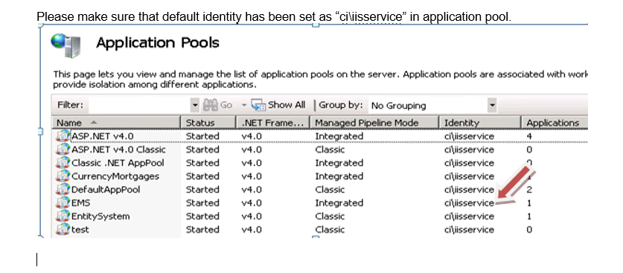

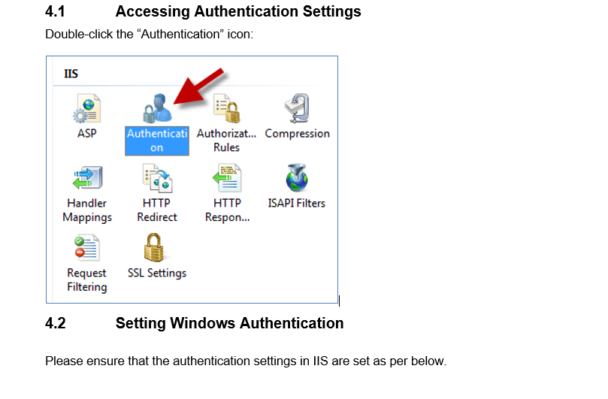

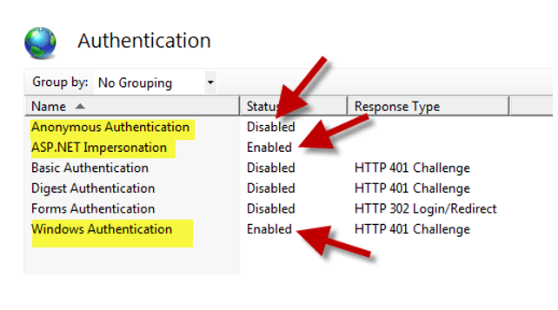

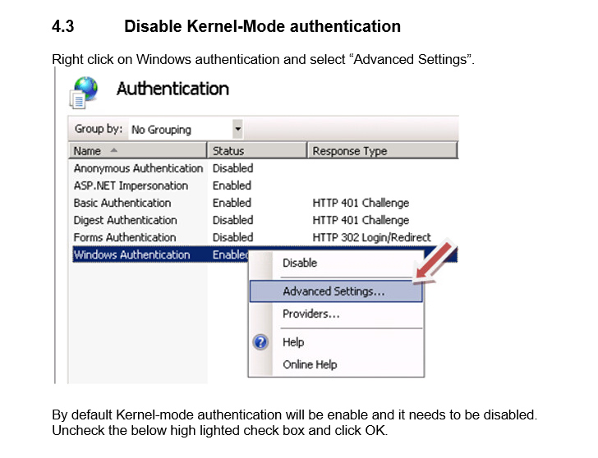

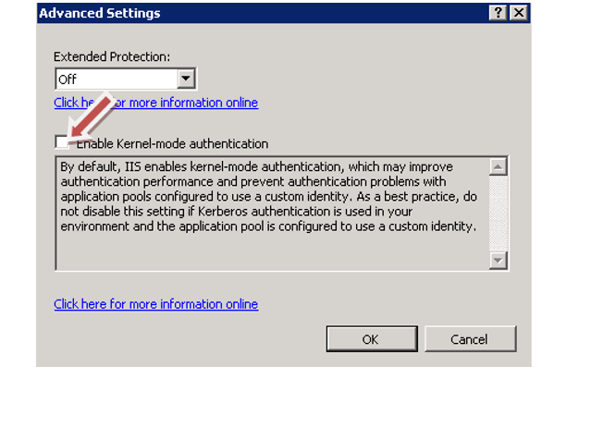

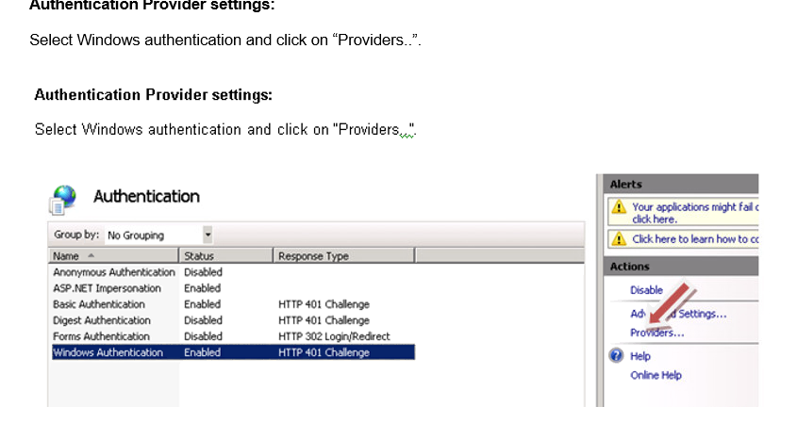

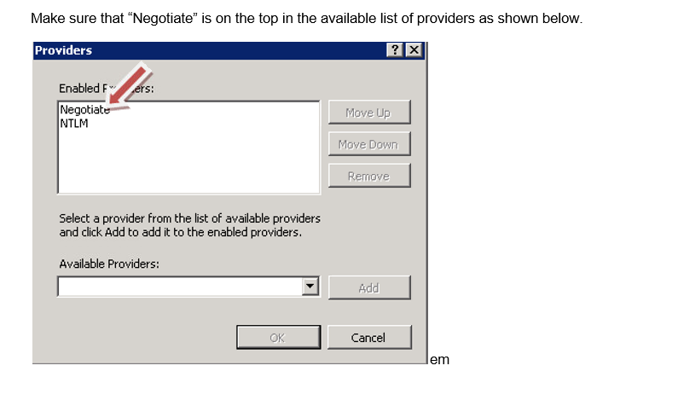

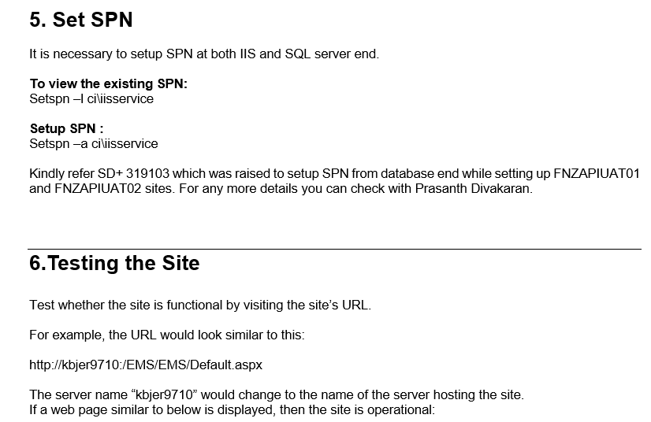

IIS Known Issues and resolutions

Issue 1: IIS application pool can not access database

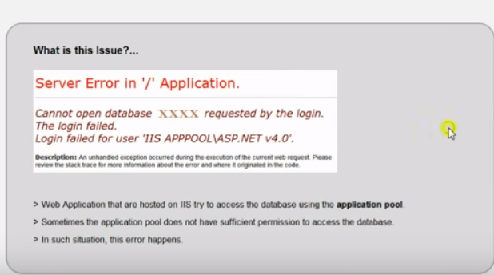

Solution:

Open SQL management studio, select database and go to Security🡪users and check whether user associated with application pool in IIS is present or not. If not then create a new user and provide permissions “db_datareader” and “db_datawriter” as shown in below screens:

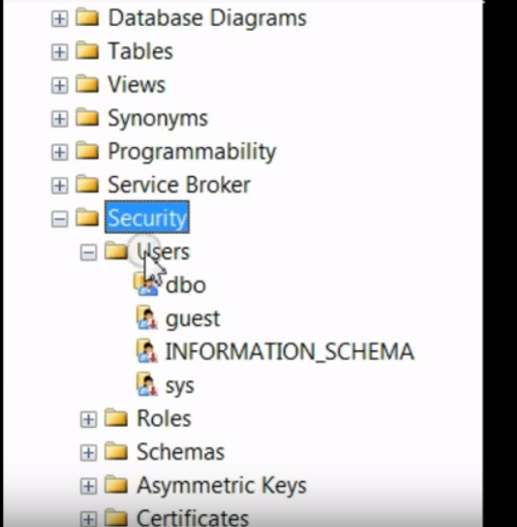

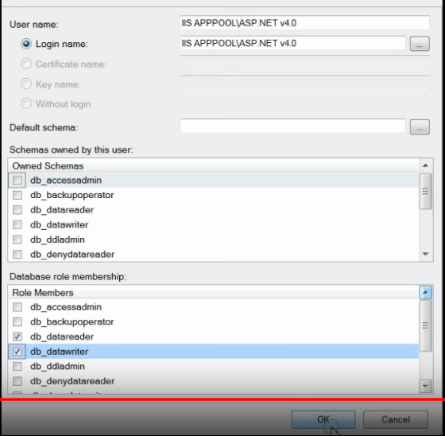

Issue 2: HTTP Error 503

Cause: Application pool not running

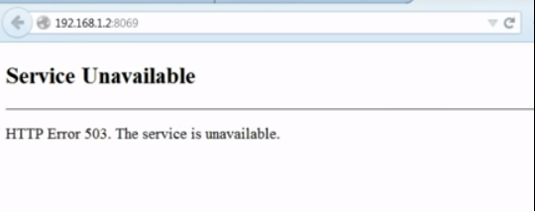

Solution 1: Start the corresponding application pool (if it is stopped)

Solution 2: If Application pool is in already started state then follow below steps:

Select Application pool- ->right click 🡪advanced settings🡪Load User Profile->False🡪OK

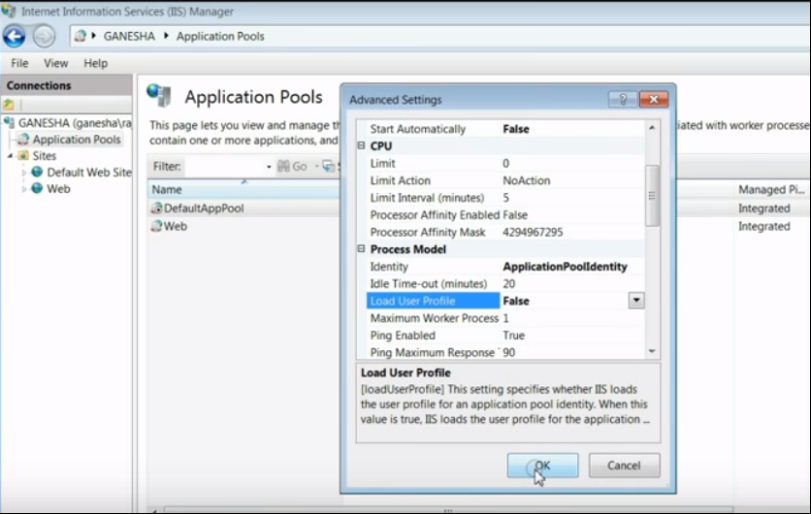

Issue 3: HTTP Error 500.19 Error Code: 0x800700005

Cause: Permission Issue

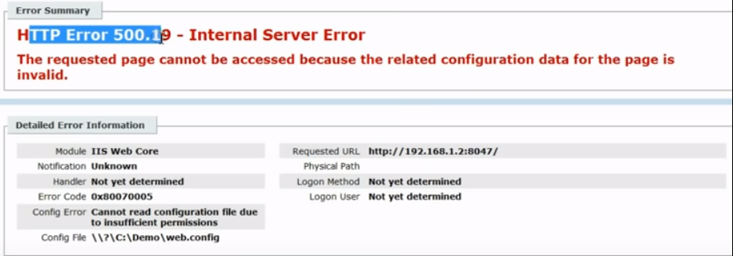

Solution: Select Web site 🡪Edit Permissions🡪Security🡪Authenticated Users🡪Full Control🡪Apply

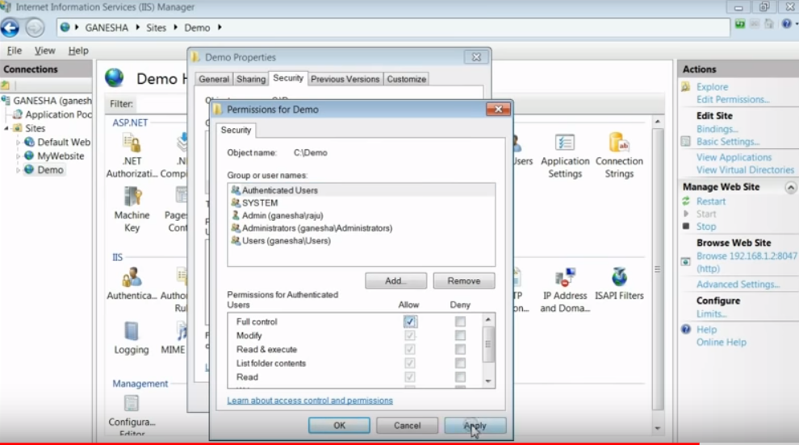

Issue 4: HTTP Error 404.2

Cause: Application pool is set to Classic Mode instead of Integrated

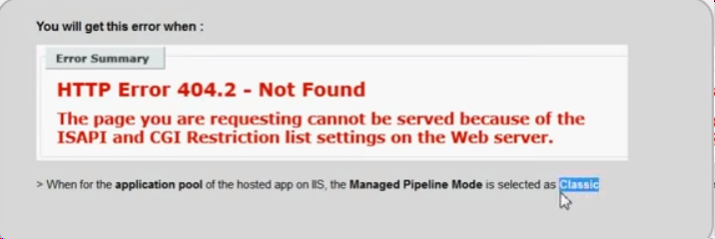

Solution: Select Application pool🡪Advance settings🡪Manage Pipeline Mode🡪Integrated🡪Save

Issue 5: HTTP Error 4.3.14 Error Code: 0x00000000

Cause: Directory Browsing is disabled

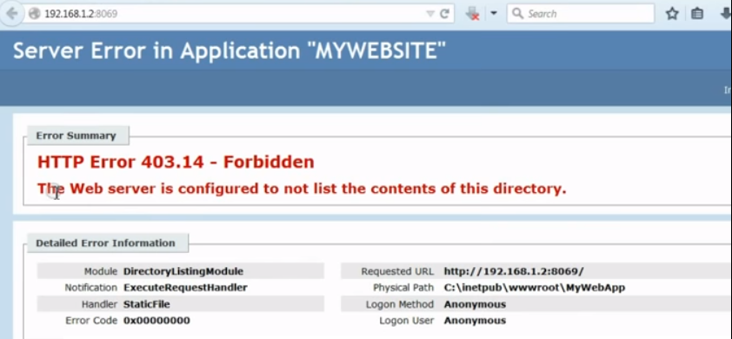

Solution: Select website🡪directory browsing🡪enable🡪ok

Issue 6 : Error code: 0x800700c1

1. Could not load file or Assembly. An attempt was made to load a program with an incorrect format
2. The requested page cannot be accessed because the related configuration data for the page is invalid

In your application, if any of the dll is of 32 bit, you can expect this error.

Cause: Running 32 bit application on 64 bit IIS

Solution: Select application pool🡪right click🡪advanced setting🡪Enable 32-Bit applications 🡪True

Issue 7: This configuration section can not be used at this path.

This happens when section is locked at parent level

Cause: The reason is while installing IIS, we may have forgot to enable some extensions like .ASP, CGI etc

Solution: Open Control panel🡪Program and Features🡪Turn Windows features ON or Off🡪IIS🡪Word Wide Web Services🡪Application development Features🡪Select all extensions

Issue 8: HTTP Error 500.19 Error Code -0x800700d

Cause: Configuration file is not written correctly.

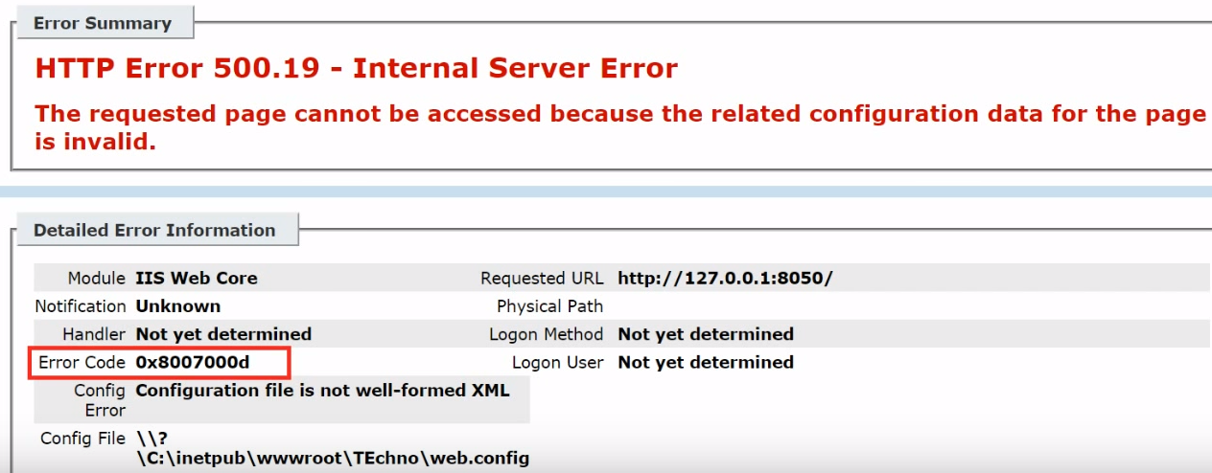

Solution: Open Web.cofig or System.cofig file and check if any spell mistakes or any random characters got entered

Issue 9 : HTTP Error 404.3 Error Code: 0x80070032

File extension not found

Solution: Select website🡪MIME Type and add file extension type

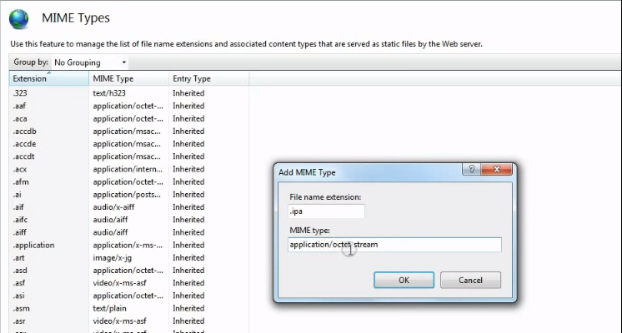

Issue 10: Windows authentication is not available in IIS under Authentication section

Solution: Check the installed windows edition on your system

If it is Windows 10 Home Single Language then upgrade \install windows 10 pro

Post install, enable windows authentication, follow below steps

Open control panel🡪 Programs and features🡪Turn Windows features On or Off🡪IIS🡪Word Wide Web Services🡪Security🡪Windows Authentication

Issue 11: Host your IIS site on Internet along with Intranet

e.g your site name is. www.Myfirstapp.com’

Solution:

1. Open bindings and give hostname as [www.Myfirstapp.com](http://www.Myfirstapp.com) with port 80 or 8080
2. Goto C:\Windows\System 32\drivers\etc\hosts file (since it is windows file it will not allow the eidt the same file, so copy the file to desktop, make the changes and then replace with original file)
3. At the end of the file add 127.0.0.1 [www.Myfirstapp.com](http://www.Myfirstapp.com) and save the file

Enhancement 1 : Auto start a website at specific time or avoid delayed first load of website after app pool recycle

Steps: Note: Need IIS version 7.5 or above else it will be difficult

1. For IIS version 7.5, install this “Application initialization Module for IIS 7.5”. For version 8.5 and above its already installed so no further installation is required.
2. Restart machine🡪open IIS and note down app pool name
3. Now Open C:\Windows\System 32\inetsrv\config\applicationHost.config on Notepad
4. Navigate to Applicationpools node of your webside change the details as shown below:

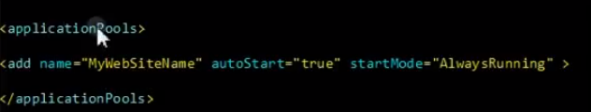

1. Now navigate to ‘Sites’ node and change “preloadEnabled=true”

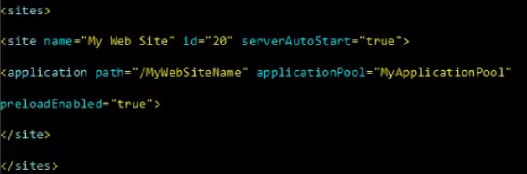

1. Save config file

Enhancement 2: Add ASP.NET as Application pool in IIS

Steps:

1. Install .Net Framework 4.0 in your system
2. Install IIS (if its not there already)
3. Open command prompt with administrative privilege and navigate to **C:\Windows\Microsoft.Net\Framework\v4.0.303319\** and press enter
4. Type “**aspnet_regiis.exe –ir”** and enter 🡪This will register ASP.NET 4.0 in application pool in IIS

Enhancement 3: Improve web site performance

Solution 1: Select application pool🡪right click🡪advanced setting🡪Maximum Workers Process🡪Change it to “2” from “1”

NOTE: You can increase the worker processes for performance improvement only when you have good hardware say good processer and RAM

Solution 2 : If you have less RAM e.g. 4gb Ram and if the load demands more memory then to avoid out of memory error we can use virtual memory, follow below steps:

My computer🡪Properties🡪Advanced🡪Performance🡪Settings🡪Advanced🡪Virtual Memory 🡪Change🡪Custom size provide minimum and maximum memory details, this is called Paging file or virtual memoryis call

e.g Initial Size: 5000MB

Maximum Size: 15000 MB

So when our memory is out of stock then this memory is used by windows.

**IIS SECURITIES:**



