TUTORIAL – 11
PYTHON AUTOMATION TESTING
1. Aim
To analyze automation testing in Python for website navigation, forms, multi-page workflows, links, product selection, cart navigation, checkout handling, validation, and regression testing.
2. Software / Environment Required
Python
PyCharm IDE
Google Chrome
Selenium Python library
Internet connection
Install Selenium in the PyCharm Terminal:\npip install selenium
3. Script / Source Code
Create a Python file named tutorial11.py in the PyCharm project and enter the following code:
from selenium import webdriver
from selenium.webdriver.common.by import By
from selenium.webdriver.support.ui import WebDriverWait
from selenium.webdriver.support import expected_conditions as EC
driver = webdriver.Chrome()
driver.maximize_window()
wait = WebDriverWait(driver, 10)
try:
# 1. Open website
driver.get("https://www.saucedemo.com/")
print("Website opened successfully")
# 2. Login
wait.until(
EC.visibility_of_element_located((By.ID, "user-name"))
).send_keys("standard_user")
driver.find_element(By.ID, "password").send_keys("secret_sauce")
driver.find_element(By.ID, "login-button").click()
# 3. Validate products page
wait.until(EC.url_contains("inventory"))
assert "inventory" in driver.current_url
print("Login Test: PASS")
# 4. Product selection
wait.until(
EC.element_to_be_clickable(
(By.ID, "add-to-cart-sauce-labs-backpack")
)
).click()
print("Product Selection: PASS")
# 5. Open cart
driver.find_element(By.CLASS_NAME, "shopping_cart_link").click()
assert "cart" in driver.current_url
print("Cart Navigation: PASS")
# 6. Checkout
driver.find_element(By.ID, "checkout").click()
# 7. Fill checkout form
wait.until(
EC.visibility_of_element_located((By.ID, "first-name"))
).send_keys("Student")
driver.find_element(By.ID, "last-name").send_keys("Testing")
driver.find_element(By.ID, "postal-code").send_keys("380001")
driver.find_element(By.ID, "continue").click()
# 8. Validate multi-page workflow
wait.until(EC.url_contains("checkout-step-two"))
assert "checkout-step-two" in driver.current_url
print("Multi-Page Workflow: PASS")
# 9. Back and forward navigation
driver.back()
driver.forward()
print("Back/Forward Navigation: PASS")
finally:
driver.quit()
print("Tutorial 11 Completed Successfully")
4. Procedure
Open PyCharm and create a project named SoftwareTesting.
Create a Python file named tutorial11.py.
Open PyCharm Terminal and run: pip install selenium.
Run the script. Selenium opens Chrome and navigates to SauceDemo.
The script logs in, selects a product, opens the cart, fills the checkout form, validates the workflow, and checks back/forward navigation.
After execution, review the messages in the PyCharm Run/Console window.
5. Output Screenshot
Screenshot 1 – Source Code

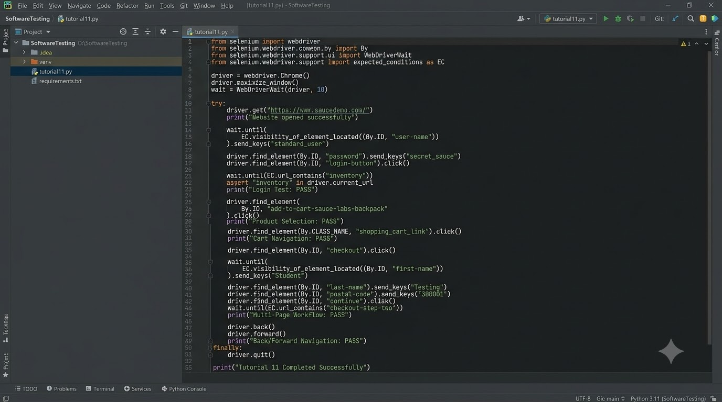
Screenshot 2 – Login Page

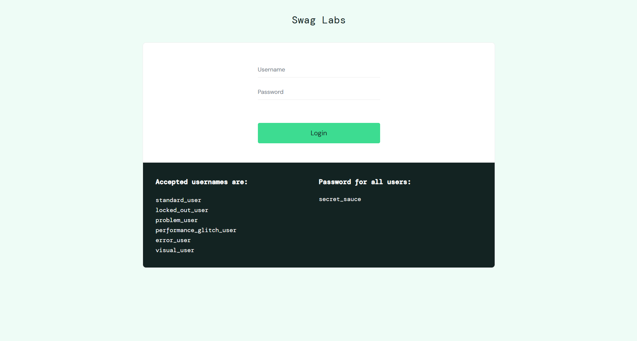

Screenshot 3 – Product Page

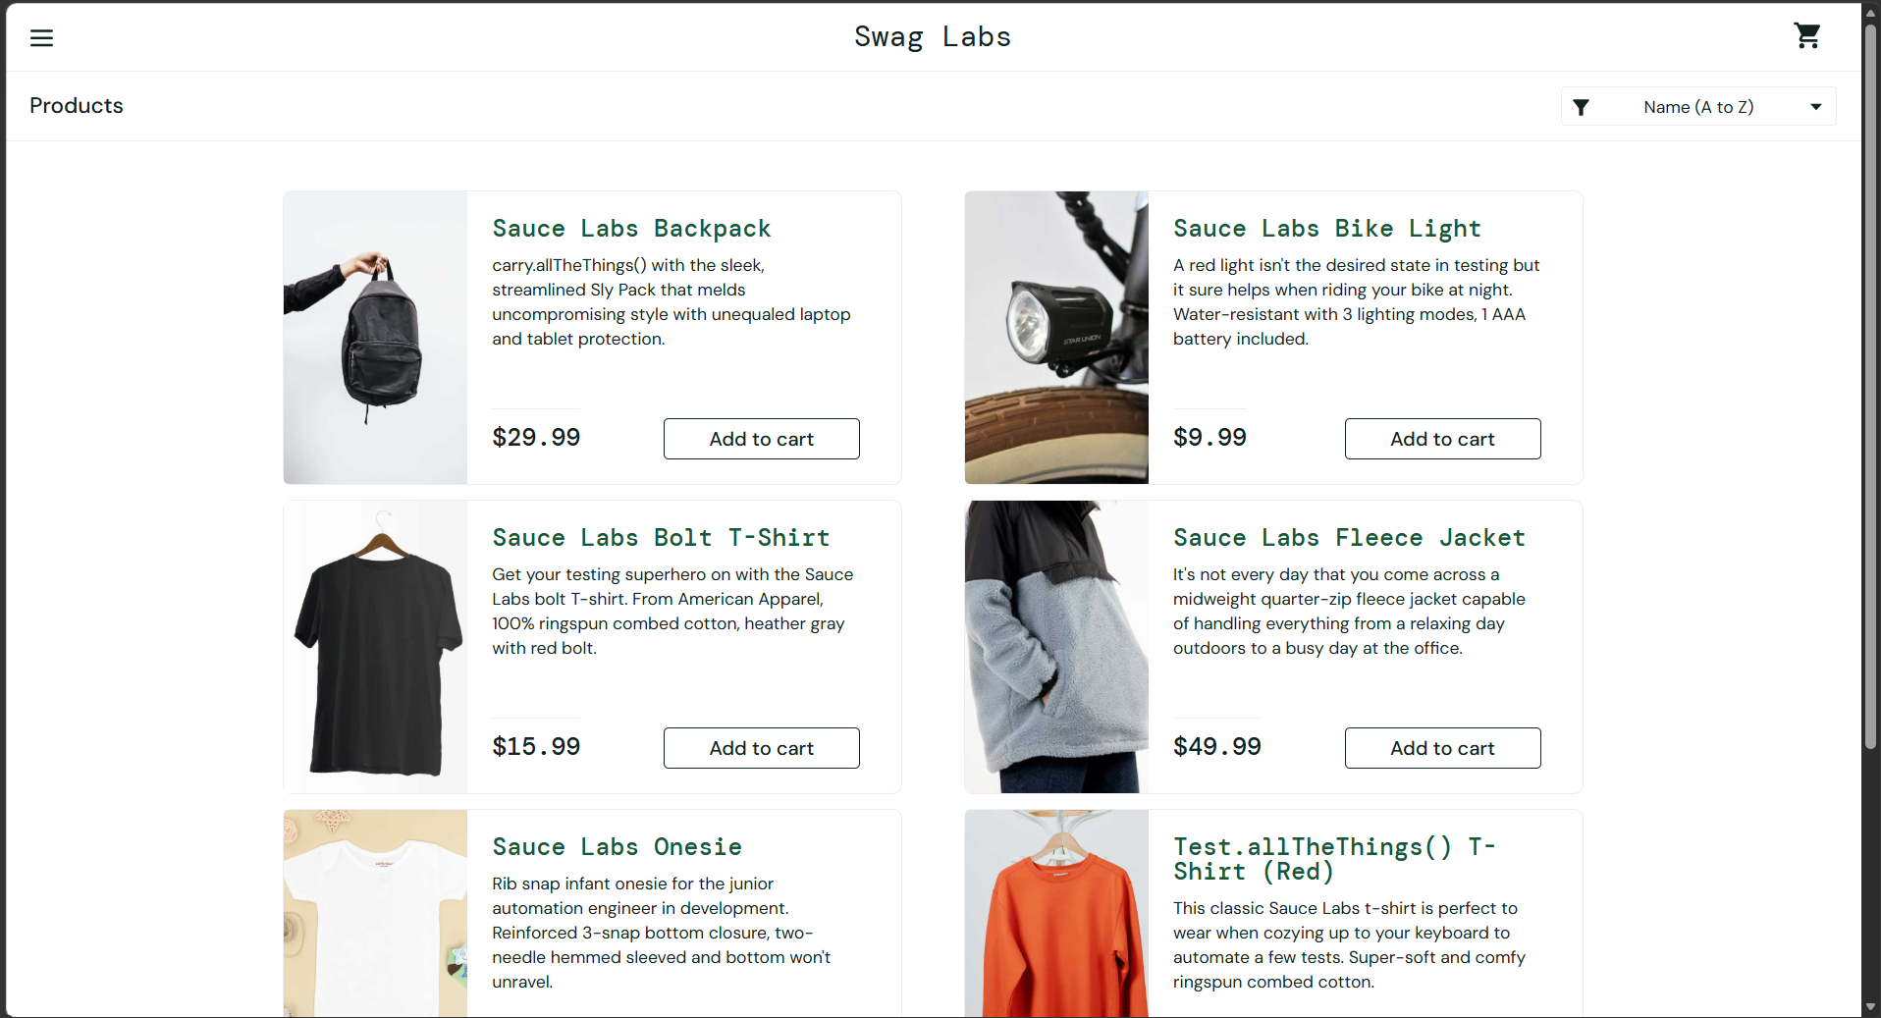
Screenshot 4 – Cart Page

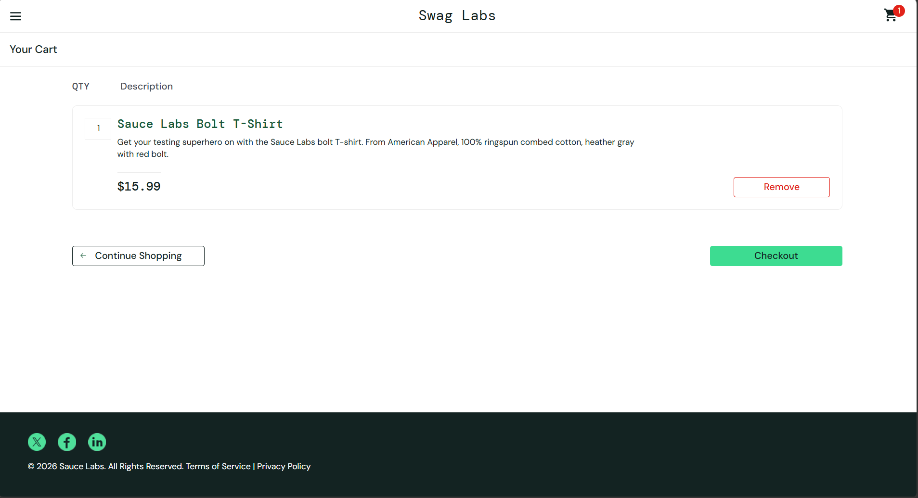

Screenshot 5 – Checkout Page

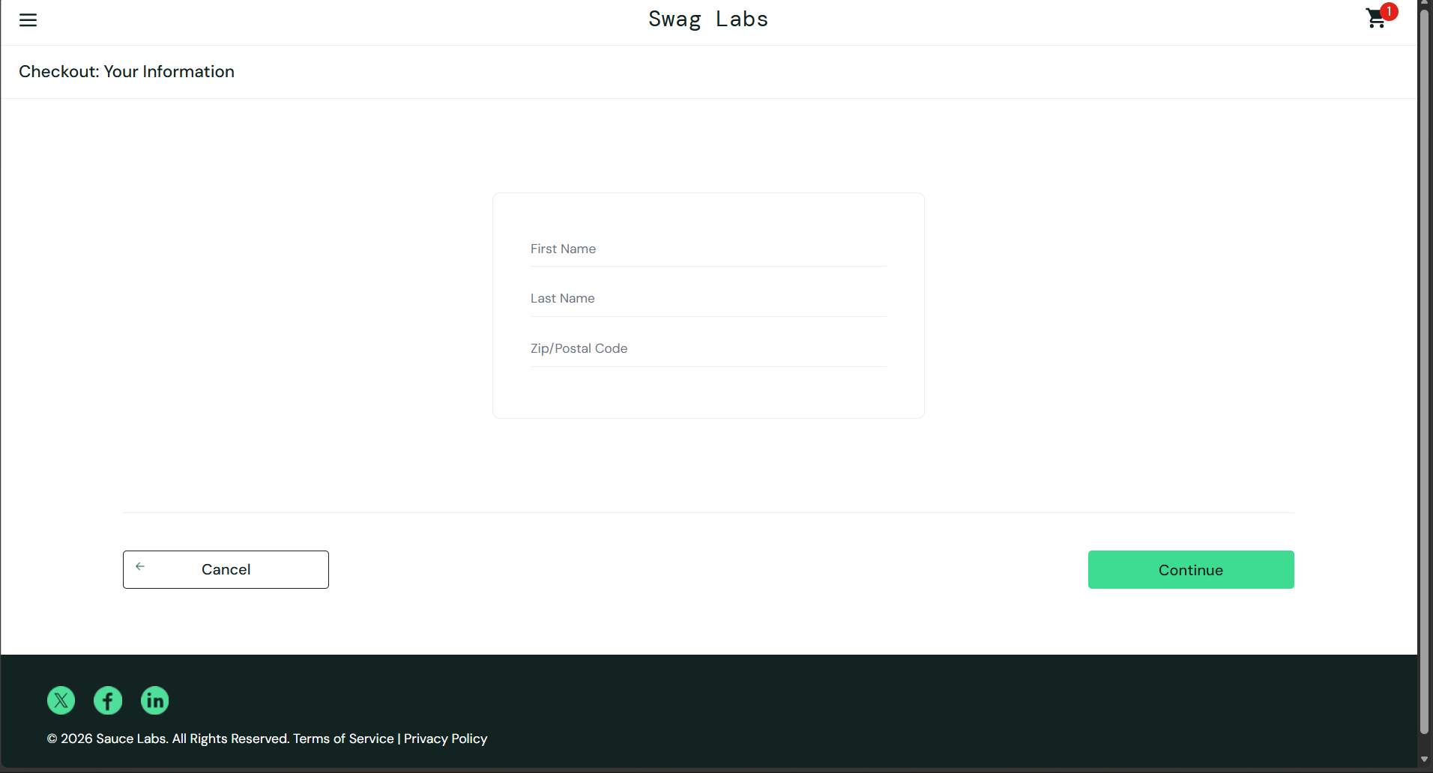
Screenshot 6 – PyCharm Console Output

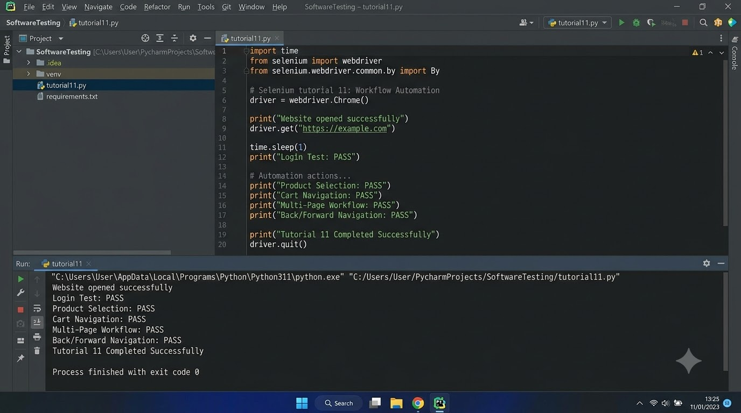

6. Expected Console Output
Website opened successfully
Login Test: PASS
Product Selection: PASS
Cart Navigation: PASS
Multi-Page Workflow: PASS
Back/Forward Navigation: PASS
Tutorial 11 Completed Successfully
7. Conclusion
The Python Selenium script automates the main SauceDemo shopping workflow, including website navigation, login, product selection, cart navigation, checkout form entry, page validation, and browser back/forward navigation. Successful execution should be verified using the actual PyCharm console and browser screenshots.

