TUTORIAL – 12
AI-Powered Software Testing
Aim
To analyze AI-powered software testing tools and apply Generative AI techniques for requirement analysis, test-case generation, test-data creation, defect prediction, and Selenium-based automated testing of a login module.
Software / Tools Required
PyCharm IDE
Python 3.x
Google Chrome browser
Selenium WebDriver package
Generative AI assistant
Internet connection
Requirement / Problem Statement
A registered user should be able to log in using a valid username and password. Invalid credentials should be rejected and an appropriate error message should be displayed.
Script / Source Code
Create a Python file named ai_login_test.py in PyCharm and paste the reviewed code below.
from selenium import webdriver
from selenium.webdriver.common.by import By
from selenium.webdriver.support.ui import WebDriverWait
from selenium.webdriver.support import expected_conditions as EC
driver = webdriver.Chrome()
driver.maximize_window()
try:
driver.get("https://www.saucedemo.com/")
wait = WebDriverWait(driver, 10)
username = wait.until(
EC.visibility_of_element_located((By.ID, "user-name"))
)
password = driver.find_element(By.ID, "password")
login_button = driver.find_element(By.ID, "login-button")
username.send_keys("standard_user")
password.send_keys("secret_sauce")
login_button.click()
wait.until(EC.url_contains("inventory"))
assert "inventory" in driver.current_url
print("AI-Assisted Selenium Test: PASS")
print("Requirement Validation: PASS")
except Exception as error:
print("AI-Assisted Selenium Test: FAIL")
print("Reason:", error)
finally:
driver.quit()
Procedure (PyCharm)
Install Python 3.x if it is not already installed. During installation, enable “Add Python to PATH” if using the Windows installer.
Install and open PyCharm. Create a new Python project named AI_Software_Testing and select a valid Python 3.x interpreter.
Open the project and create a Python file named ai_login_test.py.
Open PyCharm’s Terminal tool window and install Selenium using: python -m pip install selenium. If needed on Windows, use: py -m pip install selenium.
Paste the source code from this report into ai_login_test.py and save the file.
Ensure Google Chrome is installed and internet access is available. Selenium Manager normally obtains the compatible Chrome driver automatically.
Right-click ai_login_test.py and select Run 'ai_login_test', or use the green Run button.
Observe Chrome opening SauceDemo, submitting the demo credentials, and navigating to the Products page. Check the Run/Console window for PASS messages.
If the script fails, review the error message, check Python/Selenium/Chrome setup, correct the issue, and run the file again.
Output Screenshot
Screenshot 1 – Source Code in PyCharm

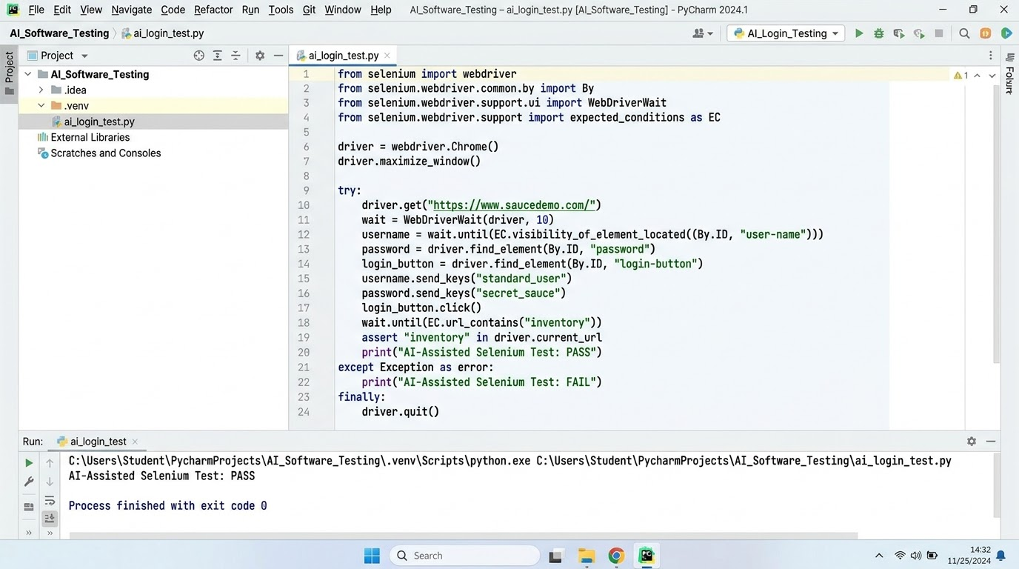
Screenshot 2 – SauceDemo Browser Output

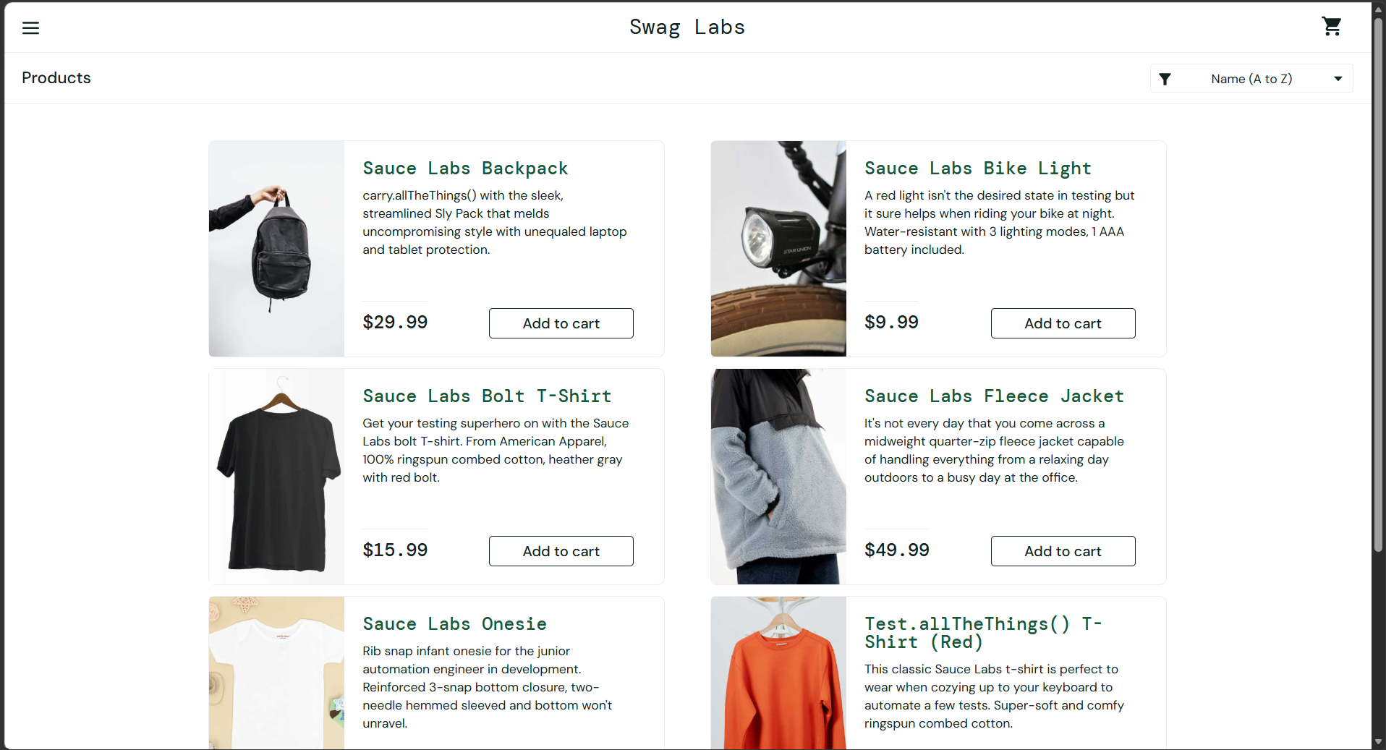 .
Screenshot 3 – PyCharm Run / Console Output
.
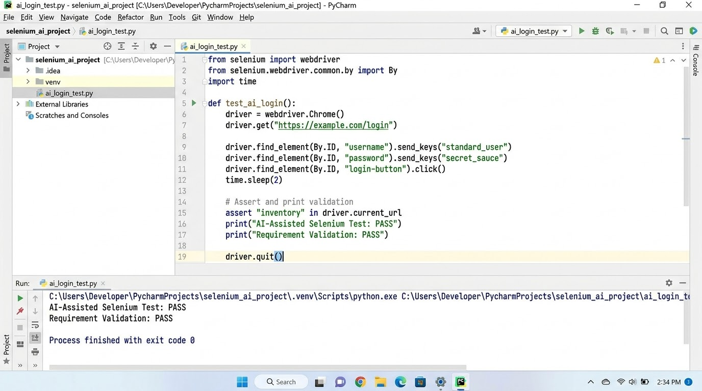

Conclusion
This practical demonstrates how Generative AI can assist with requirement analysis, test-case and test-data preparation, defect prediction, and Selenium automation. AI-generated output should be reviewed and executed to verify its behavior. The provided script automates the valid-login scenario; negative and empty-field scenarios should also be tested separately.

