TUTORIAL – 13
Selenium Environment Setup

Aim
To create and configure Python, Selenium WebDriver, PyCharm IDE, browser drivers, and automation testing libraries for Selenium testing. The configuration is verified by running a basic Selenium program that launches Chrome and opens the Selenium website.
Software / Tools Required
PyCharm IDE
Python 3.x
Google Chrome browser
Selenium WebDriver package
Generative AI assistant
Internet connection

Script / Source Code
from selenium import webdriver
driver = webdriver.Chrome()
driver.maximize_window()
driver.get("https://www.selenium.dev/")
print("Browser launched successfully")
print("Page Title:", driver.title)
print("Current URL:", driver.current_url)
driver.quit()

Output Screenshot
Screenshot 1 – Chrome showing the Selenium website

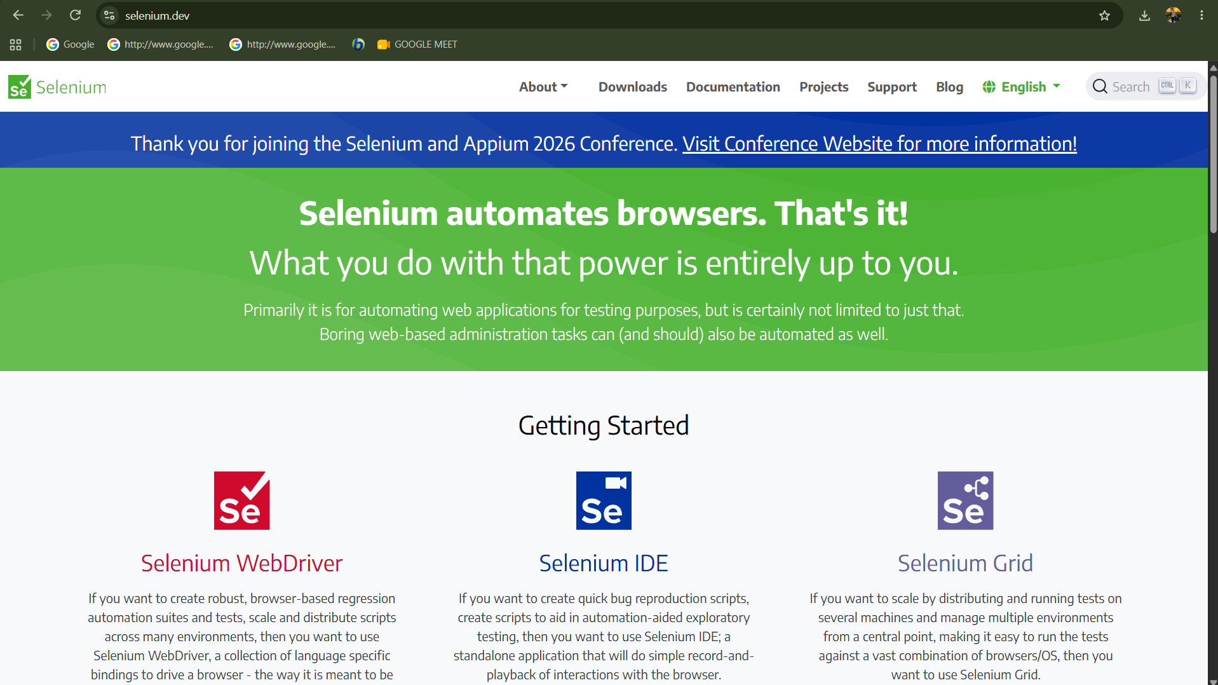

Screenshot 2 – PyCharm console displaying the output.
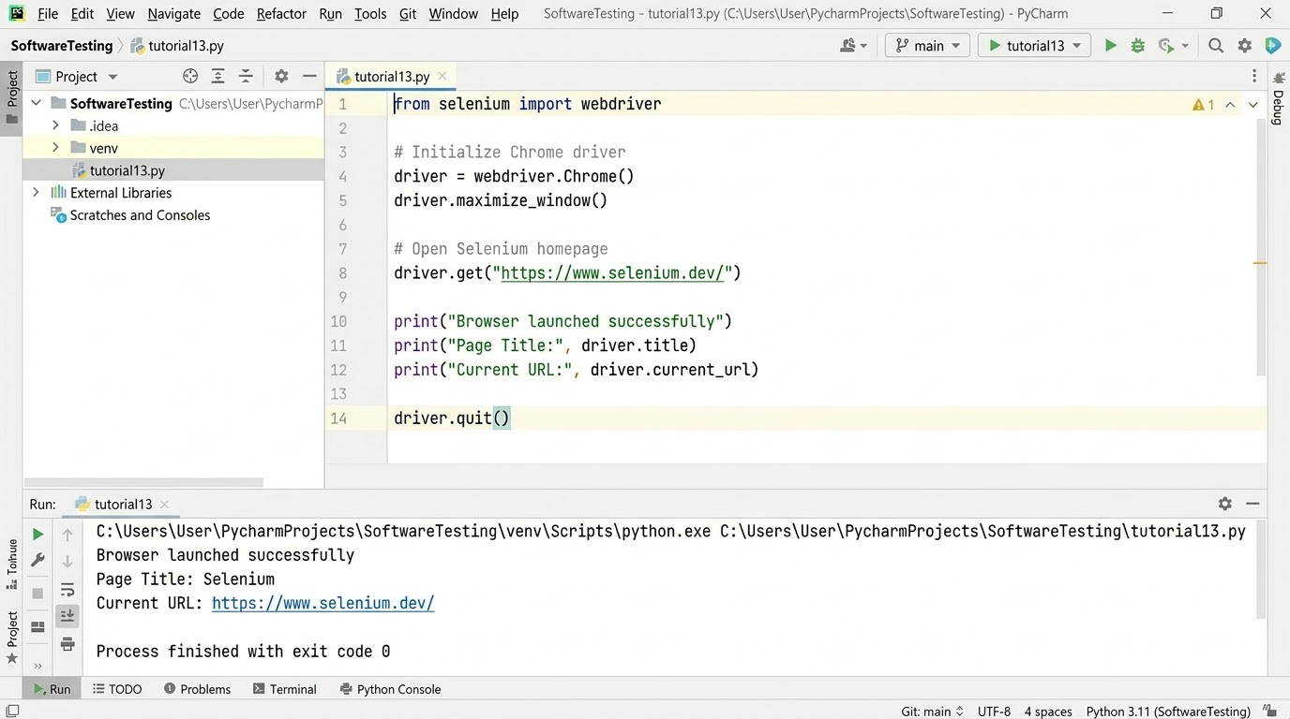

Conclusion
The Selenium environment setup is intended to be successful when Python, PyCharm, Selenium WebDriver, and Google Chrome work together to launch the browser and open the Selenium website. The console should display the browser launch message, page title, and current URL. Replace this conclusion with the observed result if execution differs.

