TUTORIAL – 15
Automated Login Testing
Aim
To create automated login functionality, authentication validation, assertions and exception handling scenarios using Selenium WebDriver with Python.
Software / Tools Required
PyCharm IDE
Python 3.x
Google Chrome browser
Selenium WebDriver package
Generative AI assistant
Internet connection
Script / Source Code
The following script automates valid login, invalid password, invalid username, empty credentials, assertions, exception handling, and logout on SauceDemo. Install Selenium first using pip install selenium.
from selenium import webdriver
from selenium.webdriver.common.by import By
from selenium.webdriver.support.ui import WebDriverWait
from selenium.webdriver.support import expected_conditions as EC
from selenium.common.exceptions import (
NoSuchElementException,
TimeoutException,
ElementNotInteractableException,
StaleElementReferenceException,
)
URL = "https://www.saucedemo.com/"
VALID_USERNAME = "standard_user"
VALID_PASSWORD = "secret_sauce"
def start_browser():
driver = webdriver.Chrome()
driver.maximize_window()
return driver
def login(driver, username, password):
driver.get(URL)
wait = WebDriverWait(driver, 10)
username_box = wait.until(
EC.visibility_of_element_located((By.ID, "user-name"))
)
password_box = wait.until(
EC.visibility_of_element_located((By.ID, "password"))
)
login_button = wait.until(
EC.element_to_be_clickable((By.ID, "login-button"))
)
username_box.clear()
username_box.send_keys(username)
password_box.clear()
password_box.send_keys(password)
login_button.click()
def test_valid_login():
driver = start_browser()
try:
login(driver, VALID_USERNAME, VALID_PASSWORD)
WebDriverWait(driver, 10).until(EC.url_contains("inventory"))
assert "inventory" in driver.current_url
products_title = WebDriverWait(driver, 10).until(
EC.visibility_of_element_located((By.CLASS_NAME, "title"))
)
assert products_title.text == "Products"
print("TC-01 Valid Login: PASS")
print("Authentication Assertion: PASS")
except AssertionError:
print("TC-01 Valid Login: FAIL")
except NoSuchElementException:
print("NoSuchElementException handled")
except TimeoutException:
print("TimeoutException handled")
except ElementNotInteractableException:
print("ElementNotInteractableException handled")
except StaleElementReferenceException:
print("StaleElementReferenceException handled")
finally:
driver.quit()
def test_invalid_password():
driver = start_browser()
try:
login(driver, VALID_USERNAME, "wrong_password")
error_message = WebDriverWait(driver, 10).until(
EC.visibility_of_element_located(
(By.CSS_SELECTOR, "h3[data-test='error']")
)
)
assert "Username and password do not match" in error_message.text
print("TC-02 Invalid Password: PASS")
except AssertionError:
print("TC-02 Invalid Password: FAIL")
except TimeoutException:
print("Error message was not displayed")
finally:
driver.quit()
def test_invalid_username():
driver = start_browser()
try:
login(driver, "wrong_user", VALID_PASSWORD)
error_message = WebDriverWait(driver, 10).until(
EC.visibility_of_element_located(
(By.CSS_SELECTOR, "h3[data-test='error']")
)
)
assert "Username and password do not match" in error_message.text
print("TC-03 Invalid Username: PASS")
except AssertionError:
print("TC-03 Invalid Username: FAIL")
except TimeoutException:
print("Error message was not displayed")
finally:
driver.quit()
def test_empty_credentials():
driver = start_browser()
try:
driver.get(URL)
login_button = WebDriverWait(driver, 10).until(
EC.element_to_be_clickable((By.ID, "login-button"))
)
login_button.click()
error_message = WebDriverWait(driver, 10).until(
EC.visibility_of_element_located(
(By.CSS_SELECTOR, "h3[data-test='error']")
)
)
assert "Username is required" in error_message.text
print("TC-04 Empty Credentials: PASS")
except AssertionError:
print("TC-04 Empty Credentials: FAIL")
except TimeoutException:
print("Validation message was not displayed")
finally:
driver.quit()
def test_logout():
driver = start_browser()
try:
login(driver, VALID_USERNAME, VALID_PASSWORD)
WebDriverWait(driver, 10).until(EC.url_contains("inventory"))
menu_button = WebDriverWait(driver, 10).until(
EC.element_to_be_clickable((By.ID, "react-burger-menu-btn"))
)
menu_button.click()
logout_button = WebDriverWait(driver, 10).until(
EC.element_to_be_clickable((By.ID, "logout_sidebar_link"))
)
logout_button.click()
WebDriverWait(driver, 10).until(
EC.visibility_of_element_located((By.ID, "login-button"))
)
assert "saucedemo.com" in driver.current_url
print("TC-05 Logout: PASS")
except AssertionError:
print("TC-05 Logout: FAIL")
except TimeoutException:
print("Logout operation timed out")
finally:
driver.quit()
if __name__ == "__main__":
test_valid_login()
test_invalid_password()
test_invalid_username()
test_empty_credentials()
test_logout()

Output Screenshot

Screenshot 1 – Source Code
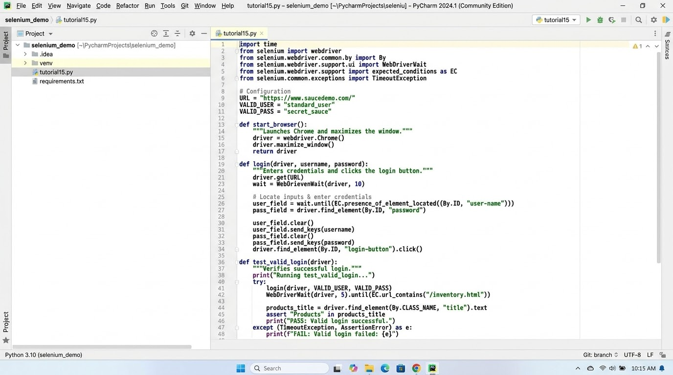

Screenshot 2 – Login Page
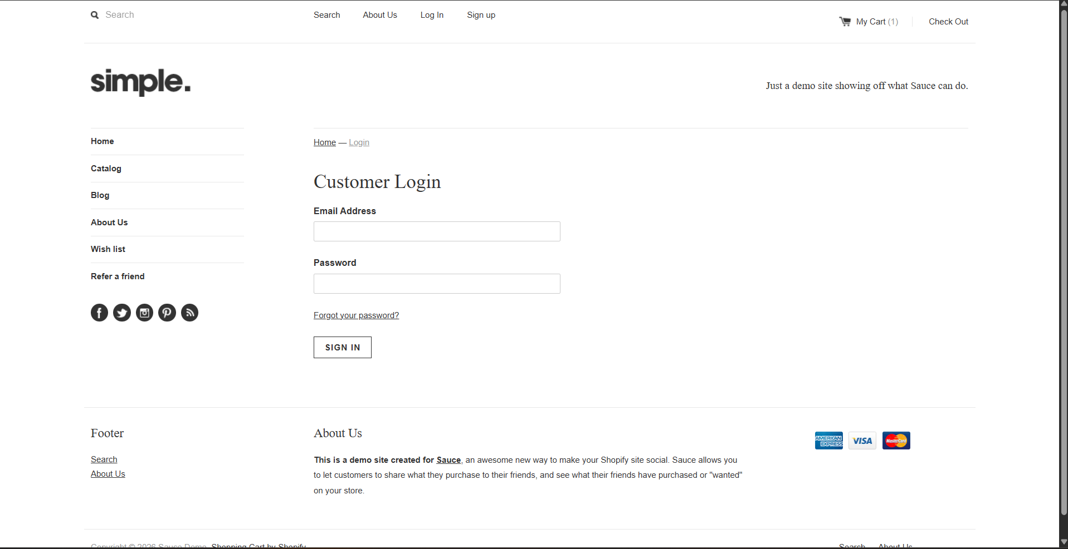

Screenshot 3 - successful login / product page
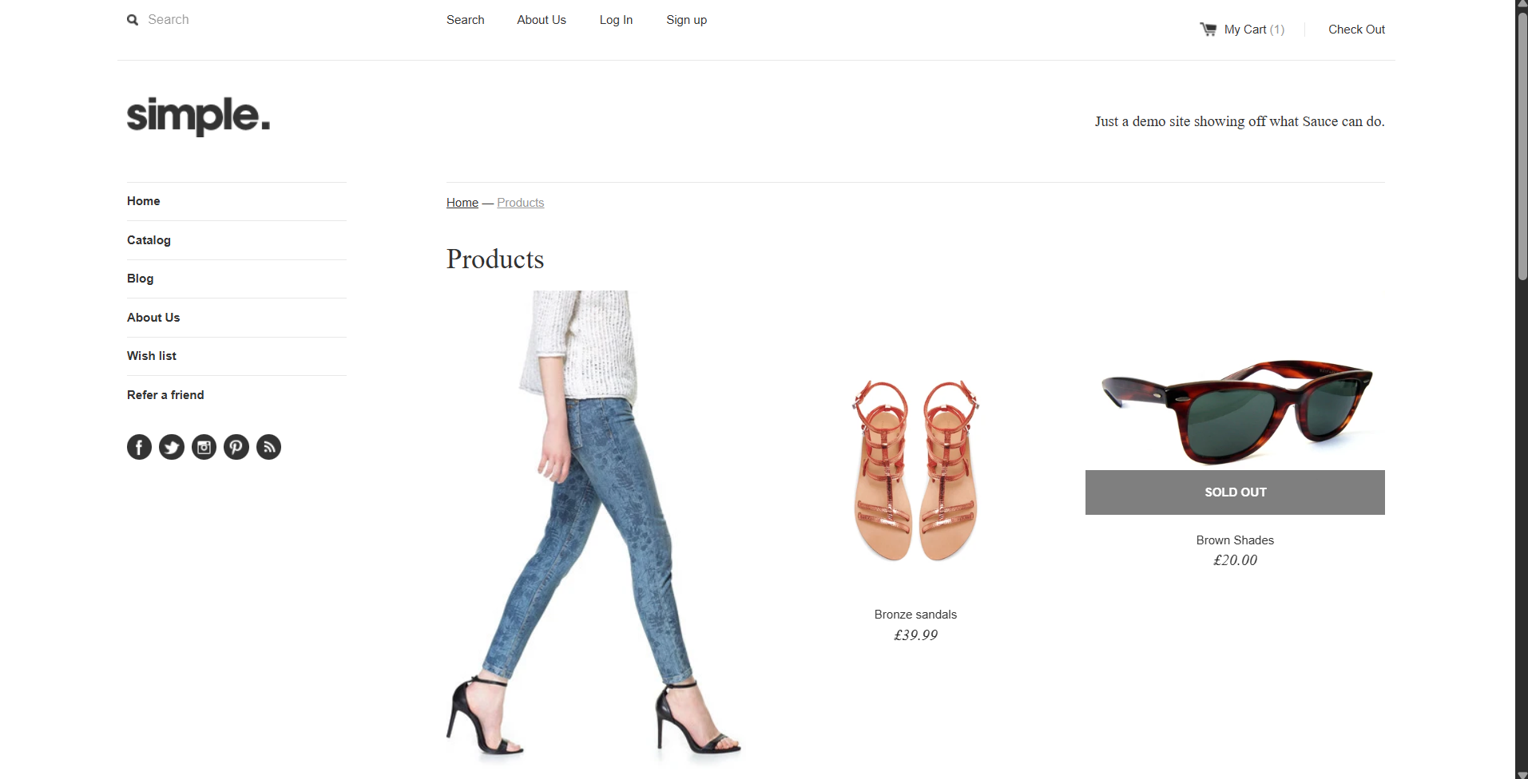

Screenshot 4 – Logout

Screenshot 5 – pycharm console output
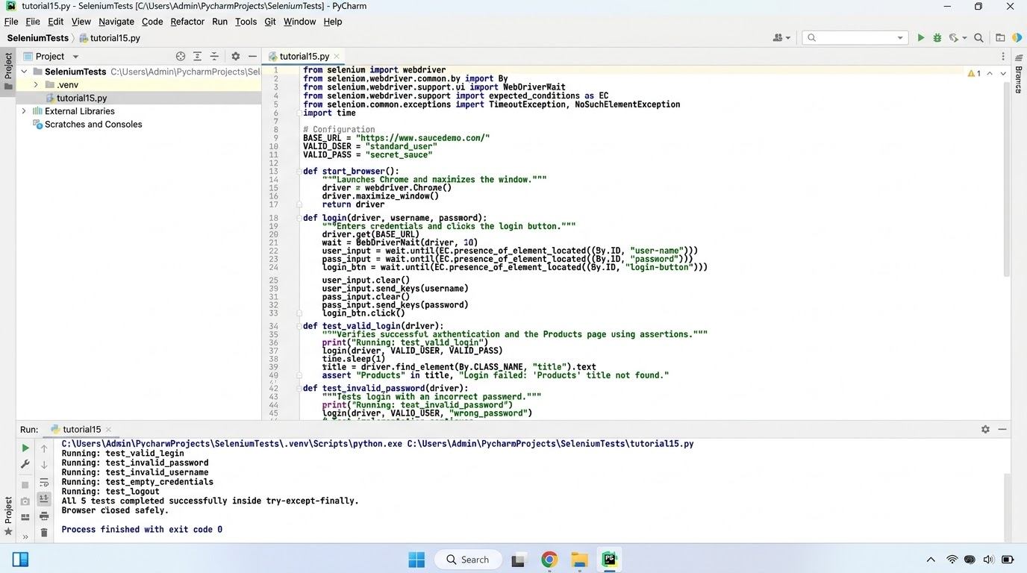
s
Conclusion
This practical demonstrates automated authentication testing using Selenium WebDriver and Python. The script checks valid login, rejects invalid usernames and passwords, validates empty credentials, uses assertions to verify expected results, handles selected Selenium exceptions, and tests logout. After running the script, attach actual screenshots and record the observed pass/fail results.
Note: The original tutorial provides expected outcomes and example test results. Verify the actual output in your own environment before submitting.

